How to use gitbash and github

**Step 1**: Install git bash (command prompt).

**Step 2:** Create a folder and create any text/word file inside that folder.

**Step 3:** Create an account in Git hub and create a public repository.

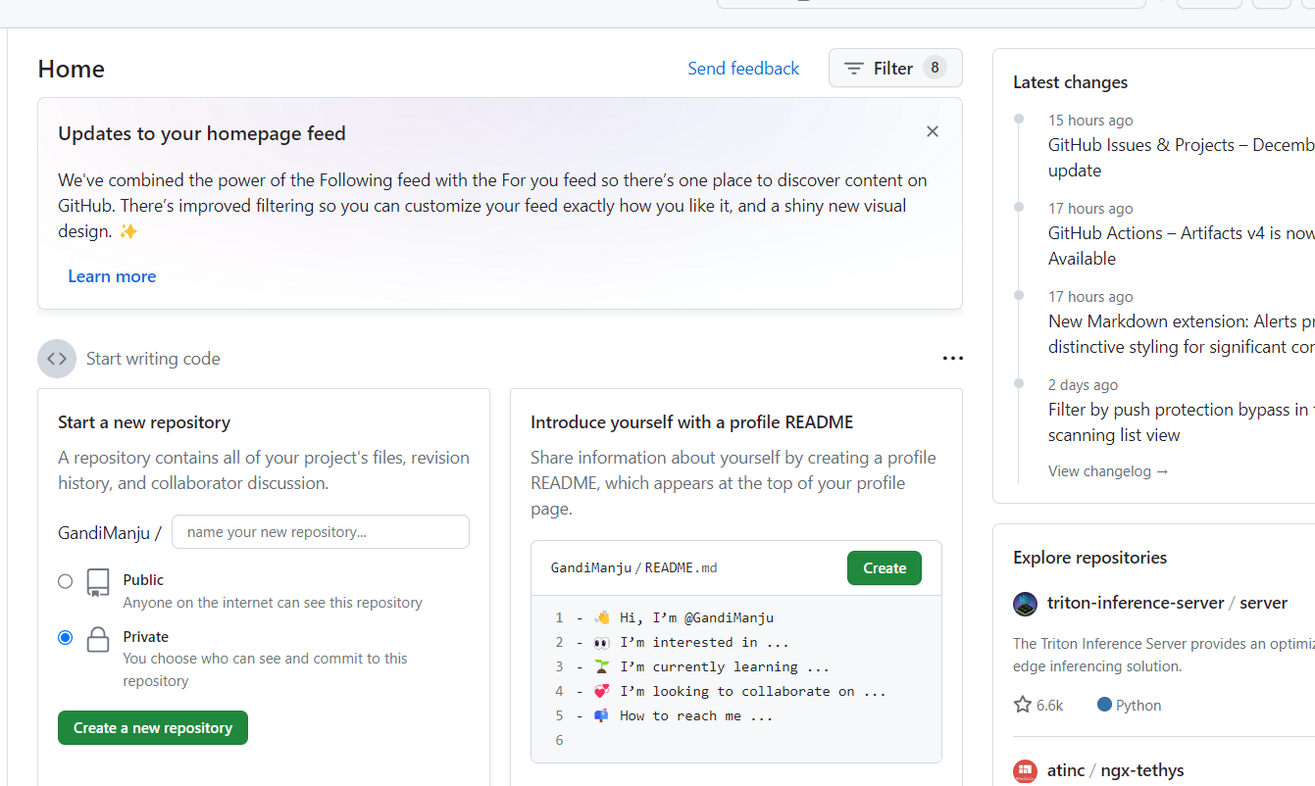

**Step 4:** Open git bash and follow the below commands

1. **git init** (command creates a new Git repository.)
2. **cd (**directory)
3. **cd (**folder name)
4. **git status** (displays the state of the working directory and the staging area.)
5. **git add** ("git add <file>..." to include in what will be committed)
6. **git commit -m** "first commit" (we can pass message inside the double quotes)
7. **git push (**git push --set-upstream origin master**)**

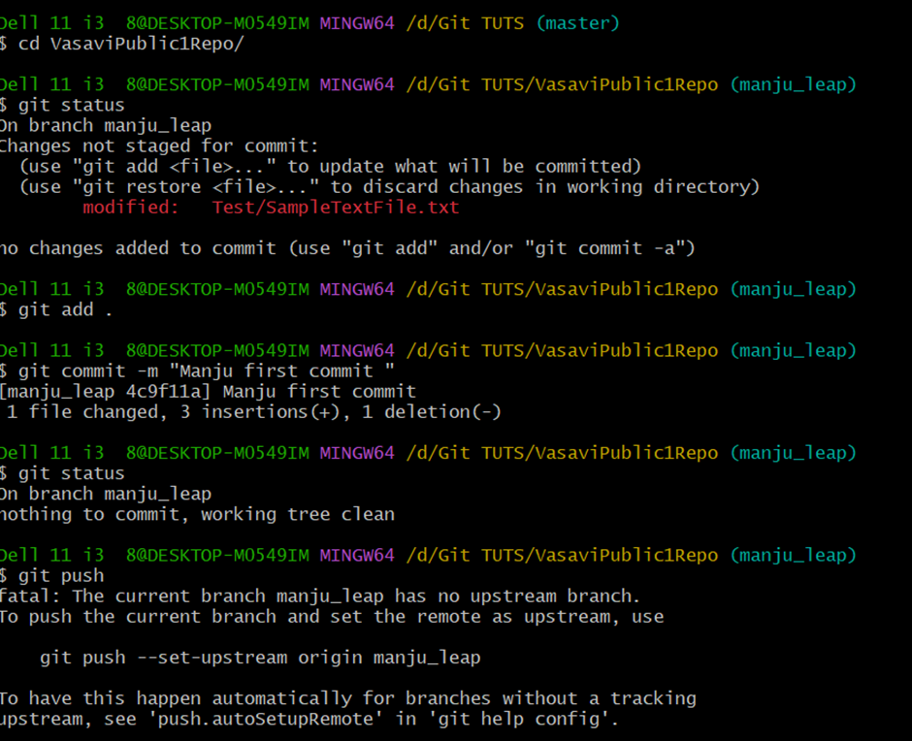

**Step 5:** If push the command is not working and getting error as below

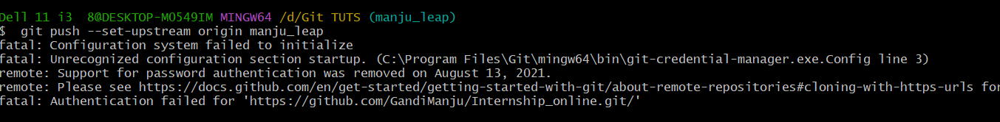

Use the following actions to resolve the error

**Option 1:**

1) Clone the repository again to a new path/folder

2) Update the Username and Password in git bash using the following command

* git config --global [user.name](http://user.name/) <USERNAME>
* git config --global user.email <EMAILID>

Ensure you have updated the email correctly and you could see the email and username updated when you give the git config --list

3) Try now by closing and opening the git bash

4) Try the Git Push

**Option 2:**

1) Got to your [github.com](http://github.com/) account

2) Click on the profile -> Settings -> Developer Setting -> Personal Access Tokens

3) You can click on "New Personal Token “, Give a name for the token, and select for 30 days or any period

4) Select all options available and click on "Generate Token" and copy that

5) Now you can issue the push command again and when after entering the username/email id and for password please paste the generated token.

6) to avoid the login again, you can issue the command.