**E-Stock Application**

**Login Page –** SPA built using Angular

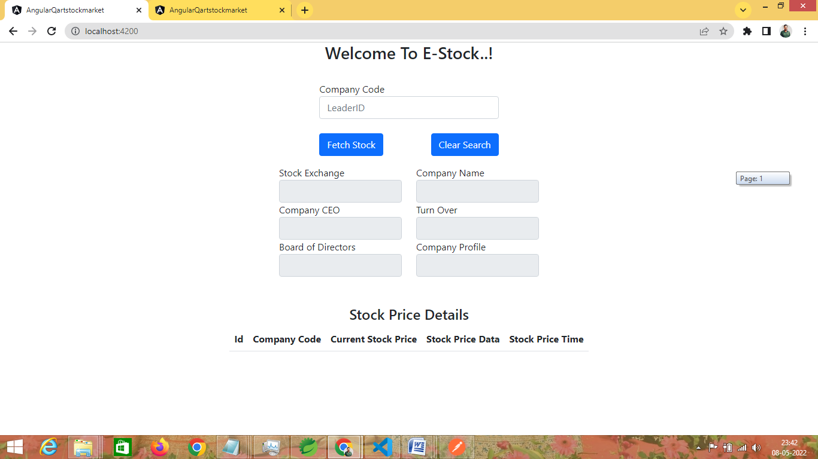

**Fetching Stock Details –** With a Valid Company Code, API fetches Company Details along with stock prices.

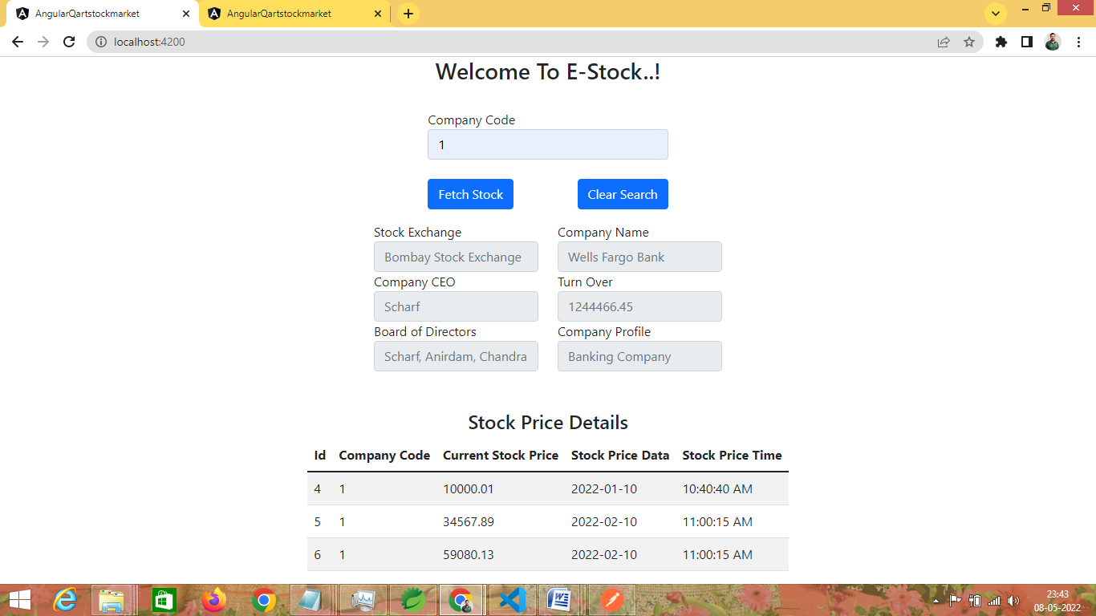

**Error Screen** : Display error message for incorrect company code

