BLOG APP WEBSITE

1. PROJECT REPORT

BACHELOR OF SCIENCE

SUBMITTED BY

BATHINA POORNA SAI

Team LTVIP2023PMID03098



A.M. A.L College

(Recognised by Andhra University

A.M.A.L COLLEGE, KOTHURU, ANAKAPALLE, . ANDHRAPRADESH

INTRODUCTION

A Blog is a type of website that is updated regularly with new content. Most blogs contain short, informal articles called blog posts. These posts usually contain some combination of text, photos, videos, and other media. At its core, a blog is just a space on the Web that you can create to record and express your opinions, experiences, and interests.

DECLARATION

To the best of my knowledge and belief, this paper is based on my own work, all sources have been properly acknowledged, and the paper follows the guidelines as mentioned by the organization. I

assure that this paper does not violate any Copyright rules and I abide by the laws in case of any violation.

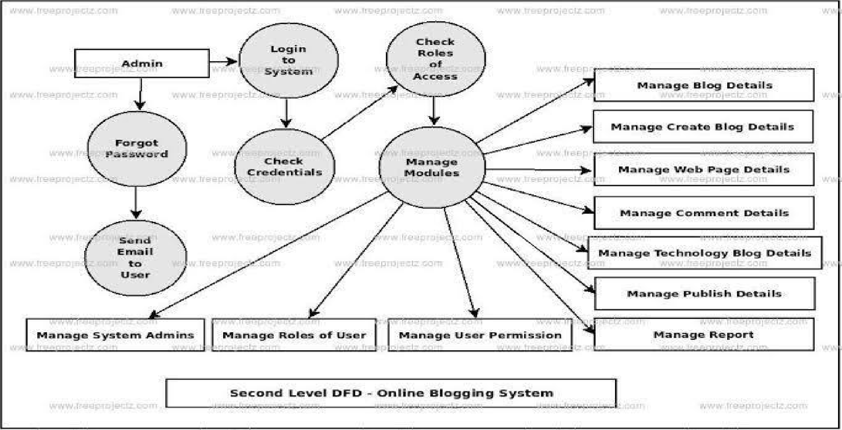

SOFTWARE USED

Code Editor I used for this project is VS Code, It is used to code complex piece of prograrns and to develop complex projects. Further technologies I used for this project are HTMLS, CSS, JS.

2.1 HTMLS

It is the code for creating web pages, using tags and other commands that a browser rends and eOiiVCi'tS into the iiOt'iÄiiil web pages that people see.

2.2 css

CSS is the language for describing the presentation of Web pages, including colours, layout, and fonts.

Result / Output

Home Section:

It displays my name, my current work, status and where I am from on the topic also has navigation bar which displays other tabs of my website and my contact detail shortcuts on top right.

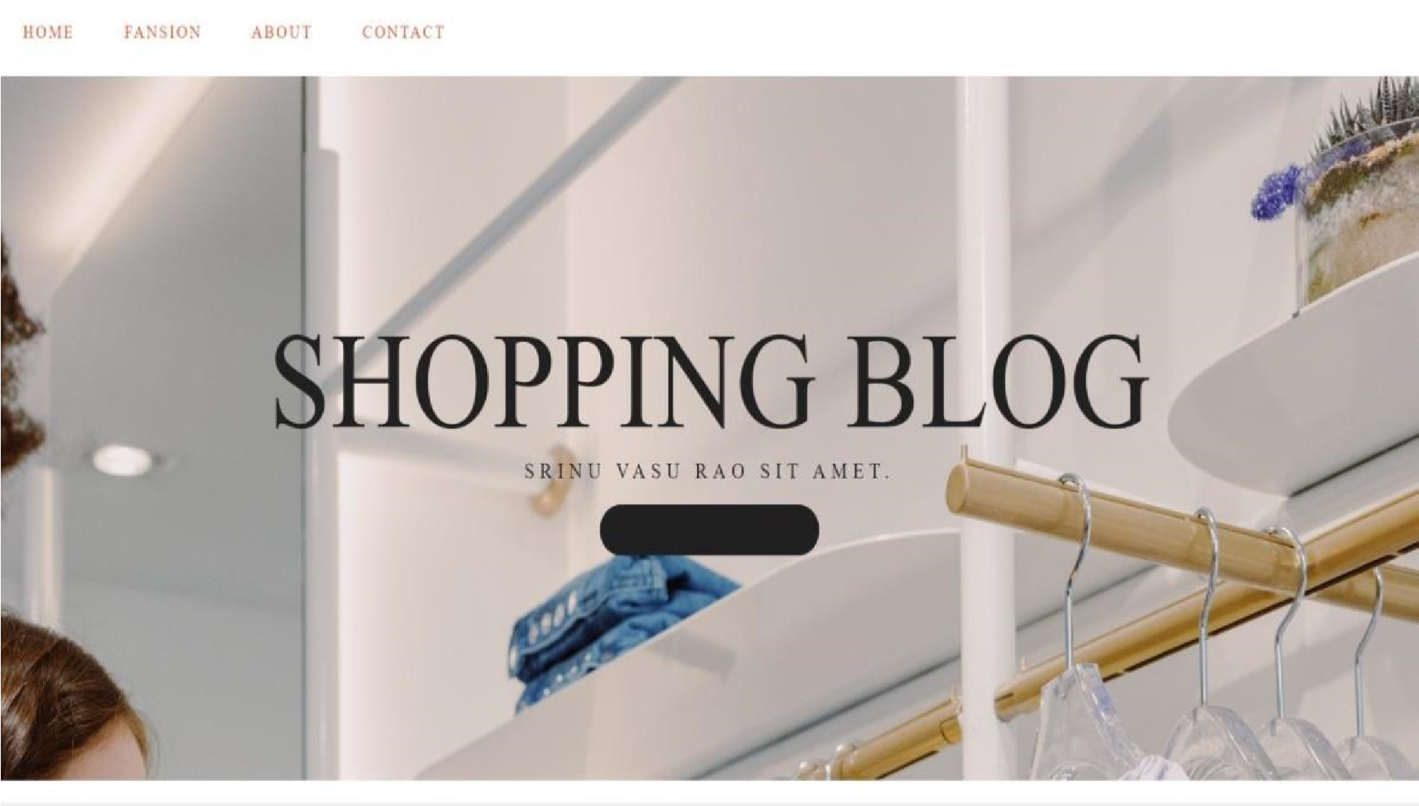

About Section:

It displays a quick introduction for me and provides my skills and education.

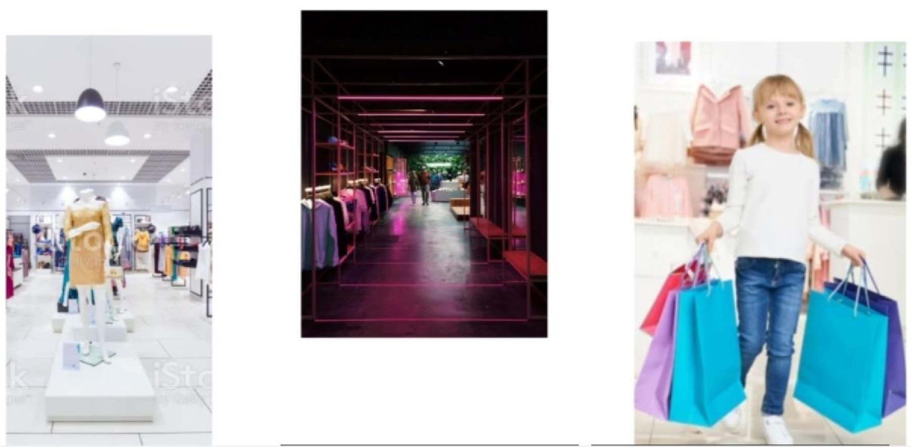

Contact Details Section:

This section has all the links listed below: I.

Facebook

1. Twitter
2. WhatsApp
3. Instagram
4. Linked In



# ADVANTAGES:

* “0” Financial Investment
* Turn Your Traffic into Leads
* Work From Anywhere
* Build your Community
* Position Your Brand
* Excellent Source of Income

# DISADVANTAGES:

* Needs Maintenace
* A Steady Source of Income ? “NO”
* Hug Investment of Time &Work
* Not All Bloggers Make Money
* Market Trends Always on The Swirl
* You Always Run Out of Ideas

Applications:

Common uses include teaching and educational and corporate use. Your blog can be a personal diary, a project collaboration tool, a guide, or any means of communicating and publishing information on the web.

Conclusion;

Conclusions are a great opportunity to reemphasize your blog’s purpose and influence readers to take any desired action after they’ve been engaged with your writing. Just like this conclusion is reminding you what we’ve discussed in this blog, so to should your conclusions.

Future Scope:

The scope for blog eventually grows with time, depending on the blogs’ performance and revenue. However, wellbuilt reference help one become successful as a professional blog. Blog must maintain consistency in their writing and marketing aspects.