GEETHANJALI COLLEGE OF ENGINEERING AND TECHNOLOGY
(UGC Autonomous) | Affiliated to JNTUH | Approved by AICTE
Cheeryal (V), Keesara (M), Medchal District, Telangana – 501301
DEPARTMENT OF COMPUTER SCIENCE AND ENGINEERING
(ARTIFICIAL INTELLIGENCE AND MACHINE LEARNING)

DIGITAL DOCUMENT SEARCH SYSTEM
USING ADVANCED DATA STRUCTURES
PROJECT-BASED LEARNING (PBL) REPORT
for the course
ADVANCED DATA STRUCTURES LAB | 25CS21L01
BACHELOR OF TECHNOLOGY
in
COMPUTER SCIENCE AND ENGINEERING
(ARTIFICIAL INTELLIGENCE AND MACHINE LEARNING)
SUBMITTED BY
S. No. | Name of Student | Hall Ticket No.
1 | K. Akshaya | 26R15A6604
2 | P. Shanmuka Sai Prabhath | 26R15A6605
3 | R. Malavika | 26R15A6606
4 | V. Chaithanya | 26R15A6607

UNDER THE GUIDANCE OF
Dr. H. Venkata Ramana Rao
Associate Professor, Department of CSE (AI&ML)
II B.Tech. | I Semester | AIML-A | A.Y. 2026–27

CERTIFICATE
This is to certify that the Project-Based Learning report entitled “Digital Document Search System Using Advanced Data Structures” is a record of the project work undertaken by the following students in partial fulfilment of the requirements of Advanced Data Structures Lab (25CS21L01), II B.Tech., I Semester, Department of Computer Science and Engineering (Artificial Intelligence and Machine Learning), Geethanjali College of Engineering and Technology, during the academic year 2026–27.
S. No. | Student Name | Hall Ticket No.
1 | K. Akshaya | 26R15A6604
2 | P. Shanmuka Sai Prabhath | 26R15A6605
3 | R. Malavika | 26R15A6606
4 | V. Chaithanya | 26R15A6607

The project has been developed under the guidance of Dr. H. Venkata Ramana Rao, Associate Professor, Department of CSE (AI&ML).
____________________________ | ____________________________
Dr. H. Venkata Ramana Rao  Project Guide | Dr. L. Venkateswarlu  Head of the Department  Department of CSE (AI&ML)
Place: GCET, Cheeryal Date: ____________________

DECLARATION
We declare that the project report entitled “Digital Document Search System Using Advanced Data Structures” is prepared as part of the Advanced Data Structures Lab PBL activity. All external references and software resources used in the project shall be acknowledged. The final source code, screenshots, implementation results and individual contributions recorded in the submitted version must correspond to the work actually performed by our group.
S. No. | Student Name | Signature
1 | K. Akshaya | ________________
2 | P. Shanmuka Sai Prabhath | ________________
3 | R. Malavika | ________________
4 | V. Chaithanya | ________________

ACKNOWLEDGEMENT
We express our sincere gratitude to the management and faculty of Geethanjali College of Engineering and Technology for the academic environment and facilities provided to carry out this PBL activity. We thank the Department of Computer Science and Engineering (Artificial Intelligence and Machine Learning) for encouraging application-oriented learning. We are particularly grateful to our guide, Dr. H. Venkata Ramana Rao, Associate Professor, for his guidance on data-structure selection, algorithm design, implementation, testing and report preparation.

TABLE OF CONTENTS
S. No. | Contents | Page No.
1 | Abstract | 1
2 | Chapter 1 Introduction | 1
3 | Chapter 2 Requirements and System Design | 3
4 | Chapter 3 Data Structures and Architecture | 4
5 | Chapter 4 Algorithms and Complexity Analysis | 6
6 | Chapter 5 Implementation | 8
7 | Chapter 6 Testing, Results and Discussion | 9
8 | Chapter 7 Conclusion and Future Scope | 11
9 | References | 11
10 | Appendix A Complete C Program | 12
11 | Appendix B Sample Execution and Evidence | 24
12 | Appendix C Group Contribution Record | 26

ABSTRACT
The Digital Document Search System is a menu-driven C application that stores text documents and retrieves them quickly by keyword, word prefix, exact phrase or title. It combines four advanced data structures and algorithms: a standard trie that acts as an inverted index from words to documents, an AVL tree that keeps document titles in a height-balanced search tree, three string-matching algorithms (brute force, Knuth-Morris-Pratt and Boyer-Moore) for phrase search, and merge sort for ranking results by relevance. Documents are stored in a binary file and reloaded on the next run, and the in-memory indexes are rebuilt from it. Index lookups cost time proportional to the length of the word and title operations cost O(log D) for D documents. On a five-document sample corpus, Boyer-Moore needed 277 character comparisons for the pattern “search” against 1,310 for brute force. The application is a teaching prototype; it has no graphical interface, ranking beyond term frequency or multi-user support.
Keywords Advanced Data Structures; Trie; AVL Tree; Pattern Matching; KMP; Boyer-Moore; Merge Sort; File Organization; C Programming.
CHAPTER 1 INTRODUCTION
1.1 Background
Digital libraries, lecture notes and project reports quickly grow into collections that cannot be searched by eye. A naïve search program opens every document and scans it from beginning to end for each query, and it lists documents in the order in which they were stored. This is easy to write but its cost grows with the size of the whole collection for every single query. Search engines avoid this by building an index in advance, so that a query only touches the small part of the data that can match.
1.2 Problem Statement
Design and implement a menu-driven document search prototype in C. The user must be able to add documents by typing them or importing a text file, list them in alphabetical order of title, view and delete them, and search them by keyword (all words must occur), by word prefix, by exact phrase and by title. Keyword results must be ranked by relevance. The system must reject duplicate titles, handle unknown queries, invalid menu choices and empty input without corrupting the stored data, and must keep the documents between runs.
1.3 Objectives
- Build an inverted index with a standard trie for keyword and prefix search.
- Maintain a self-balancing AVL tree of titles for sorted listing, lookup and deletion.
- Implement Brute Force, KMP and Boyer-Moore phrase search and compare their number of character comparisons.
- Rank keyword results with merge sort and store documents in a binary file.
- Verify the system against defined functional test cases and explain time and space complexity and limitations.
1.4 Scope and Assumptions
The prototype stores up to 1,000 documents, with titles of up to 99 characters. Words are sequences of letters and digits, converted to lower case, with a maximum length of 63 characters. Document titles are unique, ignoring case. The indexes live in memory while the program runs and are rebuilt from the binary file docs.dat at start-up. The program is intended for academic demonstration; it does not support stemming, stop words, fuzzy matching or several users at once.
1.5 Relevance to the ADS Laboratory
The project integrates several topics of the Advanced Data Structures course in one application: standard tries, AVL trees, pattern matching (brute force, KMP and Boyer-Moore), merge sort and file organization with basic file operations. It also supports the laboratory’s emphasis on building data structures and analysing the efficiency of their operations, since the program reports comparison counts and structure heights while it runs.
CHAPTER 2 REQUIREMENTS AND SYSTEM DESIGN
2.1 Functional and Non-functional Requirements
ID | Requirement | Acceptance Criterion
FR-01 | Add and import documents | A document typed in or read from a text file is stored with a unique ID and indexed.
FR-02 | Prevent duplicate titles | A second document with the same title (ignoring case) is rejected.
FR-03 | Keyword search | Only documents containing every keyword are returned, highest relevance first.
FR-04 | Prefix search | Up to 20 indexed words that start with the prefix are listed with document counts.
FR-05 | Phrase search | Every occurrence of the phrase is found with the algorithm chosen by the user.
FR-06 | Title search and listing | Titles are listed alphabetically; exact and prefix title lookup work.
FR-07 | Delete and persist | A deleted document disappears from every search; saved documents reload on restart.
NFR-01 | Correctness | Search results are always consistent with the stored documents.
NFR-02 | Efficiency | The choice of data structures is justified by complexity.
NFR-03 | Usability | The interface provides a readable menu, tables and highlighted matches.

2.2 Operating Sequence
At start-up the program loads docs.dat, if it exists, and builds the trie and the AVL tree from the stored documents. When a document is added, its title is checked against the AVL tree for duplicates, the record is stored, the title is inserted into the AVL tree and every word of the text is inserted into the trie together with the document ID and a frequency count. A keyword query is split into words, each word is looked up in the trie, documents present in every posting list are kept, their frequencies are added to give a score, and merge sort orders them. Phrase search scans the text of each document with the chosen matching algorithm. Deleting a document removes its title from the AVL tree and rebuilds the trie. Saving writes all documents to the binary file.
2.3 Key Design Invariants
- Every stored document has exactly one node in the AVL title tree, and titles are unique ignoring case.
- For every node of the AVL tree the heights of its two subtrees differ by at most one.
- Each posting list of the trie holds at most one posting per document, and its frequency is at least one.
- The trie and the AVL tree are derived data: rebuilding them from the stored documents gives the same index.
CHAPTER 3 DATA STRUCTURES AND ARCHITECTURE
3.1 Proposed Architecture
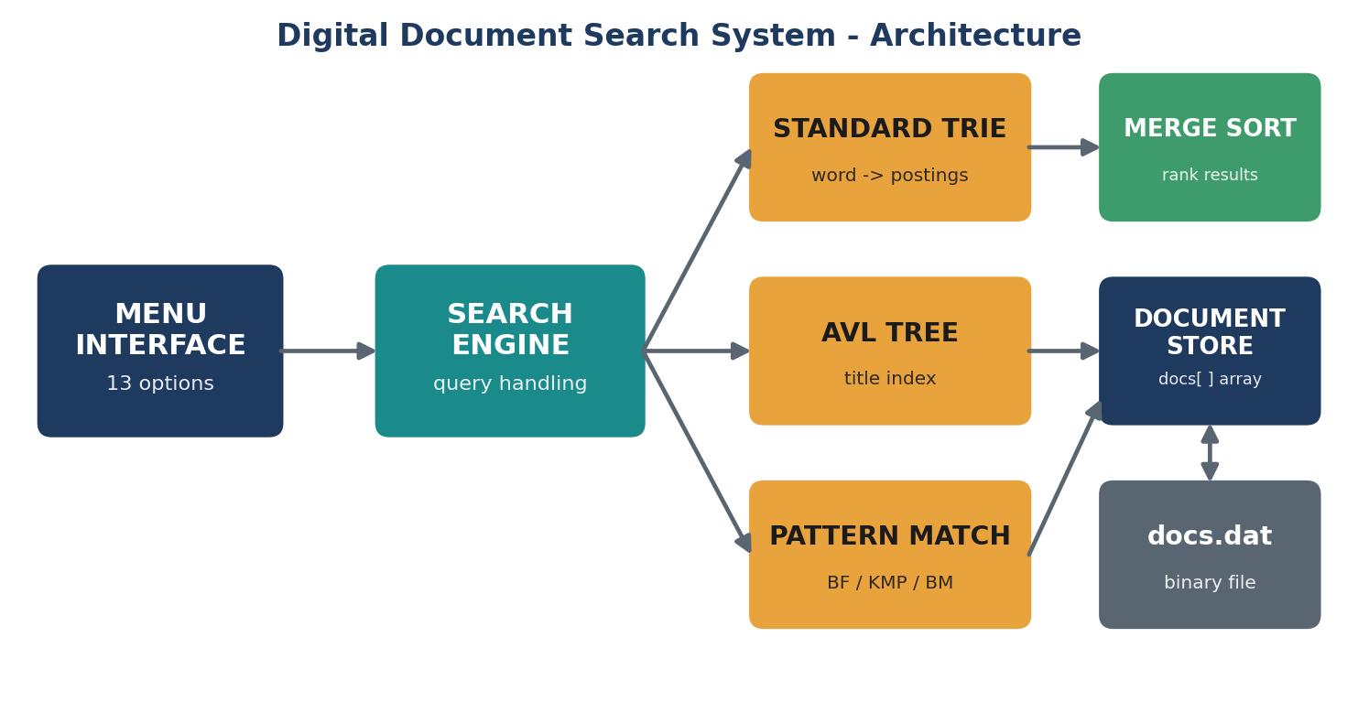
Figure 3.1 Architecture of the Digital Document Search System
3.2 Selection of Data Structures
Structure | Responsibility | Justification
Standard trie | Maps every word to the documents that contain it, with frequencies | Lookup and insertion take O(L) for a word of length L, independent of the number of words; supports prefix queries.
AVL tree | Keeps document titles ordered and balanced | Insert, search and delete are O(log D) even for sorted input; in-order traversal gives sorted titles.
Pattern matching | Finds a phrase inside document text (Brute Force, KMP, Boyer-Moore) | Shows the trade-off between simple scanning, prefix-table reuse and character skipping.
Merge sort | Orders keyword results by relevance | Stable, O(k log k) in all cases, no bad input.
Binary file | Stores document records between runs | Fixed-size title field and length-prefixed content allow simple sequential read and write.

3.3 Data Representation
typedef struct { int id; char title[100]; char *content; int len; } Document;
typedef struct Posting { int docId, freq; struct Posting *next; } Posting;
typedef struct TrieNode {
struct TrieNode *child[36]; /* a-z and 0-9 */
Posting *post; int isEnd;
} TrieNode;
typedef struct AVL {
char title[100]; int docId, height;
struct AVL *left, *right;
} AVL;
typedef struct { int id, score; } Result; /* sorted by merge sort */
3.4 Design Choice and Limitations
A trie uses more memory than a hash table, because every node holds 36 child pointers, but it gives prefix search and a lookup time that depends only on the length of the word. The AVL tree is preferred to a plain binary search tree because titles often arrive in sorted order, which would degrade an unbalanced tree to a list. The index is relevance-ranked only by term frequency. All structures are kept in memory and are rebuilt from the binary file; deleting a document rebuilds the whole trie, which is simple but slow for very large collections.
CHAPTER 4 ALGORITHMS AND COMPLEXITY ANALYSIS
4.1 Keyword Search Algorithm
KEYWORD_SEARCH(query)
for each word w in query:
node = TRIE_FIND(w)
for each posting (doc, freq) of node:
hits[doc] += 1; score[doc] += freq
results = { doc : hits[doc] == number of words }
MERGE_SORT(results by score descending, then ID)
return results
4.2 AVL Insertion and Rebalancing
AVL_INSERT(node, title)
if node is empty: return new node(title)
if title < node.title: node.left = AVL_INSERT(node.left, title)
else: node.right = AVL_INSERT(node.right, title)
update height(node)
b = height(left) - height(right)
if b > 1: (rotate left child left first if it leans right); rotate right
if b < -1: (rotate right child right first if it leans left); rotate left
return node
4.3 Pattern Matching Algorithms
Brute Force tries the pattern at every text position and compares from the left, so it needs O(n·m) comparisons for a text of n characters and a pattern of m characters. Knuth-Morris-Pratt first builds an LPS table (the length of the longest proper prefix that is also a suffix for every prefix of the pattern); after a mismatch it moves the pattern using this table and never re-reads text characters, giving O(n + m). Boyer-Moore compares from the right end of the pattern and uses the bad-character rule: on a mismatch it jumps to align the mismatched text character with its last occurrence in the pattern, so it often skips many characters and is sub-linear in practice, with O(n·m) as the worst case. All three count their character comparisons in the global counter cmpCount, which the program reports.
4.4 Complexity Comparison
Operation | Primary Structure | Average / Expected | Worst Case
Index a document | Trie | O(T·L) | O(T·L)
Keyword search | Trie + merge sort | O(q·L + k log k) | O(q·D + k log k)
Prefix search | Trie | O(P + S) | O(P + S)
Title insert / search / delete | AVL tree | O(log D) | O(log D)
Phrase search, Brute Force | Text scan | O(n·m) | O(n·m)
Phrase search, KMP | Text scan + LPS | O(n + m) | O(n + m)
Phrase search, Boyer-Moore | Text scan + bad character | about O(n/m) | O(n·m)
Space usage | All structures | O(T·L + D) | O(T·L + D)

T = number of word occurrences indexed, L = word length, q = words in the query, D = number of documents, k = results, P = prefix length, S = trie nodes visited below the prefix (the program stops after 20 words), n = text length, m = pattern length. The trie space is the worst case in which no words share a prefix. The “average” column for Boyer-Moore is the usual behaviour on natural-language text, not a proven bound.
4.5 Illustrative Operation Trace
Step | Command | Effect | AVL state
1 | Add “Introduction to AVL Trees” | Becomes the root of the AVL tree | Root: Introduction, height 1
2 | Add “Understanding Tries” | Placed as right child (U > I) | Root: Introduction, height 2
3 | Add “String Matching Algorithms” | Right-left imbalance at the root; double rotation | Root: String, height 2
4 | Add “Hashing and Collision Resolution” | Inserted left of Introduction; balanced | Root: String, height 3
5 | Add “File Organization Basics” | Left-left imbalance at Introduction; right rotation | Root: String, height 3

The five titles are the sample documents loaded by menu option 12, in that order. The AVL height of 3 after step 5 matches the value reported by the Statistics option. Titles are compared ignoring case.
CHAPTER 5 IMPLEMENTATION
5.1 Technology and Environment
Programming language: C (C11). Data structures: standard trie with posting lists, AVL tree, document array and binary file. Suitable compiler: GCC or another C11-compatible compiler. The source program in Appendix A uses only the standard C library and compiles without external dependencies; on Windows it enables ANSI colours through the console API.
5.2 Modules
Module | Key Functions | Description
Document store | add_doc_internal, op_add, op_import, op_delete | Holds document records, enforces unique titles and keeps the trie and AVL tree in step.
Trie index | trie_insert, trie_find, index_document, rebuild_trie, trie_collect | Tokenises text, builds posting lists and supports keyword and prefix queries.
AVL title index | avl_insert, avl_delete, avl_search, avl_inorder, avl_prefix | Balanced title tree with rotations; sorted listing and title search.
Pattern matching | brute_force, kmp, boyer_moore, run_algo, op_pattern, op_compare | Phrase search with a selectable algorithm and a comparison table.
Ranking | merge_sort, op_keyword | Orders keyword results by relevance score.
File and interface | save_docs, load_docs, menu, header, table_line, main | Binary file I/O, menu loop, coloured tables and status bar.

5.3 Implementation Details
The trie has one node per character, with 36 child pointers for the letters a-z and the digits 0-9. index_document reads a document character by character, forms lower-case words and calls trie_insert; because documents are indexed one at a time, a word’s newest posting is always at the head of its list and a repeated word only increments that posting’s frequency. The AVL tree stores titles compared ignoring case; rebalance recomputes heights after every insert and delete and applies the four rotation cases. KMP builds its LPS table in O(m) time, and Boyer-Moore keeps a 256-entry table of the last position of each character in the pattern. Documents are written to docs.dat as fixed-size title fields followed by length-prefixed content, so loading is a sequence of simple reads. Memory for every document, posting and node is released when a document is deleted or the index is rebuilt.
5.4 Compile and Run
gcc -std=c11 -Wall -Wextra -pedantic doc_search.c -o doc_search
./doc_search # Linux / macOS
doc_search.exe # Windows (after compiling to an .exe)
On the first run choose option 12 to load five sample documents, then try keyword search (6), prefix search (7), phrase search (8), the algorithm comparison (9) and title search (10). Option 13, or option 0 on exit, writes the documents to docs.dat; this file is created in the folder in which the program is run.
CHAPTER 6 TESTING, RESULTS AND DISCUSSION
6.1 Testing Approach
Functional verification covers successful operations and boundary conditions. The cases below were run on the program in Appendix A with the five sample documents. The “Observed Result” column was recorded from the console output of that run.
Test ID | Test Scenario | Expected Result | Observed Result
TC-01 | Load sample documents (12) | Five documents added and indexed | 5 documents, 138 unique words, 505 trie nodes, AVL height 3
TC-02 | List all documents (3) | Titles in alphabetical order | IDs 5, 4, 1, 3, 2 (File, Hashing, Introduction, String, Understanding)
TC-03 | Keyword “search” | Ranked results, most frequent first | 4 results: IDs 1 and 2 (score 2), IDs 3 and 5 (score 1)
TC-04 | Keyword “zebra” | No result | “No document contains all the keywords.”
TC-05 | Prefix “has” | Words starting with has | hash, hashed, hashing, each in 1 document
TC-06 | Phrase “bad character”, all three algorithms | Same single match in document 3 | 1 match; 1200 (BF), 1246 (KMP), 188 (BM) comparisons
TC-07 | Add a document with an existing title | Rejected | “A document with this title already exists.”
TC-08 | Delete ID 2, then keyword “trie” | Deleted document no longer found | “No document contains all the keywords.”
TC-09 | Save and restart, list documents | Remaining documents reloaded | “Loaded 4 saved document(s)”, four titles listed

6.2 Sample Results
For the pattern “search” over the five sample documents, all three algorithms find the same six matches, but Brute Force needs 1,310 character comparisons, KMP 1,299 and Boyer-Moore only 277. The keyword query “search” returns four documents with relevance scores 2, 2, 1 and 1. A prefix query such as “co” lists the indexed words that begin with those letters, and after the document about tries is deleted a search for “trie” correctly finds nothing. Screenshots of these runs are included in Appendix B.
6.3 Discussion
The sample demonstrates the benefit of using the right structure for each query type: the trie answers word and prefix questions without scanning documents, the AVL tree gives ordered titles and logarithmic title lookup, and the matching algorithms are needed only when an exact phrase must be located in the text. The comparison counts are measured values on a very small corpus of 1,229 characters. Run times are of the order of two milliseconds for 200 repeated passes and are dominated by copying the text to lower case, so no run-time speedup is claimed, only the reduction in comparisons.
6.4 Limitations
The prototype ranks results by term frequency only and does not use inverse document frequency, stemming or stop-word removal. It indexes only letters and digits, supports at most 1,000 documents, rebuilds the whole trie after a deletion and handles one user at a time. These are deliberate simplifications for the laboratory course.
CHAPTER 7 CONCLUSION AND FUTURE SCOPE
The Digital Document Search System demonstrates how several advanced data structures can be combined to solve a practical retrieval problem. The standard trie provides keyword and prefix search, the AVL tree keeps titles ordered and searchable in logarithmic time, Brute Force, KMP and Boyer-Moore show different ways to locate an exact phrase, merge sort ranks the results and a binary file keeps the documents between runs. Functional test cases confirm correct behaviour for ordinary and boundary inputs. The project connects theory such as tree balancing, prefix trees, pattern-matching shifts and complexity analysis with a working C program. Possible extensions include a B+ tree index on disk and stemming, TF-IDF ranking and fuzzy matching.
REFERENCES
[1] R. F. Gilberg and B. A. Forouzan, Data Structures: A Pseudocode Approach with C, 2nd ed., Cengage Learning.
[2] Reema Thareja, Data Structures Using C, 3rd ed., Oxford University Press.
[3] A. S. Tanenbaum, Y. Langsam and M. J. Augenstein, Data Structures Using C, PHI/Pearson Education.
[4] Geethanjali College of Engineering and Technology, Advanced Data Structures Lab (25CS21L01) syllabus, A.Y. 2026–27.
[5] D. E. Knuth, J. H. Morris and V. R. Pratt, “Fast pattern matching in strings,” SIAM Journal on Computing, vol. 6, no. 2, pp. 323–350, 1977.
[6] R. S. Boyer and J. S. Moore, “A fast string searching algorithm,” Communications of the ACM, vol. 20, no. 10, pp. 762–772, 1977.
[7] G. M. Adelson-Velsky and E. M. Landis, “An algorithm for the organization of information,” Doklady Akademii Nauk SSSR, vol. 146, pp. 263–266, 1962.

APPENDIX A COMPLETE C PROGRAM
Complete source code of the project: save it as doc_search.c and compile it as shown in Section 5.4. Long lines are wrapped for printing; the file in the repository is unwrapped.
/*
* DIGITAL DOCUMENT SEARCH SYSTEM
* Advanced Data Structures in C - Project Based Learning
*
* Advanced concepts used:
* 1. Standard Trie -> inverted index (word -> documents), prefix search / autocomplete
* 2. AVL Tree -> self-balancing title index (sorted listing, title search, delete)
* 3. Pattern Matching -> Brute Force, KMP, Boyer-Moore (bad character) with comparison counts
* 4. Merge Sort -> ranking of search results by relevance
* 5. File Organization -> binary file (docs.dat) storing records, text-file import
*
* Compile : gcc doc_search.c -o doc_search
* Run : ./doc_search
*/
#include <stdio.h>
#include <stdlib.h>
#include <string.h>
#include <ctype.h>
#include <time.h>
#ifdef _WIN32
#include <windows.h>
#endif
#define MAX_DOCS 1000
#define TITLE_LEN 100
#define DATA_FILE "docs.dat"
#define ALPHA 36 /* a-z and 0-9 */
/* ====================================================================
* DOCUMENT STORE
* ==================================================================== */
typedef struct {
int id;
char title[TITLE_LEN];
char *content;
int len;
} Document;
Document *docs[MAX_DOCS]; /* docs[id] ; NULL if empty/deleted */
int nextId = 1;
int docCount = 0;
/* ====================================================================
* INPUT HELPERS
* ==================================================================== */
void read_line(const char *prompt, char *buf, int size) {
printf("%s", prompt);
if (!fgets(buf, size, stdin)) { buf[0] = '\0'; return; }
buf[strcspn(buf, "\r\n")] = '\0';
}
int read_int(const char *prompt) {
char b[64];
read_line(prompt, b, sizeof b);
return atoi(b);
}
void to_lower_copy(const char *src, char *dst) {
int i;
for (i = 0; src[i]; i++) dst[i] = (char)tolower((unsigned char)src[i]);
dst[i] = '\0';
}
int ci_cmp(const char *a, const char *b) {
while (*a && *b) {
int x = tolower((unsigned char)*a), y = tolower((unsigned char)*b);
if (x != y) return x - y;
a++; b++;
}
return tolower((unsigned char)*a) - tolower((unsigned char)*b);
}
/* ====================================================================
* UI HELPERS (colours, banners, tables) - ASCII only, works everywhere
* ==================================================================== */
int useColor = 1;
#define RESET "\033[0m"
#define BOLD "\033[1m"
#define DIM "\033[2m"
#define RED "\033[31m"
#define GREEN "\033[32m"
#define YELLOW "\033[33m"
#define CYAN "\033[36m"
void setc(const char *c) { if (useColor) fputs(c, stdout); }
void ui_init(void) {
#ifdef _WIN32
HANDLE hd = GetStdHandle(STD_OUTPUT_HANDLE); DWORD mode = 0;
if (hd == INVALID_HANDLE_VALUE || !GetConsoleMode(hd, &mode) ||
!SetConsoleMode(hd, mode | 0x0004)) useColor = 0;
#endif
}
void ui_ok(const char *m) { setc(GREEN); printf(" [ OK ] "); setc(RESET); printf("%s\n", m); }
void ui_err(const char *m) { setc(RED); printf(" [ !! ] "); setc(RESET); printf("%s\n", m); }
void ui_info(const char *m) { setc(CYAN); printf(" [ i ] "); setc(RESET); printf("%s\n", m); }
void header(const char *t) {
printf("\n"); setc(BOLD CYAN);
printf(" %s\n ", t);
for (size_t i = 0; i < strlen(t); i++) putchar('-');
setc(RESET); printf("\n\n");
}
void table_line(const int *w, int n) {
printf(" +");
for (int i = 0; i < n; i++) { for (int k = 0; k < w[i] + 2; k++) putchar('-'); putchar('+'); }
printf("\n");
}
void pause_screen(void) {
char b[16];
setc(DIM); printf("\n Press Enter to return to the menu..."); setc(RESET);
if (!fgets(b, sizeof b, stdin)) b[0] = 0;
}
/* ====================================================================
* 1. STANDARD TRIE (inverted index)
* ==================================================================== */
typedef struct Posting {
int docId;
int freq;
struct Posting *next;
} Posting;
typedef struct TrieNode {
struct TrieNode *child[ALPHA];
Posting *post;
int isEnd;
} TrieNode;
TrieNode *trieRoot = NULL;
int trieNodes = 0, trieWords = 0;
int cidx(char c) { return isdigit((unsigned char)c) ? 26 + (c - '0') : c - 'a'; }
char idxc(int i) { return i < 26 ? (char)('a' + i) : (char)('0' + i - 26); }
TrieNode *trie_new(void) {
TrieNode *n = (TrieNode *)calloc(1, sizeof(TrieNode));
trieNodes++;
return n;
}
void trie_insert(const char *word, int docId) {
TrieNode *cur = trieRoot;
for (int i = 0; word[i]; i++) {
int k = cidx(word[i]);
if (!cur->child[k]) cur->child[k] = trie_new();
cur = cur->child[k];
}
if (!cur->isEnd) { cur->isEnd = 1; trieWords++; }
if (cur->post && cur->post->docId == docId) {
cur->post->freq++;
} else {
Posting *p = (Posting *)malloc(sizeof(Posting));
p->docId = docId; p->freq = 1; p->next = cur->post;
cur->post = p;
}
}
TrieNode *trie_find(const char *word) {
TrieNode *cur = trieRoot;
for (int i = 0; word[i]; i++) {
if (!isalnum((unsigned char)word[i])) return NULL;
cur = cur->child[cidx(word[i])];
if (!cur) return NULL;
}
return cur;
}
void trie_free(TrieNode *n) {
if (!n) return;
for (int i = 0; i < ALPHA; i++) trie_free(n->child[i]);
Posting *p = n->post;
while (p) { Posting *t = p->next; free(p); p = t; }
free(n);
}
/* tokenise a document and add every word to the trie */
void index_document(Document *d) {
char w[64]; int n = 0;
for (int i = 0; i <= d->len; i++) {
unsigned char c = (i < d->len) ? (unsigned char)d->content[i] : ' ';
if (isalnum(c)) { if (n < 63) w[n++] = (char)tolower(c); }
else if (n) { w[n] = '\0'; trie_insert(w, d->id); n = 0; }
}
}
void rebuild_trie(void) {
trie_free(trieRoot);
trieNodes = 0; trieWords = 0;
trieRoot = trie_new();
for (int i = 1; i < MAX_DOCS; i++)
if (docs[i]) index_document(docs[i]);
}
/* DFS to list all words with a given prefix */
void trie_collect(TrieNode *n, char *buf, int depth, int *printed, int limit) {
if (!n || *printed >= limit) return;
if (n->isEnd) {
int nd = 0;
for (Posting *p = n->post; p; p = p->next) nd++;
buf[depth] = '\0';
printf(" | %-24s | %9d |\n", buf, nd);
(*printed)++;
}
for (int i = 0; i < ALPHA; i++) {
if (n->child[i]) {
buf[depth] = idxc(i);
trie_collect(n->child[i], buf, depth + 1, printed, limit);
}
}
}
/* ====================================================================
* 2. AVL TREE (title index)
* ==================================================================== */
typedef struct AVL {
char title[TITLE_LEN];
int docId, height;
struct AVL *left, *right;
} AVL;
AVL *avlRoot = NULL;
int h(AVL *n) { return n ? n->height : 0; }
int mx(int a, int b) { return a > b ? a : b; }
void upd(AVL *n) { n->height = 1 + mx(h(n->left), h(n->right)); }
int bal(AVL *n) { return n ? h(n->left) - h(n->right) : 0; }
AVL *rot_right(AVL *y) {
AVL *x = y->left; y->left = x->right; x->right = y;
upd(y); upd(x); return x;
}
AVL *rot_left(AVL *x) {
AVL *y = x->right; x->right = y->left; y->left = x;
upd(x); upd(y); return y;
}
AVL *rebalance(AVL *n) {
upd(n);
int b = bal(n);
if (b > 1) {
if (bal(n->left) < 0) n->left = rot_left(n->left); /* LR */
return rot_right(n); /* LL */
}
if (b < -1) {
if (bal(n->right) > 0) n->right = rot_right(n->right); /* RL */
return rot_left(n); /* RR */
}
return n;
}
AVL *avl_insert(AVL *n, const char *title, int id) {
if (!n) {
AVL *t = (AVL *)calloc(1, sizeof(AVL));
strcpy(t->title, title); t->docId = id; t->height = 1;
return t;
}
int c = ci_cmp(title, n->title);
if (c < 0) n->left = avl_insert(n->left, title, id);
else n->right = avl_insert(n->right, title, id);
return rebalance(n);
}
AVL *avl_min(AVL *n) { while (n->left) n = n->left; return n; }
AVL *avl_delete(AVL *n, const char *title) {
if (!n) return NULL;
int c = ci_cmp(title, n->title);
if (c < 0) n->left = avl_delete(n->left, title);
else if (c > 0) n->right = avl_delete(n->right, title);
else {
if (!n->left || !n->right) {
AVL *t = n->left ? n->left : n->right;
free(n);
return t;
}
AVL *s = avl_min(n->right);
strcpy(n->title, s->title); n->docId = s->docId;
n->right = avl_delete(n->right, s->title);
}
return rebalance(n);
}
AVL *avl_search(AVL *n, const char *title, int *steps) {
while (n) {
(*steps)++;
int c = ci_cmp(title, n->title);
if (c == 0) return n;
n = c < 0 ? n->left : n->right;
}
return NULL;
}
void avl_inorder(AVL *n) {
if (!n) return;
avl_inorder(n->left);
printf(" | %3d | %-38.38s | %7d |\n", n->docId, n->title, docs[n->docId] ? docs[n->docId]->len :
0);
avl_inorder(n->right);
}
void avl_prefix(AVL *n, const char *pre, int *found) {
if (!n) return;
avl_prefix(n->left, pre, found);
if (ci_cmp(n->title, pre) >= 0) {
char lt[TITLE_LEN], lp[TITLE_LEN];
to_lower_copy(n->title, lt); to_lower_copy(pre, lp);
if (strncmp(lt, lp, strlen(lp)) == 0) {
printf(" | %3d | %-38.38s |\n", n->docId, n->title);
(*found)++;
}
}
avl_prefix(n->right, pre, found);
}
void avl_free(AVL *n) {
if (!n) return;
avl_free(n->left); avl_free(n->right); free(n);
}
/* ====================================================================
* 3. PATTERN MATCHING (Brute Force, KMP, Boyer-Moore)
* ==================================================================== */
long cmpCount = 0;
int brute_force(const char *t, int n, const char *p, int m, int *first) {
int count = 0;
for (int i = 0; i <= n - m; i++) {
int j = 0;
while (j < m) {
cmpCount++;
if (t[i + j] != p[j]) break;
j++;
}
if (j == m) { count++; if (*first < 0) *first = i; }
}
return count;
}
int kmp(const char *t, int n, const char *p, int m, int *first) {
int *lps = (int *)calloc(m, sizeof(int));
for (int i = 1, len = 0; i < m; ) { /* build LPS table */
if (p[i] == p[len]) lps[i++] = ++len;
else if (len) len = lps[len - 1];
else lps[i++] = 0;
}
int count = 0, i = 0, j = 0;
while (i < n) {
cmpCount++;
if (t[i] == p[j]) {
i++; j++;
if (j == m) { count++; if (*first < 0) *first = i - m; j = lps[j - 1]; }
} else if (j) j = lps[j - 1];
else i++;
}
free(lps);
return count;
}
int boyer_moore(const char *t, int n, const char *p, int m, int *first) {
int bad[256];
for (int i = 0; i < 256; i++) bad[i] = -1;
for (int i = 0; i < m; i++) bad[(unsigned char)p[i]] = i;
int count = 0, s = 0;
while (s <= n - m) {
int j = m - 1;
while (j >= 0) {
cmpCount++;
if (p[j] != t[s + j]) break;
j--;
}
if (j < 0) {
count++; if (*first < 0) *first = s;
s += (s + m < n) ? m - bad[(unsigned char)t[s + m]] : 1;
} else {
int sh = j - bad[(unsigned char)t[s + j]];
s += sh > 1 ? sh : 1;
}
}
return count;
}
const char *algoName[] = { "", "Brute Force", "KMP", "Boyer-Moore" };
int run_algo(int algo, const char *t, int n, const char *p, int m, int *first) {
if (m == 0 || m > n) return 0;
if (algo == 1) return brute_force(t, n, p, m, first);
if (algo == 2) return kmp(t, n, p, m, first);
return boyer_moore(t, n, p, m, first);
}
void print_snippet(const char *t, int n, int pos, int m) {
int st = pos > 30 ? pos - 30 : 0;
int e = pos + m + 30 < n ? pos + m + 30 : n;
printf(" ");
setc(DIM); printf("..."); setc(RESET);
for (int i = st; i < e; i++) {
if (i == pos) setc(BOLD YELLOW);
if (i == pos + m) setc(RESET);
putchar((t[i] == '\n' || t[i] == '\r') ? ' ' : t[i]);
}
setc(RESET); setc(DIM); printf("..."); setc(RESET); printf("\n");
}
/* ====================================================================
* 4. MERGE SORT (ranking)
* ==================================================================== */
typedef struct { int id; int score; } Result;
int better(Result a, Result b) { /* a should come before b */
if (a.score != b.score) return a.score > b.score;
return a.id < b.id;
}
void merge_sort(Result *a, Result *tmp, int lo, int hi) {
if (lo >= hi) return;
int mid = (lo + hi) / 2;
merge_sort(a, tmp, lo, mid);
merge_sort(a, tmp, mid + 1, hi);
int i = lo, j = mid + 1, k = lo;
while (i <= mid && j <= hi) tmp[k++] = better(a[j], a[i]) ? a[j++] : a[i++];
while (i <= mid) tmp[k++] = a[i++];
while (j <= hi) tmp[k++] = a[j++];
for (k = lo; k <= hi; k++) a[k] = tmp[k];
}
/* ====================================================================
* 5. FILE ORGANIZATION (binary file + text import)
* ==================================================================== */
void save_docs(void) {
FILE *f = fopen(DATA_FILE, "wb");
if (!f) { ui_err("Could not write the data file."); return; }
fwrite(&nextId, sizeof(int), 1, f);
fwrite(&docCount, sizeof(int), 1, f);
for (int i = 1; i < MAX_DOCS; i++) {
if (!docs[i]) continue;
fwrite(&docs[i]->id, sizeof(int), 1, f);
fwrite(docs[i]->title, TITLE_LEN, 1, f);
fwrite(&docs[i]->len, sizeof(int), 1, f);
fwrite(docs[i]->content, 1, docs[i]->len, f);
}
fclose(f);
{ char m[128]; snprintf(m, sizeof m, "Saved %d document(s) to %s", docCount, DATA_FILE); ui_ok(m); }
}
int add_doc_internal(const char *title, char *content, int len, int id) {
if (id < 0) id = nextId;
if (id >= MAX_DOCS) { ui_err("Document limit reached."); free(content); return -1; }
Document *d = (Document *)malloc(sizeof(Document));
d->id = id;
strncpy(d->title, title, TITLE_LEN - 1); d->title[TITLE_LEN - 1] = '\0';
d->content = content; d->len = len;
docs[id] = d;
if (id >= nextId) nextId = id + 1;
docCount++;
avlRoot = avl_insert(avlRoot, d->title, id);
index_document(d);
return id;
}
void load_docs(void) {
FILE *f = fopen(DATA_FILE, "rb");
if (!f) return;
int savedNext, count;
if (fread(&savedNext, sizeof(int), 1, f) != 1 || fread(&count, sizeof(int), 1, f) != 1) {
fclose(f); return; }
for (int i = 0; i < count; i++) {
int id, len; char title[TITLE_LEN];
if (fread(&id, sizeof(int), 1, f) != 1) break;
if (fread(title, TITLE_LEN, 1, f) != 1) break;
if (fread(&len, sizeof(int), 1, f) != 1) break;
char *c = (char *)malloc(len + 1);
if ((int)fread(c, 1, len, f) != len) { free(c); break; }
c[len] = '\0';
add_doc_internal(title, c, len, id);
}
if (savedNext > nextId) nextId = savedNext;
fclose(f);
{ char m[128]; snprintf(m, sizeof m, "Loaded %d saved document(s) from %s", docCount, DATA_FILE);
ui_info(m); }
}
int title_exists(const char *title) {
int steps = 0;
return avl_search(avlRoot, title, &steps) != NULL;
}
/* ====================================================================
* MENU OPERATIONS
* ==================================================================== */
int valid_id(int id) { return id > 0 && id < MAX_DOCS && docs[id]; }
void op_add(void) {
header("ADD DOCUMENT");
char title[TITLE_LEN];
read_line(" Title : ", title, sizeof title);
if (!title[0]) { ui_err("Title cannot be empty."); return; }
if (title_exists(title)) { ui_err("A document with this title already exists."); return; }
printf(" Content (type text, finish with a single '.' on its own line):\n\n");
int cap = 256, len = 0; char *buf = (char *)malloc(cap); char line[1024];
while (fgets(line, sizeof line, stdin)) {
if (strcmp(line, ".\n") == 0 || strcmp(line, ".\r\n") == 0 || strcmp(line, ".") == 0) break;
int l = (int)strlen(line);
while (len + l + 1 > cap) { cap *= 2; buf = (char *)realloc(buf, cap); }
memcpy(buf + len, line, l); len += l;
}
buf[len] = '\0';
int id = add_doc_internal(title, buf, len, -1);
if (id > 0) { char m[128]; snprintf(m, sizeof m, "Document added with ID %d and indexed.", id);
printf("\n"); ui_ok(m); }
}
void op_import(void) {
header("IMPORT FROM TEXT FILE");
char path[256], title[TITLE_LEN];
read_line(" File path : ", path, sizeof path);
FILE *f = fopen(path, "rb");
if (!f) { ui_err("Cannot open that file."); return; }
fseek(f, 0, SEEK_END); long sz = ftell(f); fseek(f, 0, SEEK_SET);
char *buf = (char *)malloc(sz + 1);
int len = (int)fread(buf, 1, sz, f); buf[len] = '\0'; fclose(f);
read_line(" Title (Enter = file name) : ", title, sizeof title);
if (!title[0]) {
const char *sl = strrchr(path, '/'); if (!sl) sl = strrchr(path, '\\');
strncpy(title, sl ? sl + 1 : path, TITLE_LEN - 1); title[TITLE_LEN - 1] = '\0';
}
if (title_exists(title)) { ui_err("A document with this title already exists."); free(buf); return;
}
int id = add_doc_internal(title, buf, len, -1);
if (id > 0) { char m[160]; snprintf(m, sizeof m, "Imported as ID %d (%d characters).", id, len);
printf("\n"); ui_ok(m); }
}
void op_list(void) {
header("ALL DOCUMENTS (sorted by title - AVL in-order traversal)");
if (!docCount) { ui_info("No documents yet. Use option 12 to load samples."); return; }
int w[] = {3, 38, 7};
table_line(w, 3);
printf(" | %-3s | %-38s | %-7s |\n", "ID", "Title", "Chars");
table_line(w, 3);
avl_inorder(avlRoot);
table_line(w, 3);
printf(" %d document(s)\n", docCount);
}
void op_view(void) {
header("VIEW DOCUMENT");
int id = read_int(" Document ID : ");
if (!valid_id(id)) { ui_err("No such document."); return; }
printf("\n"); setc(BOLD); printf(" %s", docs[id]->title); setc(RESET);
setc(DIM); printf(" (ID %d, %d chars)\n", id, docs[id]->len); setc(RESET);
printf(" ----------------------------------------------------------\n");
printf("%s\n", docs[id]->content);
}
void op_delete(void) {
header("DELETE DOCUMENT");
int id = read_int(" Document ID to delete : ");
if (!valid_id(id)) { ui_err("No such document."); return; }
char m[160]; snprintf(m, sizeof m, "Deleted \"%s\" (removed from AVL, trie rebuilt).",
docs[id]->title);
avlRoot = avl_delete(avlRoot, docs[id]->title);
free(docs[id]->content); free(docs[id]); docs[id] = NULL; docCount--;
rebuild_trie();
ui_ok(m);
}
/* keyword search: AND of all words, ranked by total frequency */
void op_keyword(void) {
header("KEYWORD SEARCH (Trie inverted index + Merge Sort ranking)");
char q[256], shown[256];
read_line(" Keywords (all must appear) : ", q, sizeof q);
strcpy(shown, q);
int score[MAX_DOCS] = {0}, hits[MAX_DOCS] = {0}, nw = 0;
char *tok = strtok(q, " \t");
while (tok) {
char w[64]; to_lower_copy(tok, w); nw++;
TrieNode *n = trie_find(w);
if (n && n->isEnd)
for (Posting *p = n->post; p; p = p->next) { hits[p->docId]++; score[p->docId] += p->freq; }
tok = strtok(NULL, " \t");
}
if (!nw) { ui_err("Empty query."); return; }
Result *res = (Result *)malloc(sizeof(Result) * MAX_DOCS), *tmp = (Result *)malloc(sizeof(Result) *
MAX_DOCS);
int cnt = 0;
for (int i = 1; i < MAX_DOCS; i++)
if (docs[i] && hits[i] == nw) { res[cnt].id = i; res[cnt].score = score[i]; cnt++; }
printf("\n");
if (!cnt) { ui_info("No document contains all the keywords."); free(res); free(tmp); return; }
merge_sort(res, tmp, 0, cnt - 1);
int w[] = {4, 3, 34, 5, 12};
table_line(w, 5);
printf(" | %-4s | %-3s | %-34s | %-5s | %-12s |\n", "Rank", "ID", "Title", "Score", "Relevance");
table_line(w, 5);
int top = res[0].score;
for (int i = 0; i < cnt; i++) {
int bar = res[i].score * 12 / (top ? top : 1); if (bar < 1) bar = 1;
char b[16]; int k; for (k = 0; k < bar; k++) b[k] = '#'; b[k] = 0;
printf(" | %-4d | %-3d | %-34.34s | %-5d | ", i + 1, res[i].id, docs[res[i].id]->title,
res[i].score);
setc(GREEN); printf("%-12s", b); setc(RESET); printf(" |\n");
}
table_line(w, 5);
printf(" %d result(s) for \"%s\"\n", cnt, shown);
free(res); free(tmp);
}
void op_prefix(void) {
header("PREFIX SEARCH / AUTOCOMPLETE (Trie)");
char q[64], w[64], buf[128];
read_line(" Prefix : ", q, sizeof q);
to_lower_copy(q, w);
TrieNode *cur = trieRoot;
for (int i = 0; w[i] && cur; i++) {
if (!isalnum((unsigned char)w[i])) { cur = NULL; break; }
cur = cur->child[cidx(w[i])];
}
printf("\n");
if (!w[0] || !cur) { ui_info("No words match that prefix."); return; }
strcpy(buf, w);
int ws[] = {24, 9};
table_line(ws, 2);
printf(" | %-24s | %-9s |\n", "Word", "Documents");
table_line(ws, 2);
int printed = 0;
trie_collect(cur, buf, (int)strlen(w), &printed, 20);
table_line(ws, 2);
printf(" showing up to 20 suggestions\n");
}
int choose_algo(void) {
printf("\n 1 Brute Force\n 2 Knuth-Morris-Pratt (KMP)\n 3 Boyer-Moore\n\n");
int a = read_int(" Choose algorithm [default 2] : ");
return (a >= 1 && a <= 3) ? a : 2;
}
void op_pattern(void) {
header("PHRASE SEARCH (pattern matching inside document text)");
char p[256], lp[256];
read_line(" Phrase / pattern : ", p, sizeof p);
if (!p[0]) return;
to_lower_copy(p, lp);
int algo = choose_algo(), m = (int)strlen(lp), total = 0, docsHit = 0;
cmpCount = 0;
printf("\n Algorithm: "); setc(BOLD); printf("%s\n\n", algoName[algo]); setc(RESET);
for (int i = 1; i < MAX_DOCS; i++) {
if (!docs[i]) continue;
char *lt = (char *)malloc(docs[i]->len + 1);
to_lower_copy(docs[i]->content, lt);
int first = -1, c = run_algo(algo, lt, docs[i]->len, lp, m, &first);
if (c) {
setc(BOLD); printf(" [ID %d] %s", i, docs[i]->title); setc(RESET);
printf(" - %d match(es)\n", c);
print_snippet(docs[i]->content, docs[i]->len, first, m);
printf("\n");
total += c; docsHit++;
}
free(lt);
}
if (!total) ui_info("Pattern not found in any document.");
printf(" Summary: %d match(es) in %d document(s) | %ld character comparisons\n", total, docsHit,
cmpCount);
}
void compare_pass(int a, const char *lp, int m, long *total) {
*total = 0;
for (int i = 1; i < MAX_DOCS; i++) {
if (!docs[i]) continue;
char *lt = (char *)malloc(docs[i]->len + 1);
to_lower_copy(docs[i]->content, lt);
int first = -1;
*total += run_algo(a, lt, docs[i]->len, lp, m, &first);
free(lt);
}
}
void op_compare(void) {
header("ALGORITHM COMPARISON (Brute Force vs KMP vs Boyer-Moore)");
char p[256], lp[256];
read_line(" Pattern to benchmark : ", p, sizeof p);
if (!p[0]) return;
to_lower_copy(p, lp);
int m = (int)strlen(lp);
long cm[4], tot[4]; double ms[4]; long top = 1;
for (int a = 1; a <= 3; a++) {
cmpCount = 0;
compare_pass(a, lp, m, &tot[a]);
cm[a] = cmpCount; if (cm[a] > top) top = cm[a];
clock_t st = clock();
for (int rep = 0; rep < 200; rep++) compare_pass(a, lp, m, &tot[a]);
ms[a] = (double)(clock() - st) * 1000.0 / CLOCKS_PER_SEC;
}
printf("\n");
int w[] = {12, 7, 11, 8, 20};
table_line(w, 5);
printf(" | %-12s | %-7s | %-11s | %-8s | %-20s |\n", "Algorithm", "Matches", "Comparisons", "Time
ms", "Work done");
table_line(w, 5);
for (int a = 1; a <= 3; a++) {
int bar = (int)(cm[a] * 20 / top); if (bar < 1) bar = 1;
char b[24]; int k; for (k = 0; k < bar; k++) b[k] = '#'; b[k] = 0;
printf(" | %-12s | %-7ld | %-11ld | %-8.2f | ", algoName[a], tot[a], cm[a], ms[a]);
setc(a == 3 ? GREEN : (a == 2 ? YELLOW : RED)); printf("%-20s", b); setc(RESET); printf(" |\n");
}
table_line(w, 5);
printf(" Time covers 200 repeated passes over all documents.\n");
}
void op_title(void) {
header("TITLE SEARCH (AVL tree)");
char t[TITLE_LEN];
read_line(" Title or starting letters : ", t, sizeof t);
int steps = 0;
AVL *n = avl_search(avlRoot, t, &steps);
printf("\n");
if (n) { char m[200]; snprintf(m, sizeof m, "Exact match: ID %d - %s (found in %d AVL step(s))",
n->docId, n->title, steps); ui_ok(m); }
else { char m[100]; snprintf(m, sizeof m, "No exact match (%d AVL step(s) taken).", steps);
ui_info(m); }
printf("\n Titles starting with \"%s\":\n", t);
int w[] = {3, 38};
table_line(w, 2);
int found = 0;
avl_prefix(avlRoot, t, &found);
if (!found) printf(" | %-45s |\n", "none");
table_line(w, 2);
}
void op_stats(void) {
header("SYSTEM STATISTICS");
long chars = 0;
for (int i = 1; i < MAX_DOCS; i++) if (docs[i]) chars += docs[i]->len;
int w[] = {30, 12};
table_line(w, 2);
printf(" | %-30s | %-12ld |\n", "Documents stored", (long)docCount);
printf(" | %-30s | %-12ld |\n", "Total characters", chars);
printf(" | %-30s | %-12ld |\n", "Unique words indexed (trie)", (long)trieWords);
printf(" | %-30s | %-12ld |\n", "Trie nodes", (long)trieNodes);
printf(" | %-30s | %-12ld |\n", "AVL tree height", (long)h(avlRoot));
table_line(w, 2);
}
void op_sample(void) {
header("LOAD SAMPLE DOCUMENTS");
const char *titles[] = {
"Introduction to AVL Trees",
"Understanding Tries",
"String Matching Algorithms",
"Hashing and Collision Resolution",
"File Organization Basics"
};
const char *texts[] = {
"An AVL tree is a self balancing binary search tree. After every insertion or deletion the
heights "
"of the two child subtrees differ by at most one. Rotations restore balance, so search, insert
and "
"delete all take logarithmic time.\n",
"A trie is a tree used for storing strings. Each edge represents a character and every path
from the "
"root spells a word. Tries make prefix search and autocomplete very fast, and search time
depends only "
"on the length of the word.\n",
"String matching finds a pattern inside a text. Brute force checks every position. The KMP
algorithm "
"uses a prefix table to avoid rechecking characters. Boyer Moore compares from the right and
skips "
"ahead using the bad character rule, which is fast in practice for search in documents.\n",
"Hashing maps a key to a table index using a hash function. When two keys map to the same index
a "
"collision occurs. Collision resolution uses linear probing, quadratic probing, double hashing
or "
"chaining with linked lists.\n",
"File organization describes how records are stored on disk. A file can be sequential, indexed
or "
"hashed. Text files store characters while binary files store raw bytes. Indexing a file makes "
"document search faster because the index points directly to the record.\n"
};
int added = 0;
for (int i = 0; i < 5; i++) {
if (title_exists(titles[i])) continue;
int len = (int)strlen(texts[i]);
char *c = (char *)malloc(len + 1); memcpy(c, texts[i], len + 1);
if (add_doc_internal(titles[i], c, len, -1) > 0) added++;
}
char m[100]; snprintf(m, sizeof m, "Added %d sample document(s).", added); ui_ok(m);
}
/* ====================================================================
* MAIN
* ==================================================================== */
void clear_screen(void) { if (useColor) printf("\033[2J\033[H"); else printf("\n\n"); }
void menu(void) {
clear_screen();
setc(BOLD CYAN);
printf("\n +==========================================================+\n");
printf(" | DIGITAL DOCUMENT SEARCH SYSTEM |\n");
printf(" | Advanced Data Structures in C - PBL Mini Project |\n");
printf(" +==========================================================+\n");
setc(RESET);
#define ITEM(n, label, tag) do { setc(BOLD); printf(" %2d ", n); setc(RESET); \
printf("%-34s", label); setc(DIM); printf("%s\n", tag); setc(RESET); } while (0)
#define SECTION(t) do { setc(YELLOW); printf("\n %s\n", t); setc(RESET); } while (0)
SECTION("DOCUMENTS");
ITEM(1, "Add document", "[File organization]");
ITEM(2, "Import from text file", "[Text file I/O]");
ITEM(3, "List all documents", "[AVL in-order]");
ITEM(4, "View a document", "");
ITEM(5, "Delete a document", "[AVL delete + trie rebuild]");
SECTION("SEARCH");
ITEM(6, "Keyword search", "[Trie + Merge Sort]");
ITEM(7, "Prefix search / autocomplete", "[Trie]");
ITEM(8, "Phrase search", "[Brute Force / KMP / Boyer-Moore]");
ITEM(9, "Compare algorithms", "[Pattern matching analysis]");
ITEM(10, "Search by title", "[AVL search]");
SECTION("SYSTEM");
ITEM(11, "Statistics", "");
ITEM(12, "Load sample documents", "");
ITEM(13, "Save to file", "[Binary file]");
ITEM(0, "Save and exit", "");
setc(DIM);
printf("\n ----------------------------------------------------------\n");
printf(" Documents: %d | Words indexed: %d | AVL height: %d\n", docCount, trieWords,
h(avlRoot));
printf(" ----------------------------------------------------------\n");
setc(RESET);
}
int main(void) {
ui_init();
trieRoot = trie_new();
load_docs();
int ch;
do {
menu();
ch = read_int("\n Enter choice > ");
switch (ch) {
case 1: op_add(); break;
case 2: op_import(); break;
case 3: op_list(); break;
case 4: op_view(); break;
case 5: op_delete(); break;
case 6: op_keyword(); break;
case 7: op_prefix(); break;
case 8: op_pattern(); break;
case 9: op_compare(); break;
case 10: op_title(); break;
case 11: op_stats(); break;
case 12: op_sample(); break;
case 13: save_docs(); break;
case 0: header("SAVING"); save_docs(); printf("\n Goodbye!\n\n"); break;
default: ui_err("Invalid choice.");
}
if (ch != 0) pause_screen();
} while (ch != 0);
return 0;
}
APPENDIX B SAMPLE EXECUTION AND EVIDENCE
B.1 Reference Console Output
LOAD SAMPLE DOCUMENTS
[ OK ] Added 5 sample document(s).
KEYWORD SEARCH (Trie inverted index + Merge Sort ranking)
Keywords (all must appear) :
+------+-----+------------------------------------+-------+--------------+
| Rank | ID | Title | Score | Relevance |
+------+-----+------------------------------------+-------+--------------+
| 1 | 1 | Introduction to AVL Trees | 2 | ############ |
| 2 | 2 | Understanding Tries | 2 | ############ |
| 3 | 3 | String Matching Algorithms | 1 | ###### |
| 4 | 5 | File Organization Basics | 1 | ###### |
+------+-----+------------------------------------+-------+--------------+
PREFIX SEARCH / AUTOCOMPLETE (Trie)
Prefix :
+--------------------------+-----------+
| Word | Documents |
+--------------------------+-----------+
| collision | 1 |
| compares | 1 |
+--------------------------+-----------+
showing up to 20 suggestions
PHRASE SEARCH (pattern matching inside document text)
Phrase / pattern :
Choose algorithm [default 2] :
Algorithm: Boyer-Moore
[ID 3] String Matching Algorithms - 1 match(es)
...ght and skips ahead using the bad character rule, which is fast in practi...
Summary: 1 match(es) in 1 document(s) | 188 character comparisons
ALGORITHM COMPARISON (Brute Force vs KMP vs Boyer-Moore)
Pattern to benchmark :
+--------------+---------+-------------+----------+----------------------+
| Algorithm | Matches | Comparisons | Time ms | Work done |
+--------------+---------+-------------+----------+----------------------+
| Brute Force | 6 | 1310 | 2.01 | #################### |
| KMP | 6 | 1299 | 1.90 | ################### |
| Boyer-Moore | 6 | 277 | 2.42 | #### |
+--------------+---------+-------------+----------+----------------------+
Time covers 200 repeated passes over all documents.
SAVING
------
[ OK ] Saved 5 document(s) to docs.dat
Goodbye!
The transcript is the console output of one run of the program (menu screens and colours removed) after loading the sample documents, listing them, a keyword search, a prefix search, a Boyer-Moore phrase search and the algorithm comparison. Terminal screenshots of the same run follow in B.2.
B.2 Screenshot Evidence
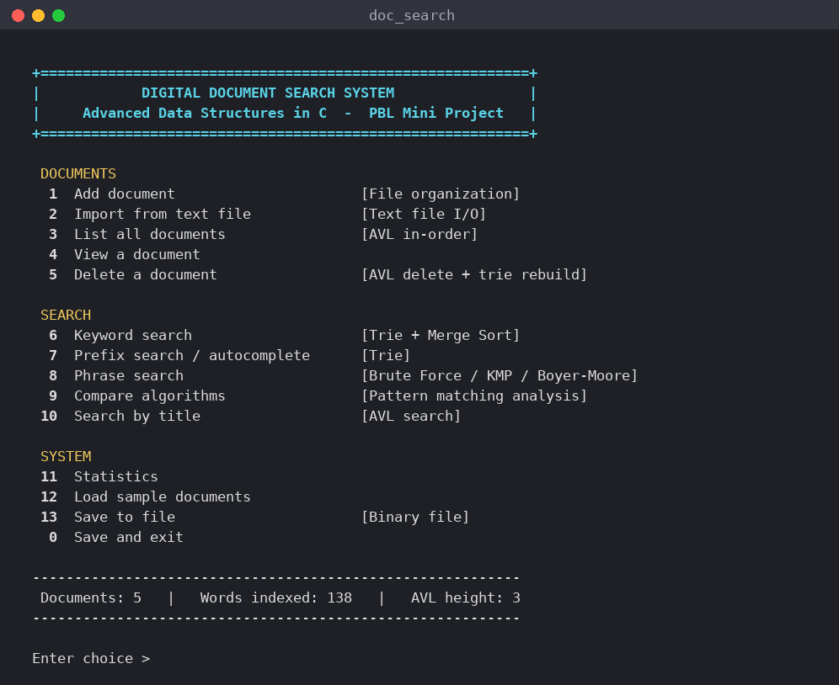
Figure B.1 Main menu with status bar after loading the sample documents
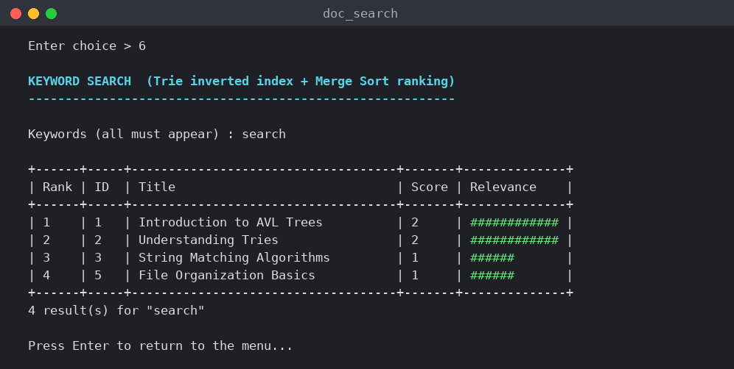
Figure B.2 Keyword search “search”: trie lookup and merge-sort ranking
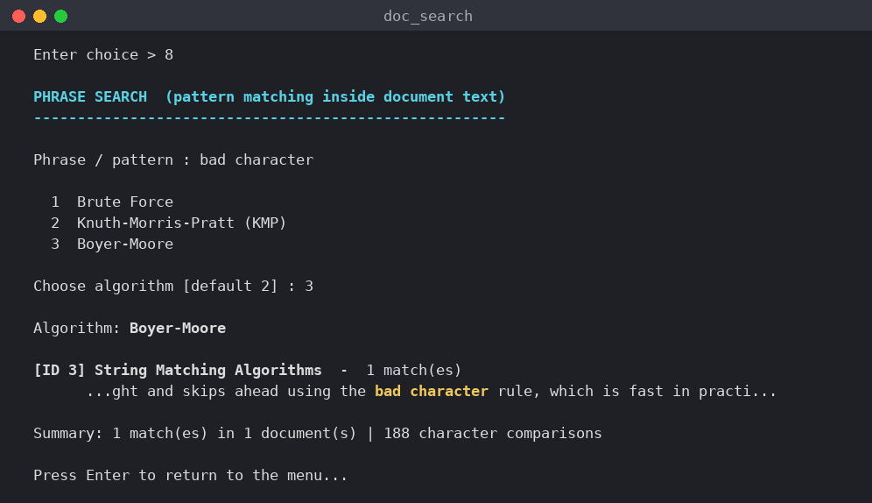
Figure B.3 Phrase search “bad character” with Boyer-Moore and highlighted match
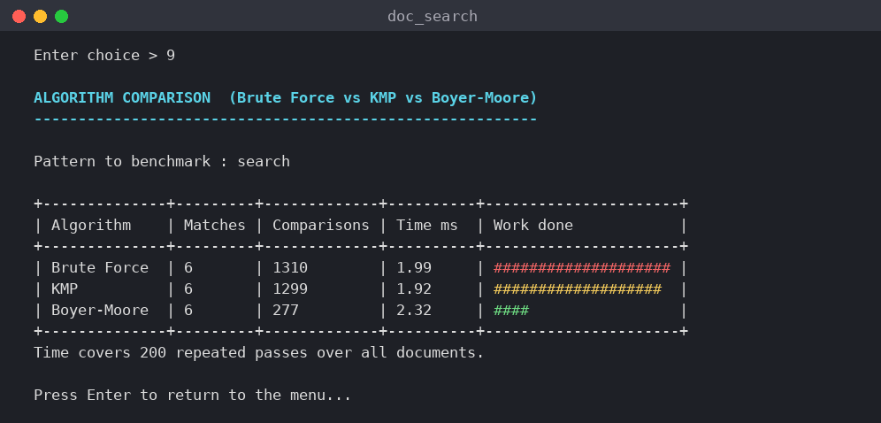
Figure B.4 Comparison of Brute Force, KMP and Boyer-Moore comparison counts
APPENDIX C GROUP CONTRIBUTION RECORD
Record specific work completed by each student. The final distribution must reflect actual participation in the submitted project.
Student / Hall Ticket No. | Major Contribution | Supporting Evidence
K. Akshaya / 26R15A6604 | Trie inverted index, keyword search and prefix search | Source file / test case
P. Shanmuka Sai Prabhath / 26R15A6605 | AVL title index, document store and binary file handling | Source file / screenshot
R. Malavika / 26R15A6606 | Pattern matching (Brute Force, KMP, Boyer-Moore) and comparison | Test case / output
V. Chaithanya / 26R15A6607 | Menu interface, testing and documentation | Test record / report

Draft allocation by module. Update this table so that it reflects the work actually done by each member before the report is submitted.
Submission Checklist
[ ] All student names, roll numbers, project title and batch details are correct.
[ ] Cover page and certificate have the required approvals and signatures.
[ ] Complete compilable C source code is attached.
[ ] Architecture, algorithms and complexity analysis are explained.
[ ] Test evidence and original output screenshots are included.
[ ] References and individual contributions are recorded.
[ ] One A4 copy is printed on one side and soft-bound as required.

