**Novel Embedded System for Real Time Fault Diagnosis of Photovoltaic Modules**

**ABSTRACT**

This project introduces a novel embedded system for real-time fault diagnosis of photovoltaic (PV) modules to enhance the efficiency and longevity of solar energy systems. The system continuously monitors various environmental and operational conditions using multiple sensors, including DHT11 for temperature and humidity monitoring, LDR for light intensity measurement, voltage sensors for output power, and MEMS tilt sensors to detect orientation changes. To maintain optimal PV performance, the system incorporates a water pump and servo motor for automated cleaning. Fault notifications are provided through buzzer and LED alerts for on-site warnings and a GSM module for SMS notifications to remote users. Data is also displayed on a 16x2 LCD for real-time local monitoring. By ensuring early detection and resolution of faults such as dirt accumulation, shading, and overheating, this system reduces maintenance costs and improves energy output, contributing to sustainable renewable energy management.

**CHAPTER 1**

**INTRODUCTION**

The increasing demand for renewable energy has led to widespread adoption of photovoltaic (PV) systems for sustainable power generation. Solar energy is one of the most promising renewable energy sources due to its abundance, environmental benefits, and ability to reduce dependency on fossil fuels. However, the efficiency of PV modules can be significantly affected by various environmental and operational factors, including dust accumulation, shading, overheating, and structural misalignment. These issues not only reduce power output but also increase maintenance costs and decrease the lifespan of PV panels. To address these challenges, an effective fault diagnosis system is essential for ensuring the optimal performance and reliability of PV modules.

Traditional maintenance of solar panels relies on periodic inspections and manual cleaning, which can be inefficient, costly, and time-consuming. Real-time monitoring and fault diagnosis provide a more proactive approach by detecting anomalies at an early stage and enabling timely corrective actions. Embedded systems, combined with advanced sensors and automation techniques, offer a viable solution for continuous monitoring and fault detection in PV systems.

This project introduces a novel embedded system for real-time fault diagnosis of photovoltaic modules, integrating multiple sensors and automated mechanisms to enhance PV efficiency. The system utilizes a **DHT11 sensor** to monitor temperature and humidity, an **LDR (Light Dependent Resistor)** to measure light intensity, **voltage sensors** to track power output, and a **MEMS tilt sensor** to detect orientation changes. In addition to fault detection, the system incorporates an **automated cleaning mechanism** using a water pump and servo motor to remove dust and debris from PV panels.

To ensure effective fault communication, the system provides both **on-site and remote alerts**. A **buzzer and LED indicators** offer immediate local notifications, while a **GSM module** sends SMS alerts to remote users for timely intervention. A **16x2 LCD display** presents real-time operational data for local monitoring. By enabling early detection and resolution of common PV faults, this system improves energy output, reduces maintenance efforts, and enhances the long-term sustainability of solar power systems. The proposed embedded system represents an innovative approach to smart solar panel management, contributing to the broader goal of efficient and sustainable renewable energy utilization.

**OBJECTIVE**

The objective of this project is to develop a **real-time embedded system** for fault diagnosis in photovoltaic (PV) modules to enhance efficiency, reduce maintenance costs, and ensure long-term sustainability. The system integrates **multiple sensors** for environmental and operational monitoring, an **automated cleaning mechanism**, and **fault notification alerts** via buzzer, LED, LCD display, and GSM module. By enabling early fault detection and automated maintenance, the system ensures optimal PV performance and contributes to improved renewable energy management.

**CHAPTER 2**

**LITERATURE SURVEY**

Faults in any components (modules, connection lines, converters, inverters, etc.) of photovoltaic (PV) systems (stand-alone, grid-connected or hybrid [PV](https://www.sciencedirect.com/topics/materials-science/photovoltaics) systems) can seriously affect the efficiency, energy yield as well as the security and reliability of the entire [PV](https://www.sciencedirect.com/topics/engineering/photovoltaics) plant, if not detected and corrected quickly. In addition, if some faults persist (e.g. [arc fault](https://www.sciencedirect.com/topics/engineering/arc-fault), ground fault and line-to-line fault) they can lead to risk of fire. [Fault detection and diagnosis](https://www.sciencedirect.com/topics/engineering/fault-detection-and-diagnosis) (FDD) methods are indispensable for the system reliability, operation at high efficiency, and safety of the [PV](https://www.sciencedirect.com/topics/materials-science/photovoltaics) plant. In this paper, the types and causes of [PV systems](https://www.sciencedirect.com/topics/engineering/photovoltaic-system) (PVS) failures are presented, then different methods proposed in literature for FDD of PVS are reviewed and discussed; particularly faults occurring in [PV](https://www.sciencedirect.com/topics/engineering/photovoltaics) arrays (PVA). Special attention is paid to methods that can accurately detect, localise and classify possible faults occurring in a PVA. The advantages and limits of FDD methods in terms of feasibility, complexity, cost-effectiveness and generalisation capability for large-scale integration are highlighted. Based on the reviewed papers, challenges and recommendations for future research direction are also provided.-G.M.Tina

In this paper a fault diagnosis method for photovoltaic (PV) modules is developed using an open source Machine Learning (ML) platform (Edge impulse). The idea is to develop a TinyML to classify certain defects that can frequently occur on PV modules (e.g. dirty, degradation and dust deposit on PV modules), and then to integrate the impulse into an Edge device for real time application. In this regard a database of infrared thermography image was built and used. The model could be run locally without internet connection. This method could help users to diagnosis their PV modules and make decision about the maintenance schedule (cleaning or replacing of PV modules). Results clearly report the feasibility of the method with a mean accuracy of 93.4 %. The main advantage is that, thanks to this platform, embedded ML model could be developed quickly. Moreover, edge processes are not affected by the latency and bandwidth issues becoming outstanding methods for real-time diagnostics.-Adel Mellit

Photovoltaic (PV) systems are significantly influenced by various environmental parameters such as irradiance, ambient temperature (Ta), relative humidity (RH), and wind speed (WS). These factors directly impact the system’s ability to generate electrical power. The degree of influence each parameter has on PV output can be quantified using correlation coefficients. A correlation coefficient close to +1 or -1 indicates a strong positive or negative relationship, meaning the variable has a strong impact on the PV system’s output. Conversely, a coefficient near 0 suggests a weak or negligible relationship. Among these parameters, irradiance plays a primary role, especially when it falls perpendicularly to the surface of the PV module, allowing for maximum power generation. However, power losses can occur due to shading, which is especially critical in bifacial PV modules where both front and rear sides contribute to energy capture—rear-side shading can significantly reduce output. When comparing types of irradiance, Plane of Array (POA) irradiance, which measures sunlight directly on the tilted surface of the PV modules, shows a stronger correlation with PV output than Global Horizontal Irradiance (GHI), which measures sunlight on a flat, horizontal surface. This indicates that POA is a more accurate predictor of PV performance. – G.G.Kim

The initial step in assessing the condition of a system involves determining whether it is operating normally or abnormally. This evaluation is carried out through the continuous monitoring of total voltages and currents in the system. If these measured values exceed a predefined threshold, denoted as VTH1, the system flags a potential abnormal condition. For simplicity, this threshold is assumed to match a specific pickup value that triggers the abnormality detection process. If there is no significant variation in voltage or current levels, the system is considered to be in a normal or healthy state, referred to as "State 0." However, when the system's condition is unclear or ambiguous, the abnormal state is further categorized into two distinct types: "High" and "Low." This classification is based on analyzing the rate of change in the voltage across each string. If the voltage changes slowly—specifically, at a rate below a secondary threshold value VTH2—the system is identified to be in an abnormal state characterized by high current. In contrast, if the voltage changes rapidly, i.e., at a rate higher than VTH2, it indicates an abnormal state associated with low current. This approach allows for a more nuanced diagnosis of faults by distinguishing between high and low current abnormalities based on voltage variation rates.- Abd el-Ghany

Fault Detection and Diagnosis (FDD) and monitoring systems play a crucial role in the effective management, surveillance, and maintenance of photovoltaic (PV) plants. These systems are increasingly being developed with real-time monitoring capabilities, allowing for timely identification and response to faults that could affect the performance and safety of PV systems. A key feature of such systems is their ability to process various inputs, including electrical parameters (like voltage and current) and environmental conditions (such as temperature and irradiance). They are designed with selectivity in mind, meaning they can accurately distinguish between different types of faults, and they are optimized for rapid fault detection to minimize downtime and prevent further damage. FDD systems are generally categorized into two main groups: electrical methods and thermal/optical methods. This classification is useful for detecting a wide range of physical and electrical issues in PV modules, such as delamination, cracks, hot spots, yellowing, discoloration, and soiling. Specifically, electrical and thermal methods have proven effective in identifying more technical issues like diode failures, ground faults, and arc faults in PV arrays. Most electrical-based FDD approaches rely on simulating various fault conditions using PV models, which helps in accurately distinguishing between different fault types and implementing the appropriate corrective measures.- B.G.Bhang

**CHAPTER 3**

**PROPOSED SYSTEM**

The proposed system is a **real-time embedded fault diagnosis system** for photovoltaic (PV) modules, designed to enhance performance and longevity. It integrates multiple sensors, including a **DHT11** for temperature and humidity monitoring, an **LDR** for light intensity measurement, **voltage sensors** for power output tracking, and a **MEMS tilt sensor** for detecting panel misalignment.

To maintain PV efficiency, the system features an **automated cleaning mechanism** using a **water pump and servo motor** to remove dust and debris. Faults such as overheating, shading, and misalignment are identified in real-time, with alerts provided through **LED indicators, a buzzer, and a GSM module** for remote SMS notifications. A **16x2 LCD display** ensures local monitoring. By offering automated fault detection and maintenance, the system reduces downtime, lowers maintenance costs, and improves overall solar energy output.

**BENEFITS:**

1. **Enhanced Efficiency:** Real-time monitoring and automated cleaning improve PV module efficiency by reducing power losses due to dust, shading, and overheating.
2. **Reduced Maintenance Costs:** Automated fault detection minimizes manual inspections, lowering operational costs and extending the lifespan of photovoltaic panels.
3. **Remote Fault Alerts:** GSM-based SMS notifications enable timely maintenance responses, reducing downtime and ensuring consistent solar energy output.
4. **Sustainable Energy Management:** Early fault detection and automated cleaning contribute to reliable, long-term renewable energy generation with minimal human intervention.

**WORKING PRINCIPLE:**

The system operates through the following steps:

1. **Data Collection:** Sensors continuously collect data on temperature, humidity, light intensity, voltage output, and tilt angle.
2. **Data Processing:** The Arduino processes the collected data and compares it against predefined thresholds.
3. **Fault Detection:** When a fault is detected, the following actions occur:
   * A buzzer and LED are activated to provide immediate local alerts.
   * The GSM module sends an SMS notification detailing the fault.
   * If dust or shading is detected, the water pump and servo motor are activated to clean the PV module.
4. **Data Display:** The 16x2 LCD shows real-time sensor readings and alerts, ensuring local visibility of system status.

This working principle ensures timely fault detection, immediate response, and improved PV performance.

**3.1 BLOCK DIAGRAM**

Regulated power supply

Solar panel

Raspberry-pi Pico

LCD

Voltage sensor

LDR sensor

Relay

Water pump

MEMS

Servo motor

Voltage sensor

DHT11 sensor

Buzzer /LED

System Workflow

When you power on your embedded system, the Raspberry Pi Pico W takes charge by first initializing all the peripheral components connected to it. This initialization process involves setting up the communication protocols and configuring the input/output (I/O) pins for each sensor and actuator.

* Sensor Initialization: The Pico W establishes communication with the voltage sensor to begin reading the electrical potential generated by the solar panel. It also initializes the DHT11 sensor to start capturing temperature and humidity data (although you specifically mentioned temperature alerts, the DHT11 typically provides both). The MEMS sensor is initialized to provide readings on the solar panel's orientation in three-dimensional space, allowing for the detection of any tilt. If you're using the LDR to monitor light intensity, it's also initialized at this stage.
* Output Device Readiness: The LCD is prepared to display system status and sensor readings. The servo motor, buzzer, LED, and relay are set to their initial, inactive states, awaiting instructions based on the sensor data analysis.
* Continuous Data Acquisition: Once initialized, the system enters a continuous loop. Within this loop, the Pico W actively reads data from all the sensors at regular intervals. The voltage sensor provides the instantaneous voltage output of the solar panel. Using this voltage reading, the Pico W performs a calculation (likely based on a known or assumed resistance or load) to determine the current being produced by the panel. The DHT11 provides the current ambient temperature around the solar panel. The MEMS sensor reports the current tilt angles along its axes. The LDR provides the current light intensity falling on the panel.
* Real-time Data Display: The acquired sensor data, particularly the voltage and calculated current, is processed and displayed on the local LCD screen. This provides a direct, on-site indication of the solar panel's performance and the environmental conditions.
* Cloud Data Logging: Simultaneously, the Raspberry Pi Pico W, leveraging its Wi-Fi connectivity, transmits the collected sensor data (voltage, current, temperature, tilt angles, and potentially light intensity) to the ThinkSpeak cloud platform. This data is timestamped and stored, allowing for remote monitoring, historical analysis of the solar panel's performance trends, and visualization through charts and dashboards.

Fault Detection and Alerting Mechanisms: Identifying and Reporting Issues

A core function of your system is to identify deviations from normal operating conditions and alert you to potential faults. This is achieved by continuously comparing the sensor readings against predefined thresholds.

* Low Power Detection: The Raspberry Pi Pico W constantly evaluates the incoming voltage and the calculated current. You will have set specific minimum acceptable values (thresholds) for both. If the measured voltage or the calculated current drops below these respective thresholds, it indicates a potential issue with the solar panel's performance. This could be due to shading, dirt accumulation, internal faults, or other factors. Upon detecting this low power condition, the Pico W triggers an alert. This alert involves using the GSM module to send a Short Message Service (SMS) notification to a pre-configured mobile phone number, informing you about the low voltage and/or current.
* High Temperature Detection: The temperature readings from the DHT11 sensor are continuously monitored. You will have defined a maximum allowable temperature for the solar panel's environment. If the measured temperature exceeds this threshold, it could indicate overheating, which can damage the panel or reduce its efficiency. In this case, the Pico W triggers a high-temperature alert. This alert also involves sending an SMS notification via the GSM module. Additionally, the Pico W activates the buzzer to produce an audible warning, which will continue until the temperature falls back below the defined threshold.
* Tilt Angle Deviation Detection: The MEMS sensor plays a crucial role in detecting any unintended changes in the solar panel's orientation. You will have established a set of default or expected tilt angle values (or a range of acceptable values). If the readings from the MEMS sensor indicate that the panel's tilt has significantly changed from these default values, it could imply that the panel has been physically moved or misaligned, which can affect its energy capture efficiency. Upon detecting such a deviation, the Pico W triggers a tilt angle alert, sending an SMS notification via the GSM module to inform you of the potential misalignment.

Automated Response and Maintenance: Taking Action

Your system goes beyond just alerting; it also incorporates an automated response mechanism to address one of the potential causes of low power output.

* Automated Cleaning: When the system detects a low voltage and/or current condition, it initiates an automated cleaning process. The Raspberry Pi Pico W sends a control signal to the servo motor. This servo motor is mechanically linked to a cleaning mechanism (e.g., a wiper or brush) that can move across the surface of the solar panel. The activation of the servo motor causes this mechanism to operate, effectively cleaning the solar panel's surface to remove any dust, dirt, or debris that might be obstructing sunlight and reducing its output.
* Post-Cleaning Monitoring: After the cleaning cycle is complete (the duration of which would likely be programmed into the Pico W), the system continues to monitor the voltage and current output of the solar panel. This allows it to determine if the cleaning process has resolved the low power issue. If the voltage and current return to normal levels, the alerts might cease. If the problem persists, further investigation might be required.
* Visual and Control Elements: The LED can serve as a visual indicator of the system's status. For instance, it could blink during normal operation, light up steadily during an alert, or indicate when the cleaning process is active. The relay provides a means for the Raspberry Pi Pico W to control external circuits or loads based on the solar panel's performance or the detected faults. For example, it could be used to disconnect a load if the voltage drops too low to protect the load or the panel itself.

In essence, your embedded system acts as a proactive guardian for your solar module. It continuously monitors its performance and environmental conditions, promptly alerts you to any anomalies, and even takes automated steps to mitigate certain issues, all while providing valuable data for remote analysis and long-term performance tracking

**CHAPTER 4**

**HARDWARE TOOLS**

* RASPBERRY PI PICO
* LCD
* LDR
* SOLAR PANNEL
* VOLTAGE SENSOR
* MEMS SENSOR
* DHT11
* RELAY
* WATER PUMP
* SERVO MOTOR
* BUZZER
* LED
* REGULATED POWER SUPPLY

**4.1 DESCRIPTION OF TOOLS**

1. **RASPBERRY PI PICO**

The Raspberry Pi Foundation made the Raspberry Pi Pico, a microprocessor board that came out in January 2021. It's different from their usual single-board computers because it has a smaller size and is geared toward microcontroller uses.

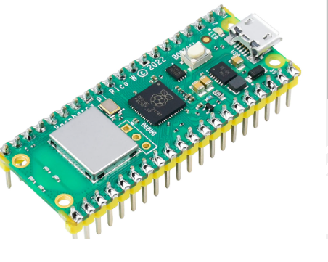

Some important things about the Raspberry Pi Pico are:

RP2040 microprocessor: The Raspberry Pi created the RP2040 microprocessor chip that gives it power. The RP2040 has a 133MHz dual-core ARM Cortex-M0+ processor, which is more than enough processing power for many embedded apps.

2.Flexible I/O Pins: The Pico has 26 GPIO pins that can be set up to do different things, such as digital input/output, PWM (Pulse Width Modulation) output, SPI (Serial Peripheral Interface), I2C (Inter-Integrated Circuit), UART (Universal Asynchronous Receiver-Transmitter), and more.

3.The device can be written in a number of languages, such as MicroPython, C/C++, and CircuitPython. This means that both new and expert coders can use it.

4. It's cheap: The Raspberry Pi Pico is priced reasonably, so it's an easy choice for students, teachers, and workers who want to use microcomputer technology in their projects.

The Raspberry Pi Pico W is a microcontroller board based on the Raspberry Pi RP2040 microcontroller, with added Wi-Fi and Bluetooth capabilities. It has a total of **40 pins**, with **26 multi-function GPIO (General Purpose Input/Output) pins** available to the user. These pins can be configured for various functionalities.

Here's a detailed look at the pin configurations of the Raspberry Pi Pico W:

**Power Pins:**

* **Pin 40 (VBUS):** Connected to the micro-USB port, supplies 5V when powered via USB. Can also be used to power external peripherals.
* **Pin 39 (VSYS):** Main system input voltage pin. Accepts a voltage range from 1.8V to 5.5V. This is the power source when not using USB, for example, when powered by a battery.
* **Pin 36 (3V3_OUT):** Regulated 3.3V output pin. Can be used to power external components, with a recommended maximum load current of 300mA.
* **Pin 37 (3V3_EN):** 3.3V enable pin. Pulling this pin low will disable the onboard 3.3V regulator, effectively turning off the Pico W. It is usually pulled high internally.
* **Pins 3, 8, 13, 18, 23, 28, 33, 38 (GND):** Ground pins. There are multiple ground pins for convenience.
* **Pin 35 (ADC_VREF):** Analog-to-Digital Converter (ADC) voltage reference pin. It is internally connected to the filtered 3.3V supply.
* **Pin 33 (AGND):** Analog ground pin for the ADC. Should be used as the ground reference for analog signals.
* **Pin 30 (RUN):** Reset pin for the RP2040 microcontroller. Pulling this pin low will reset the Pico W.

**General Purpose Input/Output (GPIO) Pins:**

* **GP0 - GP22 (Pins 1, 2, 4-7, 9-12, 14-17, 19-22):** These are general-purpose digital input/output pins. Each can be configured as an input or an output pin. They operate at 3.3V logic levels.
* **GP26 - GP28 (Pins 31, 32, 34):** These are also general-purpose digital input/output pins and can additionally be used as analog inputs for the ADC (ADC0, ADC1, ADC2 respectively).

**Special Function Pins:**

* **Pin 25 (WL_GPIO0/LED):** Connected to the onboard user LED. It's controlled by the wireless chip, not directly by the RP2040 GPIO. While it can be used as an output with special care, it's primarily intended for the LED.
* **Pin 30 (BOOTSEL):** When this pin is held low during power-up or reset, the Pico W will enter UF2 bootloader mode, allowing you to program it via USB.
* **Pin 37 (3V3_EN):** Used to enable or disable the 3.3V power supply.
* **GPIO23, GPIO24, GPIO25, GPIO29:** These GPIOs are primarily used for communication with the onboard wireless module and are generally not exposed for user interfacing on the header pins. However, GPIO29 is also connected to the ADC as ADC3 for measuring the VSYS voltage divided by three.
* **WL_GPIO1:** Controls the power saving mode of the onboard SMPS.
* **WL_GPIO2:** Senses the voltage at the VBUS pin. It will be high if VBUS is present and low otherwise.

**Communication Interfaces:**

The GPIO pins can be configured to support various communication protocols:

* **UART (Universal Asynchronous Receiver/Transmitter):**
  + UART0: TX (GP0, GP12, GP16), RX (GP1, GP13, GP17), CTS (GP2, GP6, GP10, GP14, GP18), RTS (GP3, GP7, GP11, GP15, GP19)
  + UART1: TX (GP4, GP8, GP20, GP28), RX (GP5, GP9, GP21, GP29), CTS (GP6, GP10, GP22, GP26), RTS (GP7, GP11, GP23, GP27)
* **I2C (Inter-Integrated Circuit):**
  + I2C0: SDA (GP0, GP4, GP8, GP12, GP16, GP20, GP24, GP28), SCL (GP1, GP5, GP9, GP13, GP17, GP21, GP25, GP29)
  + I2C1: SDA (GP2, GP6, GP10, GP14, GP18, GP22, GP26), SCL (GP3, GP7, GP11, GP15, GP19, GP23, GP27)
* **SPI (Serial Peripheral Interface):**
  + SPI0: RX/MISO (GP0, GP4, GP16, GP20), TX/MOSI (GP3, GP7, GP19, GP23), SCK (GP2, GP6, GP18, GP22), CSn (GP1, GP5, GP17, GP21)
  + SPI1: RX/MISO (GP8, GP12, GP24, GP28), TX/MOSI (GP11, GP15), SCK (GP10, GP14), CSn (GP9, GP13)

**Analog to Digital Converter (ADC):**

* **ADC0 (Pin 31):** Connected to GP26
* **ADC1 (Pin 32):** Connected to GP27
* **ADC2 (Pin 34):** Connected to GP28
* **ADC3 (Internal):** Connected to GP29, used to measure VSYS/3

**PWM (Pulse Width Modulation):**

Almost all GPIO pins can be configured as PWM outputs. There are 16 PWM channels available across the RP2040's 8 PWM slices (each slice has two output channels, A and B). The specific PWM channel assignment to GPIO pins can be flexible.

**Debugging Pins:**

* **SWCLK (Serial Wire Clock):** Dedicated pin for the SWD debug interface.
* **SWDIO (Serial Wire Data Input/Output):** Dedicated pin for the SWD debug interface.
* **GND:** Ground pin for the debug interface.

These pins are typically located near the RP2040 chip on the board.

5. Support from the community: Like other Raspberry Pi goods, the Pico has a large and busy community of users and creators who help each other with projects and offer support, lessons, and other useful information.

Overall, the Raspberry Pi Pico is a flexible and affordable microcontroller board that can be used for a lot of different embedded projects, from easy projects like making LEDs blink to more complicated ones like making IoT (Internet of Things) devices and robots.

1. **LCD**

LCD (Liquid Crystal Display) screen is an electronic display module and find a wide range of applications. A 16x2 LCD display is very basic module and is very commonly used in various devices and circuits. These modules are preferred over seven segments and other multi segment LEDs. The reasons being: LCDs are economical; easily programmable; have no limitation of displaying special & even custom characters (unlike in seven segments), animationsand so on.

**3.6.1 Introduction of LCD**

The most commonly used Character based LCDs are based on Hitachi's HD44780 controller or other which are compatible with HD44580.

A **16x2 LCD** means it can display 16 characters per line and there are 2 such lines. In this LCD each character is displayed in 5x7 pixel matrix. This LCD has two registers, namely, Command and Data.

The command register stores the command instructions given to the LCD. A command is an instruction given to LCD to do a predefined task like initializing it, clearing its screen, setting the cursor position, controlling display etc. The data register stores the data to be displayed on the LCD. The data is the ASCII value of the character to be displayed on the LCD.

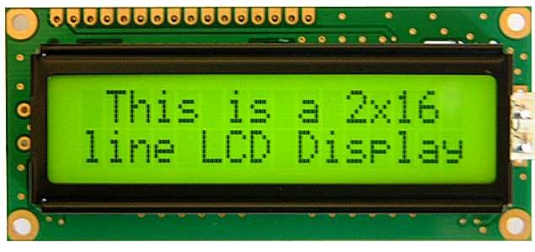

Fig3.17: 16x2 LCD display

**3.6.2Pin Description of LCD**

Most LCDs with 1 controller has 14 Pins and LCDs with 2 controller has 16 Pins (two pins are extra in both for back-light LED connections). Pin description is shown in the table below.

**Pin Configuration table for a 16X2 LCD character display:-**

|  |  |  |
| --- | --- | --- |
| **Pin Number** | **Symbol** | **Function** |
| **1** | Vss | Ground Terminal |
| **2** | Vcc | Positive Supply |
| **3** | Vdd | Contrast adjustment |
| **4** | RS | Register Select; 0→Instruction Register, 1→Data Register |
| **5** | R/W | Read/write Signal; 1→Read, 0→ Write |
| **6** | E | Enable; Falling edge |
| **7** | DB0 | Bi-directional data bus, data transfer is performed once, thru DB0 to DB7, in the case of interface data length is 8-bits; and twice, through DB4 to DB7 in the case of interface data length is 4-bits. Upper four bits first then lower four bits. |
| **8** | DB1 |
| **9** | DB2 |
| **10** | DB3 |
| **11** | DB4 |
| **12** | DB5 |
| **13** | DB6 |
| **14** | DB7 |
| **15** | LED-(K) | Back light LED cathode terminal |
| **16** | LED+(A) | Back Light LED anode terminal |

Table3.1: Pin Description of LCD

**3.6.3 Data/Signals/Execution of LCD**

LCD accepts two types of signals, one is data, and another is control. These signals are recognized by the LCD module from status of the RS pin. Now data can be read also from the LCD display, by pulling the R/W pin high. As soon as the E pin is pulsed, LCD display reads data at the falling edge of the pulse and executes it, same for the case of transmission.

LCD display takes a time of 39-43µS to place a character or execute a command. Except for clearing display and to seek cursor to home position it takes 1.53ms to 1.64ms. Any attempt to send any data before this interval may lead to failure to read data or execution of the current data in some devices. Some devices compensate the speed by storing the incoming data to some temporary registers.

**3.6.4 Commands and Instruction set**

Only the instruction register (IR) and the data register (DR) of the LCD can be controlled by the MCU. Before starting the internal operation of the LCD, control information is temporarily stored into these registers to allow interfacing with various MCUs, which operate at different speeds, or various peripheral control devices. The internal operation of the LCD is determined by signals sent from the MCU. These signals, which include register selection signal (RS), read/write signal (R/W), and the data bus (DB0 to DB7), make up the LCD instructions.

There are four categories of instructions that:

* Designate LCD functions, such as display format, data length, etc.
* Set internal RAM addresses
* Perform data transfer with internal RAM
* Perform miscellaneous functions

Although looking at the table you can make your own commands and test them. Below is a brief list of useful commands which are used frequently while working on the LCD.

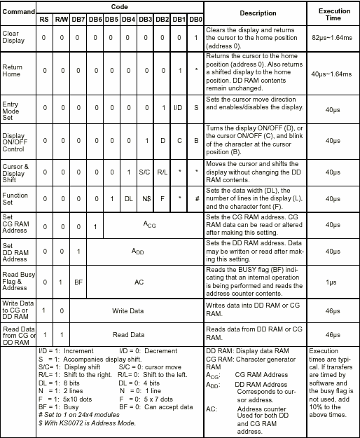Table3.2: Showing various LCD Command Description

**3.6.5 List of Commands**

|  |  |  |  |
| --- | --- | --- | --- |
| **No.** | **Instruction** | **Hex** | **Decimal** |
| 1 | Function Set: 8-bit, 1 Line, 5x7 Dots | 0x30 | 48 |
| 2 | Function Set: 8-bit, 2 Line, 5x7 Dots | 0x38 | 56 |
| 3 | Function Set: 4-bit, 1 Line, 5x7 Dots | 0x20 | 32 |
| 4 | Function Set: 4-bit, 2 Line, 5x7 Dots | 0x28 | 40 |
| 5 | Entry Mode | 0x06 | 6 |
| 6 | Display off Cursor off (clearing display without clearing DDRAM content) | 0x08 | 8 |
| 7 | Display on Cursor on | 0x0E | 14 |
| 8 | Display on Cursor off | 0x0C | 12 |
| 9 | Display on Cursor blinking | 0x0F | 15 |
| 10 | Shift entire display left | 0x18 | 24 |
| 12 | Shift entire display right | 0x1C | 30 |
| 13 | Move cursor left by one character | 0x10 | 16 |
| 14 | Move cursor right by one character | 0x14 | 20 |
| 15 | Clear Display (also clear DDRAM content) | 0x01 | 1 |
| 16 | Set DDRAM address or coursor position on display | 0x80+add* | 128+add* |
| 17 | Set CGRAM address or set pointer to CGRAM location | 0x40+add** | 64+add** |

Table3.3: Frequently Used Commands and Instructions forLCD

* CGRAM address from 0x00 to 0x3F, 0x00 to 0x07 for char1 and so on.

**3.6.6 Liquid crystal displays interfacing with Controller**

The LCD standard requires 3 control lines and 8 I/O lines for the data bus.

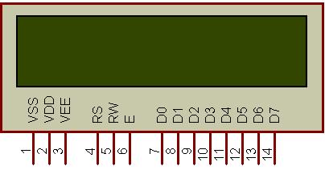

Fig3.18: Pins of LCD

• **8 data pins D7:D0**

Bi-directional data/command pins

Alphanumeric characters are sent in ASCII format.  
 • **RS:  Register Select**

RS = 0 -> Command Register is selected  
RS = 1 -> Data Register is selected

• **R/W: Read or Write**

0 -> Write,

  1 -> Read  
 • **E: Enable (Latch data)**

Used to latch the data present on the data pins. A high-to-low edge is needed to latch the data.

1. **LDR**

**LDR – Light Dependent Resistors Circuit and Working Principle**

The majority of lighting and household tools are controlled by hand. But handling machines may waste electricity if individuals aren't cautious or anything odd occurs. The light-dependent resistor circuit overcomes the issue by controlling loads depending on light brightness. A photo resistor or LDR is another name for this device. Made of high-resistance semiconductors. An LDR circuit and its operation are explained in this article.

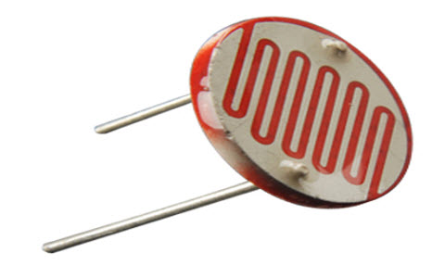

Light Dependent Resistor

**Construction of a LDR**

A light-sensitive substance like clay is placed over an insulating layer to form an LDR. It is laid zigzag to get the desired power and resistance. The metal-placed portions are divided by the zigzag.

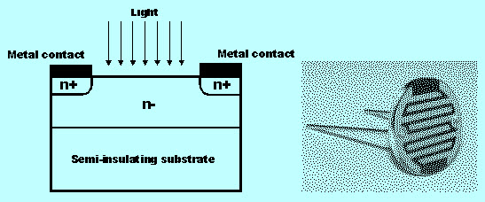

Construction of a LDR

Ohmic touches are on the sides. Links should have low resistance so the light action alters resistance most. Environmentally harmful lead and cadmium materials are not utilized.

**Working Principle of Light Dependent Resistor**

LDRs function by photo conduction, a visual effect.Light makes the substance less conductive. Light moves electrons in the LDR's valence band toward the conduction band. Light photons must have higher energy than the material's band gap to move electrons from valance to conduction.

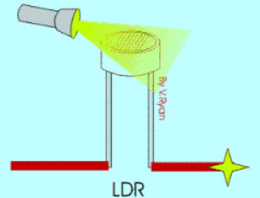

LDR Working Principle

Because of this, when light has a lot of energy, it moves more electrons into the conduction band, which makes a lot of charge carriers. The device's resistance goes down as the process has more of an effect and more current flows through it.

**Light Dependent Resistor Circuit**

See the image below for the LDR circuit, which includes an LDR, switch, Darlington pair, diode, and resistors. Power is supplied to the load.

The LDR circuit gets DC power from a bridge rectifier or battery. This circuit converts AC to DC. In the bridge rectifier circuit, a step-down transformer converts 230v to 12v. The diodes form a bridge to convert AC to DC. The voltage converter converts 12v DC to 6v DC, which the system receives as DC voltage. The bridge rectifier and load need 230v AC power to function in the light sensor circuit.

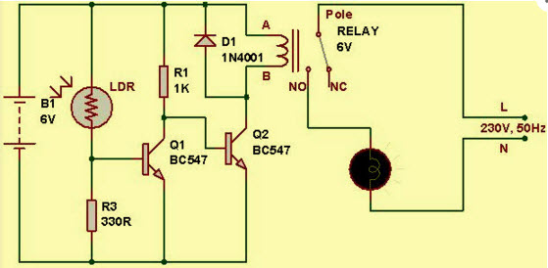

Light Dependent Resistor Circuit Diagram

A low resistance of around 100Ω is seen in the morning. The light sensor circuit above sends power via the LDR and ground through the variable resistor and resistance. Light-dependent resistors have less resistance than the rest of the sensor circuit during the day or when light strikes the LDR. Naturally, electricity flows in the direction with the least resistance.

Therefore, the relay coil doesn't acquire enough power to strengthen. Thus, the light is off throughout the day. Similarly, the LDR's resistance peaks at 20MΩ at night. Because the resistor is high, current flow is minimal or virtually nonexistent.Now, current via the low-resistance channel raises the Darlington pair's base voltage over 1.4v. Turning on the Darlington pair transistor powers the relay coil. It switches the light at night.

**Applications of LDR**

Light-dependent resistors are cheap and simple. They employ these devices to detect light. The majority of LDR resistors are utilized in thief alarm circuits, warning locks, street lights, light intensity meters, and light sensors. One project—using LDR to manage street light brightness and conserve power—will help you comprehend this concept.

**Power Conserving of Intensity Controlled Street Lights using LDR**

Today, HID lighting illuminate highways. These lights are energy-intensive, and there is no way to switch them on and off from dawn to nightfall. For electricity savings, utilize LDR to adjust street light levels using LEDs.

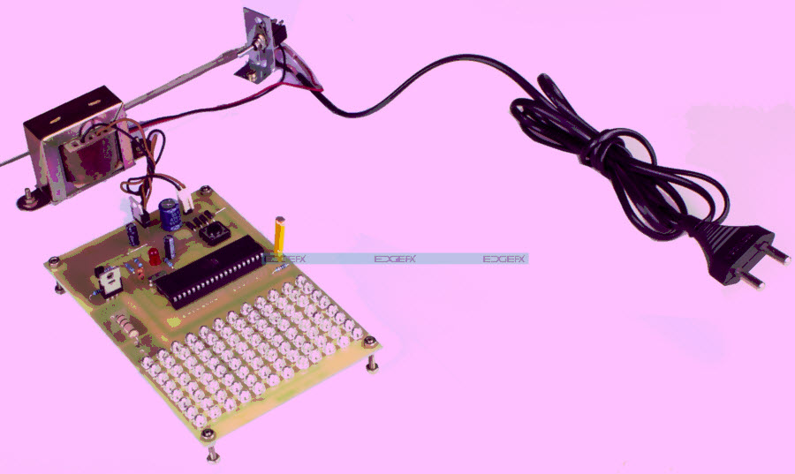

Intensity Controlled Street Light using LDR by Edgefxkits.com

Current HID bulbs are the target of the recommended repair.The recommended solution uses light-emitting diodes and enables the user adjust brightness. These lights last longer and use less power than HID bulbs for the same price.

This project's ability to adjust light levels at night is its most crucial feature, unlike HID bulbs. LDRs sense light, and their resistance reduces significantly over the day. The processor receives an ani/p signal.

An LED street light's microcontroller has been programmed to regulate its brightness depending on Pulse width modulation data. Light intensity is strong at night. With less traffic during peak hours, the intensity eventually reduces till dawn. Finally, the LED lights are switched off at 6 a.m. and on at 6 p.m. everyday. This will continue.

This idea may be enhanced with a solar screen. Changing the sun's brightness to the correct voltage powers roadway lights.

1. **SOLAR PANNEL**

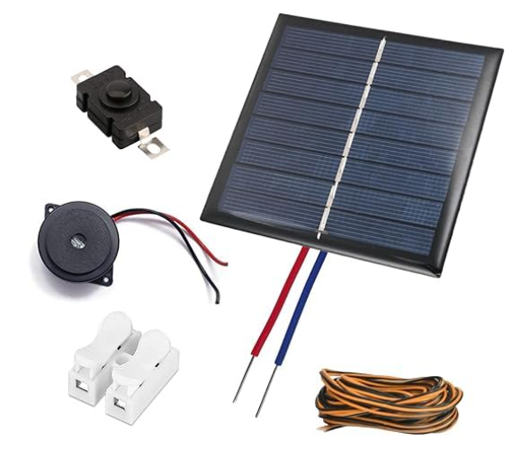

Solar panels are devices that convert sunlight into electricity, a process known as photovoltaic PV energy conversion. They are a critical component of renewable energy systems, helping to reduce reliance on fossil fuels and decrease greenhouse gas emissions.

**How Solar Panels Work**

Solar panels are made up of many solar cells, typically composed of silicon, a semiconductor material. When sunlight hits these cells, it knocks electrons loose from their atoms, generating an electric current. This current is then captured and can be used to power homes, businesses, or stored in batteries for later use.

**Types of Solar Panels**

There are several types of solar panels, each with its own advantages and applications

1. Monocrystalline Solar Panels These are made from a single crystal structure and are known for their high efficiency and durability. They are often more expensive but provide more power per square meter.
2. Polycrystalline Solar Panels These are made from multiple crystal structures, making them slightly less efficient but more affordable. They are commonly used in residential installations.
3. Thin Film Solar Panels These are made by depositing one or more thin layers of photovoltaic material on a substrate. They are flexible and lightweight but generally less efficient than crystalline panels.

**Benefits of Solar Panels**

1. Renewable Energy Source Solar panels harness energy from the sun, which is a renewable and inexhaustible resource.
2. Reduces Electricity Bills By generating your own electricity, you can significantly reduce your electricity bills. In some cases, surplus energy can be sold back to the grid.
3. Low Maintenance Costs Solar panels require minimal maintenance, with most systems lasting 25 to 30 years with little degradation in performance.
4. Environmental Impact Solar panels produce clean green energy and help to reduce carbon footprints by reducing the reliance on fossil fuels.

**Challenges**

1. Initial Cost The upfront cost of solar panel installation can be high, although prices have been decreasing over time.
2. Intermittency Solar panels only generate electricity when the sun is shining, which can be a limitation in cloudy regions or during nighttime.
3. Space Requirement To generate significant amounts of energy, solar panels require a large surface area, which may not be feasible for all buildings.

**Future of Solar Panels**

The future of solar panels looks promising, with ongoing advancements in technology leading to higher efficiency, lower costs, and new applications. Innovations such as bifacial panels, which capture sunlight from both sides, and solar tiles that integrate seamlessly with roofing materials, are expanding the possibilities of solar energy.

As the world continues to prioritize sustainability, solar panels will play an increasingly important role in the global energy landscape, contributing to a cleaner, more resilient energy future.

1. **VOLTAGE SENSOR**

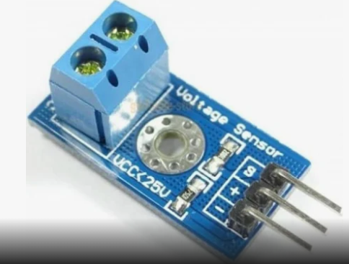

A **voltage sensor** is an electronic device used to measure and monitor the voltage levels in a circuit. It plays a crucial role in various applications, including industrial automation, renewable energy systems, power monitoring, and IoT-based projects. Voltage sensors are used to detect fluctuations, prevent electrical failures, and ensure system efficiency by providing real-time voltage readings.

**Working Principle**

Voltage sensors operate based on the principle of voltage division or electromagnetic induction. They convert the voltage in an electrical circuit into a readable signal that can be processed by microcontrollers or monitoring systems. There are two main types of voltage sensors:

1. **Contact Voltage Sensors** – These sensors are directly connected to the circuit and measure voltage through direct electrical contact. They are commonly used in low-voltage applications, such as battery monitoring and small electronic circuits.
2. **Non-Contact Voltage Sensors** – These sensors detect voltage without direct contact, often using electromagnetic fields. They are mainly used for high-voltage applications, ensuring safety while measuring power lines and industrial equipment.

**Types of Voltage Sensors**

1. **AC Voltage Sensors** – Measure alternating current (AC) voltage, commonly used in power grid monitoring and industrial applications.
2. **DC Voltage Sensors** – Measure direct current (DC) voltage, widely used in battery-operated devices, solar panels, and automotive applications.

**Applications of Voltage Sensors**

* **Solar Power Systems** – Monitor solar panel output to ensure efficient energy generation.
* **Battery Management Systems** – Measure battery voltage for proper charging and discharging control.
* **Industrial Automation** – Ensure stable voltage supply for machines and equipment.
* **IoT-based Monitoring** – Provide real-time voltage data for smart energy management.

Voltage sensors are essential for maintaining stable electrical performance, preventing failures, and optimizing energy efficiency in various applications. Their integration with IoT technology enhances remote monitoring and automation capabilities.

1. **MEMS SENSOR**

Micro-Electro-Mechanical Systems (MEMS) sensors are miniature devices that integrate mechanical and electrical components on a single chip, typically measuring just a few millimeters in size. These sensors play a crucial role in various applications, including automotive, consumer electronics, medical devices, and industrial automation.

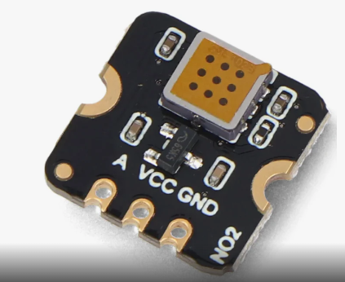

MEMS sensors function by converting physical stimuli—such as acceleration, pressure, temperature, and humidity—into electrical signals. Common types of MEMS sensors include accelerometers, gyroscopes, pressure sensors, and microphones. For example, accelerometers are widely used in smartphones to detect orientation, while gyroscopes help in navigation systems by measuring angular velocity.

One of the key advantages of MEMS technology is its ability to provide high precision and sensitivity in measurements while maintaining a compact form factor. This miniaturization allows for the integration of multiple sensors onto a single chip, reducing manufacturing costs and improving system reliability.

MEMS sensors are also energy-efficient, making them suitable for battery-powered devices. As technology advances, their applications are expanding into fields like IoT (Internet of Things), smart homes, and wearable devices, where real-time data collection and analysis are essential.

The ongoing research in MEMS technology aims to enhance sensor performance, increase functionality, and reduce costs further. As a result, MEMS sensors are poised to play a pivotal role in the evolution of smart devices and systems, contributing significantly to advancements in automation and data-driven technologies.

1. **DHT11**

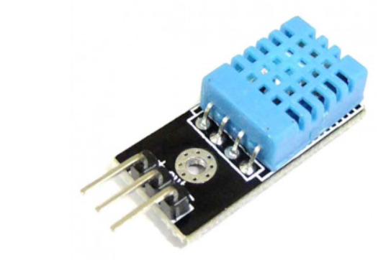

The DHT11 is a low-cost digital temperature and humidity sensor that is widely used in various projects and applications. It features a single-wire digital interface, making it easy to connect to microcontrollers such as Arduino, Raspberry Pi, and other platforms. With its simplicity and affordability, the DHT11 has become a popular choice for hobbyists, students, and professionals alike in monitoring and controlling environmental conditions.

Measuring temperature and humidity accurately is crucial in many scenarios, ranging from home automation to industrial processes. The DHT11 sensor utilizes a thermistor to measure temperature and a humidity sensing element to measure relative humidity. These elements detect changes in environmental conditions and convert them into electrical signals, which are then processed by the sensor's onboard microcontroller.

One of the key advantages of the DHT11 is its simplicity of use. It requires minimal external components to operate, making it ideal for beginners and rapid prototyping. Additionally, its low cost makes it accessible for budget-conscious projects without compromising performance.

However, the DHT11 does have some limitations. Its accuracy may not be as high as more expensive sensors, with temperature readings typically within ±2°C and humidity readings within ±5%. Furthermore, its response time can be relatively slow compared to other sensors, especially in rapidly changing conditions.

Despite these limitations, the DHT11 remains a popular choice for many applications due to its simplicity, affordability, and adequate performance for many use cases. It can be found in various projects, including weather stations, indoor climate monitoring systems, greenhouse automation, and more.

In summary, the DHT11 is a low-cost digital temperature and humidity sensor known for its simplicity, affordability, and ease of use. While it may not offer the highest accuracy or fastest response time, its versatility and accessibility make it a valuable tool for a wide range of projects and applications.

1. **RELAY**

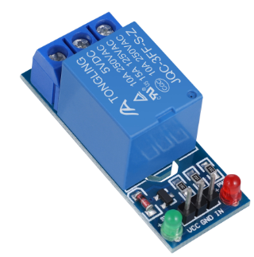

A relay module is an essential electronic component used to control high-power devices with low-power signals, making it a crucial element in automation and electrical projects. It acts as an electrically operated switch, allowing low-power circuits like microcontrollers (e.g., Arduino, Raspberry Pi) to safely control high-power appliances such as lights, fans, motors, or even home appliances

A relay module typically consists of a coil, an armature, and a set of contacts. When a low-power signal is applied to the coil, it generates a magnetic field, causing the armature to move and either open or close the circuit, thereby controlling the flow of current to the connected high-power device. This switching mechanism ensures that microcontrollers or other low-power circuits are isolated from the high-power circuits, protecting them from damage.

Relay modules come in different configurations, such as single-channel or multi-channel, allowing them to control multiple devices simultaneously. They can be operated in either Normally Open (NO) or Normally Closed (NC) modes, depending on the application.

In home automation, relay modules are used to automate devices like fans, lights, and other appliances based on sensor inputs or pre-set conditions. Their reliability, simplicity, and ability to handle high voltages make relay modules indispensable for projects involving the automation of electrical devices.

1. **SERVO MOTOR**

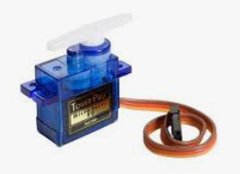

A servo motor is a specialized motor designed to provide precise control of angular or linear position, velocity, and acceleration. It operates through a closed-loop system, which uses feedback to ensure the output shaft reaches and maintains the desired position. This feedback is typically provided by a potentiometer or an encoder, which continuously monitors the motor's position.

Servo motors are integral to applications requiring high precision and reliability. They are commonly used in robotics, CNC machinery, automated manufacturing, and even in consumer electronics like RC vehicles and drones. These motors usually consist of a DC motor, a gear reduction unit, a control circuit, and a position sensor.

The working principle of a servo motor involves sending a control signal that specifies the desired position. The motor's control circuit compares this signal with the feedback from the position sensor. If there is a discrepancy, the motor adjusts its position until the feedback matches the control signal, thus ensuring accurate positioning.

1. **BUZZER**

A **buzzer** or **beeper** is an [audio](http://en.wikipedia.org/wiki/Sound) signaling device, which may be [mechanical](http://en.wikipedia.org/wiki/Machine), [electromechanical](http://en.wikipedia.org/wiki/Electromechanics), or [electronic](http://en.wikipedia.org/wiki/Electronics). Typical uses of buzzers and beepers include [alarms](http://en.wikipedia.org/wiki/Alarm), [timers](http://en.wikipedia.org/wiki/Timer) and confirmation of user input such as a mouse click or keystroke.

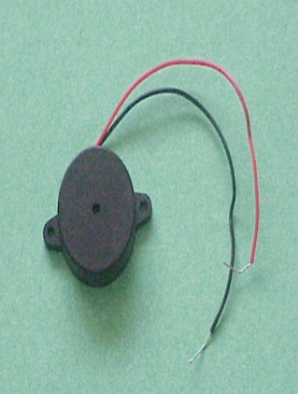

**Buzzer**

**FEATURES**

• The PB series are high-performance buzzers with a unimorph piezoelectric ceramic element and an integral self-excitation oscillator circuit.

• They exhibit extremely low power consumption in comparison to electromagnetic units.

• They are constructed without switching contacts to ensure long life and no electrical noise.

• Compact, yet produces high acoustic output with minimal voltage.

**Mechanical**

A [joy buzzer](http://en.wikipedia.org/wiki/Joy_buzzer) is an example of a purely mechanical buzzer.

**Electromechanical**

Early devices were based on an electromechanical system identical to an [electric bell](http://en.wikipedia.org/wiki/Electric_bell) without the metal gong. Similarly, a [relay](http://en.wikipedia.org/wiki/Relay) may be connected to interrupt its own actuating [current](http://en.wikipedia.org/wiki/Electric_current), causing the [contacts](http://en.wikipedia.org/wiki/Switch) to buzz. Often these units were anchored to a wall or ceiling to use it as a sounding board. The word "buzzer" comes from the rasping noise that electromechanical buzzers made.

**VOLTAGE BUZZER SOUND CONTROLS**

When resistance is connected in series (as shown in illustrations (a) and (b)), abnormal oscillation may occur when adjusting the sound volume. In this case, insert a capacitor in parallel to the voltage oscillation board (as shown in illustration (c)). By doing so, abnormal oscillation can be prevented by grounding one side. However, the voltage VB added to the voltage oscillation board must be within the maximum input voltage range, and as capacitance of 3.3μF or greater should be connected.



**Resistance connected in series**

1. **LED**

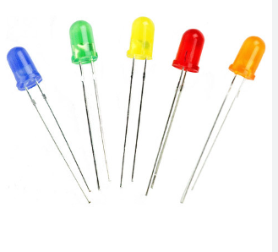

An LED (Light Emitting Diode) bulb is a highly efficient lighting technology that converts electrical energy into light using a semiconductor material. Unlike traditional incandescent or CFL (Compact Fluorescent Lamp) bulbs, LED bulbs have a much higher efficiency, producing more light per unit of energy consumed. This makes them significantly more energy-efficient and environmentally friendly.

LED bulbs operate by passing current through a semiconductor diode, which emits light when energized. They generate very little heat compared to incandescent bulbs, which lose a large portion of energy as heat. This results in LED bulbs having a much lower power consumption and longer lifespan, typically lasting between 15,000 to 50,000 hours, compared to just 1,000 to 2,000 hours for incandescent bulbs.

In addition to their energy efficiency, LED bulbs offer instant brightness, can be dimmed without flicker, and are available in various color temperatures, from warm white to cool blue. They are also durable, shock-resistant, and emit light in a specific direction, reducing the need for reflectors.

LED bulbs are increasingly popular in residential, commercial, and industrial settings due to their energy-saving benefits, low maintenance, and long lifespan.

1. **REGULATED POWER SUPPLY:**

All digital circuits require regulated power supply. In this article we are going to learn how to get a regulated positive supply from the mains supply.

**STEP DOWN**

**TRANSFORMER**

**BRIDGE**

**RECTIFIER**

**FILTER**

**CIRCUIT**

**REGULATOR SECTION**

**shows the basic block diagram of a fixed regulated power supply**

**CHAPTER 5**

**SOFTWARE TOOLS**

1. Arduino ide
2. Embedded c programming
3. Windows OS

**5.1 DESCRIPTION OF TOOLS**

**1. Arduino IDE:**

Arduino IDE Software. You can get different versions of Arduino IDE from the Download page on the Arduino Official website. You must select your software, which is compatible with your operating system (Windows, IOS, or Linux). After your file download is complete, unzip the file.

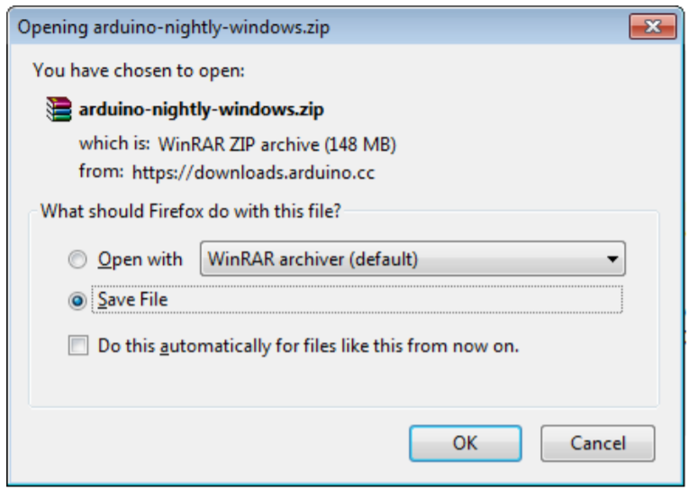

Launch Arduino IDE. After your Arduino IDE software is downloaded, you need to unzip the folder. Inside the folder, you can find the application icon with an infinity label (application.exe). Doubleclick the icon to start the IDE.

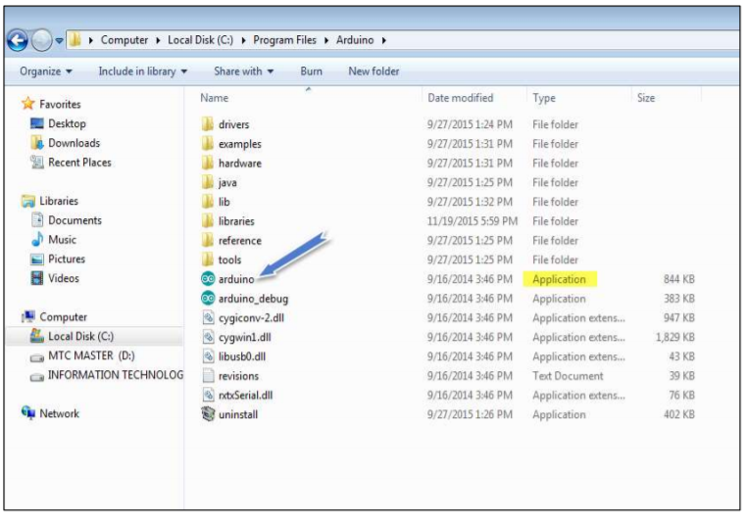

Open your first project. Once the software starts, you have two options:

• Create a new project.

• Open an existing project example.

To create a new project, select File --> New

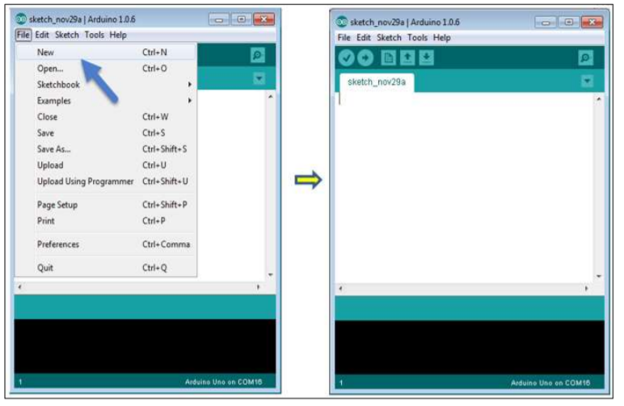

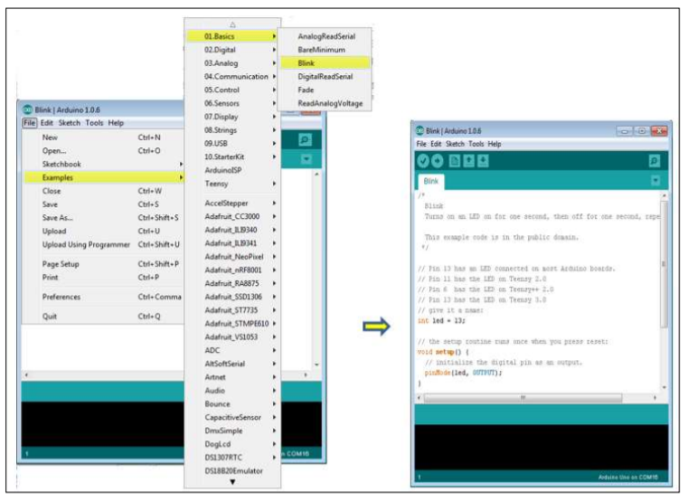

Here, we are selecting just one of the examples with the name Blink. It turns the LED on and off with some time delay. You can select any other example from the list

Select your serial port. Select the serial device of the Raspberry Pi Pico W. Go to Tools -> Serial Port menu. This is likely to be COM3 or higher (COM1 and COM2 are usually reserved for hardware serial ports). To find out, you can disconnect your Arduino board and re-open the menu, the entry that disappears should be of the Arduino board. Reconnect the board and select that serial port.

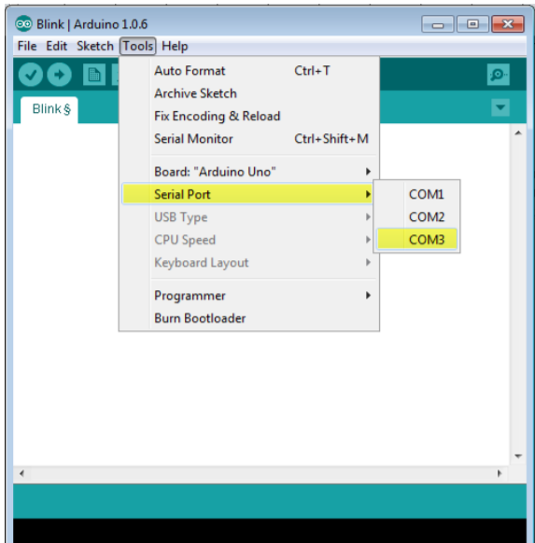

Before explaining how we can upload our program to the board, we must demonstrate the function of each symbol appearing in the Arduino IDE toolbar.

1. Used to check if there is any compilation error.
2. Used to upload a program to the Raspberry pi pico board.
3. Shortcut used to create a new sketch.
4. Used to directly open one of the example sketch.
5. Used to save your sketch.
6. Serial monitor used to receive serial data from the board and send the serial data to the board.

Now, simply click the "Upload" button in the environment.

Wait a few seconds; you will see the RX and TX LEDs on the board, flashing. If the upload is successful, the message "Done uploading" will appear in the status bar.

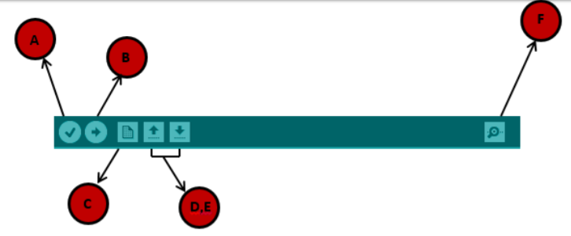

In this chapter, we will study in depth, the Arduino program structure and we will learn more new terminologies used in the Arduino world. The Arduino software is open-source. The source code for the Java environment is released under the GPL and the C/C++ microcontroller libraries are under the LGPL. Sketch: The first new terminology is the Arduino program called “sketch”. Structure Arduino programs can be divided in three main parts: Structure, Values (variables and constants), and Functions. In this tutorial, we will learn about the Arduino software program, step by step, and how we can write the program without any syntax or compilation error. Let us start with the Structure. Software structure consist of two main functions:

•Setup( ) function

•Loop( ) function

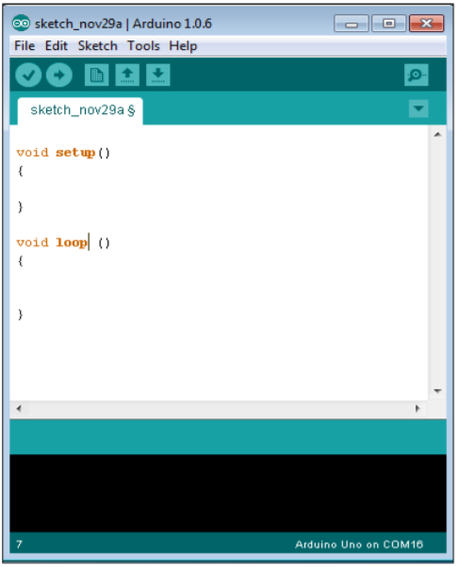

Data types in C refers to an extensive system used for declaring variables or functions of different types. The type of a variable determines how much space it occupies in the storage and how the bit pattern stored is interpreted. The following table provides all the data types that you will use during Arduino programming.

**CHAPTER 6**

**RESULTS AND DISCUSSION**

* 1. During normal Condition

Under normal operating conditions, the solar module system hums along efficiently. The voltage sensor steadily reports optimal output, leading to a calculated current well above the low threshold, ensuring consistent energy generation. The ambient temperature, as measured by the DHT11, remains comfortably below the high-temperature limit, preventing any thermal stress on the panel. The MEMS sensor confirms the solar panel's stable and correct tilt angle, maximizing sunlight capture. Simultaneously, the Raspberry Pi Pico W diligently collects these stable sensor readings, transmitting them seamlessly to the ThinkSpeak cloud for continuous data logging and performance tracking. The local LCD displays these normal voltage and current values, offering a real-time visual confirmation of healthy operation. Crucially, with all parameters within their defined ranges, the fault detection mechanisms remain inactive. The servo motor stays still, the buzzer silent, and no alert SMS messages are dispatched via the GSM module. The LED might blink gently, indicating the system's active yet uneventful monitoring state. In essence, the system provides a silent yet vigilant oversight, ensuring optimal solar energy harvesting without the need for intervention

* 1. When the solar panel's output voltage dips below the established low voltage threshold, the embedded system immediately recognizes this anomaly. Consequently, the calculated current also registers a value below its normal operating range, signaling a potential drop in energy generation. This triggers the system's low power fault detection mechanism. As a result, the Raspberry Pi Pico W activates the GSM module to dispatch an SMS notification to the designated mobile number, alerting the user about the detected low voltage and current condition. Furthermore, the system initiates the automated cleaning process by activating the servo motor, which in turn operates the cleaning mechanism to remove any potential obstructions like dust or debris from the solar panel's surface.. While the temperature and tilt angle might still be within normal ranges, the primary focus shifts to addressing the low power output through automated cleaning and remote notification.
  2. When the temperature of the solar panel is high

If the ambient temperature surrounding the solar panel rises above the predefined high-temperature threshold, the DHT11 sensor detects this critical change, and the Raspberry Pi Pico W identifies a potential overheating situation. This triggers the high-temperature fault detection mechanism. Immediately, the system activates the GSM module to send an SMS notification to the designated mobile number, warning the user about the elevated temperature. In parallel, the buzzer is activated, emitting an audible alarm to provide an immediate local warning of the high temperature condition.Unlike the low voltage scenario, a high temperature typically doesn't trigger the servo motor for cleaning. The buzzer will continue to sound until the temperature, as reported by the DHT11, falls back below the established threshold, indicating a return to a safer operating range.

4.when tilt angle of the panel is changed

When the MEMS sensor detects a significant deviation in the solar panel's tilt angle from its pre-defined default or acceptable range, the Raspberry Pi Pico W identifies a potential misalignment. This triggers the tilt angle change detection mechanism. Consequently, the system activates the GSM module to send an SMS notification to the designated mobile number, informing the user about the detected change in the panel's orientation. The primary response is to alert the user about the potential misalignment, allowing for manual inspection and adjustment of the solar panel's position to ensure optimal sunlight capture.

**CHAPTER 7**

**CONCLUSION**

The proposed embedded system for real-time fault diagnosis in photovoltaic (PV) modules enhances solar energy efficiency by addressing common issues such as dust accumulation, shading, overheating, and misalignment. By integrating multiple sensors, an automated cleaning mechanism, and real-time alerts via LED indicators, buzzer, LCD display, and GSM module, the system ensures **early fault detection and timely maintenance**. This proactive approach reduces **manual inspection costs, minimizes downtime, and extends the lifespan** of PV modules.

The system’s ability to provide **remote notifications and automated responses** makes it highly effective for large-scale solar installations, improving reliability and energy output. By reducing maintenance efforts and ensuring **consistent power generation**, this innovative solution contributes to the broader goal of **sustainable and efficient renewable energy management**, making solar power more viable and cost-effective in the long run.

**FUTURE SCOPE:**

The proposed system can be enhanced by integrating **IoT and cloud computing** for remote data analysis and predictive maintenance. **AI-based fault detection** can improve diagnostic accuracy, reducing false alerts. Expanding the system with **solar tracking mechanisms** can further optimize energy generation. Additionally, using **self-cleaning nanocoatings** on PV panels may reduce cleaning frequency. Future developments can make the system **more scalable, efficient, and adaptable** for large solar farms and smart grid applications.

**REFERENCES**

1. Dec. 2022, [online] Available: [https://www.iea.org/reports/world-energy-outlook-2022](https://www.iea.org/reports/world-energy-outlook-2022).

2. A. Mellit, G. M. Tina and S. A. Kalogirou, "Fault detection and diagnosis methods for photovoltaic systems: A review", Renewable Sustain. Energy Rev., vol. 91, pp. 1-17, Aug. 2018

3. M. Aghaei, A. Gandelli, F. Grimaccia, S. Leva and R. E. Zich, "IR real-time analyses for PV system monitoring by digital image processing techniques", Proc. Int. Conf. Event-Based Control Commun. Signal Process., pp. 1-6, 2015.

4. P. B. Quater, F. Grimaccia, S. Leva, M. Mussetta and M. Aghaei, "Light unmanned aerial vehicles (UAVs) for cooperative inspection of PV plants", IEEE J. Photovolt., vol. 4, no. 4, pp. 1107-1113, Jul. 2014

5. X. Li, W. Li, Q. Yang, W. Yan and A. Y. Zomaya, "An unmanned inspection system for multiple defects detection in photovoltaic plants", IEEE J. Photovolt., vol. 10, no. 2, pp. 568-576, Mar. 2020.

6. V. Lofstad-Lie, E. S. Marstein, A. Simonsen and T. Skauli, "Cost-effective flight strategy for aerial thermography inspection of photovoltaic power plants", IEEE J. Photovolt., vol. 12, no. 6, pp. 1543-1549, Nov. 2022.

7. B. Du, Y. He, Y. He, J. Duan and Y. Zhang, "Intelligent classification of silicon photovoltaic cell defects based on eddy current thermography and convolution neural network", IEEE Trans. Ind. Inform., vol. 16, no. 10, pp. 6242-6251, Oct. 2020.

8. N. Prajapati, R. Aiyar, A. Raj and M. Paraye, "Detection and identification of faults in a PV module using CNN based algorithm", Proc. 3rd Int. Conf. Emerg. Technol., pp. 1-5, 2022.

9. D. Rocha et al., "A deep learning approach for PV failure mode detection in infrared images: First insights", Proc. IEEE 49th Photovolt. Specialists Conf., pp. 630-632, 2022.

10. N. Kellil, A. Aissat and A. Mellit, "Fault diagnosis of photovoltaic modules using deep neural networks and infrared images under Algerian climatic conditions", Energy, vol. 263, Jan. 2023.

11. A. Mellit and S. Kalogirou, "Artificial intelligence and Internet of Things to improve efficacy of diagnosis and remote sensing of solar photovoltaic systems: Challenges recommendations and future directions", Renewable Sustain. Energy Rev., vol. 143, Jun. 2021.

12. P. Warden and D. Situnayake, *TinyML: Machine Learning With TensorFlow Lite on Arduino and Ultra-Low-Power Microcontrollers*, Sebastopol, CA, USA: O'Reilly Media, 2019.

13. A. Mellit, N. Blasuttigh and A. Massi Pavan, "TinyML for fault diagnosis of photovoltaic modules using edge impulse platform", Proc. IEEE 11th Int. Conf. Smart Grid (icSmartGrid), pp. 1-5, 2023.

14. K. K. Patel, S. M. Patel and P. Scholar, "Internet of things-IOT: Definition characteristics architecture enabling technologies application and future challenges", Int. J. Eng. Sci. Comput., vol. 6, no. 5, pp. 6122-6131, 2016

15. C. Henry, S. Poudel, S.-W. Lee and H. Jeong, "Automatic detection system of deteriorated PV modules using drone with thermal camera", Appl. Sci., vol. 10, no. 11, May 2020.

16. A. Mellit, "An embedded solution for fault detection and diagnosis of photovoltaic modules using thermographic images and deep convolutional neural networks", Eng. Appl. Artif. Intell., vol. 116, Nov. 2022.

17. S. Vergura, "Rules and issues of outdoor infrared inspection of photovoltaic modules by unmanned aerial vehicles", Proc. IEEE Int. Conf. Environ. Elect. Eng. Ind. Commercial Power Syst. Europe, pp. 1-5, 2021.

18. "IEC TS 62446-3:2017; Photovoltaic (PV) Systems—Requirements for Testing", 2017.

19. R. Vignesh, B. T. Oh and C.-C. J. Kuo, "Fast non-local means (NLM) computation with probabilistic early termination", IEEE Signal Process. Lett., vol. 17, no. 3, pp. 277-280, Mar. 2010.