*A project report*

*on*

## SMART SOLAR MONITOR: REAL-TIME FAULT DIAGNOSIS AND AUTOMATED MAINTENANCE SYSTEM FOR PHOTOVOLTAIC MODULES

*Submitted in partial fulfilment of the requirement for the award of the degree of*

**BACHELOR OF TECHNOLOGY**

*In*

**ELECTRICAL AND ELECTRONICS ENGINEERING**

Submitted by

|  |  |
| --- | --- |
| **S.LIKHIL SAI PRAKASH** | **21B91A02D4** |
| **S.DEVI SAI REDDY** | **21B91A02D2** |
| **P.VIJAYA RATHNANJALI** | **21B91A02C3** |
| **P.SATYA VENKAT** | **21B91A02B9** |
| **MD.ANAS MALIK** | **21B91A0295** |
|  |  |

Under the esteemed guidance of

**Dr.B.S.S.SANTOSH M.Tech.,Ph.d.**

**Assistant Professor, EEE Department**



**DEPARTMENT OF ELECTRICAL & ELECTRONICS ENGINEERING**

**S.R.K.R. ENGINEERING COLLEGE (A)**

**(Affiliated to JNTU KAKINADA) (Recognized by A.I.C.T.E, New Delhi)**

**(Accredited by N.B.A., NAAC with ‘A+’ grade, New Delhi)**

**CHINNA AMIRAM, BHIMAVARAM-534204**

**(2025**

**S.R.K.R. ENGINEERING COLLEGE (A)**

**(Affiliated to JNTU KAKINADA) (Recognized by A.I.C.T.E, New Delhi)**

**(Accredited by N.B.A., NAAC with ‘A+’ grade, New Delhi)**

**CHINNA AMIRAM, BHIMAVARAM-534204**

**DEPARTMENT OF ELECTRICAL AND ELECTRONICS ENGINEERING**



**Certificate**

This is to certify that Mr./Ms. S.LIKHIL SAI PRAKASH, S.DEVI SAI REDDY, P.VIYAYA RATHNANJALI, P.SATYA VENKAT, MD.ANAS MALIK of final year B. Tech., EEE, have carried out the project work on “SMART SOLAR MONITOR: REAL-TIME FAULT DIAGNOSIS AND AUTOMATED MAINTENANCE SYSTEM FOR PHOTOVOLTAIC MODULES” in partial fulfilment of the requirements for the award of the Degree of ‘Bachelor of Technology’ with specialization of Electrical and Electronics Engineering in S.R.K.R. Engineering College (A), Bhimavaram. This is a bonafide record of the work done by us during the academic year 2024 – 2025. The results of this project work have not been submitted to any other university or Institute for the award of any degree.

|  |  |
| --- | --- |
| Guide | Head of the Department |
| **Dr. B.S.S.SANTOSH,M.Tech.,Ph.D.** | **Dr. B.R.K. VARMA, M.E., Ph.D.** |
| Assistant Professor | Professor & HOD |

**CERTIFICATE OF EXAMINATION**

This is to certify that we had examined the project report and here by accord our approval of it as a study carried out and presented in a manner required for its acceptance in partial fulfilment of the award of the degree of **BACHELOR OF TECHNOLOGY** in **ELECTRICAL AND ELECTRONICS ENGINEERING** for which it has been submitted.

This approval does not necessarily endorse or accept every statement made, opinion expressed or conclusions drawn as recorded in the report. It only signifies the acceptance of the report for the purpose of which it is submitted.

**INTERNAL EXAMINER EXTERNAL EXAMINER**

**DECLARATION**

This thesis entitled “TITLE OF THE PROJECT IN CAPITAL LETTERS ONLY” has been carried out by us in the partial fulfilment of the requirements for the award of the degree of Bachelor of Technology in the Department of Electrical and Electronics Engineering, Sagi Rama Krishnam Raju Engineering College (A), Bhimavaram. We hereby declare that this thesis has not been submitted to any other university/institute for the award of any other degree/diploma.

|  |  |  |
| --- | --- | --- |
| **Roll. No.** | **Name** | **Signature** |
| 21B9XXXXX | Student Name-1 | _________________ |
| 21B9XXXXX | Student Name-2 | _________________ |
| 21B9XXXXX | Student Name-3 | _________________ |
| 21B9XXXXX | Student Name-4 | _________________ |
| 21B9XXXXX | Student Name-5 | _________________ |
| 21B9XXXXX | Student Name-6 | _________________ |

**ACKNOWLEDGEMENT**

<Content must be in TIMES NEW ROMAN, Font SIZE-12, Line spacing-1.5, and Paragraph Justify mode>

Words are inadequate to express the overwhelming sense of gratitude and humble regards to my supervisor <Guide Name>, <Designation> Assistant/Associate/Professor Professor in Department of Electrical and Electronics Engineering for his constant motivation, support, expert guidance, constant supervision and constructive suggestion for the submission of my progress report of thesis work “PROJECT TITLE”.

We would like to express our deep sense of gratitude and sincere regards to Dr. B.R.K. VARMA, Head of Electrical and Electronics Engineering Department for his intense support throughout the project work. We are over whelmed to thank our principal Dr. K. V. MURALI KRISHNAM RAJU and management of S.R.K.R Engineering College who has given all the facilities and support for the successful completion of our project.

We take this opportunity to express our acknowledgement to all the faculty members of Electrical and Electronics Engineering Department for giving valuable advices and support which paved the way for successful completion of our project.

We take this opportunity to convey our sincere thanks to all those who have directly and indirectly contributed for the successful completion of our project work

Project Associates21B91A02XX  
21B91A02XX  
21B91A02XX  
21B91A02XX  
21B91A02XX  
21B91A02XX

# ABSTRACT

# <Headings, Font-14, Times New Roman, Centre alligned>

<Content must be in TIMES NEW ROMAN, Font-12, Line spacing-1.5, and Paragraph Justify mode> A brief summary of your project work is necessary with clearly mentioning the outcomes and detailing of the work done, but not exceeding one page.

# TABLE OF CONTENTS (With Sample Data shown below)

ABSTRACT vi

<Headings, Font-14, Times New Roman, Centre alligned> vi

TABLE OF CONTENTS vii

LIST OF FIGURES viii

LIST OF TABLES ix

CHAPTER -1 <, Centre, Font-14, Bold, Times New Roman> 1

INTRODUCTION<Centre, Font-14, Bold, Times New Roman> 1

1.1 INTRODUCTION <Font-14, Bold, Times New Roman> 1

1.2 TYPICAL BLDC MOTOR APPLICATIONS <Font-14, Bold, Times New Roman> 1

1.2.1 Constant load 2

1.2.2 Varying loads 2

CHAPTER - 2 3

PERMANENT MAGNET BRUSHLESS DC MOTOR 3

2.1 Introduction 3

2.1.1 BRUSHED Vs BRUSHLESS DC MOTORS <Font-13, Bold, Times New Roman> 3

2.1.2 APPLICATIONS OF BRUSHED AND BRUSHLESS DC MOTOR 4

CHAPTER – 7 5

CONCLUSION 5

FUTURE SCOPE 6

APPENDIX – A 7

REFERENCES 8

# LIST OF FIGURES (With Sample Data shown below)

|  |  |  |
| --- | --- | --- |
| **Fig. No.** | **Title of Figure** | **Page No.** |
| 1.1 | DC Power supply adapter | 2 |
| 2.1 | Brushless Dc Motor | 3 |
| 2.2 | Step-down Transformer | 4 |

# LIST OF TABLES (With Sample Data shown below)

|  |  |  |
| --- | --- | --- |
| **Table No.** | **Title of Figure** | **Page No.** |
| Table 1.1 | List of Components. | 2 |
| Table 1.2 |  |  |

# CHAPTER -1

< Centre, Font-14, Bold, Times New Roman>

# INTRODUCTION<Centre, Font-14, Bold, Times New Roman>

# INTRODUCTION <Font-14, Bold, Times New Roman> (With Sample Data shown below)

<Font-12, Times New Roman, Justify mode, Line spacing - 1.5> (Sample Data) Brushless dc (BLDC) motors are preferred as small horsepower control motors due to their high efficiency, silent operation, compact form, reliability, and low maintenance. However, the problems are encountered in these motors for variable speed operations over last two decades. Continuing technology development in power semiconductors, microprocessors, adjustable speed drive control schemes and permanent-magnet brushless electric motor production have been combined to enable reliable, cost-effective solution for a broad range of adjustable speed applications.

<Font-12, Times New Roman, Justified, Line spacing - 1.5> (Sample Data) Household appliances are expected to be one of fastest-growing end-product market for electronic motor drivers over the next five years. The major appliances include clothes' washers, room air conditioners, refrigerators, vacuum cleaners, freezers, etc. Household appliance have traditionally relied on historical classic electric motor technologies such as single phase AC induction, including split phase, capacitor-start, capacitor-run types, and universal motor. These classic motors typically are operated at constant-speed directly fi-om main AG power without regarding the efficiency. Consumers now demand for lower energy costs, better performance, reduced acoustic noise, and more convenience featxires. The traditional technologies cannot provide these solutions.

# 1.2 TYPICAL BLDC MOTOR APPLICATIONS <Font-14, Bold, Times New Roman>

(Sample Data) BLDC motors find applications in every segment of the market. Such as, appliances, industrial control, automation, aviation and so on. We can categorize the BLDC motor control into three major types such as

## 1.2.1 CONSTANT LOAD

(Sample Data) motors find applications in every segment of the market. Such as, appliances, industrial control, automation, aviation and so on. We can categorize the BLDC motor control into three major types such as.

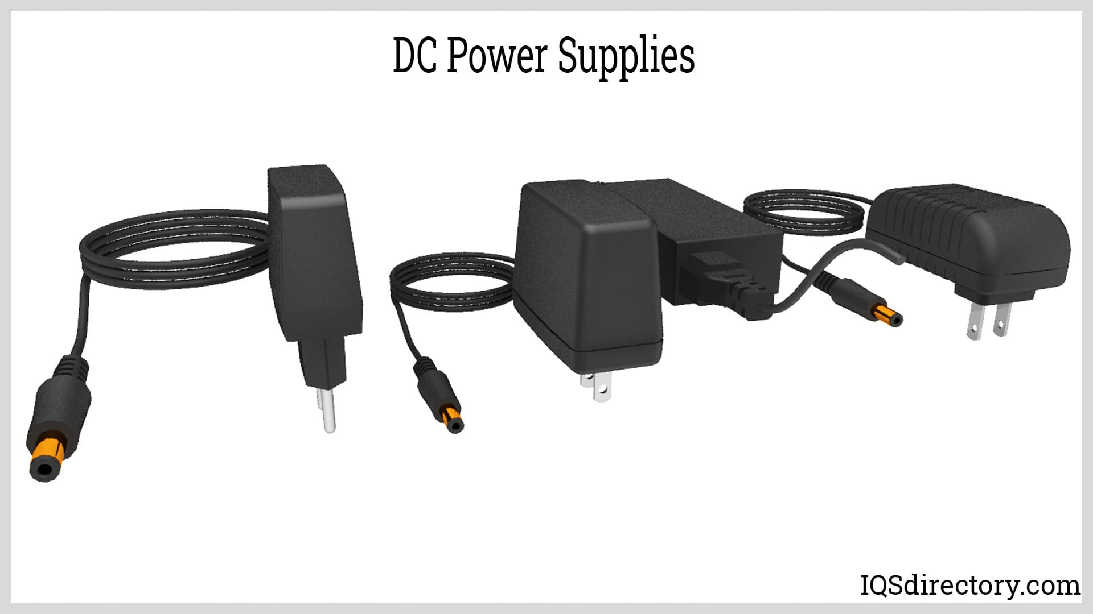

Fig. 1.1 DC Power supply adapter

## 1.2.2 VARYING LOADS

(Sample Data) motors find applications in every segment of the market. Such as, appliances, industrial control, automation, aviation and so on. We can categorize the BLDC motor control into three major types such as motors find applications in every segment of the market. Such as, appliances, industrial control, automation, aviation and so on. We can categorize the BLDC motor control into three major types such as.

Table.1.1 List of Components

|  |  |  |  |
| --- | --- | --- | --- |
| **Sl.No.** | **Component** | **Ratting** | **Quantity** |
| 1 | Transformer | 230V/15V, 1 A | 1 |
| 2 | Diode | 1N4007, 1A | 4 |
| 3 | Electrolytic Capacitor | 2200uF, 25V | 1 |
| 10uF, 63V | 2 |
| 4 | Resistors | 1K ohms | 1 |
| 470 Ohms | 1 |
| 5 | Polyster Film Capacitor | 0.1u F, 100V | 2 |
| 6 | PBT Connector | 2-pin green | 3 |
| 7 | DC power | Male Connector | 1 |
| 8 | LED | RED & Green | 2 |
| 9 | PCB Board | 4x4 | 1 |
| 10 | Voltage Regulator | LM7812 - 1.5A | 1 |
| 11 | Voltage Regulator | LM7805 - 1.5A | 1 |

# CHAPTER – 2

# PERMANENT MAGNET BRUSHLESS DC MOTOR

# 2.1 Introduction

(Sample Data) Permanent magnet Brushless (BL) DC Motors have received the considerable attention throughout the industrial world since the early 1970. BLDC are used in computer disc drives and small fans exclusive. The brushless D.C Motor is the ideal choice for applications that require high reliability, high power-to-volume ratio. BLDC Motors are derivatives of the most commonly used dc motor. BLDC motor when operated at rated conditions the life expectancy is 10,000 hours. It is electronically commutated. Efficiency ranges from 90 % to 96%.

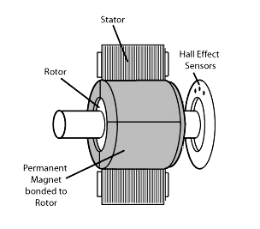

Fig. 2.1 Brushless Dc Motor.

## 2.1.1 BRUSHED Vs BRUSHLESS DC MOTORS <Font-13, Bold, Times New Roman>

(Sample Data) A brushed DC motor uses a configuration of wound wire coils, the armature, acting as a two-pole electromagnet. The current's directionality is reversed twice per cycle by the commutator, a mechanical rotary switch. This facilitates flow of the current through the armature; thus, the electromagnet’s poles pull and push against the permanent magnets along the outside of the motor. The commutator then reverses the polarity of the armature's electromagnet as its poles cross the permanent magnets' poles.

A brushless motor, by contrast, utilizes a permanent magnet as its external rotor. In addition, it uses three phases of driving coils and a specialized sensor that tracks rotor position. As the sensor tracks the rotor position, it sends out reference signals to the controller. The controller, in turn, activates the coils in a structured way – one phase after the other.

## 2.1.2 APPLICATIONS OF BRUSHED AND BRUSHLESS DC MOTOR

Today, the brushless motor is far more common than the brushed motor. However, both can be found in a wide range of applications. Brushed DC motors are still used frequently in household appliances and in automobiles. They also maintain a strong industrial niche because of the ability to alter the torque to speed ratio exclusive to brushed motor.

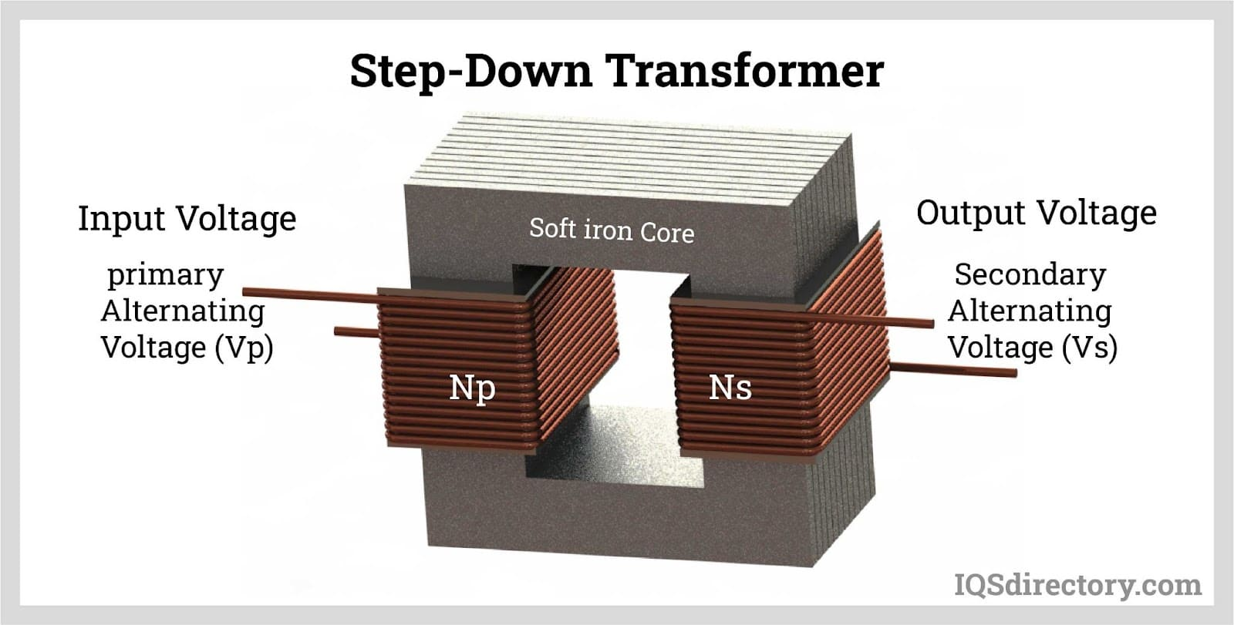

Fig. 2.2 Step-down Transformer

# CHAPTER – 7

# CONCLUSION

(Sample Data) This work has presented the techniques applied for minimizing the torque ripples in BLDC motor from the control side. Control techniques for minimizing pulsating torque could apply advanced methods, depending on the accurate information of machine parameters. In conclusion, the demand in BLDC motor is to produce a BLDC drive with smooth operation to suit any application where needed.

# FUTURE SCOPE

(Sample Data) The scope for future work is summarized as follows.

Developments of new fuzzy controllers to achieve better performance. This fuzzy controller should, at least, take into account the following considerations:

* Develop a completely auto adaptive controller.
* The controller must be adaptive to any motor.
* Try to overcome the electrical noise, which appear in any power drive.

# APPENDIX – A

Matlab Main Code Or Arduino Code or Derivations (whatever is necessary or Important)

Here you can give your detailed derivations or Matlab Code or Arduino Code of your project.

If your work contains more derivations or many other platform Codes, then you can increase the page headings as “APPENDIX – A”, “APPENDIX – B”, “APPENDIX – C” and so on.

# REFERENCES

Everyone follow the below pattern for writing the references of your work

[Sl.No] Author-1, Author-2, author-3, “Title of the paper”, published in <name of conference> or <publisher>, <volume>, <page numbers>, <Year.>

Some samples are shown below.

[1] Y. Murai, Y. Kawase, K. Ohashi, K. Nagatake & K. Okuyama, “Torque ripple improvement for brushless DC miniature motors” IEEE Transactions on Industry Applications, vol. 25, no.3, pp. 441-450,May/Junl989.

[2] P. Pillay and R. Krishnan, “Modeling, simulation, and analysis of permanent- magnet motor drives. II. The brushless DC motor drive”, IEEE Transactions on Industry Applications, pp. 274–279, 1989.

[3] R. Krishnan and G.-H. Rim, “Modeling, simulation, and analysis of variable-speed constant frequency power conversion scheme with a permanent magnet brushless dc generator”, *in* *IEEE Transactions on Industrial Electronics*, 37(4), 291–296, 1990.

[4] R. Carlson, M. Lajoie-Mazenc & J. C. D. S. Fagundes, “Analysis of torque ripple due to phase commutation in brushless DC machines”, Industry Applications, IEEE Transactions on, vol. 28no.3, pp 632-638, May/Jun 1992.

[5]. R. Krishnan, “Electric Motor Drives”, Prentice Hall, Upper Saddle River, NJ, 2001.

[6] Q. Zhao, and F.C. Lee, “High-Efficiency, High Step-Up DC–DC Converters”, IEEE Trans. on Power Electr., vol. 18, issue 1, pp. 65-73, January 2003.