SUPERCONSCIOUSNESS
Project title: Integrated Educational Consultancy and Student Guidance Platform
Document purpose: Detailed module specification and operational workflow document.
Primary users: Students, counsellors, administrators, and education-content managers.

1. Executive Abstract
Superconsciousness, documented as Dumick Educational Consultancy, is an integrated education and career guidance platform that supports students throughout the higher-education planning journey. It combines profile creation, academic and preference capture, college and course discovery, recommendation categories, scholarship research, entrance-exam information, fee comparison, aptitude assessment, shortlisting, webinars, and appointment scheduling.
Student experience: Students create a structured profile, describe their academic interests and study preferences, explore institutions and careers, compare costs, identify scholarships, understand entrance requirements, complete assessments, and discuss their evidence with a counsellor.
Counsellor experience: Counsellors manage assigned students, review progress and assessment reports, document guidance, schedule appointments, and help students convert research into a practical application plan.
Operating principle: The platform connects discovery and counselling in one secure record so that research, evidence, decisions, and next actions remain connected.
2. Problem and Objectives
Students often face career ambiguity, scattered admissions information, difficult international comparisons, complex scholarships, and unclear entrance-exam requirements. Counsellors need one place to manage student records, progress, assessment reports, appointments, and action plans.
Objectives:
- Create complete student profiles.
- Map preferences.
- Provide transparent recommendations.
- Support scholarships, fees, exams, and assessments.
- Improve counsellor follow-up.
- Preserve historical records.
- Protect student information.

3. Platform Architecture
Two portals
The Student Dashboard supports exploration and planning. The Counsellor/Admin Suite supports account creation, roster management, reporting, progress tracking, scheduling, and resource sharing.
Shared layer
Profiles, academics, preferences, institutions, courses, fees, scholarships, assessments, recommendations, appointments, progress notes, and audit records move through controlled shared services.
Access model
Students see their own information. Counsellors see assigned students. Administrators and content managers receive broader permissions according to role and audit rules.
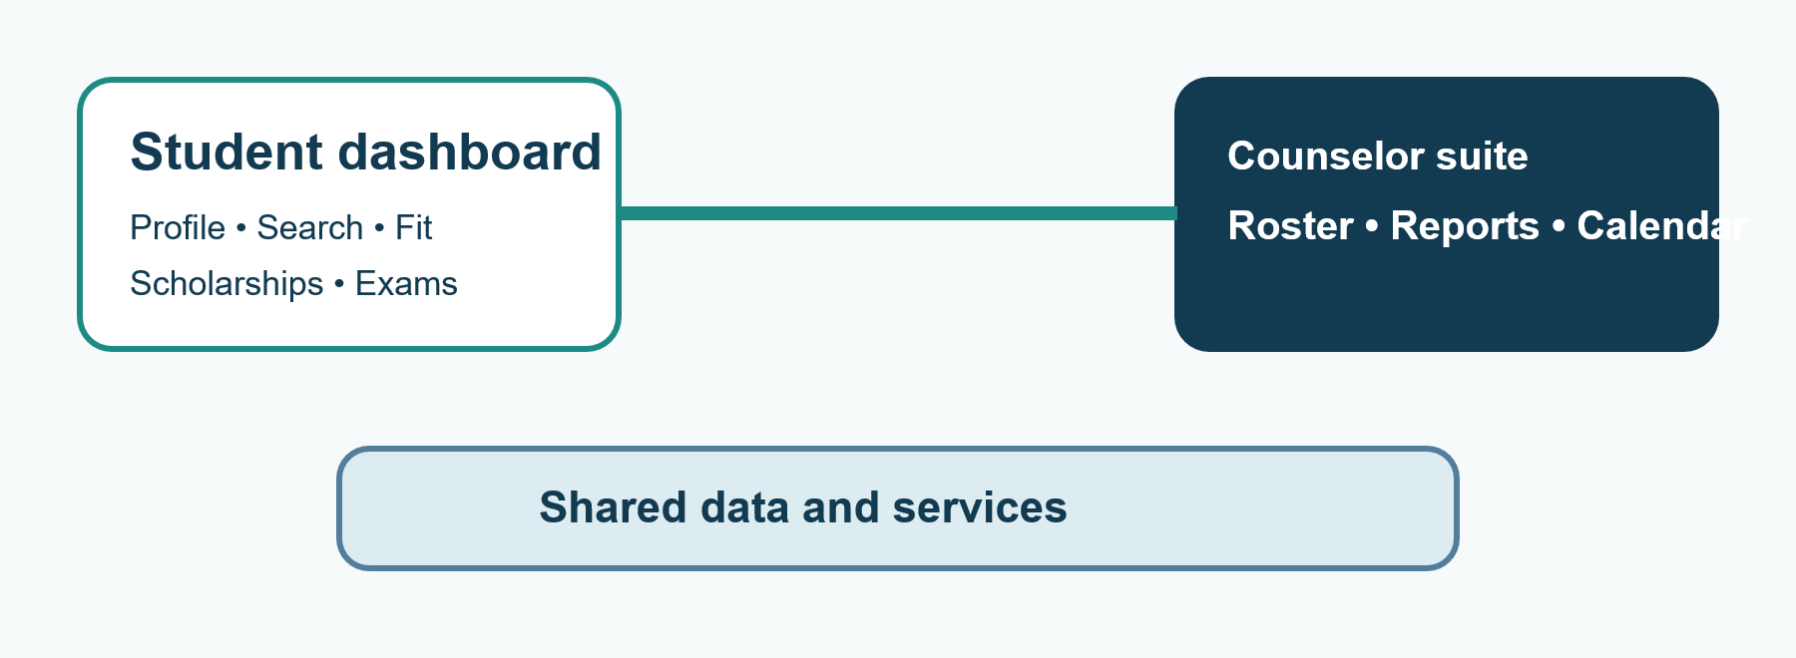

Student Dashboard
- Basic Information
- Preferences
- Education details
- Entrance Exam
- Extra Circular Activities
- Personal Information

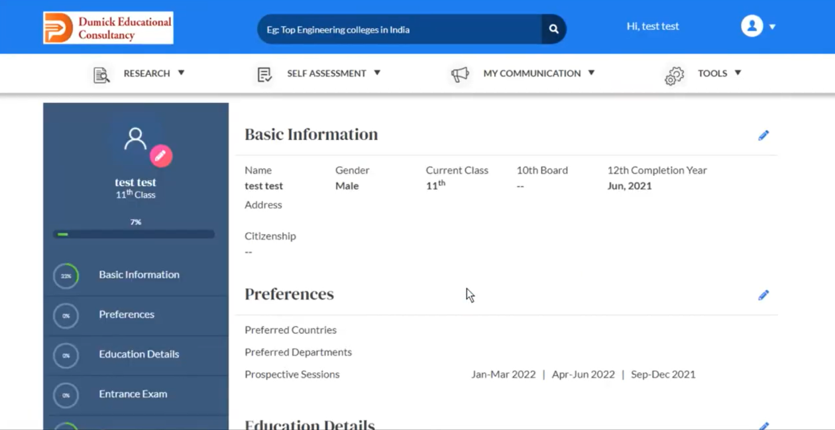

4. Module 1— Account and Profile Intake
Create the verified student record that powers every later recommendation and counselling action.
Steps
- Student or counsellor opens the registration flow.
- Enter name, gender, class or grade, email, phone, address, board or curriculum, Citizenship and passing-out year.
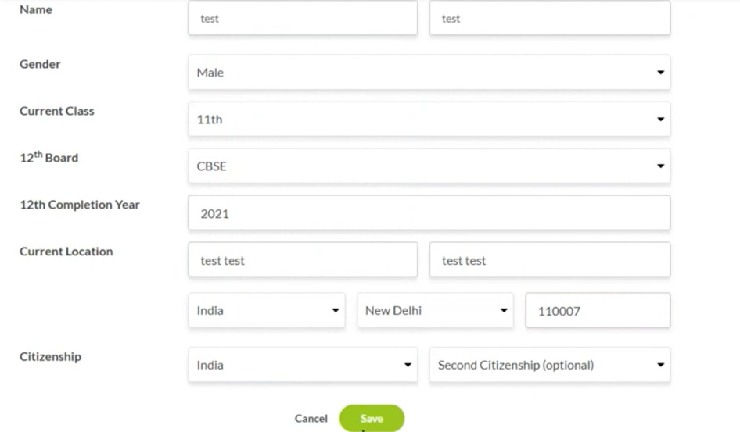
5. Module 2 — Preferences
Capture the academic direction and personal evidence needed for accurate matching.
Steps
- Select priority countries and study destinations.
- Select department and sub-department or specialization.

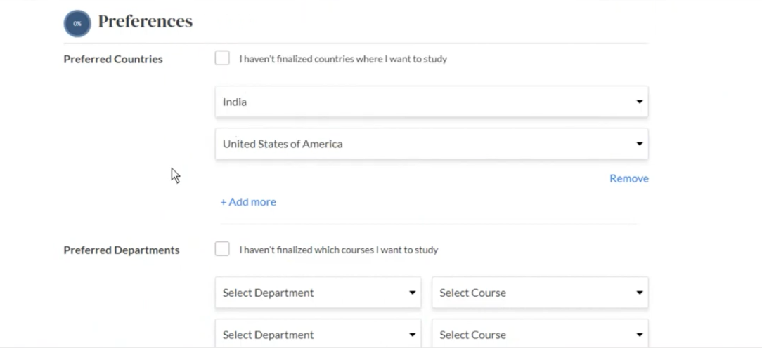
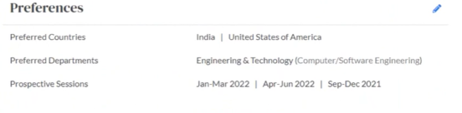
- Module 3—Education Details

Add Education Details of Student so that recommendations will be based on that details.

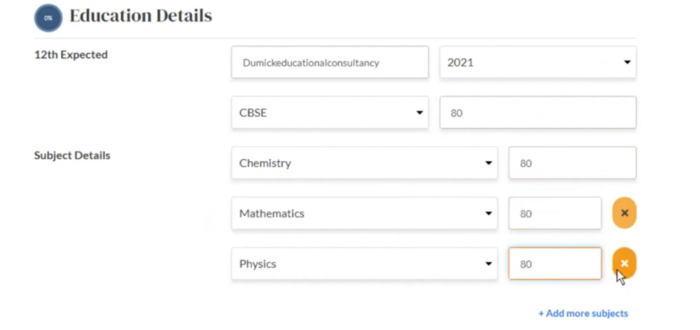

7.Module 4 — Entrance Exam

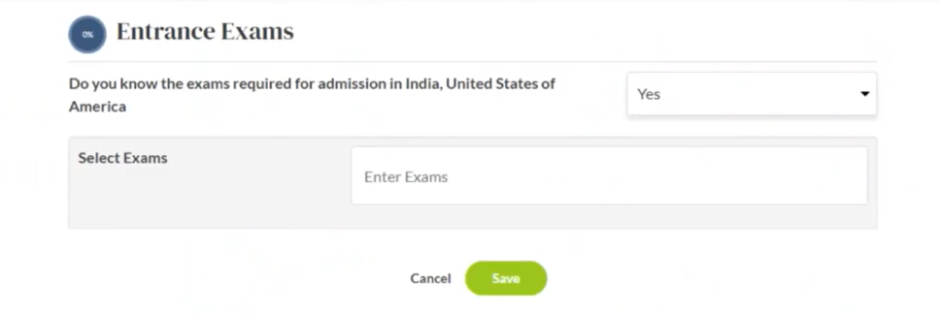

8.Module 5 — Personal Information

- Enter Mobile number , Email, Alternate Email and Parent Details.
- Add Extracurricular Activities and Achievements
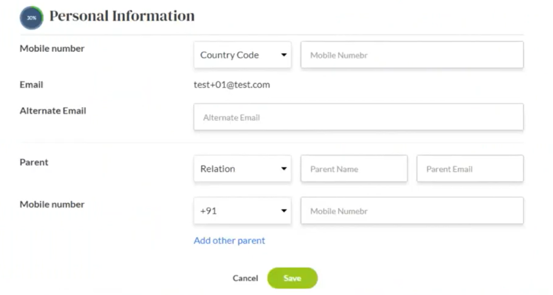

9. Module 6 — College and Course Discovery
Help students and counsellors explore institutions and programs through searchable, verified information.
Steps
- Search by college name, country, city, department, course, or specialization.
- Apply filters for location, program, fees, scholarships, and exam requirements.
- Open the institution profile.
- Review rankings, courses, eligibility, campus facilities, popular programs, placement information, deadlines, contact details, and official website.
- Compare selected colleges and save relevant options.

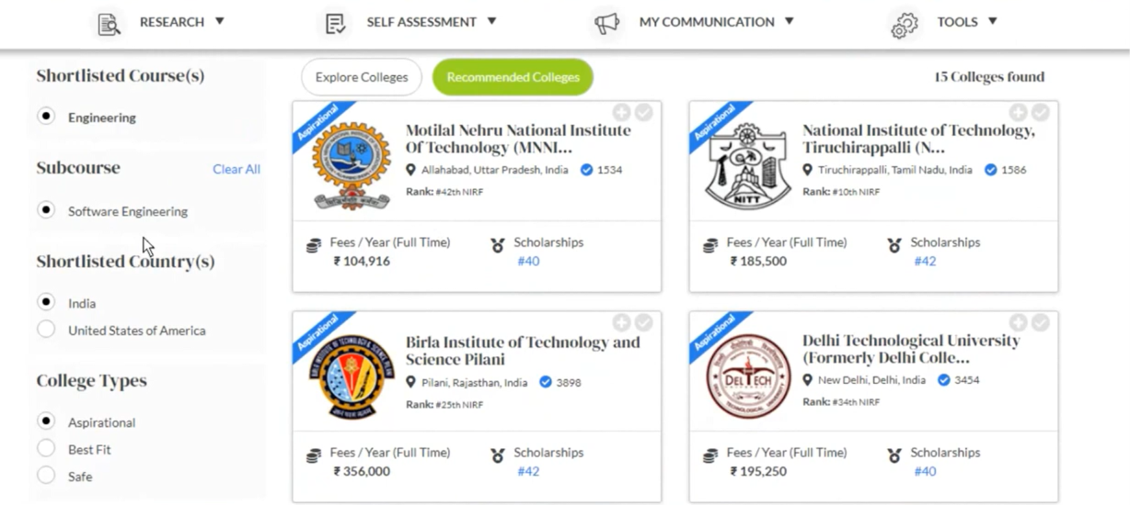

10. Module 7 — Three-Tier Fit and Recommendation Engine
Turn academic and preference data into an understandable application strategy.
Steps
- Read the validated student profile.
- Compare academic credentials with historical or defined admission benchmarks.
- Consider destination, department, course, and financial alignment.
- Place institutions into Safe, Best-Fit, or Aspirational categories.
- Show the reason for the category and the evidence used.
- Allow counsellor review before final shortlist decisions.
Fit categories
• Safe: above 95% admission chance.
• Best-Fit: 50% to 95%.
• Aspirational: below 50% or a reach target.
Supporting analysis
Use historical cohort comparisons, academic scatter-plot context, popular course information, and student-city or geographic diversity insights where available.
Outputs
Balanced application list, fit explanation, counsellor review point, and alternative college recommendations.

11. Module 8 — Scholarship Discovery and Eligibility
Find funding opportunities that match a student’s academic, demographic, destination, and study preferences.
Steps
- Read the student profile and selected department.
- Search the scholarship database.
- Filter by country, department, gender, study level, eligibility, and deadline.
- Open the scholarship detail page.
- Review award value, eligibility, academic cutoff, age or demographic rules, required documents, deadline, and official provider.
- Save the opportunity and open the verified application portal.
Outputs
Scholarship shortlist, eligibility checklist, document checklist, deadline reminders, and official application link.
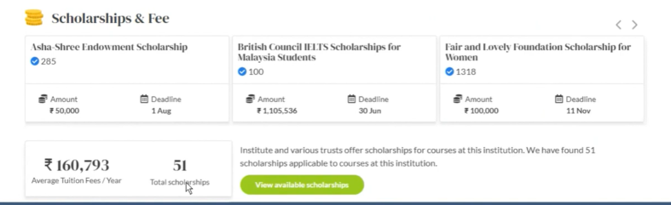

12. Module 9 — Fee Calculator and Country Comparison
Help families and counsellors compare affordability before committing to an application path.
Steps
- Select country, department, course, and institution tier.
- Compare top-tier, mid-level, and emerging institutions.
- View tuition and additional costs such as living expenses, health coverage, travel, and personal costs.
- Normalize values across currencies with a visible reference date.
- Compare countries side by side.
- Record a budget decision or identify a lower-cost alternative.
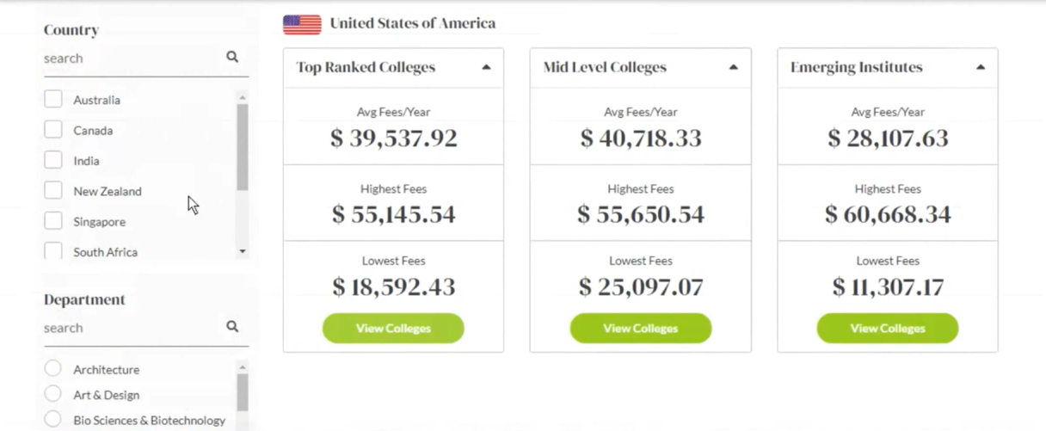

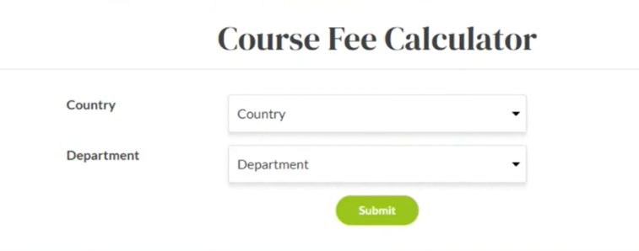

13. Module 10 — Entrance-Exam Intelligence and Mock Tests
Give students one place to understand required tests and plan preparation.
Steps
• 1.Identify exams required by selected colleges.
• 2.Open exam details for format, sections, duration, scoring, validity, and deadlines.
• 3.Review preparation books, resources, study guidance, and test-day tips.
• 4.Follow the official registration link.
• 5. Take a timed mock test where available.
• 6. Record planned or completed exam status for counsellor follow-up.
Coverage
The platform may provide structured information for SAT, ACT, TOEFL, IELTS, GRE, and other relevant exams based on the target institution or destination.
Outputs
Exam plan, deadline checklist, preparation path, mock-test result, and official registration route.

14. Module 11 — Eight-Pathway Assessment Suite
Reduce career ambiguity by combining interests, learning preferences, aptitude, and problem-solving evidence.
Steps
- Counsellor assigns an assessment using a controlled access code.
- Student reads instructions and limitations.
- Student completes the selected test with progress protection or auto-save.
- The system scores the attempt using the active version.
- Generate a report with score ranges, interest clusters, and matching streams.
- Counsellor reviews the report with academics, preferences, and shortlist evidence.
Eight pathways
• Learning Style; Post-10th Stream Selector; Career Personality; Multiple Intelligences; Engineering Branch Selector; Management and Commerce Aptitude; Humanities, Law and Policy Affinity; Cognitive and Problem-Solving Assessment.
Outputs
Diagnostic report, career-stream suggestions, discussion points, and counsellor action plan.

15. Module 12 — Shortlists, Webinars, and Appointments
Move from research into organized decisions and human guidance.
Steps
- Bookmark preferred colleges, courses, scholarships, exams, or careers.
- Organize the shortlist by fit and priority.
- Browse recorded or upcoming expert webinars by field or destination.
- Counsellor schedules a meeting with date, title, description, invited student, and optional files.
- Appointment appears on both calendars.
- Counsellor records follow-up actions after the session.
Outputs
Shortlist portfolio, learning-resource history, synchronized appointment, files, notes, and next actions.

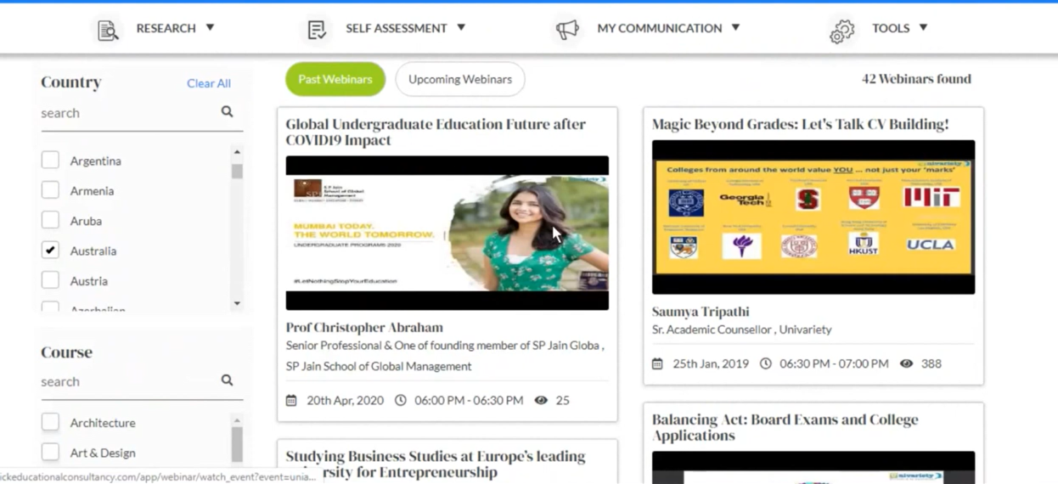

16. Module 13— Counsellor and Administration Suite
Give staff a complete view of student progress and operational workload.
Steps
• Counsellor logs in with authorized credentials.
• Create student accounts when direct registration is restricted.
• Search by name or email and filter by passing-out year or board.
• Open the student progress report.
• Review profile completion, assessment status, shortlist, and pending milestones.
• Export authorized data.
• Schedule appointments, attach files, and record notes.
Operational views
• Roster management, cohort statistics, profile completion, assessment monitoring, global search, reports, resource access, webinar library, appointment calendar, and secure exports.
Outputs
Updated student record, counsellor action plan, appointment record, progress report, and auditable staff activity.
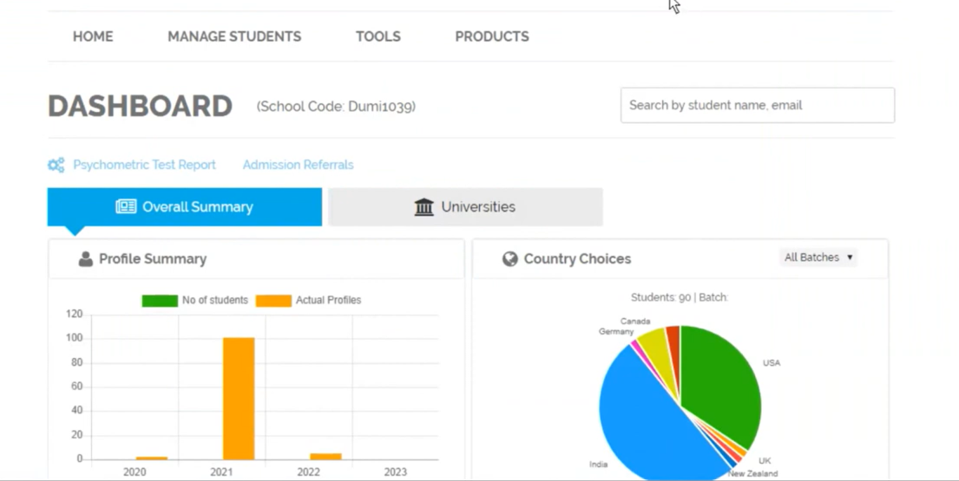

17.Module 14 — Manage Students
Counsellor can track every student details and track their classrooms and progress and assessment reports and data

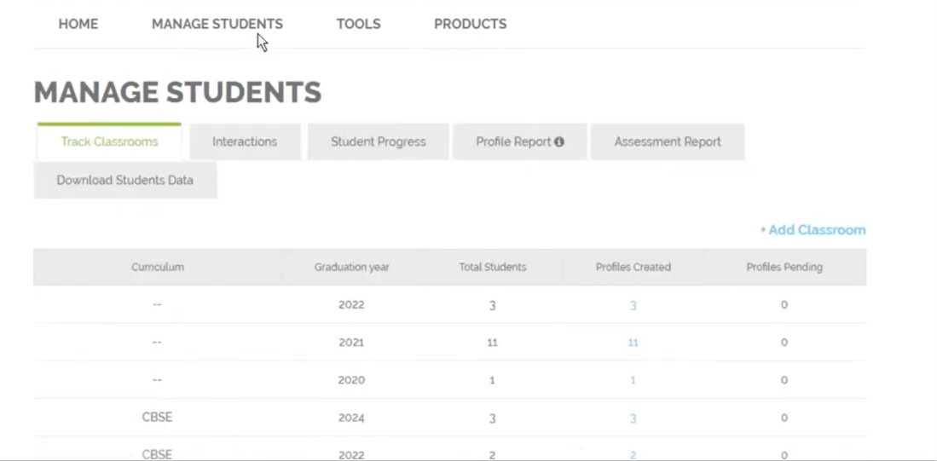
Assessment Reports
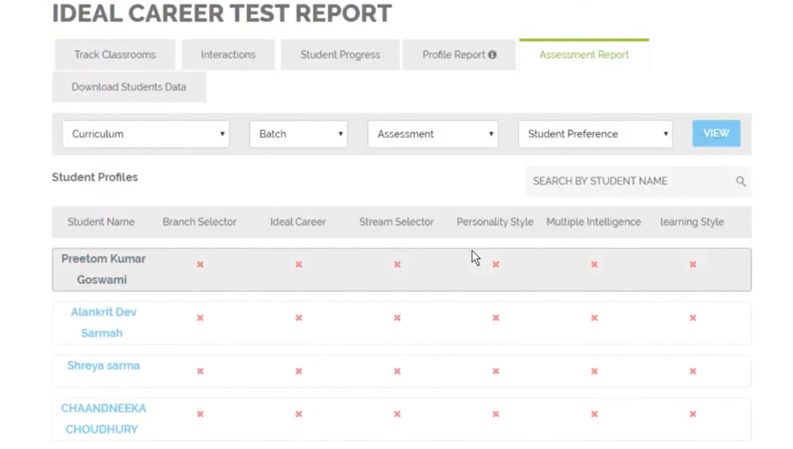
Profile Reports
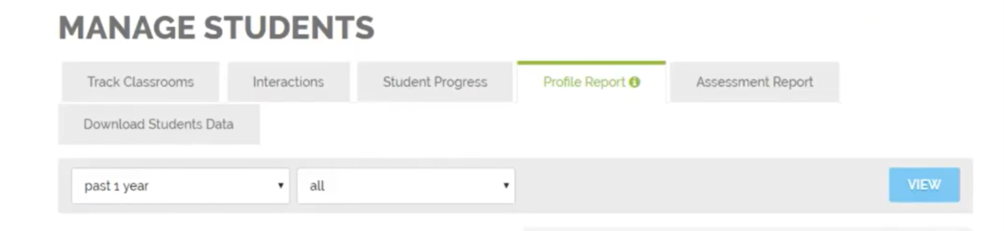

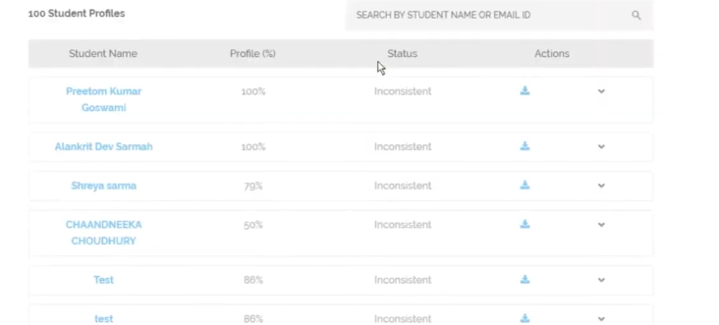

17. End-to-End Operational Workflow
Eight phases
• Phase 1: onboarding and profile intake.
• Phase 2: preference and academic portfolio.
• Phase 3: recommendations and fit review.
• Phase 4: institution research and shortlist.
• Phase 5: fees and scholarships.
• Phase 6: exam strategy and mock testing.
• Phase 7: assessment and career interpretation.
• Phase 8: counsellor appointment and application action plan.
Decision loop
If evidence is incomplete, the counsellor returns the student to profile updates, additional research, another assessment, or budget refinement before finalizing the action plan.
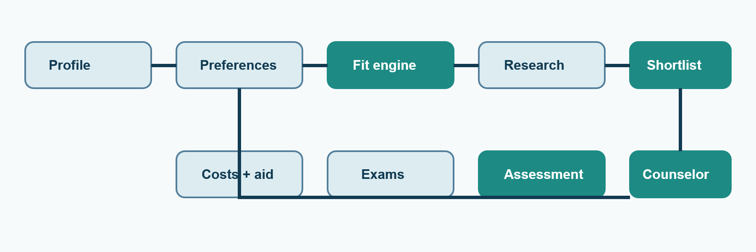

18. Reports, History, and Governance
Reports
Maintain profile history, recommendation decisions, scholarship and fee checks, exam status, assessment results, appointments, counsellor notes, and shortlist changes.
Freshness controls
Audit scholarships and deadlines, refresh currency or cost references, verify official links, and flag expired or outdated records.
Governance
Restrict access by role, log sensitive changes and downloads, preserve assessment versions, and provide authorized exports for operational planning.

19. Functional and Non-Functional Requirements
Functional
• Separate student and counsellor/admin accounts; profile validation; searchable catalogs; recommendations; scholarship filters; fee comparison; exam details; mock testing; assessment codes; shortlists; webinars; appointments; reports; and exports.
Non-functional
• Security, privacy, usability, responsiveness, reliability, performance, accessibility, auditability, data accuracy, data freshness, and scalable support for additional students, counsellors, destinations, and content.

20. Implementation Roadmap and Conclusion
Phase 1
Finalize requirements, roles, journeys, database entities, and access rules.
Phase 2
Build authentication, profile intake, preferences, and core dashboards.
Phase 3
Build discovery, fit categories, scholarships, fees, and exam guidance.
Phase 4
Build assessments, counsellor tools, appointments, reports, webinars, and exports.
Phase 5
Test security, recommendation logic, data freshness, accessibility, reliability, and recovery.
Conclusion
Superconsciousness connects student discovery, academic evidence, financial planning, assessments, and professional counselling into one traceable journey from profile creation to application action plan.

