SAI PRAKASH REDDY MARASANI

CIN:304378287and python and I

Course: CIS 562 Authorizing Websites

Instructor: Prof. Phillip Thomas

Date: August 31 2015

**PRAKASH INSIGHTS**

**GO BEYOND THE DATA**

Abstract

In the face of an ever-changing world, people, politicians, leaders, organizations are constantly facing new challenges undergoing profound change and being affected with controversies which they didn't do intentionally. Social media is so vast through which they can communicate with people same time some of the tweets or posts are creating controversies. Prakash Insights is a website developed for users ranging from students, leaders, politicians to analyze their tone of speech or message or tweet so that there will not be any controversy or misconception of speech or post. An attractive and easy-to-use interface for analyzing their tweets or speech or post just a click away. Users can go to prakashinsights.saiprakki.info and click on services where they can analyze their speech or post by clicking analyze button. So Prakash Insights is not a luxury it can be considered as a service or necessity. Our website was build on using JS. JSON, CSS, JADE ,WordPress and using Watson services.

Features of Prakash Insights

The Home page of the website looks like below

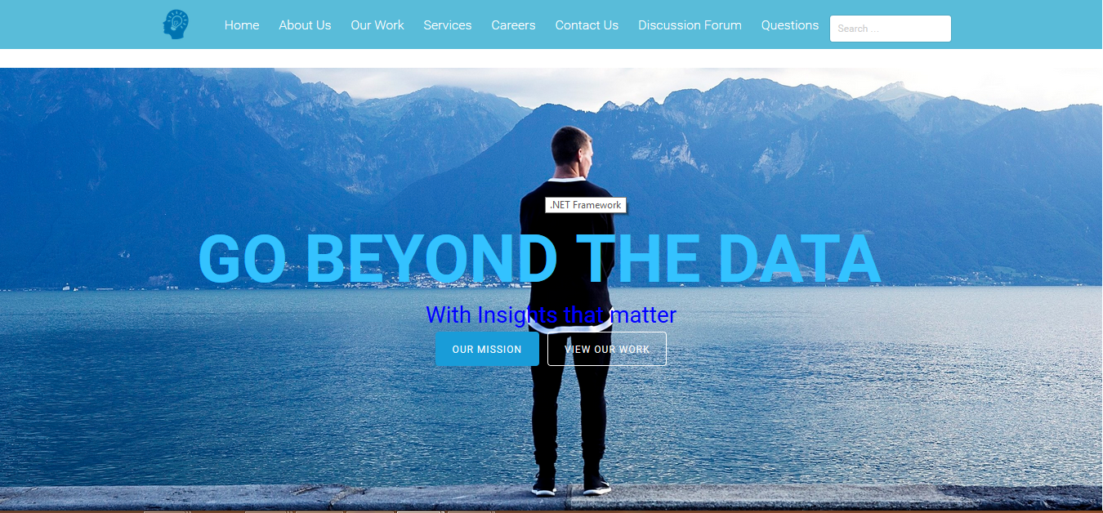

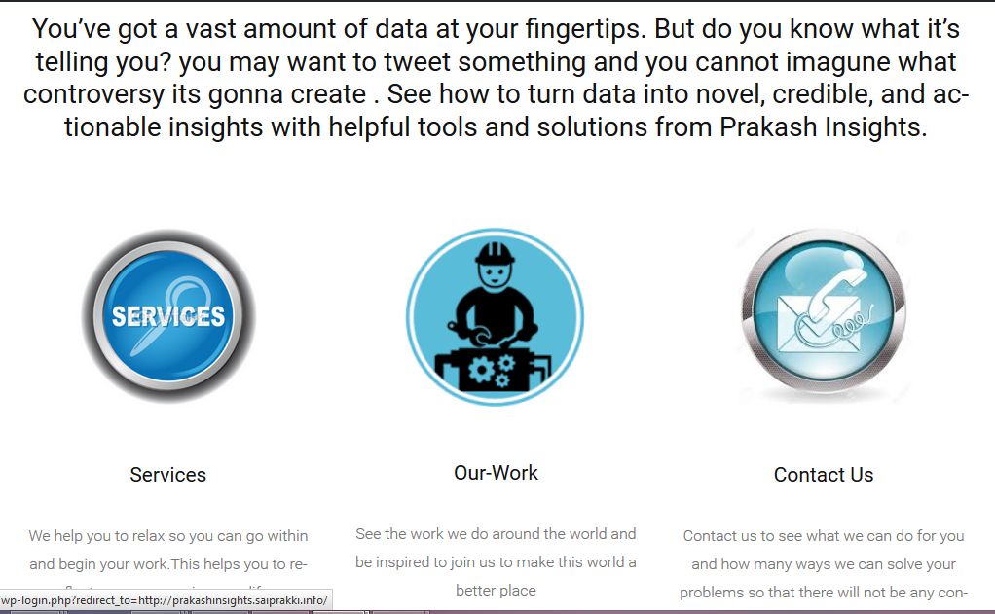

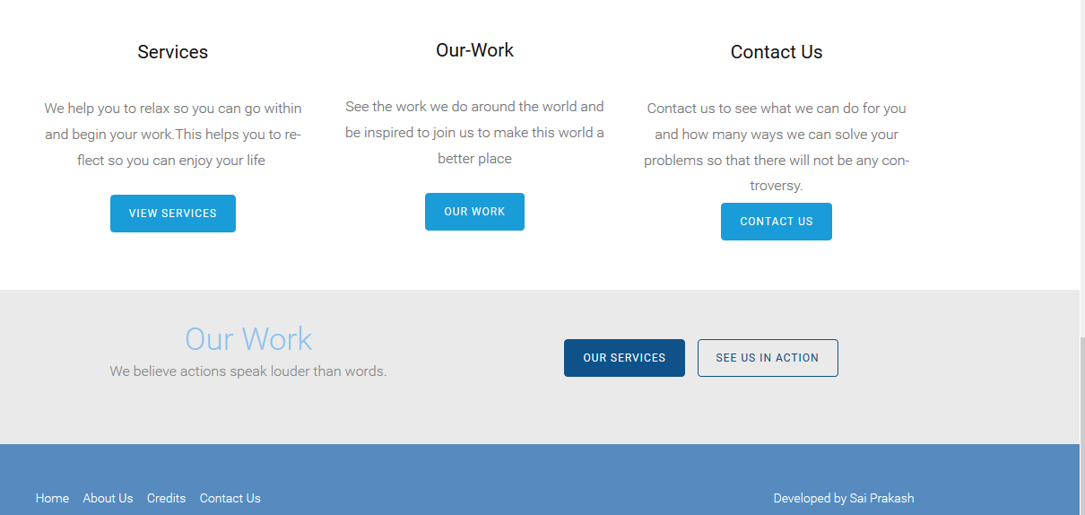

Apart from using Prakash Insights services , the website provides discussion forum so that any new or returning user can post their queries which are continously being monitored by our technical team and at same time if you post something someone will try to answer or explain your question.

There is a services tab in the navigation bar of the Prakash Insights website which opens up an nice interface offered at Prakash Insights where you should give an twitter ID and message and then click analyze.

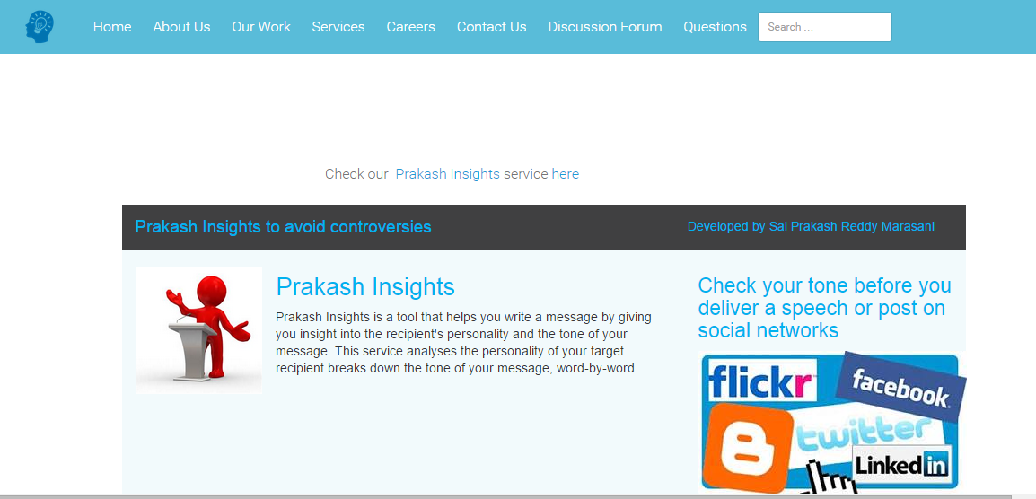

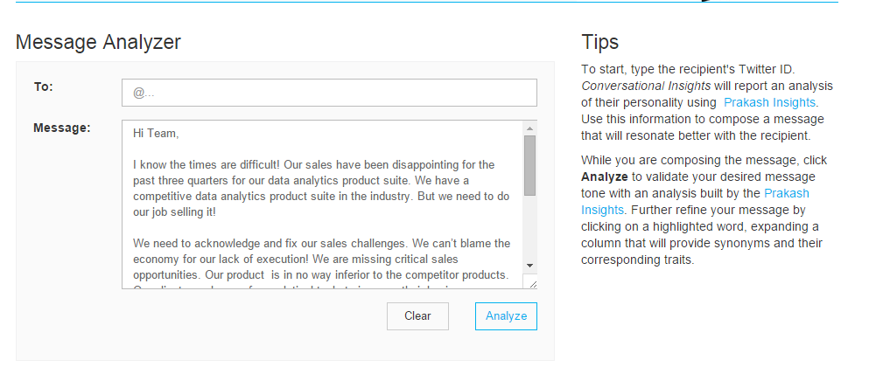

In message we will be providing an default one where an user can try or check our service.

There is a “Contact Us” page where information regarding emails addresses and phone numbers of all the staff working at Prakash Insights is available. Hence Users/Clients can contact Prakash Insights team members by visiting “Contact Us” section. You can also post your questions here where we will go through each and every question posted by users.

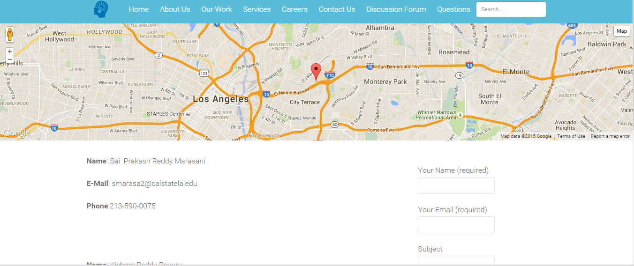

We also have an Careers page where users or any people who are interested working with us can post their resume.

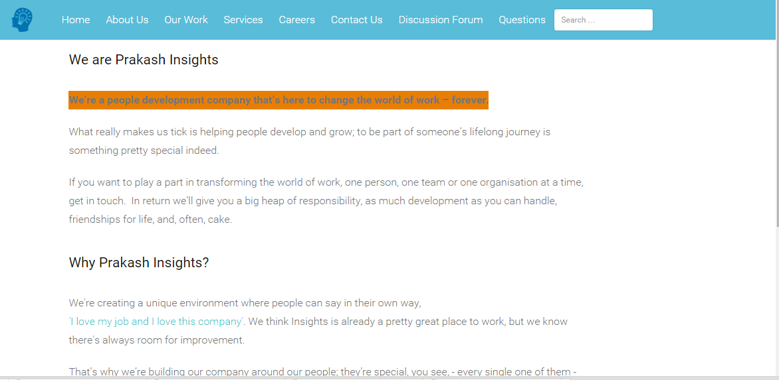

In About us page you can find information about developers. In ourwork page you can see comments from our users.

We have used OpenSSL to generate certificate and key to change the URL of Prakash Insights from Bluemix domain prakashinsights.mybluemi.net to custom domain [http://prakashinsights.ashu.saiprakki.info.](http://HelloDoctor.app.richricha.com.S)

Download and install the [Cloud-foundry](https://github.com/cloudfoundry/cli) from the following link:

<https://github.com/cloudfoundry/cli>

**Deploying application to Bluemix:**

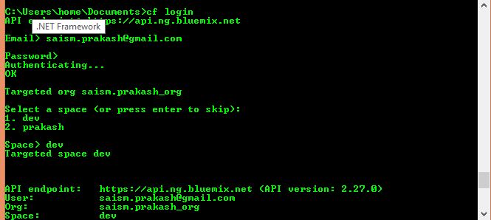

We have used Command Line Interface(cloud foundry) extensively from creating app to generation of ssl keys and running it on local host. First I have changed manifest.yml

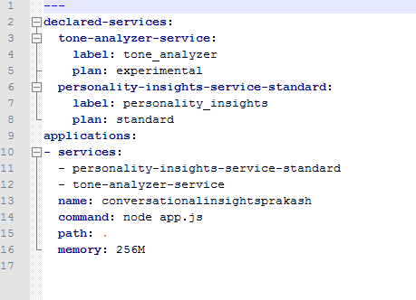

I created services from cloud foundry

 then I pushed those services using command cf push

To check environment variables use command cf env conversationalinsightsprakash

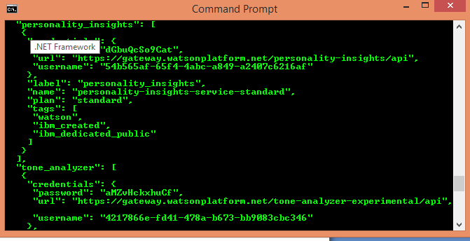

change them in app.js

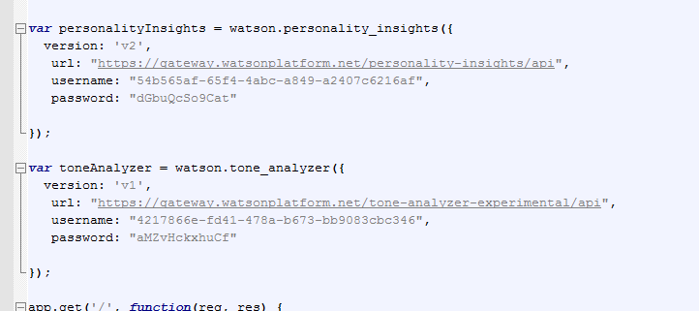

How to change URL from *.mybluemix.net to *prakashinsights.saiprakki.info using SSL

1. Download OpenSSL.
2. Open the path where OpenSSL has been installed. In my PC, openSSL is installed in the below cd OpenSSL\bin
3. Now enter the command🡪set OPENSSL_CONF=c:\OpenSSL\bin\openssl.cfg

openssl genrsa -des -out server.key 1024

1. Now enter phase key for server.key.
2. Now enter the command 🡪openssl req -new -key server.key -out server.csr
3. Now enter some details regarding country, state, instituition name
4. Now run the command🡪openssl genrsa 2048

openssl genrsa -out my-prvkey.pem 1024

1. Finally, the server.key and server.csr will be downloaded in C:\OpenSSL\bin.

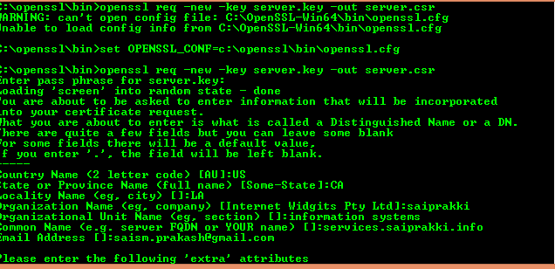

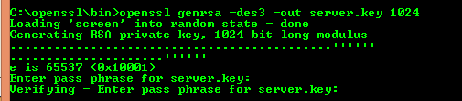

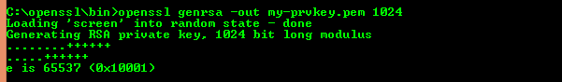



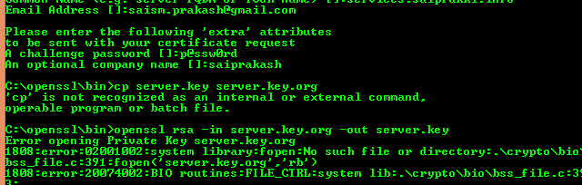

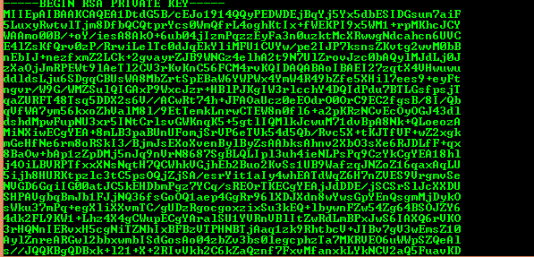

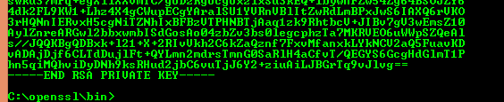

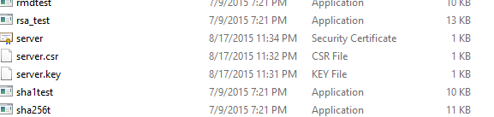

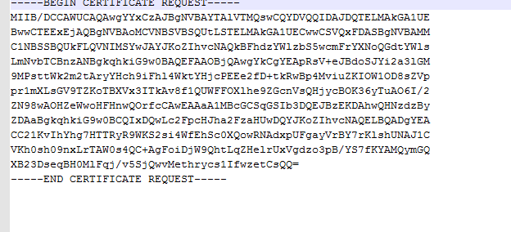

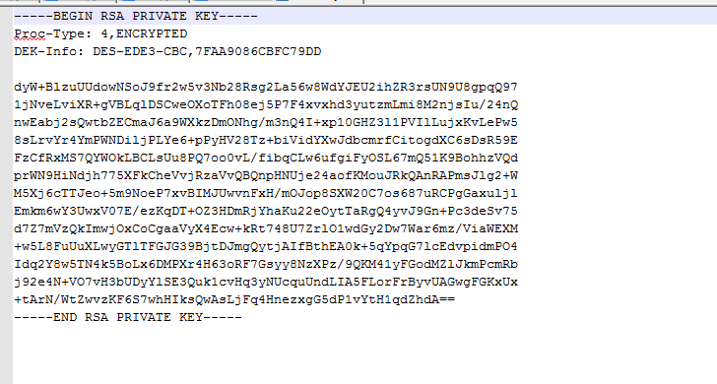

Configuring DNS for your custom domain

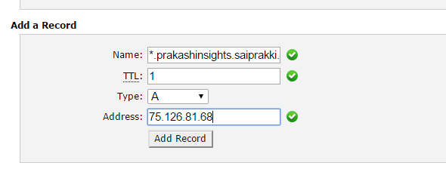

In order to change domain we need to create a domain with address

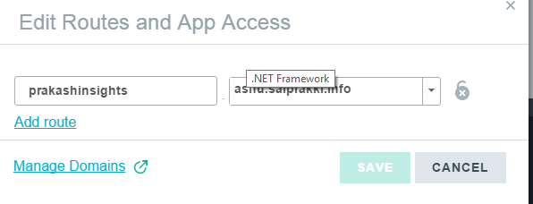

git hub code is showing errors (its not showing output which it is intended to)

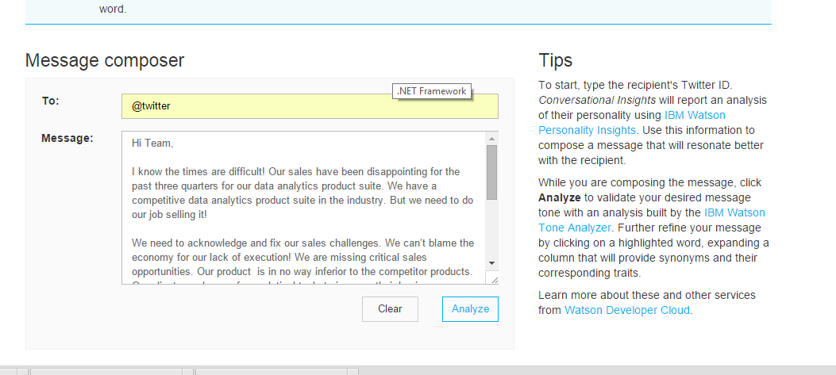

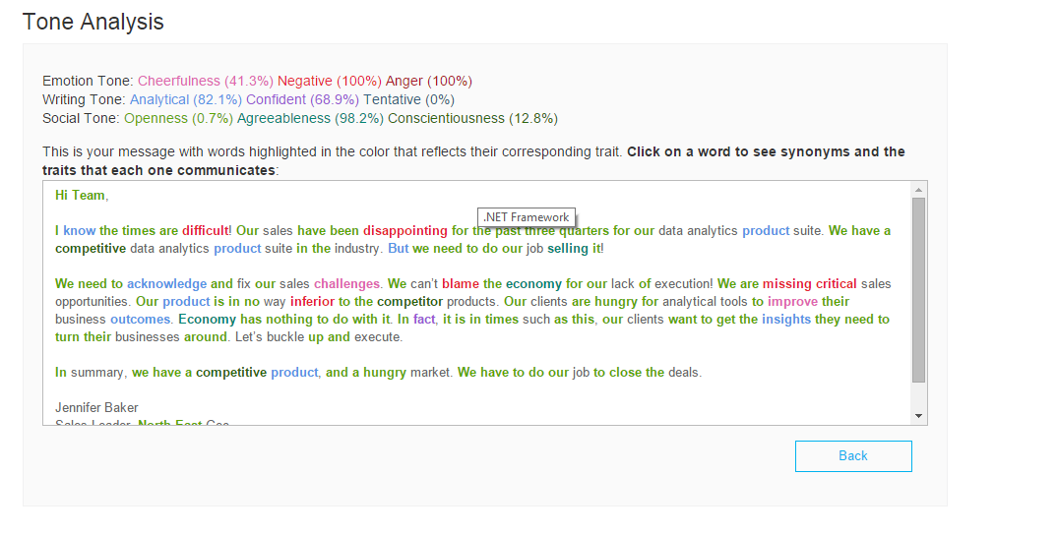

**Now lets see our code**

**Sample input and output:**

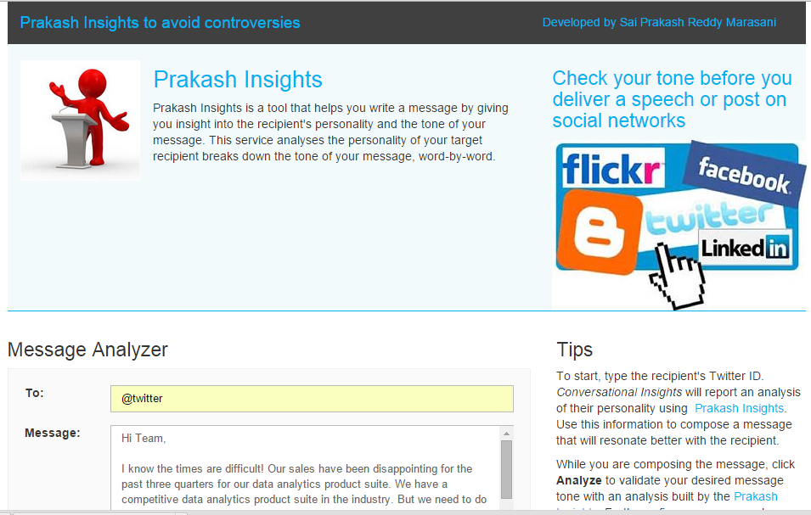

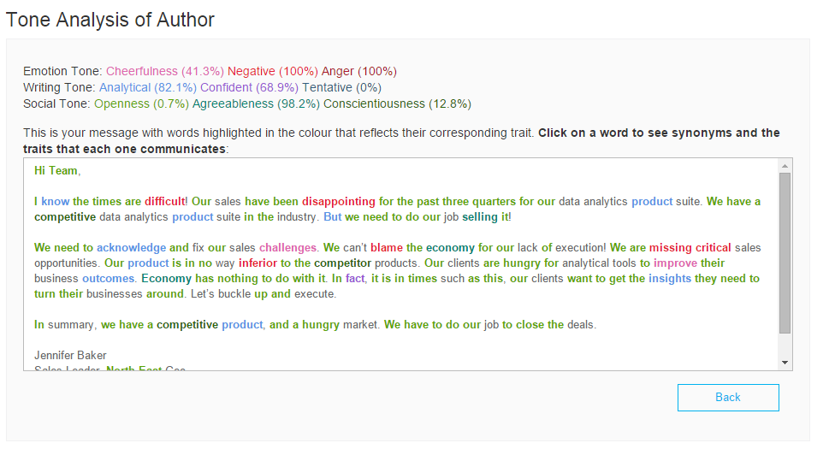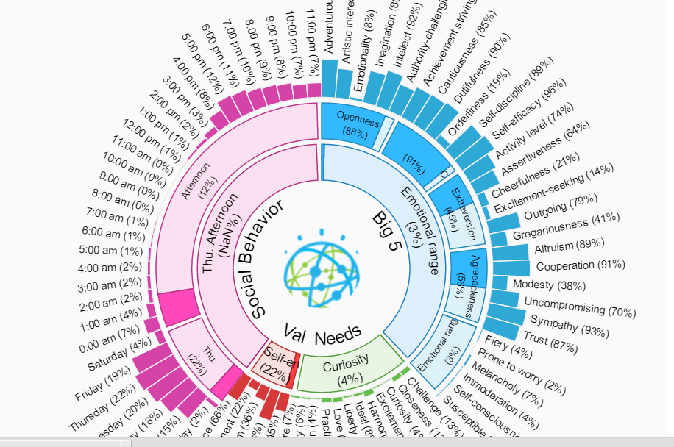

Conclusion

Prakash Insights is a website developed for users ranging from students, leaders, politicians to analyze their tone of speech or message or tweet so that there will not be any controversy or misconception of speech or post. An attractive and easy-to-use interface for analyzing their tweets or speech or post just a click away. While developing Prakash Insights I had lot of experience on coding and using cloud foundry and programming languages like java and python and I hope this meets users requirements.

**References**

1.https://github.com/watson-developer-cloud

2. https://dev.twitter.com/rest/public

3. https://dev.twitter.com/oauth/overview/application-owner-access-tokens

4. https://console.ng.bluemix.net/catalog/