5.Parent and Child
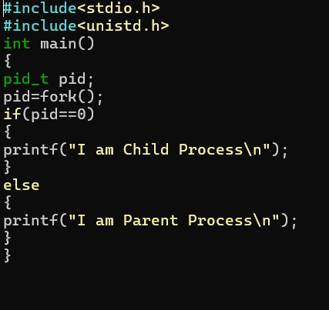
OUTPUT:
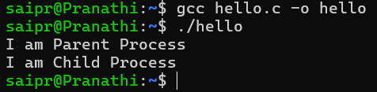
6.
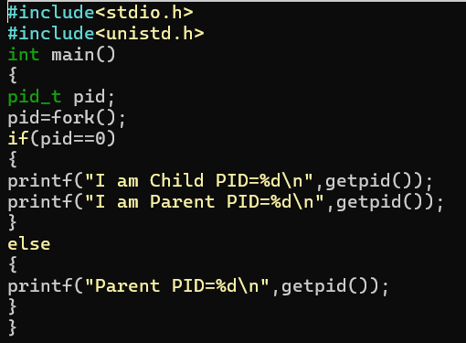
OUTPUT:
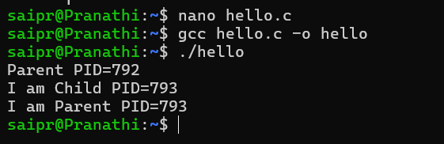
7.Wait
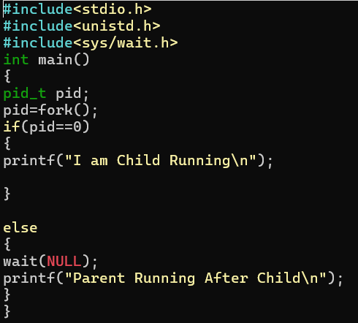
OUTPUT:
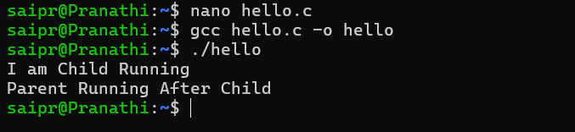
8.

