11. To Store Commands, Maintain History Buffer, Handle Capacity Limits, Retrieve Entries, Display History, Validate Consistency.
To Create Pipeline Structures, Store Commands, Maintain Execution Order, Connect Processes, Validate Pipeline Layout, Test Configurations.
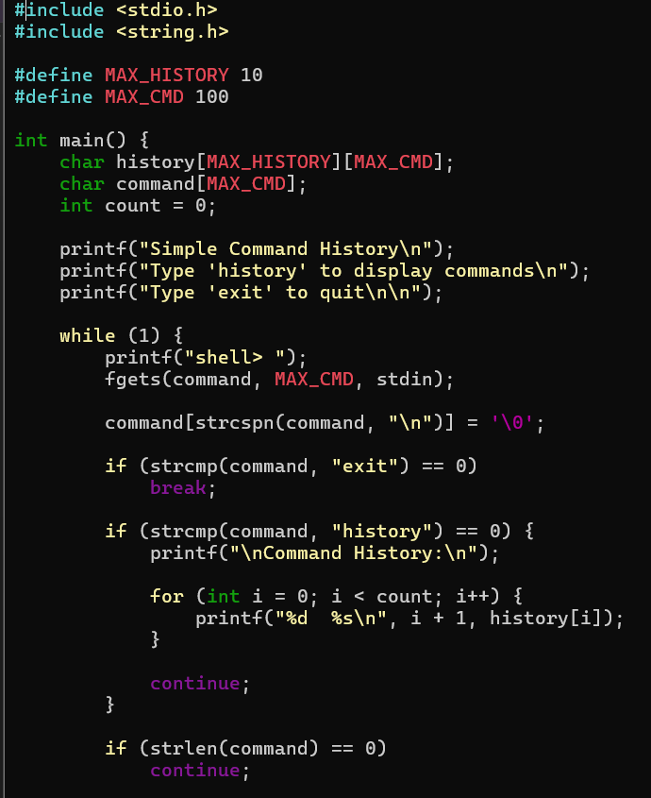
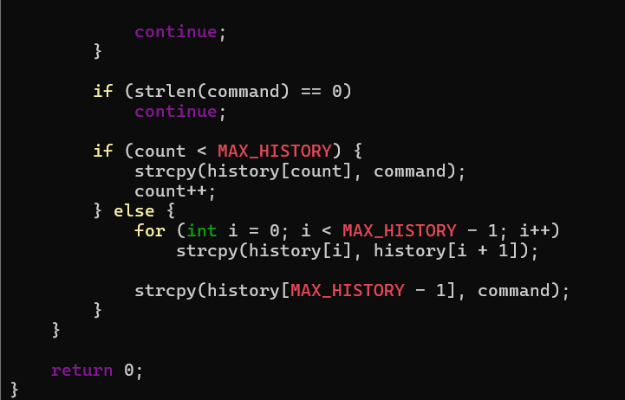
OUTPUT:
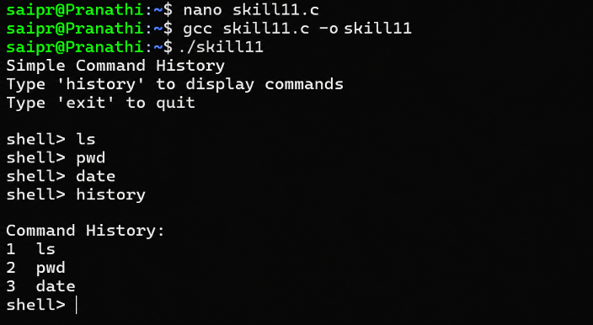
12. To Create Pipes, Redirect Streams, Execute Connected Commands, Close Descriptors, Synchronize Processes, Test Data Flow.
To Support Multiple Pipes, Manage Descriptor Arrays, Launch Multiple Processes, Coordinate Execution, Cleanup Resources, Test Long Pipelines.
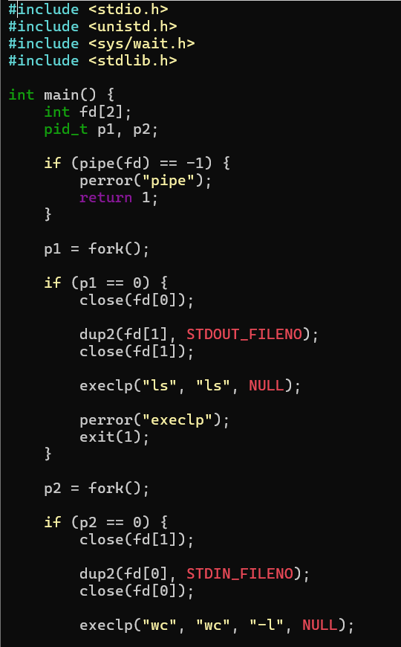
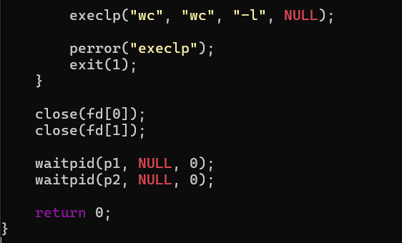
OUTPUT:
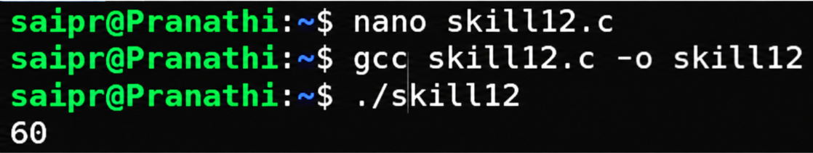
13.To Parse Input Redirection, Open Files, Redirect stdin, Handle Missing Files, Restore Streams, Test File Inputs.

To Parse Output Redirection, Create Output Files, Redirect stdout, Handle Permissions, Verify Output Data, Test Redirection.
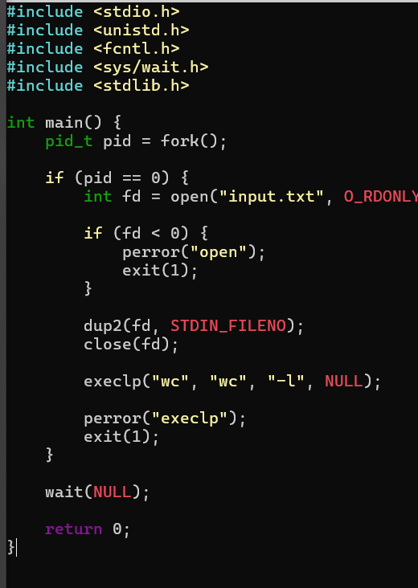
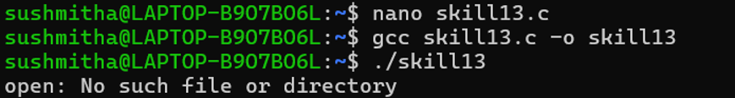
14. To Parse Append Operator, Open Files in Append Mode, Redirect Streams, Preserve Existing Data, Validate Appends, Test Scenarios.
To Parse stderr Redirection, Redirect Error Streams, Capture Error Output, Verify File Contents, Handle Failures, Test Error Cases.
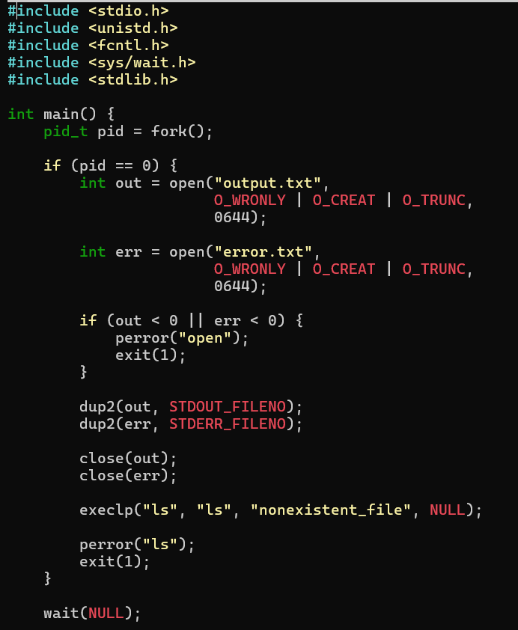
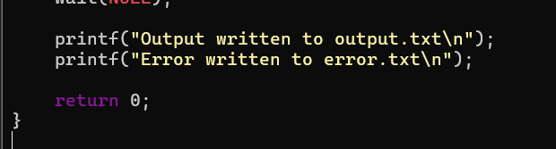
OUTPUT:
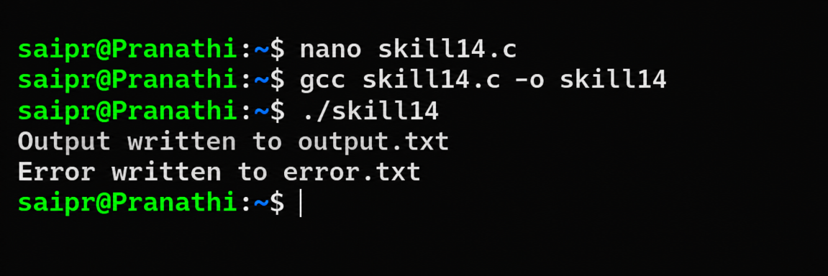
15. To Parse Combined Redirection, Duplicate File Descriptors, Merge Streams, Verify Ordering, Handle Edge Cases, Test Integrated Outputs.
To Parse Complex Commands, Combine Pipes and Redirections, Resolve Execution Order, Validate Syntax, Generate Execution Plans, Test Scenarios.
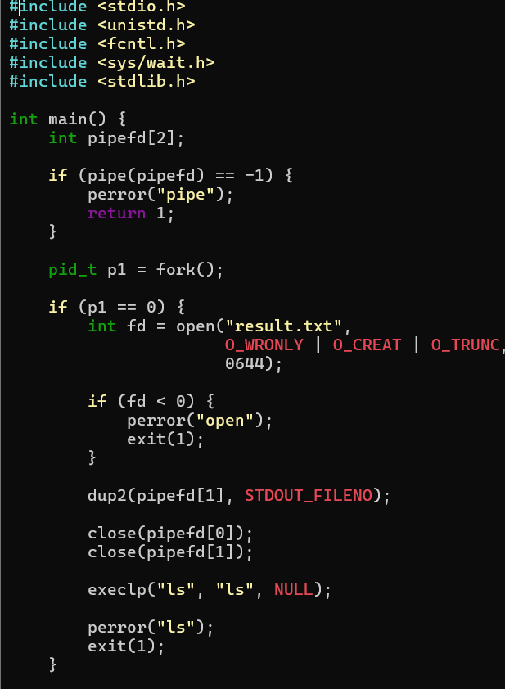
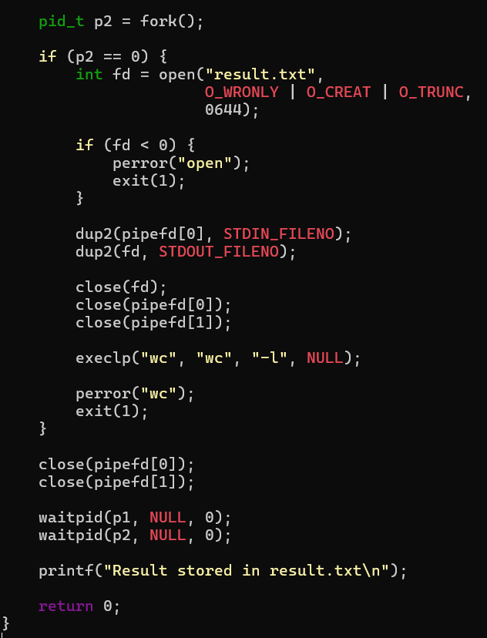
OUTPUT:
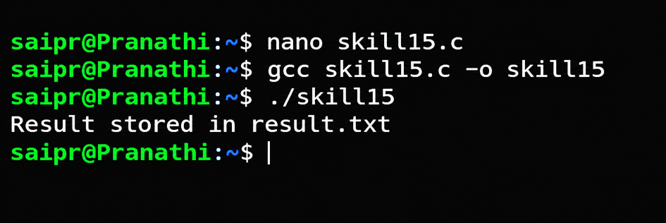
16. To Detect Background Jobs, Launch Non-Blocking Processes, Return Prompt Immediately, Store Job Information, Monitor Execution, Test Background Tasks.To Create Job Table, Store Process Groups, Track States, Update Status, Remove Completed Jobs, Validate Job Records.
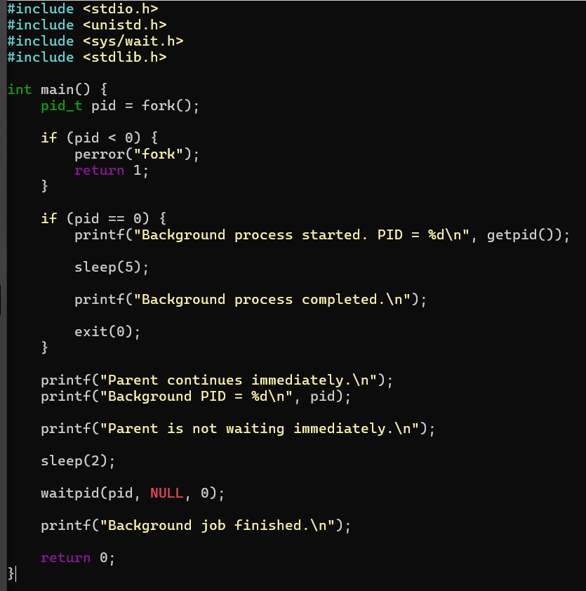
OUTPUT:
