Transcriptomic Analysis Reveals Ribosomal, Mitochondrial and ER-Associated Stress Signatures in Glucotoxic Human Podocytes
V Sai Pranav¹ and Prashantha C N¹*
¹ Department of Biotechnology, School of Applied Sciences, REVA University, Bengaluru, India
*Correspondence: Prashantha C N — prashantha@reva.edu.in

Abstract
Diabetic kidney disease (DKD) is one of the major complications in diabetic patients that occurs due to constant high glucose levels which subsequently causes damage to podocytes due to mitochondrial dysfunction, oxidative stress and imbalance in normal cellular activities[1,2]. Various studies have been done on pathways related to glucotoxicity, but very few studies have been made about transcriptional response of podocytes under high glucose level conditions[3,4], and it is not understood completely. In this paper, we have analysed publicly available RNA-seq data from human podocytes cultured under various glucose conditions (GSE307956) to understand and interpret gene expression changes according to various glucotoxic stress.
Our analysis helps us understand various transcriptomic changes that occur under high-glucose conditions, i.e., ribosomal activity, mitochondrial function, proteostasis, and endoplasmic reticulum (ER) function. Network and regulatory analysis helped in the analysis and identification of various hub genes and transcription factors that may cause damage to podocytes and metabolic changes. Among the altered genes, NOMO3 was marked as an important protein that was associated with endoplasmic reticulum dysfunction during the glucotoxic stress[5].

Overall, this study provides an overview of how high glucose levels damage podocytes' internal environment. Key pathways such as ER stress and ribosomal dysfunction are pinpointed as they act as early and critical drivers in the progress of diabetic kidney disease[6,7].

Keywords: RNA-seq; podocyte; diabetic kidney disease (DKD); transcriptomics; glucotoxicity; NOMO3; endoplasmic reticulum (ER) stress; ribosomal dysfunction; transcription factors; STRING network analysis.

1. Introduction
Diabetic kidney disease (DKD) is a leading cause of chronic kidney disease and end-stage renal failure worldwide[6,7].
Persistent hyperglycaemia drives DKD progression through oxidative stress, mitochondrial dysfunction, inflammatory signalling, proteostasis imbalance and large-scale transcriptional reprogramming[8,9]. Podocytes, highly specialised epithelial cells of the glomerular filtration barrier, are particularly vulnerable to glucotoxic injury. Their dysfunction and loss contribute directly to proteinuria, glomerulosclerosis and progressive renal decline. Although several glucotoxic signalling pathways have been characterised, the integrated transcriptomic response of podocytes to sustained high-glucose exposure remains incompletely understood.
RNA sequencing (RNA-seq) and modern bioinformatics approaches provide powerful tools for investigating disease-associated transcriptional alterations. Differential expression frameworks such as DESeq2[1] enable robust identification of differentially expressed genes (DEGs), while over-representation analysis (ORA)[2], Gene Set Enrichment Analysis (GSEA)[3], protein–protein interaction (PPI) network analysis[17] and transcription factor (TF) activity inference[18,19] facilitate systems-level interpretation of coordinated biological responses. Previous studies have implicated mTORC1 hyperactivation[10–12], ER stress and immune-inflammatory signalling in DKD progression[13]; however, the relationships linking glucotoxic stress with ribosomal dysfunction, ER membrane integrity and podocyte dedifferentiation remain poorly characterised.
In the present study, we performed a comprehensive secondary bioinformatics analysis of RNA-seq data from human podocytes cultured under high-, medium- and normal-glucose conditions (GSE307956). Our objectives were to characterise the global transcriptional response to high-glucose, identify conserved core gene signatures, define enriched biological pathways, identify key regulatory hubs and transcription factor programmes, and validate major findings using independent human DKD transcriptomic data[16]. This integrated analytical framework revealed coordinated activation of ribosomal, mitochondrial, proteostatic and ER stress-associated programmes alongside suppression of transcriptional regulators essential for podocyte identity.

2. Materials and Methods

2.1 Dataset Collection and Quality Assessment
Raw RNA-seq count data were obtained from the Gene Expression Omnibus database under accession GSE307956. The dataset, generated by Tian et al.[14], included human podocytes cultured under high-glucose (30 mM), medium-glucose (15 mM) and normal-glucose (5.5 mM) conditions, with three biological replicates per group (n = 9). Data processing and analysis were performed in R[25].
Variance-stabilising transformation (VST) was applied before quality assessment. Principal component analysis (PCA), sample-distance heatmaps and hierarchical clustering were used to evaluate sample grouping, replicate consistency and potential outliers. The overall workflow used in this study is summarised in Figure A.
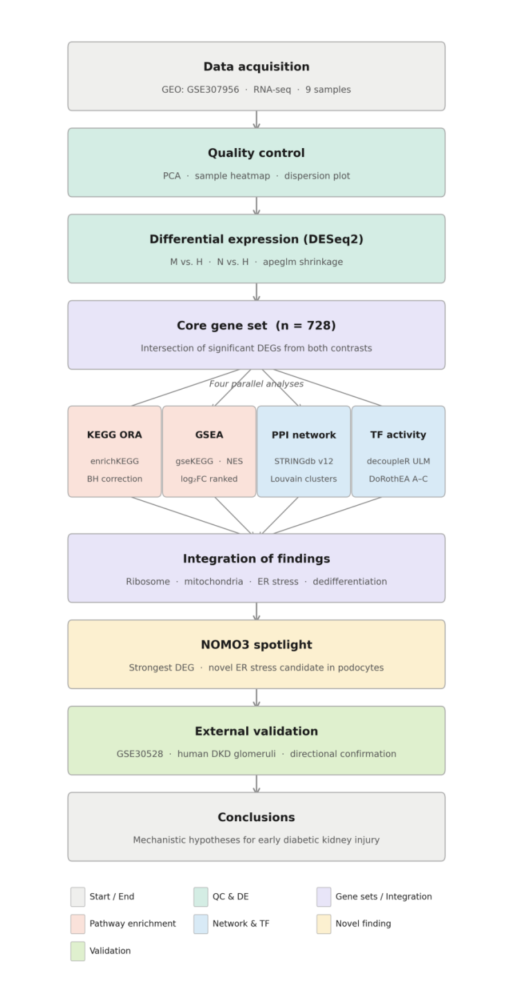
Figure A. Overview of the bioinformatics analytical workflow from RNA-seq data retrieval (GSE307956) through differential expression analysis, enrichment analysis, protein–protein interaction network analysis, transcription factor activity inference and external validation using human DKD transcriptomic data (GSE30528).

2.2 Differential Expression and Core Gene Identification
Differential expression analysis was performed using DESeq2[1]. Two comparisons were analysed: medium-glucose versus high-glucose (M vs. H) and normal-glucose versus high-glucose (N vs. H). Genes with adjusted p-values < 0.05 and |log₂FC| > 0.5 were considered significantly differentially expressed. Log2 fold changes were shrunk using the apeglm method.
Significant genes shared between both contrasts were intersected to generate a conserved core gene set. Volcano plots were generated using the ggplot2 package.

2.3 Functional Enrichment and Network Analysis
Functional enrichment analysis was conducted using clusterProfiler[2]. Gene Ontology (GO) and KEGG pathway analyses[4,5] were performed to identify significantly enriched biological pathways. Gene Set Enrichment Analysis (GSEA)[3] was additionally carried out using ranked log₂ fold change values from the M vs. H comparison.
Protein–protein interaction (PPI) networks were constructed using STRINGdb[17], and network topology analysis was performed with the igraph package. The transcript LOC102723728 was further annotated as NOMO3, and a dedicated interaction network was generated to investigate its molecular context.

2.4 Transcription Factor Analysis and External Validation
Transcription factor (TF) activity analysis was performed using the decoupleR package with the DoRothEA regulon database[18,19]. TFs with adjusted p-values < 0.05 were considered significantly altered.
External validation was conducted using the GSE30528 dataset[16], which contains glomerular transcriptomic data from DKD patients and healthy controls. Differential expression analysis was performed to assess whether key hub genes identified in the primary analysis showed similar expression patterns in independent human DKD tissue data.

3. Results

3.1 Quality Control and Sample Separation
PCA of VST-normalised counts showed clear separation of the three glucose conditions, with PC1 accounting for approximately 87% of total transcriptomic variance (Figure 1A). High-glucose samples (H1–H3) clustered in the lower-left region (PC1: ∼−13 to −12), medium-glucose samples (M1–M3) in the upper-right quadrant (PC1: ∼+9 to +11), and normal-glucose samples (N1–N3) in the lower-right region (PC1: ∼0 to +5), confirming that glucose condition is the dominant driver of transcriptomic variation.

Sample-distance heatmap analysis confirmed strong within-group clustering and clear inter-group separation (Figure 1B). H-group samples formed a tight, highly similar cluster; M-group samples constituted a distinct second cluster; and N-group samples showed intermediate within-group variance. Dispersion analysis confirmed appropriate shrinkage behaviour and adequate model fit (Figure 1C).

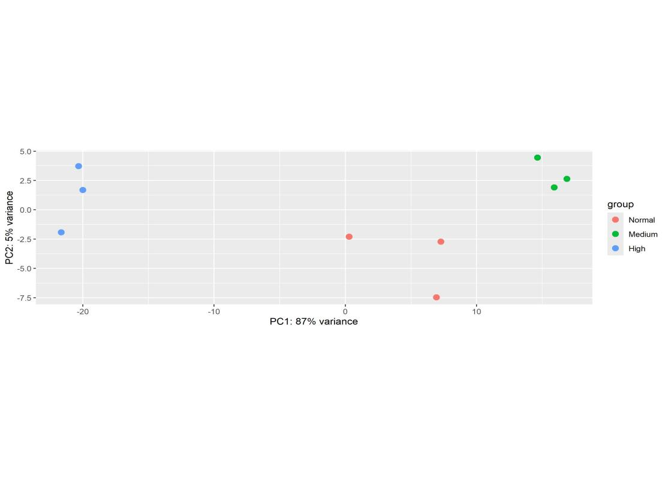
Figure 1A. Principal component analysis (PCA) of variance-stabilised transcriptomic profiles from human podocyte samples. The three glucose conditions (H = high glucose, M = medium glucose, N = normal glucose) are resolved along PC1, which accounts for 87% of total transcriptomic variance. Salmon = high glucose; green = medium glucose; blue = normal glucose.
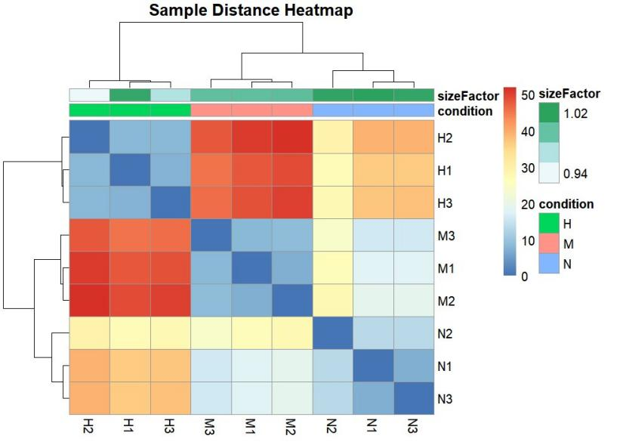
Figure 1B. Sample-distance heatmap based on Euclidean distances of VST-normalised counts. Hierarchical clustering correctly resolves all three glucose conditions.
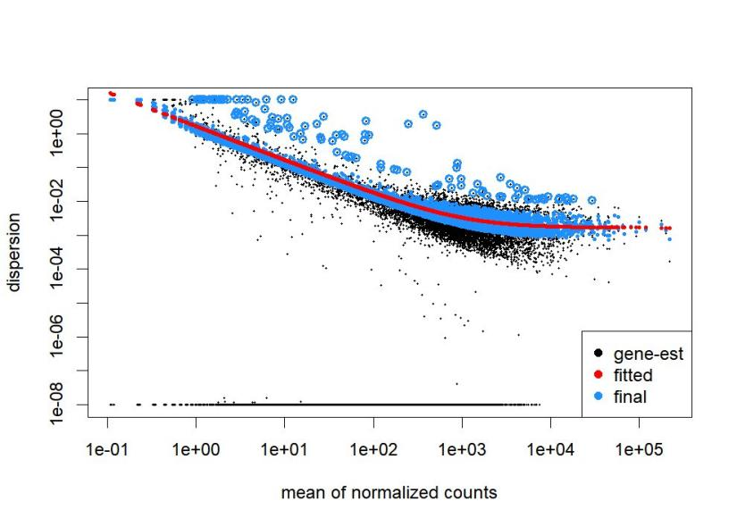
Figure 1C. DESeq2 dispersion plot. Black dots: per-gene dispersion estimates; red line: fitted parametric trend; blue circles: final shrinkage-adjusted dispersions. The characteristic mean–dispersion relationship confirms appropriate model fitting.

3.2 Differential Expression Analysis
Both pairwise contrasts yielded substantial numbers of statistically significant DEGs (Figures 2A–2D). Volcano plot analysis of the M vs. H contrast (Figure 2A) revealed a pronounced asymmetry, with considerably more genes upregulated under medium-glucose conditions than under high-glucose, consistent with broad transcriptional suppression driven by chronic hyperglycaemia. MA plots (Figures 2C–2D) confirmed appropriate dispersion of significant genes across mean expression levels in both contrasts.

The transcript corresponding to NOMO3 (Nodal Modulator 3; formerly annotated as LOC102723728) exhibited a –log₁₀(adjusted p-value) exceeding 250—far surpassing every other feature—alongside marked expression changes across all glucose conditions. This signal was consistent in both glucose-reduction contrasts.
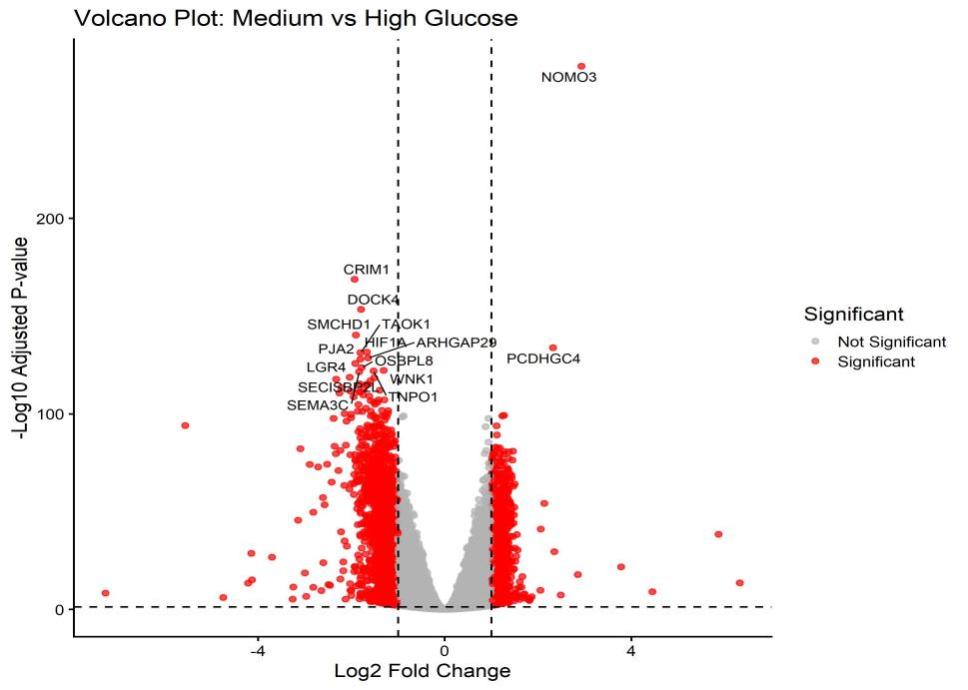
Figure 2A. Volcano plot of differential expression for the M vs. H contrast. Red dots: significant DEGs (|log₂FC| > 0.5, p.adj < 0.05); grey dots: non-significant genes. The highest-ranked transcript (NOMO3) is labelled.
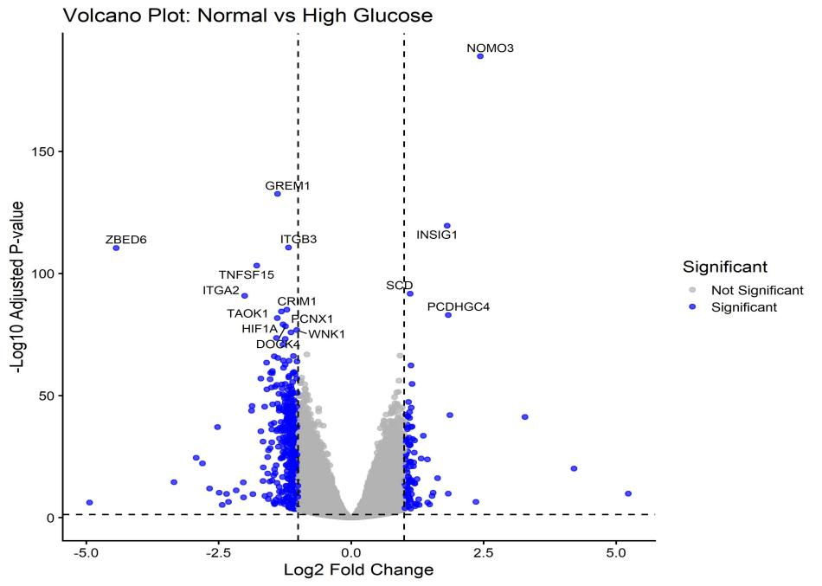
Figure 2B. Volcano plot of differential expression for the N vs. H contrast. Blue dots: significant DEGs; grey dots: non-significant genes. Significance thresholds are identical to Figure 2A.
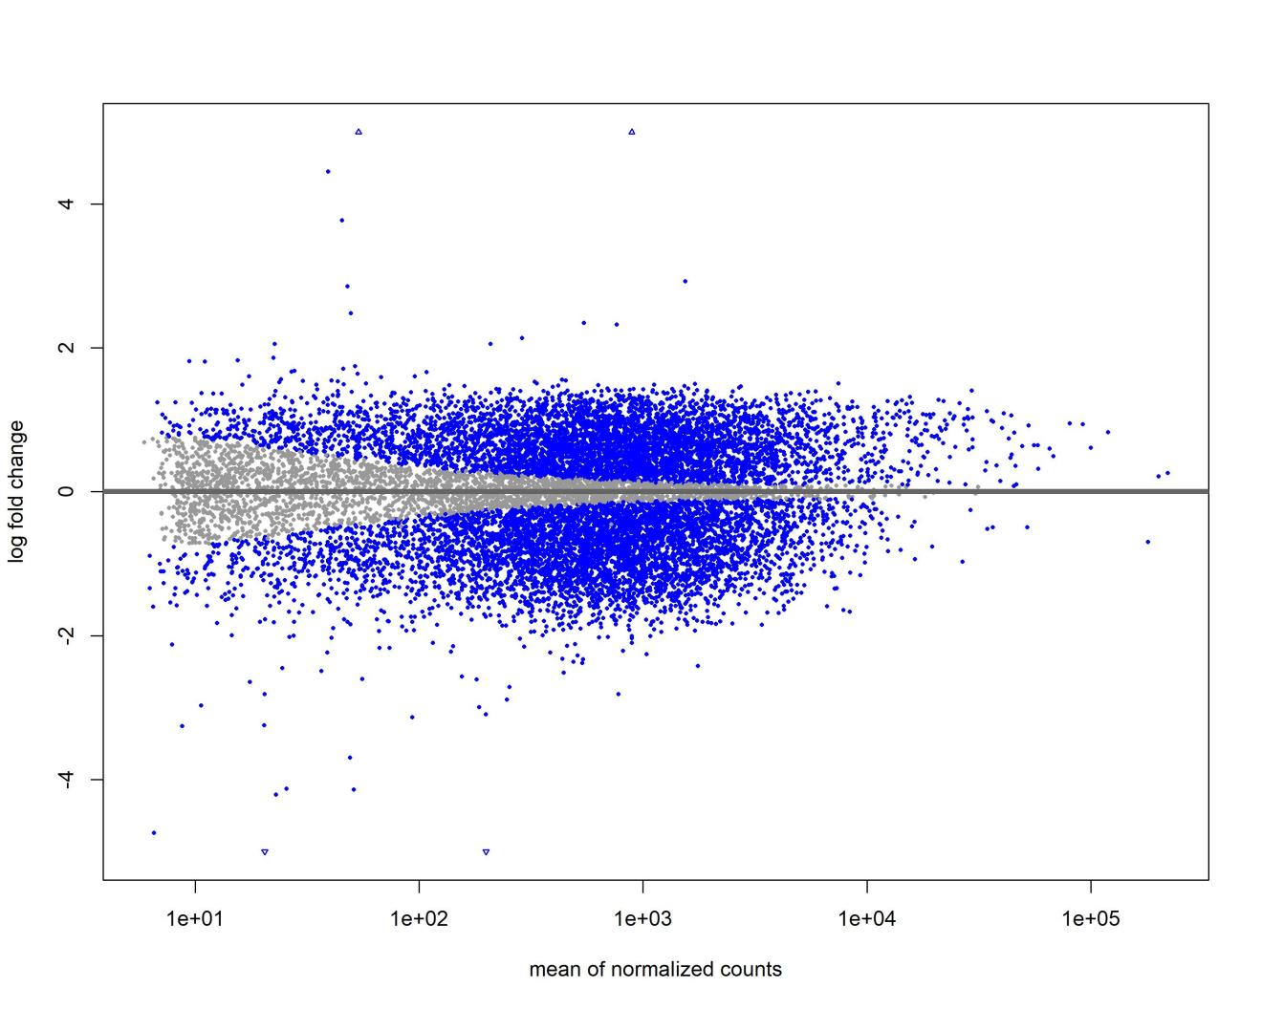
Figure 2C. MA plot (mean expression vs. log2 fold change) for the M vs. H contrast. Blue dots: significant DEGs (padj < 0.05, |log2FC| > 0.5); grey dots: non-significant genes. Triangles indicate genes with extreme fold changes beyond the displayed axis range.
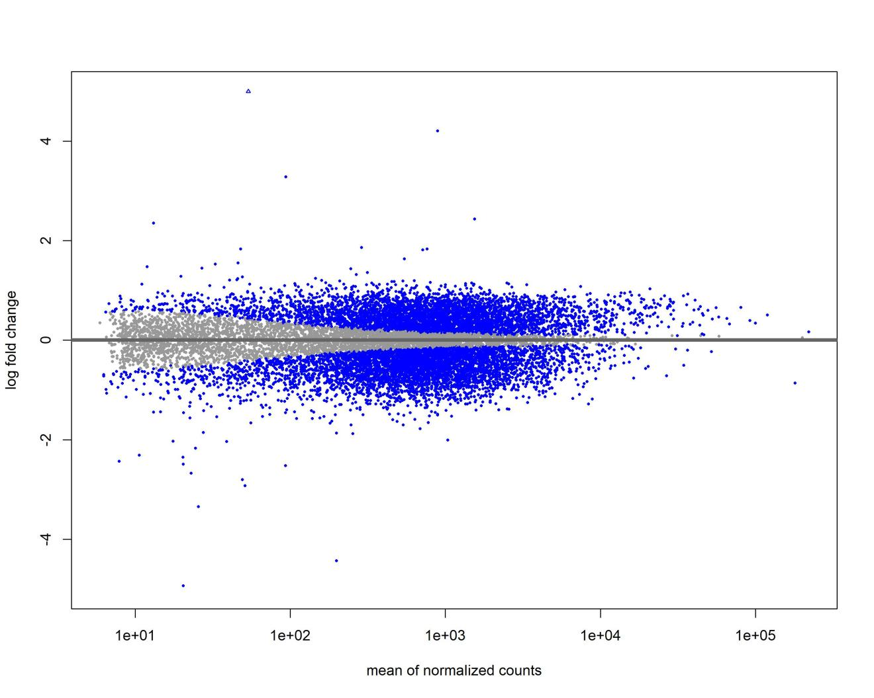
Figure 2D. MA plot for the N vs. H contrast. Blue dots: significant DEGs; grey dots: non-significant genes. Compared to the M vs. H contrast, fewer significant genes are observed, consistent with the lower number of DEGs (517 vs. 2,619).

3.3 Core Gene Set and Expression Heatmap
A robust consensus gene set was obtained by taking the intersection of significant DEGs from both glucose-reduction contrasts, yielding 728 transcripts consistently altered under high-glucose conditions. Heatmaps of the top 20 significant DEGs in the M vs. H contrast (Figure 3) display row-normalised VST expression values across all nine samples.

Two distinct expression clusters were apparent. The first comprised genes most strongly suppressed by high glucose, of which NOMO3 was by far the most prominent (padj < 1×10⁻²⁵³), followed by PCDHGC4. The second, larger cluster contained genes strongly expressed under high glucose that decreased progressively under medium and normal glucose, including HIF1A, TAOK1, CRIM1, DOCK4, IGF2BP3, PJA2, SMCHD1, ARHGAP29, WNK1, SEMA3C, DDX3X, KIF5B, ACTR2, ATAD2, LGR4, OSBPL8, TNPO1 and SECISBP2L. The near-parallel expression profiles of medium- and normal-glucose samples suggest that the observed transcriptomic shifts represent a threshold-bound glucotoxic response rather than a linear, dose-dependent effect. Specifically, the upregulation of NOMO3 and PCDHGC4 under medium and normal glucose—relative to their suppression under high glucose—implicates these genes in ER membrane integrity and cellular adhesion, respectively, both of which are compromised by glucotoxic stress.
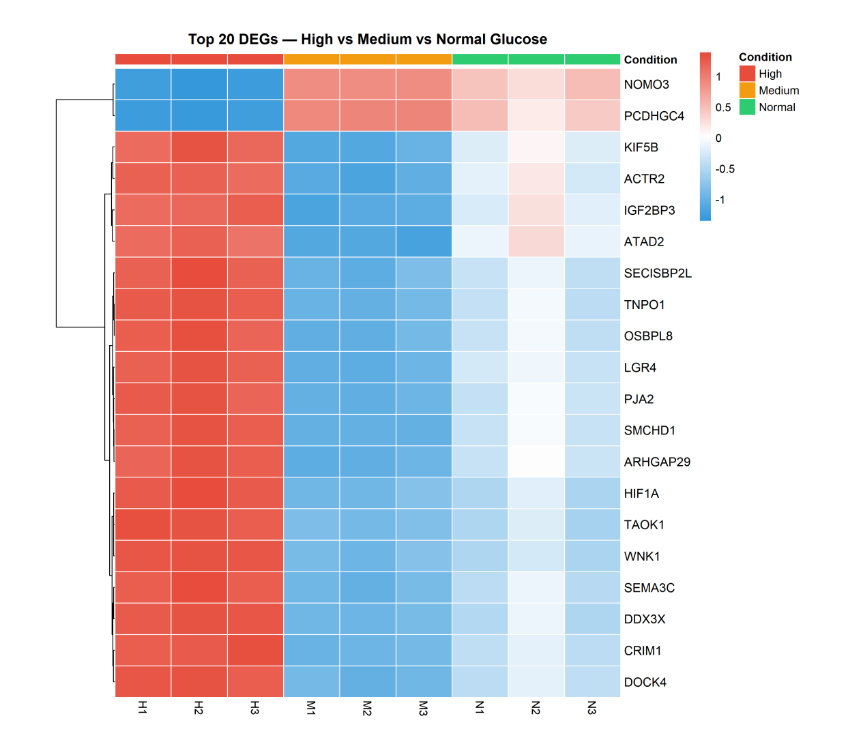
Figure 3. Heatmap of the top 20 differentially expressed genes from the M vs. H contrast across all nine samples. Row-normalised VST expression values are displayed (red = high expression, blue = low expression). Gene rows are hierarchically clustered; sample columns are ordered by condition. H = high glucose; M = medium glucose; N = normal glucose. NOMO3 (formerly annotated as LOC102723728) is the most significantly differentially expressed gene (padj < 1×10⁻²⁵⁰).

3.4 KEGG Pathway Over-Representation Analysis
KEGG ORA of the 728 core genes identified 15 significantly enriched pathways (adjusted p-value < 0.05; Figure 4). The Ribosome pathway exhibited the highest GeneRatio (∼0.76) and the smallest adjusted p-value (< 1 × 10⁻⁷), indicating that approximately 76% of KEGG-annotated ribosomal genes were present in the core set—a striking enrichment consistent with broad activation of the translational machinery under high-glucose conditions[10,11]. Oxidative phosphorylation (GeneRatio ∼0.69, p.adj < 1 × 10⁻⁷) and Proteasome (GeneRatio ∼0.70) were also highly enriched, indicating coordinated perturbation of mitochondrial energy metabolism and protein quality control. Disease-associated pathways—including Parkinson disease, Huntington disease and diabetic cardiomyopathy—were also significantly enriched, most likely reflecting substantial mechanistic overlap with mitochondrial dysfunction and oxidative stress[8,9] rather than direct disease involvement.
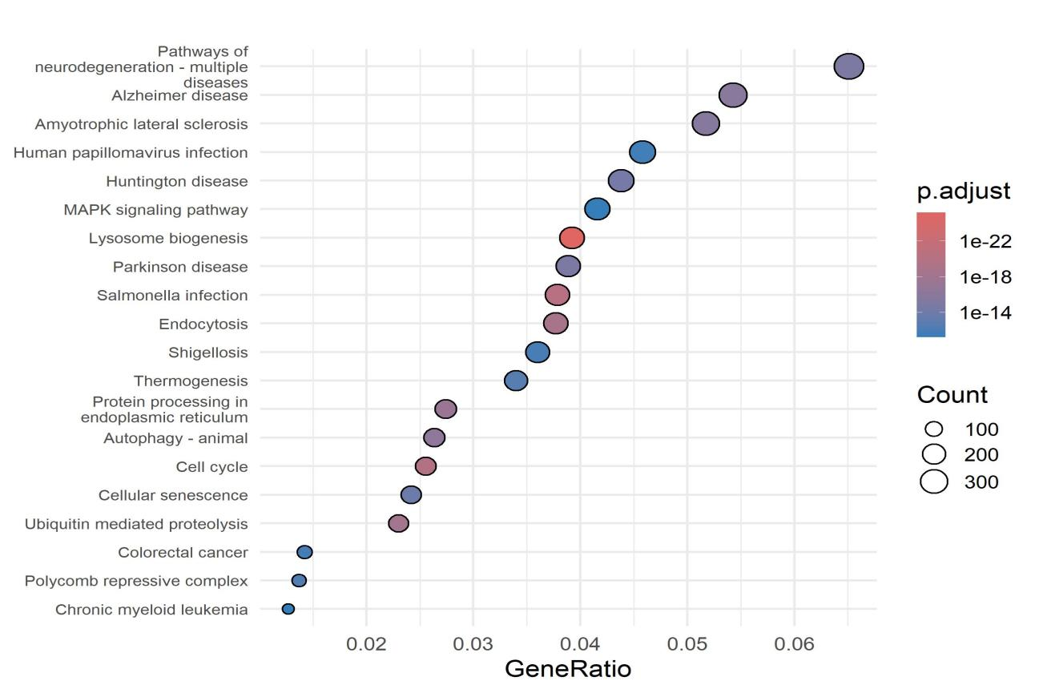
Figure 4. KEGG pathway over-representation analysis (dot plot) of the 728-gene core signature. The x-axis represents GeneRatio (proportion of pathway genes present in the core set). Dot size: number of core genes in the pathway; dot colour: Benjamini–Hochberg adjusted p-value. Only pathways with p.adj < 0.05 are shown.
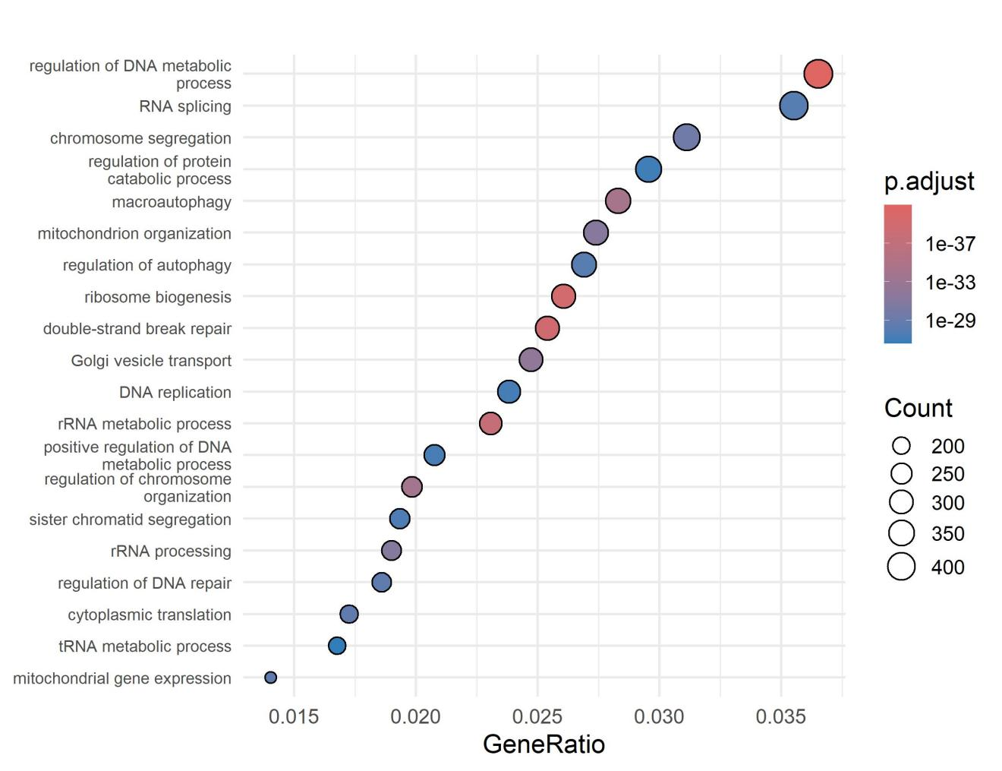
Figure 4B. Gene Ontology (GO) biological process over-representation analysis (dot plot) of the 728-gene core signature. The x-axis represents GeneRatio. Dot size: number of core genes; dot colour: Benjamini-Hochberg adjusted p-value. Top 20 enriched GO terms are shown.
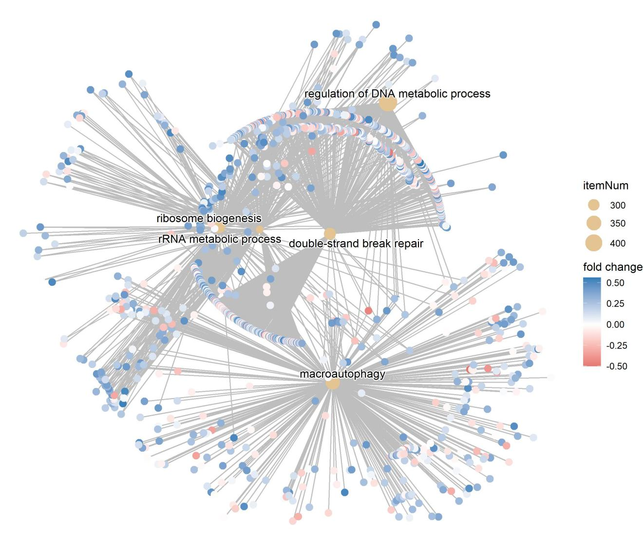
Figure 4C. GO biological process enrichment network (cnetplot) visualising the relationship between enriched GO terms and their associated core genes. Hub nodes (tan) represent GO pathways; peripheral nodes represent individual genes coloured by log2 fold change. Grey edges link genes to their associated pathways.

3.5 Gene Set Enrichment Analysis (GSEA)
Pre-ranked GSEA confirmed coordinated activation of ribosomal and mitochondrial pathways under high-glucose conditions (Figures 5A–5C). Among all pathways tested, the Ribosome pathway returned the highest normalised enrichment score (NES) and the lowest adjusted p-value (p.adj < 1 × 10⁻⁸). Oxidative phosphorylation, Parkinson disease, Staphylococcus aureus infection, Coronavirus disease and Prion disease pathways were also significantly enriched, with adjusted p-values ranging from 1 × 10⁻⁷ to 1 × 10⁻⁶.

The GSEA dot plot (Figure 5A) summarises enriched pathways ranked by GeneRatio and significance. The ridge plot (Figure 5B) illustrates NES distributions per pathway: the Ribosome and Oxidative phosphorylation pathways displayed narrow unimodal distributions, consistent with coherent and coordinated gene regulation, whereas Staphylococcus aureus infection showed a broader multimodal pattern. Together, the ORA and GSEA results provide orthogonally validated evidence for coordinated upregulation of ribosomal, mitochondrial and proteasomal programmes under high-glucose conditions.
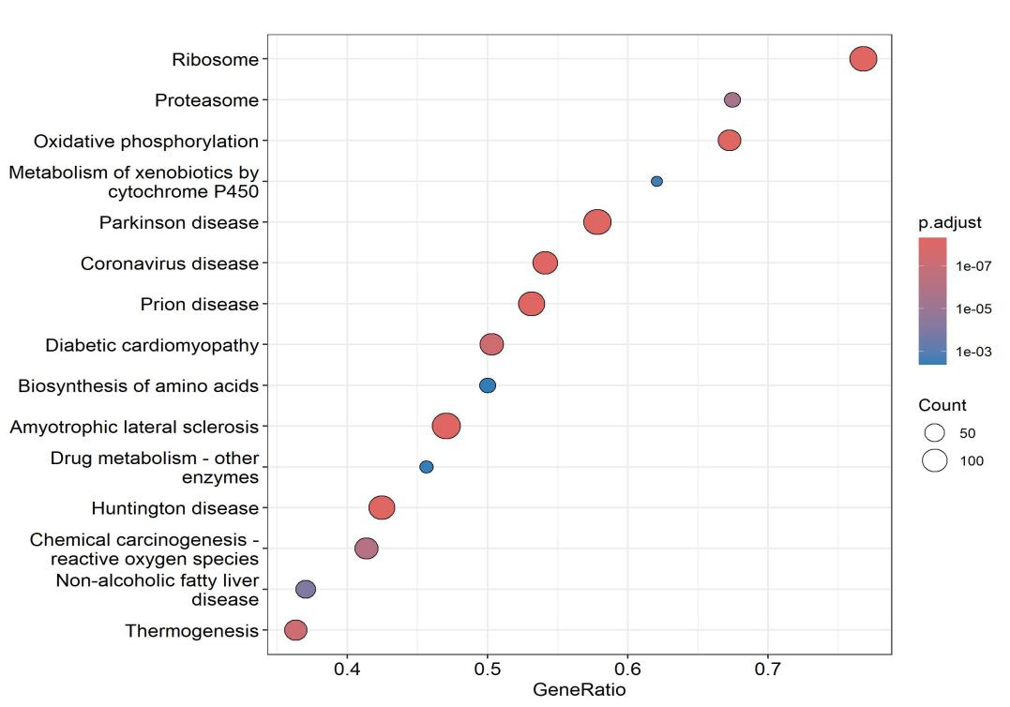
Figure 5A. Dot plot of significantly enriched pathways from GSEA against the KEGG database. Pathways are sorted by GeneRatio. Dot size represents the number of core genes in the pathway; colour represents adjusted p-value. All pathways shown have p.adj < 0.05.
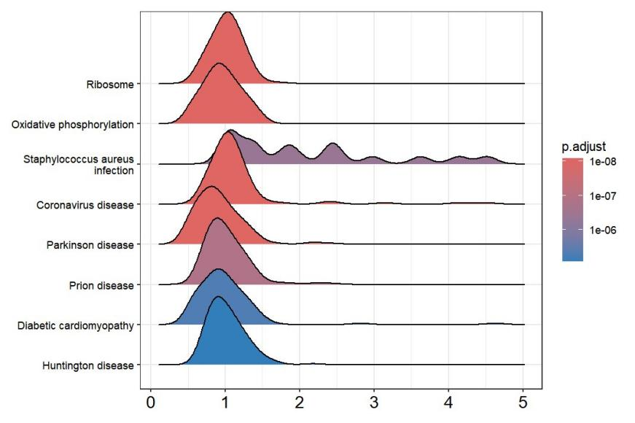
Figure 5B. Ridge plot of GSEA enrichment score distributions for significantly enriched KEGG pathways. Enrichment score is shown on the x-axis; colour indicates adjusted p-value. The Ribosome and Oxidative phosphorylation pathways display tight unimodal distributions, consistent with concerted gene regulation.
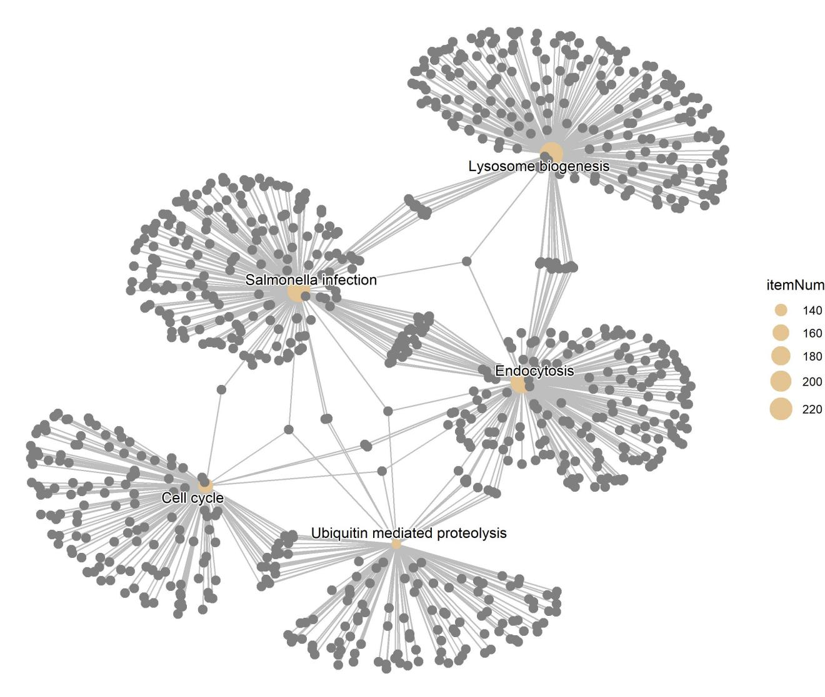
Figure 5C. KEGG pathway enrichment network (cnetplot) showing connections between significantly enriched KEGG pathways and their associated core genes. Hub nodes (tan) represent KEGG pathways; peripheral nodes represent genes coloured by log2 fold change. Node size reflects the number of associated genes.

3.6 NOMO3 Expression Analysis
NOMO3 was the most strongly differentially expressed transcript in the entire dataset, exhibiting a –log₁₀(adjusted p-value) exceeding 250. Expression profiling across glucose conditions confirmed marked and consistent downregulation of NOMO3 under high glucose relative to both medium- and normal-glucose conditions (Figure 6). NOMO3 encodes an endoplasmic reticulum-associated component of the BOS/SEC61 membrane protein insertion complex, essential for ER membrane architecture and membrane protein biogenesis[20,21]. To our knowledge, this suggests a previously unreported association between NOMO3 and podocyte glucotoxicity.
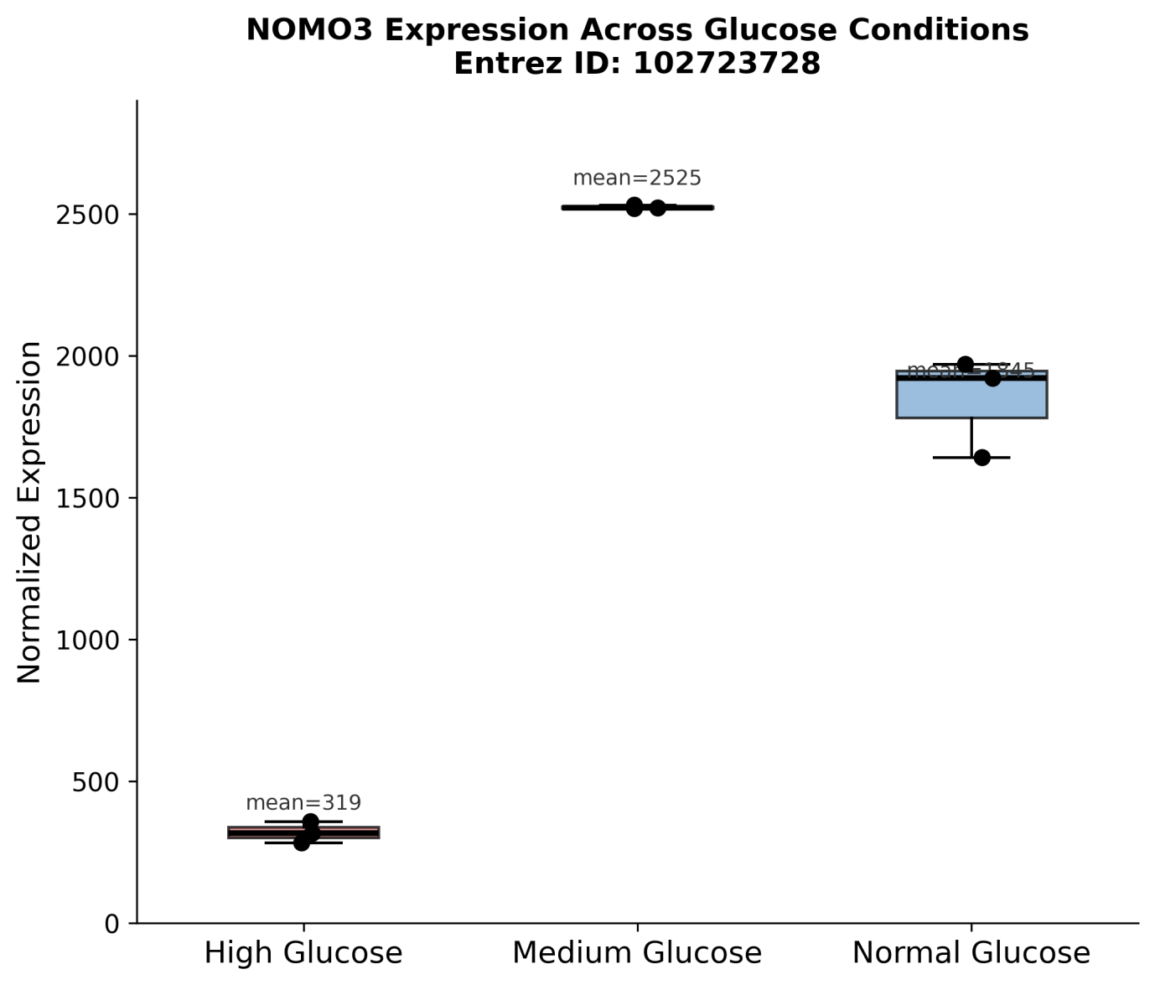
Figure 6. Normalised expression levels of NOMO3 across high- (H), medium- (M) and normal-glucose (N) conditions. NOMO3 is markedly and consistently downregulated under high glucose across all biological replicates.

3.7 Protein–Protein Interaction Network Analysis

3.7A Core Gene PPI Network
The STRING database (v12.0)[17] was used to construct a PPI network from 675 filtered core genes at a confidence threshold of 0.400. Of these, 628 were successfully mapped to STRING identifiers, yielding a network comprising 476 nodes and 1,147 interactions (Figure 7A). The Louvain clustering algorithm identified 36 functional communities, with the five largest containing between 49 and 63 genes, reflecting substantial modular organisation of the high-glucose transcriptional response.

Network topology analysis identified EP300 (degree = 49) as the highest-ranked hub. Additional highly connected downregulated hubs included ATM, ESR1 and PIK3R1—factors implicated in transcriptional regulation, DNA damage response and metabolic adaptation. Among upregulated hubs, HIF1A and ribosomal proteins predominated, including RPS15, RPS19, RPL13, MRPL12 and MRPL27. Overall, the PPI analysis revealed coordinated suppression of major transcriptional and stress-response regulators alongside activation of translational and mitochondrial machinery.
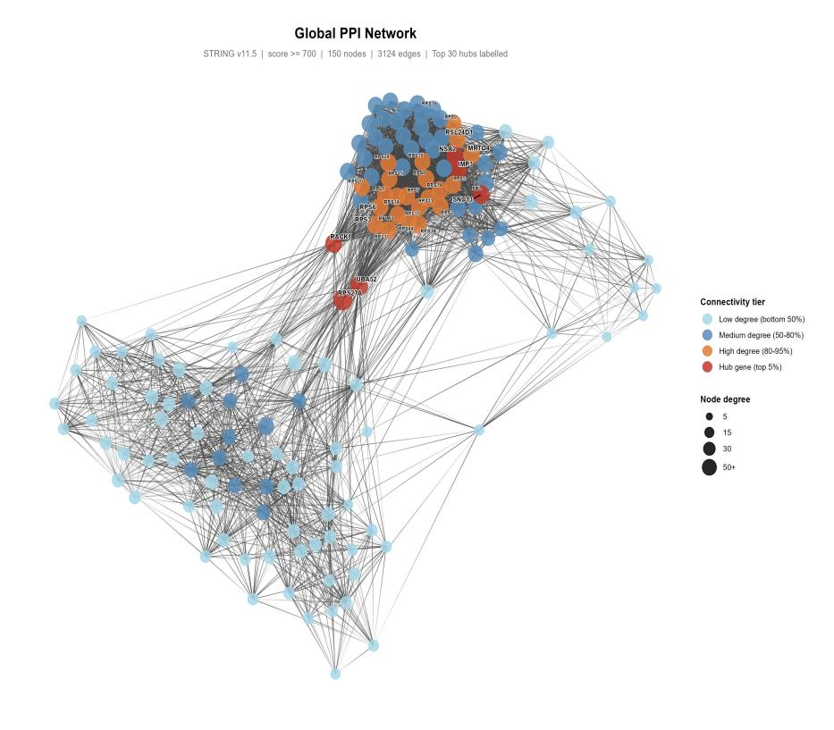
Figure 7A. STRING-derived protein–protein interaction (PPI) network of core glucose-responsive genes. Node size represents degree centrality. Communities identified by Louvain clustering are colour-coded. Major hub genes are indicated.

3.7B NOMO3 Dedicated PPI Network
The exceptional statistical significance of NOMO3 motivated construction of a dedicated PPI network using STRINGdb (v12.0, confidence ≥ 0.400)[17], which revealed 22 direct interaction partners and 65 total interactions (Figure 7B). Both other members of the back-of-Sec61 (BOS) complex, NCLN (Nicalin) and TMEM147, were among the most biologically relevant interactions, establishing NOMO3’s role in the ER membrane protein insertion complex under high-glucose conditions. Further interactions with ER-resident CCDC47 and ER calcium homeostasis regulator TMCO1 provide additional support for a role in ER membrane remodelling under glucotoxic stress. Notably, NOMO3 directly interacted with FCF1, a ribosome biogenesis factor, and DENR, a translation reinitiation factor, creating a direct molecular link between NOMO3 and the ribosomal pathway enrichment detected in the core gene set analysis. These interactions suggest that NOMO3 downregulation under high-glucose conditions could, at least in part, compromise ER membrane protein biogenesis—standing in stark contrast to the broad upregulation of translational machinery observed elsewhere in this study.
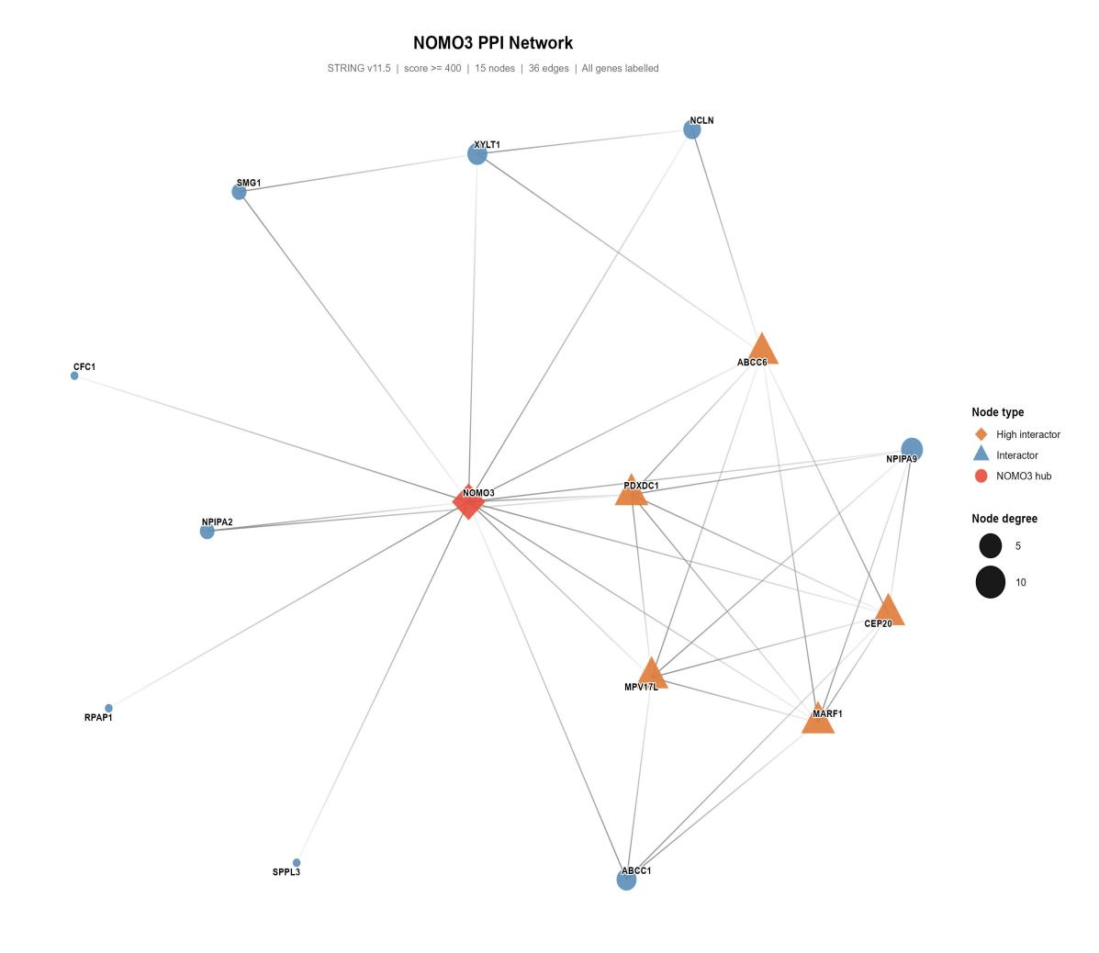
Figure 7B. NOMO3 protein–protein interaction network constructed using STRING v12.0 (confidence score ≥ 0.400). NOMO3 is shown in red; interaction partners are shown in blue. Node size reflects degree centrality. Key interactions include NCLN and TMEM147 (BOS complex partners), FCF1 (ribosome biogenesis), DENR (translation reinitiation) and TMCO1 (ER calcium homeostasis).

3.8 External Validation Against Human DKD Transcriptomic Data (GSE30528)
External validation was performed using a publicly available microarray dataset of microdissected glomerular tissue from patients with DKD and healthy controls (GSE30528). Ribosomal hub genes—specifically RPS15, RPS19, and RPL13—exhibited concordant directional changes in human glomerular tissue compared to our in vitro model (Figure 8). While NOMO3 was also identified as a significantly regulated hub gene in our in vitro podocyte model, it was not represented on the HG-U133A microarray platform used in this dataset, precluding its validation in this cohort. These findings confirm the conservation of key ribosomal signatures in human diabetic glomerular tissue.

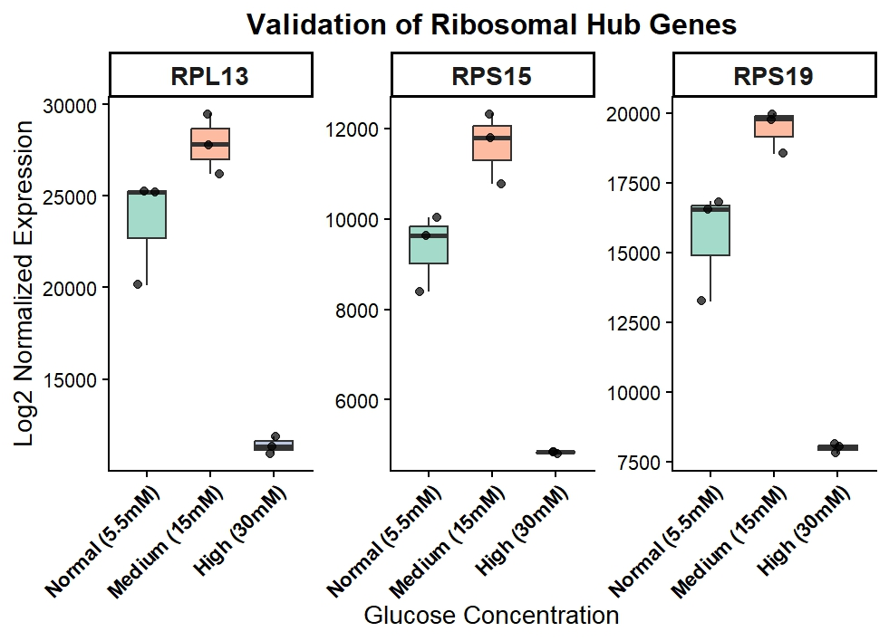
Figure 8. External validation of ribosomal hub gene expression in human DKD transcriptomic data (GSE30528). Normalised expression levels of validated hub genes (RPS15, RPS19, and RPL13) across three glucose conditions: Normal (5.5 mM), Medium (15 mM), and High (30 mM). The boxplots demonstrate concordant directional expression changes observed between the in vitro podocyte model and human glomerular tissue. Note: NOMO3 was excluded from this validation due to its absence on the HG-U133A microarray platform.

3.9 Transcription Factor Activity Analysis
TF activity inference identified 19 significantly altered transcription factors under high-glucose conditions (Figure 9). E2F1 was the most strongly activated, followed by RELA (NF-κB subunit), IRF1, TP53 and JUN, consistent with activation of inflammatory and stress-response signalling under hyperglycaemic conditions. MYC and PPARG were also among the activated TFs; MYC is an established regulator of ribosomal biogenesis and cap-dependent translation[3,10], and its activation aligns with coordinated induction of the translational machinery observed across pathway enrichment analyses.

Conversely, ESR1 and HIF1A showed the most pronounced reduction in activity under high-glucose conditions, followed by CREB1, FOXO3, SMAD4, STAT1, SP1, NFKB1, STAT3, RUNX1 and SMAD3. The suppression of HIF1A is notable, as this transcription factor coordinates cellular responses to hypoxia and metabolic stress. The marked reduction in SMAD3 and SMAD4 activity suggests attenuation of TGF-β canonical signalling under hyperglycaemia, while decreased FOXO3 and CREB1 activity implies impaired oxidative stress defence and energy-sensing responses. The collective downregulation of these transcriptional regulators supports a model of glucotoxic podocyte stress in which the progressive erosion of metabolic and homeostatic transcriptional programmes contributes to podocyte vulnerability in DKD[22].
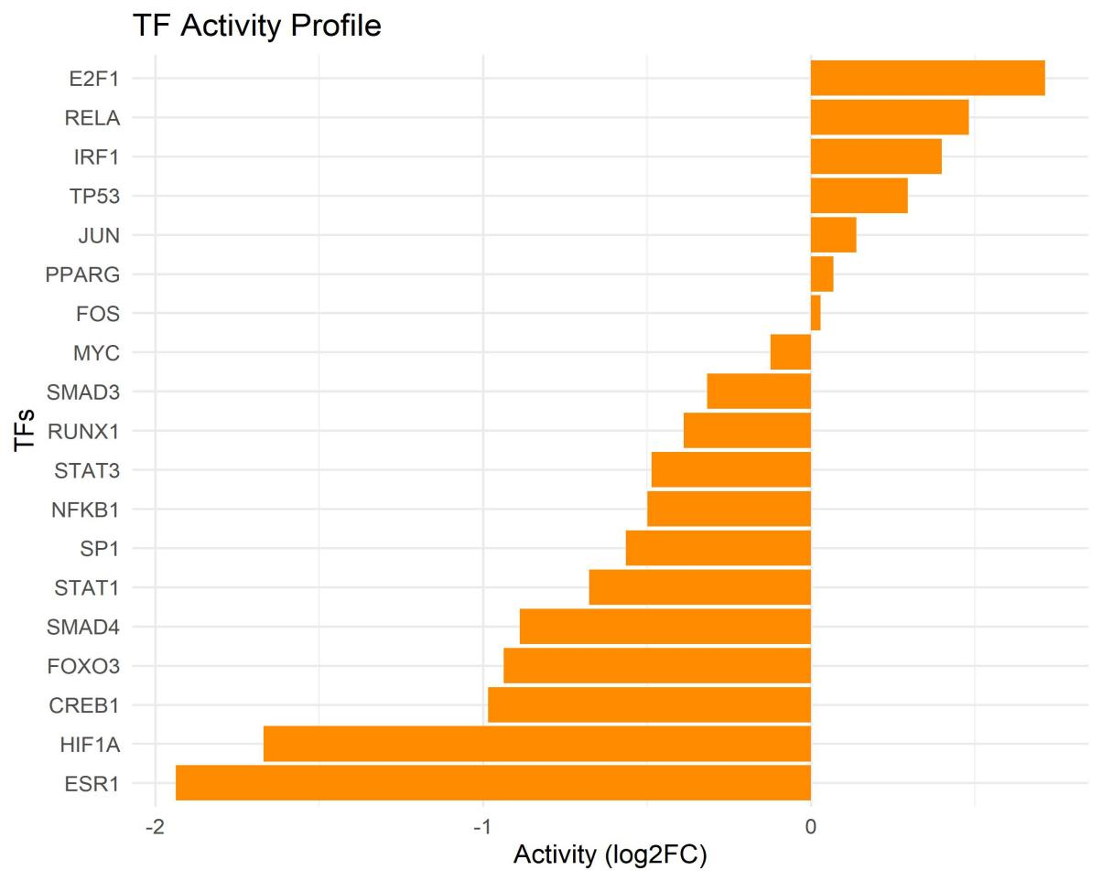
Figure 9. Transcription factor activity profile inferred using DoRothEA regulons and decoupleR. TF activity is displayed as log2 fold change relative to high-glucose conditions. Positive values indicate increased activity (E2F1, RELA, IRF1, TP53, JUN, PPARG, FOS, MYC); negative values indicate decreased activity (SMAD3, RUNX1, STAT3, NFKB1, SP1, STAT1, SMAD4, FOXO3, CREB1, HIF1A, ESR1). All TFs shown have adjusted p-value < 0.05.

4. Discussion

This study presents a multi-layered transcriptomic characterisation of high-glucose-induced transcriptional remodelling in human podocytes. By integrating differential expression analysis, pathway enrichment, protein–protein interaction (PPI) network analysis, transcription factor (TF) activity inference and external validation, the findings converged on four major biological themes: (1) ribosomal and translational activation, (2) mitochondrial metabolic remodelling, (3) proteostasis and ER stress adaptation, and (4) progressive loss of podocyte epithelial identity.

One of the most prominent findings was the strong enrichment of ribosomal pathways in both ORA and GSEA analyses. Ribosomal proteins including RPS15, RPS19 and RPL13 emerged as major hubs in the PPI network, while TF activity analysis demonstrated activation of E2F1, RELA and IRF1 as the highest-ranked transcription factors, alongside activation of MYC, consistent with established roles for these regulators in ribosomal biogenesis and cap-dependent translation. Together, these findings suggest coordinated enhancement of translational and inflammatory signalling under high-glucose conditions, potentially linked to mTORC1-mediated anabolic signalling. Previous studies have shown that hyperglycaemia-induced mTORC1 activation promotes ribosomal protein synthesis and translation initiation through phosphorylation of S6 kinase and 4E-BP1.

Mitochondrial and oxidative phosphorylation pathways were also strongly enriched. Upregulation of mitochondrial ribosomal proteins such as MRPL12 and MRPL27 further supports enhanced mitochondrial translation and metabolic remodelling during glucotoxic stress. Similar increases in oxidative phosphorylation gene expression have been reported in diabetic cellular models and are thought to contribute to mitochondrial superoxide generation and glucotoxic injury. The enrichment of Parkinson and Huntington disease pathways likely reflects overlapping mechanisms related to mitochondrial dysfunction and oxidative stress rather than direct disease involvement.

Among all transcripts, NOMO3 showed the strongest differential expression signal. NOMO3 encodes an ER-associated component of the BOS/SEC61 membrane protein insertion complex involved in ER membrane organisation and membrane protein biogenesis. Its marked suppression under high-glucose conditions suggests a previously unreported association between NOMO3 dysfunction and podocyte glucotoxicity. Since ER stress is a recognised driver of podocyte injury in DKD, reduced NOMO3 expression may impair ER membrane integrity and compromise protein processing capacity under glucotoxic conditions. Further experimental studies are required to define its mechanistic role.

PPI network analysis additionally identified coordinated suppression of EP300, ATM and PIK3R1, indicating reduced activity of major transcriptional, DNA damage response and metabolic regulatory pathways, while HIF1A emerged as a key activated hub in the PPI network. In parallel, TF activity analysis demonstrated decreased activity of ESR1, HIF1A, CREB1, FOXO3 and SMAD family members, factors involved in oxidative stress defence, metabolic adaptation and growth factor signalling. Together, these findings support a model of glucotoxic podocyte stress in which translational and inflammatory activation occurs alongside attenuation of key metabolic and homeostatic transcriptional programmes.

The simultaneous activation of translational machinery and mitochondrial oxidative phosphorylation observed in the present study is consistent with previous reports describing hyperactivation of the mTORC1 signalling pathway in DKD models. However, the marked repression of NOMO3 suggests a possible uncoupling between increased protein synthesis and ER membrane processing capacity. This imbalance may contribute to early glucotoxic ER stress and impaired protein handling in podocytes.

External validation using human DKD glomerular transcriptomic data further supported the biological relevance of the identified ribosomal signatures despite differences in experimental platform and tissue composition. The consistency of findings across multiple analytical approaches strengthens the robustness of the major biological themes identified in this study.

Several limitations should be acknowledged. The small sample size limits the statistical power to detect transcripts with modest effect sizes. As a secondary bioinformatics analysis of publicly available data, the findings require experimental validation. In addition, pathway enrichment analyses depend on existing annotation databases and may reflect overlapping pathway membership. The precise functional roles of NOMO3 and mTOR-associated signalling in glucotoxic podocyte injury therefore remain to be experimentally established.

Overall, these findings support a model in which glucotoxic stress induces coordinated translational, mitochondrial and ER-associated remodelling in podocytes, potentially contributing to early DKD progression.

5.Limitations
This study is limited by its reliance on a single publicly available RNA-seq dataset (GSE307956) with a small sample size (n = 3 per condition), which reduces statistical power and may limit generalisability. The in vitro high-glucose model does not fully recapitulate the complex in vivo environment of diabetic kidney disease, including immune, vascular, and hemodynamic influences. Although rigorous quality control was applied, residual batch effects or technical variability cannot be excluded. Core gene selection using strict thresholds and intersection criteria may omit biologically relevant but modest expression changes. Pathway enrichment and PPI analyses are constrained by incomplete and biased database annotations, while transcription factor activity inference remains indirect and does not capture post-translational regulation. External validation using glomerular microarray data is limited by platform differences and tissue heterogeneity. Finally, all findings are correlative, and key mechanistic insights—particularly involving NOMO3—require experimental validation.

6. Conclusions
High-glucose exposure induces extensive transcriptional remodelling in human podocytes, characterised by coordinated activation of ribosomal, mitochondrial, proteostatic and ER stress-associated programmes. Integrated multi-layered transcriptomic analysis identified:

- Strong activation of the translational machinery, evidenced by marked ribosomal pathway enrichment and activation of E2F1, MYC and RELA transcription factors;
- Mitochondrial metabolic remodelling, driven by coordinated upregulation of oxidative phosphorylation and mitochondrial ribosomal protein gene programmes;
- Proteostasis-associated stress responses, reflecting increased protein synthesis and degradation turnover; and
- Suppression of podocyte identity-associated transcriptional programmes, consistent with glucotoxic dedifferentiation.

NOMO3 emerges as a compelling candidate gene that may link glucotoxic ER stress to impaired membrane biogenesis in podocytes. These findings provide several mechanistic hypotheses pertinent to early diabetic kidney injury and establish a foundation for future functional studies of ribosomal remodelling, ER stress adaptation and podocyte dedifferentiation in diabetic nephropathy.

7. Summary of Analytical Pipeline
Analysis Step | Method / Tool
Normalisation | DESeq2 median-of-ratios; apeglm LFC shrinkage
DE Contrasts | M vs. H and N vs. H (H = reference)
DEG Threshold | p.adj < 0.05; |log₂FC| > 0.5
Core Gene Set | Intersection of significant DEGs from both contrasts (n = 728)
QC Methods | PCA (VST counts), sample-distance heatmap, dispersion plot
GO ORA | enrichGO(), org.Hs.eg.db, BP ontology, BH correction
KEGG ORA | enrichKEGG(), organism=‘hsa’, BH correction
GSEA | gseKEGG(), ranked by M vs. H log₂FC, nPerm = 1000
PPI Network | STRINGdb v12.0 (confidence ≥ 0.400); igraph; Louvain clustering
TF Inference | decoupleR v2.17; DoRothEA regulons (A–C); ULM method
External Validation | GSE30528 (human DKD glomerular microarray)
Visualisation | ggplot2, pheatmap, enrichplot, clusterProfiler
R version | R 4.3; DESeq2 1.42; clusterProfiler 4.10

Acknowledgements
The authors thank Xiaochen Tian and colleagues for making the RNA-seq dataset (GSE307956) publicly available via the Gene Expression Omnibus database, enabling this secondary bioinformatics analysis.
Data Availability Statement
All data analysed in this study are publicly available. Primary RNA-seq count data are accessible via the Gene Expression Omnibus (GEO) under accession GSE307956. External validation data are available under GEO accession GSE30528. No new data were generated in this study.
Conflict of Interest Statement
The authors declare that the research was conducted in the absence of any commercial or financial relationships that could be construed as a potential conflict of interest.
AI Writing Disclosure
The authors declare that AI-assisted tools were used during the preparation of this manuscript for the purposes of text drafting, language editing and literature contextualisation. No AI tools were used to generate, analyse or interpret the underlying data. All bioinformatics analyses—including DESeq2 differential expression, clusterProfiler pathway enrichment (ORA and GSEA), STRINGdb PPI network construction and decoupleR transcription factor inference—were carried out by the authors. All AI-assisted content was critically reviewed and revised by the authors, who accept full accountability for the scientific validity of this work.

References

- Ortiz A, et al. (2026). The updated global burden of chronic kidney disease. Nephrol Dial Transplant.
- Brownlee M. (2005). The pathobiology of diabetic complications. Diabetes.
- Afkarian M, et al. (2025). Precision medicine in diabetic kidney disease. Diabetes Care.
- Guo C, et al. (2024). Identification of key immune-related genes in diabetic nephropathy. BMC Med Genomics.
- Li T, et al. (2026). Integrative analysis of mitochondrial and ER stress signatures. Frontiers in Physiology.
- Shankland SJ, et al. (2024). Podocytes in health and disease. N Engl J Med.
- PMC Review (2026). Mechanism of endoplasmic reticulum stress in diabetic kidney disease. PMC12749553.

