DEEP ALGORITHMS

IAM & PAM Console
Quick Start Guide
A short, picture-led guide to every screen you will use day to day.
WHAT IS IN THIS GUIDE
01 Signing In  02 The Screen Layout  03 The Dashboard  04 Users  05 User Details  06 Resources  07 Roles | 08 Policies  09 Audit Logs  10 Alerts  11 Your Profile and MFA  12 Common Tasks  13 If Something Goes Wrong  14 Words You Will See

01 SIGNING IN
This is the login page. It is the first screen you see, and the only one you can reach without an account.
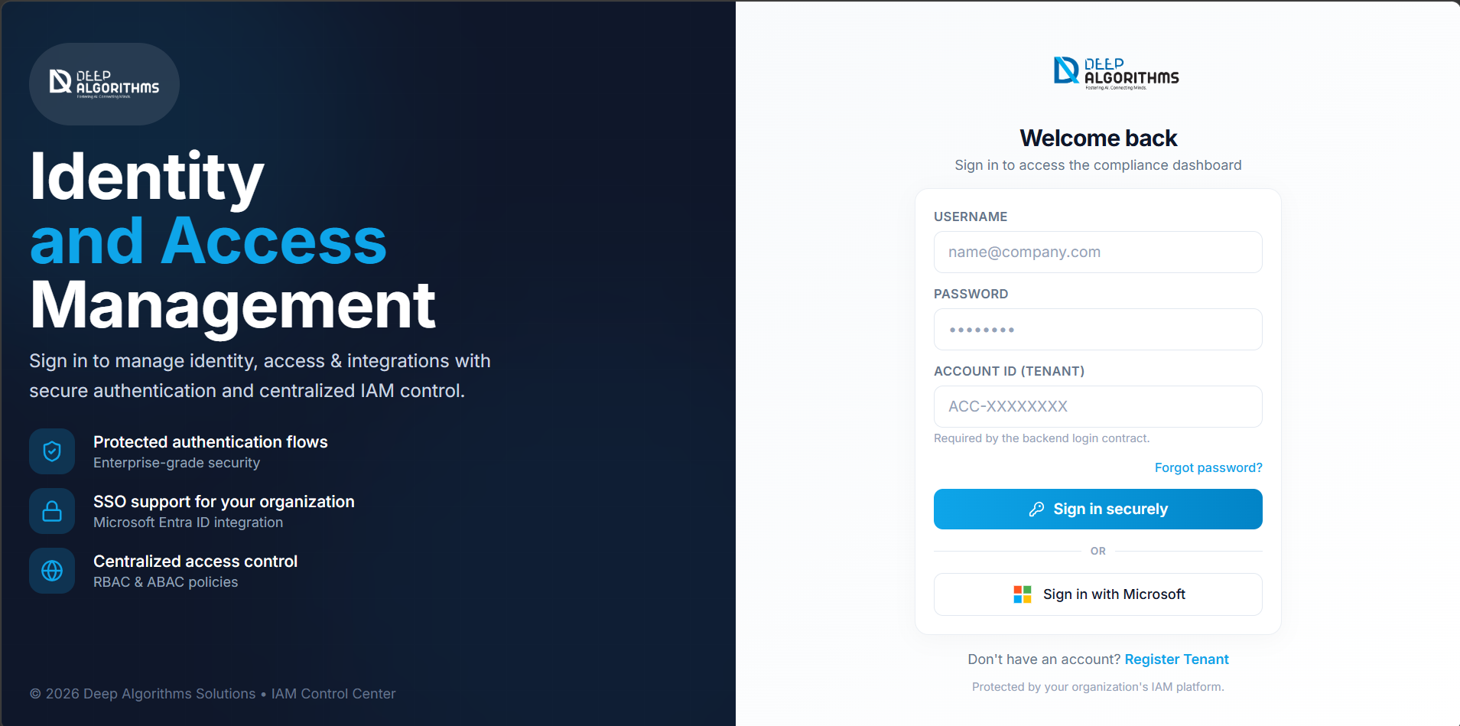
The sign-in page.
You need three things: your username or email, your password, and your Account ID (for example ACC-1A2B3C4D). Ask your administrator if you do not have the Account ID.
1. Type your Username or Email.
2. Type your Password. Select the eye icon to check what you typed.
3. Type your Account ID.
4. Select Sign In. The Dashboard opens.
Or use your company login: select Sign in with Microsoft instead and complete your company's screen.
If two-factor is on, a code page appears next. Open your authenticator app and type the six-digit code, or select Use a backup code.
Forgot your password? Select Forgot password?, type your email, and follow the link that is sent to you. To sign out later, select your name at the top-right, then Sign out.

02 THE SCREEN LAYOUT
Every page looks the same. Once you know these three parts, you can find anything.
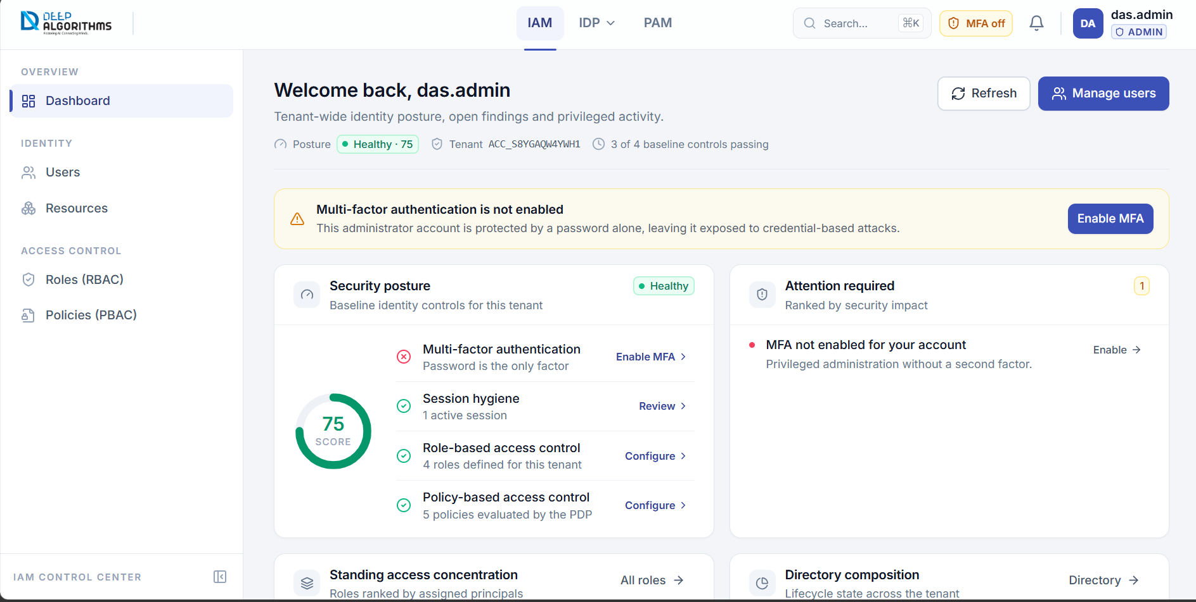
The three-part layout: top bar, sidebar and working area.
- The top bar stays fixed at the top. It holds the IAM / PAM switch, global search, the alert bell and your profile menu.
- The sidebar runs down the left. It is your menu. The page you are on is tinted and marked with a coloured bar.
- The working area fills the rest of the screen and shows the page you chose.
Switching products: select IAM for identity and access management, or PAM for privileged access monitoring. The sidebar changes to match.

Quick search
Press Ctrl+K (or ⌘+K on a Mac) from anywhere, then start typing. Results are grouped into Pages, Users, Roles and Policies. Use the arrow keys and press Enter to open one.
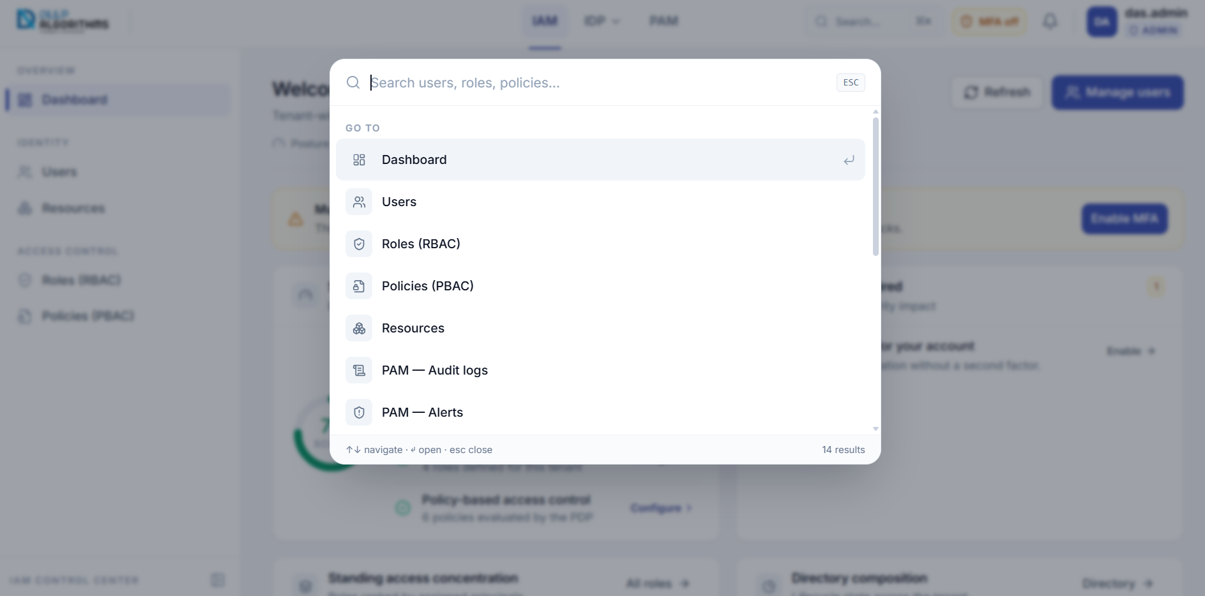
Global search, opened with Ctrl+K.

03 THE DASHBOARD
IAM → Dashboard. This is your home page. It tells you how secure your tenant is and what needs fixing.
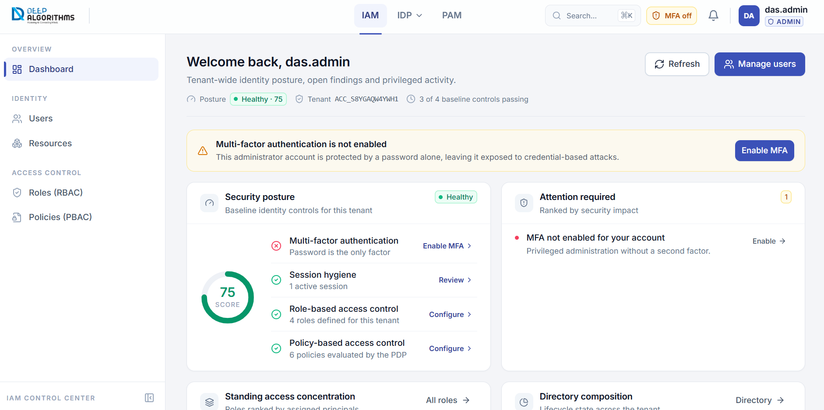
The Dashboard.
- Security posture — a score out of 100 and four baseline checks, each with a tick or a cross.
- Attention required — the list of things to fix, most serious first. Each row has a button that takes you straight there.
- Directory composition — how many identities you have and how many are active.
- Recent activity — the latest access events. Select any row to open the full audit trail.
Select Refresh at any time to re-read every figure on the page.

04 USERS
IAM → Identity → Users. This is your company directory: everyone who can sign in.
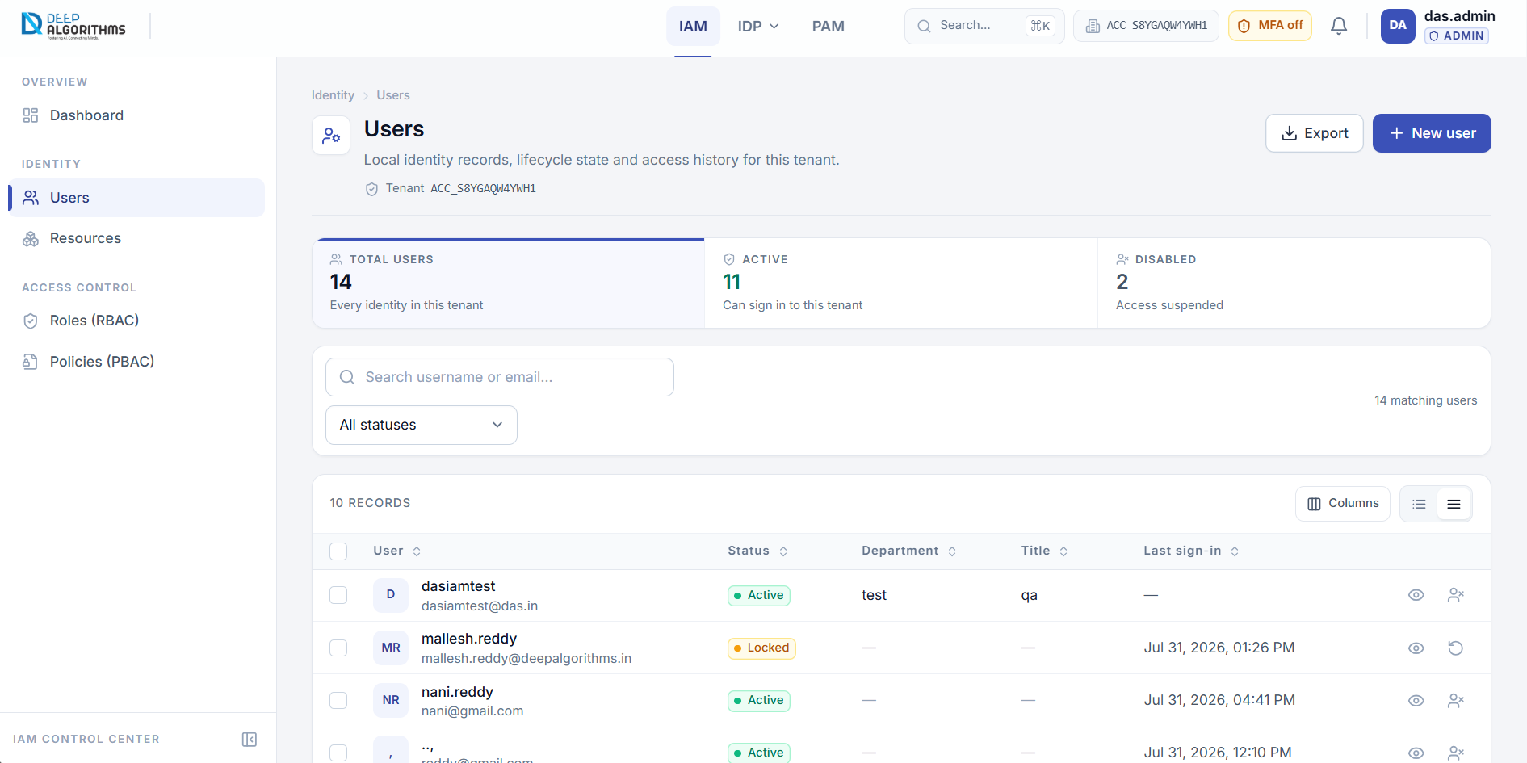
The Users page.
Type in the search box to find someone, or choose a status from All statuses. Select the eye icon on a row to open that person. Export downloads the list as a spreadsheet.

Adding a new user
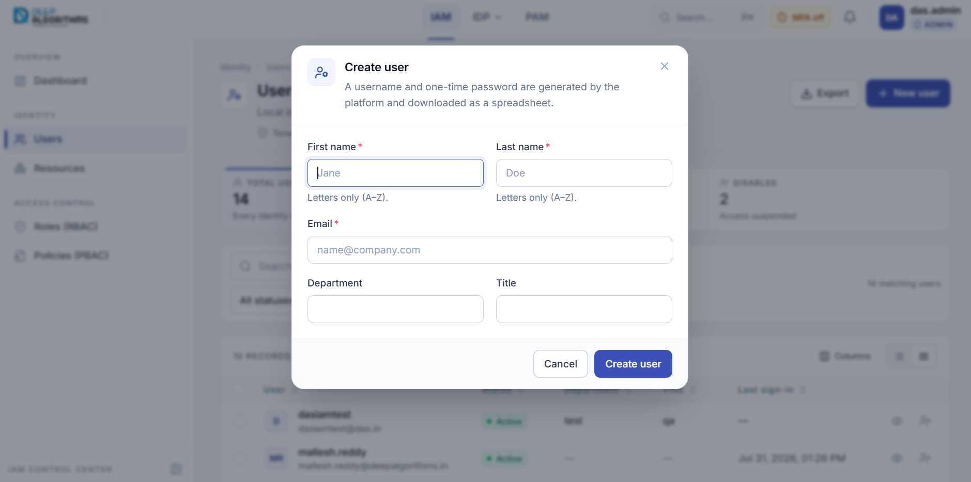
The Create user dialog.
1. Select New user at the top-right.
2. Type the First name and Last name. Letters only.
3. Type the Email, for example name@company.com.
4. Optionally add a Department and Title.
5. Select Create user.
To suspend someone: select Disable user on their row. Their access stops immediately. Select Enable user to restore it.

05 USER DETAILS
Select any user to open their page. This is where you give and remove their access.
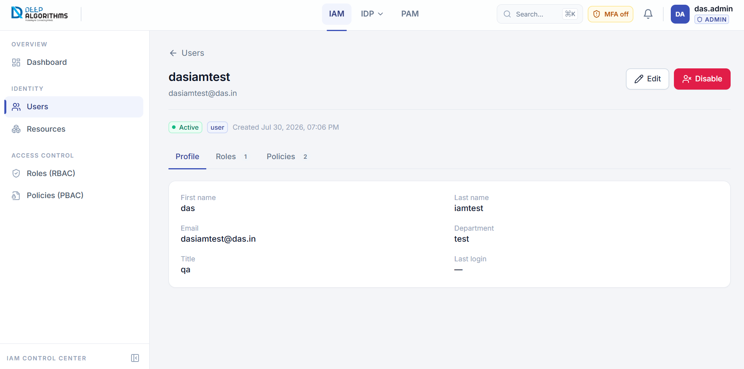
A user detail page.
Three tabs organise the page — Profile, Roles and Policies — and the number beside each is its count.

Giving someone a role
1. Open the Roles tab.
2. Select Assign role.
3. Choose the role from the list.
4. Select Assign. The person immediately gains everything that role allows.
To take it away, select Remove on the role and confirm.

Seeing everything a person can do
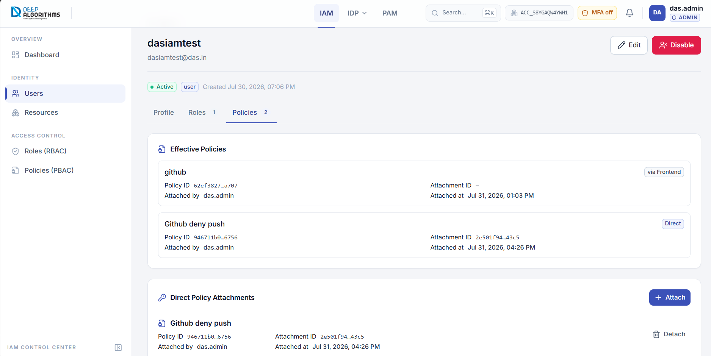
The Policies tab on a user detail page.
The Policies tab lists every policy that reaches this person. A Direct badge means it was given to them individually; via <role name> means it arrived through a role. Use Attach policy here to grant one directly.

06 RESOURCES
IAM → Identity → Resources. This is the register of the systems you protect. A system must be listed here before a policy can name it.
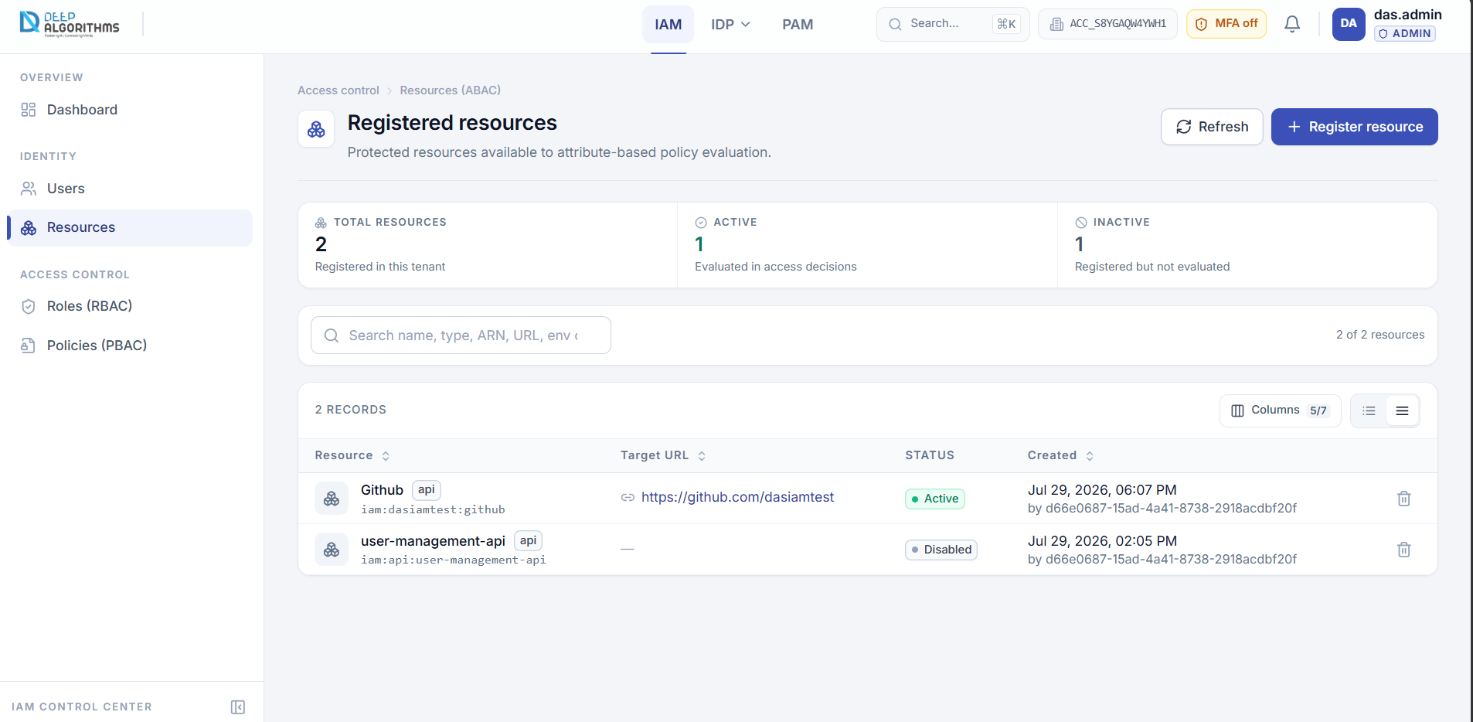
The Resources page.

Registering a resource
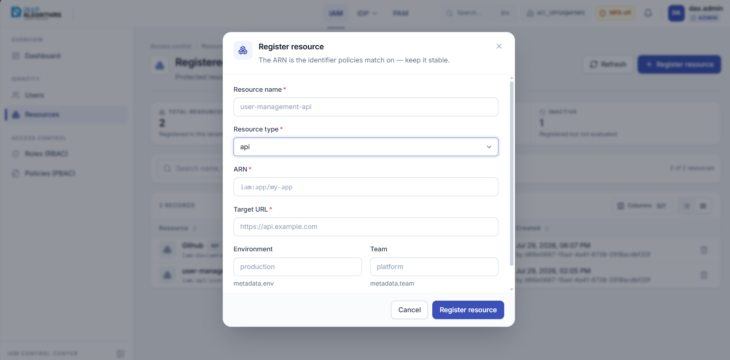
The Register resource dialog.
1. Select Register resource at the top-right.
2. Type a Resource name, for example user-management-api.
3. Choose a Resource type: application, api, dataset, database, service or storage.
4. Type the ARN that policies will match on, for example iam:app/my-app. Choose it carefully — it should never change.
5. Type the Target URL, beginning with http:// or https://.
6. Leave Active ticked, then select Register resource.

07 ROLES
IAM → Access Control → Roles (RBAC). A role is a job. You attach policies to a role, then give the role to people.
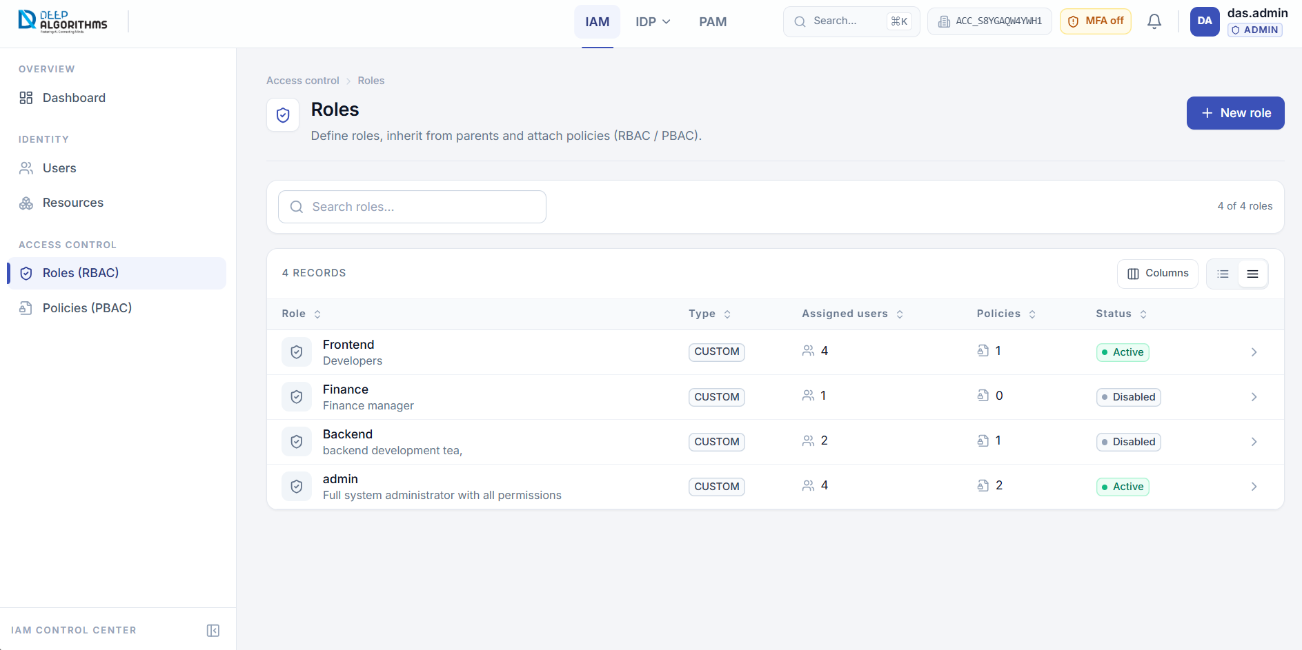
The Roles page.

Creating a role
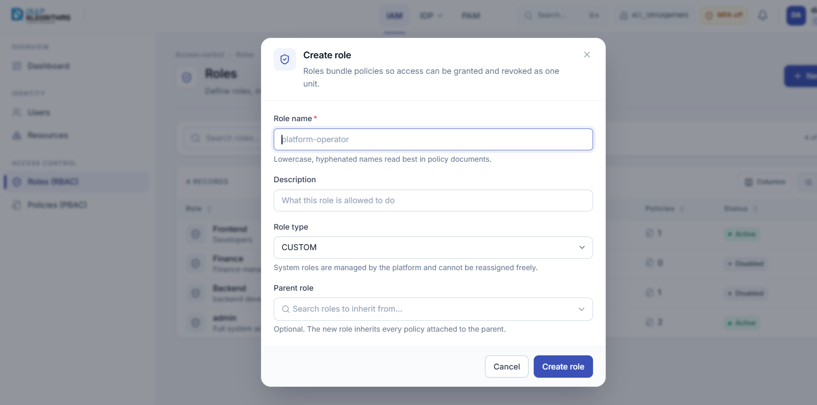
The Create role dialog.
1. Select New role at the top-right.
2. Type a Role name of at least three characters, for example platform-operator.
3. Type a one-sentence Description. Reviewers rely on this.
4. Leave Role type as CUSTOM.
5. Optionally choose a Parent role to inherit its policies.
6. Select Create role.
A new role grants nothing until you attach a policy to it.

Filling a role with permissions
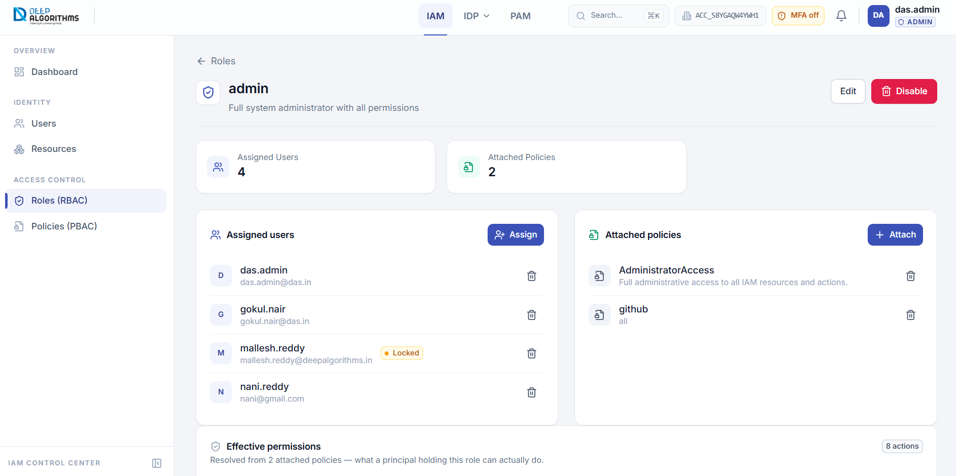
A role detail page.
Open the role to see who holds it and what it carries. Select Attach policy, choose a policy, and select Attach. Everyone with the role gains it at once.
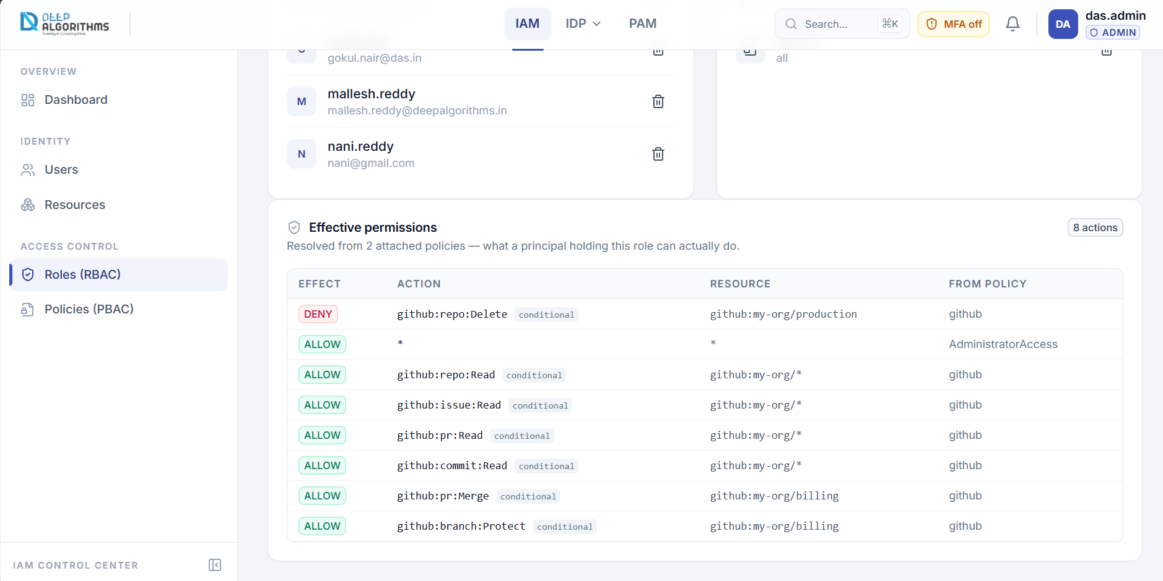
Effective permissions: what the role actually allows.
Effective permissions turns every attached policy into a plain list of what the role allows. DENY lines are shown first because a deny always wins.

08 POLICIES
IAM → Access Control → Policies (PBAC). A policy is the actual rule: who may do what, to which resource.
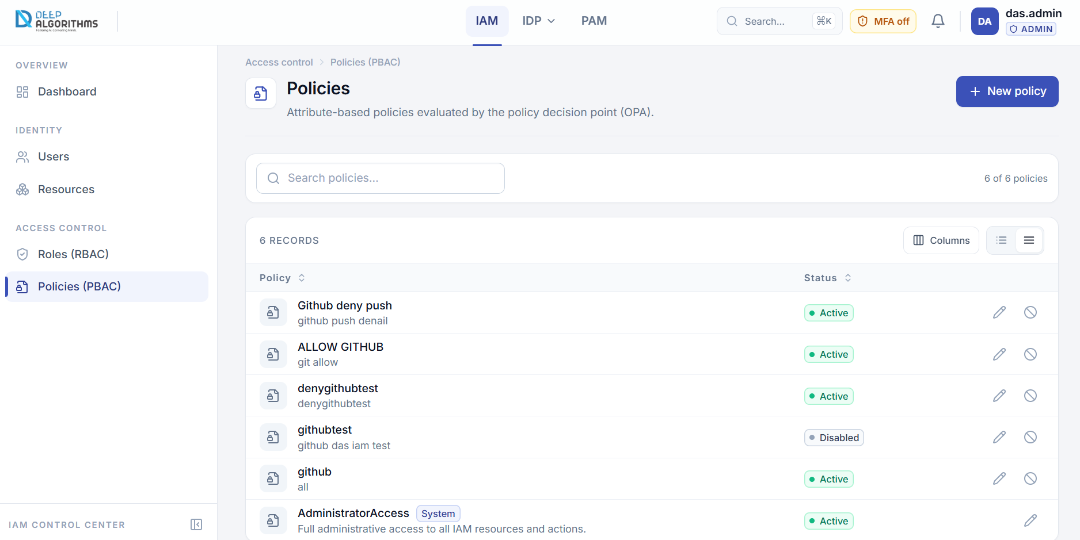
The Policies page.
Select a policy, or the pencil icon, to open it in the editor. Policies marked System are managed by the platform and cannot be disabled.

Writing a policy
1. Select New policy.
2. Type a Policy name such as finance-read-only, and a Description explaining who it is for.
3. In the statement card, set the switch to Allow or Deny.
4. Add the Actions it covers, for example iam:user:Read.
5. Add the Resources it applies to. An asterisk means everything.
6. Select Save.
Deny always wins. If any policy denies an action, the person cannot do it — no matter how many others allow it.

09 AUDIT LOGS
PAM → Audit Logs. This is the record of everything that happened: every sign-in and every access decision.
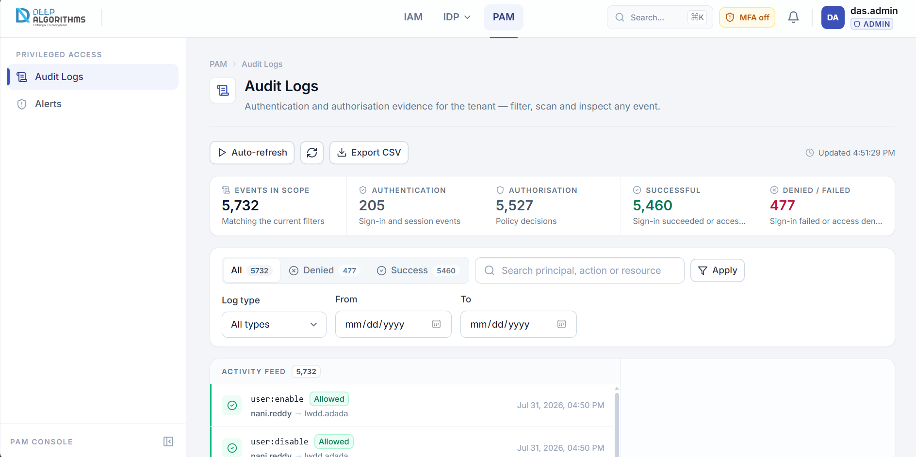
The Audit Logs page.
Each row shows the action, a badge reading Allowed or Denied, who did it, what they touched and when. Use the filters at the top to narrow it down, and Export CSV to download what you see.

Looking at one event
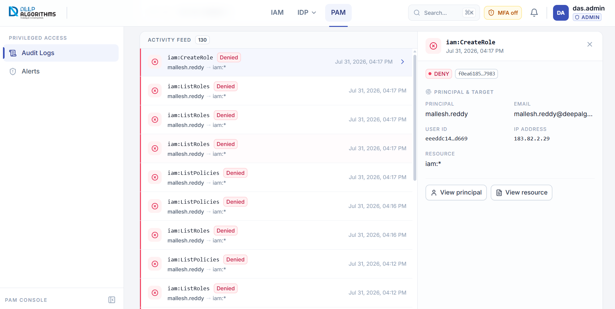
The event detail panel.
Select any row to open this panel. Matched policies tells you exactly which rule produced the decision — this is usually the answer to "why was this blocked?". Select the X to close it.

10 ALERTS
PAM → Alerts, or select the bell in the top bar. Every entry here is an access attempt that was refused.
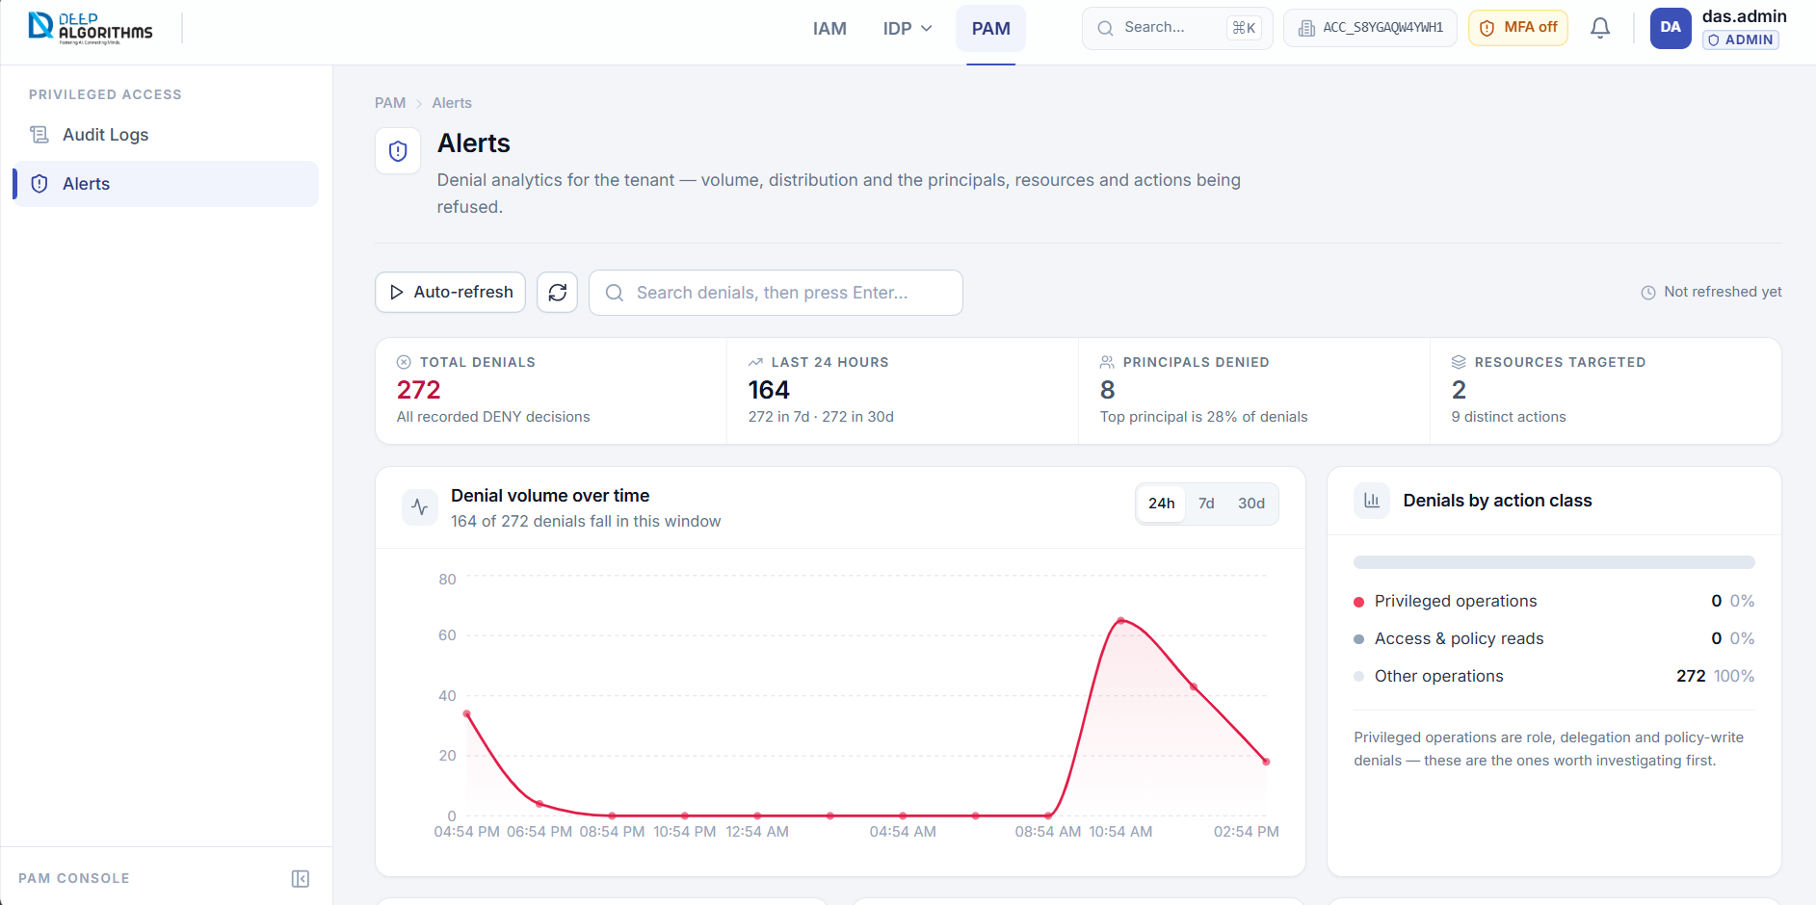
The Alerts page.
- Total denials, and how many happened in the last 24 hours, 7 days and 30 days.
- Principals denied — how many different people or systems were refused.
- Denials by action class — privileged operations are listed first. Look at these before anything else.
- Recent denials — the individual records. Select one to see why it was refused.
Opening this page clears the unread count on the bell.

11 YOUR PROFILE AND MFA
Select your name at the top-right to open this menu.
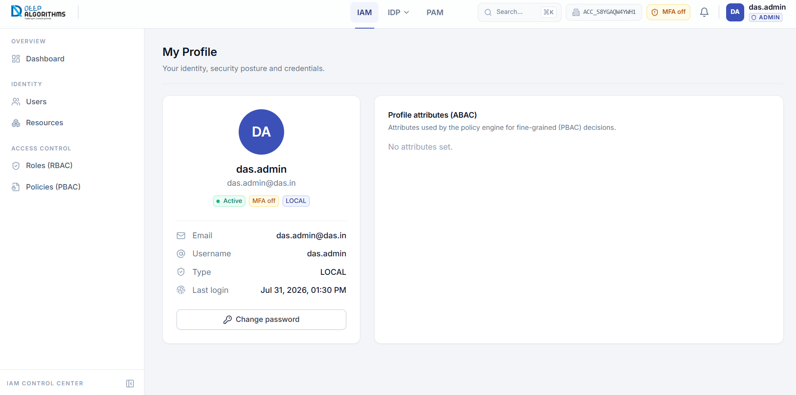
My profile.
My profile shows your username, email, status and last sign-in. Multi-factor authentication protects your account with a code from your phone — turn it on.
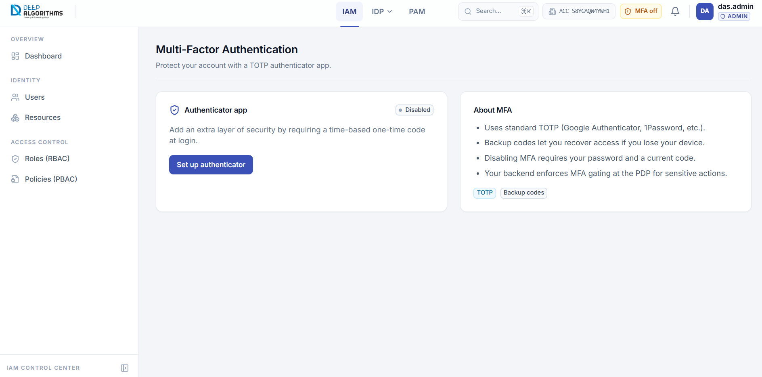
The Multi-Factor Authentication page.

Turning on two-factor verification
1. Install an authenticator app on your phone, such as Google Authenticator.
2. Select Set up authenticator.
3. Scan the QR code with your app, or copy the Manual key into it.
4. Type the six-digit code your app shows into 6-digit code.
5. Select Verify & enable.
6. Copy the backup codes and save them somewhere safe. Each one works once.
Active sessions in the same menu shows every device signed in to your account. Select Sign out on any device you do not recognise.

12 COMMON TASKS
I want to… | Go to
Add a new employee | IAM → Users → New user
Stop someone's access now | IAM → Users → Disable user on their row
Give someone more access | Open the user → Roles tab → Assign role
See what a role allows | IAM → Roles → open it → Effective permissions
Protect a new system | IAM → Resources → Register resource
Find out why something was blocked | PAM → Audit Logs → select the event → Matched policies
Check for suspicious activity | PAM → Alerts
Secure my own account | Profile menu → Multi-factor authentication

13 IF SOMETHING GOES WRONG
What you see | What to do
Sign-in failed. Check your details and try again. | Check all three fields, including the Account ID. For security, the page will not say which one was wrong.
The verification code is not accepted | Codes expire in seconds — wait for the next one. If you have lost your phone, use a backup code.
A page says it could not load | Select Retry. If it keeps failing, sign out and sign in again.
The audit trail will not open | Your account is not permitted to read it. Ask a root administrator for audit access.
A role grants nothing | No policies are attached to it yet. Open the role and select Attach policy.
A user cannot do something they should | Check Effective permissions on their role. A DENY anywhere overrides every ALLOW.

14 WORDS YOU WILL SEE
Term | What it means
Tenant | Your company's own isolated workspace. Nothing is shared with any other tenant.
Account ID | The code that identifies your tenant when you sign in, for example ACC-1A2B3C4D.
User | One person who can sign in.
Role | A job, such as platform-operator. You give roles to people.
Policy | The rule itself: who may do what, to which resource.
Resource | A system you protect — an app, an API, a database.
ARN | The permanent name of a resource that policies match on, for example iam:app/my-app.
Allow / Deny | What a rule does. A Deny always beats an Allow.
Effective permissions | The plain list of what a role or person can actually do, once every policy is worked out.
MFA | Multi-factor authentication — a second code from your phone on top of your password.
Backup code | A single-use code that gets you in if you lose your phone.
Audit log | The permanent record of every sign-in and every access decision.
Denial | An access attempt that was refused. These appear on the Alerts page.
Session | One device signed in to your account.

For anything not covered here, contact your administrator or the DEEP ALGORITHMS support team.

