DEEP ALGORITHMS

IAM & PAM Console
User Manual and Client Guide
Identity & Access Management (IAM) · Privileged Access Management (PAM)
Prepared for clients, new administrators and first-time users
CONTENTS
01 About This Manual  02 Understanding the Platform  03 Getting Access to the Console  04 Finding Your Way Around  05 The Dashboard  06 Users and User Details  07 Resources  08 Roles and Role Details | 09 Policies and the Policy Editor  10 PAM — Audit Logs and Alerts  11 Your Account  12 Conventions Across the Console  13 Additional Pages by Direct Link  14 Common Tasks — Quick Reference  15 Troubleshooting  16 Glossary

01 ABOUT THIS MANUAL
This manual explains how to use the DEEP ALGORITHMS IAM & PAM Console from beginning to end. It assumes you have never seen the platform before. Buttons are named exactly as they appear on screen, and every task is written as numbered steps.
Who should read this: new administrators who create users, grant access and review security activity; client teams evaluating or adopting the platform; and auditors and reviewers who read access records and denial reports.
Conventions: bold is something you can see and click. This style is a value you type or copy. Numbered lists are procedures — follow them from top to bottom. Technical words are explained where they first appear and collected in the Glossary (section 16). The document is formatted for Letter paper and can be printed or shared as a PDF.
Console — the word used in this manual for the website itself: the set of web pages you sign in to in order to manage identity, access and security records.

02 UNDERSTANDING THE PLATFORM
The console does two related jobs. IAM (Identity and Access Management) answers "who exists, and what are they allowed to do?" — you create people (users), define groupings of permissions (roles), write the rules that decide access (policies), and register the systems being protected (resources). PAM (Privileged Access Management) answers "what actually happened?" — you read the record of every sign-in and access decision (Audit Logs), and review the attempts that were refused (Alerts).

Key terms you will meet immediately
Tenant | A separate workspace for one company. Your records are never mixed with another company's. Also called an account. | Policy | A document of rules. Each states an effect (Allow or Deny), actions such as iam:user:Read, and resources.
Account ID | The identifier of your tenant, usually ACC-XXXXXXXX. Needed at sign-in and shown in the top bar. | Resource | A system, application, dataset or service the platform protects, registered with a stable identifier called an ARN.
User | One person's identity record: username, email, status and granted access. | Permission decision | The Allow or Deny returned each time someone tries to do something. A Deny always wins over an Allow.
Role | A collection of permissions granted as a single unit. Removing the role removes them all at once.

How the pieces fit together
1. Register a tenant for your company. This also creates the first administrator.
2. Register the resources you want to protect, so policies have something to refer to.
3. Write policies stating what may and may not be done to those resources.
4. Create roles and attach the policies to them.
5. Create users and assign the roles. Where one person needs an exception, attach a policy directly to that user.
6. Review activity in PAM → Audit Logs, and investigate refusals in PAM → Alerts.

03 GETTING ACCESS TO THE CONSOLE

3.1 Registering a company tenant
If your company has no workspace yet, register a tenant first. This public page — no sign-in needed — creates an isolated tenant and a root administrator account inside it, whose password is generated by the platform and shown only once.
1. Open the sign-in page and select Register Tenant (direct address /register-tenant).
2. In Company name, type your organisation's name, for example Acme Corporation.
3. In Domain, type your company's internet domain, for example acme.com. It must be a valid domain name.
4. In Admin email, type the email address of the first administrator, and fill in First name and Last name.
5. Select Register company and wait; the button shows Registering… while the request is in progress.
6. On success the page shows Tenant registered and a credentials spreadsheet downloads automatically. Check the six values on screen against the file: account_id, email, password, company_name, domain, tenant_id.
7. Store the file somewhere safe and private, then select Continue to sign in.
Important: the administrator password is issued once and never shown again. If the download did not start, select Download again while the result is still on screen. Once you leave the page, the password cannot be retrieved.
If registration fails, read the red message at the top of the form, check the domain and email address, correct the highlighted fields and select Register company again.

3.2 Signing in
You need your username (or email address), your password and your Account ID, for example ACC-1A2B3C4D. If you do not know it, ask your administrator or check the credentials spreadsheet from tenant registration.
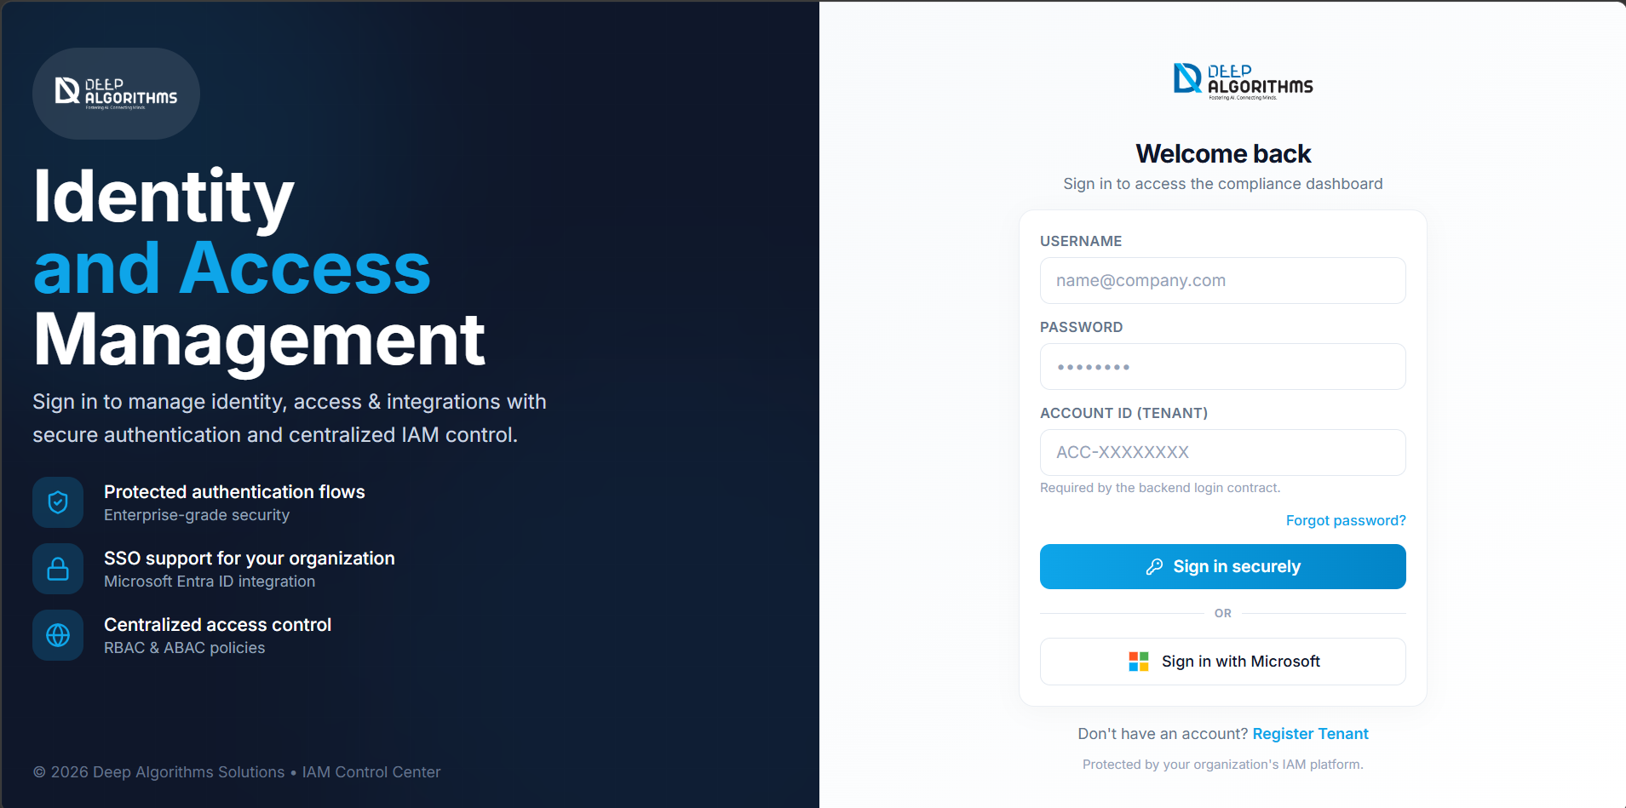
The sign-in page. All three fields are required.
1. Open the console address in your web browser.
2. Type your username or email address in Username, and your password in Password.
3. Type your tenant identifier in Account ID (tenant).
4. Select Sign in securely. The button shows Signing in… while it works.
5. Without two-factor verification you go straight to the Dashboard; with it, continue at section 3.3.
Single sign-on uses your existing company credentials instead of a separate password: select Sign in with Microsoft below the divider marked or and complete your company's screen. If the redirect does not complete, a message says sign-in could not be started — try again, or use your username and password. If your details are not accepted, the page shows Sign-in failed; for security it never states which field was wrong, so check all three.

3.3 Two-factor verification at sign-in
Multi-factor authentication (MFA) — a second proof of identity in addition to your password, normally a six-digit code from an authenticator app on your phone. A stolen password alone is then not enough to access your account.
1. After entering your password, the Two-factor verification screen appears.
2. Open your authenticator app and find the entry for this console.
3. Type the current six-digit code into Authentication code, then select Verify & sign in.
If verification does not work: codes expire quickly, so wait for a new one. If you have lost your phone, use a backup code saved when you set up two-factor verification (section 11.2). If the page says your session expired, select Back to login and start again.

3.4 Forgotten password, and signing out
1. On the sign-in page, select Forgot password?. The Reset your password page appears.
2. Type your address in Email and select Send reset link. A confirmation states that if an account exists for that address a link is on its way; for security the page does not reveal whether the address is registered.
3. Open the link in the email. The Choose a new password page appears.
4. Type your new password in New password, then the same value in Confirm new password.
5. Select Reset password. A confirmation appears and you are returned to the sign-in page.
If the two do not match, a message says Passwords do not match and nothing is saved. If the page reports a missing or invalid reset token, the link has expired — request a new one. To sign out, select your name or initials at the top-right, then Sign out (shown in red).

04 FINDING YOUR WAY AROUND
Every page uses the same three-part layout: the top bar, a thin fixed strip that never scrolls away; the sidebar, a vertical menu down the left; and the working area, where the page you selected is displayed.

4.1 The top bar
Item | What it does
Menu button (three lines) | Small screens and tablets only. Opens the sidebar as a slide-out drawer.
Logo | Returns you to the Dashboard from anywhere in the console.
Product switcher (IAM · PAM) | Switches the working context; the sidebar changes to that product's menu. IAM opens the Dashboard, PAM opens Audit Logs.
Search… (⌘K hint) | Opens global search. On small screens this becomes a magnifying-glass button.
Tenant chip | The Account ID of the tenant you are working in. Visible on wide screens.
MFA off (amber) | Appears only if your own account has no second factor. Opens the Multi-Factor Authentication page.
Bell | How many refused access attempts have been recorded since you last reviewed them; turns red when unread. Opens PAM → Alerts and clears the count.
Profile | Your account menu — My profile, Multi-factor authentication, Active sessions, Sign out — plus your username, email, account type (Admin or User) and Account ID. Move with the arrow keys, choose with Enter, close with Escape.

4.2 The sidebar
Product | Section | Menu item | Opens
IAM | Overview | Dashboard | Security posture, open findings and recent activity (section 5).
IAM | Identity | Users | The directory of people in your tenant (section 6).
IAM | Identity | Resources | The registry of protected systems (section 7).
IAM | Access Control | Roles (RBAC) | Roles and what they grant (section 8).
IAM | Access Control | Policies (PBAC) | Access rules (section 9).
PAM | Privileged Access | Audit Logs | The full record of sign-ins and access decisions (section 10).
PAM | Privileged Access | Alerts | Analysis of refused access attempts (section 10).

The item you are on is tinted and marked with a coloured bar on its left edge. The arrow button at the foot collapses the sidebar to a strip of icons — rest the pointer on one to see its name — and expands it again; your choice is remembered next time you sign in. On a phone or small tablet, open the sidebar with the menu button and close it with the X, by tapping outside it, by pressing Escape, or by choosing a page. The label at the foot tells you which product you are in: IAM Control Center or PAM Console.

4.3 Global search (command palette)
1. Select Search… in the top bar, or press Ctrl+K (Command+K on a Mac).
2. Start typing part of a name, email address, role name or policy name.
3. Results are grouped into Go to (pages), Users, Roles and Policies.
4. Move through results with the arrow keys, then press Enter or select one to open it. Press Escape to close without going anywhere.

05 THE DASHBOARD
How to get there: IAM → sidebar → Dashboard, or the logo from any page (web address /). The Dashboard answers four questions in order: is my tenant secure, what must I fix, how large is my access footprint, and what has just happened.
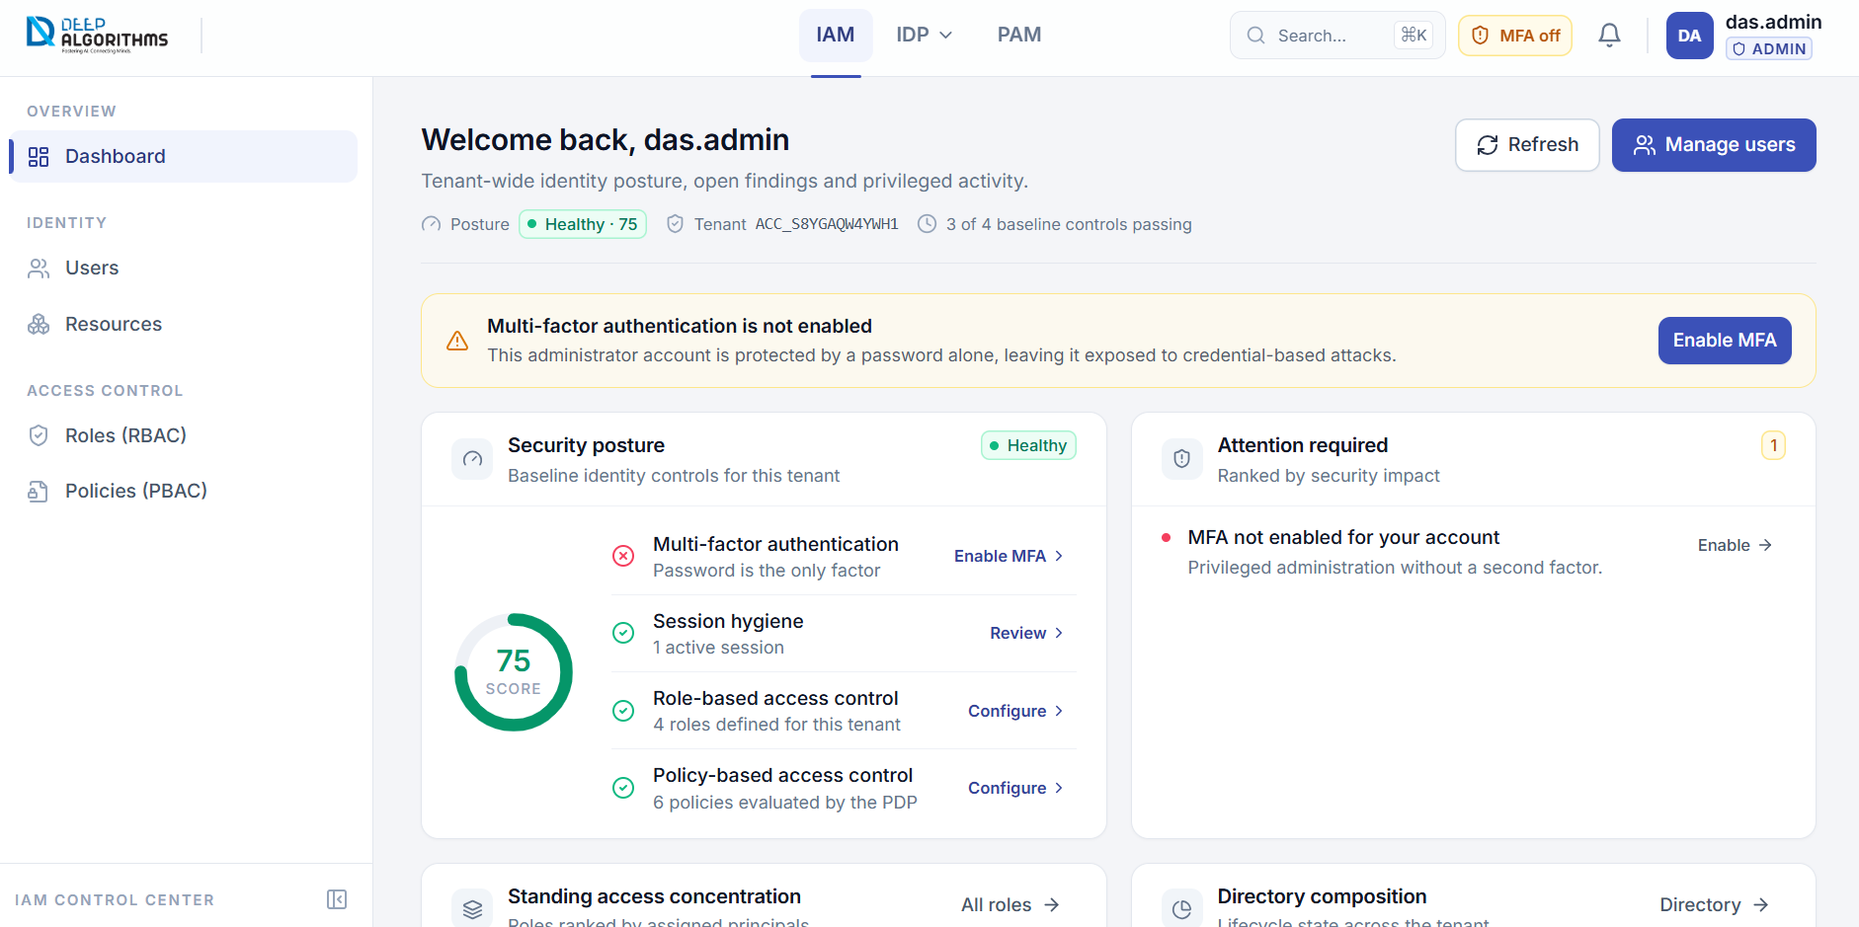
The Dashboard, showing the three-part layout: top bar, sidebar and working area.
The header greets you by name and shows Posture (Healthy, Needs attention or Critical, with a score out of 100), Tenant and Baseline controls passing. Refresh re-reads every figure; Manage users opens the Users page for administrators. If your own account has no second factor, an amber banner appears — select Enable MFA in it to reach the setup page.

5.1 Security posture
A circular score and a checklist of four baseline controls, each with a green tick or red cross, a short explanation and a link to the page where you can act on it. The score is the share of controls that pass, so fixing one raises it after you select Refresh.
Control | Passes when… | Link
Multi-factor authentication | Your account has a second factor enabled. | Enable MFA / Manage
Session hygiene | You have at least one and fewer than ten active sessions. | Review
Role-based access control | At least one role is defined in the tenant. | Configure
Policy-based access control | At least one policy exists. | Configure

5.2 The remaining panels
- Attention required — what to fix, most serious first, with a coloured dot for severity: a missing second factor, too many concurrent sessions, no roles, or no policies. Each row has an Enable, Review, Configure or Create button; when nothing needs attention it shows No open findings.
- Standing access concentration — ranks roles by how many people hold them. Select a bar to open that role, or All roles for the Roles page; the footer gives the total number of roles and how many have no assignments.
- Directory composition — total identities, the percentage active, and a bar split into Active, Disabled and Other states. Select Directory to open the Users page.
- Recent authorisation activity — the latest events, each with the action, a badge reading Allowed, Denied or Info, the person or system, the resource and the time. Select any row, or Open PAM, for Audit Logs.
- Your account — your username, email, account type, whether MFA is enabled, active sessions, last sign-in and tenant. Select Profile to open it.

06 USERS AND USER DETAILS
How to get there: IAM → sidebar → Identity → Users. Select any row, or its eye button, to open one person's detail page. This page is your company directory: see everyone in the tenant, create users, suspend or restore access, and export lists. If it asks for an Account ID first, type your tenant identifier and select Continue — the console remembers it.

6.1 Reading and filtering the directory
- Three figures above the table always describe the whole tenant: Total users, Active (can sign in) and Disabled (access suspended). Selecting one filters the table to exactly what it counts, and the All statuses dropdown always agrees with it.
- Type into Search username or email… to narrow the table as you type, or choose a state (Active, Disabled, Locked, Offboarded or Deleted) from All statuses. The line on the right states how many match; Clear filters resets it.
- Columns are User (initials, username, email), Status, Department, Title, Last sign-in and row actions: View user (eye) opens the detail page, Disable user suspends access at once and Enable user restores it. Select a heading with a sort arrow to sort; again to reverse.

6.2 Creating a user
1. Select New user at the top-right. The Create user dialog opens.
2. In First name and Last name, type the person's names. Only the letters A–Z are accepted — no numbers, spaces or punctuation — and the field tells you at once if it cannot accept what you type.
3. In Email, type a valid work email address, for example name@company.com.
4. Optionally fill in Department and Title. These are useful later, because access rules can refer to them.
5. Select Create user. If anything is missing or invalid, a summary appears at the top of the dialog and the affected fields are highlighted.
6. On success a User created window shows the generated Username and One-time password, and a spreadsheet with the same details downloads automatically.
7. Copy or save the credentials, give them to the new user through a secure channel, then select Done.
The one-time password is shown only in this window. Once you close it the password cannot be retrieved — the user would need a password reset instead.

6.3 Bulk actions and export
1. Tick the box at the left of each row you want, or the box in the table header to select every row on the page. A blue bar appears stating how many rows are selected.
2. Choose Disable, Enable or Export (downloads the selected users as a spreadsheet).
3. Wait for the confirmation. If some users could not be changed, it tells you how many succeeded and how many failed. Select Clear to drop the selection.
To export the directory, apply any filter you want reflected in the file, then select Export in the page header. The spreadsheet contains Username, Email, Status, Department, Title and Last Login for the rows shown.

6.4 The user detail page
This is everything the platform knows about one person, and everything you can change about their access. The header shows the username and email with Edit, Disable (when active) and Enable (when not); below sit the status badge, account type and creation date. Three tabs organise the page — Profile, Roles and Policies — and the number beside each is its count.

Editing profile details
1. Select Edit in the header. The dialog opens with the current values filled in.
2. Change First name and Last name as needed — letters and spaces only, since numbers and symbols are rejected as you type.
3. Change Email, Department or Title if required, then select Save. If a field is invalid, a summary appears at the top of the dialog; correct it and save again.

Assigning and removing a role
1. Select the Roles tab, then Assign.
2. In the Role box, start typing a role name. The list narrows as you type, and roles the person already holds are not offered.
3. Select the role, then Assign to confirm. The person immediately gains every permission that role grants.
4. To remove a role, select Detach on its row, read the confirmation stating which role will be removed, then select Detach again to proceed or Cancel. The person loses that role's permissions at once, unless another role or a direct policy grants the same thing.

The Policies tab
Effective Policies lists every policy that applies to this person, however it reached them, with source badges — Direct if attached to the person, or via <role name> through a role — plus, where available, the policy and attachment identifiers, who attached it and when. Direct Policy Attachments lists only the policies attached individually: the ones you can add and remove here.
1. In the Direct Policy Attachments card, select Attach.
2. In the Policy box, type part of a policy name or description and select the policy you want.
3. Optionally set Expires at; on that date the attachment is removed automatically. Dates in the past are not accepted. Leave it empty for access with no end date.
4. Select Attach. A confirmation appears and the policy is listed in both cards.
5. To remove one, select Detach on its row, read the confirmation naming the policy, then select Detach policy. The permissions are withdrawn unless a role still grants them.
Prefer roles for anything more than one person needs. Direct attachments are best kept for genuine exceptions, and are easier to review when they carry an expiry date.

07 RESOURCES
How to get there: IAM → sidebar → Identity → Resources. This is the register of the things you protect: until a system is registered here, policies have no stable name to refer to. Registering a resource does not change the system itself; it records its identity so access rules can name it.
ARN — a short, stable text identifier for a resource, for example iam:app/my-app. Policies match on the ARN, so once a resource is in use its ARN should not be changed. · Target URL — the web address of the resource, for example https://api.example.com, recorded for reference and shown in the table as a link.
Three figures sit above the table — Total resources, Active (evaluated in access decisions) and Inactive (registered but not evaluated); here they are information only, not filters. Type into Search name, type, ARN, URL, env or team… to narrow the table. The columns are Resource (name, type badge and ARN), Target URL, Environment, Team, Status and Created.

7.1 Registering a resource
1. Select Register resource at the top-right of the page.
2. In Resource name, type a clear name, for example user-management-api.
3. Choose a Resource type: application, api, dataset, database, service or storage. If none fits, choose Other… and type your own in Custom type.
4. In ARN, type the identifier policies will match on, for example iam:app/my-app. Choose it carefully — it should stay the same for the life of the resource.
5. In Target URL, type the full web address, beginning with http:// or https://. Optionally set Environment and Team to help you organise the registry.
6. Leave Active — evaluate this resource in access decisions ticked, unless you are registering something in advance and do not want it evaluated yet.
7. Select Register resource. Empty or invalid required fields are highlighted with a short message. On success a confirmation names the new resource and the table refreshes.

7.2 Disabling a resource
1. Find the resource and select the bin icon (Disable resource) at the end of its row.
2. Read the confirmation dialog: policies referring to this ARN stay in place but stop matching.
3. Select Disable resource to proceed, or Cancel. The table refreshes and the summary figures update.
Disabling a resource cannot be undone. If in doubt, note the resource's ARN and settings before you disable it.
Select Refresh to re-read the registry. If the list cannot be loaded at all, the page says so and offers Retry — deliberately different from an empty registry, so you are never misled into thinking you have none.

08 ROLES AND ROLE DETAILS
How to get there: IAM → sidebar → Access Control → Roles (RBAC). Select any role to open its detail page; you can also reach one from the Dashboard's concentration panel or from global search.
RBAC (role-based access control) — granting access by giving people roles, rather than by granting permissions to each person individually. It is the most reliable way to keep access consistent and reviewable.
The list compares roles at a glance: Role (name and description, with a shield icon marking platform-managed roles), Type (SYSTEM or CUSTOM), Assigned users (a dash means the count was not reported), Policies and Status. Search roles… searches names, descriptions and types. Select a row, or the arrow at its end, to open the role.

8.1 Creating a role
1. Select New role at the top-right.
2. In Role name, type a name of at least three characters. Lowercase, hyphenated names such as platform-operator read best in policy documents and audit records. A name already in use is rejected.
3. In Description, describe in one sentence what the role is allowed to do. Reviewers rely on this.
4. Leave Role type as CUSTOM unless you have been told to create a platform-managed role.
5. Optionally choose a Parent role. The new role then inherits every policy attached to that parent, on top of anything you attach directly.
6. Select Create role. Problems are listed at the top of the dialog. On success the new role appears in the table — it grants nothing yet, so attach policies to it next.
An empty tenant shows No roles yet with a New role button, and the Dashboard's role-based access control check fails — which is why creating your first role early is worthwhile.

8.2 The role detail page
This page answers three questions about one role: who holds it, which policies it carries, and what it lets people do. The header shows the name and description with Edit (change the description or parent role) and Disable; summary cards beneath show Assigned Users, Attached Policies and — if the role inherits from another — Inherits From.
1. Select Assign in the users card, type part of a name or email in the User box, select the person, then select Assign. People who already hold the role are not offered.
2. To remove someone, select the bin icon on their row and read the confirmation, which names the role and the person and warns that they lose every permission the role grants unless another role or a direct policy provides it. Select Detach role to proceed.
3. Select Attach in the policies card, type part of a policy name or description, select the one you want and select Attach. Every person holding this role immediately gains the permissions the policy grants.
4. To detach a policy, select the bin icon on its row, read the confirmation warning that everyone holding the role loses those permissions, then select Detach policy.
The Effective permissions table resolves every attached policy into the permissions the role grants: Effect (ALLOW or DENY, Deny first because a Deny always decides the outcome), Action (lines marked conditional apply only when extra conditions are met), Resource (an asterisk means everything) and From policy. If no policies are attached, the panel says the role grants nothing on its own; if some could not be read, a note says so.
To edit a role, select Edit, change the Description and choose or clear the Parent role, then Save. To take it out of service, select Disable and read the confirmation — everyone assigned this role loses its permissions — then select the confirm button.

09 POLICIES AND THE POLICY EDITOR
How to get there: IAM → sidebar → Access Control → Policies (PBAC). Select a policy on that page, or New policy, to open the editor.
PBAC (policy-based access control) — writing access rules as documents that can take attributes and conditions into account, rather than fixed permission lists. It allows rules such as "allow only people in the engineering department".
The list shows Policy (the name, a System badge where the platform manages it, and the description), Status and the actions Edit policy (pencil) and, for policies you own, Disable policy — system policies are protected, so no disable button is offered. Search policies… searches names and descriptions; select a row or the pencil to open the editor.

9.1 Disabling a policy
1. Select Disable policy on the policy's row.
2. Read the confirmation carefully: the policy stops being evaluated immediately, and requests that relied on it for an Allow decision will start to be denied. Existing sessions are not ended.
3. Select Disable policy to proceed, or Cancel. A confirmation appears and the list refreshes.
Before disabling a policy, open it and read Attached entities (section 9.4) to see which roles depend on it — the quickest way to understand who will be affected.

9.2 How the editor is organised
The editor reads top to bottom, and a bar at the bottom of the screen tells you whether you have unsaved changes.
- Policy information — Policy name is required; lowercase hyphenated names such as finance-read-only read best in audit records. In Description, explain why the policy exists and who it is for, because reviewers see this first. Document version is filled in for you.
- Identifiers & shape — read-only: the policy identifier, whether it is a system or custom policy, its status, when it was created and last updated, and a summary of its size. If it includes a wildcard, this panel says so.
- What this policy grants — one line per action listing Effect, Action, Resource and the Statement that produced it, Deny first. Use it to check your intent before you save.

9.3 Statements — the rules themselves
Statement — one rule inside a policy. It says whether to Allow or Deny, what actions it covers, which resources it applies to, and optionally under what conditions.
Each statement is a card whose header shows the statement number and name, an Incomplete badge if it is missing an action or a resource, a Conditional badge if it has conditions, and an Allow / Deny switch.
1. Set the effect using the Allow / Deny switch in the card header.
2. In Action, type one or more permissions separated by commas, for example iam:user:Read, iam:user:List. A value such as iam:* covers a whole service.
3. In Resource, select from the registry list. Type to search by name or ARN and choose as many as apply, or choose *All resources ()* for a wildcard. Values not in the registry are marked CUSTOM* but remain usable.
4. Optionally give the statement an ID in Statement ID — a short label such as AllowFinanceRead that appears in decision records.
5. Optionally add a Condition in JSON, for example { "StringEquals": { "user.department": "engineering" } }. It must be valid JSON.
Select Add statement to add an empty card, the copy icon to duplicate one, or the bin icon to remove one. A policy always keeps at least one card.
If a policy grants a wildcard action or resource, an amber notice appears near the top of the page. A wildcard matches everything it covers, including things added in future — scope it to named resources where the intent is narrower.

9.4 Editing as JSON, attached entities and saving
Select Edit as JSON to edit the document directly, then Back to form to read it back into the statement cards; if the text is not valid JSON a message says so and the form is left untouched. The Policy document panel shows exactly what will be stored and evaluated, and Copy places it on your clipboard.
For a saved policy, Attached entities lists the roles that inherit it today with the number of users each has; if it is attached to no role, the panel says so, and a note appears if only the first roles could be checked. To grant the policy to one person, select Attach to user here or in the page header, type part of a name or email, select the person, optionally set Expires at (past dates are not accepted), then select Attach.
1. Check the bar at the bottom of the screen: it reads either Unsaved changes with the number of statements ready to save, or a confirmation that there is nothing to save.
2. Select Create policy (new policy) or Save changes (existing policy). The same button is available in the page header.
3. If something is wrong — a missing name, a statement with no action or resource, or an invalid condition — a message explains exactly what to fix.
4. On success a confirmation appears and you are returned to the Policies list. To abandon your changes, select Cancel.

10 PAM — AUDIT LOGS AND ALERTS
How to get there: select PAM in the top bar; the sidebar changes to show Audit Logs and Alerts. Audit Logs is for investigation — filter, scan and inspect individual events when you need to know exactly what one person or system did, and when. Alerts is for analysis — understand refused attempts as a whole when you want to know what is being denied, to whom, and where it is concentrating.
Audit log — the permanent record of what happened; each entry is an event. · Authentication (AuthN) — proving who you are; records SUCCESS or FAILURE. · Authorisation (AuthZ) — deciding whether an identity may do something; records ALLOW or DENY. · Successful — an event that either authenticated successfully or was allowed; Denied / failed covers both a failed sign-in and a refused access decision. · Principal — the person or system that performed the action.

10.1 Audit Logs
This is the evidence trail for your tenant: filter it down to the events you care about, scan the list, then select one to see everything recorded about it.
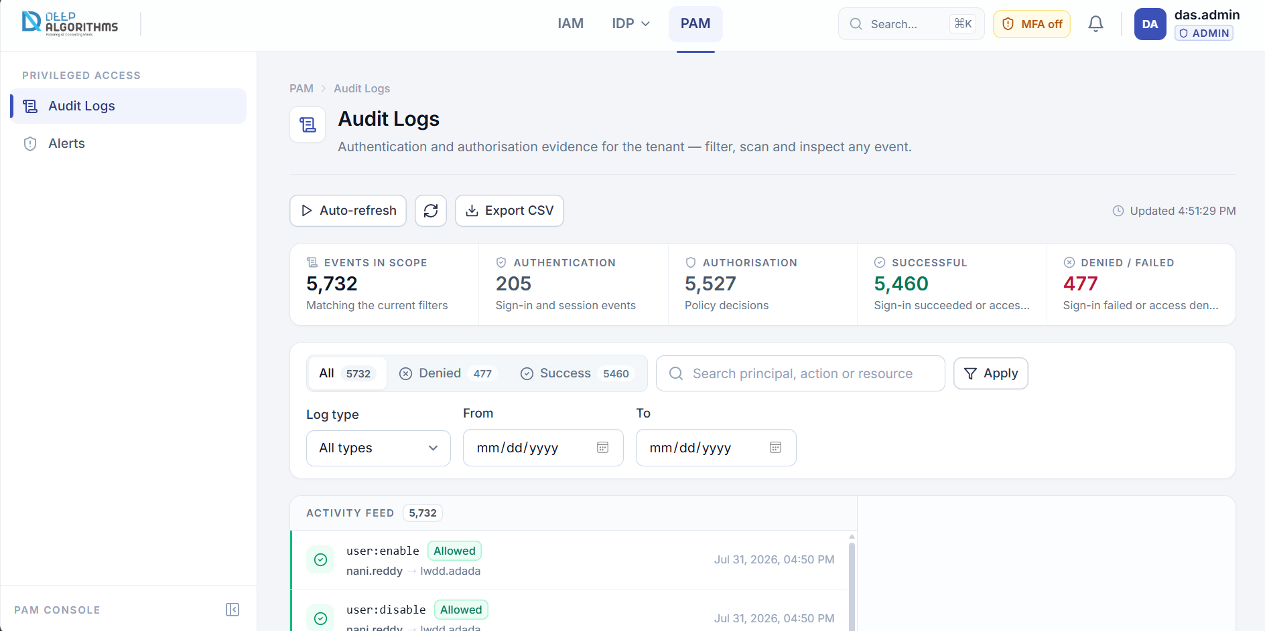
PAM → Audit Logs: filters, the event feed and the detail panel.
Live controls. Auto-refresh re-reads the page every 30 seconds and then reads Live · 30s; select it again to pause. The circular arrow refreshes once. Export CSV downloads the events listed as a spreadsheet of Time, Type, User, Action, Decision, Resource, Status and IP.
The scope band. Five figures describe everything matching your filters, not just the page in view: Events in scope, Authentication, Authorisation, Successful and Denied / failed. Where a figure came from a bounded set of recent events rather than a whole-set total, the hint text says so; one the platform cannot supply shows a dash rather than a possibly wrong number.

Filtering the trail
1. Decision. Choose All, Denied or Success in the segmented control. Each option carries its own count, so you can see how much evidence exists before you open it.
2. Text search. Type a principal, action or resource into the search box, then press Enter or select Apply. Search is applied on demand, not on every keystroke.
3. Log type. Choose All types, AuthN (sign-in events) or AuthZ (access decisions).
4. Date range. Set From and To to restrict the period. On a small screen, select More filters to reveal log type and dates.
5. Everything applied is echoed below the bar as removable chips under Applied. Select the X on a chip to clear just that one, or Reset to clear all filters — your rows-per-page choice is kept.

Reading the feed and inspecting one event
Each row carries a coloured bar on its left edge — red for a denial, green for an allowed action, blue for an access decision, grey for a sign-in — then the action name and a badge reading Denied, Allowed, AuthZ or AuthN, the principal, an arrow, the resource and the time. Use the range, page numbers and Prev / Next at the foot, and change Rows to 10, 20, 50 or 100.
1. Select any row in the feed. Its details appear in the panel on the right; on a narrow screen the panel replaces the feed and offers Back to feed.
2. Read the header — the action name, the time and a red or green outcome icon — then the badges: the decision, whether it was an authentication or authorisation event, and the short event identifier.
3. Under Principal & target, read the principal, email, user identifier, IP address and resource; select the small copy icon next to an identifier to copy it. User agent shows the browser or client used, where recorded.
4. For a refused event, read Matched policies — the rules that produced the decision, each with its effect. This is the "why" behind a denial.
5. Select Raw event payload to expand the complete technical record, and again to collapse it.
6. Select View principal to open that person's user page, or View resource to look the resource up in the registry. Select the X at the top of the panel to close it.
Drilling in from Alerts opens this page with the search term filled in and the decision filter set to Denied; Reset clears it. If your session may not read the tenant audit trail, the feed explains this instead of showing an empty list, and no Retry is offered because repeating the request cannot succeed — sign out and back in, or ask a root administrator for audit access.

10.2 Alerts
How to get there: PAM → sidebar → Alerts, or the bell. Every entry is an access attempt that was refused, and the page shows the shape of the problem first — how many, over what period, to whom and against what — before individual records. Opening it counts as reviewing your alerts, so the bell's unread count is cleared.
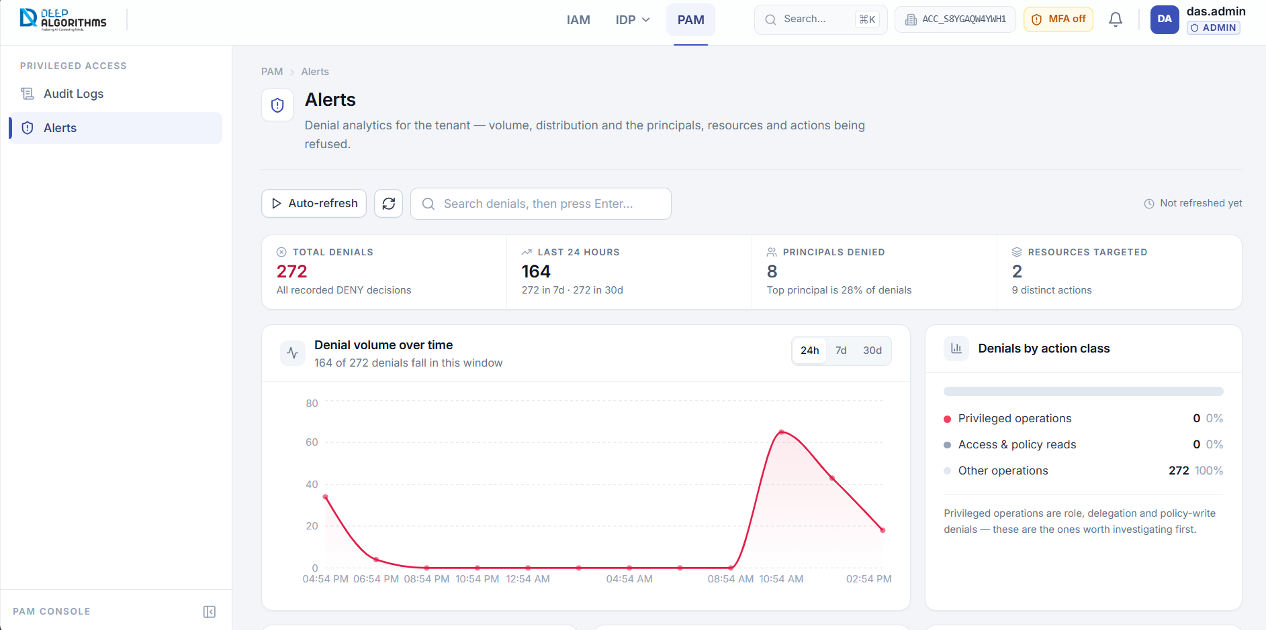
PAM → Alerts: volume band, trend chart and ranked panels.
Live controls. Auto-refresh, when on, reads Live · 60s and updates every 60 seconds. Search denials, then press Enter… searches principal, action, resource and reason; Clear appears once applied.
The volume band. Total denials counts every recorded refusal, or those matching your search. Last 24 hours shows denials in the past day, with 7-day and 30-day figures underneath. Principals denied shows how many distinct identities were refused, with the share held by the busiest one. Resources targeted shows how many distinct resources and actions were involved.
1. Denial volume over time. Choose a window with the 24h / 7d / 30d control. The subtitle states how many denials fall inside it out of the total, and says so if the analysis used a bounded set of recent denials. If there were none, the panel says so rather than drawing an empty chart.
2. Denials by action class. Denials are grouped so you can tell routine refusals from important ones: Privileged operations (roles, delegation or policy changes — investigate first), Access & policy reads and Other operations. The bar shows the proportions; the list beneath gives the count and percentage for each.
3. The three ranked panels. Top denied principals, Most targeted resources and Most denied actions show which identities are refused most, which systems people are refused access to, and which operations are refused most, with privileged actions highlighted in red.
4. To investigate a ranked row, select its bar. Audit Logs opens with that term already searched and the decision filter set to Denied.
At the foot of the page, Recent denials lists individual refusals with the same layout as the audit feed; select a row to open its detail panel, including Matched policies. If there are no denials at all, the feed shows All clear.

11 YOUR ACCOUNT

11.1 My profile
How to get there: profile menu (top right) → My profile. The left card shows your initials, username and email, your status badge, whether MFA is on or off, your user type and last sign-in. The right card, Profile attributes, lists the attributes recorded against your identity — the values access rules can refer to, such as a department.
1. Select Change password at the bottom of the left card.
2. In Current password, type the password you use now.
3. In New password, type your new password. It must be at least 10 characters and include an upper-case letter, a lower-case letter, a digit and a special character.
4. Type the same value again in Confirm new password, then select Update password. If the two entries do not match, a message says so and nothing is saved.
5. On success, sign in again with the new password on your other devices.

11.2 Multi-factor authentication
How to get there: profile menu → Multi-factor authentication, the amber MFA off chip in the top bar, or Enable MFA on the Dashboard. The badge at the top of the first card shows whether MFA is ACTIVE or DISABLED.
1. Install an authenticator app on your phone if you do not have one. Any standard app works, for example Google Authenticator or 1Password.
2. Select Set up authenticator. A QR code appears. Open your app, choose to add an account and scan it. If you cannot scan, copy the value shown in Manual key (if you can't scan) and type it into your app instead.
3. Your app now shows a six-digit code that changes every 30 seconds. Type the current code into 6-digit code.
4. Select Verify & enable. The status badge changes to ACTIVE and a list of backup codes is displayed.
5. Save them now: select Copy in the Save your backup codes card, paste them into a secure password manager or another safe store — never an email or an unprotected file — then close the card.
Backup code — a single-use code that lets you sign in if you lose access to your authenticator app. Each code works once.
To generate new codes, select Regenerate backup codes, type your Password and a Current MFA code, then Regenerate; the previous codes stop working, so replace your saved copy. To turn the second factor off, select Disable MFA, type your Password and a Current MFA code (both required), then Disable MFA. That leaves your account protected by a password alone: the Dashboard reports it as a high-severity finding and the amber MFA off chip returns.

11.3 Active sessions
Session — one signed-in device. Ending (revoking) a session signs that device out immediately and forces it to authenticate again.
How to get there: profile menu → Active sessions. The page shows every device signed in to your account, with a summary line giving the total and how many are other than the one you are using; your current device is shown first, tinted, and marked This device. Each row shows the browser and operating system, how the session was created (Password, SSO or Token), the IP address, when it was signed in and when it expires.
1. To end one session, find the device you do not recognise and select the sign-out icon at the end of its row.
2. Read the confirmation — the device is signed out immediately and must authenticate again — then select the confirm button.
3. To end every other session, select Sign out all other sessions in the page header. It appears only when other sessions exist.
4. Read the confirmation, which states how many sessions will end and confirms you stay signed in on this device, then select the confirm button.
Reviewing sessions is one of the four baseline controls on the Dashboard, which raises an unusually high number of concurrent sessions as a finding and links here.

12 CONVENTIONS ACROSS THE CONSOLE
Convention | How it behaves
Page header | A breadcrumb, the page title, a one-line description, live context such as your tenant identifier, and the page's main buttons on the right.
Summary bands | The figures above a table always describe the whole tenant or the whole filtered set — never just the rows on screen. On the Users page they are also filters.
Tables | Select a heading with a sort arrow to sort, and again to reverse. The two small icons at the top-right switch between comfortable and compact rows, and Columns ticks the columns you want (Show all columns restores them); both are remembered per table. Below tablet width, tables become a stacked list, so there is no sideways scrolling.
Pagination | The range and total (for example 11–20 of 348), a Rows selector, numbered pages and Prev / Next; on a phone this becomes a simple page / total indicator.
Search and filters | List pages filter as you type; PAM search fields wait for Enter or Apply. Applied filters are echoed as removable chips, and Clear filters or Reset always returns the unfiltered view.
Forms and validation | Required fields must be completed before a form will save. Problems appear both on the field and in a summary at the top of the dialog, and some fields check as you type. Buttons show a spinner and a wording change such as Registering…, so do not select them twice. Cancel or Escape closes a dialog without saving.
Confirmations and messages | Anything that removes access asks first and states the consequence in plain words. Short messages appear briefly at the edge of the screen; amber notices warn you about something, and error panels replace content that could not be loaded and offer Retry.
Keyboard shortcuts | Ctrl+K / ⌘+K opens or closes global search; ↑ and ↓ move through results or the profile menu; Enter opens the highlighted result or applies a search; Escape closes search, a menu, a dialog or the mobile sidebar.

12.1 Status badges and downloaded files
ACTIVE / ENABLED | In use and working normally. | DELETED | Removed.
DISABLED | Deliberately switched off; can be restored. | EXPIRED | Passed its end date and no longer valid.
LOCKED | Temporarily blocked, usually after repeated failed sign-ins. | REVOKED | Withdrawn before its end date.
PENDING_VERIFICATION | Created but not yet verified. | SUSPENDED | A tenant that has been put on hold.
OFFBOARDED | The person has left and access has been withdrawn.

The console downloads a spreadsheet in five places: Register Tenant on success (tenant and root administrator credentials), Users → New user (the new user's username and one-time password), Users → Export (the users currently shown), Users → selection → Export (the selected users only) and PAM Audit Logs → Export CSV (the events currently listed).
Credential files contain passwords. Store them in a password manager or an access-controlled location, and delete stray copies from your downloads folder.

13 ADDITIONAL PAGES REACHABLE BY DIRECT LINK
These pages are part of the console but are not listed in the sidebar in the current build. Administrators reach them by typing their address, or by following a link from another page, and each uses the conventions in section 12. If a page shows a card asking for an Account ID, type your tenant identifier and select Continue.
Page | Address | Purpose
Service Accounts | /identity/service-accounts | Non-human identities used by software rather than people. Create one with a name and description, open its Keys, or delete it — which revokes all of its keys.
API Keys | /identity/api-keys | The keys that let software authenticate. Open this page from a service account to generate a key with a name and a lifetime in days. The key is shown once and can be copied; keys can also be revoked from the list.
Decision Simulator | /pbac/check | Tests what the platform would decide without changing anything. Choose a principal, type an action and a resource ARN, optionally add resource attributes as JSON, then select Evaluate. The result shows ALLOW or DENY with the full decision record.
Tenants | /identity/tenants | Registers an additional company or account from inside the console, showing the resulting Account ID, company, domain and status.
IAM Control (as a Service) | /integrations/iam-control | Reference information on using the platform's decision service from your own applications.
SSO Providers | /settings/sso | Reference information about the single sign-on providers configured for this deployment.

14 COMMON TASKS — QUICK REFERENCE
I want to… | Do this
Add a new employee | IAM → Users → New user → complete the form → save the one-time credentials → open the user → Roles → Assign.
Stop someone signing in today | IAM → Users → find them → Disable user. Reverse it later with Enable user.
Give a team access to a new system | IAM → Resources → Register resource → Policies → New policy naming that ARN → Roles → open the team's role → Attach the policy.
Give one person a temporary exception | IAM → Users → open them → Policies → Attach → choose the policy → set Expires at.
See exactly what a role allows | IAM → Roles → open the role → read Effective permissions.
Find out who holds a role | IAM → Roles → open the role → Assigned users.
Find out who is affected by a policy | IAM → Policies → open it → Attached entities.
Investigate a refused request | PAM → Alerts → select the principal, resource or action → the audit trail opens pre-filtered → select the event → read Matched policies.
Produce an activity report for a period | PAM → Audit Logs → set From and To → Export CSV.
Check whether the tenant is configured safely | IAM → Dashboard → read Security posture and Attention required.
Protect my own account | Profile menu → Multi-factor authentication → Set up authenticator.
Remove a device I do not recognise | Profile menu → Active sessions → revoke that session.
Test a rule before relying on it | Open the Decision Simulator (/pbac/check) and evaluate the principal, action and resource.

15 TROUBLESHOOTING
What you see | What to do
Sign-in is refused | Check all three fields, including the Account ID. For security the message does not say which was wrong. If you have forgotten your password, use Forgot password?.
The verification code is rejected | Wait for your app to show a new code and enter that. If your phone is unavailable, use a saved backup code.
A page asks for an Account ID | Type your tenant identifier and select Continue. It is remembered afterwards.
A list is empty but you expected rows | Check for applied filters — chips or a highlighted summary figure — and select Clear filters or Reset.
A panel says content could not be loaded | Select Retry. If it keeps failing, refresh the page, then contact your administrator.
The audit trail says it is not available to this session | Your session is not permitted to read the tenant trail. Sign out and back in, or ask a root administrator for audit access.
A figure shows a dash instead of a number | The platform could not supply that figure for the current scope. The console shows a dash rather than a number that might be wrong.
A count seems to describe only one page | It does not. Summary bands describe the whole tenant or filtered set; the toolbar line beside a search box describes your current query.
A credentials download did not start | Use Download again or Copy while the result is still on screen. Check your browser's download blocker.
The one-time password window was closed too early | The password cannot be recovered. Ask the user to reset their password, or create the record again.
A user still has access after a role was removed | Open the user → Policies → Effective Policies and look at the source badges. Another role, or a direct attachment, may grant the same permission.
A policy has no effect | Check that it is ACTIVE, that its statements are complete (no Incomplete badge), that the resource ARN matches a registered and active resource, and that no Deny rule overrides it.
The screen looks cramped | Collapse the sidebar with the arrow button at its foot, and switch the table to compact rows.

16 GLOSSARY
Account ID | The identifier of your tenant, usually ACC-XXXXXXXX. Required at sign-in. | Parent role | A role whose policies are inherited by another role.
Action | Something that can be done, named in a policy, for example iam:user:Read. | PBAC | Policy-based access control — access rules written as documents that can include conditions.
Allow / Deny | The two outcomes of an access decision. A Deny always wins over an Allow. | Policy | A document of rules stating what may and may not be done, and to what.
ARN | The stable text identifier of a registered resource, which policies match on. | Principal | The person or system that performed an action.
Attribute | A fact recorded about an identity or resource that a policy condition can test. | RBAC | Role-based access control — granting access by assigning roles.
Audit log | The permanent record of sign-ins and access decisions. | Resource | A protected system, application, dataset or service, registered with an ARN.
Authentication (AuthN) | Proving who you are. Records SUCCESS or FAILURE. | Role | A collection of permissions granted to users as a single unit.
Authorisation (AuthZ) | Deciding whether an identity may do something. Records ALLOW or DENY. | Service account | An identity used by software rather than a person.
Backup code | A single-use code that lets you sign in when your authenticator app is unavailable. | Session | One signed-in device. Revoking it signs that device out.
Denial | An access attempt that was refused. Denials are the subject of the PAM Alerts page. | Statement | One rule inside a policy: an effect, actions, resources and optional conditions.
Effective policies | Everything that applies to one person, directly or inherited through a role. | Status badge | The coloured label showing the state of a record, such as ACTIVE or DISABLED.
IAM | Identity and Access Management — who exists and what they may do. | System policy / role | A policy or role managed by the platform, protected from routine changes.
MFA | Multi-factor authentication — a second proof of identity in addition to a password. | Tenant | A separate workspace for one company, with its own users, roles, policies and records.
PAM | Privileged Access Management — what happened, and the analysis of refusals. | Wildcard | The asterisk character, meaning "everything this covers", including items added later.

End of manual · DEEP ALGORITHMS IAM & PAM Console

