Experiment – 4
Aim – To implement various Feature Selection Techniques and Train Models based on the selected features.
Logistic Regression Model:
Import data and data preprocessing –
import pandas as pd
df=pd.read_csv('breast-cancer.csv')
X=df.drop('diagnosis',axis=1)
Y=df['diagnosis']
from sklearn.preprocessing import LabelEncoder
X = X.drop(columns=['Unnamed: 32'])
le = LabelEncoder()
Y = le.fit_transform(Y)
Import packages –
from sklearn.linear_model import LogisticRegression
from sklearn.model_selection import train_test_split
from sklearn.metrics import accuracy_score, confusion_matrix, classification_report
from sklearn.preprocessing import StandardScaler
from sklearn.feature_selection import SelectKBest, f_classif, chi2, mutual_info_classif
from sklearn.preprocessing import MinMaxScaler
import matplotlib.pyplot as plt
import numpy as np
from sklearn.metrics import roc_curve, roc_auc_score
F-classif (ANOVA F-test) –
F-Classif is a univariate feature selection method used in classification problems and is based on the ANOVA (Analysis of Variance) F-test. It evaluates each feature independently by measuring how strongly it is related to the target class. The method works by comparing the variation of feature values between different classes with the variation within the same class. Features that show large differences in mean values across classes receive higher F-scores and are considered more relevant for classification tasks.
The F-statistic is calculated as the ratio of between-class variance to within-class variance, and a corresponding p-value indicates the statistical significance of each feature. A high F-score and a low p-value suggest that the feature has a strong influence on class separation. F-Classif works best with numerical features and categorical targets, does not require feature scaling, and is computationally efficient. However, since it evaluates features individually, it does not capture interactions or non-linear relationships between features.x
# 1. Split first
X_train, X_test, y_train, y_test = train_test_split(
X, Y, test_size=0.3, random_state=42
)
# 2. Feature selection
selector = SelectKBest(score_func=f_classif, k=7)
X_train_selected = selector.fit_transform(X_train, y_train)
X_test_selected = selector.transform(X_test)
# # Get the selected feature columns (boolean mask)
selected_columns = X.columns[selector.get_support()]
# # Print the names of the selected features
print("Selected Features:", selected_columns)
Selected Features: Index(['radius_mean', 'perimeter_mean', 'concave points_mean', 'radius_worst',
'perimeter_worst', 'area_worst', 'concave points_worst'],
dtype='object')
# 3. Scaling
scaler = StandardScaler()
X_train_scaled = scaler.fit_transform(X_train_selected)
X_test_scaled = scaler.transform(X_test_selected)
# 4. Train model
model = LogisticRegression(max_iter=1000)
model.fit(X_train_scaled, y_train)
y_pred = model.predict(X_test_scaled)
y_pred
array([0, 1, 1, 0, 0, 1, 1, 1, 1, 0, 0, 1, 0, 1, 0, 1, 0, 0, 0, 1, 1, 0,
1, 0, 0, 0, 0, 0, 0, 1, 0, 0, 0, 0, 0, 0, 1, 0, 1, 0, 0, 1, 0, 0,
0, 0, 0, 0, 0, 0, 1, 1, 0, 0, 0, 0, 0, 1, 1, 0, 0, 1, 1, 0, 0, 0,
1, 1, 0, 0, 1, 1, 0, 1, 0, 0, 0, 1, 0, 0, 1, 0, 0, 1, 1, 1, 1, 1,
0, 0, 0, 0, 0, 0, 0, 0, 1, 1, 0, 1, 1, 0, 1, 1, 0, 0, 0, 1, 1, 0,
1, 0, 0, 1, 0, 1, 0, 0, 0, 1, 0, 0, 0, 1, 0, 1, 1, 0, 0, 1, 1, 1,
0, 0, 0, 1, 0, 0, 1, 1, 0, 1, 0, 0, 1, 0, 1, 1, 0, 0, 1, 0, 0, 0,
0, 1, 1, 0, 0, 0, 0, 0, 0, 0, 0, 0, 0, 0, 0, 1, 0])
#5. Metrics
accuracy = accuracy_score(y_test, y_pred)
conf_matrix = confusion_matrix(y_test, y_pred)
class_report = classification_report(y_test, y_pred)
print(f"Accuracy: {accuracy}")
print(f"Confusion Matrix:\n{conf_matrix}")
print(f"Classification Report:\n{class_report}")
Accuracy: 0.9649122807017544
Confusion Matrix:
[[105 3]
[ 3 60]]
Classification Report:
precision recall f1-score support

0 0.97 0.97 0.97 108
1 0.95 0.95 0.95 63

accuracy 0.96 171
macro avg 0.96 0.96 0.96 171
weighted avg 0.96 0.96 0.96 171
#Confusion Matrix
cm = confusion_matrix(y_test, y_pred)
plt.figure()
plt.imshow(cm)
plt.title("Confusion Matrix")
plt.colorbar()
plt.xlabel("Predicted Label")
plt.ylabel("True Label")
# Show values inside cells
for i in range(cm.shape[0]):
for j in range(cm.shape[1]):
plt.text(j, i, cm[i, j], ha="center", va="center")
plt.show()
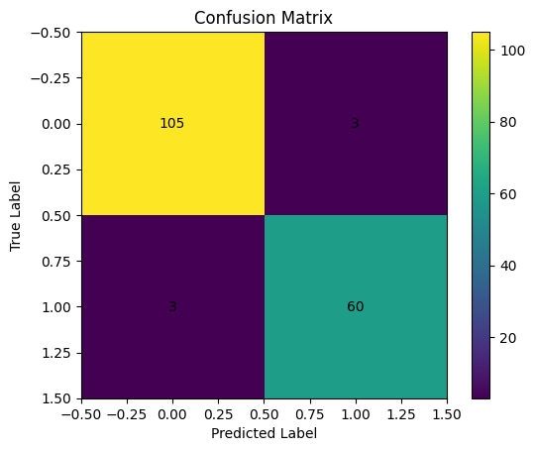
# ROC curve
y_prob = model.predict_proba(X_test_scaled)[:, 1]
# Compute the ROC curve
fpr, tpr, thresholds = roc_curve(y_test, y_prob)
# Calculate the AUC (Area Under the Curve)
roc_auc = roc_auc_score(y_test, y_prob)
plt.figure(figsize=(8, 6))
plt.plot(fpr, tpr, color='darkorange', lw=2, label=f'ROC curve (AUC = {roc_auc:.2f})')
plt.plot([0, 1], [0, 1], color='navy', lw=2, linestyle='--') # Diagonal line (random classifier)
plt.xlim([0.0, 1.0])
plt.ylim([0.0, 1.05])
plt.xlabel('False Positive Rate')
plt.ylabel('True Positive Rate (Recall)')
plt.title('Receiver Operating Characteristic (ROC) Curve')
plt.legend(loc='lower right')
plt.show()
print(f"AUC (Area Under the Curve): {roc_auc:.2f}")
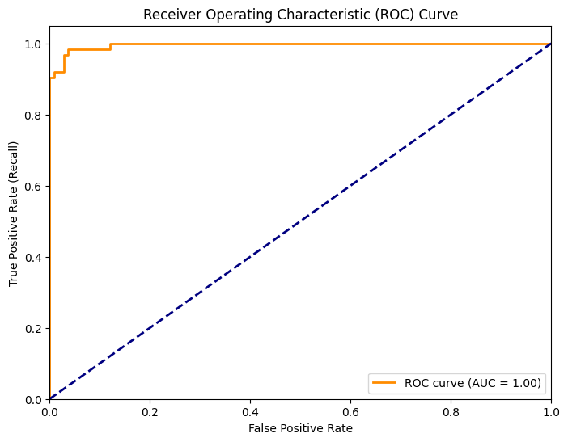

Chi2 Test
The Chi-square (χ²) test is a statistical feature selection method used in classification problems to measure the dependence between each input feature and the target class. It evaluates whether the observed frequency distribution of a feature is significantly different across different class labels. If a feature and the target variable are independent, the Chi-square value will be low; a high Chi-square value indicates that the feature is strongly associated with the class and is therefore important for classification.
The Chi-square test works only with non-negative feature values, which is why scaling methods like Min–Max scaling are commonly applied before using it. It is especially suitable for categorical data or discretized numerical features and is often used in text classification and count-based datasets. While the Chi-square test is simple and computationally efficient, it evaluates each feature independently and cannot capture interactions between features or handle negative values directly.

# 1. Split first
X_train, X_test, y_train, y_test = train_test_split(
X, Y, test_size=0.3, random_state=42
)
# 2. Scaling
scaler = MinMaxScaler()
X_train_scaled = scaler.fit_transform(X_train)
X_test_scaled = scaler.transform(X_test)
# Select
selector = SelectKBest(score_func=chi2, k=7)
X_train_selected = selector.fit_transform(X_train_scaled, y_train)
X_test_selected = selector.transform(X_test_scaled)
# 3. Feature names
selected_columns = X_train.columns[selector.get_support()]
print("Selected Features:", selected_columns)
Selected Features: Index(['concavity_mean', 'concave points_mean', 'radius_worst',
'perimeter_worst', 'area_worst', 'concavity_worst',
'concave points_worst'],
dtype='object')
# 4. Train model
model = LogisticRegression(max_iter=1000)
model.fit(X_train_selected, y_train)
y_pred = model.predict(X_test_selected)
#5. Metrics
accuracy = accuracy_score(y_test, y_pred)
conf_matrix = confusion_matrix(y_test, y_pred)
class_report = classification_report(y_test, y_pred)
print(f"Accuracy: {accuracy}")
print(f"Confusion Matrix:\n{conf_matrix}")
print(f"Classification Report:\n{class_report}")
Accuracy: 0.9415204678362573
Confusion Matrix:
[[105 3]
[ 7 56]]
Classification Report:
precision recall f1-score support

0 0.94 0.97 0.95 108
1 0.95 0.89 0.92 63

accuracy 0.94 171
macro avg 0.94 0.93 0.94 171
weighted avg 0.94 0.94 0.94 171
#Confusion Matrix
cm = confusion_matrix(y_test, y_pred)
plt.figure()
plt.imshow(cm)
plt.title("Confusion Matrix")
plt.colorbar()
plt.xlabel("Predicted Label")
plt.ylabel("True Label")
# Show values inside cells
for i in range(cm.shape[0]):
for j in range(cm.shape[1]):
plt.text(j, i, cm[i, j], ha="center", va="center")
plt.show()
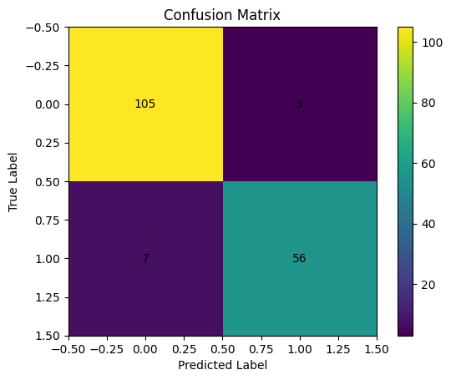
# ROC curve
y_prob = model.predict_proba(X_test_selected)[:, 1]
# Compute the ROC curve
fpr, tpr, thresholds = roc_curve(y_test, y_prob)
# Calculate the AUC (Area Under the Curve)
roc_auc = roc_auc_score(y_test, y_prob)
plt.figure(figsize=(8, 6))
plt.plot(fpr, tpr, color='darkorange', lw=2, label=f'ROC curve (AUC = {roc_auc:.2f})')
plt.plot([0, 1], [0, 1], color='navy', lw=2, linestyle='--') # Diagonal line (random classifier)
plt.xlim([0.0, 1.0])
plt.ylim([0.0, 1.05])
plt.xlabel('False Positive Rate')
plt.ylabel('True Positive Rate (Recall)')
plt.title('Receiver Operating Characteristic (ROC) Curve')
plt.legend(loc='lower right')
plt.show()
print(f"AUC (Area Under the Curve): {roc_auc:.2f}")
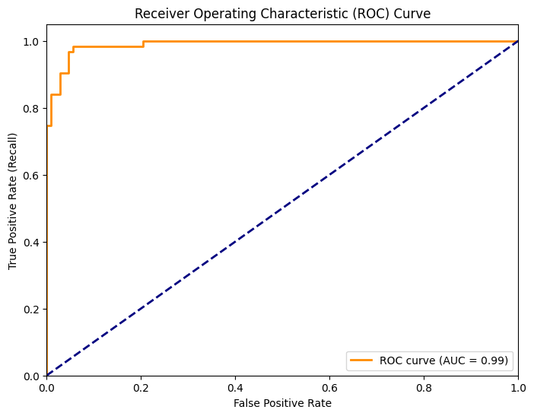

Mutual_info_classif –
Mutual Information for Classification (mutual_info_classif) is a feature selection method that measures the amount of information a feature provides about the target class. It is based on information theory and quantifies how much knowing the value of a feature reduces the uncertainty of the class label. If a feature contains no useful information about the target, its mutual information score will be close to zero; higher values indicate stronger dependency between the feature and the class.
Unlike statistical tests such as F-test or Chi-square, mutual_info_classif can capture both linear and non-linear relationships between features and the target variable. It does not require feature scaling and works with continuous as well as discrete features. However, since it estimates probabilities from data, it can be computationally more expensive and may be sensitive to sample size. Like other univariate methods, it evaluates features independently and does not account for interactions between multiple features.

# 1. Train–test split
X_train, X_test, y_train, y_test = train_test_split(
X, Y, test_size=0.3, random_state=42
)
# 2. Feature selection (NO scaling here)
selector = SelectKBest(score_func=mutual_info_classif, k=7)
X_train_selected = selector.fit_transform(X_train, y_train)
X_test_selected = selector.transform(X_test)
selected_columns = X_train.columns[selector.get_support()]
print("Selected Features:", selected_columns)
# 3. Scaling (ONLY because Logistic Regression needs it)
scaler = StandardScaler()
X_train_scaled = scaler.fit_transform(X_train_selected)
X_test_scaled = scaler.transform(X_test_selected)
Selected Features: Index(['perimeter_mean', 'concavity_mean', 'concave points_mean',
'radius_worst', 'perimeter_worst', 'area_worst',
'concave points_worst'],
dtype='object')
#4. Train model
model = LogisticRegression(max_iter=1000)
model.fit(X_train_scaled, y_train)
y_pred = model.predict(X_test_scaled)
#5. Metrics
accuracy = accuracy_score(y_test, y_pred)
conf_matrix = confusion_matrix(y_test, y_pred)
class_report = classification_report(y_test, y_pred)
print(f"Accuracy: {accuracy}")
print(f"Confusion Matrix:\n{conf_matrix}")
print(f"Classification Report:\n{class_report}")
Accuracy: 0.9649122807017544
Confusion Matrix:
[[105 3]
[ 3 60]]
Classification Report:
precision recall f1-score support

0 0.97 0.97 0.97 108
1 0.95 0.95 0.95 63

accuracy 0.96 171
macro avg 0.96 0.96 0.96 171
weighted avg 0.96 0.96 0.96 171
#Confusion Matrix
cm = confusion_matrix(y_test, y_pred)
plt.figure()
plt.imshow(cm)
plt.title("Confusion Matrix")
plt.colorbar()
plt.xlabel("Predicted Label")
plt.ylabel("True Label")
# Show values inside cells
for i in range(cm.shape[0]):
for j in range(cm.shape[1]):
plt.text(j, i, cm[i, j], ha="center", va="center")
plt.show()

# ROC curve
y_prob = model.predict_proba(X_test_scaled)[:, 1]
# Compute the ROC curve
fpr, tpr, thresholds = roc_curve(y_test, y_prob)
# Calculate the AUC (Area Under the Curve)
roc_auc = roc_auc_score(y_test, y_prob)
plt.figure(figsize=(8, 6))
plt.plot(fpr, tpr, color='darkorange', lw=2, label=f'ROC curve (AUC = {roc_auc:.2f})')
plt.plot([0, 1], [0, 1], color='navy', lw=2, linestyle='--') # Diagonal line (random classifier)
plt.xlim([0.0, 1.0])
plt.ylim([0.0, 1.05])
plt.xlabel('False Positive Rate')
plt.ylabel('True Positive Rate (Recall)')
plt.title('Receiver Operating Characteristic (ROC) Curve')
plt.legend(loc='lower right')
plt.show()
print(f"AUC (Area Under the Curve): {roc_auc:.2f}")
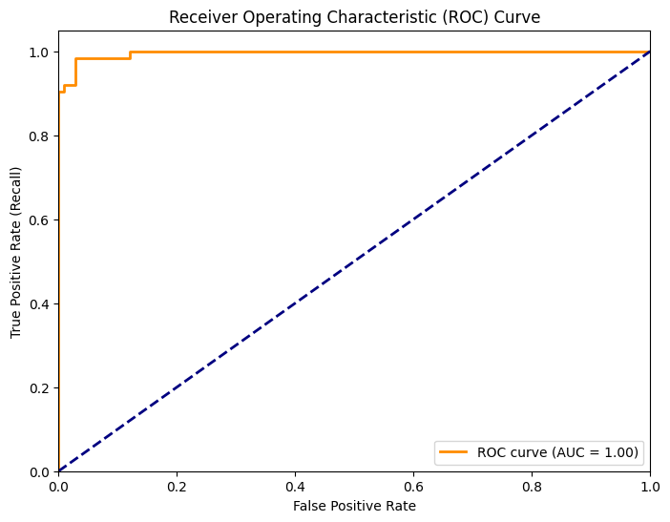

Decision Tree Model:
Import data and data preprocessing –
import pandas as pd
df=pd.read_csv('breast-cancer.csv')
X=df.drop('diagnosis',axis=1)
Y=df['diagnosis']
from sklearn.preprocessing import LabelEncoder
X = X.drop(columns=['Unnamed: 32'])
le = LabelEncoder()
Y = le.fit_transform(Y)
Import Packages –
from sklearn.model_selection import train_test_split
from sklearn.feature_selection import SelectKBest, f_classif, chi2, mutual_info_classif
from sklearn.tree import DecisionTreeClassifier
from sklearn.metrics import accuracy_score, confusion_matrix, classification_report
from sklearn.metrics import roc_curve, roc_auc_score
import matplotlib.pyplot as plt
import numpy as np
from sklearn.preprocessing import MinMaxScaler
F-classif (ANOVA)-
# 1. Split
X_train, X_test, y_train, y_test = train_test_split(
X, Y, test_size=0.3, random_state=42
)
# 2. Feature Selection
selector = SelectKBest(score_func=f_classif, k=7)
X_train_selected = selector.fit_transform(X_train, y_train)
X_test_selected = selector.transform(X_test)
print("Selected Features:", X.columns[selector.get_support()])
Selected Features: Index(['radius_mean', 'perimeter_mean', 'concave points_mean', 'radius_worst',
'perimeter_worst', 'area_worst', 'concave points_worst'],
dtype='object')
# 3. Train Decision Tree
model = DecisionTreeClassifier(random_state=42)
model.fit(X_train_selected, y_train)
# 4. Prediction
y_pred = model.predict(X_test_selected)
# 5. Metrics
print("Accuracy:", accuracy_score(y_test, y_pred))
print("Confusion Matrix:\n", confusion_matrix(y_test, y_pred))
print("Classification Report:\n", classification_report(y_test, y_pred))
Accuracy: 0.9532163742690059
Confusion Matrix:
[[105 3]
[ 5 58]]
Classification Report:
precision recall f1-score support

0 0.95 0.97 0.96 108
1 0.95 0.92 0.94 63

accuracy 0.95 171
macro avg 0.95 0.95 0.95 171
weighted avg 0.95 0.95 0.95 171
cm = confusion_matrix(y_test, y_pred)
plt.imshow(cm)
plt.title("Confusion Matrix - Decision Tree (F-test)")
plt.colorbar()
plt.xlabel("Predicted")
plt.ylabel("Actual")
for i in range(cm.shape[0]):
for j in range(cm.shape[1]):
plt.text(j, i, cm[i, j], ha="center", va="center")
plt.show()
#Confusion Matrix
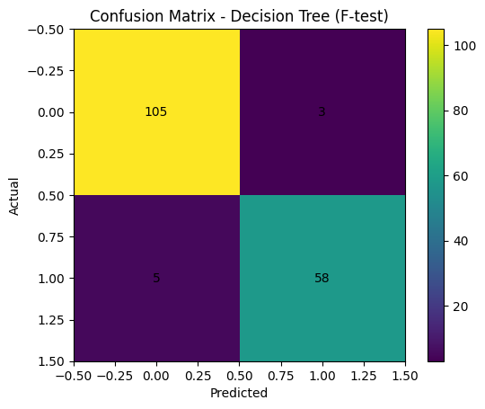
#ROC Curve
y_prob = model.predict_proba(X_test_selected)[:, 1]
fpr, tpr, _ = roc_curve(y_test, y_prob)
roc_auc = roc_auc_score(y_test, y_prob)
plt.plot(fpr, tpr, label=f"AUC = {roc_auc:.2f}")
plt.plot([0,1],[0,1],'--')
plt.legend()
plt.title("ROC Curve - Decision Tree (F-test)")
plt.show()
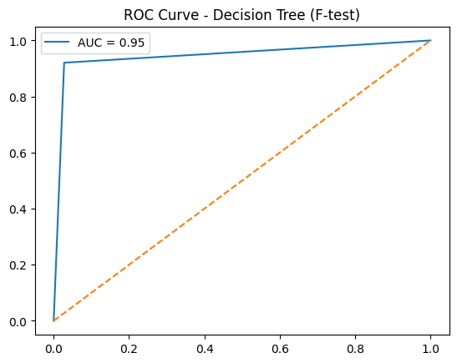
Chi2 –
# 1. Split
X_train, X_test, y_train, y_test = train_test_split(
X, Y, test_size=0.3, random_state=42
)
# 2. Scaling (MANDATORY for chi2)
scaler = MinMaxScaler()
X_train_scaled = scaler.fit_transform(X_train)
X_test_scaled = scaler.transform(X_test)
# 3. Feature Selection
selector = SelectKBest(score_func=chi2, k=7)
X_train_selected = selector.fit_transform(X_train_scaled, y_train)
X_test_selected = selector.transform(X_test_scaled)
print("Selected Features:", X.columns[selector.get_support()])
Selected Features: Index(['concavity_mean', 'concave points_mean', 'radius_worst',
'perimeter_worst', 'area_worst', 'concavity_worst',
'concave points_worst'],
dtype='object')

# 4. Train Decision Tree
model = DecisionTreeClassifier(random_state=42)
model.fit(X_train_selected, y_train)
# 5. Prediction
y_pred = model.predict(X_test_selected)
# 6. Metrics
print("Accuracy:", accuracy_score(y_test, y_pred))
print("Confusion Matrix:\n", confusion_matrix(y_test, y_pred))
print("Classification Report:\n", classification_report(y_test, y_pred))
Accuracy: 0.9532163742690059
Confusion Matrix:
[[105 3]
[ 5 58]]
Classification Report:
precision recall f1-score support

0 0.95 0.97 0.96 108
1 0.95 0.92 0.94 63

accuracy 0.95 171
macro avg 0.95 0.95 0.95 171
weighted avg 0.95 0.95 0.95 171
#Confusion Matrix
cm = confusion_matrix(y_test, y_pred)
plt.imshow(cm)
plt.title("Confusion Matrix - Decision Tree (Chi²)")
plt.colorbar()
plt.xlabel("Predicted")
plt.ylabel("Actual")
for i in range(cm.shape[0]):
for j in range(cm.shape[1]):
plt.text(j, i, cm[i, j], ha="center", va="center")
plt.show()
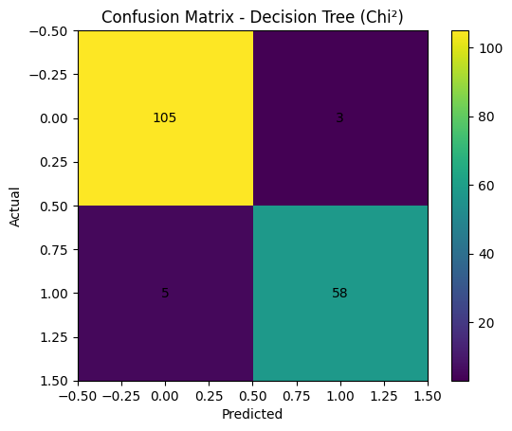
#ROC Curve
y_prob = model.predict_proba(X_test_selected)[:, 1]
fpr, tpr, _ = roc_curve(y_test, y_prob)
roc_auc = roc_auc_score(y_test, y_prob)
plt.plot(fpr, tpr, label=f"AUC = {roc_auc:.2f}")
plt.plot([0,1],[0,1],'--')
plt.legend()
plt.title("ROC Curve - Decision Tree (Chi²)")
plt.show()
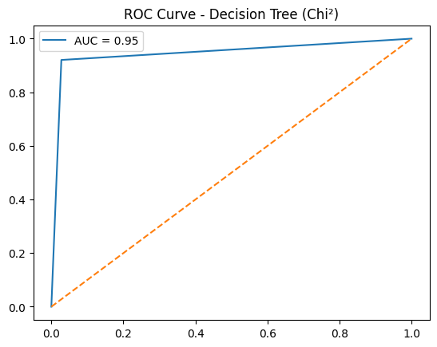

Mutual_info_classif –
# 1. Split
X_train, X_test, y_train, y_test = train_test_split(
X, Y, test_size=0.3, random_state=42
)
# 2. Feature Selection
selector = SelectKBest(score_func=mutual_info_classif, k=7)
X_train_selected = selector.fit_transform(X_train, y_train)
X_test_selected = selector.transform(X_test)
print("Selected Features:", X.columns[selector.get_support()])
Selected Features: Index(['perimeter_mean', 'concavity_mean', 'concave points_mean',
'radius_worst', 'perimeter_worst', 'area_worst',
'concave points_worst'],
dtype='object')

# 3. Train Decision Tree
model = DecisionTreeClassifier(random_state=42)
model.fit(X_train_selected, y_train)
# 4. Prediction
y_pred = model.predict(X_test_selected)
# 5. Metrics
print("Accuracy:", accuracy_score(y_test, y_pred))
print("Confusion Matrix:\n", confusion_matrix(y_test, y_pred))
print("Classification Report:\n", classification_report(y_test, y_pred))
Accuracy: 0.9298245614035088
Confusion Matrix:
[[104 4]
[ 8 55]]
Classification Report:
precision recall f1-score support

0 0.93 0.96 0.95 108
1 0.93 0.87 0.90 63

accuracy 0.93 171
macro avg 0.93 0.92 0.92 171
weighted avg 0.93 0.93 0.93 171
#Confusion Matrix
cm = confusion_matrix(y_test, y_pred)
plt.imshow(cm)
plt.title("Confusion Matrix - Decision Tree (Mutual Info)")
plt.colorbar()
plt.xlabel("Predicted")
plt.ylabel("Actual")
for i in range(cm.shape[0]):
for j in range(cm.shape[1]):
plt.text(j, i, cm[i, j], ha="center", va="center")
plt.show()
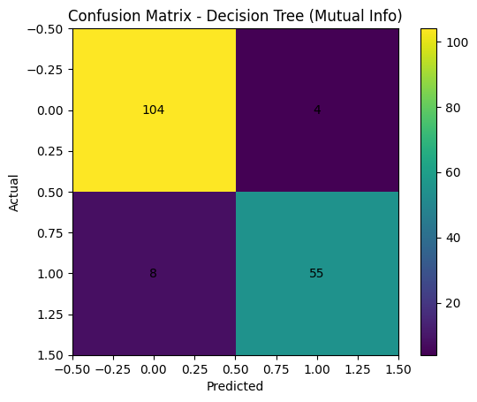
#ROC Curve
y_prob = model.predict_proba(X_test_selected)[:, 1]
fpr, tpr, _ = roc_curve(y_test, y_prob)
roc_auc = roc_auc_score(y_test, y_prob)
plt.plot(fpr, tpr, label=f"AUC = {roc_auc:.2f}")
plt.plot([0,1],[0,1],'--')
plt.legend()
plt.title("ROC Curve - Decision Tree (Mutual Info)")
plt.show()
