6. Implement relational algebra operations a. Selection operation b. Hash Join c. Merge Join
*****Install SQLite3 database and then experiment join operations*****
Join Clause
A JOIN clause combines the records from two tables on the basis of common attributes.
The different types of joins are as follows:

INNER JOIN (OR JOIN) – Gives the records that have common attributes in both tables.
LEFT JOIN – Gives all records from the left table and only the common records from the right table.
RIGHT JOIN – Gives all records from the right table and only the common records from the left table.
Merge Join: can be implemented using either Inner/Left/Right Joins
FULL OUTER JOIN – Gives all records when there is a common attribute in either the left or the right table.
CROSS JOIN – Gives records of one table with all other records of another table.
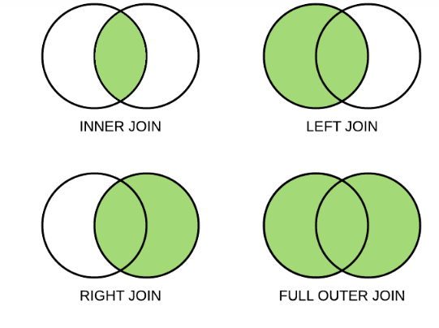
SQLite does not directly support the RIGHT JOIN and FULL OUTER JOIN.
Using only SQLite Database:

SQLite Commands
The standard SQLite commands to interact with relational databases are similar to SQL. They are CREATE, SELECT, INSERT, UPDATE, DELETE and DROP. These commands can be classified into groups based on their operational nature −

Following is the basic syntax of sqlite3 command to create a database: −
$sqlite3 DatabaseName.db

Always, database name should be unique within the RDBMS.
Once a database is created, you can verify it in the list of databases using the following SQLite .databases command.
sqlite>.databases
seq name file
--- --------------- ----------------------
0 main /home/sqlite/testDB.db
You will use SQLite .quit command to come out of the sqlite prompt as follows −
sqlite>.quit

Consider a case when you have multiple databases available and you want to use any one of them at a time. SQLite ATTACH DATABASE statement is used to select a particular database, and after this command, all SQLite statements will be executed under the attached database.

Syntax
Following is the basic syntax of SQLite ATTACH DATABASE statement.
ATTACH DATABASE 'DatabaseName' As 'Alias-Name';
The above command will also create a database in case the database is already not created, otherwise it will just attach database file name with logical database 'Alias-Name'.
SQLite DETACH DATABASE statement is used to detach and dissociate a named database from a database connection which was previously attached using ATTACH statement. If the same database file has been attached with multiple aliases, then DETACH command will disconnect only the given name and rest of the attachment will still continue. You cannot detach the main or temp databases.

Following is the basic syntax of SQLite DETACH DATABASE 'Alias-Name' statement.
DETACH DATABASE 'Alias-Name';
Here, 'Alias-Name' is the same alias, which you had used while attaching the database using ATTACH statement
SQLite CREATE TABLE statement is used to create a new table in any of the given database. Creating a basic table involves naming the table and defining its columns and each column's data type.

Syntax
Following is the basic syntax of CREATE TABLE statement.
CREATE TABLE database_name.table_name(
column1 datatype PRIMARY KEY(one or more columns),
column2 datatype,
column3 datatype,
.....
columnN datatype
);

Following is an example which creates a COMPANY table with ID as the primary key and NOT NULL are the constraints showing that these fields cannot be NULL while creating records in this table.
sqlite> CREATE TABLE COMPANY(
ID INT PRIMARY KEY NOT NULL,
NAME TEXT NOT NULL,
AGE INT NOT NULL,
ADDRESS CHAR(50),
SALARY REAL
);

You can verify if your table has been created successfully using SQLite command .tables command, which will be used to list down all the tables in an attached database.
sqlite>.tables
COMPANY DEPARTMENT

You can get complete information about a table using the following SQLite .schema command.
sqlite>.schema COMPANY
CREATE TABLE COMPANY(
ID INT PRIMARY KEY NOT NULL,
NAME TEXT NOT NULL,
AGE INT NOT NULL,
ADDRESS CHAR(50),
SALARY REAL
);

SQLite DROP TABLE statement is used to remove a table definition and all associated data, indexes, triggers, constraints, and permission specifications for that table.
You have to be careful while using this command because once a table is deleted then all the information available in the table would also be lost forever.
Following is the basic syntax of DROP TABLE statement. You can optionally specify the database name along with table name as follows −
DROP TABLE database_name.table_name;

SQLite INSERT INTO Statement is used to add new rows of data into a table in the database.

Syntax
Following are the two basic syntaxes of INSERT INTO statement.
INSERT INTO TABLE_NAME [(column1, column2, column3,...columnN)]
VALUES (value1, value2, value3,...valueN);
Here, column1, column2,...columnN are the names of the columns in the table into which you want to insert data.
You may not need to specify the column(s) name in the SQLite query if you are adding values for all the columns of the table. However, make sure the order of the values is in the same order as the columns in the table. The SQLite INSERT INTO syntax would be as follows −
INSERT INTO TABLE_NAME VALUES (value1,value2,value3,...valueN);

Consider you already have created COMPANY table in your testDB.db as follows −
sqlite> CREATE TABLE COMPANY(
ID INT PRIMARY KEY NOT NULL,
NAME TEXT NOT NULL,
AGE INT NOT NULL,
ADDRESS CHAR(50),
SALARY REAL
);
Now, the following statements would create six records in COMPANY table.
INSERT INTO COMPANY (ID,NAME,AGE,ADDRESS,SALARY)
VALUES (1, 'john', 32, 'California', 20000.00 );

You can create a record in COMPANY table using the second syntax as follows −
INSERT INTO COMPANY VALUES (7, 'James', 24, 'Houston', 10000.00 );

SQLite SELECT statement is used to fetch the data from a SQLite database table which returns data in the form of a result table. These result tables are also called result sets.

Syntax
Following is the basic syntax of SQLite SELECT statement.
SELECT column1, column2, columnN FROM table_name;

Here, column1, column2 ... are the fields of a table, whose values you want to fetch. If you want to fetch all the fields available in the field, then you can use the following syntax −
SELECT * FROM table_name;

If you want to fetch only selected fields of COMPANY table, then use the following query −
sqlite> SELECT ID, NAME, SALARY FROM COMPANY;

SQLite WHERE clause is used to specify a condition while fetching the data from one table or multiple tables.
If the given condition is satisfied, means true, then it returns the specific value from the table. You will have to use WHERE clause to filter the records and fetching only necessary records.
The WHERE clause not only is used in SELECT statement, but it is also used in UPDATE, DELETE statement, etc.,

Following is the basic syntax of SQLite SELECT statement with WHERE clause.
SELECT column1, column2, columnN
FROM table_name
WHERE [condition]

sqlite> SELECT * FROM COMPANY WHERE AGE >= 25 AND SALARY >= 65000;
SQLite AND & OR operators are used to compile multiple conditions to narrow down the selected data in an SQLite statement. These two operators are called conjunctive operators.
These operators provide a means to make multiple comparisons with different operators in the same SQLite statement.

The AND operator allows the existence of multiple conditions in a SQLite statement's WHERE clause. While using AND operator, complete condition will be assumed true when all the conditions are true. For example, [condition1] AND [condition2] will be true only when both condition1 and condition2 are true.

Syntax
Following is the basic syntax of AND operator with WHERE clause.
SELECT column1, column2, columnN
FROM table_name
WHERE [condition1] AND [condition2]...AND [conditionN];

sqlite> SELECT * FROM COMPANY WHERE AGE >= 25 AND SALARY >= 65000;

sqlite> SELECT * FROM COMPANY WHERE AGE >= 25 OR SALARY >= 65000;

SQLite UPDATE Query is used to modify the existing records in a table. You can use WHERE clause with UPDATE query to update selected rows, otherwise all the rows would be updated.
Following is the basic syntax of UPDATE query with WHERE clause.
UPDATE table_name
SET column1 = value1, column2 = value2...., columnN = valueN
WHERE [condition];

UPDATE COMPANY SET ADDRESS = 'Texas' WHERE ID = 6;

If you want to modify all ADDRESS and SALARY column values in COMPANY table, you do not need to use WHERE clause and UPDATE query will be as follows −
sqlite> UPDATE COMPANY SET ADDRESS = 'Texas', SALARY = 20000.00;

SQLite DELETE Query is used to delete the existing records from a table. You can use WHERE clause with DELETE query to delete the selected rows, otherwise all the records would be deleted.
Following is the basic syntax of DELETE query with WHERE clause.
DELETE FROM table_name
WHERE [condition];

Following is an example, which will DELETE a customer whose ID is 7.
sqlite> DELETE FROM COMPANY WHERE ID = 7;

If you want to DELETE all the records from COMPANY table, you do not need to use WHERE clause with DELETE query, which will be as follows −
sqlite> DELETE FROM COMPANY;

SQLite ORDER BY clause is used to sort the data in an ascending or descending order, based on one or more columns.
Following is the basic syntax of ORDER BY clause.
SELECT column-list
FROM table_name
[WHERE condition]
[ORDER BY column1, column2, .. columnN] [ASC | DESC];
You can use more than one column in the ORDER BY clause. Make sure whatever column you are using to sort, that column should be available in the column-list.

Following is an example, which will sort the result in descending order by SALARY.
sqlite> SELECT * FROM COMPANY ORDER BY SALARY ASC;

Following is an example, which will sort the result in descending order by NAME and SALARY.
sqlite> SELECT * FROM COMPANY ORDER BY NAME, SALARY ASC;

SQLite GROUP BY clause is used in collaboration with the SELECT statement to arrange identical data into groups.
GROUP BY clause follows the WHERE clause in a SELECT statement and precedes the ORDER BY clause.

Following is the basic syntax of GROUP BY clause. GROUP BY clause must follow the conditions in the WHERE clause and must precede ORDER BY clause if one is used.
SELECT column-list
FROM table_name
WHERE [ conditions ]
GROUP BY column1, column2....columnN
ORDER BY column1, column2....columnN

You can use more than one column in the GROUP BY clause.

Now, our table has the following records with duplicate names.
ID NAME AGE ADDRESS SALARY
---------- ---------- ---------- ---------- ----------
1 Paul 32 California 20000.0
2 Allen 25 Texas 15000.0
3 Teddy 23 Norway 20000.0
4 Mark 25 Rich-Mond 65000.0
5 David 27 Texas 85000.0
6 Kim 22 South-Hall 45000.0
7 James 24 Houston 10000.0
8 Paul 24 Houston 20000.0
9 James 44 Norway 5000.0
10 James 45 Texas 5000.0
Again, let us use the same statement to group-by all the records using NAME column as follows −
sqlite> SELECT NAME, SUM(SALARY) FROM COMPANY GROUP BY NAME ORDER BY NAME;
This will produce the following result.
NAME SUM(SALARY)
---------- -----------
Allen 15000
David 85000
James 20000
Kim 45000
Mark 65000
Paul 40000
Teddy 20000

Let us use ORDER BY clause along with GROUP BY clause as follows −
sqlite> SELECT NAME, SUM(SALARY)
FROM COMPANY GROUP BY NAME ORDER BY NAME DESC;
This will produce the following result.
NAME SUM(SALARY)
---------- -----------
Teddy 20000
Paul 40000
Mark 65000
Kim 45000
James 20000
David 85000
Allen 15000

Using Python the Join operations:
Cursor class
Following are the various methods provided by the Cursor class/object.
Sr.No | Method & Description
1 | execute()  This routine executes an SQL statement. The SQL statement may be parameterized (i.e., placeholders instead of SQL literals). The psycopg2 module supports placeholder using %s sign  For example:cursor.execute("insert into people values (%s, %s)", (who, age))
2 | executemany()  This routine executes an SQL command against all parameter sequences or mappings found in the sequence sql.
3 | fetchone()  This method fetches the next row of a query result set, returning a single sequence, or None when no more data is available.
4 | fetchmany()  This routine fetches the next set of rows of a query result, returning a list. An empty list is returned when no more rows are available. The method tries to fetch as many rows as indicated by the size parameter.
5 | fetchall()  This routine fetches all (remaining) rows of a query result, returning a list. An empty list is returned when no rows are available.

Here, we will create a simple database having two tables Advisor(AdvisorID, AdvisorName) and Student(StudentID, StudentName, AdvisorID) where AdvisorID of the Student table is the foreign key referencing AdvisorID of the Advisor table.

# Import required libraries
import sqlite3

# Connect to SQLite database
# New file created if it doesn't already exist
conn = sqlite3.connect(r'C:\Users\SQLite\Test.db')

# Create cursor object
cursor = conn.cursor()

# Create and populate tables
cursor.executescript('''
CREATE TABLE Advisor(
AdvisorID INTEGER NOT NULL,
AdvisorName TEXT NOT NULL,
PRIMARY KEY(AdvisorID)
);

CREATE TABLE Student(
StudentID NUMERIC NOT NULL,
StudentName NUMERIC NOT NULL,
AdvisorID INTEGER,
FOREIGN KEY(AdvisorID) REFERENCES Advisor(AdvisorID),
PRIMARY KEY(StudentID)
);

INSERT INTO Advisor(AdvisorID, AdvisorName) VALUES
(1,"John Paul"),
(2,"Anthony Roy"),
(3,"Raj Shetty"),
(4,"Sam Reeds"),
(5,"Arthur Clintwood");

INSERT INTO Student(StudentID, StudentName, AdvisorID) VALUES
(501,"Geek1",1),
(502,"Geek2",1),
(503,"Geek3",3),
(504,"Geek4",2),
(505,"Geek5",4),
(506,"Geek6",2),
(507,"Geek7",2),
(508,"Geek8",3),
(509,"Geek9",NULL),
(510,"Geek10",1);

''')

#Commit changes to database
conn.commit()

# Closing the connection
conn.close()

INNER JOIN
Inner join also represented as join which gives the records that have common attributes in both tables.
Syntax:
SELECT columns
FROM table1
[INNER] JOIN table2
ON table1.column = table2.column;
INNER keyword is optional

# Import required libraries
import sqlite3

# Connect to SQLite database
conn = sqlite3.connect(r'C:\Users\SQLite\Test.db')

# Create cursor object
cursor = conn.cursor()

# Query for INNER JOIN
sql = '''SELECT StudentID, StudentName, AdvisorName
FROM Student
INNER JOIN Advisor
ON Student.AdvisorID = Advisor.AdvisorID;'''

# Executing the query
cursor.execute(sql)

# Fetching rows from the result table
result = cursor.fetchall()
for row in result:
print(row)

# Closing the connection
conn.close()

LEFT JOIN
Gives all records from the left table, and only the common records from the right table.
Syntax:
SELECT columns
FROM table1
LEFT [OUTER] JOIN table2
ON table1.column = table2.column;
OUTER keyword is optional

# Import required libraries
import sqlite3

# Connect to SQLite database
conn = sqlite3.connect(r'C:\Users\SQLite\Test.db')

# Create cursor object
cursor = conn.cursor()

# Query for LEFT JOIN
sql = '''SELECT StudentID, StudentName, AdvisorName
FROM Student
LEFT JOIN Advisor
USING(AdvisorID) ;'''

# Executing the query
cursor.execute(sql)

# Fetching rows from the result table
result = cursor.fetchall()
for row in result:
print(row)

# Closing the connection
conn.close()

Since the column name (AdvisorID) of joined tables is same, the clause USING(AdvisorID) can be used instead of ON Student.AdvisorID = Advisor.AdvisorID.

RIGHT JOIN
Gives all records from the right table, and only the common records from the left table. As mentioned before, SQLite does not directly support RIGHT JOIN. However, it can be emulated using LEFT JOIN by switching the positions of the student and advisor table.
Syntax:
SELECT columns
FROM table1
RIGHT [OUTER] JOIN table2
ON table1.column = table2.column;
OUTER keyword is optional

# Import required libraries
import sqlite3

# Connect to SQLite database
conn = sqlite3.connect(r'C:\Users\SQLite\Test.db')

# Create cursor object
cursor = conn.cursor()

# Query for RIGHT JOIN
sql = '''SELECT StudentID, StudentName, AdvisorName
FROM Advisor
LEFT JOIN Student
USING(AdvisorID);'''

# Executing the query
cursor.execute(sql)

# Fetching rows from the result table
result = cursor.fetchall()
for row in result:
print(row)

# Closing the connection
conn.close()

FULL OUTER JOIN
Gives all records when there is a common attribute in either left or the right table. As mentioned before, SQLite does not directly support FULL OUTER JOIN. However, it can be emulated using LEFT JOIN. In this query, the second SELECT statement has the positions of the student and advisor table switched. The UNION ALL clause retains the duplicate rows from the result of both SELECT queries. And the WHERE clause in the second SELECT statement removes rows that already included in the result set of the first SELECT statement.

Syntax:
SELECT columns
FROM table1
FULL [OUTER] JOIN table2
ON table1.column = table2.column;
OUTER keyword is optional

# Import required libraries
import sqlite3

# Connect to SQLite database
conn = sqlite3.connect(r'C:\Users\SQLite\Test.db')

# Create cursor object
cursor = conn.cursor()

# Query for FULL OUTER JOIN
sql = '''SELECT StudentID, StudentName, AdvisorName
FROM Student
LEFT JOIN Advisor
USING(AdvisorID)
UNION ALL
SELECT StudentID, StudentName, AdvisorName
FROM Advisor
LEFT JOIN Student
USING(AdvisorID)
WHERE Student.AdvisorID IS NULL;'''

# Executing the query
cursor.execute(sql)

# Fetching rows from the result table
result = cursor.fetchall()
for row in result:
print(row)

# Closing the connection
conn.close()

CROSS JOIN
It combines all records of one table with all other records of another table, that is, it creates a Cartesian product of records from the join tables.
Syntax:
SELECT columns
FROM table1
CROSS JOIN table2;

# Import required libraries
import sqlite3

# Connect to SQLite database
conn = sqlite3.connect(r'C:\Users\SQLite\Test.db')

# Create cursor object
cursor = conn.cursor()

# Query for CROSS JOIN
sql = '''SELECT StudentID, StudentName, AdvisorName
FROM Student
CROSS JOIN Advisor;'''

# Executing the query
cursor.execute(sql)

# Fetching rows from the result table
result = cursor.fetchall()
for row in result:
print(row)

# Closing the connection
conn.close()

Hash join in MySQL 8
Hash joins allow vertical partitioning (representing groups of columns from a single table in separate files or indexes) to become a viable option for physical database design.
The hash join has two inputs: the build input and probe input. The query optimizer assigns these roles so that the smaller of the two inputs is the build input.
Hash joins are used for many types of set-matching operations: inner join; left, right, and full outer join; left and right semi-join; intersection; union; and difference.
Hash join is a way of executing a join where a hash table is used to find matching rows between the two inputs (an input is one or more tables). It is typically more efficient than nested loop joins, especially if one of the inputs can fit in memory. To see how it works, we will use the following query as an example:
SELECT columns
FROM table1
JOIN table2
ON table1.column = table2.column;

Example:
SELECT
given_name, country_name
FROM
persons JOIN countries ON persons.country_id = countries.country_id;

The build phase
The literature usually divides hash join in two phases; the build phase and the probe phase. In the build phase, the server builds an in-memory hash table where rows from one of the inputs are stored, using the join attribute(s) as the hash table key. This input is also known as the build input, and let us assume that ‘countries’ is designated as the build input. Ideally, the server will choose the smaller of the two inputs as the build input (measured in bytes, not number of rows). Since ‘countries.country_id’ is the join condition that belongs to the build input, this is used as the key in the hash table. Once all the rows has been stored in the hash table, the build phase is done.
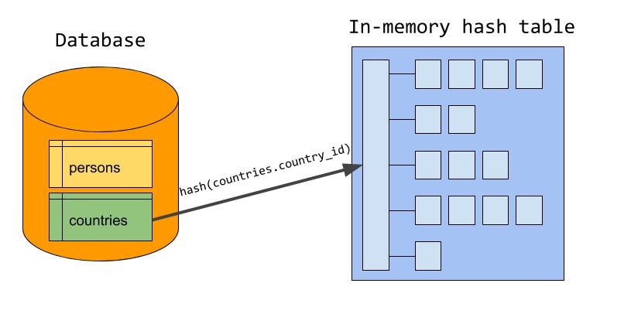

The probe phase
During the probe phase, the server starts reading rows from the probe input (‘persons’ in our example). For each row, the server probes the hash table for matching rows using the value from ‘persons.country_id’ as the lookup key. For each match, a joined row is sent to the client. In the end, the server has scanned each input only once, using constant time lookup to find matching rows between the two inputs.
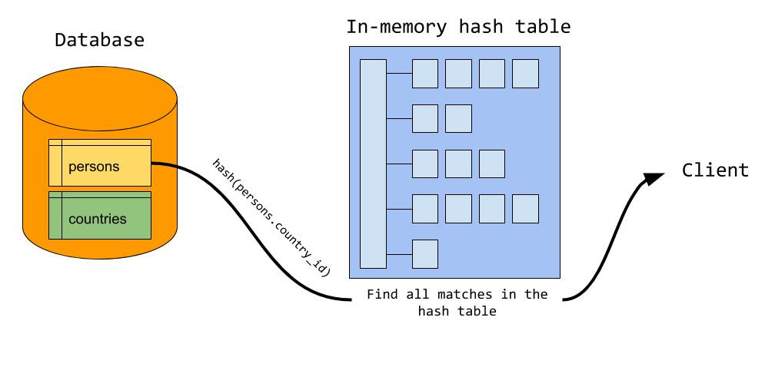
This works very well given that the server can store the entire build input in memory. The amount of memory available is controlled by the system variable join_buffer_size, and can be adjusted at runtime. But what happens if the build input is bigger than the available memory? We spill to disk!

Spill to disk
When the memory goes full during the build phase, the server writes the rest of the build input out to a number of chunk files on disk. The server tries to set the number of chunks so that the largest chunk fits exactly in memory (we will see why soon), but MySQL has a hard upper limit of 128 chunk files per input. Which chunk file a row is written to is determined by calculating a hash of the join attribute. Note that in the illustration, there is a different hash function used than the one used in the in-memory build phase. We will see why a bit later.
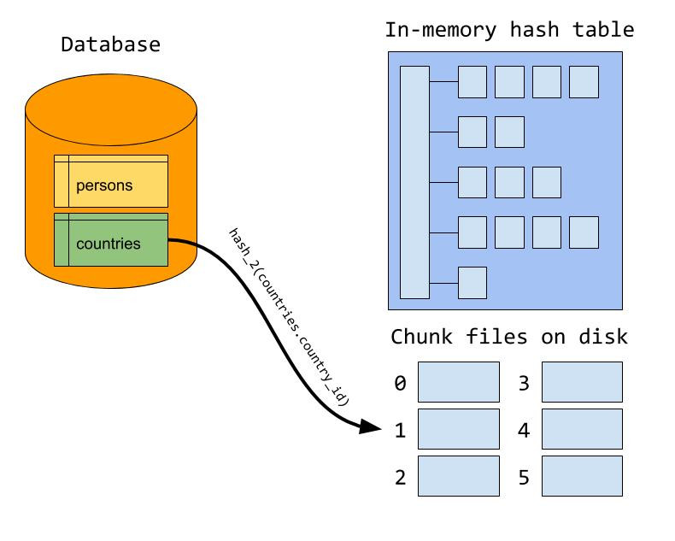
During the probe phase, the server probes for matching rows in the hash table, just like when everything fits in memory. But in addition, a row may also match one of the rows from the build input that is written to disk. Thus, each row from the probe input is also written to a set of chunk files. Which chunk file a row is written to is determined using the same hash function and formula that is used when the build input is written to disk. This way, we know for sure that matching rows between the two inputs will be located in the same pair of chunk files.
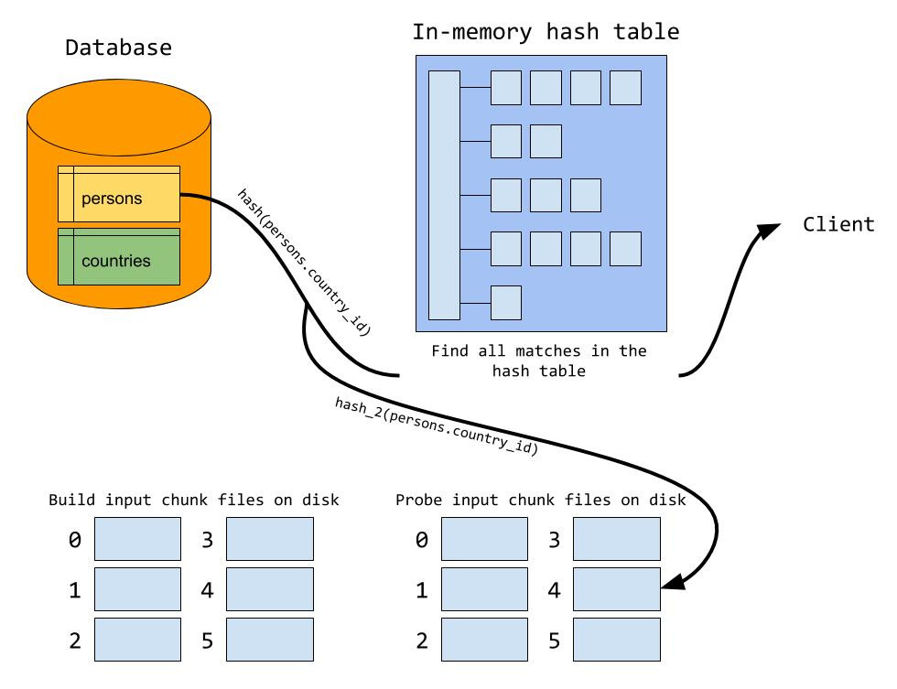
When the probe phase is done, we start reading chunk files from disk. In general, the server does a build and probe phase using the first set of chunk files as the build and probe input. We load the first chunk file from the build input into the in-memory hash table. This explains why we want the largest chunk to fit exactly in memory; if the chunk files are too big we need to split it up in even smaller chunks. After the build chunk is loaded, we read the corresponding chunk file from the probe input and probe for matches in the hash table, just like when everything fits in memory. When the first pair of chunk files is processed, we move to the next pair of chunk files, continuing until all pair of chunk files has been processed.
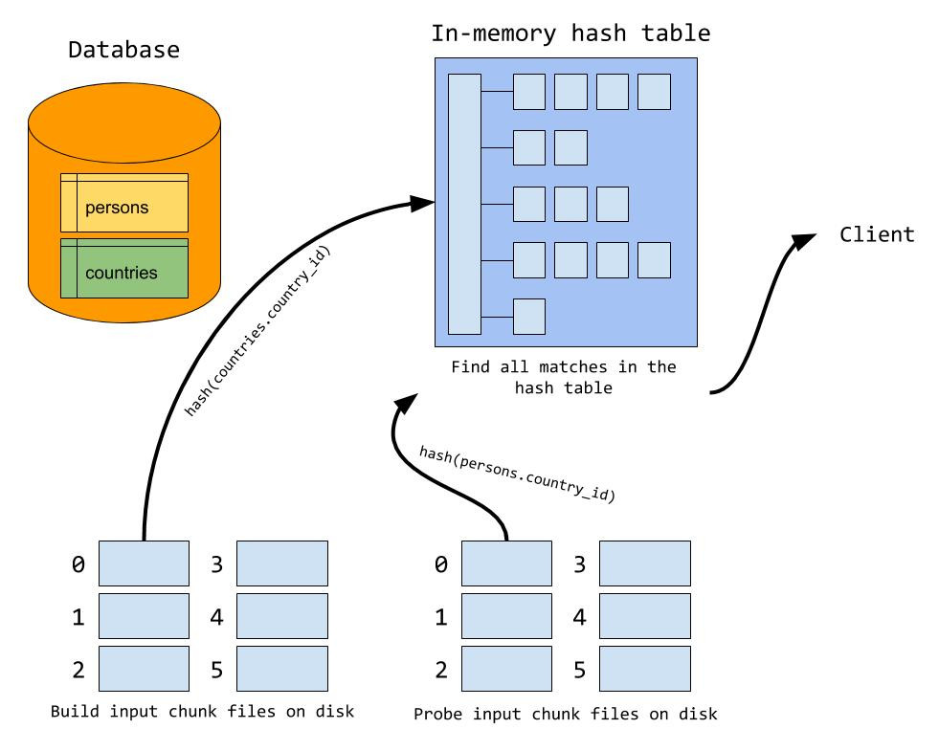
You might have guessed now why we should use two different hash functions when partitioning rows out to chunk files and writing rows to the hash table. If we were to use the same hash function for both operations, we would get an extremely bad hash table when loading a build chunk file into the hash table since all rows in the same chunk file would hash to the same value.

