Experiment – 3
Aim – Apply Pandas, data visualization, and Data Preprocessing to the given dataset.
Pandas
This code imports the pandas library and loads the CSV file dataset_3.csv into a DataFrame named df, enabling structured data analysis and manipulation.
import pandas as pd
df=pd.read_csv("dataset_3.csv")
This code checks the shape of the DataFrame, showing that it contains 32 rows and 5 columns, which represents the dataset’s dimensions.
df.shape
(32, 5)
This code retrieves and displays the column names of the DataFrame, indicating that the dataset contains five features: Duration, Date, Pulse, Maxpulse, and Calories.
df.columns
Index(['Duration', 'Date', 'Pulse', 'Maxpulse', 'Calories'], dtype='object')
This code provides a concise summary of the DataFrame, including the number of entries, column names, data types, and non-null counts for each column.
df.info()
<class 'pandas.core.frame.DataFrame'>
RangeIndex: 32 entries, 0 to 31
Data columns (total 5 columns):
# Column Non-Null Count Dtype
--- ------ -------------- -----
0 Duration 32 non-null int64
1 Date 31 non-null object
2 Pulse 32 non-null int64
3 Maxpulse 32 non-null int64
4 Calories 30 non-null float64
dtypes: float64(1), int64(3), object(1)
memory usage: 1.4+ KB
This code displays the first five rows of the DataFrame, giving a quick overview of the dataset’s structure and sample values.
df.head()
 | Duration | Date | Pulse | Maxpulse | Calories
0 | 60 | '2020/12/01' | 110 | 130 | 409.1
1 | 60 | '2020/12/02' | 117 | 145 | 479.0
2 | 60 | '2020/12/03' | 103 | 135 | 340.0
3 | 45 | '2020/12/04' | 109 | 175 | 282.4
4 | 45 | '2020/12/05' | 117 | 148 | 406.0
This code displays the first seven rows of the DataFrame, allowing a slightly broader view of the dataset’s initial records and values.
df.head(7)
 | Duration | Date | Pulse | Maxpulse | Calories
0 | 60 | '2020/12/01' | 110 | 130 | 409.1
1 | 60 | '2020/12/02' | 117 | 145 | 479.0
2 | 60 | '2020/12/03' | 103 | 135 | 340.0
3 | 45 | '2020/12/04' | 109 | 175 | 282.4
4 | 45 | '2020/12/05' | 117 | 148 | 406.0
5 | 60 | '2020/12/06' | 102 | 127 | 300.0
6 | 60 | '2020/12/07' | 110 | 136 | 374.0
This code displays the last seven rows of the DataFrame, providing an overview of the dataset’s ending records and values.
df.tail(7)
 | Duration | Date | Pulse | Maxpulse | Calories
25 | 60 | '2020/12/25' | 102 | 126 | 334.5
26 | 60 | 20201226 | 100 | 120 | 250.0
27 | 60 | '2020/12/27' | 92 | 118 | 241.0
28 | 60 | '2020/12/28' | 103 | 132 | NaN
29 | 60 | '2020/12/29' | 100 | 132 | 280.0
30 | 60 | '2020/12/30' | 102 | 129 | 380.3
31 | 60 | '2020/12/31' | 92 | 115 | 243.0
This code selects and displays the Calories column from the DataFrame, returning it as a pandas Series for focused analysis
df["Calories"]
0 409.1
1 479.0
2 340.0
3 282.4
4 406.0
5 300.0
6 374.0
7 253.3
8 195.1
9 269.0
10 329.3
11 250.7
12 250.7
13 345.3
14 379.3
15 275.0
16 215.2
17 300.0
18 NaN
19 323.0
20 243.0
21 364.2
22 282.0
23 300.0
24 246.0
...
28 NaN
29 280.0
30 380.3
31 243.0
Name: Calories, dtype: float64
This code selects the Calories and Date columns from the DataFrame and displays the first five rows, allowing a focused view of these two features.
df[["Calories","Date"]].head()
 | Calories | Date
0 | 409.1 | '2020/12/01'
1 | 479.0 | '2020/12/02'
2 | 340.0 | '2020/12/03'
3 | 282.4 | '2020/12/04'
4 | 406.0 | '2020/12/05'
This code uses integer-based indexing to select rows from index 1 to 3 of the DataFrame, extracting a specific subset of records.
df.iloc[1:4]
 | Duration | Date | Pulse | Maxpulse | Calories
1 | 60 | '2020/12/02' | 117 | 145 | 479.0
2 | 60 | '2020/12/03' | 103 | 135 | 340.0
3 | 45 | '2020/12/04' | 109 | 175 | 282.4
This code uses integer-based indexing to select rows 1 to 3 and columns 0 to 2, returning a specific subset of the DataFrame.
df.iloc[1:4,0:3]
 | Duration | Date | Pulse
1 | 60 | '2020/12/02' | 117
2 | 60 | '2020/12/03' | 103
3 | 45 | '2020/12/04' | 109
This code selects the rows at indices 0, 8, and 10 from the DataFrame using integer-based indexing, retrieving those specific records.
df.iloc[[0,8,10]]
 | Duration | Date | Pulse | Maxpulse | Calories
0 | 60 | '2020/12/01' | 110 | 130 | 409.1
8 | 30 | '2020/12/09' | 109 | 133 | 195.1
10 | 60 | '2020/12/11' | 103 | 147 | 329.3
This code generates descriptive statistics for the numerical columns of the DataFrame, including measures such as mean, standard deviation, minimum, and maximum values.
df.describe()
 | Duration | Pulse | Maxpulse | Calories
count | 32.000000 | 32.000000 | 32.000000 | 30.000000
mean | 68.437500 | 103.500000 | 128.500000 | 304.680000
std | 70.039591 | 7.832933 | 12.998759 | 66.003779
min | 30.000000 | 90.000000 | 101.000000 | 195.100000
25% | 60.000000 | 100.000000 | 120.000000 | 250.700000
50% | 60.000000 | 102.500000 | 127.500000 | 291.200000
75% | 60.000000 | 106.500000 | 132.250000 | 343.975000
max | 450.000000 | 130.000000 | 175.000000 | 479.000000
This code removes the Date column from the DataFrame and then calculates the mean of each remaining column across all rows.
df2=df.drop("Date",axis=1)
df2.mean(0)
Duration 68.4375
Pulse 103.5000
Maxpulse 128.5000
Calories 304.6800
dtype: float64
This code defines a lambda function to check whether the Duration is at least 60 minutes, applies it to create a new Boolean column, and then displays the first five rows of the updated DataFrame.
durationfunc=lambda x: x>=60
df2["Duration_mins_above_60"]=df["Duration"].apply(durationfunc)
df2.head()
 | Duration | Pulse | Maxpulse | Calories | Duration_mins_above_60
0 | 60 | 110 | 130 | 409.1 | True
1 | 60 | 117 | 145 | 479.0 | True
2 | 60 | 103 | 135 | 340.0 | True
3 | 45 | 109 | 175 | 282.4 | False
4 | 45 | 117 | 148 | 406.0 | False

Data Visualization
This code imports the required libraries for data analysis and visualization, and then loads the CSV file dataset_3.csv into a pandas DataFrame for further processing.
import pandas as pd
import matplotlib.pyplot as plt
import seaborn as sns
df = pd.read_csv("dataset_3.csv")
This code displays a summary of the DataFrame, showing the total number of records, column names, data types, and the count of non-null values in each column.
df.info()
<class 'pandas.core.frame.DataFrame'>
RangeIndex: 32 entries, 0 to 31
Data columns (total 5 columns):
# Column Non-Null Count Dtype
--- ------ -------------- -----
0 Duration 32 non-null int64
1 Date 31 non-null object
2 Pulse 32 non-null int64
3 Maxpulse 32 non-null int64
4 Calories 30 non-null float64
dtypes: float64(1), int64(3), object(1)
memory usage: 1.4+ KB
This code creates a scatter plot of Duration versus Calories, labels the axes, adds a title, and displays the visualization to show the relationship between exercise duration and calories burned.
plt.plot(df['Duration'], df['Calories'], 'bo')
plt.xlabel('Duration')
plt.ylabel('Calories')
plt.title('Duration vs Calories')
plt.show()
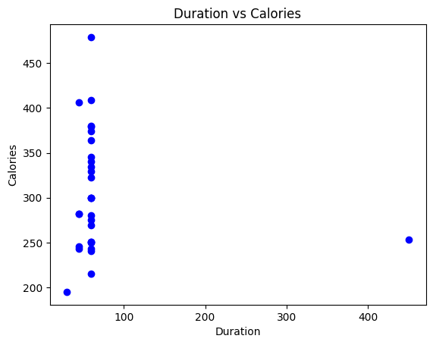
This code creates a histogram of the Duration values with 20 bins and a KDE curve, labels the axes, sets the title, and displays the plot to show the distribution of duration data.
plt.figure(figsize=(7,5))
sns.histplot(df['Duration'], bins=20, kde=True)
plt.xlabel("Duration")
plt.ylabel("Count")
plt.title("Duration Distribution")
plt.show()
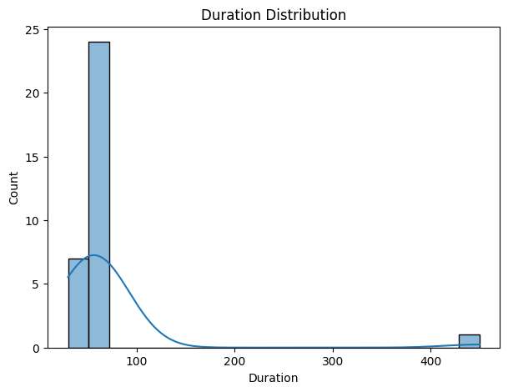
This code converts the Date column to datetime format, extracts the month into a new column, and then creates a boxplot to visualize how Calories are distributed across different months.
df['Date'] = pd.to_datetime(df['Date'], errors='coerce')
df['Month'] = df['Date'].dt.month
plt.figure(figsize=(8,5))
sns.boxplot(x='Month', y='Calories', data=df)
plt.xlabel("Month")
plt.ylabel("Calories")
plt.title("Calories Distribution by Month")
plt.show()
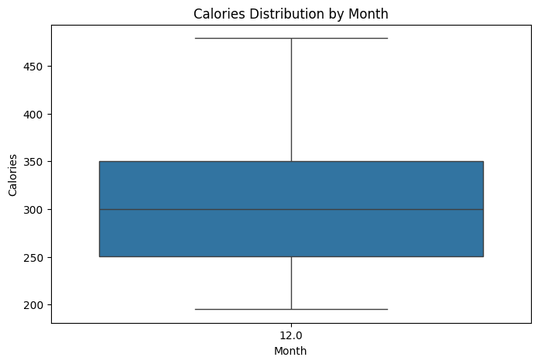
This code generates a histogram of the Pulse values with 25 bins and a KDE curve, labels the axes, adds a title, and displays the plot to show the distribution of pulse rates.
plt.figure(figsize=(8,5))
sns.histplot(df['Pulse'], bins=25, kde=True)
plt.xlabel("Pulse")
plt.ylabel("Frequency")
plt.title("Pulse Distribution")
plt.show()
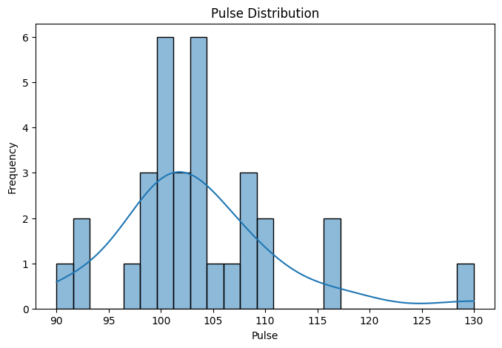
This code computes the correlation matrix of the dataset and visualizes it using a heatmap with annotations, making it easy to understand the relationships between numerical variables.
plt.figure(figsize=(10,8))
sns.heatmap(df.corr(), annot=True, cmap="coolwarm")
plt.title("Correlation Heatmap of Fitness Dataset")
plt.show()
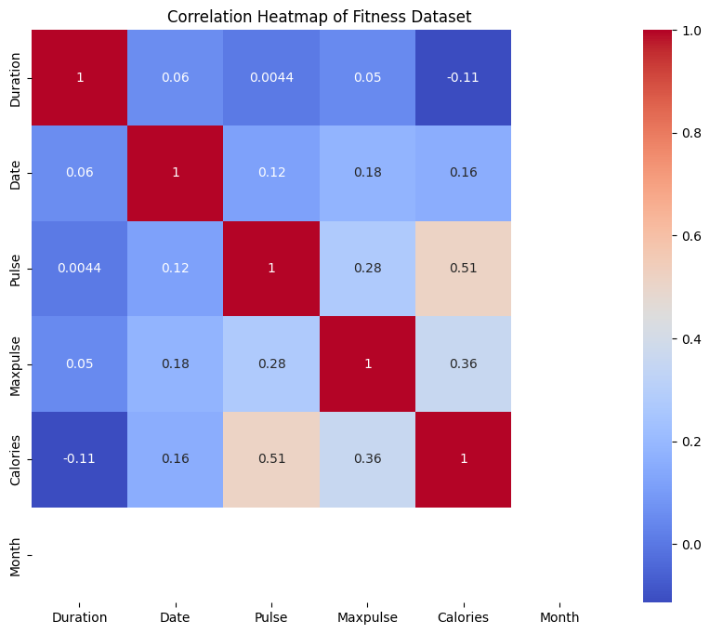
This code creates pairwise scatter plots and distributions for Duration, Pulse, Maxpulse, and Calories, helping to visually analyze relationships and patterns among these variables.
sns.pairplot(df[['Duration', 'Pulse', 'Maxpulse', 'Calories']])
plt.show()
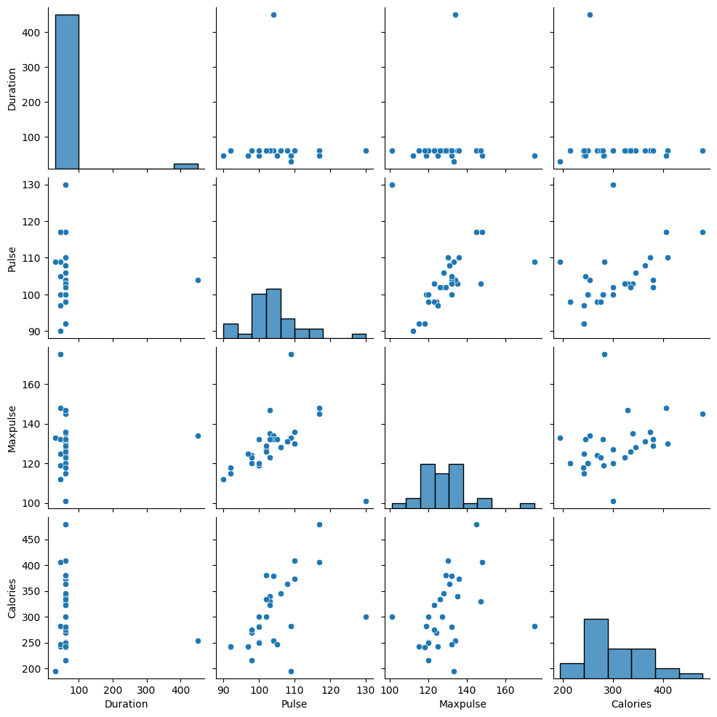

Data Preprocessing
This code imports the pandas library, loads the CSV file dataset_3.csv into a DataFrame, and then displays a summary of the dataset including column types and non-null counts.
import pandas as pd
df=pd.read_csv('dataset_3.csv')
df.info()
<class 'pandas.core.frame.DataFrame'>
RangeIndex: 32 entries, 0 to 31
Data columns (total 5 columns):
# Column Non-Null Count Dtype
--- ------ -------------- -----
0 Duration 32 non-null int64
1 Date 31 non-null object
2 Pulse 32 non-null int64
3 Maxpulse 32 non-null int64
4 Calories 30 non-null float64
dtypes: float64(1), int64(3), object(1)
memory usage: 1.4+ KB
This code generates descriptive statistics for the numerical columns in the DataFrame, summarizing their central tendency and spread.
df.describe()
 | Duration | Pulse | Maxpulse | Calories
count | 32.000000 | 32.000000 | 32.000000 | 30.000000
mean | 68.437500 | 103.500000 | 128.500000 | 304.680000
std | 70.039591 | 7.832933 | 12.998759 | 66.003779
min | 30.000000 | 90.000000 | 101.000000 | 195.100000
25% | 60.000000 | 100.000000 | 120.000000 | 250.700000
50% | 60.000000 | 102.500000 | 127.500000 | 291.200000
75% | 60.000000 | 106.500000 | 132.250000 | 343.975000
max | 450.000000 | 130.000000 | 175.000000 | 479.000000
This code displays the first five rows of the DataFrame, providing a quick preview of the dataset’s structure and values.
df.head()
 | Duration | Date | Pulse | Maxpulse | Calories
0 | 60 | '2020/12/01' | 110 | 130 | 409.1
1 | 60 | '2020/12/02' | 117 | 145 | 479.0
2 | 60 | '2020/12/03' | 103 | 135 | 340.0
3 | 45 | '2020/12/04' | 109 | 175 | 282.4
4 | 45 | '2020/12/05' | 117 | 148 | 406.0
This code checks each column for missing values and returns the total count of null entries per column in the DataFrame.
df.isnull().sum()
Duration 0
Date 1
Pulse 0
Maxpulse 0
Calories 2
dtype: int64
This code calculates the mean of the Calories column, replaces missing values in that column with the mean, and then verifies that no null values remain.
calories_mean = df['Calories'].mean()
df['Calories'].fillna(calories_mean, inplace=True)
df.isnull().sum()
Duration 0
Date 1
Pulse 0
Maxpulse 0
Calories 0
dtype: int64
This code sorts the DataFrame by the Date column, resets the index, and then filters the rows where the Date value is missing to identify invalid or unparsed dates.
df = df.sort_values(by='Date').reset_index(drop=True)
df[df['Date'].isna()]
 | Duration | Date | Pulse | Maxpulse | Calories
31 | 45 | NaN | 100 | 119 | 282.0
This code fills missing values in the Date column using forward fill followed by backward fill, ensuring continuity of dates. It then checks the DataFrame to confirm that no missing values remain.
df['Date'] = df['Date'].ffill().bfill()
df.isna().sum()
Duration 0
Date 0
Pulse 0
Maxpulse 0
Calories 0
dtype: int64
This code calculates the most frequent Duration value, computes the interquartile range to determine an upper bound for outliers, and then filters the dataset to identify records with unusually high duration values.
duration_mode = df['Duration'].mode()[0]
duration_mode
Q1 = df['Duration'].quantile(0.25)
Q3 = df['Duration'].quantile(0.75)
IQR = Q3 - Q1
upper_bound = Q3 + 1.5 * IQR
upper_bound
high_duration_outliers = df[
df['Duration'] > upper_bound
]
high_duration_outliers
 | Duration | Date | Pulse | Maxpulse | Calories
7 | 450 | '2020/12/08' | 104 | 134 | 253.3
This code replaces Duration values that exceed the calculated upper bound with the mode of the Duration column, effectively treating high outliers.
df.loc[df['Duration'] > upper_bound, 'Duration'] = duration_mode
This code removes duplicate rows from the DataFrame in place, ensuring that each record in the dataset is unique.
df.drop_duplicates(inplace=True)
Scaling is a data preprocessing technique that adjusts the range of numerical features so they are on a similar scale. It prevents features with larger values from dominating the learning process and improves the performance and convergence of many machine learning algorithms, especially distance-based and gradient-based models.

Standard scaling (Z-score normalization) rescales numerical features so that they have a mean of 0 and a standard deviation of 1. This helps algorithms treat all features equally and improves model stability, especially for methods sensitive to feature magnitude.
This code creates a StandardScaler, makes a copy of the dataset, and applies standard scaling to the selected numerical columns. The transformed values replace the original ones, and the first few rows of the scaled DataFrame are displayed.
from sklearn.preprocessing import StandardScaler
standard_scaler = StandardScaler()
df_standard = df.copy()
df_standard[['Duration','Pulse','Maxpulse','Calories']] = (
standard_scaler.fit_transform(df_standard[['Duration','Pulse','Maxpulse','Calories']])
)
df_standard.head()
 | Duration | Date | Pulse | Maxpulse | Calories
0 | 0.510061 | '2020/12/01' | 0.818140 | 0.094980 | 1.627893
1 | 0.510061 | '2020/12/02' | 1.714788 | 1.257241 | 2.736104
2 | 0.510061 | '2020/12/03' | -0.078508 | 0.482401 | 0.532365
3 | -1.466426 | '2020/12/04' | 0.690047 | 3.581761 | -0.380839
4 | -1.466426 | '2020/12/05' | 1.714788 | 1.489693 | 1.578745
Min–Max scaling rescales numerical features to a fixed range, usually between 0 and 1. It preserves the original distribution shape while ensuring all values lie within the same bounded interval.
This code initializes a MinMaxScaler, creates a copy of the DataFrame, and applies min–max scaling to the selected numerical columns. The scaled values replace the originals, and the first few rows of the transformed dataset are displayed.
from sklearn.preprocessing import MinMaxScaler
minmax_scaler = MinMaxScaler()
df_minmax = df.copy()
df_minmax[['Duration','Pulse','Maxpulse','Calories']] = (
minmax_scaler.fit_transform(df_minmax[['Duration','Pulse','Maxpulse','Calories']])
)
df_minmax.head()
 | Duration | Date | Pulse | Maxpulse | Calories
0 | 1.0 | '2020/12/01' | 0.500 | 0.391892 | 0.753787
1 | 1.0 | '2020/12/02' | 0.675 | 0.594595 | 1.000000
2 | 1.0 | '2020/12/03' | 0.325 | 0.459459 | 0.510391
3 | 0.5 | '2020/12/04' | 0.475 | 1.000000 | 0.307503
4 | 0.5 | '2020/12/05' | 0.675 | 0.635135 | 0.742867
Robust scaling scales features using the median and interquartile range (IQR), making it less sensitive to outliers compared to standard and min–max scaling.
This code creates a RobustScaler, copies the dataset, and applies robust scaling to the selected numerical columns. The transformed values replace the original ones, and the first few rows of the scaled DataFrame are displayed.
from sklearn.preprocessing import RobustScaler
robust_scaler = RobustScaler()
df_robust = df.copy()
df_robust[['Duration','Pulse','Maxpulse','Calories']] = (
robust_scaler.fit_transform(df_robust[['Duration','Pulse','Maxpulse','Calories']])
)
df_robust.head()
 | Duration | Date | Pulse | Maxpulse | Calories
0 | 0.0 | '2020/12/01' | 1.000000 | 0.16 | 1.203530
1 | 0.0 | '2020/12/02' | 2.000000 | 1.36 | 1.974628
2 | 0.0 | '2020/12/03' | 0.000000 | 0.56 | 0.441258
3 | -15.0 | '2020/12/04' | 0.857143 | 3.76 | -0.194153
4 | -15.0 | '2020/12/05' | 2.000000 | 1.60 | 1.169333
MaxAbs scaling scales features by dividing each value by the maximum absolute value of that feature, resulting in values within the range −1 to 1. It preserves sparsity and does not shift the data’s center.
This code initializes a MaxAbsScaler, creates a copy of the DataFrame, and applies max-absolute scaling to the selected numerical columns. The scaled values replace the original ones, and the first few rows of the transformed dataset are displayed.
from sklearn.preprocessing import MaxAbsScaler
maxabs_scaler = MaxAbsScaler()
df_maxabs = df.copy()
df_maxabs[['Duration','Pulse','Maxpulse','Calories']] = (
maxabs_scaler.fit_transform(df_maxabs[['Duration','Pulse','Maxpulse','Calories']])
)
df_maxabs.head()
 | Duration | Date | Pulse | Maxpulse | Calories
0 | 1.00 | '2020/12/01' | 0.846154 | 0.742857 | 0.854071
1 | 1.00 | '2020/12/02' | 0.900000 | 0.828571 | 1.000000
2 | 1.00 | '2020/12/03' | 0.792308 | 0.771429 | 0.709812
3 | 0.75 | '2020/12/04' | 0.838462 | 1.000000 | 0.589562
4 | 0.75 | '2020/12/05' | 0.900000 | 0.845714 | 0.847599

Encoding is a data preprocessing technique used to convert categorical or non-numeric data into numerical form so that it can be understood by machine learning algorithms. Most ML models work only with numbers, so encoding ensures that categorical information (such as dates, labels, or categories) is represented in a meaningful numeric format without losing essential patterns. The choice of encoding method depends on whether the categories have an order, are purely nominal, or represent structured information like time.

This code applies label encoding to the Date column by converting each unique date into a unique integer value. A copy of the dataset is used to preserve the original data, and the first few rows are displayed to show the original dates alongside their encoded numerical labels.
from sklearn.preprocessing import LabelEncoder
df_label = df.copy()
le = LabelEncoder()
df_label['Date_encoded'] = le.fit_transform(df_label['Date'].astype(str))
df_label[['Date', 'Date_encoded']].head()
 | Date | Date_encoded
0 | '2020/12/01' | 0
1 | '2020/12/02' | 1
2 | '2020/12/03' | 2
3 | '2020/12/04' | 3
4 | '2020/12/05' | 4
This code performs one-hot encoding on the Date column by creating a separate binary column for each unique date. The encoded features are converted into a DataFrame, combined with the original numerical columns, and the first few rows of the fully encoded dataset are displayed.
from sklearn.preprocessing import OneHotEncoder
df_ohe = df.copy()
ohe = OneHotEncoder(sparse_output=False, handle_unknown='ignore')
encoded = ohe.fit_transform(df_ohe[['Date']].astype(str))
encoded_df = pd.DataFrame(encoded, columns=ohe.get_feature_names_out(['Date']))
df_ohe_encoded = pd.concat([df_ohe.drop(columns=['Date']), encoded_df], axis=1)
df_ohe_encoded.iloc[:, -5:].head() # Displaying last 5 columns for brevity
 | Date_'2020/12/28' | Date_'2020/12/29' | Date_'2020/12/30' | Date_'2020/12/31' | Date_20201226
0 | 0.0 | 0.0 | 0.0 | 0.0 | 0.0
1 | 0.0 | 0.0 | 0.0 | 0.0 | 0.0
2 | 0.0 | 0.0 | 0.0 | 0.0 | 0.0
3 | 0.0 | 0.0 | 0.0 | 0.0 | 0.0
4 | 0.0 | 0.0 | 0.0 | 0.0 | 0.0

References-
https://www.kaggle.com/datasets/themrityunjaypathak/pandas-practice-dataset

