Experiment – 6
Agglomerative Clustering
Aim- To Demonstrate Agglomerative Hierarchical Clustering on the given dataset and analyze cluster formation.
Theory- Agglomerative Hierarchical Clustering is a bottom-up clustering technique where each data point initially starts as its own individual cluster. The algorithm then repeatedly merges the two most similar clusters until a stopping condition is met—usually when all points form a single cluster or when a predefined number of clusters is reached. Similarity between clusters is calculated using a distance metric such as Euclidean distance, and the way distances are measured between clusters depends on the chosen linkage method (single, complete, average, or Ward’s method). The entire merging process is represented using a dendrogram, a tree-like diagram that visually shows how clusters are combined at different distance levels.
One major advantage of agglomerative hierarchical clustering is that it does not require the number of clusters to be specified in advance, unlike k-means. This makes it useful for exploratory data analysis where the underlying structure of the data is unknown. Additionally, the dendrogram provides interpretability, allowing analysts to choose a suitable cut-off level to obtain meaningful clusters. However, the algorithm is computationally expensive for large datasets and is sensitive to noise and outliers, since early incorrect merges cannot be undone. Despite these limitations, agglomerative clustering is widely used in domains like bioinformatics, text analysis, and social network analysis where hierarchical relationships are important.
Code-
import pandas as pd
df=pd.read_csv('income.csv')
df.head()
 | age | fnlwgt | education_num | capital_gain | capital_loss | hours_per_week | income_level
0 | 39 | 77516 | 13 | 2174 | 0 | 40 | 0
1 | 50 | 83311 | 13 | 0 | 0 | 13 | 0
2 | 38 | 215646 | 9 | 0 | 0 | 40 | 0
3 | 53 | 234721 | 7 | 0 | 0 | 40 | 0
4 | 28 | 338409 | 13 | 0 | 0 | 40 | 0

df.isna().sum()
age 0
fnlwgt 0
education_num 0
capital_gain 0
capital_loss 0
hours_per_week 0
income_level 0
dtype: int64
df.info()
<class 'pandas.core.frame.DataFrame'>
RangeIndex: 48842 entries, 0 to 48841
Data columns (total 7 columns):
# Column Non-Null Count Dtype
--- ------ -------------- -----
0 age 48842 non-null int64
1 fnlwgt 48842 non-null int64
2 education_num 48842 non-null int64
3 capital_gain 48842 non-null int64
4 capital_loss 48842 non-null int64
5 hours_per_week 48842 non-null int64
6 income_level 48842 non-null int64
dtypes: int64(7)
memory usage: 2.6 MB
df.columns
Index(['age', 'fnlwgt', 'education_num', 'capital_gain', 'capital_loss',
'hours_per_week', 'income_level'],
dtype='object')
x=df.drop('income_level',axis=1)
y=df['income_level']
x.head()
 | age | fnlwgt | education_num | capital_gain | capital_loss | hours_per_week
0 | 39 | 77516 | 13 | 2174 | 0 | 40
1 | 50 | 83311 | 13 | 0 | 0 | 13
2 | 38 | 215646 | 9 | 0 | 0 | 40
3 | 53 | 234721 | 7 | 0 | 0 | 40
4 | 28 | 338409 | 13 | 0 | 0 | 40

from sklearn.preprocessing import StandardScaler
scaler=StandardScaler()
x=scaler.fit_transform(x)
x
array([[ 0.02599598, -1.06197924, 1.136512 , 0.14693247, -0.2171271 ,
-0.03408696],
[ 0.82830842, -1.00710388, 1.136512 , -0.14480353, -0.2171271 ,
-2.21303208],
[-0.04694151, 0.24603353, -0.41933527, -0.14480353, -0.2171271 ,
-0.03408696],
...,
[-0.04694151, 1.75486457, 1.136512 , -0.14480353, -0.2171271 ,
0.77292975],
[ 0.39068346, -1.00161161, 1.136512 , 0.58722034, -0.2171271 ,
-0.03408696],
[-0.26575399, -0.07117353, 1.136512 , -0.14480353, -0.2171271 ,
1.57994645]])
from sklearn.cluster import AgglomerativeClustering
from sklearn.model_selection import train_test_split

model = AgglomerativeClustering(n_clusters=3)
X_train, X_test, y_train, y_test=train_test_split(x,y,test_size=0.3,random_state=42)
model.fit(X_train)
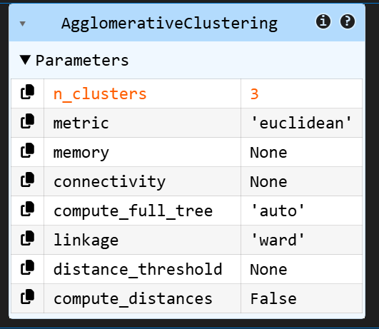
y_pred=model.fit_predict(X_test)
from sklearn.metrics import accuracy_score, classification_report,confusion_matrix
print("accuracy_score=",accuracy_score(y_pred,y_test))
print("classification_report",classification_report(y_pred,y_test))
print("confussion matrix",confusion_matrix(y_pred,y_test))
accuracy_score= 0.7577970381491844
classification_report precision recall f1-score support

0 0.97 0.77 0.86 13902
1 0.09 0.50 0.16 673
2 0.00 0.00 0.00 78

accuracy 0.76 14653
macro avg 0.35 0.42 0.34 14653
weighted avg 0.92 0.76 0.82 14653

confussion matrix [[10770 3132 0]
[ 339 334 0]
[ 0 78 0]]
import numpy as np
import matplotlib.pyplot as plt
import seaborn as sns
from sklearn.metrics import confusion_matrix
cm = confusion_matrix(y_test, y_pred)
plt.imshow(cm)
plt.title("Confusion matrix - AgglomerativeClustering")
plt.colorbar()
plt.xlabel("Predicted")
plt.ylabel("Actual")

for i in range(cm.shape[0]):
for j in range(cm.shape[1]):
plt.text(j,i,cm[i,j],ha="center",va="center")
plt.show()
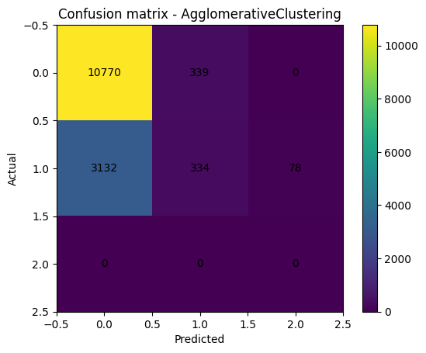
from sklearn.decomposition import PCA
pca = PCA(n_components=2) # Reducing to 2 components (2D)
X_reduced = pca.fit_transform(X_test) # Apply PCA on test data (X_test)

# Plotting the results
plt.figure(figsize=(8, 6))
plt.scatter(X_reduced[:, 0], X_reduced[:, 1], c=y_pred, cmap='viridis', s=50)

# Adding labels and title
plt.title('Agglomerative Clustering with PCA on X_test')
plt.xlabel('Principal Component 1')
plt.ylabel('Principal Component 2')

# Add color bar to indicate the cluster labels
plt.colorbar(label='Cluster Label')

# Display the plot
plt.show()

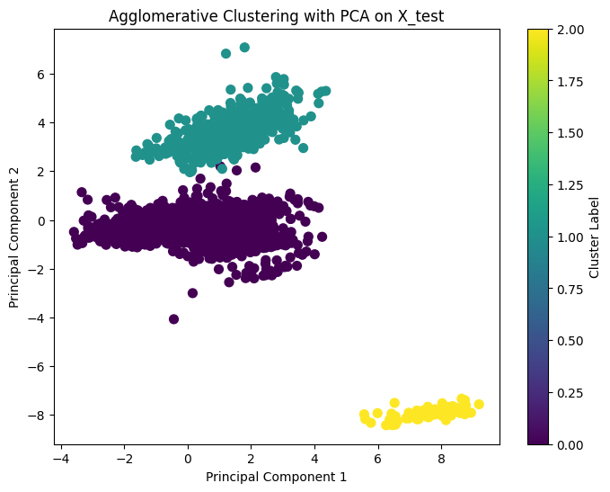
from scipy.cluster.hierarchy import dendrogram, linkage
agg_clustering = AgglomerativeClustering(n_clusters=3, linkage='ward')
df['Cluster'] = agg_clustering.fit_predict(df)
print(df)
age fnlwgt education_num capital_gain capital_loss hours_per_week \
0 39 77516 13 2174 0 40
1 50 83311 13 0 0 13
2 38 215646 9 0 0 40
3 53 234721 7 0 0 40
4 28 338409 13 0 0 40
... ... ... ... ... ... ...
48837 39 215419 13 0 0 36
48838 64 321403 9 0 0 40
48839 38 374983 13 0 0 50
48840 44 83891 13 5455 0 40
48841 35 182148 13 0 0 60

income_level Cluster
0 0 2
1 0 2
2 0 1
3 0 1
4 0 0
... ... ...
48837 0 1
48838 0 0
48839 0 0
48840 0 2
48841 1 1

[48842 rows x 8 columns]
# Plot Dendrogram
linked = linkage(df[['income_level', 'age']], method='ward')

plt.figure(figsize=(10, 7))
dendrogram(linked)
plt.title('Dendrogram for Agglomerative Clustering')
plt.xlabel('Data points')
plt.ylabel('Euclidean Distance')
plt.show()
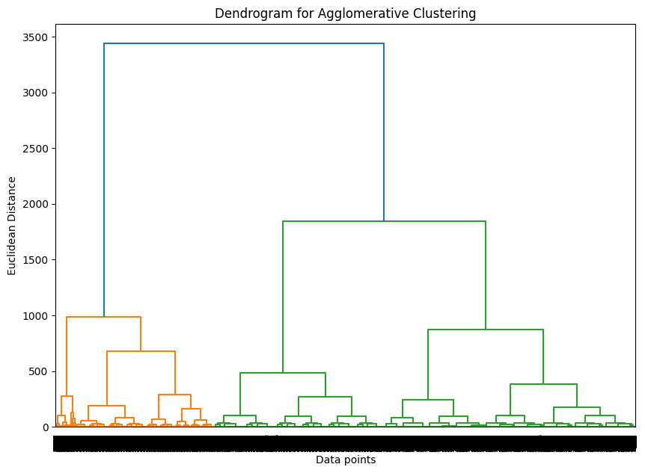

DBSCAN
Aim- To implement DBSCAN clustering and identify dense clusters and noise points in the dataset.
Theory- DBSCAN (Density-Based Spatial Clustering of Applications with Noise) is a density-based clustering algorithm that groups data points based on how closely they are packed together. It uses two key parameters: ε (epsilon), which defines the radius of a neighborhood around a point, and MinPts, the minimum number of points required to form a dense region. Points are classified as core points (enough neighbors within ε), border points (close to a core point but with fewer neighbors), or noise/outliers (points that do not belong to any cluster). Clusters are formed by connecting core points that are density-reachable from one another, allowing DBSCAN to discover clusters of arbitrary shape.
A major strength of DBSCAN is its ability to identify noise and outliers explicitly, which many clustering algorithms fail to do. It also does not require specifying the number of clusters in advance and works well with non-spherical cluster structures. However, DBSCAN is sensitive to the choice of ε and MinPts—poor parameter selection can lead to missed clusters or excessive noise. Additionally, it struggles with datasets where cluster densities vary significantly. Despite these challenges, DBSCAN is widely used in applications such as spatial data analysis, anomaly detection, and image processing due to its robustness and flexibility.
Code-
import pandas as pd
df=pd.read_csv("dbscan.csv")
df.info()
<class 'pandas.core.frame.DataFrame'>
RangeIndex: 95 entries, 0 to 94
Data columns (total 4 columns):
# Column Non-Null Count Dtype
--- ------ -------------- -----
0 Income 95 non-null int64
1 Age 95 non-null int64
2 Location 95 non-null int32
3 Cluster 95 non-null int64
dtypes: int32(1), int64(3)
memory usage: 2.7 KB
from sklearn.preprocessing import LabelEncoder
from sklearn.cluster import DBSCAN
le = LabelEncoder()
df['Location'] = le.fit_transform(df['Location'])

# Select features for clustering
X = df[['Income', 'Age', 'Location']]

# Run DBSCAN clustering
db = DBSCAN(eps=30000, min_samples=5).fit(X)

# Add the cluster labels to the data
df['Cluster'] = db.labels_

# Display the resulting clusters
print(df[['Income', 'Age', 'Location', 'Cluster']])
Income Age Location Cluster
0 25000 22 0 0
1 27000 24 1 0
2 32000 29 0 0
3 45000 35 2 0
4 48000 40 1 0
.. ... ... ... ...
90 530000 130 0 1
91 540000 132 1 1
92 550000 134 2 1
93 560000 136 3 1
94 570000 138 4 1

[95 rows x 4 columns]
import matplotlib.pyplot as plt
plt.figure(figsize=(10, 6))
plt.scatter(df['Income'], df['Age'], c=df['Cluster'], cmap='viridis', marker='o')
plt.title('DBSCAN Clustering (Income vs Age)')
plt.xlabel('Income')
plt.ylabel('Age')
plt.colorbar(label='Cluster Label')
plt.show()
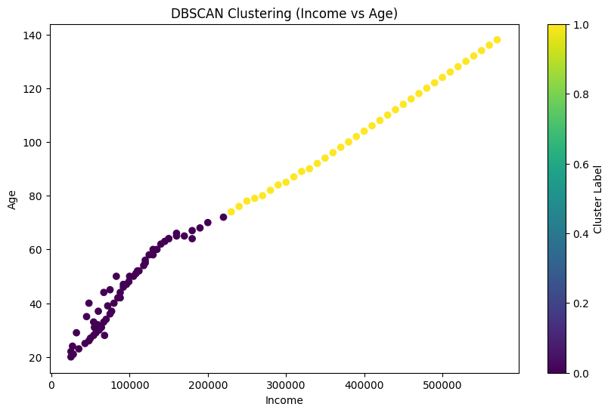

Boosting
Aim-To implement Boosting techniques and evaluate their performance on a classification dataset.
Theory -Boosting is an ensemble learning technique that improves model performance by combining multiple weak learners to form a strong predictive model. Instead of training models independently, boosting trains them sequentially, where each new model focuses more on the data points that were misclassified by previous models. During this process, higher importance (weights) is given to difficult observations, forcing subsequent learners to pay extra attention to them. Common weak learners used in boosting are shallow decision trees (decision stumps), which on their own perform only slightly better than random guessing.
Popular boosting algorithms such as AdaBoost, Gradient Boosting, and XGBoost differ in how they adjust weights and optimize errors, but all follow the same core idea of reducing bias and improving accuracy through iteration. Boosting is especially effective for complex datasets and often achieves high predictive performance in classification and regression tasks. However, it can be sensitive to noisy data and outliers, since misclassified points may receive increasing emphasis. Despite this limitation, boosting remains one of the most powerful and widely used techniques in machine learning competitions and real-world applications.
Code-
import numpy as np
import matplotlib.pyplot as plt
from sklearn.datasets import load_wine
from sklearn.preprocessing import LabelEncoder, StandardScaler
from sklearn.model_selection import train_test_split
from sklearn.tree import DecisionTreeClassifier
from sklearn.ensemble import BaggingClassifier, AdaBoostClassifier
from sklearn.metrics import accuracy_score
from sklearn.ensemble import GradientBoostingClassifier
from sklearn.metrics import accuracy_score
wine = load_wine()
X = wine.data
y = wine.target
le = LabelEncoder()
y = le.fit_transform(y)
scaler = StandardScaler()
X = scaler.fit_transform(X)
X_train, X_test, y_train, y_test = train_test_split(
X, y, test_size=0.25, random_state=42, stratify=y
)
boost_errors = []
trees = range(1, 201)
for n in trees:
boost = AdaBoostClassifier(
estimator=DecisionTreeClassifier(max_depth=1),
n_estimators=n,
learning_rate=0.5,
random_state=42
)
boost.fit(X_train, y_train)
pred = boost.predict(X_test)
boost_errors.append(1 - accuracy_score(y_test, pred))
plt.figure()
plt.plot(trees, boost_errors)
plt.xlabel("Number of Trees")
plt.ylabel("Misclassification Error")
plt.title("Boosting: Rapid Error Reduction")
plt.show()
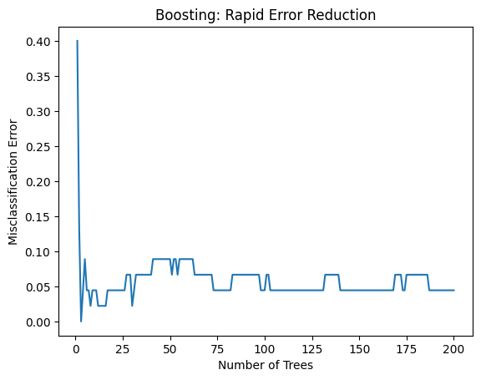
boost_configs = {
"No shrinkage": GradientBoostingClassifier(
learning_rate=1.0,
subsample=1.0,
max_features=None,
random_state=42
),
"learning_rate=0.2": GradientBoostingClassifier(
learning_rate=0.2,
subsample=1.0,
max_features=None,
random_state=42
),
"subsample=0.5": GradientBoostingClassifier(
learning_rate=1.0,
subsample=0.5,
max_features=None,
random_state=42
),
"learning_rate=0.2, subsample=0.5": GradientBoostingClassifier(
learning_rate=0.2,
subsample=0.5,
max_features=None,
random_state=42
),
"learning_rate=0.2, max_features=0.5": GradientBoostingClassifier(
learning_rate=0.2,
subsample=1.0,
max_features=0.5,
random_state=42
)
}
n_estimators = 400
boosting_errors = {}
for name, model in boost_configs.items():
model.set_params(n_estimators=n_estimators)
model.fit(X_train, y_train)
errors = []
for y_pred in model.staged_predict(X_test):
errors.append(1 - accuracy_score(y_test, y_pred))
boosting_errors[name] = errors
plt.figure(figsize=(8, 5))
for name, errors in boosting_errors.items():
plt.plot(errors, label=name)
plt.xlabel("Boosting Iterations")
plt.ylabel("Test Set Misclassification Error")
plt.title("Boosting: Effect of Shrinkage and Subsampling")
plt.legend()
plt.show()
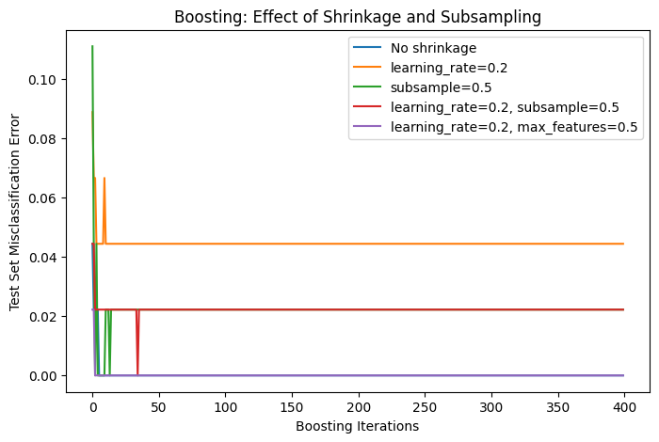
.

Bagging
Aim-To implement Bagging ensemble techniques and analyze classification performance.
Theory- Bagging (Bootstrap Aggregating) is an ensemble learning technique designed to improve model stability and accuracy by reducing variance. It works by creating multiple different training datasets using bootstrap sampling, where samples are drawn randomly with replacement from the original dataset. A separate model (often a decision tree) is trained on each bootstrap sample, and the final prediction is obtained by aggregating the outputs of all models—using majority voting for classification or averaging for regression. Since each model sees a slightly different version of the data, their errors tend to cancel out.
The main advantage of bagging is its effectiveness in handling high-variance models, especially decision trees, which are sensitive to small changes in data. Unlike boosting, bagging trains all models independently and does not focus on misclassified points, making it more robust to noise and outliers. A well-known example of bagging is the Random Forest algorithm, which further improves performance by introducing randomness in feature selection. Overall, bagging is simple, scalable, and widely used when overfitting is a concern.
Code-
import numpy as np
import matplotlib.pyplot as plt
from sklearn.datasets import load_wine
from sklearn.preprocessing import LabelEncoder, StandardScaler
from sklearn.model_selection import train_test_split
from sklearn.tree import DecisionTreeClassifier
from sklearn.ensemble import BaggingClassifier, AdaBoostClassifier
from sklearn.metrics import accuracy_score
wine = load_wine()
X = wine.data
y = wine.target
le = LabelEncoder()
y = le.fit_transform(y)
scaler = StandardScaler()
X = scaler.fit_transform(X)
X_train, X_test, y_train, y_test = train_test_split(
X, y, test_size=0.25, random_state=42, stratify=y
)
bag_errors = []
trees = range(1, 201)
for n in trees:
bag = BaggingClassifier(
estimator=DecisionTreeClassifier(),
n_estimators=n,
random_state=42,
n_jobs=-1
)
bag.fit(X_train, y_train)
pred = bag.predict(X_test)
bag_errors.append(1 - accuracy_score(y_test, pred))
plt.figure()
plt.plot(trees, bag_errors)
plt.xlabel("Number of Trees")
plt.ylabel("Misclassification Error")
plt.title("Bagging: Slow Variance Reduction")
plt.show()
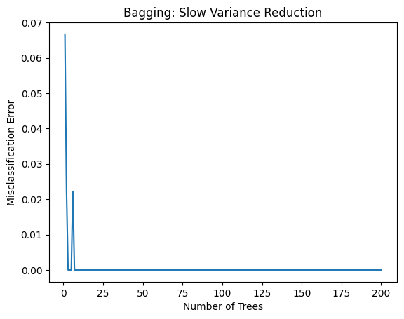
trees = range(1, 401)
bag_full = []
bag_subsample = []
bag_row_feature = []
for n in trees:
# 1️⃣ Classic Bagging (Bootstrap)
model_full = BaggingClassifier(
estimator=DecisionTreeClassifier(),
n_estimators=n,
bootstrap=True,
max_samples=1.0,
random_state=42,
n_jobs=-1
)
model_full.fit(X_train, y_train)
bag_full.append(
1 - accuracy_score(y_test, model_full.predict(X_test))
)
# 2️⃣ Row Subsampling (like subsample=0.5)
model_sub = BaggingClassifier(
estimator=DecisionTreeClassifier(),
n_estimators=n,
bootstrap=True,
max_samples=0.5,
random_state=42,
n_jobs=-1
)
model_sub.fit(X_train, y_train)
bag_subsample.append(
1 - accuracy_score(y_test, model_sub.predict(X_test))
)
# 3️⃣ Row + Feature Subsampling
model_rf_like = BaggingClassifier(
estimator=DecisionTreeClassifier(),
n_estimators=n,
bootstrap=True,
max_samples=0.5,
max_features=0.5,
random_state=42,
n_jobs=-1
)
model_rf_like.fit(X_train, y_train)
bag_row_feature.append(
1 - accuracy_score(y_test, model_rf_like.predict(X_test))
)
plt.figure(figsize=(8, 5))
plt.plot(trees, bag_full, label="Bootstrap (no subsampling)")
plt.plot(trees, bag_subsample, label="Row subsampling (0.5)")
plt.plot(trees, bag_row_feature, label="Row + Feature subsampling")
plt.xlabel("Number of Trees")
plt.ylabel("Test Set Misclassification Error")
plt.title("Bagging with Subsampling Effects")
plt.legend()
plt.show()
