Experiment – 5
ID3
Aim – A program to demonstrate the working of the decision tree based ID3 algorithm. Use an appropriate data set for building the decision tree and apply this knowledge to classify a new sample.
Theory - A decision tree is a supervised learning technique used for classification, where knowledge is represented in the form of a tree structure consisting of decision nodes, branches, and leaf nodes. Each internal node tests an attribute, each branch corresponds to an outcome of the test, and each leaf node represents a class label. The ID3 (Iterative Dichotomiser 3) algorithm, proposed by J. Ross Quinlan, builds a decision tree using a top-down, greedy approach by selecting the most informative attribute at each stage of tree construction.
ID3 uses the concepts of entropy and information gain to select the best attribute for splitting the dataset. Entropy measures the level of uncertainty or impurity in a dataset, while information gain measures the reduction in entropy achieved by partitioning the data based on a specific attribute. The attribute with the highest information gain is chosen as the splitting attribute, ensuring that the data is classified as effectively as possible at each level of the tree.
Once the decision tree is constructed, it can be used to classify new and unseen samples by traversing the tree from the root node to a leaf node based on the attribute values of the input sample. ID3 works best with categorical attributes and produces interpretable models, but it may suffer from overfitting and does not directly handle continuous attributes without preprocessing. Despite these limitations, ID3 is widely used for understanding the fundamental principles of decision tree learning.
Code –
#Load Dataset
import pandas as pd
from sklearn.datasets import load_iris
data=load_iris()
df=pd.DataFrame(load_iris().data,columns=load_iris().feature_names)
x=df
y=load_iris().target
#import libraries
from sklearn.model_selection import train_test_split
from sklearn.tree import DecisionTreeClassifier
from sklearn.metrics import accuracy_score, confusion_matrix, classification_report
import matplotlib.pyplot as plt
import numpy as np
import seaborn as sns
corr = df.corr()

# Plot heatmap
plt.figure(figsize=(8, 6))
sns.heatmap(
corr,
annot=True,
cmap="coolwarm",
linewidths=0.5,
fmt=".2f"
)
plt.title("Heatmap of Feature Correlation - Iris Dataset")
plt.show()
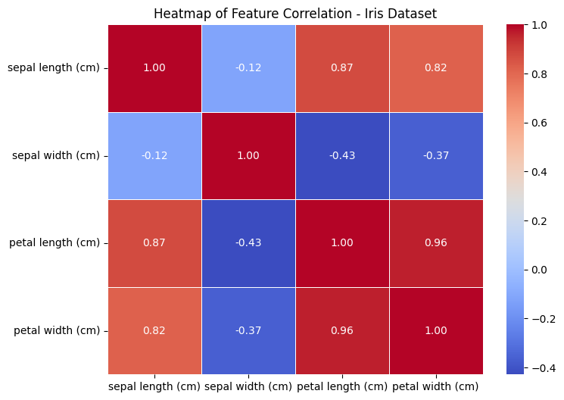
#Split data
X_train, X_test, y_train, y_test = train_test_split(
x, y, test_size=0.3, random_state=42
)
#Model
model = DecisionTreeClassifier(criterion='entropy',random_state=42)
model.fit(X_train, y_train)
#Predict
y_pred = model.predict(X_test)
y_pred
array([1, 0, 2, 1, 1, 0, 1, 2, 1, 1, 1, 0, 0, 0, 0, 1, 2, 1, 1, 2, 0, 2,
0, 2, 2, 2, 2, 2, 0, 0, 0, 0, 1, 0, 0, 2, 1, 0, 0, 0, 2, 1, 1, 0,
0])
#Metrics
print("Accuracy:", accuracy_score(y_test, y_pred))
print("Confusion Matrix:\n", confusion_matrix(y_test, y_pred))
print("Classification Report:\n", classification_report(y_test, y_pred))
Accuracy: 0.9777777777777777
Confusion Matrix:
[[19 0 0]
[ 0 13 0]
[ 0 1 12]]
Classification Report:
precision recall f1-score support

0 1.00 1.00 1.00 19
1 0.93 1.00 0.96 13
2 1.00 0.92 0.96 13

accuracy 0.98 45
macro avg 0.98 0.97 0.97 45
weighted avg 0.98 0.98 0.98 45
cm = confusion_matrix(y_test, y_pred)

plt.imshow(cm)
plt.title("Confusion Matrix - Decision Tree (ID3)")
plt.colorbar()
plt.xlabel("Predicted")
plt.ylabel("Actual")

for i in range(cm.shape[0]):
for j in range(cm.shape[1]):
plt.text(j, i, cm[i, j], ha="center", va="center")
plt.show()
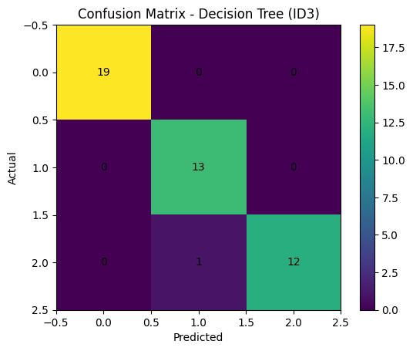
#Plot Decision tree
from sklearn.tree import DecisionTreeClassifier, plot_tree

plt.figure(figsize=(20, 12))
plot_tree(
model,
feature_names=data.feature_names,
class_names=data.target_names,
filled=True,
rounded=True
)
plt.title("Decision Tree using ID3 (Entropy) - Iris Dataset")
plt.show()

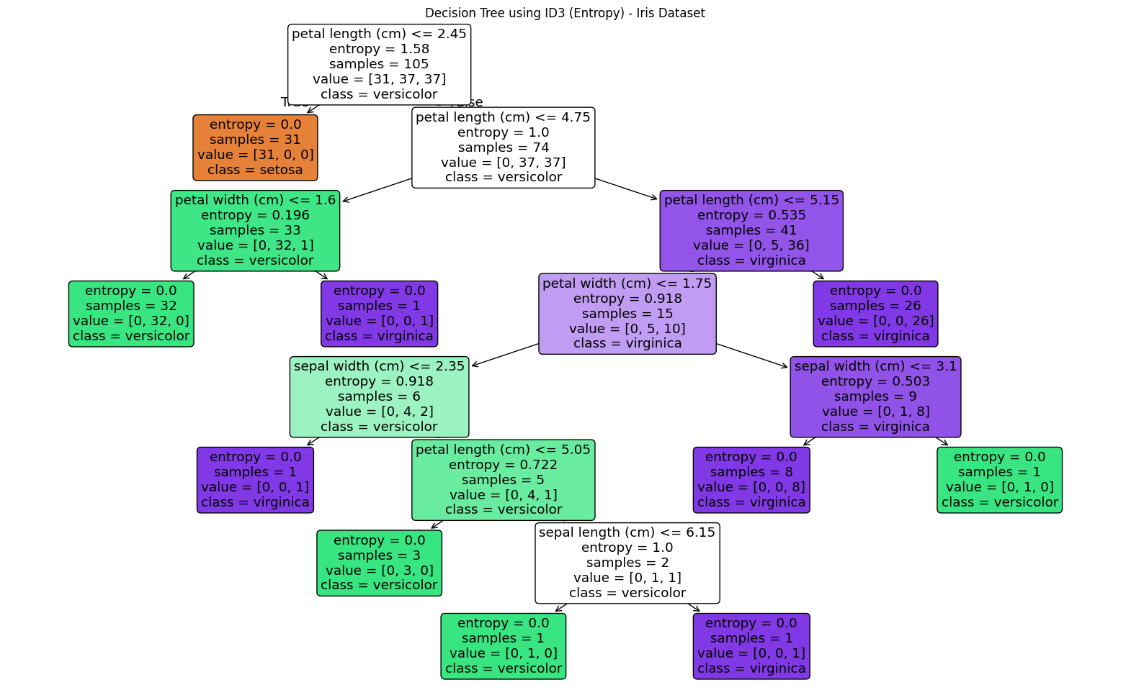

K-Nearest
Aim - Write a program to implement k-Nearest Neighbour algorithm to classify the iris data set. Print both correct and wrong predictions. Java/Python ML library classes can be used for this problem.
Theory - The k-Nearest Neighbour (k-NN) algorithm is a supervised machine learning technique used for classification and regression. It is a lazy learning algorithm, meaning it does not build an explicit model during training. Instead, all training instances are stored, and classification is performed only when a new sample needs to be classified. The algorithm works by finding the k closest data points (nearest neighbours) to the new sample based on a distance metric such as Euclidean distance.
In classification problems like the Iris dataset, k-NN determines the class of a test sample by identifying the k nearest training samples and assigning the class that occurs most frequently among them (majority voting). The value of k plays an important role: a small value of k may make the model sensitive to noise, while a larger value provides smoother decision boundaries but may reduce accuracy. Feature scaling is often applied before using k-NN, as distance calculations are affected by the magnitude of feature values.
After classification, the predicted class labels are compared with the actual class labels to evaluate performance. Predictions that match the true class are considered correct, while mismatches are considered wrong predictions. The k-NN algorithm is simple, intuitive, and effective for small datasets, but it can be computationally expensive for large datasets and sensitive to irrelevant features.
Code –
import pandas as pd
from sklearn.datasets import load_iris
data=load_iris()
df=pd.DataFrame(load_iris().data,columns=load_iris().feature_names)
x=df
y=load_iris().target
from sklearn.model_selection import train_test_split
from sklearn.neighbors import KNeighborsClassifier
from sklearn.metrics import accuracy_score, confusion_matrix, classification_report
import matplotlib.pyplot as plt
import numpy as np
import seaborn as sns
corr = df.corr()

# Plot heatmap
plt.figure(figsize=(8, 6))
sns.heatmap(
corr,
annot=True,
cmap="coolwarm",
linewidths=0.5,
fmt=".2f"
)
plt.title("Heatmap of Feature Correlation - Iris Dataset")
plt.show()

X_train, X_test, y_train, y_test = train_test_split(
x, y, test_size=0.3, random_state=42
)
knn = KNeighborsClassifier(n_neighbors=3)
knn.fit(X_train, y_train)
y_pred = knn.predict(X_test)
print("Correct Predictions:")
for i in range(len(y_test)):
if y_test[i] == y_pred[i]:
print(
f"Actual: {data.target_names[y_test[i]]}, "
f"Predicted: {data.target_names[y_pred[i]]}"
)

print("\nWrong Predictions:")
for i in range(len(y_test)):
if y_test[i] != y_pred[i]:
print(
f"Actual: {data.target_names[y_test[i]]}, "
f"Predicted: {data.target_names[y_pred[i]]}"
)
Correct Predictions:
Actual: versicolor, Predicted: versicolor
Actual: setosa, Predicted: setosa
Actual: virginica, Predicted: virginica
Actual: versicolor, Predicted: versicolor
Actual: versicolor, Predicted: versicolor
Actual: setosa, Predicted: setosa
Actual: versicolor, Predicted: versicolor
Actual: virginica, Predicted: virginica
Actual: versicolor, Predicted: versicolor
Actual: versicolor, Predicted: versicolor
Actual: virginica, Predicted: virginica
Actual: setosa, Predicted: setosa
Actual: setosa, Predicted: setosa
Actual: setosa, Predicted: setosa
Actual: setosa, Predicted: setosa
Actual: versicolor, Predicted: versicolor
Actual: virginica, Predicted: virginica
Actual: versicolor, Predicted: versicolor
Actual: versicolor, Predicted: versicolor
Actual: virginica, Predicted: virginica
Actual: setosa, Predicted: setosa
Actual: virginica, Predicted: virginica
Actual: setosa, Predicted: setosa
Actual: virginica, Predicted: virginica
...
Actual: setosa, Predicted: setosa
Actual: setosa, Predicted: setosa

Wrong Predictions:
print("Accuracy:", accuracy_score(y_test, y_pred))
print("Confusion Matrix:\n", confusion_matrix(y_test, y_pred))
print("Classification Report:\n", classification_report(y_test, y_pred))
Accuracy: 1.0
Confusion Matrix:
[[19 0 0]
[ 0 13 0]
[ 0 0 13]]
Classification Report:
precision recall f1-score support

0 1.00 1.00 1.00 19
1 1.00 1.00 1.00 13
2 1.00 1.00 1.00 13

accuracy 1.00 45
macro avg 1.00 1.00 1.00 45
weighted avg 1.00 1.00 1.00 45
cm = confusion_matrix(y_test, y_pred)

plt.imshow(cm)
plt.title("Confusion Matrix - Decision Tree (F-test)")
plt.colorbar()
plt.xlabel("Predicted")
plt.ylabel("Actual")

for i in range(cm.shape[0]):
for j in range(cm.shape[1]):
plt.text(j, i, cm[i, j], ha="center", va="center")
plt.show()
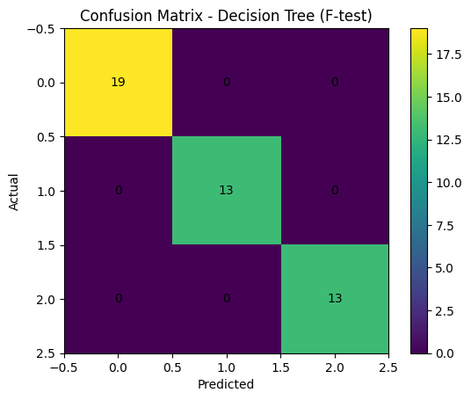
k_values = range(1, 16)
accuracies = []

# Train KNN for different K values
for k in k_values:
knn = KNeighborsClassifier(n_neighbors=k)
knn.fit(X_train, y_train)
y_pred = knn.predict(X_test)
acc = accuracy_score(y_test, y_pred)
accuracies.append(acc)

# Plot graph
plt.figure()
plt.plot(k_values, accuracies, marker='o')
plt.xlabel("Number of Neighbors (K)")
plt.ylabel("Accuracy")
plt.title("KNN Accuracy vs K Value (Iris Dataset)")
plt.show()
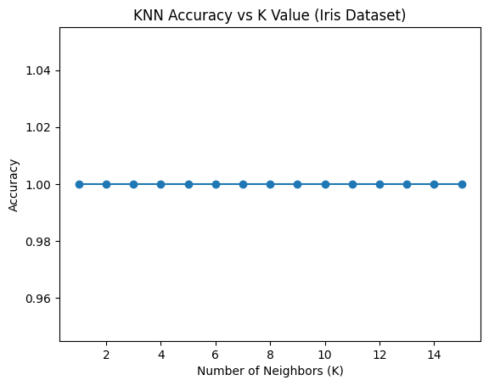
Em vs K-means
Aim - Apply EM algorithm to cluster a set of data stored in a .CSV file. Use the same data set for clustering using kMeans algorithm. Compare the results of these two algorithms and comment on the quality of clustering. You can add Java/Python ML library classes/API in the program.
Theory - Clustering is an unsupervised learning technique used to group similar data points without prior class labels. The Expectation–Maximization (EM) algorithm is a probabilistic clustering approach that assumes the data is generated from a mixture of probability distributions, typically Gaussian distributions. EM works iteratively in two steps: the Expectation (E) step, where the probability of each data point belonging to each cluster is calculated, and the Maximization (M) step, where the model parameters (means, variances, and mixing coefficients) are updated to maximize the likelihood of the data. This results in soft clustering, where each data point can belong to multiple clusters with different probabilities.
The K-Means algorithm is a distance-based clustering method that partitions the dataset into k clusters by minimizing the within-cluster sum of squared distances. It works by initially selecting cluster centroids, assigning each data point to the nearest centroid, and then updating the centroids based on the mean of assigned points. This process is repeated until convergence. K-Means performs hard clustering, meaning each data point belongs to exactly one cluster, and it assumes clusters are spherical and equally sized.
When the same dataset is clustered using both EM and K-Means, differences in clustering quality can be observed. K-Means is simpler and faster but may perform poorly when clusters overlap or have complex shapes. EM generally provides better clustering quality for such datasets because it models the underlying data distribution and handles overlapping clusters more effectively. Therefore, EM often produces more accurate and flexible clustering results compared to K-Means, especially for real-world datasets with varying cluster structures.
Code –
from sklearn.datasets import load_wine
from sklearn.preprocessing import StandardScaler
from sklearn.decomposition import PCA
from sklearn.cluster import KMeans
from sklearn.mixture import GaussianMixture
from sklearn.metrics import silhouette_score
import matplotlib.pyplot as plt
wine = load_wine()
X = wine.data
scaler = StandardScaler()
X_scaled = scaler.fit_transform(X)
pca = PCA(n_components=2)
X_pca = pca.fit_transform(X_scaled)
kmeans = KMeans(n_clusters=3, random_state=42)
kmeans_labels = kmeans.fit_predict(X_pca)
gmm = GaussianMixture(n_components=3, random_state=42)
gmm_labels = gmm.fit_predict(X_pca)
kmeans_score = silhouette_score(X_pca, kmeans_labels)
gmm_score = silhouette_score(X_pca, gmm_labels)

print("Silhouette Score (K-Means):", round(kmeans_score, 3))
print("Silhouette Score (EM/GMM):", round(gmm_score, 3))
Silhouette Score (K-Means): 0.56
Silhouette Score (EM/GMM): 0.559
plt.figure(figsize=(12, 5))
# K-Means plot
plt.subplot(1, 2, 1)
plt.scatter(X_pca[:, 0], X_pca[:, 1], c=kmeans_labels)
plt.title("K-Means Clustering (PCA Reduced Data)")
plt.xlabel("Principal Component 1")
plt.ylabel("Principal Component 2")
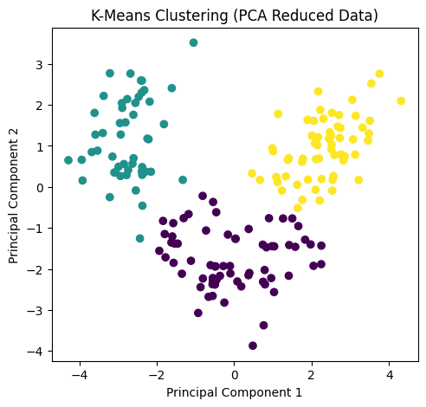
plt.subplot(1, 2, 2)
plt.scatter(X_pca[:, 0], X_pca[:, 1], c=gmm_labels)
plt.title("EM Clustering (Gaussian Mixture Model)")
plt.xlabel("Principal Component 1")
plt.ylabel("Principal Component 2")
plt.tight_layout()
plt.show()
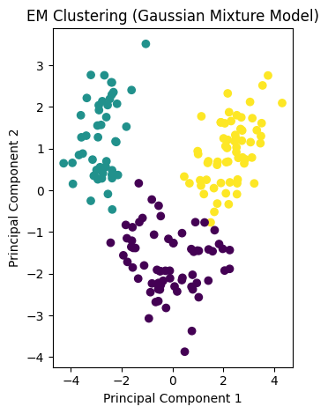

ANN
Aim - Build an Artificial Neural Network by implementing the Back propagation algorithm and test the same using appropriate data sets.
Theory - An Artificial Neural Network (ANN) is a computational model inspired by the structure and functioning of the human brain. It consists of interconnected processing units called neurons, organized into input, hidden, and output layers. Each connection between neurons has an associated weight, and learning in an ANN involves adjusting these weights so that the network can correctly map input data to output classes or values. ANNs are widely used for classification and prediction tasks due to their ability to model complex nonlinear relationships.
Backpropagation is a supervised learning algorithm used to train artificial neural networks. During training, the input data is passed forward through the network to produce an output, which is then compared with the actual target output to compute an error. This error is propagated backward through the network, and the weights are updated using gradient descent in order to minimize the loss function. The process of forward propagation, error calculation, and backward weight adjustment is repeated iteratively until the network converges to an optimal solution.
Once trained, the ANN can be tested using unseen data to evaluate its performance. The effectiveness of the network is measured using metrics such as accuracy, loss, or error rate. ANNs trained using backpropagation are powerful tools for pattern recognition and classification, but their performance depends on factors such as network architecture, learning rate, and quality of the dataset.
Code –
import numpy as np
import pandas as pd
import matplotlib.pyplot as plt
from sklearn.datasets import load_breast_cancer

data = load_breast_cancer()
df=pd.DataFrame(data.data, columns=data.feature_names)
X = data.data
y = data.target
print("Feature shape:", X.shape)
print("Target shape:", y.shape)
Feature shape: (569, 30)
Target shape: (569,)
from sklearn.model_selection import train_test_split

X_train, X_test, y_train, y_test = train_test_split(
X, y, test_size=0.3, random_state=42
)
from sklearn.preprocessing import StandardScaler

scaler = StandardScaler()
X_train = scaler.fit_transform(X_train)
X_test = scaler.transform(X_test)
from sklearn.neural_network import MLPClassifier

ann = MLPClassifier(
hidden_layer_sizes=(20, 10),
activation='relu',
solver='adam', # Uses backpropagation
max_iter=1000,
random_state=42
)
ann.fit(X_train, y_train)
y_pred = ann.predict(X_test)

from sklearn.metrics import accuracy_score

accuracy = accuracy_score(y_test, y_pred)
print("Accuracy:", accuracy)
Accuracy: 0.9766081871345029
from sklearn.metrics import confusion_matrix

cm = confusion_matrix(y_test, y_pred)
print("Confusion Matrix:\n", cm)

Confusion Matrix:
[[ 62 1]
[ 3 105]]
from sklearn.metrics import classification_report

print(classification_report(
y_test,
y_pred,
target_names=data.target_names
))
precision recall f1-score support

malignant 0.95 0.98 0.97 63
benign 0.99 0.97 0.98 108

accuracy 0.98 171
macro avg 0.97 0.98 0.98 171
weighted avg 0.98 0.98 0.98 171
from sklearn.metrics import roc_curve, auc

# Predict probabilities for positive class
y_prob = ann.predict_proba(X_test)[:, 1]

# Compute ROC curve
fpr, tpr, thresholds = roc_curve(y_test, y_prob)
roc_auc = auc(fpr, tpr)

# Plot ROC curve
plt.figure()
plt.plot(fpr, tpr, label=f"ANN (AUC = {roc_auc:.2f})")
plt.plot([0, 1], [0, 1], linestyle="--")
plt.xlabel("False Positive Rate")
plt.ylabel("True Positive Rate")
plt.title("ROC Curve - ANN (Backpropagation)")
plt.legend(loc="lower right")
plt.show()

