Experiment – 7
Locally Weighted Regression
Aim- To Implement the non-parametric Locally Weighted Regression algorithm in order to fit data points. Select appropriate data set for your experiment and draw graphs.
Theory- Locally Weighted Regression (LWR), also known as Locally Weighted Linear Regression, is a non-parametric supervised learning algorithm used for regression problems. Unlike parametric models that learn a single global function for the entire dataset, LWR fits a separate local model for each query point, making it highly effective for modeling non-linear relationships in data.
The key idea behind LWR is that points closer to the query point should have a greater influence on the prediction than points farther away. This is achieved using a distance-based weighting function, commonly a Gaussian kernel, which assigns higher weights to nearby data points and lower weights to distant ones.
Since LWR does not assume any fixed functional form for the data and does not learn global parameters during training, it is classified as a non-parametric and instance-based learning method. The model is constructed dynamically at prediction time, which allows it to adapt flexibly to local variations in the dataset.
For a given query point, LWR constructs a local regression model by minimizing a weighted least squares error function. The weights are computed using a kernel function that depends on the distance between the query point and each training sample. The Gaussian kernel is widely used due to its smooth weighting behavior.
The bandwidth parameter (τ) controls the width of the neighborhood considered:
A small τ results in a narrow neighborhood, leading to high variance and possible overfitting.
A large τ results in a broader neighborhood, leading to smoother predictions but possible underfitting.
Once the weights are calculated, a local linear regression model is fitted, and the predicted value is obtained for the query point. This process is repeated independently for each query point.
Code-
import numpy as np
import matplotlib.pyplot as plt
# Generate synthetic non-linear dataset
np.random.seed(0)
X = np.linspace(-3, 3, 100)
y = np.sin(X) + np.random.normal(0, 0.2, 100)
# Reshape for consistency
X = X.reshape(-1, 1)
y = y.reshape(-1, 1)
plt.figure()
plt.scatter(X, y)
plt.title("Before Implementing Locally Weighted Regression")
plt.xlabel("X")
plt.ylabel("y")
plt.show()
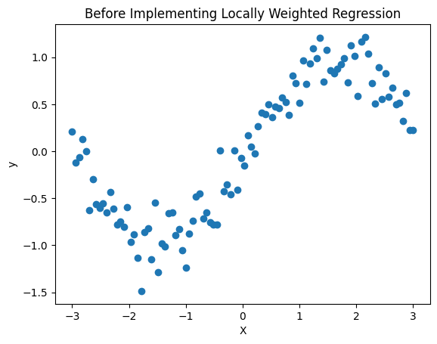
def locally_weighted_regression(X, y, x_query, tau):
"""
X : Training data (n x 1)
y : Target values (n x 1)
x_query : Point to predict
tau : Bandwidth parameter
"""
m = X.shape[0]

# Add bias term
X_b = np.hstack((np.ones((m, 1)), X))
x_q = np.array([1, x_query])

# Weight matrix
W = np.zeros((m, m))
for i in range(m):
diff = X[i] - x_query
W[i, i] = np.exp(-(diff ** 2) / (2 * tau ** 2))

# Closed-form solution
theta = np.linalg.pinv(X_b.T @ W @ X_b) @ X_b.T @ W @ y

return x_q @ theta
tau = 0.4 # Bandwidth
y_pred = []

for x in X:
y_pred.append(locally_weighted_regression(X, y, x[0], tau))

y_pred = np.array(y_pred)

plt.figure()
plt.scatter(X, y, label="Original Data")
plt.plot(X, y_pred, label="LWR Curve")
plt.title("After Implementing Locally Weighted Regression")
plt.xlabel("X")
plt.ylabel("y")
plt.legend()
plt.show()
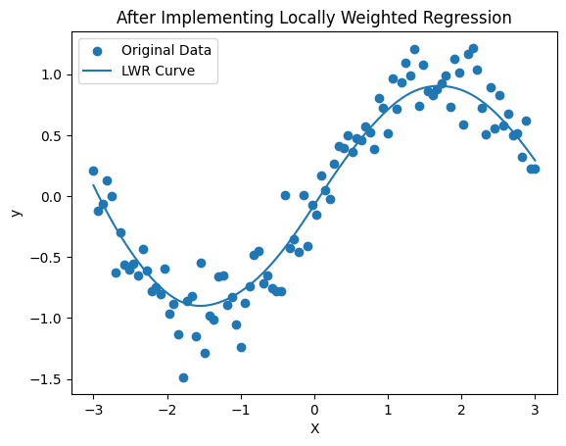

Feature Selection Using Kernels
Aim- To select the most relevant features from a dataset using kernel-based techniques (Feature selection using Kernels)
Theory- Feature selection is an important preprocessing step in machine learning that aims to identify the most relevant features from a dataset while removing redundant and irrelevant ones. Kernel-based feature selection techniques are particularly effective because they can capture non-linear relationships between input features and the target variable. Unlike traditional linear methods, kernel-based approaches implicitly map data into a higher-dimensional feature space, enabling better discrimination between important and unimportant features.
In kernel-based feature selection, kernel functions such as linear, polynomial, and Gaussian (RBF) kernels are used to measure the dependency between individual features and the output variable. A commonly used criterion is the Hilbert–Schmidt Independence Criterion (HSIC), which quantifies the statistical dependence between a feature and the target using kernel matrices. Features with higher kernel-based dependency scores are considered more relevant, as they contribute more significantly to the prediction task.
By selecting features based on kernel-based relevance measures, the dimensionality of the dataset can be reduced while preserving important information. This leads to improved model performance, reduced computational complexity, and better generalization. Kernel-based feature selection is especially useful in real-world datasets where complex, non-linear interactions exist between features and class labels.
Code-
import numpy as np
import pandas as pd
import matplotlib.pyplot as plt

from sklearn.datasets import load_breast_cancer
from sklearn.preprocessing import StandardScaler
from sklearn.metrics.pairwise import linear_kernel, polynomial_kernel, rbf_kernel
from sklearn.linear_model import LogisticRegression
from sklearn.metrics import roc_curve, auc
from sklearn.model_selection import train_test_split
data = load_breast_cancer()

X = data.data
y = data.target
feature_names = data.feature_names

scaler = StandardScaler()
X_scaled = scaler.fit_transform(X)
def compute_hsic_kernel(X_feature, y, kernel_type="rbf"):
X_feature = X_feature.reshape(-1, 1)
y = y.reshape(-1, 1)
n = X_feature.shape[0]

if kernel_type == "linear":
Kx = linear_kernel(X_feature)
Ky = linear_kernel(y)
elif kernel_type == "poly":
Kx = polynomial_kernel(X_feature, degree=3)
Ky = polynomial_kernel(y, degree=3)
elif kernel_type == "rbf":
Kx = rbf_kernel(X_feature, gamma=0.5)
Ky = rbf_kernel(y, gamma=0.5)

H = np.eye(n) - (1/n) * np.ones((n, n))
hsic = np.trace(Kx @ H @ Ky @ H) / ((n - 1) ** 2)
return hsic
kernels = ["linear", "poly", "rbf"]
selected_features = {}

for kernel in kernels:
scores = []
for i in range(X_scaled.shape[1]):
score = compute_hsic_kernel(X_scaled[:, i], y, kernel)
scores.append(score)

df_scores = pd.DataFrame({
"Feature": feature_names,
"HSIC Score": scores
}).sort_values(by="HSIC Score", ascending=False)

selected_features[kernel] = df_scores.head(10)["Feature"].values

roc_results = {}

for kernel in kernels:
feature_mask = [f in selected_features[kernel] for f in feature_names]
X_selected = X_scaled[:, feature_mask]

X_train, X_test, y_train, y_test = train_test_split(
X_selected, y, test_size=0.3, random_state=42
)

model = LogisticRegression(max_iter=500)
model.fit(X_train, y_train)

y_scores = model.predict_proba(X_test)[:, 1]

fpr, tpr, _ = roc_curve(y_test, y_scores)
roc_auc = auc(fpr, tpr)

roc_results[kernel] = (fpr, tpr, roc_auc)
plt.figure(figsize=(8, 6))

for kernel in kernels:
fpr, tpr, roc_auc = roc_results[kernel]
plt.plot(fpr, tpr, label=f"{kernel.upper()} Kernel (AUC = {roc_auc:.3f})")

plt.plot([0, 1], [0, 1], linestyle="--")
plt.xlabel("False Positive Rate")
plt.ylabel("True Positive Rate")
plt.title("ROC Curve Comparison for Different Kernels")
plt.legend()
plt.show()

