**Data Analytics Project**

**Prediction the Winner of an IPL match**

Rohan Bennur Sai Pranav M

PES1201801718 PES1201800296

→ Importing the dataset

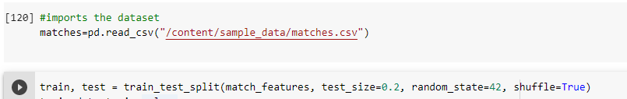

* + The dataset is imported and divided into training and testing in the ratio of 80-20 percent.

→ Data cleaning

In the above snippet, the dataset is cleaned. 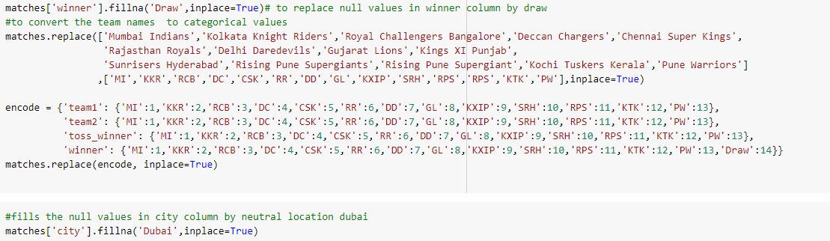

* Here the null values in the winner and city columns are replaced with ‘draw’ and ‘Dubai’ values respectively.
* The team names are then converted to categorical values

→ Building the Deep Neural Network using Tensorflow and Keras API

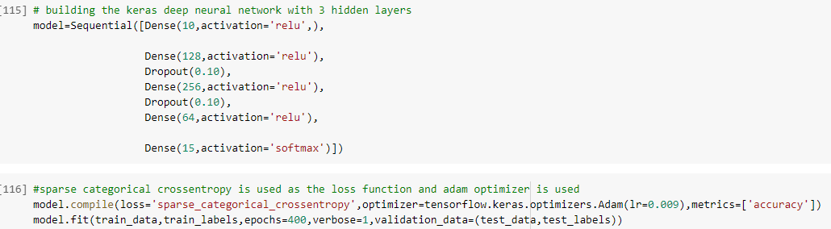

* 5 Dense layers have been used with 3 hidden layers, 1 input layer, and 1 output layer
* To reduce overfitting of the data 2 Dropout layers are used with a 0.1 dropping rate
* Since the target variable is categorical, ‘Sparse categorical cross-entropy ’ is used as a loss function and Adam is used as the optimizer with a learning rate of 0.009.
* Model is trained for 400 epochs
* Training various other models

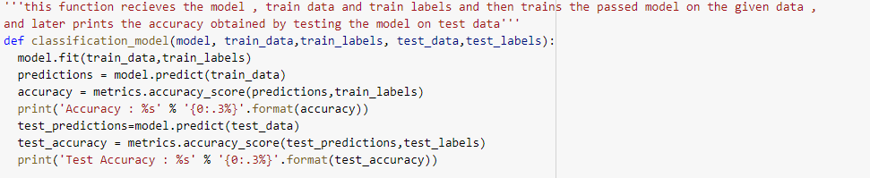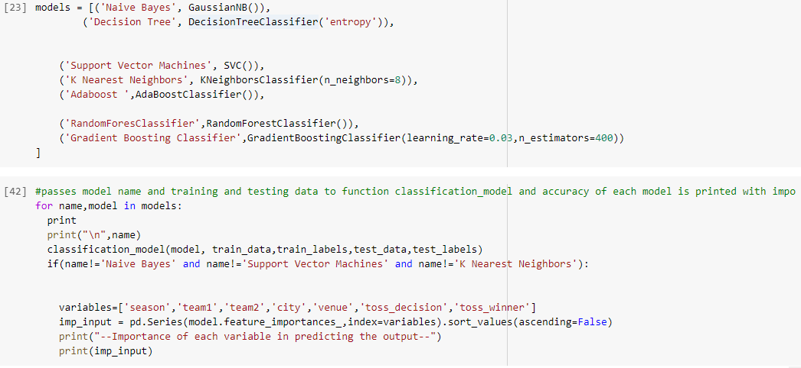

* Classification_model is a function which receives the model to train, training and testing data

-The function prints the accuracy of the model on the training and testing dataset

* Each model is passed as a parameter and training and testing accuracies are printed
* The importance of each variable in predicting the outcome is also printed

→ Results

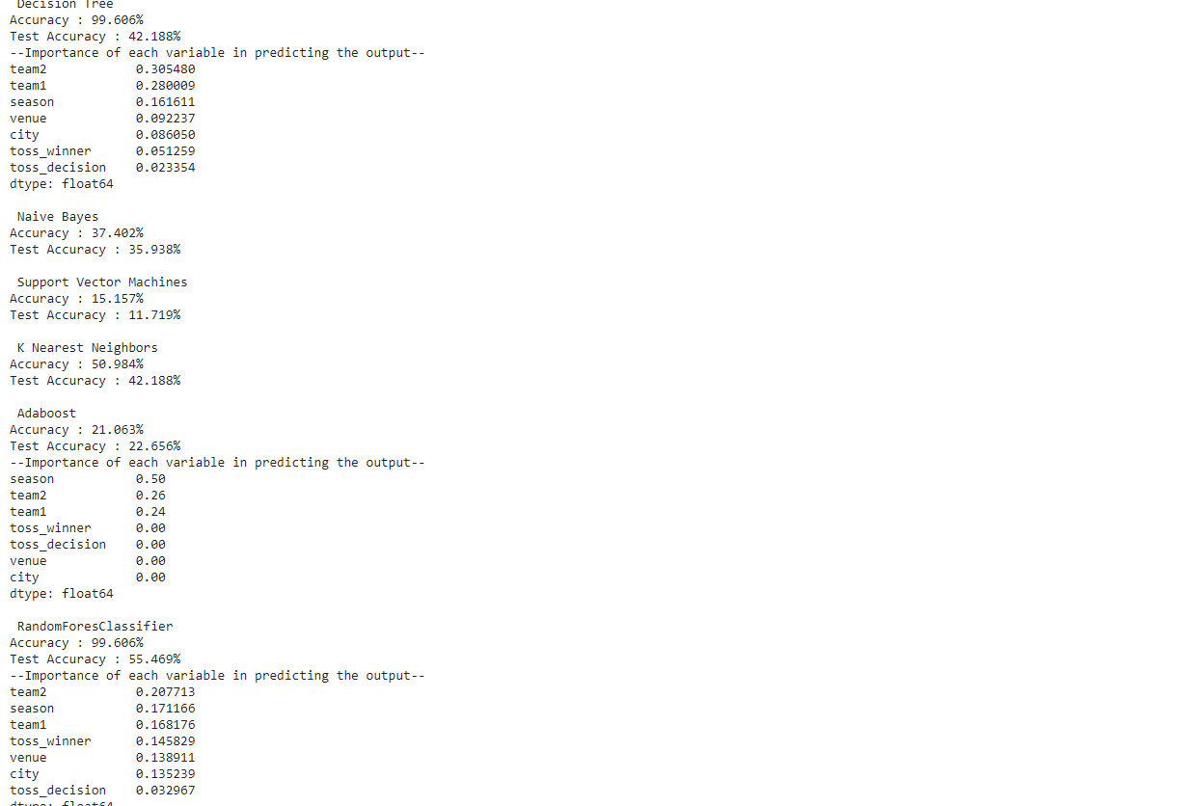

* The training and testing of each of the classification algorithms are printed along with the importance of each variable.

→ Results of Deep Neural Networks

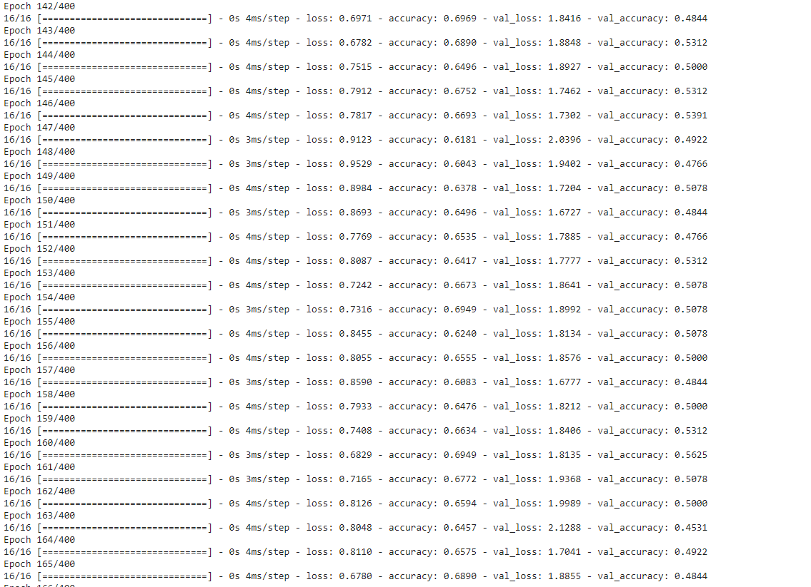

-Training and testing accuracies along with their respective losses are printed after each epoch