KL UNIVERSITY, HYDERABAD
Department of Computer Science & Engineering
PROJECT BASED LEARNING (PBL)
DETAILED PROJECT REPORT
AgroSense
Smart Greenhouse Monitoring & Irrigation Management System
Submitted by
2520040096 – K. Prasanna
2520040118 – A. Sai Pranay
Team No: 20
Under the guidance of
Dr. Karumuri Sri Rama Murthy
Assistant Professor, Department of CSE
KLU Hyderabad
Academic Year 2025 – 2026

CERTIFICATE
This is to certify that the project report entitled “AgroSense – Smart Greenhouse Monitoring & Irrigation Management System” is a bonafide work carried out by K. Prasanna (2520040096) and A. Sai Pranay (2520040118), Team No. 20, students of the Department of Computer Science and Engineering, KLU Hyderabad, as part of the Project Based Learning (PBL) course.
The work has been carried out under my supervision and guidance.

Dr. Karumuri Sri Rama Murthy
Assistant Professor, Department of CSE
KLU Hyderabad
Signature: ____________________ Date: ______________
DECLARATION
We, the members of Team No. 1, hereby declare that the project report entitled “AgroSense – Smart Greenhouse Monitoring & Irrigation Management System” submitted to the Department of Computer Science and Engineering, KLU Hyderabad, is an original work carried out by us under the guidance of Dr. Karumuri Sri Rama Murthy. The work has not been submitted to any other university or institution for the award of any degree or diploma.

K. Prananna (2520040096) ____________________
A. Sai Pranay (2520040118) ____________________
ACKNOWLEDGEMENT
We express our sincere gratitude to our project guide, Dr. Karumuri Sri Rama Murthy, Assistant Professor, Department of Computer Science and Engineering, KLU Hyderabad, for his valuable guidance, constant encouragement and suggestions throughout the development of this project.
We thank the Head of the Department and all faculty members of the Department of CSE for providing the facilities and a supportive environment. We also thank our friends and families for their continuous support.
Team No. 1: T. Sai Pavan Reddy, K. Kushal Kumar, A. Sai Pranay
ABSTRACT
Greenhouse farming depends on keeping soil moisture, temperature, humidity and light within the range required by each crop. Manual monitoring is slow, labour-intensive and error-prone, and fixed-schedule watering wastes water. AgroSense is a web-based smart greenhouse monitoring and irrigation management system that addresses these problems.
The system monitors three crop zones – Tomato (Zone A), Capsicum (Zone B) and Lettuce (Zone C). ESP32-based sensor nodes measure soil moisture, air temperature, humidity and light intensity and publish JSON telemetry over MQTT. A Node.js/Express server validates the readings, stores them in PostgreSQL/TimescaleDB (or in memory in demo mode), evaluates crop-specific threshold rules and raises warning or critical alerts. When automatic mode is enabled, the server switches the irrigation relay on and off using hysteresis thresholds; the grower can also override the pump manually. Live data are pushed to clients through Socket.IO and alerts through Server-Sent Events.
The user interface is a responsive React 18 dashboard with seven pages – Overview, Growing zones, Climate & trends, Irrigation, Alerts, Live sensors and Settings. A built-in simulator allows the whole system to be demonstrated without physical hardware. The project demonstrates a low-cost, extensible IoT architecture for precision agriculture.
Keywords: Smart agriculture, IoT, greenhouse, ESP32, MQTT, Node.js, React, TimescaleDB, automatic irrigation.
TABLE OF CONTENTS
1. Introduction 1
1.1 Background 1
1.2 Motivation 1
1.3 Objectives 1
1.4 Scope 1
2. Problem Statement 1
2.1 Problem Description 1
2.2 Existing System 1
2.3 Proposed System 1
3. System Requirements 1
3.1 Hardware Requirements 1
3.2 Software Requirements 1
3.3 Functional Requirements 1
3.4 Non-Functional Requirements 1
4. Technologies Used 1
4.1 Why these technologies? 1
5. System Design 1
5.1 Architecture 1
5.2 Data Flow 1
5.3 MQTT Topics 1
5.4 Database Design 1
5.5 REST API 1
6. Implementation 1
6.1 Project Structure 1
6.2 Firmware (ESP32 Node) 1
6.3 Backend Modules 1
6.4 Front-end Implementation 1
6.5 Deployment 1
6.6 Configuration 1
7. Output Screens 1
8. Testing 1
8.1 Test Approach 1
9. Results and Discussion 1
9.1 Current Limitations 1
10. Conclusion 1
11. Future Enhancements 1
12. References 1

(If the list above is empty, right-click it in Microsoft Word and choose “Update Field”.)

1. Introduction

1.1 Background
Agriculture is shifting from experience-based practice to data-driven precision farming. In protected cultivation such as greenhouses, crop yield and quality depend on microclimate parameters – soil moisture, air temperature, relative humidity and light intensity. Small deviations, if unnoticed for hours, can stress the plants and reduce yield. Internet of Things (IoT) technology makes it possible to sense these parameters continuously, transmit them to a server and act automatically.

1.2 Motivation
Small and medium growers often depend on manual inspection and fixed watering schedules. This leads to over-watering (wasted water and energy, root diseases), under-watering (wilting) and delayed reaction to heat. We were motivated to build an affordable, open-source system that gives a grower a single dashboard for all zones, warns early and can irrigate automatically.

1.3 Objectives
- To monitor soil moisture, temperature, humidity and light for multiple crop zones in near real time.
- To apply crop-specific moisture thresholds and generate warning/critical alerts.
- To automate irrigation using hysteresis control and also allow manual override.
- To store readings in a time-series database for trend analysis.
- To provide a responsive web dashboard for visualisation and control.
- To provide a built-in simulator so the system can be demonstrated without hardware.

1.4 Scope
The project covers the sensing firmware, MQTT communication, the Node.js backend with REST and real-time APIs, the PostgreSQL/TimescaleDB schema, deployment configuration, and the React web dashboard for three crop zones in a single greenhouse (“Greenhouse 01”). Multi-user authentication, machine-learning prediction and mobile applications are listed as future work.

2. Problem Statement

2.1 Problem Description
- Manual monitoring: growers check soil and climate by hand, so problems are noticed late.
- Water wastage: fixed-schedule watering over- or under-irrigates crops with different needs.
- No early warning: dry soil or high temperature is found only after damage has begun.
- No data history: without stored readings, trends cannot be analysed to improve yield.
- Different crop needs: tomato, capsicum and lettuce require different moisture thresholds.

2.2 Existing System
In the conventional approach, a worker inspects plants and soil visually or with a hand-held meter and waters on a timetable. Commercial greenhouse controllers exist but are expensive, closed and difficult for small farms to adopt or customise.

2.3 Proposed System
AgroSense continuously collects telemetry from every zone, compares it with the crop’s threshold, raises alerts, automatically controls the irrigation relay and stores history for analysis. All of this is presented on a single browser-based dashboard built entirely on open-source components.
Table 1: Comparison of existing and proposed systems
Aspect | Existing (manual) system | AgroSense
Monitoring | Periodic manual inspection | Continuous sensor readings
Irrigation | Fixed schedule, manual valve | Threshold-based automatic + manual override
Alerts | None | Warning / critical alerts per zone
Data storage | Paper notes, if any | PostgreSQL / TimescaleDB history
Crop-specific rules | Operator experience | Per-zone dry thresholds
Cost | Low effort tools or costly controllers | Low-cost ESP32 + open-source software

3. System Requirements

3.1 Hardware Requirements
Table 2: Hardware components
Component | Purpose
ESP32 development board | Wi-Fi enabled microcontroller; one node per zone
Soil-moisture probe (analog, GPIO 34) | Measures volumetric soil moisture; calibrated between dry = 3200 and wet = 1300 ADC counts
DHT22 sensor (GPIO 4) | Air temperature and relative humidity
LDR (GPIO 35) | Light intensity (scaled to ≈ 0–52,000 lux)
Relay module (GPIO 26) + water pump | Switches irrigation ON/OFF
Server / PC | Runs Node.js API, MQTT broker and database

3.2 Software Requirements
Table 3: Software requirements
Software | Version / Notes
Node.js | 18 or later (LTS)
npm packages (server) | express, cors, dotenv, mqtt, pg, socket.io
npm packages (client) | react 18, react-dom, recharts, socket.io-client, vite 5
Database | PostgreSQL 16 with TimescaleDB extension (optional)
MQTT broker | Eclipse Mosquitto 2
Firmware tools | Arduino IDE with WiFi, PubSubClient and DHT libraries
Browser | Any modern browser (Chrome, Edge, Firefox, Safari)
Operating system | Windows (one-click batch file provided), Linux, macOS

3.3 Functional Requirements
- Display live soil moisture, temperature, humidity and light per zone.
- Show average values across zones on the overview page.
- Show zone status as Healthy, Needs water, Dry, Critical or Saturated.
- Generate, list and resolve alerts.
- Start/stop irrigation per zone and toggle automatic mode.
- Provide a sensor input form and sample-data refresh for demonstration.
- Retrieve historical readings by zone and time range.

3.4 Non-Functional Requirements
- Usability: responsive layout for desktop and mobile, clear navigation.
- Performance: readings every 2 s from nodes; dashboard refreshes every 3–5 s.
- Reliability: automatic fallback to in-memory storage and to the simulator when no database/broker is configured.
- Security: configurable CORS origins and API rate limiting (300 requests/min per IP).
- Portability: Docker Compose for broker/database, and Render/Vercel deployment descriptors.

4. Technologies Used
The project follows a three-part software stack – front-end, back-end/middleware and database – together with an IoT sensing layer.
Table 4: Technology stack
Layer | Technology | Role in AgroSense
Front-end | React 18, Vite 5, Recharts, Socket.IO client, CSS | Single-page dashboard, charts, controls
Back-end / middleware | Node.js, Express 4, Socket.IO, MQTT.js | REST API, real-time push, device bridge, rule engine
Middleware functions | CORS, express.json, request logger, rate limiter | Cross-origin access, parsing, logging, protection
Database | PostgreSQL, TimescaleDB (pg driver) | Persistent time-series storage of readings and alerts
Messaging | MQTT (Eclipse Mosquitto) | Lightweight publish/subscribe between nodes and server
IoT firmware | Arduino C++ on ESP32 (WiFi, PubSubClient, DHT) | Sensor reading and relay control
DevOps | Docker Compose, Render, Vercel | Local infrastructure and cloud deployment

4.1 Why these technologies?
- React + Vite: component-based UI with fast development builds.
- Node.js + Express: event-driven runtime suited to many small, frequent sensor messages.
- MQTT: low-overhead protocol designed for constrained IoT devices; supports retained messages for relay commands.
- TimescaleDB: PostgreSQL extension that partitions data by time, making trend queries efficient.
- Socket.IO / SSE: push updates without polling.

5. System Design

5.1 Architecture
AgroSense uses a five-layer architecture. Sensor nodes in each zone publish telemetry to an MQTT broker; the Node.js backend subscribes, validates and stores the data, evaluates rules, and exposes REST, WebSocket and SSE interfaces; the React front end consumes these interfaces. Irrigation commands travel the opposite way as retained MQTT messages to the node’s relay.
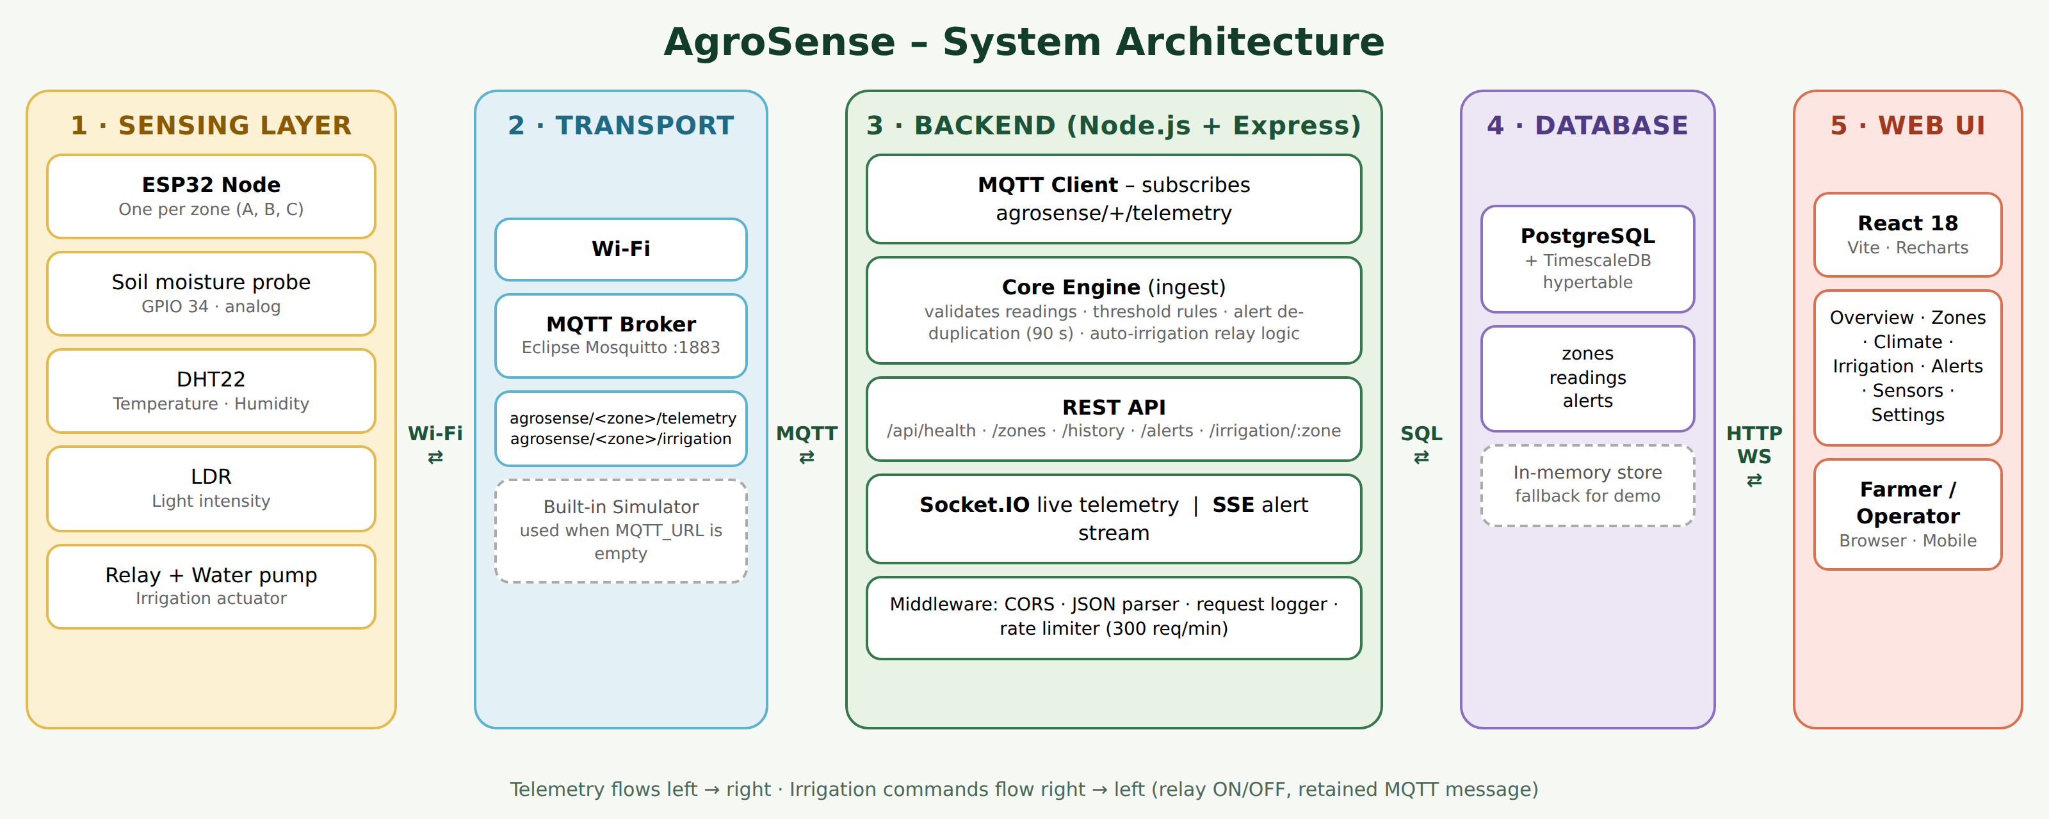
Figure 1: System architecture of AgroSense

5.2 Data Flow
Each reading passes through a fixed pipeline: validation, persistence, broadcast, threshold evaluation and – if automatic mode is on – relay control.
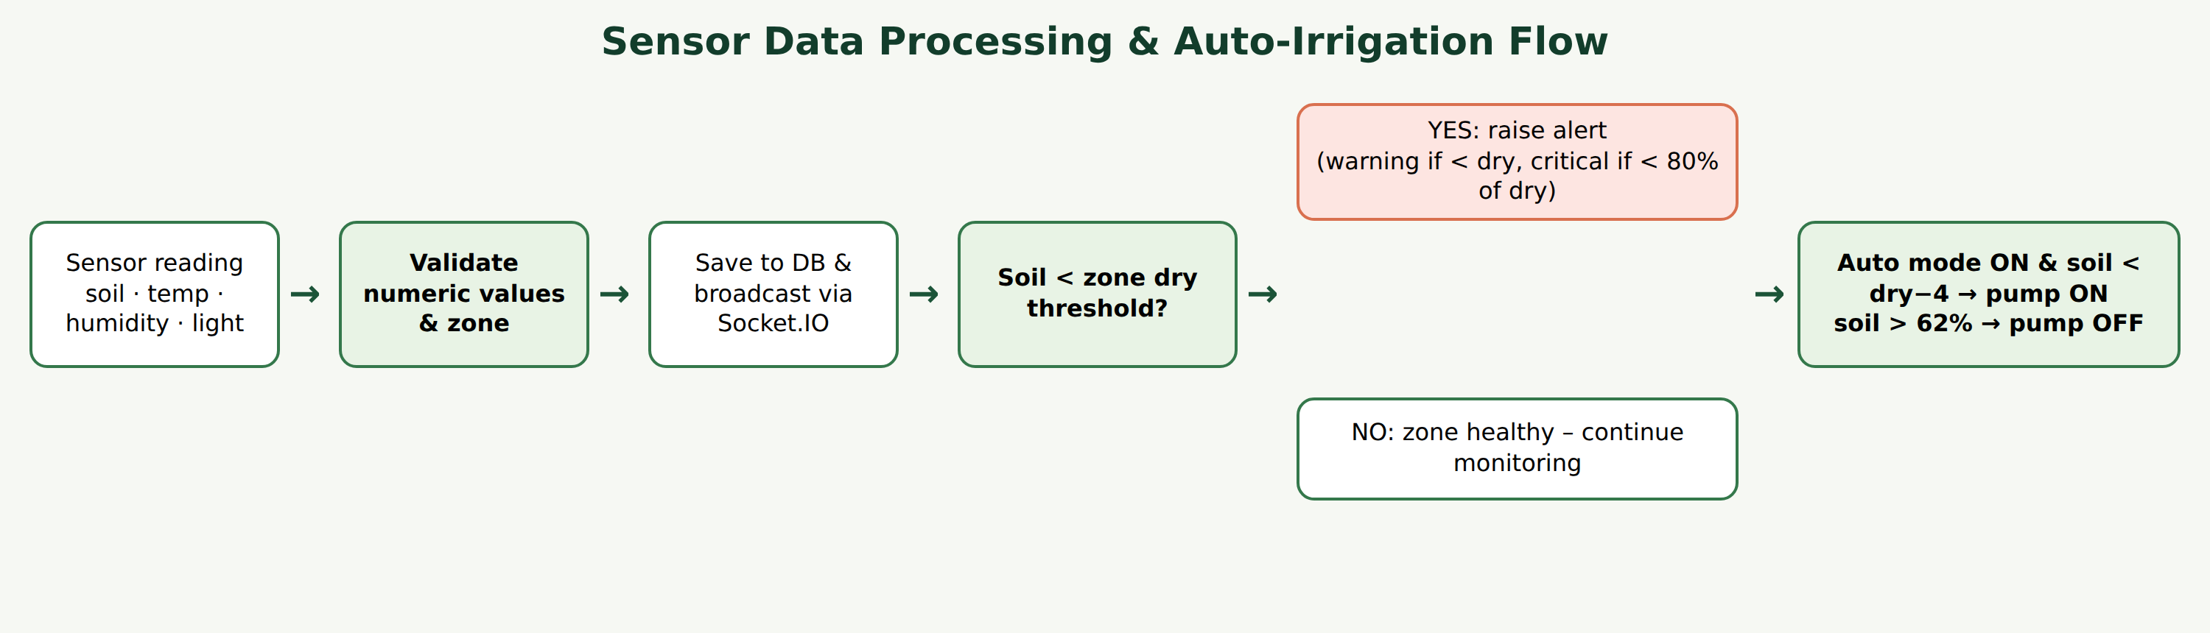
Figure 2: Sensor data processing and auto-irrigation flow

5.3 MQTT Topics
Table 5: MQTT topics
Topic | Direction | Payload
agrosense/<zone>/telemetry | Node → Server | {"soil":58.2,"temp":26.4,"humidity":67,"light":18400}
agrosense/<zone>/irrigation | Server → Node | {"on":true} (retained)

5.4 Database Design
Three tables are used. The readings table is converted into a TimescaleDB hypertable when the extension is available; otherwise plain PostgreSQL is used.
Table 6: Database tables
Table | Columns | Notes
zones | id (PK), name, crop, dry_threshold | Seeded with A–Tomato (32), B–Capsicum (30), C–Lettuce (38)
readings | time, zone (FK → zones.id), soil_moisture, temperature, humidity, light | Hypertable on time; index readings_zone_time (zone, time DESC)
alerts | id (PK, serial), time, zone, level, message | Written by the rule engine

5.5 REST API
Table 7: REST and real-time interfaces
Method | Endpoint | Description
GET | /api/health | Returns status, uptime and store type (postgres or memory)
GET | /api/zones | All zones with relay state and latest reading
GET | /api/history?zone=&hours=&bucket= | Bucketed history; hours 1–168, default 6
GET | /api/alerts | Latest 30 alerts
GET | /api/alerts/stream | Server-Sent Events stream of new alerts
POST | /api/irrigation/:zone | Body {"on":bool,"auto":bool}; sets pump state / auto mode
WS | Socket.IO events | telemetry and relay events pushed to clients

6. Implementation

6.1 Project Structure
agrosense/
├── client/ React + Vite dashboard (App.jsx, components.jsx, styles.css)
├── server/ Node.js API
│ ├── src/ index.js, core.js, mqtt.js, simulator.js, store.js
│ └── db/schema.sql PostgreSQL / TimescaleDB schema
├── firmware/ agrosense_node.ino (ESP32)
├── infra/ docker-compose.yml, mosquitto.conf
├── render.yaml API deployment descriptor
└── RUN-AGROSENSE-WINDOWS.bat

6.2 Firmware (ESP32 Node)
Each node reads the soil probe, maps the raw ADC value between the calibration points to 0–100 %, reads temperature and humidity from the DHT22 and light from the LDR, and every 2 seconds publishes a JSON message to its telemetry topic. It subscribes to the irrigation topic and drives the relay pin HIGH or LOW according to the received command.
float soil = constrain(map(analogRead(SOIL_PIN), SOIL_DRY, SOIL_WET, 0, 100), 0, 100);
float light = analogRead(LDR_PIN) * 52000.0 / 4095.0;
snprintf(buf, sizeof(buf),
"{\"soil\":%.1f,\"temp\":%.1f,\"humidity\":%.1f,\"light\":%.0f}",
soil, dht.readTemperature(), dht.readHumidity(), light);
mqtt.publish(teleTopic.c_str(), buf);

6.3 Backend Modules

6.3.1 Core engine (core.js)
The ingest() function is the heart of the server. It validates that the zone exists and all four values are numbers, saves the reading, emits a telemetry event, evaluates alert rules and applies the automatic irrigation logic. Alerts for the same key are suppressed for 90 seconds to avoid flooding.
if (r.soil < z.dry * 0.8) raise(z.id, 'critical', ...soil moisture is critically low...);
else if (r.soil < z.dry) raise(z.id, 'warning', ...soil is drying out...);
if (r.temp > 34) raise(z.id, 'warning', ...air temperature is high...);

const rl = relay[z.id];
if (rl.auto) {
if (!rl.on && r.soil < z.dry - 4) setRelay(z.id, true); // pump ON
else if (rl.on && r.soil > 62) setRelay(z.id, false); // pump OFF
}

Table 8: Zone thresholds and derived trigger values
Zone | Crop | Dry threshold | Critical alert below (80 %) | Pump ON below (dry − 4)
A | Tomato | 32 % | 25.6 % | 28 %
B | Capsicum | 30 % | 24 % | 26 %
C | Lettuce | 38 % | 30.4 % | 34 %

6.3.2 MQTT bridge (mqtt.js)
When MQTT_URL is configured, the server connects to the broker, subscribes to agrosense/+/telemetry, parses each payload and forwards it to ingest(). Relay commands emitted by the core are published to agrosense/<zone>/irrigation as retained messages so a node that reconnects immediately receives the latest command.

6.3.3 Simulator (simulator.js)
If no broker is configured, the simulator back-fills 24 hours of history at 5-minute intervals for each zone and then generates a new reading every 2 seconds. Soil moisture decreases slowly when the pump is off and rises when it is on, so automatic irrigation can be observed. Temperature, humidity and light follow a daily sinusoidal pattern.

6.3.4 Storage (store.js)
The store object hides the persistence mechanism. With DATABASE_URL set it uses a PostgreSQL pool and applies schema.sql at start-up; otherwise it keeps up to 20,000 readings in memory.

6.3.5 API server (index.js)
The Express application registers the logger, CORS, JSON parser and an IP-based rate limiter (300 requests per minute) before the routes. Socket.IO broadcasts telemetry and relay events, an SSE endpoint streams alerts, and if a built client exists in client/dist it is served by the same process.

6.4 Front-end Implementation
The dashboard is a React 18 single-page application styled with custom CSS. A sidebar lists seven pages; each navigation entry opens the page in a new browser tab (?page=<name>) so every part can be presented independently.
Table 9: Dashboard pages
Page | Content
Overview | Greeting, live snapshot banner, four average metric cards (soil, temperature, humidity, light) and zone cards
Growing zones | Detailed card for each crop zone with status badge, readings and refresh control
Climate & trends | Average climate metrics and per-zone comparison bars
Irrigation | Per-zone start/stop button and automatic-mode switch
Alerts | List of alerts with resolve action; new alert when moisture crosses below the threshold
Live sensors | Automatic sensor monitor, live feed by zone and sensor input form
Settings | Greenhouse name and operator name

In the current build the dashboard refreshes simulated readings every 3 seconds in the browser, so it works stand-alone for demonstration. The repository also contains reusable chart components (live climate line chart, soil-moisture area chart) and API/Socket.IO helpers for connecting the interface to the backend.

6.5 Deployment
- Windows: double-click RUN-AGROSENSE-WINDOWS.bat to start API and client, then open http://localhost:5173.
- Local infrastructure: docker compose up in /infra starts TimescaleDB (port 5432) and Mosquitto (port 1883).
- Cloud: render.yaml deploys the API (health check /api/health); vercel.json rewrites all routes to index.html for the client.

6.6 Configuration
Table 10: Environment variables (server/.env)
Variable | Description
PORT | API port (default 4000)
CORS_ORIGIN | Comma-separated allowed web origins
DATABASE_URL | PostgreSQL connection string; empty = in-memory storage
PGSSL | Use SSL for the database connection
MQTT_URL, MQTT_USERNAME, MQTT_PASSWORD | Broker details; empty = built-in simulator

7. Output Screens
The following screens were captured from the running AgroSense dashboard.
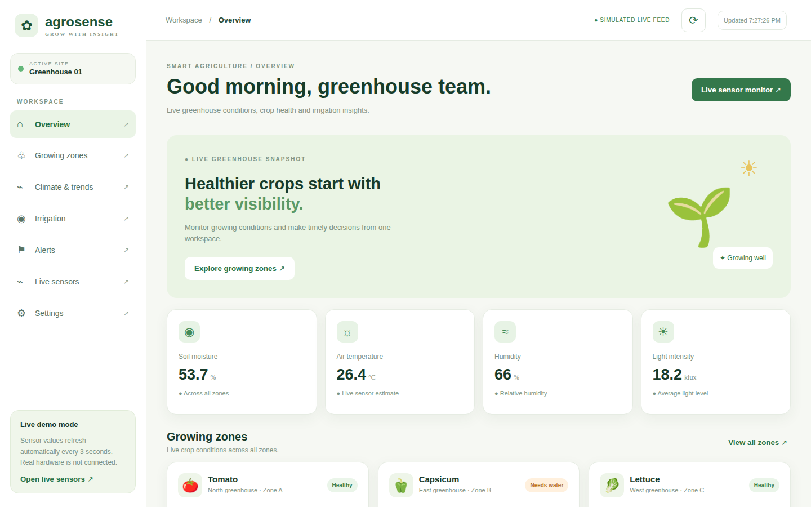
Figure 3: Overview dashboard
The overview page shows the average soil moisture, air temperature, humidity and light intensity across all zones, with zone cards listing each crop and its status.
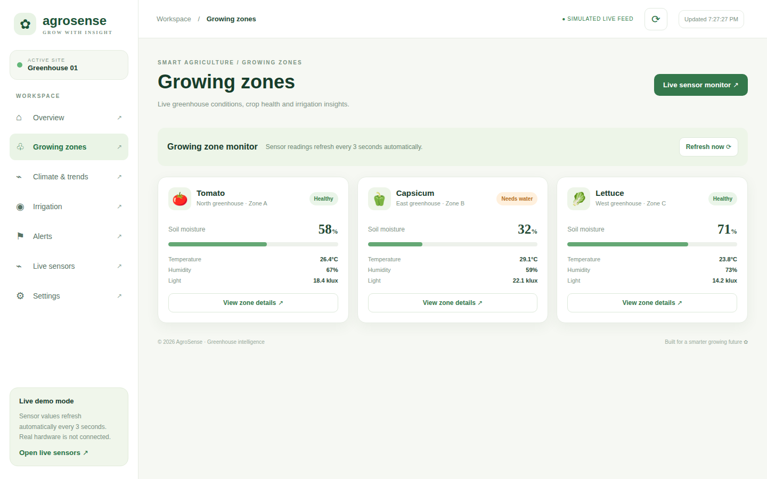
Figure 4: Growing zones page
Each growing zone (Tomato – North greenhouse, Capsicum – East greenhouse, Lettuce – West greenhouse) is shown with its readings and a status badge such as Healthy or Needs water.
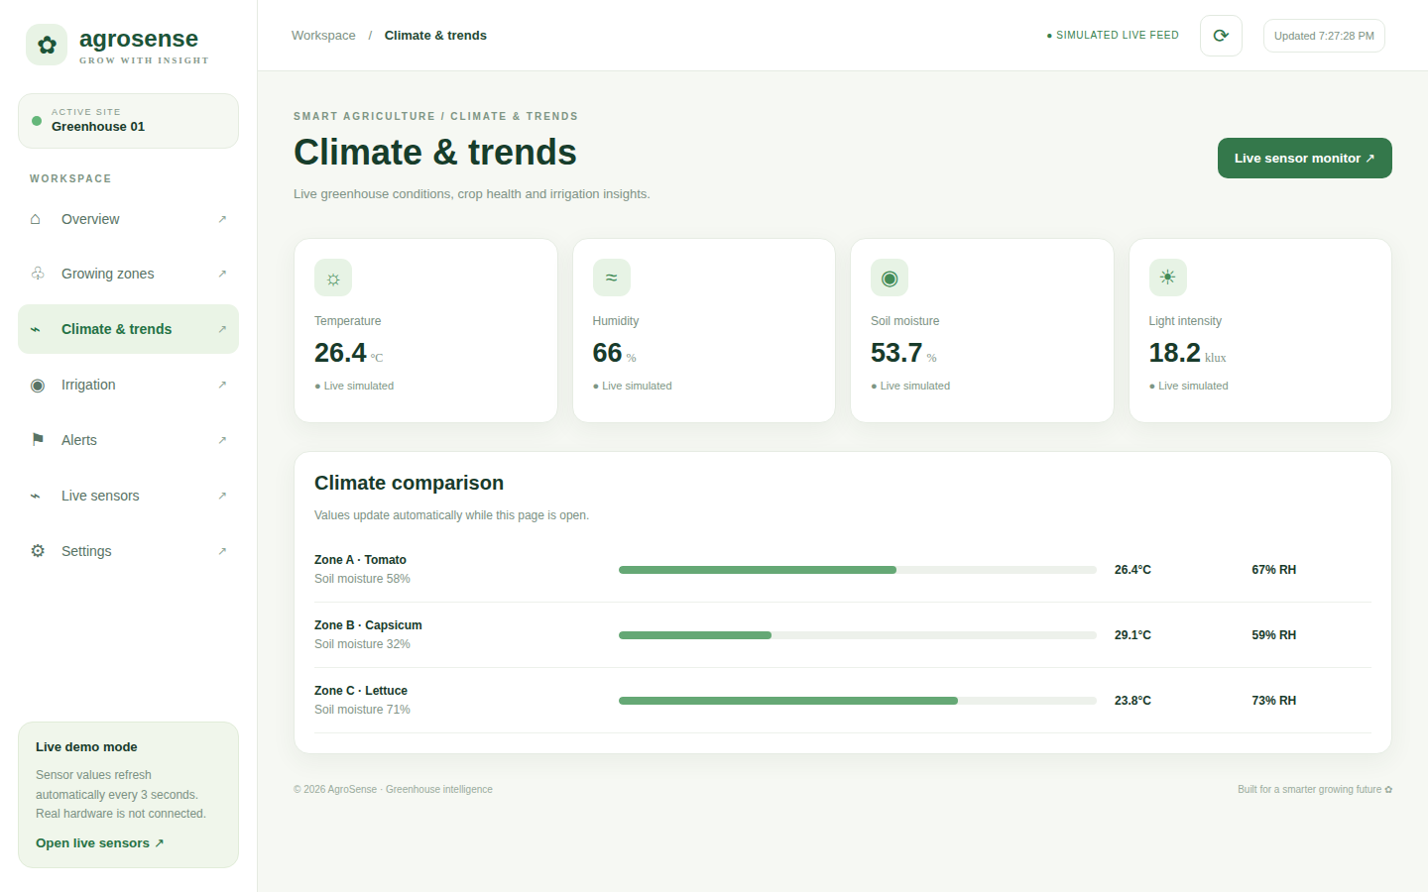
Figure 5: Climate & trends page
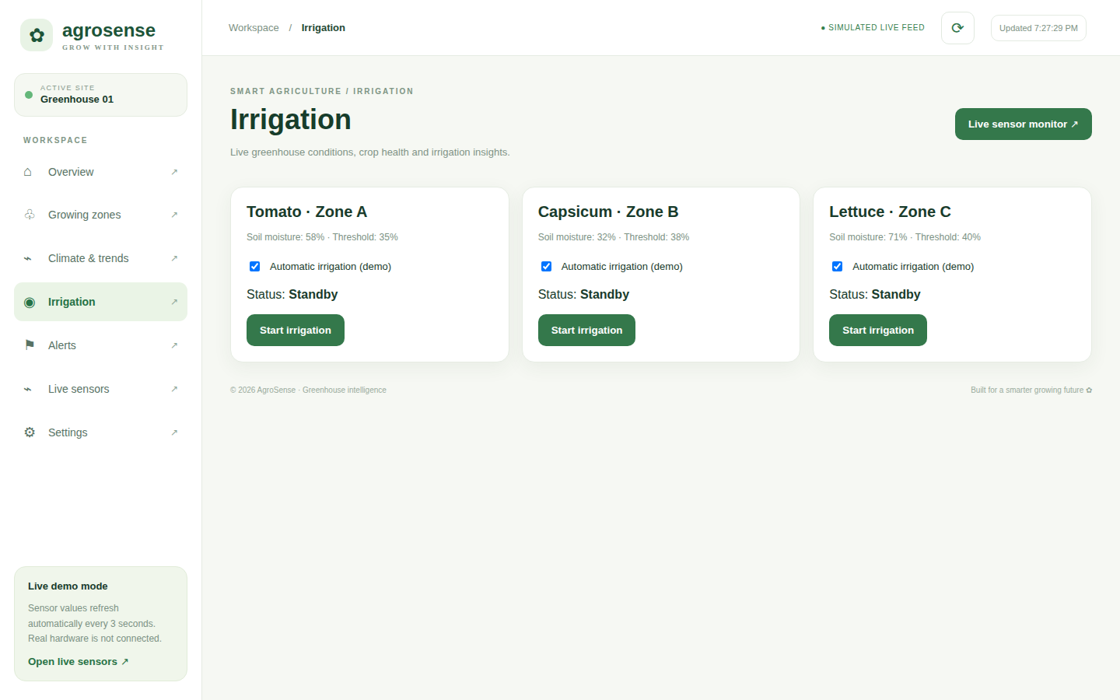
Figure 6: Irrigation control page
The irrigation page gives per-zone start/stop controls and an automatic-mode switch, along with the soil moisture and threshold for each zone.
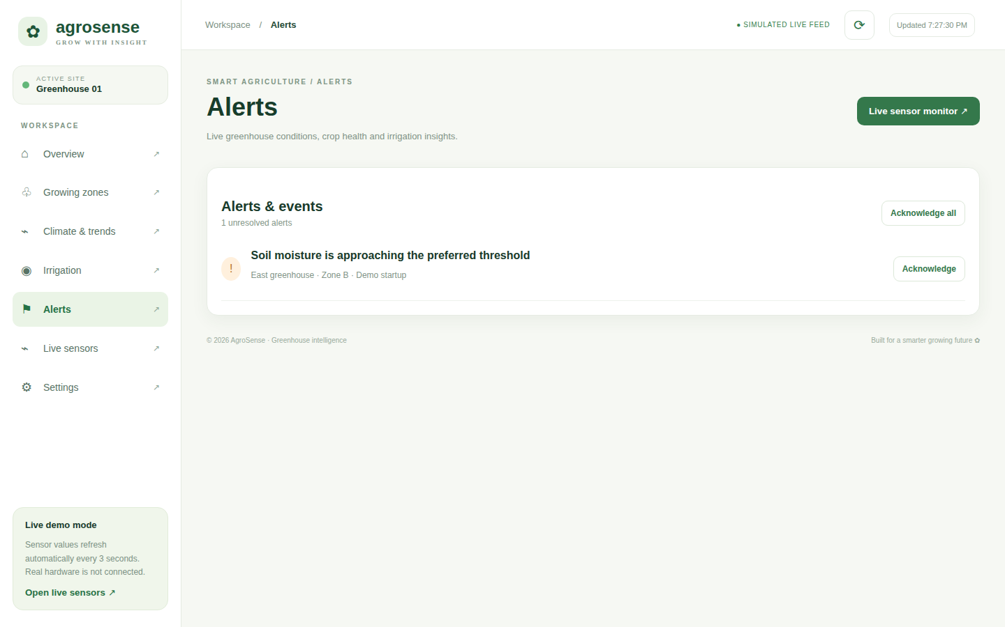
Figure 7: Alerts & events page
Alerts appear when soil moisture drops below a zone’s threshold. Unresolved alerts are counted and can be marked resolved.
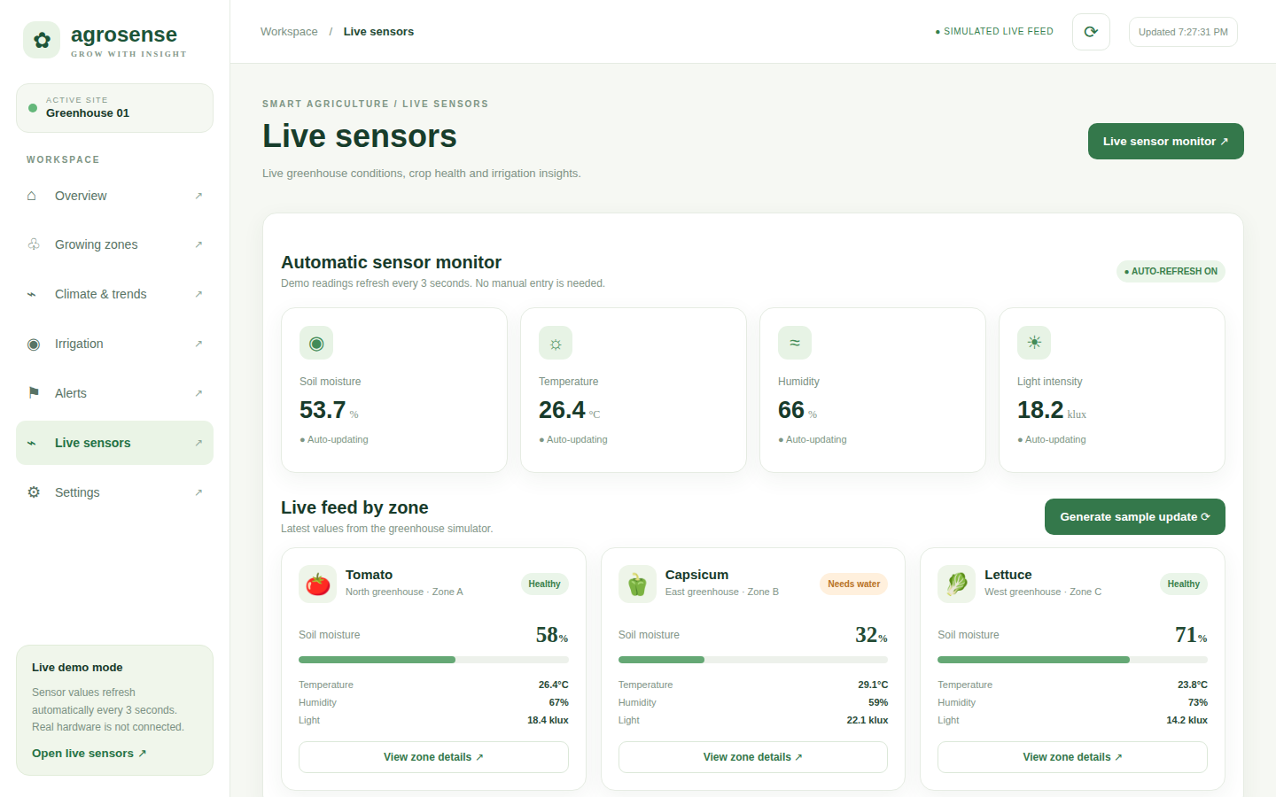
Figure 8: Live sensors page with automatic monitor
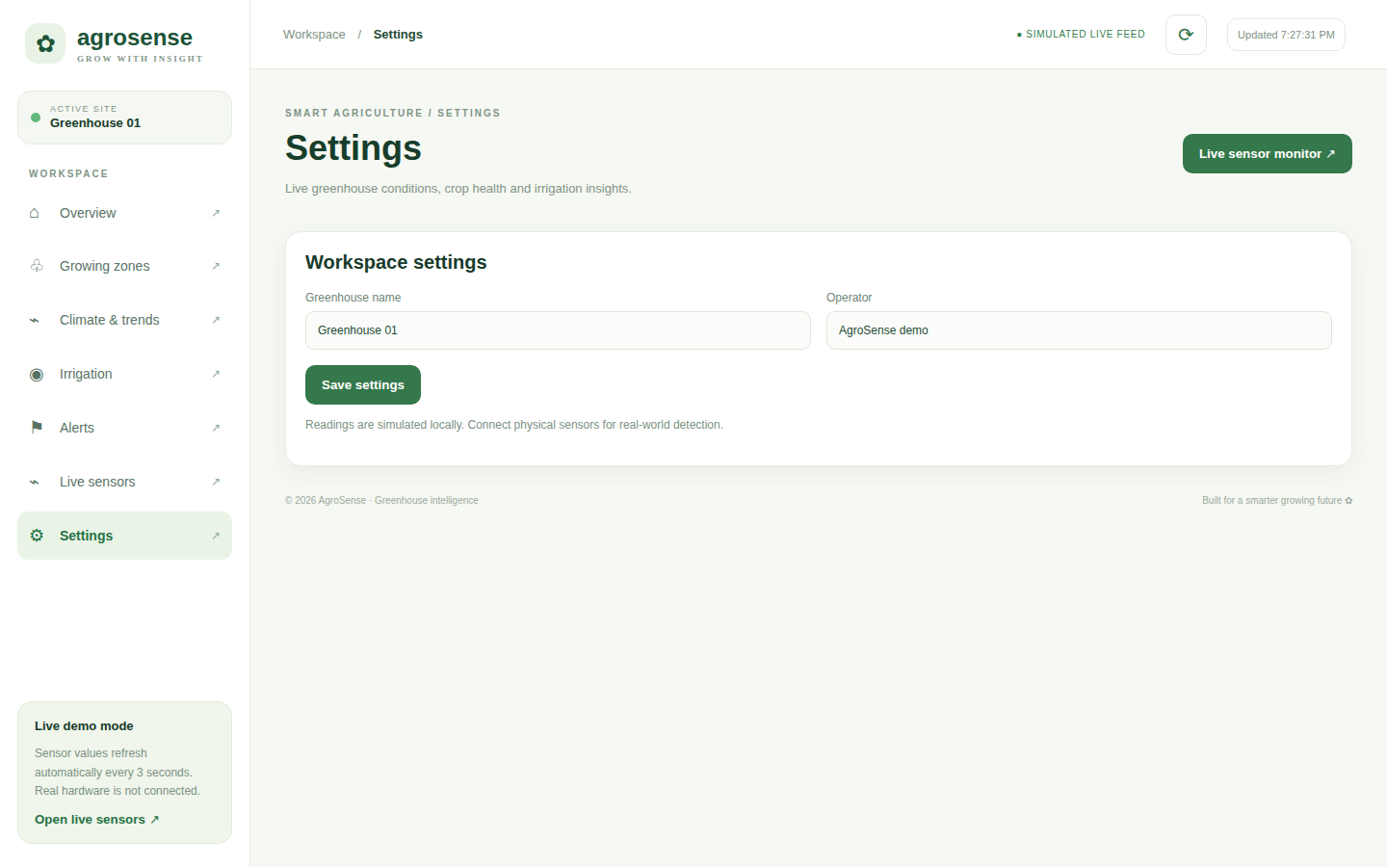
Figure 9: Workspace settings page

8. Testing

8.1 Test Approach
The project was tested at three levels: unit-level checks of the threshold rules, functional testing of the dashboard pages, and system-level checks of the data flow in simulator mode. The table lists the principal test cases and expected results; the “Observed” column is to be completed by the team during the review demonstration.
Table 11: Test cases
ID | Test | Input | Expected result | Observed
T1 | Healthy soil reading | Zone A soil = 50 % | No alert; status Healthy
T2 | Dry warning | Zone A soil = 30 % | Warning alert raised
T3 | Critical alert | Zone A soil = 20 % | Critical alert raised
T4 | High temperature | Temp = 36 °C | Heat warning raised
T5 | Auto pump ON | Auto on, soil = 27 % (Zone A) | Relay turned ON
T6 | Auto pump OFF | Pump on, soil = 63 % | Relay turned OFF
T7 | Manual override | POST /api/irrigation/A {"on":true} | Pump ON; auto mode off
T8 | Invalid payload | soil = "abc" | Reading ignored
T9 | Unknown zone | POST /api/irrigation/Z | HTTP 404
T10 | Rate limit | > 300 requests / min | HTTP 429
T11 | Alert de-duplication | Repeated low readings < 90 s | Single alert
T12 | Dashboard pages | Open all 7 pages | Each page opens and renders
T13 | Auto refresh | Wait 3 s | Values update automatically
T14 | Manual sensor input | Low soil value in form | Alert created in Alerts page

9. Results and Discussion
The dashboard presents the state of all three zones at a glance, and the colour-coded status badges make it easy to identify the zone that needs attention. In simulator mode, the backend demonstrates the complete closed loop: soil moisture falls, an alert is raised, the pump is switched on at the trigger value, moisture rises and the pump is switched off at 62 %. Because history is stored per zone, trends can be retrieved for up to 168 hours.

9.1 Current Limitations
- The packaged web interface runs on simulated browser-side data; connecting it to the live API/Socket.IO feed is the next integration step.
- No user authentication or role management.
- Thresholds are fixed in code/database rather than editable from the UI.
- Hardware tests depend on sensor calibration for each soil type.

10. Conclusion
AgroSense demonstrates an end-to-end smart greenhouse solution: ESP32 sensing nodes, MQTT transport, a Node.js rule engine with REST and real-time interfaces, time-series storage and a responsive React dashboard. It reduces manual monitoring, provides early warnings, and automates irrigation with crop-specific thresholds, while remaining low-cost and built on open-source tools. The built-in simulator makes the system easy to demonstrate and test.

11. Future Enhancements
- Live integration: wire the React dashboard to the Socket.IO/REST backend and real ESP32 nodes.
- Predictive analytics: machine-learning models to forecast soil-moisture decline and recommend irrigation timing.
- Notifications: SMS, WhatsApp or e-mail alerts and a mobile application.
- User management: authentication, roles and multi-greenhouse support.
- More sensors/actuators: pH, EC, CO₂, fans, vents, shade nets and fertigation.
- Solar and LoRa nodes: for large farms without Wi-Fi coverage.
- Editable thresholds: per-crop settings stored in the database and editable from the UI.

12. References
- Node.js Documentation. https://nodejs.org/docs
- Express.js Documentation. https://expressjs.com
- React Documentation. https://react.dev
- Vite Documentation. https://vitejs.dev
- Recharts Documentation. https://recharts.org
- Socket.IO Documentation. https://socket.io/docs
- Eclipse Mosquitto MQTT Broker. https://mosquitto.org
- MQTT Version 3.1.1 Specification, OASIS Standard.
- PostgreSQL Documentation. https://www.postgresql.org/docs
- TimescaleDB Documentation. https://docs.timescale.com
- Espressif Systems, ESP32 Series Datasheet.
- Aosong, DHT22 (AM2302) Digital Temperature and Humidity Sensor Datasheet.

