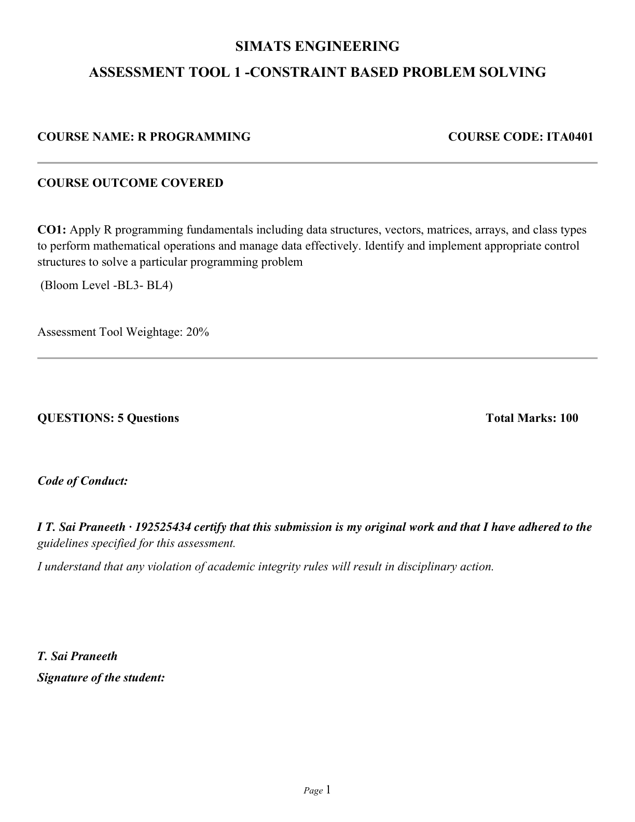

R PROGRAMMING CO1 ASSESSMENT TOOL 1
Student: T. Sai Praneeth Registration No.: 192525434

QUESTION 1: STUDENT PERFORMANCE ANALYSIS
Question: Store marks for ten students in Mathematics, Physics and Chemistry using a matrix. Calculate subject averages, identify the highest and lowest scorer in each subject, and display students whose average is above the overall average.
Answer – R Program
student_names <- paste0("Student_", sprintf("%02d", 1:10))
marks <- matrix(c(
78,82,75, 91,88,93, 64,70,68, 85,79,81,
72,76,80, 95,90,89, 58,62,65, 83,86,84,
77,73,79, 69,74,71
), nrow=10, byrow=TRUE,
dimnames=list(student_names,
c("Mathematics","Physics","Chemistry")))
print(marks)
print(round(colMeans(marks), 2))
for (s in colnames(marks)) {
x <- marks[, s]
cat(s, "highest:", rownames(marks)[which.max(x)],
max(x), "lowest:", rownames(marks)[which.min(x)],
min(x), "\\n")
}
avg <- rowMeans(marks)
grand_avg <- mean(marks)
cat("Grand average:", round(grand_avg, 2), "\\n")
print(round(avg[avg > grand_avg], 2))
Explanation
A matrix stores the marks in rows and subjects in columns. colMeans() calculates each subject average, rowMeans() calculates each student's average, and which.max()/which.min() locate the highest and lowest scores.

QUESTION 2: EMPLOYEE SALARY PROCESSING
Question: Store employee IDs, names, basic pay and allowances in a data frame. Calculate gross salary, list employees earning more than ₹50,000, identify the highest-paid employee, and produce a summary.
Answer – R Program
employees <- data.frame(
id=c("E101","E102","E103","E104","E105"),
name=c("Anita","Bharat","Charu","Deepak","Farah"),
basic=c(42000,48000,36500,52000,44000),
allowance=c(8500,6000,7000,9000,5500)
)
employees$gross <- employees$basic + employees$allowance
print(employees)
print(subset(employees, gross > 50000))
print(subset(employees, gross == max(gross)))
cat("Mean gross salary:", mean(employees$gross), "\\n")
cat("Minimum:", min(employees$gross),
"Maximum:", max(employees$gross), "\\n")
Expected Result and Explanation
Gross salaries are ₹50,500, ₹54,000, ₹43,500, ₹61,000 and ₹49,500. Four employees earn more than ₹50,000. Deepak is the highest-paid employee with a gross salary of ₹61,000. A data frame is suitable because it stores columns of different data types.

QUESTION 3: WEATHER DATA ANALYSIS USING ARRAYS
Question: Store seven daily temperature readings for Chennai, Delhi and Bengaluru in an array. Calculate city averages, identify the hottest individual reading and find which city has the greatest variation.
Answer – R Program
cities <- c("Chennai","Delhi","Bengaluru")
days <- paste0("Day", 1:7)
temps <- rbind(
Chennai=c(32,33,34,32,35,36,34),
Delhi=c(29,31,33,34,36,35,32),
Bengaluru=c(24,25,26,25,27,28,26)
)
a <- array(as.numeric(temps), dim=c(3,7,1),
dimnames=list(City=cities, Day=days,
Measure="temperature_c"))
x <- a[,,1]
print(round(rowMeans(x), 2))
pos <- which(x == max(x), arr.ind=TRUE)[1,]
cat("Hottest:", rownames(x)[pos[1]],
colnames(x)[pos[2]], max(x), "C\\n")
variation <- apply(x, 1, sd)
cat("Most variable city:", names(which.max(variation)), "\\n")
Expected Result and Explanation
The city averages are approximately Chennai 33.71°C, Delhi 32.86°C and Bengaluru 25.86°C. The highest individual reading is 36°C, occurring in Chennai on Day 6 and Delhi on Day 5. Standard deviation measures variation in the readings.

QUESTION 4: PRODUCT INVENTORY MANAGEMENT
Question: Use a list to store product IDs, names, quantities and unit prices. Calculate the value of each product, identify products with fewer than 10 units, and display a summary.
Answer – R Program
products <- list(
id=c("P01","P02","P03","P04","P05"),
name=c("Notebook","Pen Pack","Calculator","Folder","Ruler"),
quantity=c(24,8,5,16,10),
price=c(65,120,850,45,30)
)
inventory <- as.data.frame(products)
inventory$value <- inventory$quantity * inventory$price
inventory$low_stock <- inventory$quantity < 10
print(inventory)
print(inventory[inventory$low_stock, ])
cat("Total units:", sum(inventory$quantity), "\\n")
cat("Inventory value:", sum(inventory$value), "\\n")
cat("Low-stock products:", sum(inventory$low_stock), "\\n")
Expected Result and Explanation
Pen Pack (8 units) and Calculator (5 units) are low-stock products. Total quantity is 63 units and total inventory value is ₹7,715. Ruler has exactly 10 units, so it is not considered low stock because the condition is strictly less than 10.

QUESTION 5: BANK ACCOUNT PROCESSING USING FUNCTIONS
Question: Create R functions to deposit money, withdraw money, check the balance and display transaction history. Reject non-positive amounts and prevent withdrawals that exceed the available balance.
Answer – R Program
new_account <- function(opening=0) {
stopifnot(length(opening)==1, is.finite(opening), opening>=0)
list(balance=opening,
history=data.frame(type=character(),
amount=numeric(), balance_after=numeric()))
}
deposit <- function(a, amount) {
if (length(amount)!=1 || !is.finite(amount) || amount<=0)
stop("Deposit must be positive")
a$balance <- a$balance + amount
a$history <- rbind(a$history,
data.frame(type="DEPOSIT", amount=amount,
balance_after=a$balance))
a
}
withdraw <- function(a, amount) {
if (length(amount)!=1 || !is.finite(amount) || amount<=0)
stop("Withdrawal must be positive")
if (amount>a$balance) stop("Insufficient funds")
a$balance <- a$balance - amount
a$history <- rbind(a$history,
data.frame(type="WITHDRAWAL", amount=amount,
balance_after=a$balance))
a
}
a <- new_account(10000)
a <- deposit(a, 2500)
a <- withdraw(a, 1800)
cat("Balance:", a$balance, "\\n")
print(a$history)
Expected Result and Explanation
The ending balance is ₹10,700. The history contains two successful transactions. Functions separate each operation into a reusable unit. The example is for learning only and does not implement real banking security or persistent storage.

