STUDENT PERFORMANCE ANALYTICS
Project Documentation

Student Name | Prathipati Sri Venkata Sai Praneeth
Course / Branch | B.Tech – Artificial Intelligence and Machine Learning (AIML)
College | Raghu Engineering College
Project Title | Student Performance Analytics
GitHub Repository | https://github.com/saipraneeth123-dot/Student_Peformance_Analytics

1. Project Title
Student Performance Analytics is a Python-based data analysis project. It uses student marks and related academic information to summarize performance, compare subjects, identify high- and low-performing students, and produce a results file.

2. Objective
The objective of this project is to make student result analysis faster and easier. Checking every student record manually takes time and can lead to calculation mistakes. The program processes the available student dataset and calculates useful statistics so that academic performance can be understood more clearly.
Main objectives:
- Read student information from a CSV dataset.
- Use Pandas and NumPy to process and analyze the data.
- Calculate totals and average marks where the required columns are available.
- Compare subject performance and identify top and low performers.
- Determine pass/fail results using the pass criteria defined in the program.
- Save processed results to a CSV output file.

3. Technologies Used
- Python – main programming language.
- Pandas – loading, cleaning, filtering, grouping, and summarizing tabular data.
- NumPy – numerical calculations and array-based operations.
- CSV – format used to store the dataset and exported results.
- Jupyter Notebook / VS Code – development and execution environment, depending on the file used.
- Git and GitHub – version control and online project submission.
Only list additional libraries such as Matplotlib if they are actually imported and used in the submitted code.

4. Dataset Description
The project uses a student-performance dataset stored in CSV format. The earlier test run for this project used 20 student records. The dataset contains student-identification information and academic marks used by the analysis. The exact column names should be copied from the CSV file in the final submission.
The data fields used by the program may include:
- Student name or student identifier – identifies each record.
- Subject marks – scores used for total, average, and subject-wise analysis.
- Attendance, if included – used to review attendance information.
- Calculated fields such as total, average, grade, or pass/fail status – generated during processing if implemented.
Dataset note: confirm the record count and column names against the final CSV before submission. Do not include fields that are not present in your dataset.

5. Implementation
Step 1: Import libraries — Import Pandas and NumPy so the program can work with tabular data and perform numerical operations.
Step 2: Load the dataset — Read the CSV file into a Pandas DataFrame using the CSV-loading function.
Step 3: Inspect the data — Display a sample of the records and check the columns and data types. This helps confirm that the file was loaded correctly.
Step 4: Prepare the data — Check for missing or invalid values and handle them according to the logic in the submitted program.
Step 5: Calculate performance measures — Calculate totals, averages, grades, or pass/fail labels when those operations are implemented and the required data is available.
Step 6: Analyze performance — Use filtering, sorting, aggregation, and NumPy/Pandas calculations to compare students and subjects.
Step 7: Display findings — Print or display the summary statistics and the students or subjects identified by the analysis.
Step 8: Export results — Save the processed output to a CSV file, reported in the earlier run as student_performance_results.csv.

6. Key Features
- Loads student data from a CSV file.
- Summarizes student marks using Pandas and NumPy.
- Calculates student totals and averages where supported by the dataset.
- Finds high-performing and low-performing students.
- Performs subject-wise average analysis.
- Reports pass/fail counts using the project’s configured criteria.
- Exports analyzed data to a results CSV file.
Keep only the features that are present in your final code. For example, include attendance analysis only if the program actually analyzes attendance.

7. Output / Screenshots
Generated Results CSV
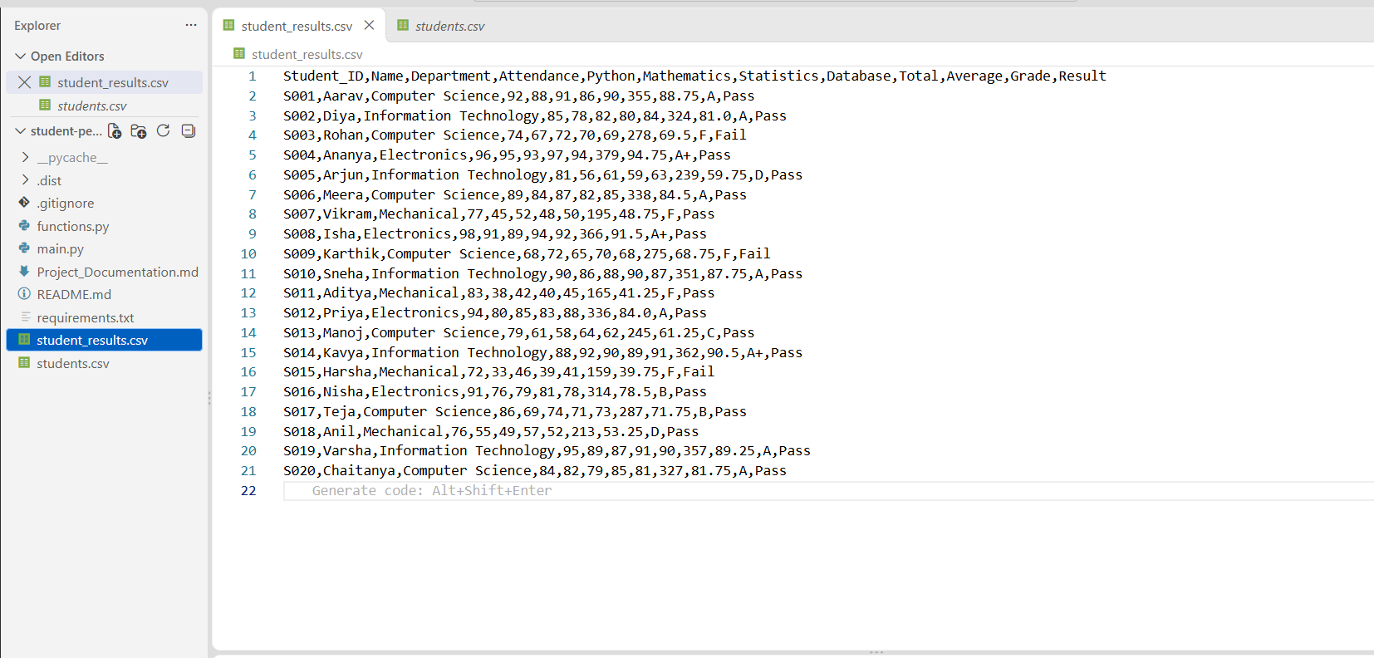

Top Performer and Department-wise Average

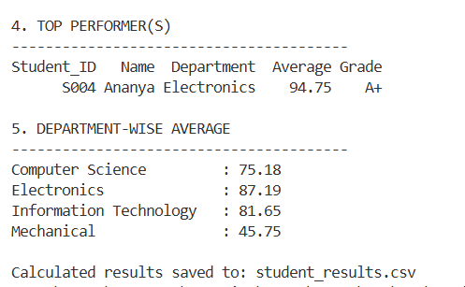
Subject-wise Average

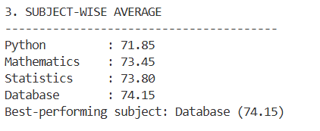
Class Summary

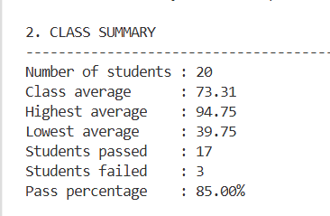

8. Final Outcome
In the earlier test run recorded for this project, the dataset contained 20 student records. The reported class average was 74.19, the highest average was 94.0 for Priya, the lowest average was 35.2 for Ajay, 18 students passed and 2 failed, and Computer Networks (CN) was reported as the best-performing subject with an average of 75.05.
These figures are included as the previously recorded test results. Before submitting this report, run the final version of your code and verify that the values match the actual output and current dataset.

9. Challenges and Learning
Challenges faced may include:
- Making sure the CSV file path is correct.
- Checking that numerical marks are stored as numbers rather than text.
- Handling missing values or unexpected data in the dataset.
- Using Pandas filtering and aggregation to produce accurate summaries.
- Verifying that exported results match the analysis output.
Learning outcomes:
- Learned how to load and work with CSV data in Python.
- Practiced Pandas DataFrame operations and NumPy numerical calculations.
- Learned to summarize data and interpret academic-performance statistics.
- Practiced testing a program, checking results, and saving output files.
- Learned to maintain and submit a project through GitHub.
Edit this section to describe the problems you personally faced and how you solved them. Use your own words so you can confidently explain the project during evaluation.

10. GitHub Repository
Repository link: https://github.com/saipraneeth123-dot/Student_Peformance_Analytics
The GitHub repository contains the submitted project files and provides a place to review the source code and related resources. Make sure the repository is public or accessible to your lecturer, and verify that the latest code and dataset are committed before submission.

