**Pepsi Vs. Coke**



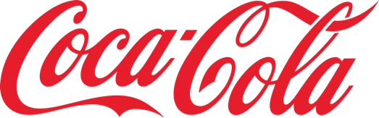

|  |  |  |  |  |
| --- | --- | --- | --- | --- |
| Company | Stock Ticker Symbol | Exchange Traded | Headquarters Address | Company Phone Number |
| Coca-Cola | KO | NYSE (New York Stock Exchange) | One Coca-Cola Plaza, P.O. Box 1734, Atlanta, GA 30301 | +1 (404) 676-2100 |
| PepsiCo | PEP | NYSE | 700 Anderson Hill Road, Purchase, NY 10577 | +1 (914) 253-2000 |

**I. Evaluate the sales trends, profitability ($) and profitability ratios (%) of both companies**

**Coca-Cola**

|  |  |  |  |  |  |  |  |  |
| --- | --- | --- | --- | --- | --- | --- | --- | --- |
| **Coca-Cola** | **2022** | | **2021** | | **2020** | | **Average** | |
|  | **$** | **%** | **$** | **%** | **$** | **%** | **$** | **%** |
| Sales/Net Operating Revenue | 43004 |  | 38655 |  | 33014 |  | 38224.33 |  |
| Gross Profit | 25004 | 58.14% | 23298 | 60.27% | 19581 | 59.31% | 22627.67 | 59.20% |
| Operating Profit | 10909 | 25.37% | 10308 | 26.67% | 8997 | 27.25% | 10071.33 | 26.35% |
| Interest Expense | 882 |  | 1597 |  | 1437 |  | 1305.33 |  |
| Net Profit (consolidated) | 9571 | 22.26% | 9804 | 25.36% | 7768 | 23.53% | 9047.67 | 23.67% |
| Current Assets | 22591 |  | 22545 |  | 19240 |  | 21458.67 |  |
| Current Liabilities | 19724 |  | 19950 |  | 14601 |  | 18091.67 |  |
| Shareholder Equity | 24105 |  | 22999 |  | 19299 |  | 22134.33 |  |
| Total Asset | 92763 |  | 94354 |  | 87296 |  | 91471 |  |
| Equity (net assets) | 25826 |  | 24860 |  | 21284 |  | 23990 |  |
| Return on Assets |  | 10.32% |  | 10.39% |  | 8.90% | 0 | 9.89% |
| Return on Equity |  | 37.06% |  | 39.44% |  | 36.50% | 0 | 37.71% |

**Note:** US$ in millions

**PepsiCo**

|  |  |  |  |  |  |  |  |  |
| --- | --- | --- | --- | --- | --- | --- | --- | --- |
| **PepsiCo** | **2022** | | **2021** | | **2020** | | **Average** | |
|  | **$** | **%** | **$** | **%** | **$** | **%** | **$** | **%** |
| Sales/Net Operating Revenue | 86392 |  | 79474 |  | 70372 |  | 78746 |  |
| Gross Profit | 45816 | 53.03% | 42399 | 53.35% | 38575 | 54.82% | 42263.33 | 53.67% |
| Operating Profit | 11512 | 13.33% | 11162 | 14.04% | 10080 | 14.32% | 10918 | 13.86% |
| Interest Expense | 939 |  | 1863 |  | 1128 |  | 1310 |  |
| Net Profit (consolidated) | 8978 | 10.39% | 7679 | 9.66% | 7175 | 10.20% | 7944 | 10.09% |
| Current Assets | 21539 |  | 21783 |  | 23001 |  | 22107.67 |  |
| Current Liabilities | 26785 |  | 26220 |  | 23372 |  | 25459 |  |
| Shareholder Equity | 17149 |  | 16043 |  | 13454 |  | 15548.67 |  |
| Total Asset | 92187 |  | 92377 |  | 92918 |  | 92494 |  |
| Equity (net assets) | 17273 |  | 16151 |  | 13552 |  | 15658.67 |  |
| Return on Assets |  | 9.74% |  | 8.31% |  | 7.72% | 0 | 8.59% |
| Return on Equity |  | 51.98% |  | 47.55% |  | 52.94% | 0 | 50.73% |

**Note:** US$ in millions

**Sales Trends**

Formula,

Sales Growth (%) = [(Current Year Sales − Prior Year Sales)/ Prior Year Sales] * 100

|  |  |  |
| --- | --- | --- |
| Company | Financial Year | Sales Growth |
| Coca-Cola | 2020-2021 | (33,014 - 37,266) / 37,266 x 100 = -11.4% |
|  | 2021-2022 | (38,655 - 33,014) / 33,014 x 100 = 17.08% |
|  | 2022-2023 | (43,004 - 38,655) / 38,655 x 100 = 11.25% |
| PepsiCo | 2020-2021 | (70,372 - 67,161) / 67,161 x 100 = 4.78% |
|  | 2021-2022 | (79,474 - 70,372) / 70,372 x 100 = 12.93% |
|  | 2022-2023 | (86,392 - 79,474) / 79,474 x 100 = 8.70% |
|  |  |  |

Analysis,

Coca-Cola's sales growth has fluctuated during the last three years. The company's sales fell by 11.41% between 2020 and 2021, most likely due to lockdowns and lower customer spending during the COVID-19 epidemic. Coca-Cola, on the other hand, saw a 17.09% increase in sales from 2021 to 2022. This increase can be linked to a variety of causes, including the relaxation of pandemic restrictions, an increase in consumer spending, and the introduction of added items.

Moving forward to 2022-2023, Coca-Cola saw an 11.25% growth in revenues. While the increase rate was not as high as the previous year, it remained positive, showing that sales are continuing to rise.

PepsiCo has outperformed Coca-Cola in terms of sustained revenue growth over the last three years. PepsiCo's sales increased by4.78% between 2020 and 2021, owing to strong demand for the company's snacks and drinks. PepsiCo's sales increased 12.93% the next year, in 2021-2022. This increase was linked to both price increases and continued high demand for PepsiCo's goods. In 2022-2023, PepsiCo's sales climbed by 8.70% continuing the favorable trend. Although the growth rate was slower than the previous year, it remained positive, indicating a sustained good sales trend.

Conclusion:

Coca-Cola's sales performance has been more volatile than PepsiCo's during the last three years. This disparity is most likely due to Coca-Cola's increased reliance on the soda business, which has been contracting recently. PepsiCo's strength is its diverse product line, which includes drinks, foodservice goods, and snacks. This diversification has benefited PepsiCo, allowing the business to effectively negotiate the obstacles posed by the COVID-19 pandemic and the declining soda market.

Despite common concerns such as a shrinking soda market and rising ingredient prices, PepsiCo and Coca-Cola are both aggressively tackling these issues. As part of their attempts to address the current challenges, their initiatives include a determined focus on innovation and increasing their product ranges.

**Profitability**

Formula,

Gross Profit Margin (%) = (Gross Profit/Sales) * 100

Operating Profit Margin (%) = (Operating Profit/Sales) * 100

Net Profit Margin (%) = (Net Profit/Sales) * 100

Profitability Ratio Analysis:

|  |  |  |  |  |  |
| --- | --- | --- | --- | --- | --- |
| Year | Ratio | Coca-Cola | Calculation | PepsiCo | Calculation |
| 2020 | Gross Profit Margin | (19581 / 33014) x 100% | 59.31% | (38575 / 70372) x 100% | 54.81% |
|  | Operating Profit Margin | (8997 / 33014) x 100% | 27.25% | (10080 / 70372) x 100% | 14.32% |
|  | Net Profit Margin | (7768 / 33014) x 100% | 23.52% | (7175 / 70372) x 100% | 10.19% |
| 2021 | Gross Profit Margin | (23298 / 38655) x 100% | 60.25% | (42399 / 79474) x 100% | 53.34% |
|  | Operating Profit Margin | (10308 / 38655) x 100% | 26.66% | (11162 / 79474) x 100% | 14.04% |
|  | Net Profit Margin | (9804 / 38655) x 100% | 25.36% | (7679 / 79474) x 100% | 9.66% |
| 2022 | Gross Profit Margin | (25004 / 43004) x 100% | 58.14% | (45816 / 86392) x 100% | 53.03% |
|  | Operating Profit Margin | (10909 / 43004) x 100% | 25.37% | (11512 / 86392) x 100% | 13.33% |
|  | Net Profit Margin | (9571 / 43004) x 100% | 22.25% | (8978 / 86392) x 100% | 10.39% |

Profit Margin

In terms of gross profit margin, Coca-Cola has regularly surpassed PepsiCo over the last three years. While Coca-Cola's margin fell somewhat between 2020 and 2022, PepsiCo's stayed largely constant.

Margin of operating profit

Coca-Cola maintained a steady edge over PepsiCo in terms of operational profit margin across the three-year period. Although Coca-Cola's operational profit margin fell somewhat between 2020 and 2022, PepsiCo's drop was more pronounced.

Margin of Profit

Coca-Cola also had greater net profit margins during the three-year period than PepsiCo. PepsiCo's net profit margin stayed largely steady from 2020 to 2022, whereas Coca-Cola's marginally declined.

In conclusion, Coca-Cola has outperformed PepsiCo in terms of profitability over the last three years, as seen by better gross, operating, and net profit margins. It is crucial to note, however, that both organizations encountered problems like the COVID-19 epidemic and rising input costs. Coca-Cola's profitability is mostly driven by its strong brand and market dominance in soda. PepsiCo, on the other hand, has diversified its profitability throughout the snack, beverage, and foodservice industries. Despite the problems, both firms are well-positioned for future development, given the expected expansion of the beverage sector as a result of urbanization, growing incomes, and changing customer tastes.

Financial Analysis:

Coca-Cola: Gross Profit Margin Trend: Remains reasonably constant, with a minor reduction from 59.31% in 2020 to 58.14% in 2022.

Operating profit margin trend: a little reduction from 27.25% in 2020 to 25.37% in 2022.

Net profit margin trend: a reduction from 23.52% in 2020 to 22.25% in 2022.

PepsiCo's Gross Profit Margin Trend: Remaining generally constant, with a minor dip from 54.81% in 2020 to 53.03% in 2022.

Operating profit margin trend: A little reduction from 14.32% in 2020 to 13.33% in 2022.

Net profit margin trend: Remaining generally constant, with a modest increase from 10.19% in 2020 to 10.39% in 2022.

Conclusion:

In general, both firms have strong profitability ratios. However, small declines in some margins highlight possible areas for improvement in operational efficiency and cost management. Investors should analyze these ratios in conjunction with other financial measures and industry standards for a complete picture of the firm's profitability and financial health.

**Return on Investment Ratios**

Formula,

Return on Assets (ROA) % = (Net Profit/Total Assets) × 100

Return on Equity (ROE) % = (Net Profit/Shareholder Equity) × 100

|  |  |  |  |  |  |
| --- | --- | --- | --- | --- | --- |
| Year | Ratio | Coca-Cola | Calculation | PepsiCo | Calculation |
| 2020 | ROA | (7768 / 87296) x 100% | 8.89% | (7175 / 92918) x 100% | 7.72% |
|  | ROE | (7768 / 19299) x 100% | 40.25% | (7175 / 13454) x 100% | 53.32% |
| 2021 | ROA | (9804 / 94354) x 100% | 10.39% | (7679 / 92377) x 100% | 8.31% |
|  | ROE | (9804 / 22999) x 100% | 42.60% | (7679 / 16043) x 100% | 47.86% |
| 2022 | ROA | (9571 / 92763) x 100% | 10.32% | (8978 / 92187) x 100% | 9.74% |
|  | ROE | (9571 / 24105) x 100% | 39.70% | (8978 / 17149) x 100% | 52.35% |

Coca-Cola:

Return on Assets (ROA) Trend: Coca-Cola experienced an uptick in Return on Assets (ROA), rising from 8.89% in 2020 to 10.32% in 2022. This means that assets are being used more efficiently to create profits.

Return on Equity (ROE) Trend: Despite a modest dip from 40.25% in 2020 to 39.70% in 2022, Coca-Cola kept its ROE reasonably steady, showing continued efficiency in leveraging equity for profitability.

PepsiCo:

Return on Assets (ROA) Trend: PepsiCo's ROA climbed from 7.72% in 2020 to 9.738% in 2022, indicating greater asset usage efficiency.

Return on Equity (ROE) Trend: PepsiCo's ROE varied, peaking at 53.32% in 2020, falling to 47.86% in 2021, and then climbing to 52.35% in 2022. This shows that equity is being used effectively to create profits despite volatility.

In conclusion, Coca-Cola and PepsiCo both exhibit positive ROA trends, indicating increasing asset usage efficiency. While ROE fluctuates, it stays high for both firms, demonstrating that equity is being used effectively to produce profits. Investors can analyze these ratios in conjunction with other financial measures and industry standards to get a complete picture of each company's financial performance.

**II Evaluate the asset utilization of both companies each year**

|  |  |  |  |  |
| --- | --- | --- | --- | --- |
| **Coca Cola** | **2022** | **2021** | **2020** | **Average** |
| Receivable Turnover | 12.33 | 11.01 | 10.50 | 11.28 |
| Fixed Assets | $ 9,841.00 | $ 9,920.00 | $10,777.00 | 10179.33 |
| Fixed Assets Turnover | 4.37 | 3.90 | 3.06 | 3.78 |
| Total Assets | $ 2,763.00 | $ 94,354.00 | $ 87,296.00 | 91471.00 |
| Total Assets Turnover | 0.46 | 0.41 | 0.38 | 0.42 |
| Inventory Turnover | 4.25 | 4.50 | 4.11 | 4.29 |
| Average Collection Period | 29.60 | 33.16 | 34.76 | 32.51 |

|  |  |  |  |  |
| --- | --- | --- | --- | --- |
| **Pepsi** | **2022** | **2021** | **2020** | **Average** |
| Receivable Turnover | 8.50 | 9.16 | 8.37 | 8.68 |
| Fixed Assets | $ 24,291.00 | $ 22,407.00 | $21,369.00 | 22689.00 |
| Fixed Assets Turnover | 3.56 | 3.55 | 3.29 | 3.47 |
| Total Assets | $ 92,187.00 | $92,377.00 | $92,918.00 | 92494.00 |
| Total Assets Turnover | 0.94 | 0.86 | 0.76 | 0.85 |
| Inventory Turnover | 7.77 | 8.53 | 7.62 | 7.97 |
| Average Collection Period | 42.94 | 39.86 | 43.59 | 42.13 |

Formula,

Receivables Turnover Ratio = Net Sales/Accounts Receivable

Fixed Asset Turnover Ratio = Net Sales/Fixed Assets

Total Asset Turnover Ratio = Net Sales/Total Assets

Inventory Turnover Ratio = Cost of Goods Sold/ Inventory

Average Collection Period = 365 days/Receivables Turnover Ratio

|  |  |  |  |  |
| --- | --- | --- | --- | --- |
| Ratio | Company | 2020 | 2021 | 2022 |
| Receivables Turnover Ratio | Coca-Cola | 33014 / 3144 = 10.50 | 38655 / 3512 = 11.01 | 43004 / 3487 = 12.33 |
|  | PepsiCo | 70372 / 8404 = 8.37 | 79474 / 10163 = 8.37 | 86392 / 10163 = 8.50 |
| Fixed Asset Turnover Ratio | Coca-Cola | 33014 / 10777 = 3.06 | 38655 / 9920 = 3.90 | 43004 / 9841 = 4.37 |
|  | PepsiCo | 70372 / 21369 = 3.29 | 79474 / 22407 = 3.55 | 86392 / 24291 = 3.56 |
| Total Asset Turnover Ratio | Coca-Cola | 33014 / 87296 = 0.38 | 38655 / 94354 = 0.41 | 43004 / 92763 = 0.46 |
|  | PepsiCo | 70372 / 92918 = 0.76 | 79474 / 92377 = 0.86 | 86392 / 92187 = 0.94 |
| Inventory Turnover Ratio | Coca-Cola | 13433 / 3266 = 4.11 | 15357 / 3414 = 4.50 | 18000 / 4233 = 4.25 |
|  | PepsiCo | 31797 / 4172 = 7.62 | 37075 / 4347 = 8.53 | 40576 / 5222 = 7.77 |
| Average Collection Period (Days) | Coca-Cola | 365 / 10.50 = 34.76 | 365 / 11.01 = 33.16 | 365 / 12.33 = 29.60 |
|  | PepsiCo | 365 / 8.37 = 43.59 | 365 / 8.50 = 42.94 | 365 / 8.50 = 42.94 |

According to the asset utilization ratios for Coca-Cola and PepsiCo from 2020 to 2022, PepsiCo looks to be doing a better job of managing their assets generally. This is evidenced by their greater receivables' turnover ratio, fixed asset turnover ratio, and inventory turnover ratio.

PepsiCo's receivables turnover ratio was 8.50 in 2022, which implies they collected their accounts receivable 8.50 times each year. Coca-Cola's receivables turnover ratio was 12.33, implying that they collected their accounts receivable 12.33 times each year. This shows that PepsiCo is more efficient in collecting debts.

PepsiCo's fixed asset turnover ratio was 3.56, suggesting that for every $1 spent on fixed assets, they produced $3.56 in revenue. Coca-Cola's fixed asset turnover ratio was 4.37, implying that for every dollar invested in fixed assets, they produced $4.37 in revenue. This implies that PepsiCo is more efficient in generating income from fixed assets.

Finally, PepsiCo's inventory turnover ratio was 7.77, implying that the company sold its inventory 7.77 times every year. Coca-Cola's inventory turnover ratio was 4.25, indicating that their inventory was sold 4.25 times every year. This indicates that PepsiCo is more efficient in inventory management and avoiding surplus stock.

Overall, PepsiCo's greater asset utilization percentages imply that they are more efficient in generating revenue and profits from their assets. This indicates that PepsiCo manages its assets better than Coca-Cola.

**III Evaluate the debt management policies of these companies by analyzing the debt utilization ratios**

Formula,

Debt-to-Total Assets Ratio % = (Total Debt/Total Assets) × 100

Interest Coverage Ratio = (Operating Profit or EBIT)/Interest Expense

|  |  |  |  |
| --- | --- | --- | --- |
| Company | Year | Debt-to-Total Assets Ratio | Interest Coverage Ratio |
| Coca-Cola | 2020 | (36377 / 92763) x 100 = 39% | 8997 / 1437 = 6.26 |
|  | 2021 | (38116 / 94354) x 100 = 40% | 10308 / 1597 = 6.45 |
|  | 2022 | (36377 / 92763) x 100 = 39% | 10909 / 882 = 12.37 |
| PepsiCo | 2020 | (40370 / 92918) x 100 = 43% | 10080 / 1128 = 8.94 |
|  | 2021 | (36026 / 92377) x 100 = 39% | 11162 / 1863 = 5.99 |
|  | 2022 | (35675 / 92187) x 100 = 39% | 11512 / 939 = 12.26 |

**Chart:**

**Debt-to-Total Assets Ratio chart**

**Coca-Cola**

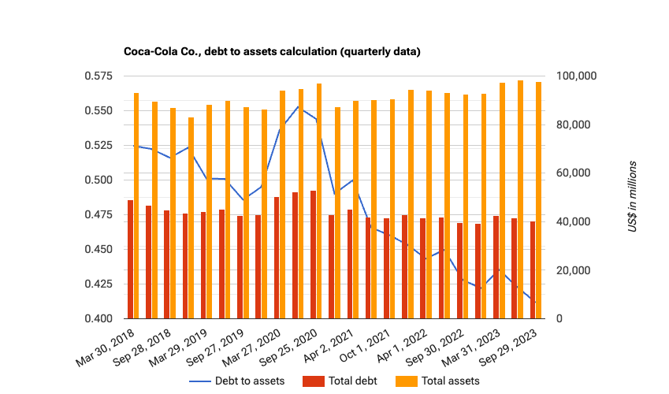

Description: A solvency ratio calculated as total debt divided by total assets.

**PepsiCo**

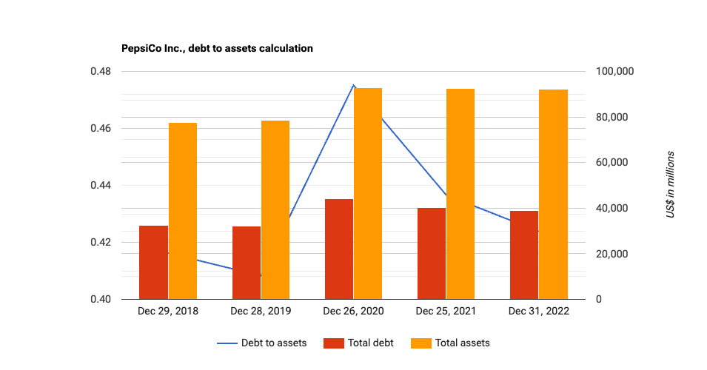Description: A solvency ratio calculated as total debt divided by total assets.

**Interest Coverage Chart**

**Coca-Cola:**

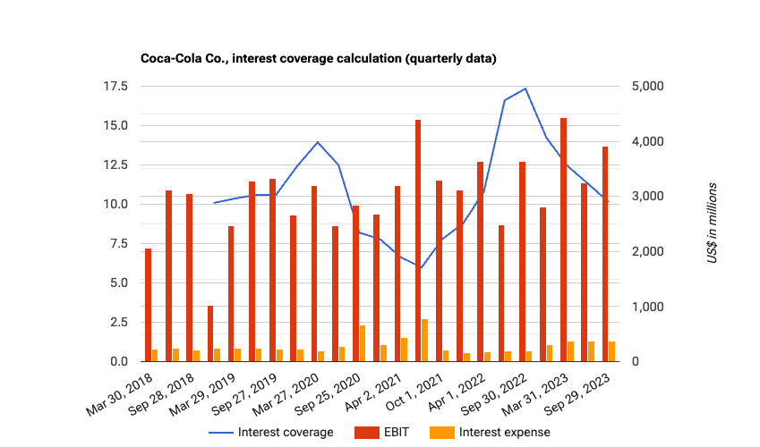

Description: A solvency ratio calculated as EBIT divided by interest payments.

**PepsiCo:**

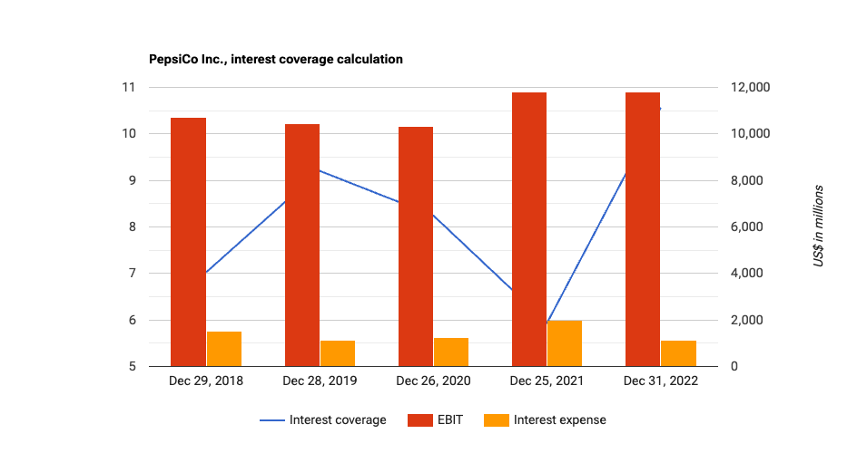

Description: A solvency ratio calculated as EBIT divided by interest payments.

Analysis:

In 2022, both Coca-Cola and PepsiCo have a debt-to-total-asset ratio of 0.40. This suggests that they are borrowing to finance around 40% of their assets. This is a prominent level of debt for a multinational firm, yet it is not unusual.

In 2022, both corporations' debt-to-total-asset ratios climbed marginally. This is most likely the result of a mix of events, including increased investment and/or share buybacks.

Coca-Cola's interest coverage ratio fell sharply in 2020 and 2021 before recovering in 2022. This is most likely due to a mix of circumstances, including lower revenue and/or higher interest rates.

PepsiCo's interest coverage ratio fell in 2020 and 2021 as well, but not as much as Coca-Cola's. This is most likely due to a mix of reasons, including a more diverse company strategy and/or better financial performance.

Overall, Coca-Cola and PepsiCo look to be financially sound businesses. They have a moderate debt load and can easily fulfill their interest payments. Coca-Cola, on the other hand, has a smaller interest coverage ratio than PepsiCo, implying that Coca-Cola is more vulnerable to fluctuations in interest rates.

**References**

The Coca-Cola Company. (2022). *Annual Filings (10-K)*. The Coca-Cola Company. <https://investors.coca-colacompany.com/filings-reports/annual-filings-10-k>

Dybek, M. (2023a, February 10). *PepsiCo Inc. (nasdaq:PEP): Income statement*. Stock Analysis on Net. <https://www.stock-analysis-on.net/NASDAQ/Company/PepsiCo-Inc/Financial-Statement/Income-Statement>

Dybek, M. (2023, February 22). *Coca-Cola Co. (**NYSE:KO): Income statement*. Stock Analysis on Net. <https://www.stock-analysis-on.net/NYSE/Company/Coca-Cola-Co/Financial-Statement/Income-Statement>

PepsiCo. (2023). *Quarterly earnings*. PepsicoUpgrade. <https://investors.pepsico.com/investors/financial-information/quarterly-earnings/index.html>

PepsicoUpgrade. (n.d.). *Annual reports & proxy information*. <https://www.pepsico.com/investors/financial-information/annual-reports-proxy-information>

**Appendices**

**Appendix I. Snapshots of Company 10-K Filings and Balance sheets**

**Coca-Cola:**

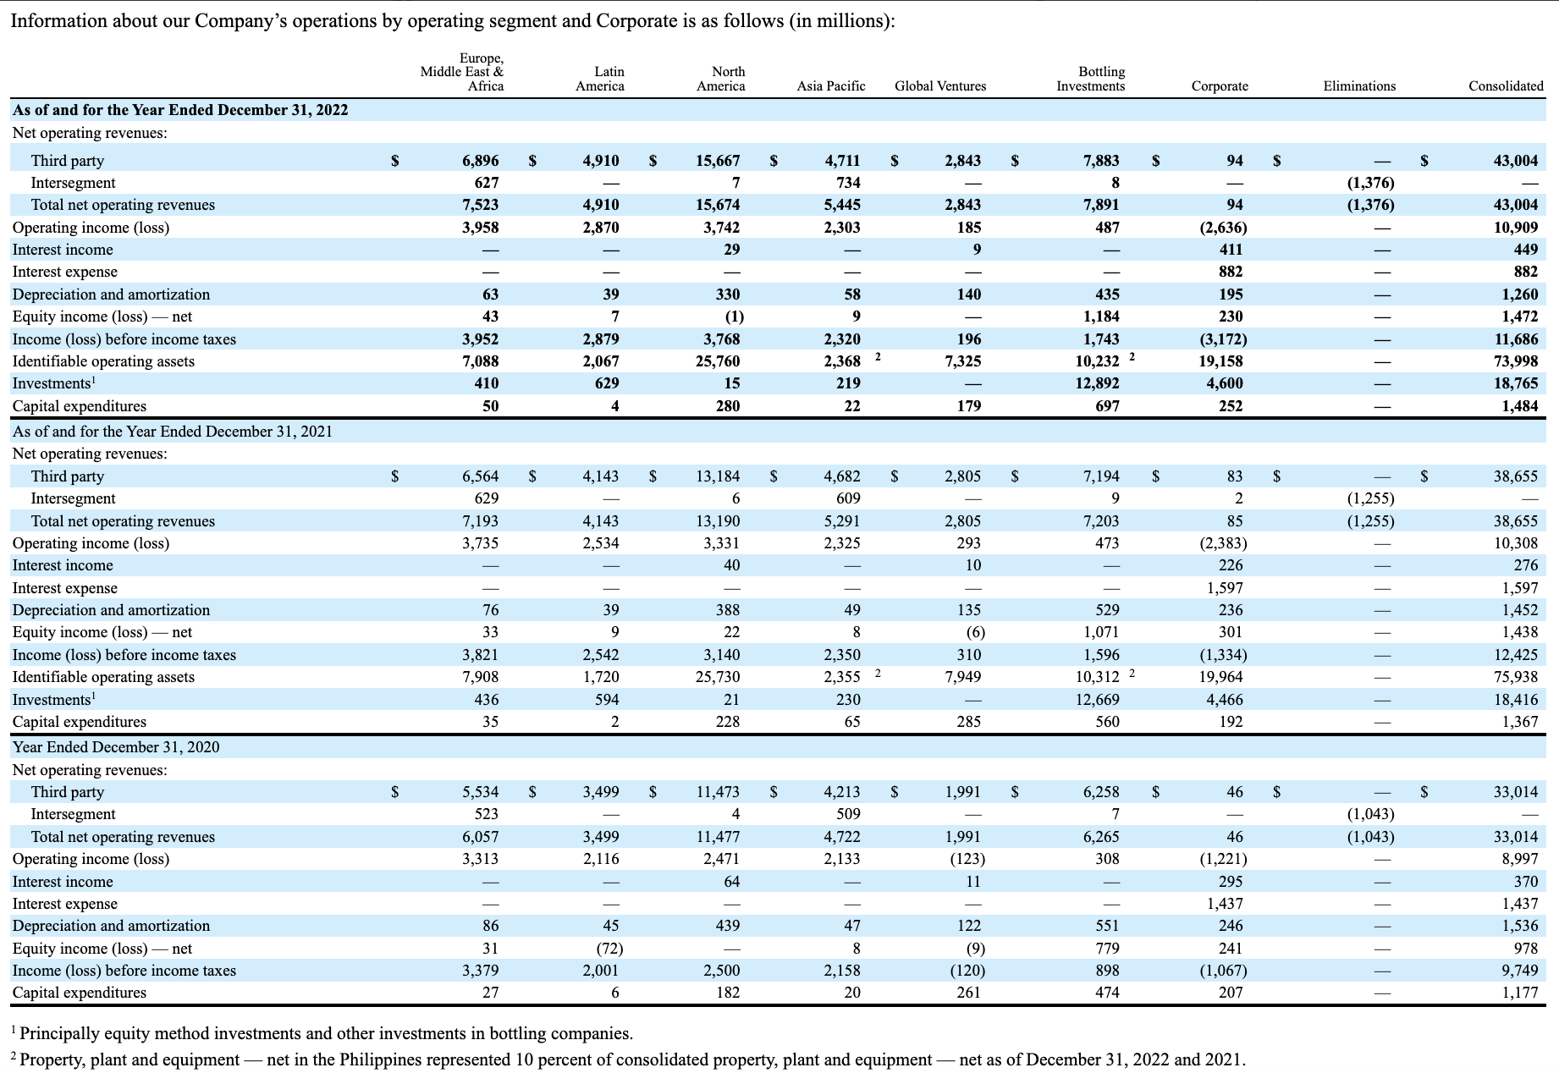

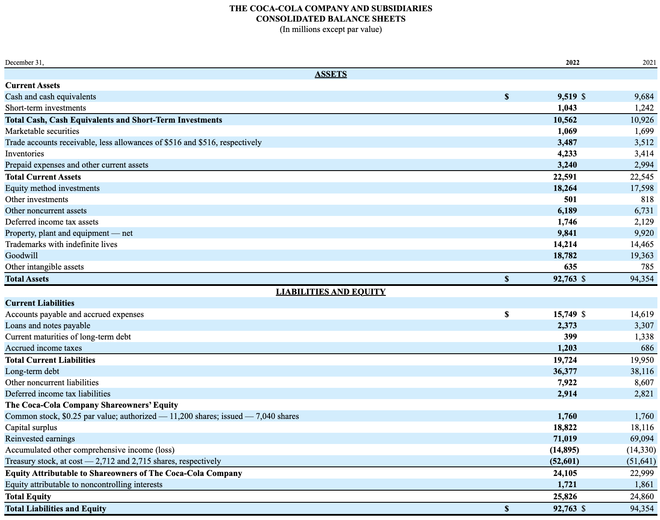

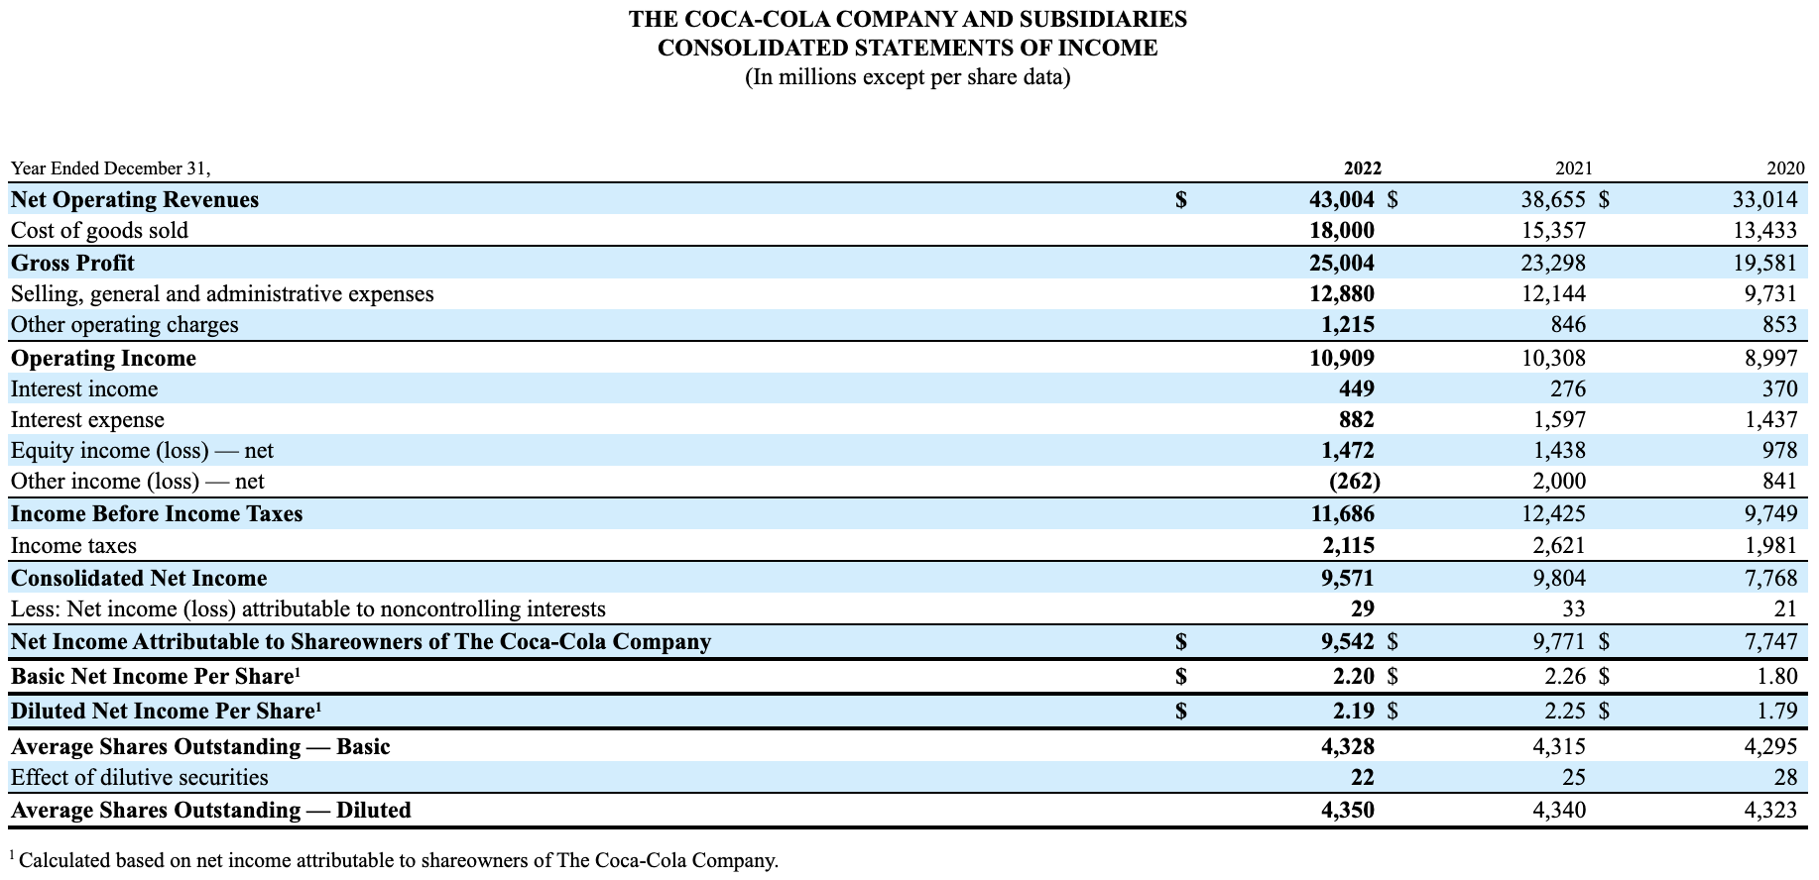

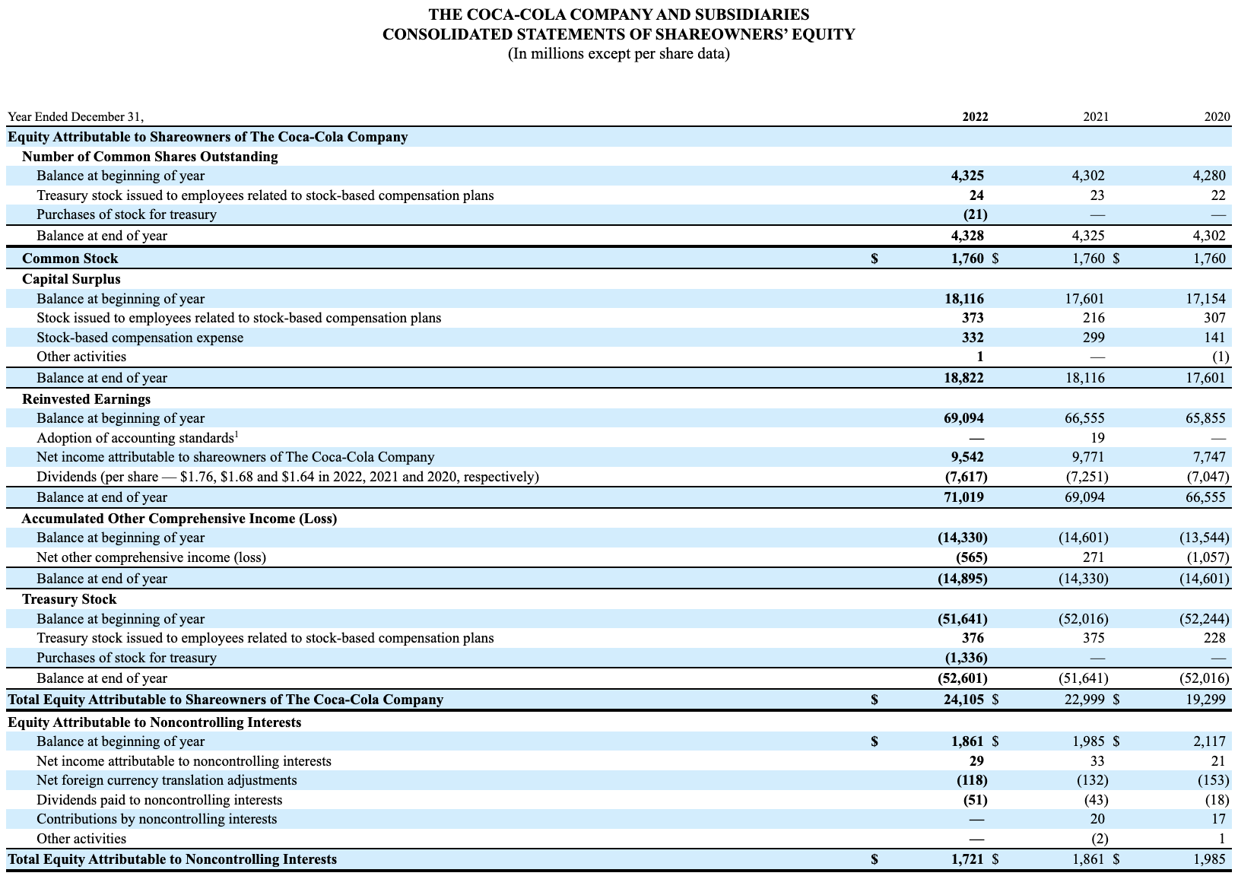

**PepsiCo:**

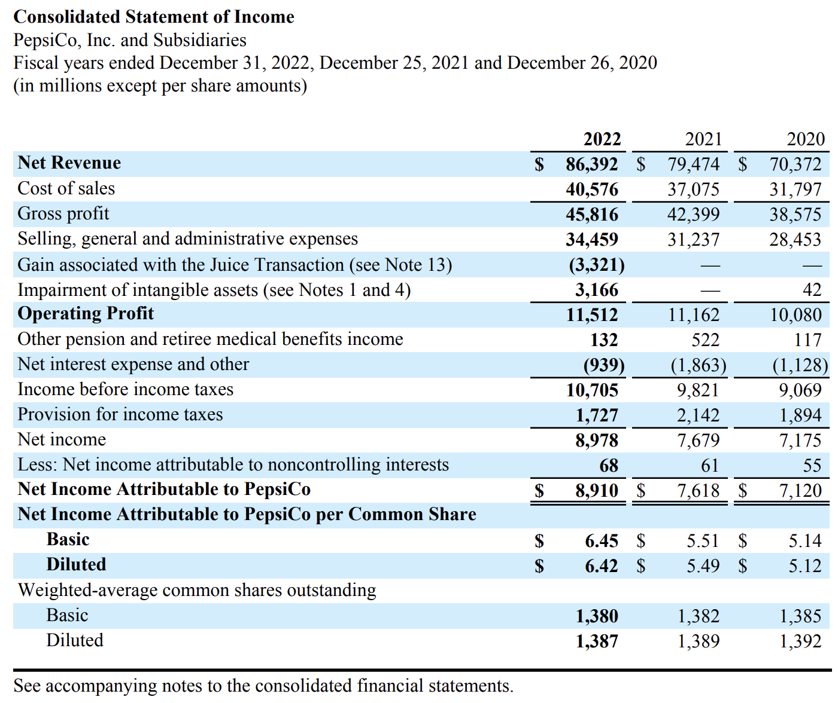

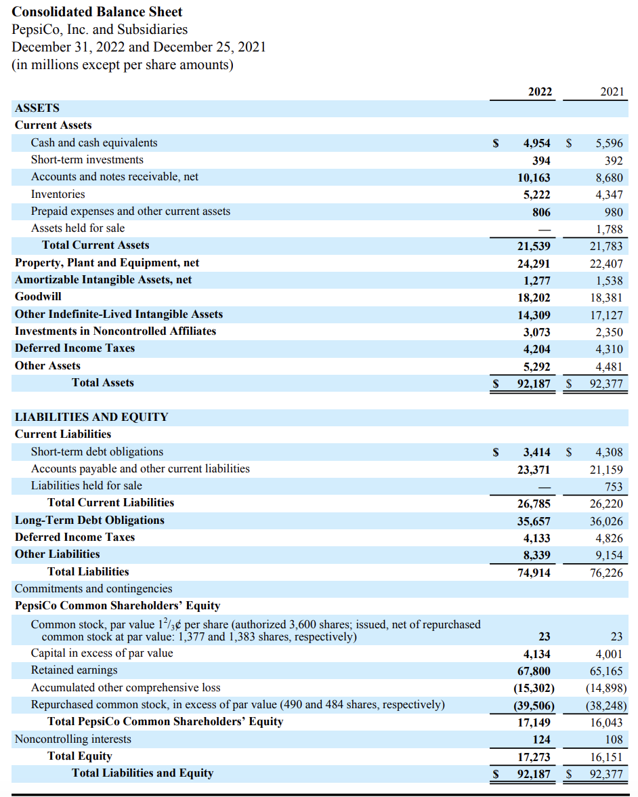

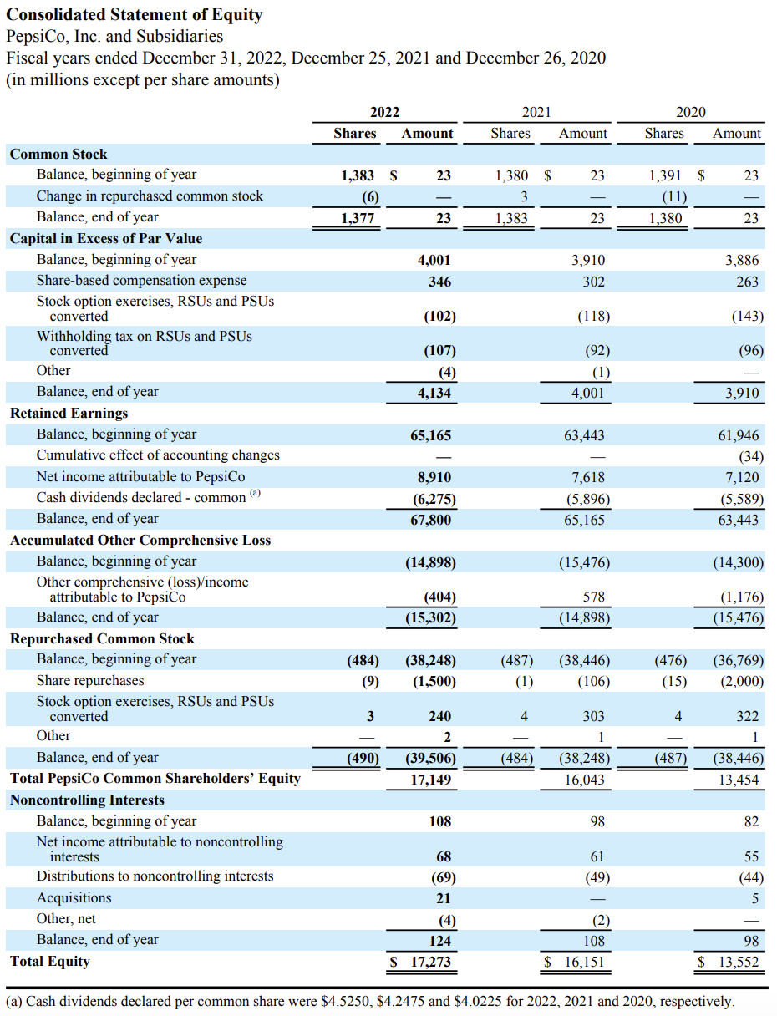

**Appendix II:** Spreadsheet calculations

