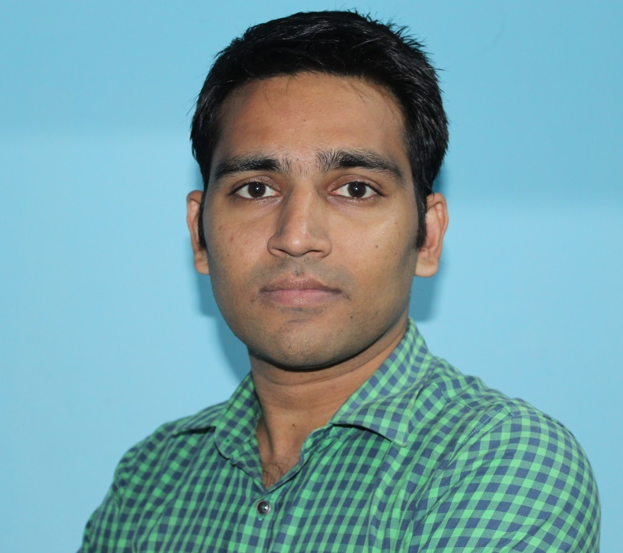
Saiprasad Dhumal
Java - Full Stack Developer

→
saiprasad08dhumal@gmail.com

08689983890
OCAJP certificatio
n

github accoun
t
hackereart
h

EDUCATION
Mtech in Computer Enginneering
VJTI, Mumbai(2013- 2015)
CGPA: 8.5
BE in Computer Engineering
University of pune(2008 - 2012)
Percentage: 60.67%
Higher Secondary School Certificate
University of pune(2006 - 2008)
Percentage: 77.17%
Secondary School Certificate
University of pune(2006)
Percentage: 88.40%
I am a java Developer with 2 years of experience. I am responsible for designing, writing clean and reusable code, performing tests and deploying
code to server. For me learning is always a great thing, mostly my experience includes working in a small team who handles all the project
responsibilities. I'm truly passionate about my work and always learn the upcoming features in this field.
ABOUT ME

SKILLS & PROFICIENCY



Java 8
Spring core and spring MVC
SQL, Hibernate orm framework
[
aws: ec2 setup, s3 api integration, rds configuration. ssl installation. domain mapping
]
HTML5, CSS
Javascript & jQuery
Bootstrap, material design
angular JS
Rasa marketing pvt. ltd.
Its a chennai based company operating in retail and other sectors. They recently started IT operations in Mumbai in 2016.
Davos Finservices pvt. ltd., Mumbai
This is mutual fund distribution company where IT department is responsible for handling user registration and
transaction of customers coming
to the website.
Uniken Systems, Pune
Company is mainly in the development of its REL-ID product which is biometric authentication system. Also there are
other projects available from
other clients.
AirIT - messaging applicatio
n
-
I am responsible for full stack web development of airit where users can login and use messaging app on
website.
Also I am part of team for backend server api development.
Technologies: spring mvc, consuming rest api and json parsing, maven,
html5, css, jquery, ajax etc.
g
Robobankin
-
KYC registration of users. facebook graph API integration for getting lead information of Facebook ads posted; just at the click of
a button.
persistent authentication/remember me functionality,
Creating responsive web UI,
basic android app using full screen web view
development and deployment on play store.
JAVA Project: Anti Piracy software for mp3 files in windows platform:

-
A J2EE web application where downloaded mp3 files plays only
on one machine. It plays through the designed player only. If it is transferred to another machine along with designed player then also it cannot be
played. Here functionalities of jlayer are used in the project. WMI scripts are used to get processor and disk IDs.
Dabewal
a
-
Technologies used: php, mysql, jquery, ajax, angular js, css3, html5. I have created dabewala.com website and android app
BACKEND
SYSTEM ADMINISTRATION
UI
EXPERIENCES

Full stack developer
April 2017 - Present
Java developer
2016 - 2017
Trainee technology
2013
PROJECTS




‘dabewala’ hosted on play store. Features: sellers and customers can register and login to the site. Sellers can customize menu, view orders and
view reviews. Customers can place order, cancel order, submit seller review and rating.
.
Behavioral retargeting marketing of e-commerce web sites
-
Using JavaScript programming, we have to store users purchase pattern.
During This project I implemented a java program to generate JavaScript code from given input of Xpath of HTML DOM object. This tool was
useful in our project.
Date of Birth
th April
20
1990
permanent address
Kolhar Bk, Tal:- Rahata, Dist:- Ahmednagar. pin: 413710.
Languages known
English, Marathi, Hindi.
Hobbies
playing football, listening music, net surfing.
Declaration:
I hereby declare that the above-mentioned information is correct up to my knowledge and I bear the responsibility for the correctness.
OTHER DETAILS

Date:
21/10/2017
Saiprasad Dhumal

