Solution to Economic Dispatch by Artificial Bee colony Algorithm
RM Saloman danaraj EEE Department
Jubail Industrial Collge, Jubail,Kingdom Of Saudi Arabia.
Mail:salorajan@gmail.com

1. Introduction
.
Economic load dispatch problem is allocating loads to plants for minimum cost while meeting the constraints. It is formulated as an optimization problem of minimizing the total fuel cost of all committed plant while meeting the demand and losses .The variants of the problems are numerous which model the objective and the constraints in different ways.
The basic economic dispatch problem can described mathematically as a minimization of problem of minimizing the total fuel cost of all committed plants subject to the constraints.
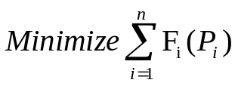 (A1)
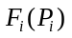is the fuel cost equation of the ‘i’th plant. It is the variation of fuel cost ($ or Rs) with generated power (MW).Normally it is expressed as continuous quadratic equation.
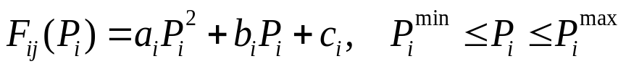 (A2)
The total generation should meet the total demand and transmission loss. The transmission loss can be determined form either B_{mn} coefficients or power flow.
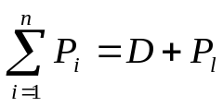 (A3)
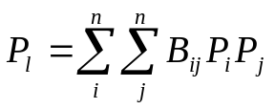 (A4)

2. Solution by Artificial Bee Colony Algorithm

- Choose a reference plant .Here we consider a first plant. Convert the constrained optimization problem as an unconstrained problem by manipulating the equations A3&A4.
- Now the problem has only n-1 variable unconstrained problem.
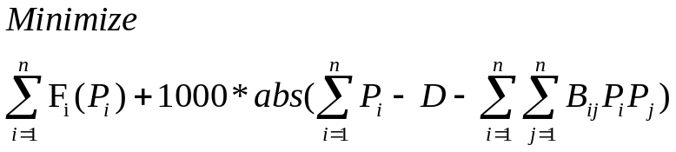
2. This software contains one example taken from the reference paper given with this program..By running the file P1.m as they are in the default ABC-eld folder the economic dispatch problem can be solved. The allocation minimum fuel cost and transmission losses are determined. By running the program the PSO and the quadratic program method can be applied to solve economic dispatch problem.
3. I am using the Artificial Bee Colony (ABC) one of the most recently defined algorithms by Dervis Karaboga in 2005, motivated by the intelligent behavior of honey bees.

* Referance Papers*/

*D. Karaboga, AN IDEA BASED ON HONEY BEE SWARM FOR NUMERICAL OPTIMIZATION,TECHNICAL REPORT-TR06, Erciyes University, Engineering Faculty, Computer Engineering Department 2005.*/

*D. Karaboga, B. Basturk, A powerful and Efficient Algorithm for Numerical Function Optimization: Artificial Bee Colony (ABC) Algorithm, Journal of Global Optimization, Volume:39, Issue:3,pp:459-171, November 2007,ISSN:0925-5001 , doi: 10.1007/s10898-007-9149-x */

*D. Karaboga, B. Basturk, On The Performance Of Artificial Bee Colony (ABC) Algorithm, Applied Soft Computing,Volume 8, Issue 1, January 2008, Pages 687-697. */

My sincere thanks to him for the efficient toolbox
ALL THE BEST

