EDUGENIE
Google Gemini Powered Learning Assistant
PROJECT COMPLETION & DEMONSTRATION REPORT

PROJECT | EduGenie — Google Gemini Powered Learning Assistant
COMPLETED BY | Sai Prasad
STATUS | PROJECT COMPLETED
REPORT DATE | 28 September 2026

PROJECT RECORD
This report presents a professional completion record and visual demonstration of the EduGenie project, using the supplied project documentation and its embedded application screenshots.

Prepared for academic / project submission

Certificate of Project Completion
This is to record that Sai Prasad has completed the project titled “EduGenie — Google Gemini Powered Learning Assistant.” The project documentation supplied for this report presents EduGenie as an AI-powered learning assistant with question answering, concept explanation, quiz generation, summarization, and learning recommendations.
The screenshots and technical evidence included in this report are reproduced from the supplied project material and are organized to provide a clear demonstration of the documented application.

Student / Developer | Sai Prasad
Project | EduGenie — Google Gemini Powered Learning Assistant
Completion Status | COMPLETED

______________________________
Student / Developer Signature

Contents

NOTE
If page numbers in the contents are not displayed immediately, open the document in Microsoft Word, select the table of contents, and choose “Update Field” → “Update entire table.”

1. Executive Summary
EduGenie is documented as a lightweight AI-powered educational assistant designed to support students through generative AI. The supplied material demonstrates a web-based interface where a learner can ask questions, request simplified explanations, generate quizzes, summarize text, and obtain learning recommendations.
The project combines a web frontend with a backend/API layer and Google Gemini-powered generation. The visual evidence in this report shows the main interface and individual workflows operating with example inputs and generated outputs.
COMPLETION STATEMENT
Sai Prasad completed the documented EduGenie project and the major user-facing learning workflows are represented in the supplied screenshots.
2. Project Profile
Project Attribute | Documented Detail
Project name | EduGenie — Google Gemini Powered Learning Assistant
Project type | Generative AI / educational assistant
Primary purpose | AI-supported learning assistance for students
AI platform | Google Gemini
Backend / API | FastAPI
Frontend | HTML and CSS web interface
Core workflows | Q&A, explanation, quiz, summarization, learning recommendations
Project owner / developer | Sai Prasad
3. Project Objectives
- Accessible learning support: Provide an easy-to-use interface for students to interact with an AI tutor.
- Question answering: Allow users to submit questions and receive generated answers.
- Concept clarification: Help users understand topics through simplified explanations.
- Active learning: Generate quiz questions to support practice and self-checking.
- Efficient revision: Summarize longer educational text into a shorter form.
- Guided learning: Generate learning recommendations or topic-based learning paths.
4. Functional Modules
No. | Module | Documented Function
01 | Ask EduGenie | Question-and-answer workflow for direct student queries.
02 | Explain a Concept | Generates a readable explanation for a requested topic.
03 | Generate a Quiz | Creates quiz questions and answer choices around a selected topic.
04 | Summarize | Produces a condensed summary from supplied educational text.
05 | Learning Recommendations | Produces a topic-oriented learning path or recommendations.

5. System Architecture
The supplied project material includes an architecture diagram representing the flow between the user-facing application, the backend/API layer, and the AI generation component. The architecture evidence is reproduced below.
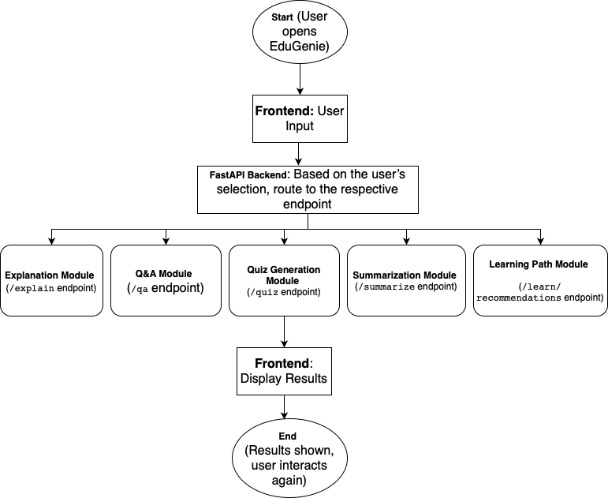
Figure 1. System architecture diagram from the supplied project documentation.
ARCHITECTURE AT A GLANCE
User interaction → web interface → backend/API processing → Gemini-powered generation → response displayed in the learning interface.
6. User Interface & Feature Demonstration
The following figures provide a visual record of the completed application's documented user-facing workflows.
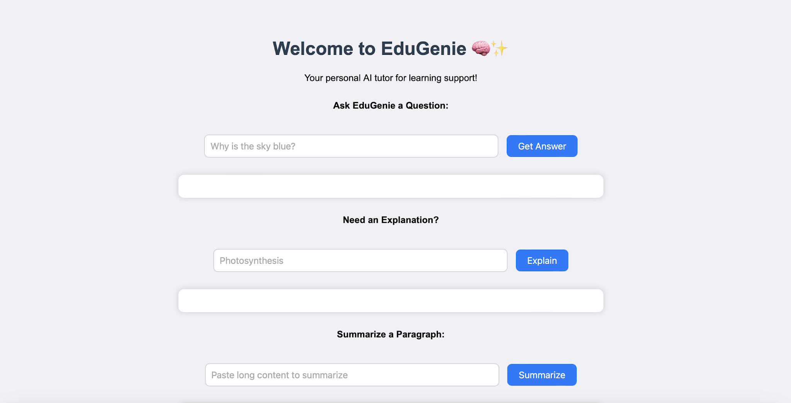
Figure 2. EduGenie home interface with the main learning functions.
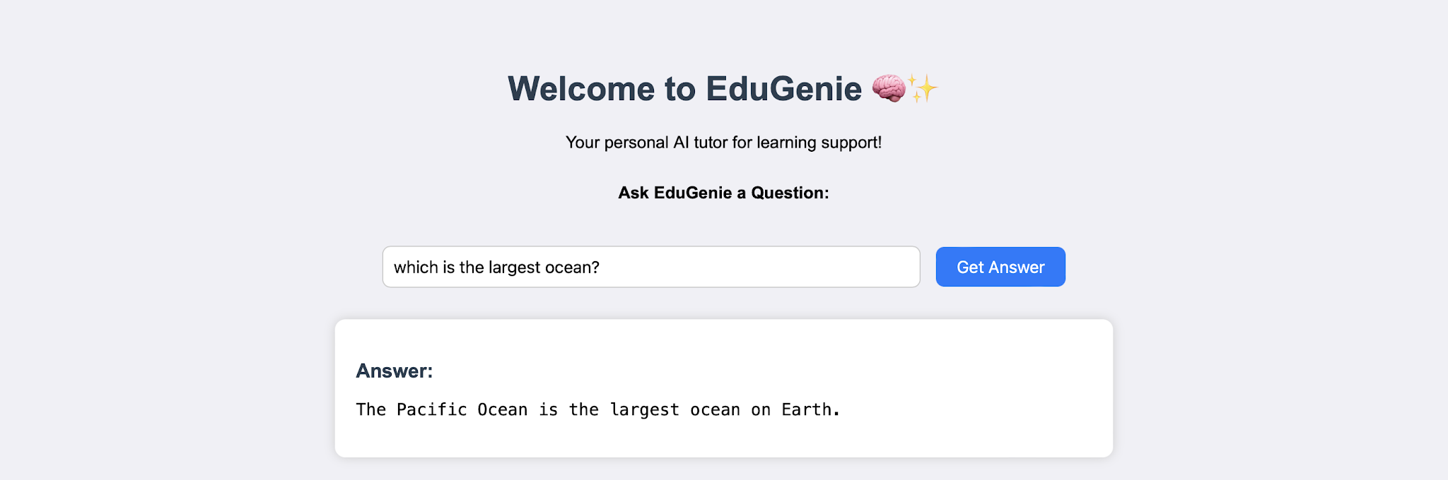
Figure 3. Question-answer workflow with an example generated response.
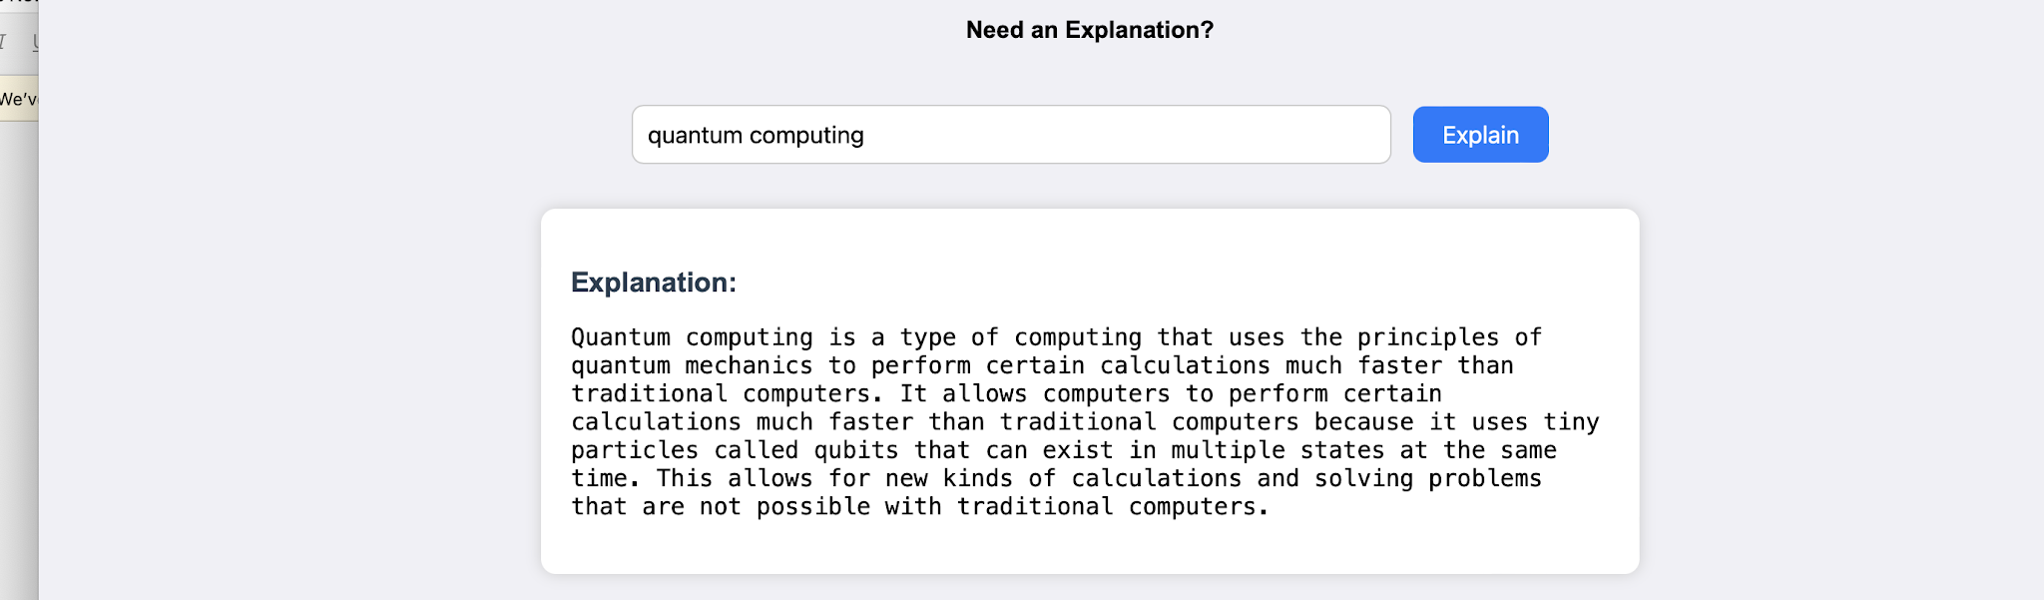
Figure 4. Concept explanation workflow using “quantum computing”.
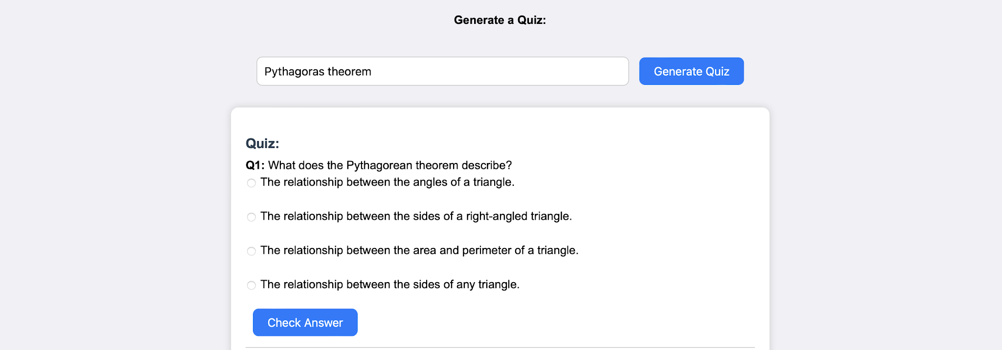
Figure 5. Quiz-generation workflow using “Pythagoras theorem”.
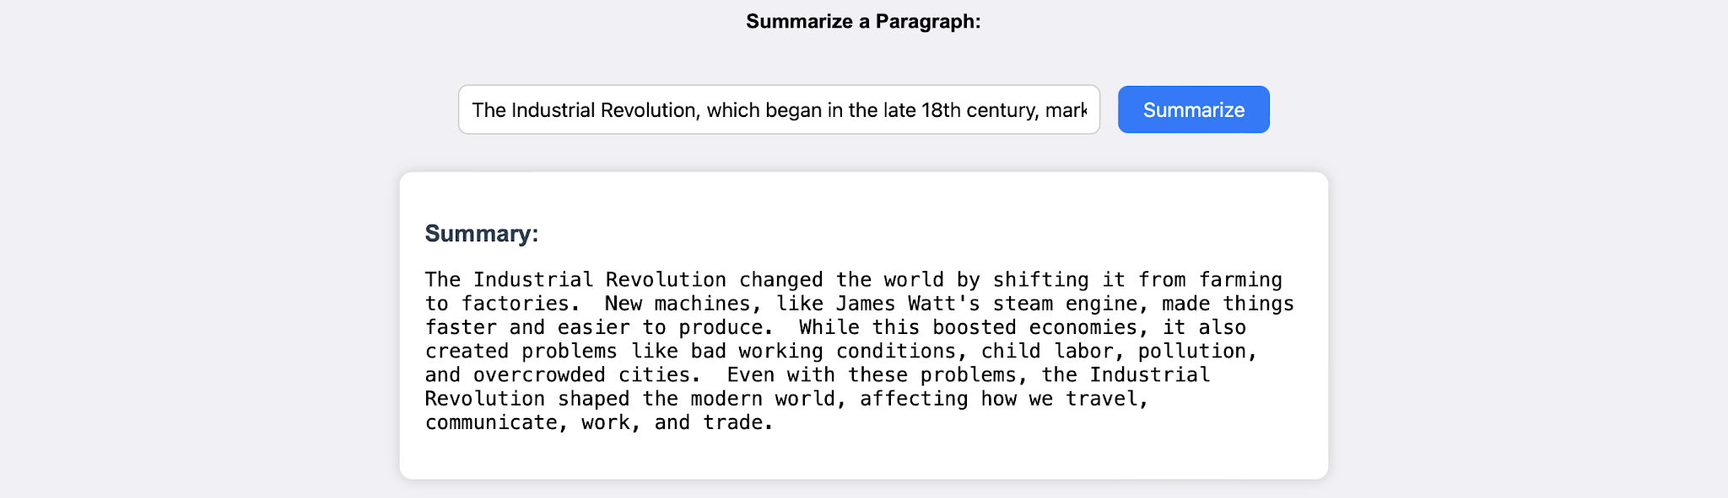
Figure 6. Text summarization workflow with an example educational passage.
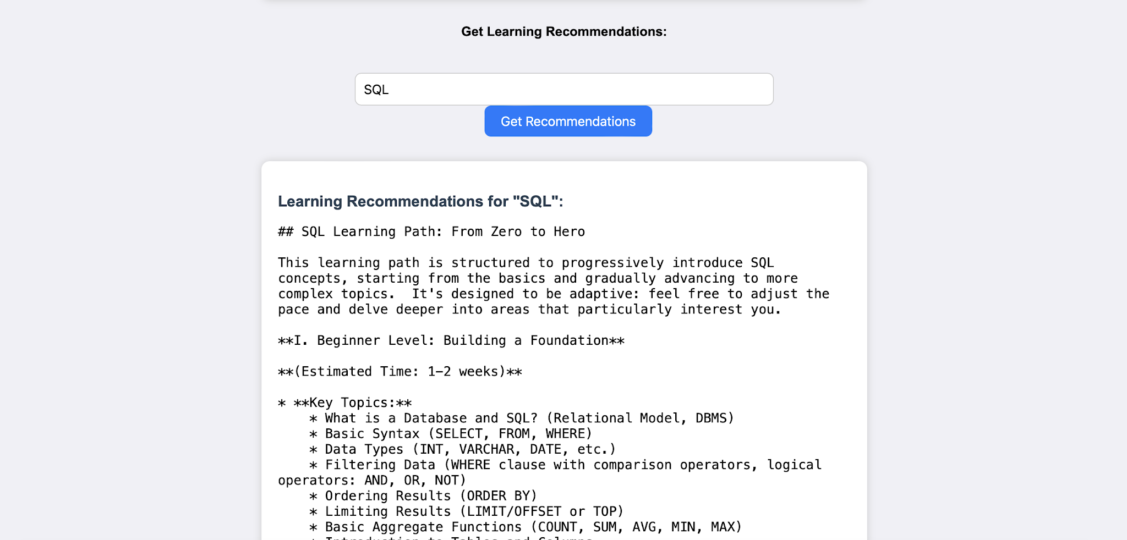
Figure 7. Learning recommendations workflow for the topic “SQL”.

7. Technical Implementation Evidence
The supplied documentation also contains technical implementation material. The following figures are included as supporting evidence of the backend and AI-oriented portions of the project.
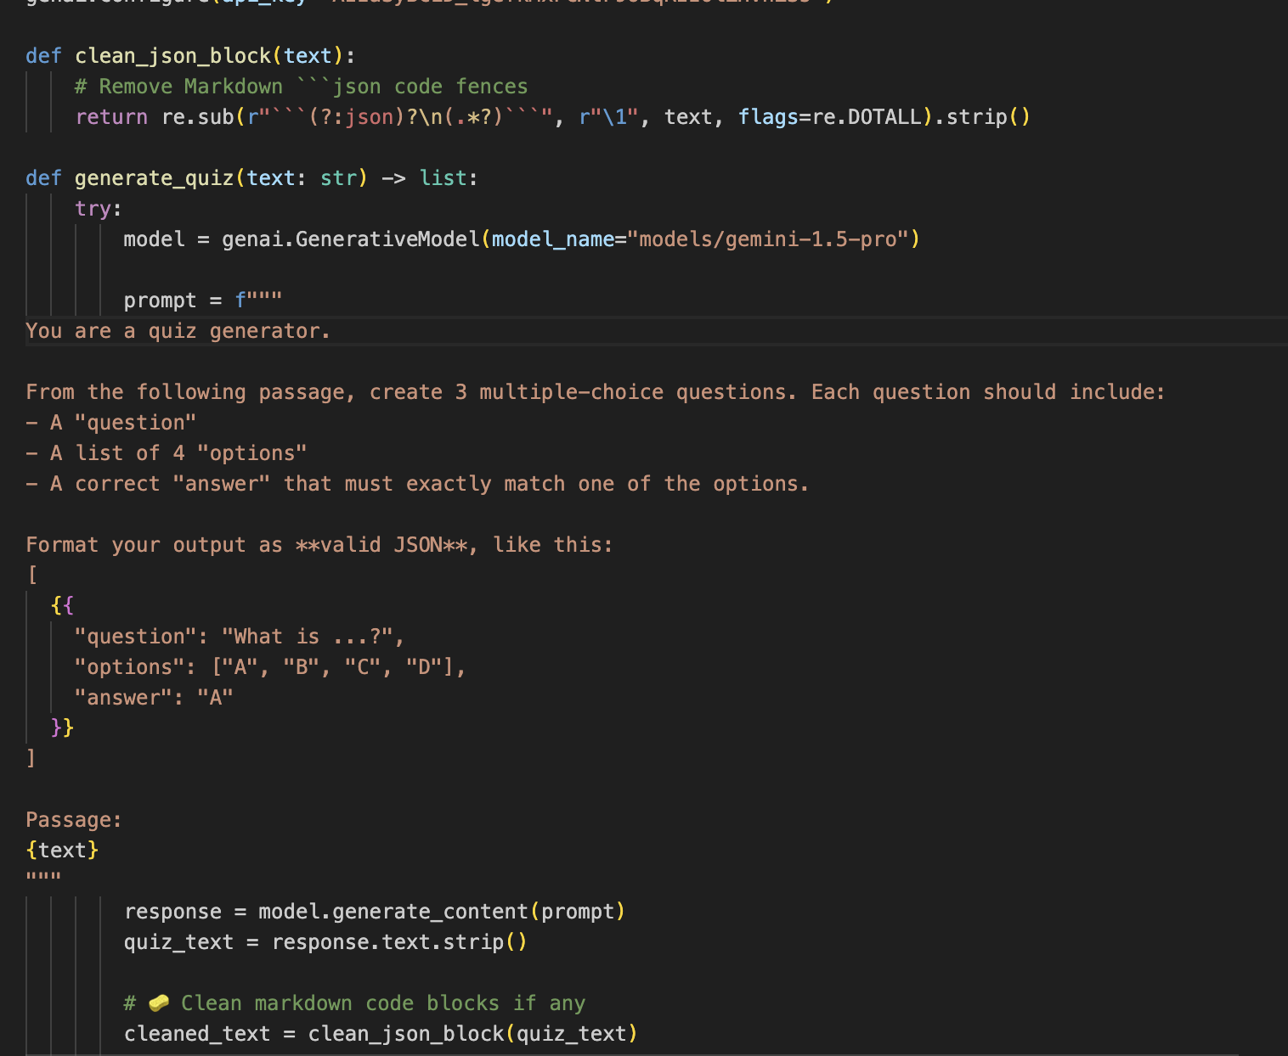
Figure 8. Backend/API implementation evidence from the supplied project material.
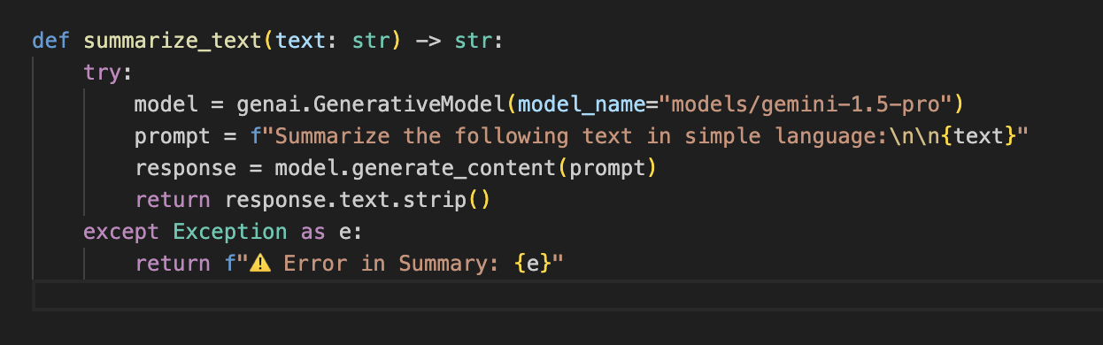
Figure 9. Gemini-powered summarization implementation evidence.
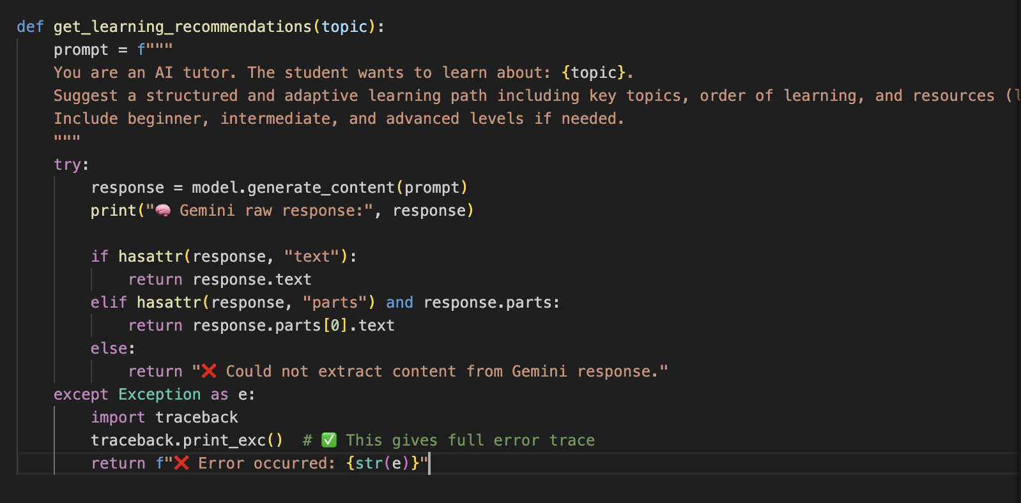
Figure 10. Learning-recommendation implementation evidence.
8. Technology Stack
Layer | Technology / Component | Role
Frontend | HTML + CSS | User interface and interaction
Backend | FastAPI | API and application logic
AI / LLM | Google Gemini | Generative responses and learning content
Application model | Generative AI | Question answering and educational content generation
9. Demonstration Matrix
Workflow | Example Input | Observed / Documented Output | Evidence
Question Answering | Which is the largest ocean? | The Pacific Ocean is the largest ocean on Earth. | Fig. 3
Explanation | Quantum computing | Generated explanatory text describing the concept. | Fig. 4
Quiz | Pythagoras theorem | Multiple-choice quiz with answer checking. | Fig. 5
Summarization | Industrial Revolution passage | Condensed summary of the supplied text. | Fig. 6
Learning Path | SQL | Topic-based learning recommendations. | Fig. 7
10. Completion Record
Based on the supplied project material and the application screenshots reproduced in this report, the project is recorded as completed by Sai Prasad.
Completion Item | Status
Project interface documented | COMPLETED
Question answering demonstrated | COMPLETED
Concept explanation demonstrated | COMPLETED
Quiz generation demonstrated | COMPLETED
Text summarization demonstrated | COMPLETED
Learning recommendations demonstrated | COMPLETED
Architecture evidence included | COMPLETED
Technical implementation evidence included | COMPLETED
11. Conclusion
EduGenie is presented in the supplied documentation as a practical Generative AI learning assistant that combines multiple educational workflows in a single interface. The project material demonstrates the application's main user interactions and supporting technical components.
This professional report consolidates that evidence into a structured project-completion record for Sai Prasad, including the documented features, architecture, technology stack, demonstration matrix, and application screenshots.
FINAL PROJECT STATUS
COMPLETED — EduGenie: Google Gemini Powered Learning Assistant
12. Developer Declaration
I, Sai Prasad, record that the EduGenie — Google Gemini Powered Learning Assistant project has been completed and that this report is prepared as a project-completion and demonstration document based on the supplied project documentation.

Name | Sai Prasad
Date | 28 September 2026

______________________________
Signature

