Pointer for Project Completion Report for Projects Approved under
NIDHI-PRAYAS by Department of Science and Technology.

General:

- Title of the project: Smart Watch Designed with Flexible Solar Cell and Strap with Liquid Silicone Rubber
- Sponsoring/collaborating agency, if any: DST supported NIDHI-PRAYAS program implemented by (SRiX Incubation)
- Start Date of the Project : 24.03.2022
- End Date of the Project : 24.03.2023
- Brief introduction about the project:
LSR has flexibility and transparency nature and it is eco -friendly, does not harm to the human skin. It has very good properties. Liquid silicone rubber composites are prepared on the basis of filler material and thickness. It’s also observed that the mechanical properties of the samples with effect of fiber particles samples are given better result compared with the effect of hardener sample. So it is clearly observed that the hardness and tensile strength of the fiber particle filler samples are much better in the 4mm and 5mm thickness samples. Also observed that when the thickness of sample increases then the corresponding strength of the fiber sample also increased. The following points are extracted from the current research work which is used to developed product:
- The maximum temperature about 150⁰C, this is the reason, the liquid silicone rubber is not influenced by the sunlight radiation.
- The flexibility of the material is high. & the hardness is 41.
- The electrical resistance of the material is 200 MΩ
- Flexible solar cells are comfortably design in the smart watch and the required voltage generated with the solar cells
- The smart watch is working in the sunlight as well as in the moon light
- Project cost (Main items of expenditure): 10,00,000/-
- Major milestones(as given in proposal/Agreement/Mutually decided with the PC): The following mile stones are achieved:
- Design solar system in liquid silicone rubber for smaller devices of energy harvesting devices
- Design a transparency material for smart watch
- Design a non reactive and flexible material for smart watch
- Assembly of Solar Smart Watch
- Details of actual implementation of the project, scope of work, time schedule etc. :
- Duration of project
- Procurement of material & Equipments-April 2022(One Month)
- Fabrication, Development of Product & Assembly – October 2022(Five Months)
- Product Analysis – January 2023 (Three Months)
- Product Marketing – April 2023 (Three Months)

- Work done under the project (technical activities for eg : Software development/Design/Testing of Technical claims):
The product is designed and developed for the smart watch applications with innovative materials approach. The liquid silicone rubber along with fiber particles improves the flexibility of the materials and required strength. The corrosion resistance and temperature resistance of the material is improved. The die preparation with lost is a challenge in our project to reduce the overall cost of the product. The additive manufacturing process or 3D printing process is used to develop the die with low cost. The CAD modeling is designed for the accurate shape of the product.
- Details of trials/testing etc (Prototype trials and tests):
The Product is developed and tested at various conditions including percentage of hardener, Liquid silicone rubber and fiber particles for the applications of smart watch and electrical insulators. The following properties are tested to confirm the properties of the product:
- Flexible test and durability of the material
- Corrosion test – The material is tested at various percentages of concentrated salts. The material which is used to develop the product also tested in various concentrated salts with respect to time and temperature.
- Transparency test – For the market ready product, the materials tested under various environmental conditions
- Product/technology details developed through the project:
The following are details for the technology used to develop the product:
- CAD Pro E is used to design the die model
- Fusion 360 software used to develop the product
- Parameter optimization using Origin software for data analysis
- FDM 3D Printer
- Testing of the materials using Shore A Hardness, Instron for Tensile Test, Transparency Test, Muffle Furnace and Chemicals.
- Radiation Test
- End product/Prototype/Process developed along with specifications and target achieved:
The final product is developed with all the required dimensions of the product and different shapes. The product also designed with different contours along with different colors.
- Product specification & standard followed, if any:
Yes, the product is developed with all the required specifications and standards.
- Details of effluents/emissions/toxic refuse materials/solid wastes etc.: No. The material is biodegradable and environment friendly.

Commercialization

- Studies on techno-economic viability undertaken for the commercialization of
results of the project & plans for commercialization, if any:
The product designed with highly flexibility and operated with solar cells. The product is more viability in terms of the economy and technical oriented.
- Name of Perspective Buyers of the technology/product: The product is under discussion stage with Amazon Company.
- Export potential of the product/process developed:
Yes. The products have a scope to export.
- Follow up funding: Yes. We are in process to expect funds to develop the product in larger scale. We are looking for additional economical support to develop the product and plant establishment.
- Employment generation potential, if any: We are providing employment source for 3 people. They are regularly working on the product development. In future, we will give more opportunity for employment.
- Whether technology developed holds promise for development at Pilot Plant/Commercial level: The product is now at pilot plant and our plan to commercialize the product in near future.
- Suggested scope for future work, if any: Yes. The products have wide scope to add some more future for medical applications.
- Final output: The product is ready with all the specification and standards
The outcomes of the project are:
- Highly flexible material designed with liquid silicone rubber and fiber particles
- Solar Cells are incorporated in the design of the smart watch
IP

Progress towards IP filing or PCT filing (IP filed, or in the process of filing) through PRAYAS funding
Patent Number: 202241004341
Date of Filing: 2022
Title of Patent: Smart watch with solar radiations Trapping Capabilities
Name of Applicant: 1. Pulla Laxmiprasanna, 2. Pulla Vasantha, 3. Pulla Sudheer, 4. Dr. P. Sammaiah

Financial:

- Details of Project cost & PRAYAS support: 10,00,000/-
- Details of Revised Project cost & PRAYAS support if any: Nil
- Reason for escalation in the cost, if any: Nil
- Report on mentoring support (number of mentor sessions conducted, feedback received, action taken on received feedback, your response on feedback, any further mentoring required in any specific area).

Annexures:

- A few good photographs/charts of Prototype/Product developed/Milestone report.

- Original document of statement of expenditure and utilization certificate (of the entire grant amount) certified by CA.

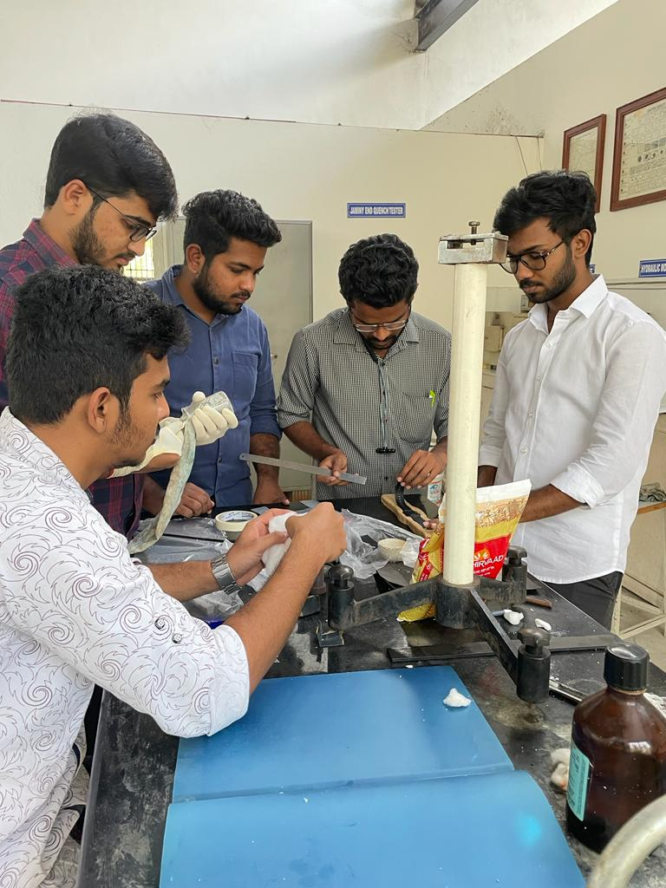
Smart watch impression formed on Atta

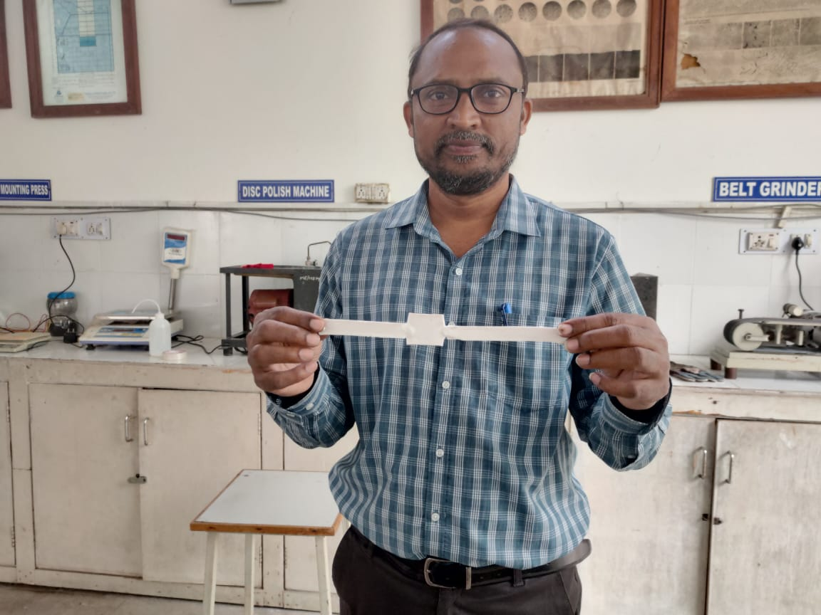
Designed Smart Watch Strap with LSR

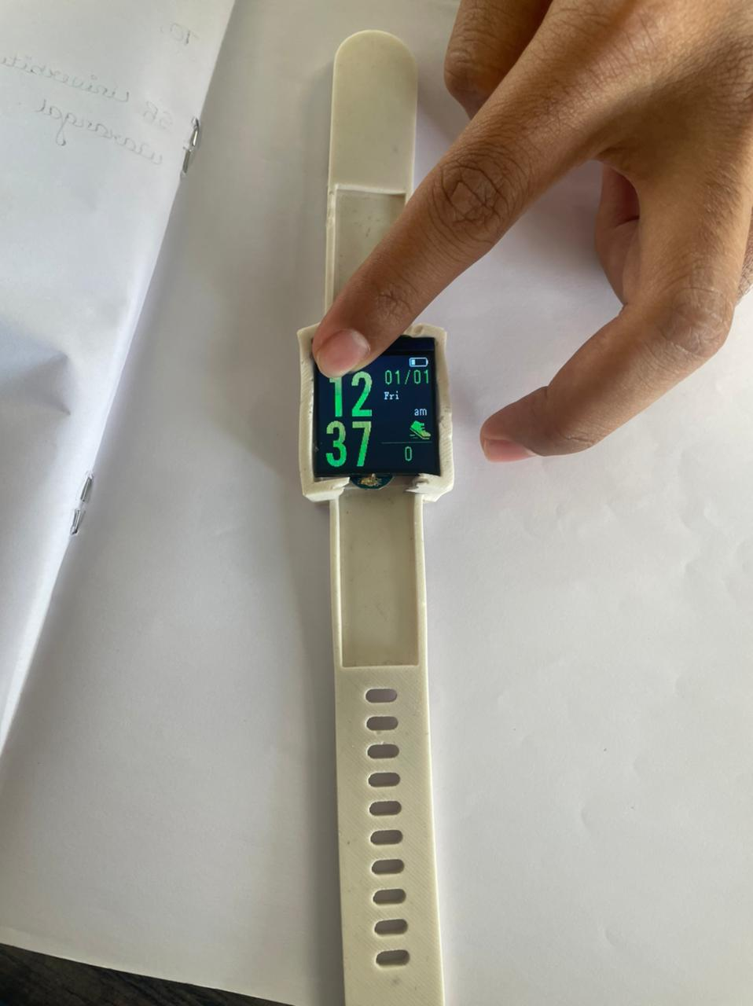
Smart Watch Strap with Electronic circuit

