DPIIT Certified Industry
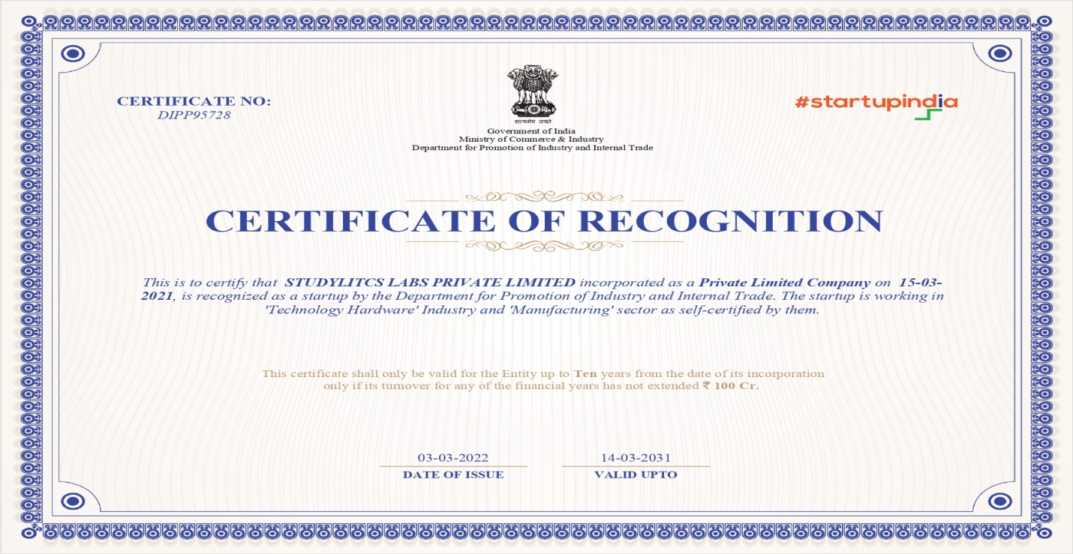
A DPIIT certified industry in India holds significant advantages, including official recognition by the government as part of the formal industrial sector, which enhances credibility and trust among stakeholders. This certification opens doors to a wide array of benefits such as access to government incentives, subsidies, and preferential treatment in procurement processes, thereby reducing operational costs and improving competitiveness. It also facilitates easier access to finance, enabling certified industries to invest in expansion, innovation, and modernization. Overall, DPIIT certification not only validates a business's compliance with regulatory standards but also positions it strategically within the Indian industrial landscape, fostering growth, sustainability, and alignment with national economic objectives.

