**Project Home Page**

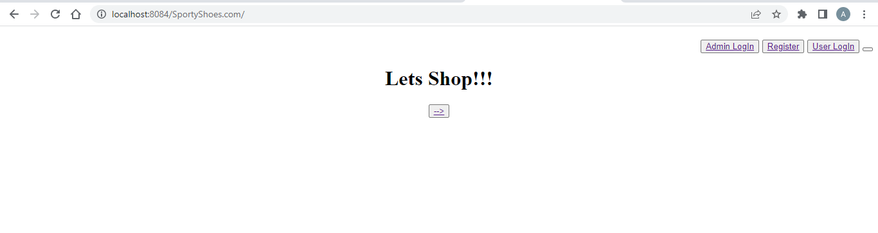

**Admin Login Page**

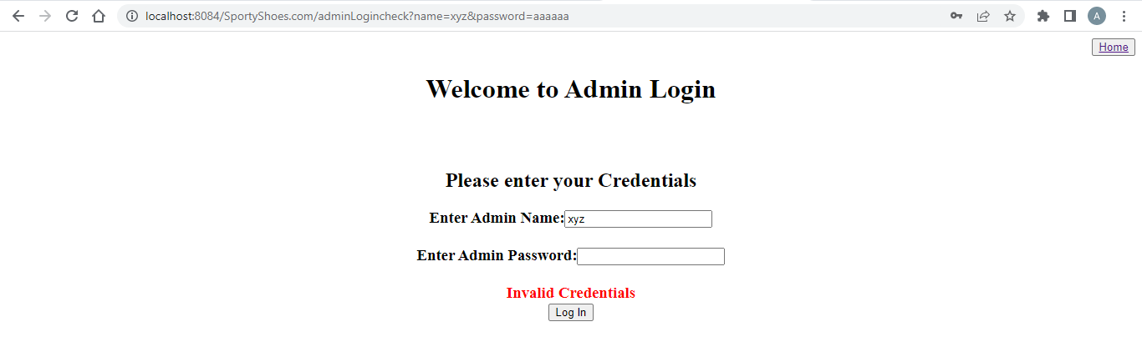

**Admin Home page**



**Manage Products Page**

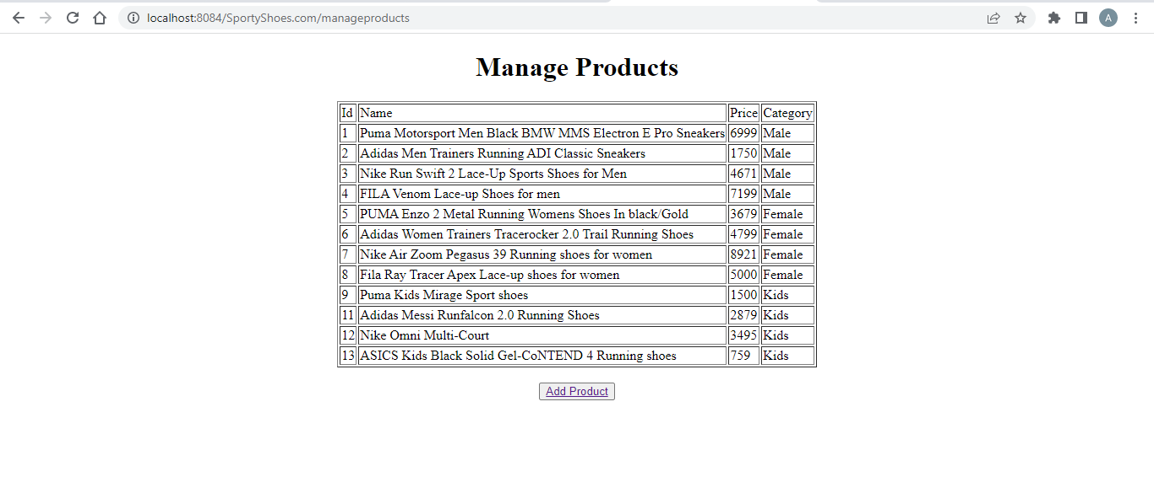

**Add Product Page**

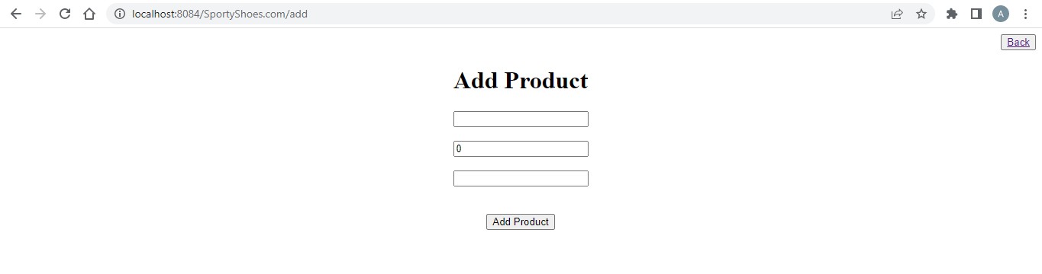

**Product Add Successful Page**

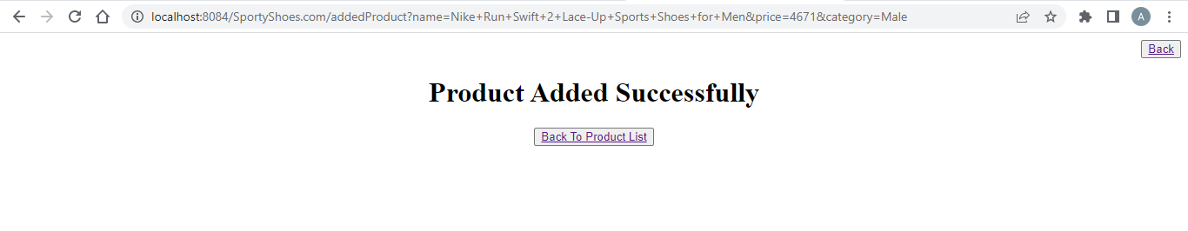

**User List**

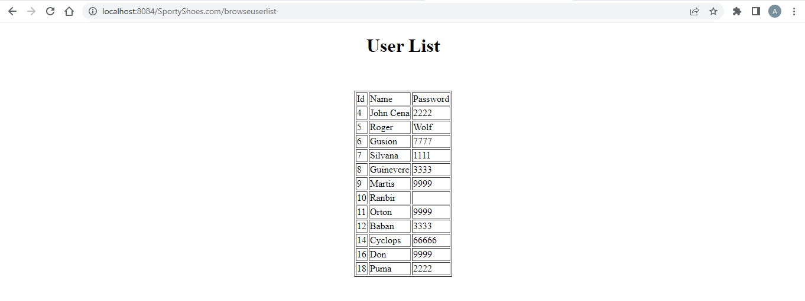

**Purchase Reports**

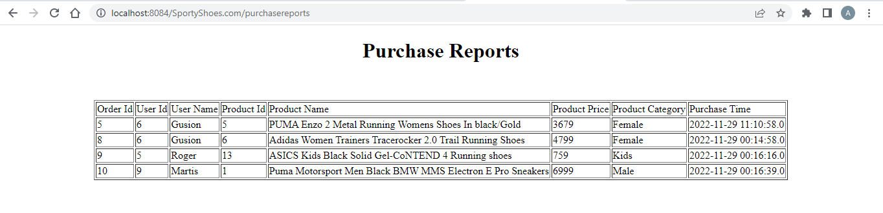

**Register User**

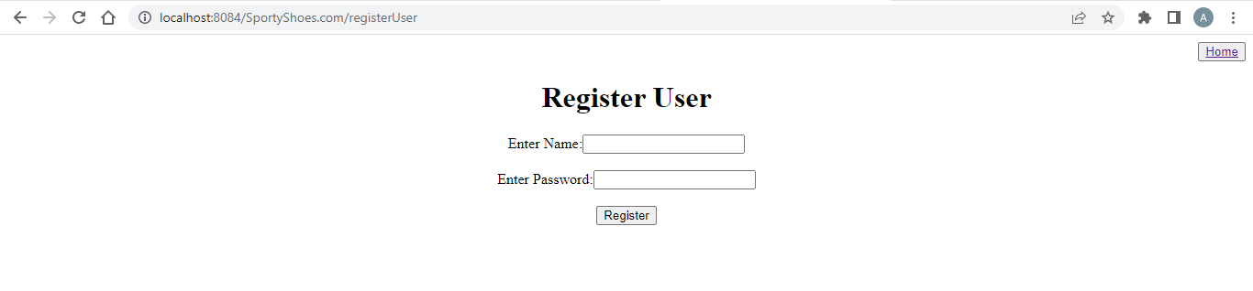

**User Registration Successful Page**

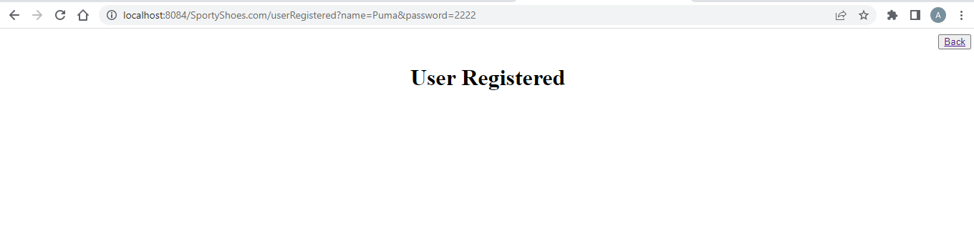

**User Login**

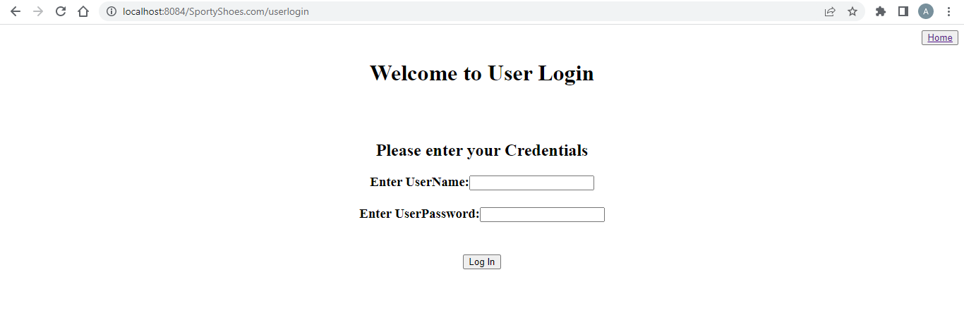

**User Home Page**

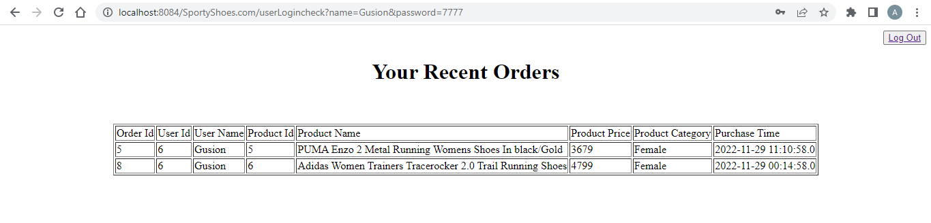

**Shopping Page**

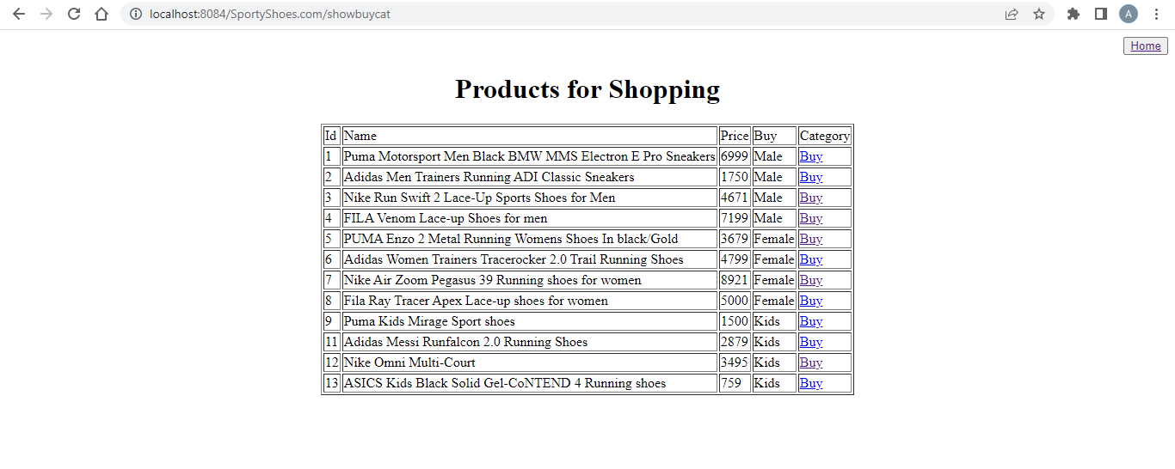

**Order Confirm Page**

