**Question :**

Suppose that the keys A through G with the hash values given below are inserted in some order into an initially empty table of size 7 using a linear-probing table (with no resizing for this problem). Which of the following could not possibly result from inserting these keys?

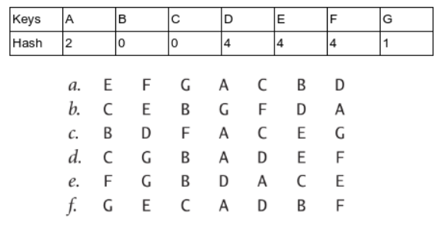

**Solution :**

Only option d is possible from the following options. When we apply a Linear Probing Hash Symbol Table to the array then the representation will be C, G, B, A, D, E, F.