**Model Building**

**Steps involved in Model building:**

* **Identifying the output and target variable.**

**Here identified target variable is booking_status and the rest are the input variables.**

* **Splitting the data into training and testing.**

**By splitting the input and output variables into train and test we got 2174 train points and 725 test points.**

* **Dividing categorical and numerical features.**
* **Pre-processing the train_data.**
* **Pre-processing the test_data.**
* **Scaling the numerical features of test_data using Standardization.**
* **Scaling the categorical features of test_data using OneHotEncoding.**

**Concatenating the numerical and categorical features.**

* **Balancing the data using SMOTE (Synthetic Minority Oversampling Technique) to rectify the imbalance in the given data. This technique is used after data transformation technique.**
* **Building the logical structure using Keras tuner a powerful Hyperparameter optimization library helps in shaping the architecture of deep learning model.**

**Creating a function.**

* **Calling the function using tuner() for training and testing of the data.**
* **Keras tuner library is used for searching the optimal hyper-parameters for Deep learning models. Keras tune is a great way to check for different numbers of combinations of kernel size, filters, and neurons in each layer.**
* **The hyperparameters that yielded the best-performing model were discovered,**

**including model architecture with six hidden layers, specific neuron counts in each layer.**

* **'he_uniform' weight initialization.**
* **'rmsprop' optimizer.**

**These hyperparameters define the final model's configuration.**

* **The final model architecture is composed of six dense hidden layers, each followed by batch normalization and dropout layers to enhance model generalization and prevent overfitting.**
* **The final model was trained on the preprocessed dataset with 10as the batch size**

**and 10 training epochs. During training, a validation split of 10% was used for**

**performance monitoring.**

* **The model achieved an accuracy of approximately 94% on the validation dataset.**
* **The model's performance was further evaluated using a confusion matrix. The goal was to maximize the diagonal elements of the matrix, indicating correct predictions.**

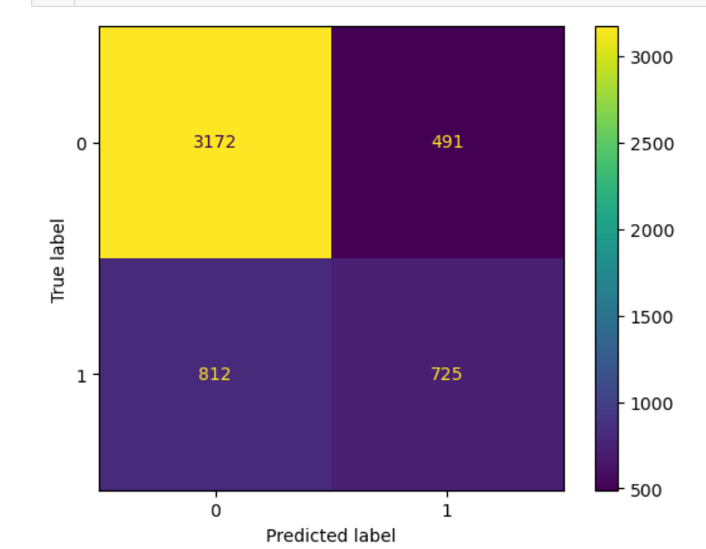

* **A high diagonal element count signifies the model's capability to make accurate classifications.**