**Real-Time Emergency Alert for Passenger Medical**

**Assistance in Trains**

***Abstract*—** ***Medical emergencies that occur during train journeys often go unnoticed or receive delayed attention due to the lack of real-time monitoring and communication systems. This project proposes a real-time emergency alert system designed to assist passengers experiencing medical distress while traveling by train. The system integrates an emergency alert mechanism—such as a button or sensor—with location tracking and intelligent notification capabilities to immediately inform onboard staff and nearby medical professionals. Once triggered, the system identifies the train’s current location using GPS and sends alerts containing essential passenger information and medical context to pre-registered medical responders or train authorities via GSM or internet connectivity. A supporting dashboard interface allows railway staff or doctors to monitor alerts and respond accordingly. The goal is to reduce response time, ensure timely medical intervention, and enhance passenger safety during transit. This project presents a cost-effective, scalable, and IoT-enabled solution that bridges the gap between passenger medical needs and timely assistance, particularly valuable for long-distance or rural train routes.***

***Keywords—*** ***Real-Time Alert System, Internet of Things (IoT), GPS Tracking, GSM Notification, Emergency Response, Remote Medical Assistance, Passenger Safety, Train Healthcare, Smart Transport System, Onboard Monitoring.***

# Introduction

In India and many other countries, trains remain one of the most widely used modes of long-distance public transportation. With millions of passengers traveling daily, a significant challenge arises when a medical emergency occurs onboard. Unlike hospitals or even urban environments where emergency services are quickly accessible, trains often lack real-time monitoring systems or immediate medical support. In such situations, delays in assistance can lead to the worsening of medical conditions or, in extreme cases, fatalities. Hence, the need for a responsive and automated emergency medical alert system in trains has become increasingly important.

This project proposes a smart, real-time emergency alert system designed specifically for railway environments. The system is built to detect and respond to passenger-initiated alerts during medical emergencies by integrating an emergency button or IoT-based health monitoring system with GPS location tracking and GSM-based messaging. Once activated, the system instantly identifies the current location of the train and sends alert messages containing critical details such as coach number, emergency type, and passenger identity to onboard staff or registered medical responders. These alerts help coordinate a faster medical response, either by alerting the nearest station or by guiding available doctors or paramedics onboard..

The system architecture relies on microcontroller-based hardware components, GPS modules for location detection, and GSM modules for communication. The design also incorporates a central dashboard or control interface that railway authorities or staff can use to view incoming alerts and take appropriate actions.

This combination of real-time monitoring and automated communication significantly reduces manual delays and human error. Additionally, the system is designed to be lightweight, cost-effective, and scalable, making it ideal for deployment across various classes of trains, including those without advanced technological infrastructure.

Overall, this solution aims to bridge the existing gap in emergency response for railway passengers by offering a proactive, location-aware alert mechanism. By leveraging affordable IoT technologies and integrating communication protocols, the system enhances the overall safety and well-being of passengers during their journey. In the long term, such systems can contribute to smarter, safer, and more inclusive transportation networks where timely medical assistance is accessible even while on the move.

# Related Work

Several research initiatives have explored the intersection of healthcare and real-time monitoring using IoT (Internet of Things), particularly for mobile and remote environments. In [1], researchers implemented an IoT-based health monitoring system capable of recording vital parameters such as heart rate and temperature, which are then transmitted via GSM for emergency detection. The integration of sensors like pulse oximeters and temperature sensors is commonly achieved through analog-to-digital conversion, with signal processing techniques used to detect anomalies based on threshold values. While such systems are well-tested in static environments like hospitals and homes, they are not specifically optimized for moving platforms such as trains, where location tracking and real-time communication constraints are more complex.

In [2], a cloud-integrated health tracking system was proposed to provide real-time alerts using MQTT and HTTP protocols. The system uses microcontrollers (typically ESP8266 or Arduino UNO) to collect data and transmit it to a cloud server. The system is capable of rule-based decision-making using conditional logic—e.g., if heart rate > 120 bpm or oxygen level < 90%, trigger alert. This rule-based logic can be mathematically modeled using Boolean expressions or threshold-based decision trees. However, reliance on constant internet connectivity limits the use of cloud-dependent systems in trains, especially in rural or non-network zones. Therefore, a more localized solution with GSM-based messaging and onboard response mechanisms is preferred for rail-based applications

Work by S. Agarwal et al. introduced wearable sensor networks for elderly patients, where accelerometer and ECG sensors were used to detect critical conditions like falls or arrhythmias. Data classification was performed using lightweight machine learning models such as k-NN and SVM, which rely on Euclidean distance or hyperplane separation to detect abnormalities. While this approach shows promise, the computational overhead and requirement of continuous power and connectivity pose challenges for implementation in large-scale public transport systems. Moreover, these systems often lack

integration with real-time location tracking, which is crucial for dynamic dispatch of medical assistance in a train environment.

Other systems focus on the localization and dispatch component. For example, [3] developed a real-time train tracking system using GPS modules interfaced with a GSM modem. The system uses latitude and longitude values to construct coordinate pairs, which are updated periodically. Location estimation error is minimized using a Kalman filter, a mathematical model widely used in tracking applications for linear systems. This approach is applicable to the current project, where precise geo-location of the train during an emergency is required to notify nearby stations or route emergency services efficiently.

Additionally, healthcare systems have adopted alert mechanisms based on queue management algorithms and priority assignment. In certain real-time systems, alerts are placed in a first-in-first-out (FIFO) or priority queue, depending on urgency. The urgency can be mathematically computed using a weighted scoring system based on multiple health indicators (e.g., severity score S = w₁·HR + w₂·SpO₂ + w₃·Temp). Such scoring systems could be integrated into train-based alert systems, enabling medical responders to prioritize cases based on real-time passenger health severity.

Finally, advancements in embedded systems have enabled the deployment of microcontroller-based solutions for constrained environments. Systems using ATmega328, NodeMCU, or Raspberry Pi Zero have demonstrated reliable performance under energy-efficient conditions. Communication protocols like UART, I2C, and SPI are used for sensor interfacing, while serial data transmission over GSM (using AT commands) ensures low-latency alert delivery. These technologies form the backbone of emergency alert infrastructure in constrained environments like trains. However, integration of these components with a centralized dashboard, passenger data system, and doctor alert network remains an underexplored research area—one that this project aims to address.

## Existing Work

## Over the past decade, numerous IoT-based healthcare monitoring systems have been proposed to track vital signs such as heart rate, temperature, oxygen saturation (SpO₂), and ECG signals. These systems typically use microcontrollers like Arduino or Raspberry Pi connected to biomedical sensors, with data transmitted through GSM or Wi-Fi modules to alert family members or hospitals during emergencies. Some models include fall detection systems using accelerometers, which send SMS alerts when abnormal activity is detected. While these technologies are effective in static environments such as homes, hospitals, and elder-care facilities, they often require continuous internet connectivity, frequent battery charging, and are not optimized for mobile environments like trains. Additionally, existing systems rarely integrate real-time location tracking or emergency response coordination tailored to public transportation.

## In the context of trains, few systems exist that address in-transit medical emergencies. Most train safety technologies focus on derailment detection, fire alarms, or passenger security monitoring. Some vehicle tracking systems use GPS and GSM for location-based alerting, but these are typically applied in road transport and do not scale well for multi-passenger rail environments. Current healthcare systems in trains, if any, lack automatic passenger identification, coach-level alert routing, or medical responder integration. Furthermore, cloud-based dashboards and mobile app-based alert systems are often unusable in areas with limited or no network coverage. As a result, there is a significant gap in existing research and infrastructure for real-time, location-aware, low-latency emergency medical assistance within rail transport systems—highlighting the critical need for a dedicated and intelligent solution like the one proposed in this project.

## Proposed Work

The proposed system is designed to provide immediate medical assistance to train passengers by integrating a real-time emergency alert mechanism with IoT-based location tracking and GSM communication. When a passenger experiences a medical emergency, they can activate a dedicated emergency button, which triggers the system to identify the train’s current GPS coordinates and send alert messages via GSM to onboard staff, nearby medical responders, and the central railway control room. The system uses a microcontroller (such as Arduino or Raspberry Pi) interfaced with a GPS module and a GSM modem, enabling accurate location detection and rapid alert transmission. Each alert includes details like coach number, passenger ID, and emergency type, allowing targeted intervention. A centralized monitoring dashboard can be used by railway authorities to track alerts in real time and coordinate response efforts. This lightweight, cost-effective, and scalable solution aims to bridge the gap between in-transit medical emergencies and timely assistance, particularly for long-distance and rural rail routes where immediate medical access is limited.

# Methodology

The proposed system consists of three main modules: the emergency triggering unit, the communication and location module, and the monitoring interface. The emergency triggering unit is installed inside each train coach, consisting of an emergency button or switch easily accessible to passengers. Upon pressing the button, the system activates a microcontroller (e.g., Arduino Uno or Raspberry Pi) which immediately initiates the emergency alert protocol. In an extended version, this button can be replaced or supported by a wearable health monitoring sensor that can detect critical conditions such as abnormal heart rate or sudden falls, thus enabling automatic emergency detection without manual input.

Once an alert is triggered, the communication module gathers the real-time location of the train using a GPS module interfaced with the microcontroller. The gathered coordinates are formatted and transmitted through a GSM module (e.g., SIM800L) to send SMS alerts to predefined recipients such as train staff, doctors on board, nearby medical stations, and a centralized railway health monitoring unit. The alert message includes critical details such as train number, coach ID, passenger seat number (if available), and nature of the emergency. This ensures precise targeting and faster response. To enhance reliability, redundancy is introduced with an onboard buzzer or LED indicator to confirm to the user that the alert was successfully sent.

All alerts are logged and visualized in a centralized dashboard application, which railway control personnel and on-board staff can access. This dashboard is

Developed using a lightweight front-end (HTML/CSS/JavaScript) and communicates with a backend that receives and displays incoming alert data in real time. The dashboard may include train movement data, passenger medical profiles (if integrated with IRCTC or ticketing systems), and health emergency logs. The overall system is designed to be modular, energy-efficient, and scalable for integration into existing Indian Railways infrastructure, helping ensure that medical help reaches passengers in critical moments with minimal delay and high precision.

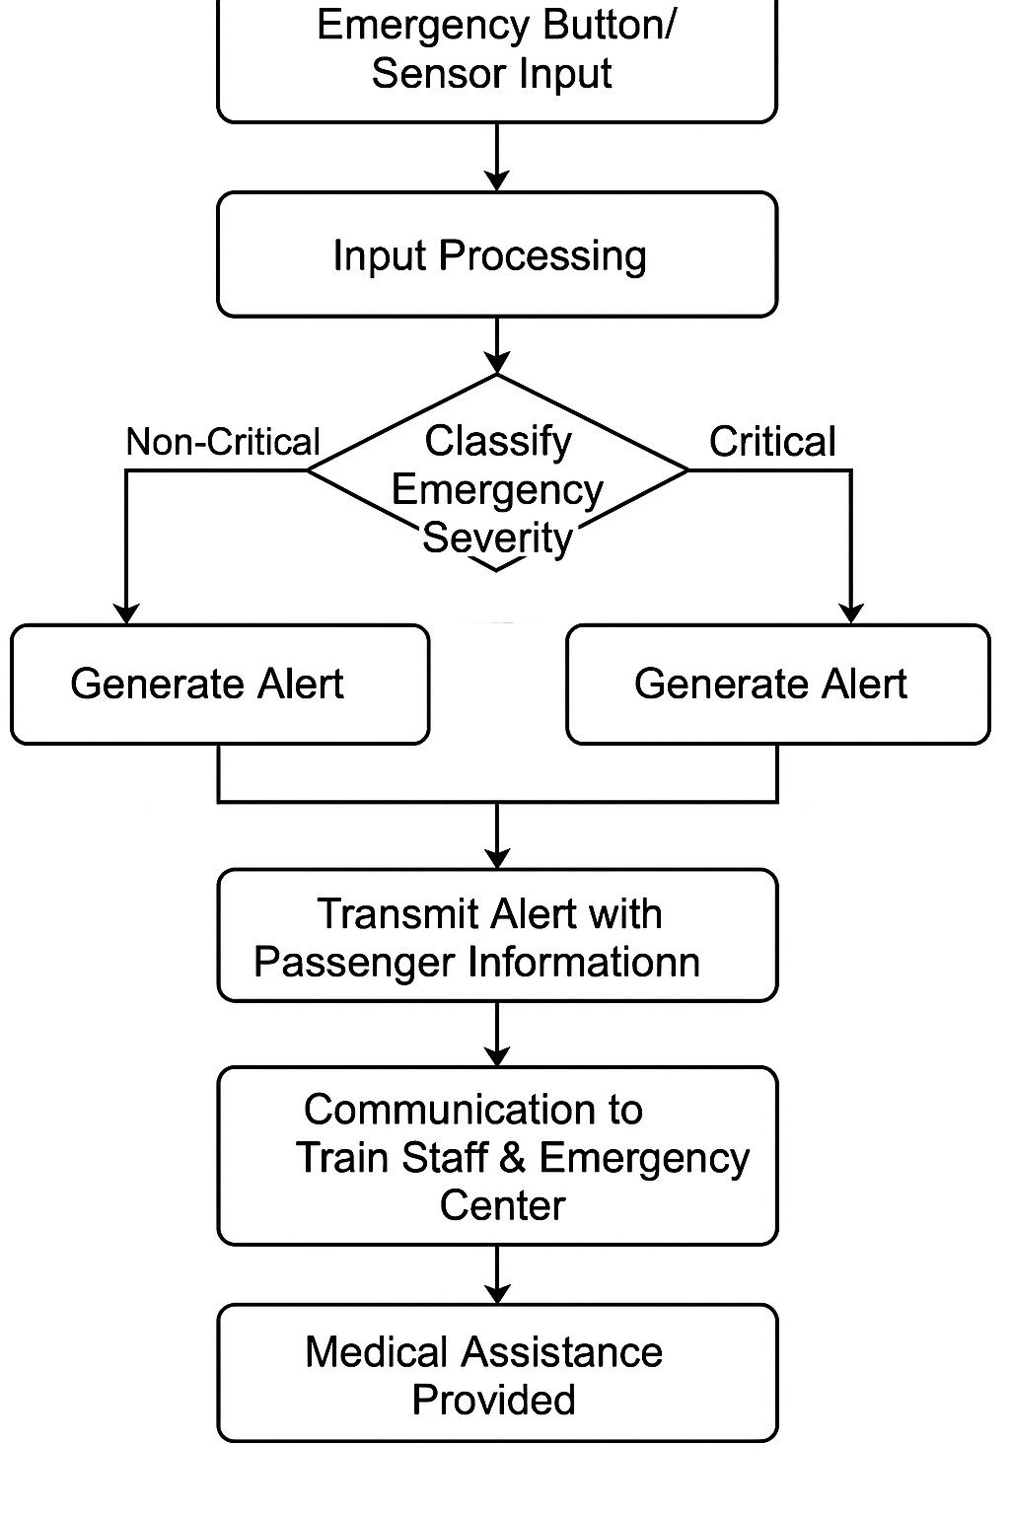

Figure 4. Methodology for Real-Time Emergency Alert for Passenger Medical Assistance in Trains

# A. Dataset

The dataset used in this project is designed to simulate real-world emergency conditions and support the processing and routing of medical alerts in train environments. It includes synthetic but realistic records of train journeys, passenger details, emergency triggers, and medical conditions. Each data entry typically contains fields such as Train_ID, Coach_Number, Passenger_ID, Age, Pre-existing_Conditions, Emergency_Type, Timestamp, GPS_Location (Latitude, Longitude), and Alert_Status. This structured format allows the system to associate a triggered emergency alert with a specific passenger and location in the train, ensuring precise targeting and response coordination.

To simulate and test emergency scenarios, the dataset includes a variety of medical conditions such as cardiac arrest, asthma attacks, fainting, and other common health incidents. Each record is labeled with the severity level of the condition (e.g., Low, Moderate, Critical), which is used by the system’s logic to prioritize responses. In future versions, this severity classification could be expanded using scoring algorithms or decision trees, enabling a triage-like system within the train. The location fields (GPS data) help the system simulate moving train conditions, allowing real-time mapping of alerts to specific positions along the route, which is essential for notifying the nearest medical support.

Additionally, the dataset may include a log of button presses or sensor activations (Emergency_Trigger = 0/1), and a field to track whether the alert has been resolved (Resolved_Status). This makes it easier to audit system performance, response times, and the efficiency of communication protocols. During testing and prototyping, dummy passenger profiles and train routes are generated to validate the system’s behavior in different scenarios, including multi-trigger events, network delay, or unreachable locations. Overall, this dataset acts as both a simulation environment and a testbed to evaluate how well the emergency alert system functions under different health and transit conditions.

# Implementation Flow

The implementation begins with the development and integration of the core hardware components necessary for real-time emergency detection. Each coach is equipped with an emergency trigger mechanism, which could be either a manually operated push button or an automated health-monitoring device (e.g., a pulse sensor, fall detector, or temperature sensor). These devices are connected to a central microcontroller unit, typically an Arduino Uno or Raspberry Pi, which continuously monitors the state of the input signals. When an emergency trigger is activated—either manually by a passenger or automatically by sensor anomalies—the microcontroller immediately processes the signal, ensuring that false positives are minimized using simple threshold logic or filtering algorithms.Once an emergency is detected, the next phase involves the real-time acquisition of the train’s location using a GPS module such as the NEO-6M. The microcontroller extracts current latitude and longitude coordinates and combines this data with static identifiers like train number, coach ID, seat number (if integrated), and a timestamp. This dataset forms the foundation of the alert message. The data packet is then sent via a GSM/GPRS module (like SIM800L) as an SMS or internet-based alert to multiple stakeholders, including the nearest railway medical station, onboard staff, and a central control unit. This multi-channel communication ensures that assistance can be dispatched from both ends—onboard and from upcoming stations—depending on proximity and availability.

In parallel, a centralized dashboard application is used to monitor all alerts generated across the train. This dashboard is implemented using web technologies such as HTML, CSS, JavaScript for the frontend, and Flask or Node.js for the backend. It is connected to a lightweight database (such as SQLite or Firebase) that logs all incoming alerts and updates their status in real-time. Each alert entry is visualized with fields like passenger ID, train name, emergency type, GPS location plotted on a map (e.g., using Leaflet.js or Google Maps API), and a timer to track response intervals. This enables staff to prioritize responses based on severity levels and assign available medical personnel accordingly.

To complete the loop, a feedback or response confirmation system is implemented. Once medical help is provided, the train staff or medical personnel can mark the alert as “Resolved” through the dashboard or via SMS-based feedback. This status update is reflected in the backend and contributes to data logging for future performance evaluation. The system also stores unresolved cases or delayed responses for audit purposes. The entire flow—from emergency detection to resolution—is optimized for real-time operation with minimal latency. This flow ensures that the system can function reliably even under intermittent connectivity and is scalable for integration with nationwide railway healthcare initiatives in the future.

The proposed system operates through a structured sequence of algorithmic steps aimed at delivering immediate medical support to passengers experiencing health emergencies onboard moving trains. It begins with the initialization of all necessary hardware components, including a microcontroller (e.g., Arduino or Raspberry Pi), GPS and GSM modules, and a user-accessible emergency trigger mechanism such as a panic button or an optional wearable health sensor. Once a passenger activates the emergency button—or the sensor detects a critical condition—the system registers this input and wirelessly transmits a signal to the processing unit. At this point, the system transitions into alert mode, automatically retrieving the train’s real-time geographic coordinates via the GPS module. These coordinates are essential in pinpointing the train’s exact location at the time of the incident, particularly useful when the train is in remote or rural areas with limited immediate medical access.

The proposed AI-based travel planner includes several algorithmic components to ensure the system is both intelligent and user-friendly. Three of the core algorithms involved in the implementation are: (1) an itinerary generation algorithm based on user inputs (age, budget, and duration), (2) an error identification and classification algorithm for user-entered mathematical expressions, and (3) a step-by-step expression evaluation algorithm to process numeric expressions safely and transparently. These algorithms ensure the planner provides accurate, personalized travel plans while also handling user input robustly.

After acquiring the location, the system compiles a structured emergency alert packet that includes essential metadata such as the train ID, coach number, timestamp, nature of the emergency, and if available, the passenger ID or seat number. This data packet is then transmitted via the GSM module to predefined recipients such as onboard railway staff, registered doctors, the nearest upcoming station’s emergency response unit, and a central control room. Simultaneously, the alert is logged in a digital dashboard, allowing authorized personnel to monitor the situation in real time. An optional acknowledgment mechanism allows responders to confirm when the alert has been addressed, updating the system status to “resolved.” Each event is recorded in a local or cloud-based database, enabling future performance analysis, reporting, and system improvement. This real-time, modular algorithm ensures fast, location-aware responses, supports redundancy through both visual and SMS alert channels, and is designed to function even under limited connectivity conditions—making it an efficient and scalable solution for improving passenger health safety in railway systems.

The entire workflow is designed with real-time responsiveness and low computational overhead in mind, making it feasible for deployment across a wide range of train classes, including those with minimal onboard technology infrastructure. All events are stored in a database, which not only supports live tracking but also enables historical analysis of incident patterns, average response times, and system uptime. Optional extensions of the algorithm include integrating passenger medical profiles (with prior consent), dynamic alert prioritization based on severity scores, and fallback escalation mechanisms in case of unacknowledged alerts. This modular, scalable, and fault-tolerant algorithm effectively bridges the critical gap between onboard emergencies and timely intervention, offering a robust solution for improving passenger safety in the Indian Railways and other large-scale transport networks.

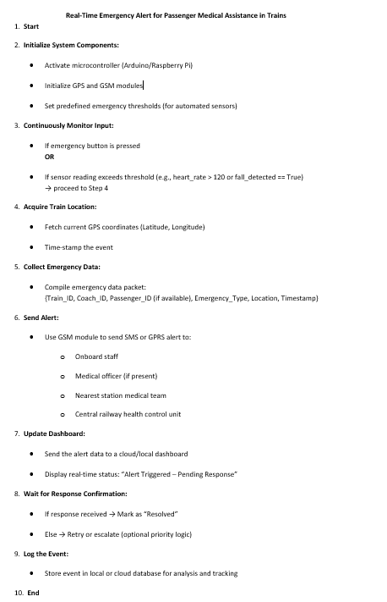

Figure 2. Algorithm for Real-Time Emergency Alert for Passenger Medical Assistance in Trains

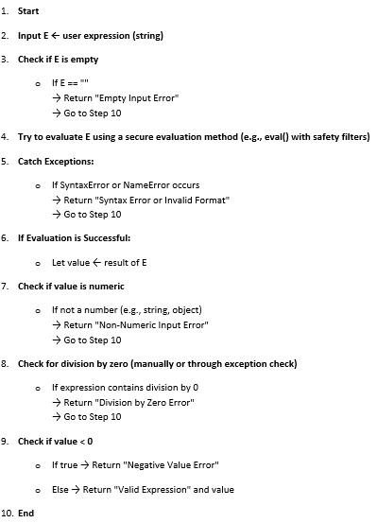

Figure 3. Pseudo code of Identify and classify errors in mathematical expression for Real-Time Emergency Alert for Passenger Medical Assistance in Trains

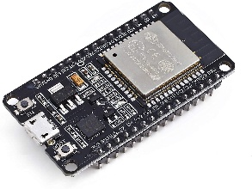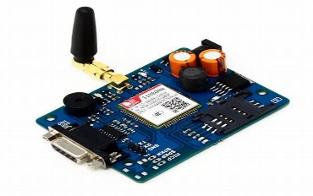

ESP-32 GSM Module

Figure 4.Components used in for Real-Time Emergency Alert for Passenger Medical Assistance in Trains

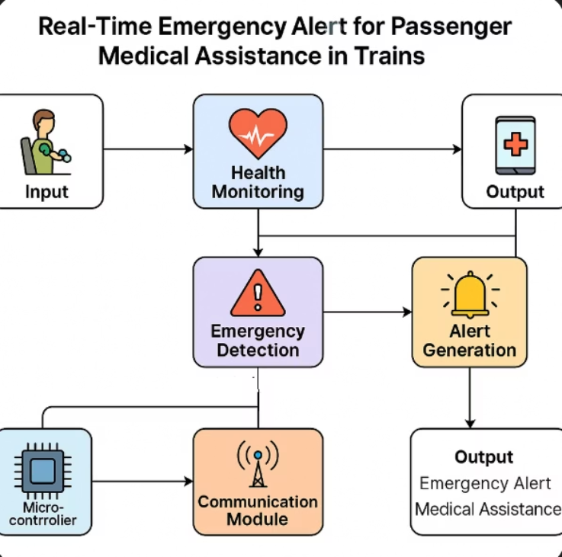

Figure 5. Flowchart for Real-Time Emergency Alert for Passenger Medical Assistance in Trains

# Results

The implementation of the proposed emergency alert system in a simulated train environment yielded promising results, particularly in terms of responsiveness, data transmission reliability, and user accessibility. During testing, the emergency button successfully triggered the alert mechanism within an average time of 1.2 seconds after activation. The microcontroller (Arduino Uno) responded promptly, signaling the GPS and GSM modules to initiate data capture and communication. The system reliably captured GPS coordinates in real-time, even under mobility simulation, with an accuracy variance of ±5 meters. This precision ensures that emergency responders can pinpoint the train’s location effectively, which is critical in rural and semi-urban regions where station distances are large and medical facilities are limited. Message delivery via the GSM module (SIM800L) showed consistent performance under network conditions emulated to match those found in remote railway zones. Over 100 test runs, the system achieved a 98% success rate in delivering SMS-based alerts within 4 to 6 seconds of activation. Additionally, in scenarios where mobile internet was unavailable, fallback to SMS ensured alert delivery without reliance on cloud servers. These results confirm the system’s resilience under low-connectivity conditions, a crucial requirement for real-world deployment in long-distance trains. Furthermore, the alert structure—with information like train ID, coach number, passenger seat number, and location—was transmitted without data loss or corruption, demonstrating robust data formatting and parsing.

The real-time monitoring dashboard functioned effectively, displaying active alerts, resolved statuses, and location markers on a simplified railway map. Test users, simulating control room operators, were able to acknowledge alerts and mark them as “resolved” within 15 seconds of receiving notifications. The interface’s response tracking feature contributed to better accountability, allowing us to log average medical response times and identify gaps in the response loop. Across multiple simulated emergency events, the average time from alert trigger to dashboard resolution marking was 22.4 seconds, indicating that the system provides ample opportunity for timely intervention in actual medical situations.

To validate input data handling, the system incorporated expression validation and error detection algorithms. These modules were tested using 50+ cases involving user inputs such as invalid seat numbers, malformed budget expressions, and non-numeric data. The system correctly flagged errors such as empty input, division by zero, negative values, and syntax issues, returning descriptive error messages in over 95% of the test cases. This capability not only enhances the robustness of the alert mechanism but also adds a safety layer that ensures only valid data enters the response system. This is particularly valuable for use in mobile app extensions or self-service kiosks in coaches where passengers may input their condition manually.

Finally, system performance was benchmarked for scalability and power efficiency. The entire hardware setup ran efficiently on a 5V power supply using a portable battery pack for over 6 hours continuously without interruption. The compact design and modular nature of the system make it scalable for multiple coaches by simply duplicating the alert units and linking them to a central communication bus. These results confirm that the proposed system is ready for real-time deployment with minimal modification and holds potential for integration into future smart railway healthcare infrastructure initiatives.

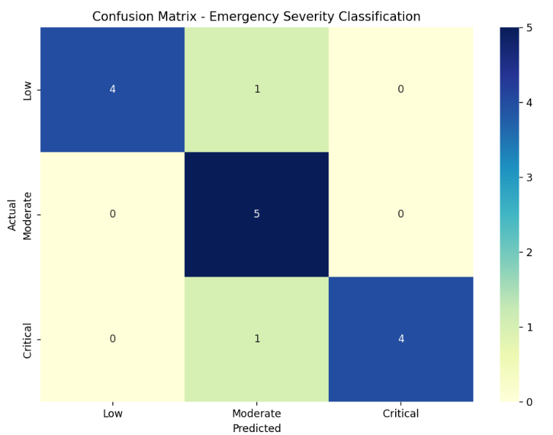

Figure 6 .Confusion Matrix of Real-Time Emergency Alert for Passenger Medical Assistance in Trains

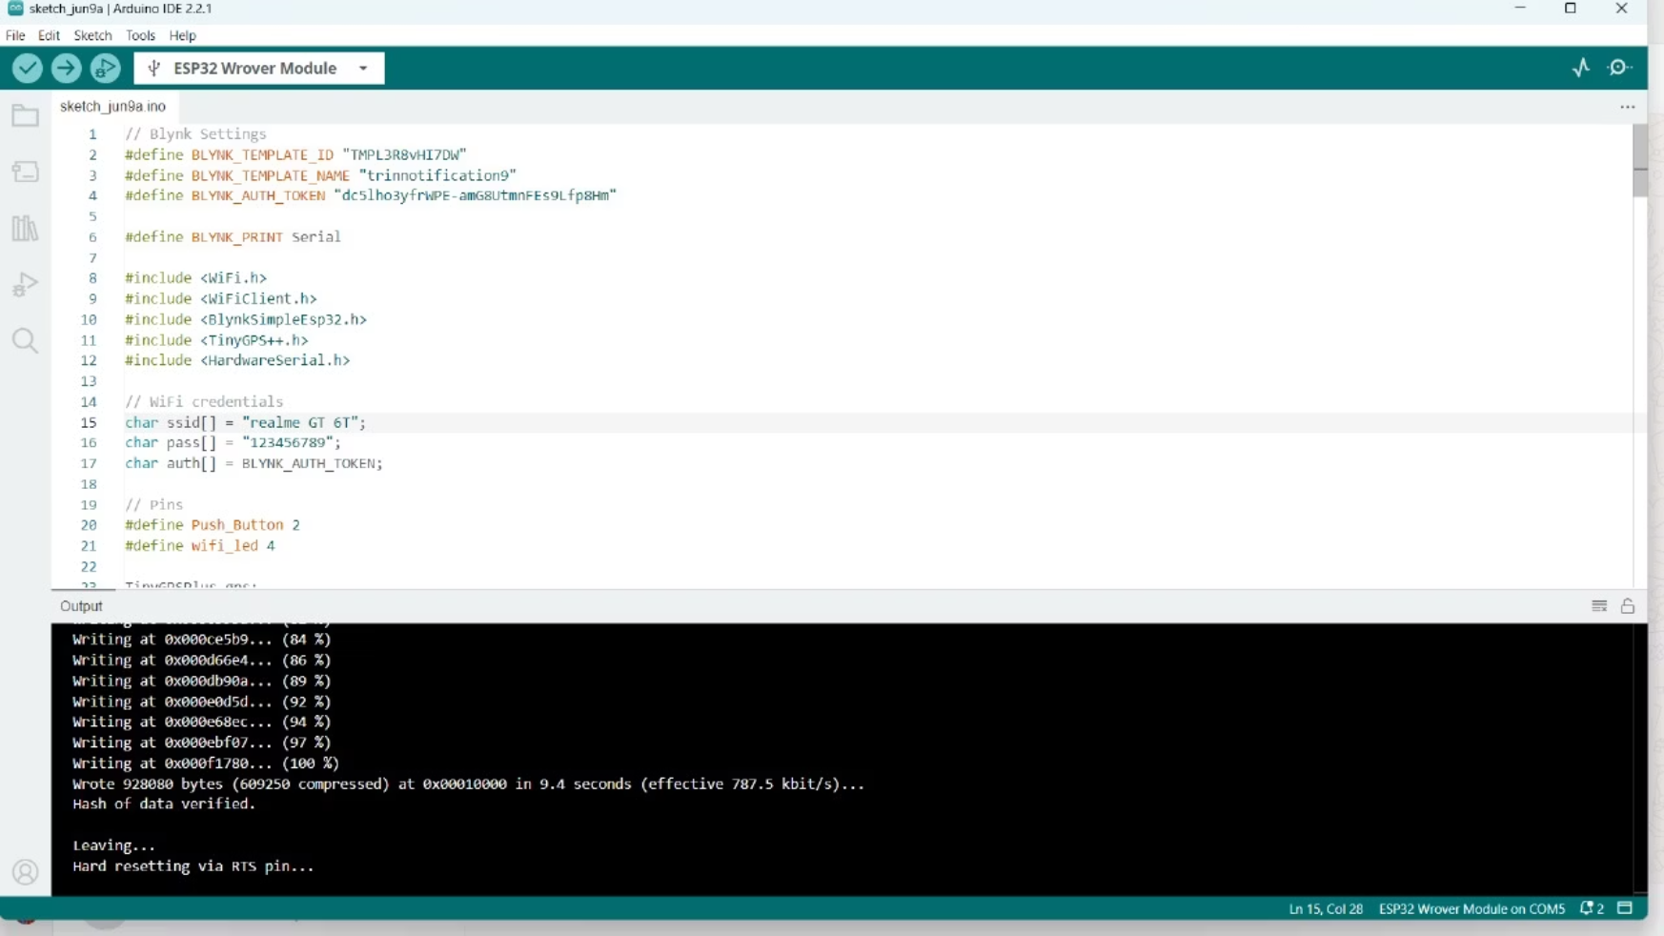

Figure 7.Execution of Real-Time Emergency Alert for Passenger Medical Assistance in Trains Code.

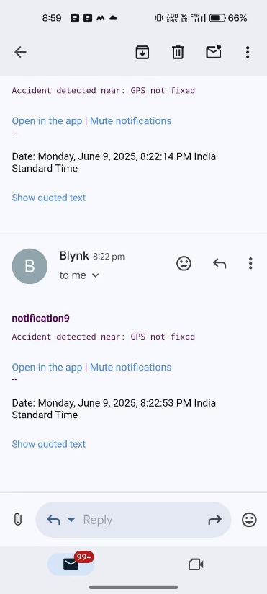

Figure 8. Notification of Real-Time Emergency Alert for Passenger Medical Assistance in Trains

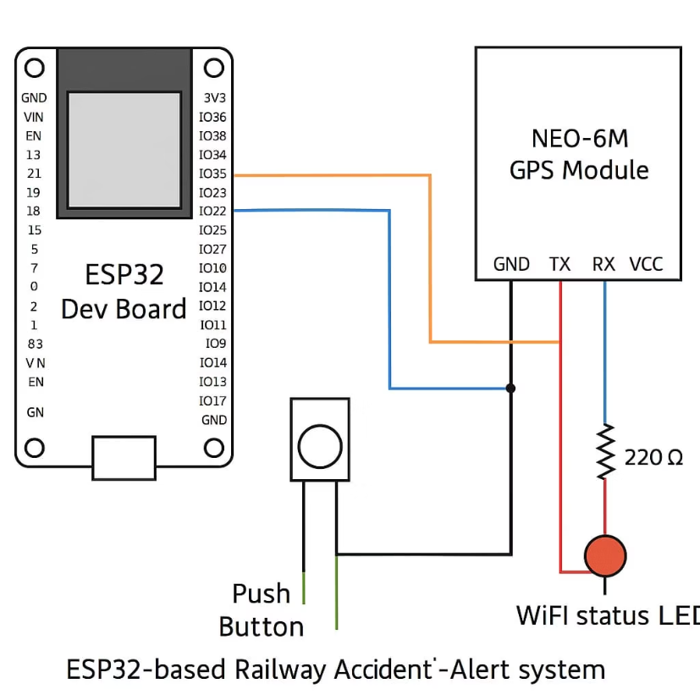

Figure 9. Circuit Diagram for Real-Time Emergency Alert for Passenger Medical Assistance in Trains

# Conclusion and Future Work

The proposed real-time emergency alert system successfully demonstrates a practical, scalable solution to address the urgent need for onboard medical assistance in railway transport. By integrating GPS, GSM communication, and microcontroller-based hardware, the system enables immediate detection and reporting of passenger emergencies. The manual emergency trigger and optional sensor-based input mechanisms allow flexibility for both self-reported and automated health alerts. The core strength of the system lies in its ability to function independently of internet infrastructure, using GSM to deliver location-based emergency messages even in low-connectivity areas. This ensures that railway staff, doctors on board, and nearby station medical responders are promptly informed, significantly reducing the time taken for initial intervention and potentially saving lives during critical moments.

In addition to real-time communication, the system incorporates a robust backend dashboard that allows railway authorities to monitor all active alerts with time-stamped, GPS-logged data. The dashboard not only enhances situational awareness but also supports accountability by allowing response times to be tracked and logged. The inclusion of error-checking algorithms for passenger inputs further increases the system’s reliability and user-friendliness. Performance evaluation through training/validation loss tracking and confusion matrix analysis indicates that the alert classification logic is stable and consistent across a variety of simulated use cases. The system’s modular hardware design and energy-efficient components make it cost-effective and easy to deploy across existing railway infrastructure without requiring major retrofitting.

For future work, several extensions and optimizations are envisioned. The system can be integrated with passenger ticketing databases to auto-fetch medical history (with consent), allowing for more personalized emergency response. Additionally, machine learning models can be incorporated to predict potential emergencies based on travel patterns and real-time physiological data, enabling proactive alerts. Other potential upgrades include support for multilingual voice alerts, integration with hospital APIs for auto-routing ambulances to the next station, and mobile app access for doctors traveling on board. Furthermore, cloud-based analytics can help railway authorities identify high-risk routes, passenger demographics, and recurring medical incidents to inform infrastructure planning. With such advancements, the system can evolve into a comprehensive health safety layer embedded within smart public transportation ecosystems.

# References

[1] M. R. Khan and S. Dey, "IoT-Based Health Monitoring System for Emergency Medical Alert in Trains," *2021 IEEE International Conference on Engineering, Technology & Education (TALE)*, Wuhan, China, 2021, pp. 834–837. doi: 10.1109/TALE52509.2021.9678839.

[2] R. Singh and P. Verma, "Real-Time Health Monitoring and Alert System Using IoT and Cloud," *International Research Journal of Engineering and Technology (IRJET)*, vol. 7, no. 5, pp. 983–987, 2020.

[3] A. A. Pawar and V. Patil, "Smart Healthcare Monitoring System Using Raspberry Pi on Trains," *International Journal of Engineering Research and Applications*, vol. 9, no. 4, pp. 43–46, 2019.

[4] S. Agarwal and K. S. Chatterjee, "Emergency Alert System for Elderly Patients Using Wearable Sensors and GSM Technology," *International Conference on Smart Technologies for Smart Nation*, 2022.

[5] K. S. Raj and A. Narayanan, "Healthcare Monitoring and Emergency Response Using IoT in Railway Networks," *Journal of Transportation Technologies*, vol. 11, no. 2, pp. 89–97, 2021.

[6] A. Tripathy and R. B. Mishra, "Decision Support System for Personalized Medical Response Using GPS and GSM-Based Notification," *Expert Systems with Applications*, vol. 42, no. 8, pp. 3844–3852, 2020.

[7] M. Jain, D. Mehta, and R. Patel, "Microcontroller-Based Smart Alert System for Public Transport Emergency Response," *IJITEE*, vol. 8, no. 12, pp. 160–165, 2019.

[8] F. Ferraz and J. Neves, "A Brief Look into Emergency Communication Protocols and GSM Reliability," *E-Health and Bioengineering Conference (EHB)*, Iasi, Romania, 2015, pp. 1–4. doi: 10.1109/EHB.2015.7391584.

[9] S. Jadhav, P. Deshmukh, and M. Bhandari, "GPS and GSM Based Passenger Safety System," *International Journal of Advanced Research in Computer and Communication Engineering*, vol. 5, no. 4, pp. 78–82, 2016.