BUSINESS REQUIREMENT DOCUMENT

PROJECT GROUP : 1 (FlatFam)

**Prepared By**: B N Sai Praveen and Himanshu Prasad

**Date**: 30-04-2025

**PROBLEM STATEMENT 1** : In many residential communities, residents often rely on outdated methods of communication, such as paper notices on bulletin boards, emails, or word of mouth, to stay informed about important updates. For instance, a neighborhood might need to notify residents about a planned water shutoff, a scheduled community clean-up day, or an upcoming neighborhood watch meeting. These traditional methods can result in missed information or delayed updates, leading to confusion and frustration among residents. For example, if a community event is announced via email but a resident doesn't check their inbox regularly, they might miss the event entirely. This lack of effective communication can contribute to a sense of disconnection and dissatisfaction within the community.

# PROJECT OVERVIEW

FlatFam is designed to streamline communication within residential communities, replacing outdated methods (like bulletin boards and emails) with a centralized digital platform. Residents will receive timely notifications, emergency notifications, event information, and more. The system will support user management (residents and admins) and enable interactions through surveys, notifications,chats and community updates.

**Key Technologies**:

* + Backend: ASP.NET Core Web API
  + Frontend: Angular
  + Additional Integrations: GeoAplify Map API.

# BUSINESS OBJECTIVE

The primary objective of FlatFam is to streamline communication between residents and administrators by providing a centralized platform for seamless interactions. With a real-time notification system, administrators can efficiently manage announcements and updates, ensuring residents are always informed. The platform also aims to improve community engagement through interactive features such as event management. By integrating tools like the Events API , FlatFam fosters participation and enables residents to voice their opinions effectively. Additionally, it ensures timely delivery of critical updates, announcements, and emergency alerts, enhancing safety and awareness within the

community. An efficient complaint-handling system further strengthens trust and accountability by allowing residents to report issues transparently and track their resolution status. Together, these objectives create a connected, participatory, and informed residential environment.

# Stakeholders

## Residents:

Residents are the primary end-users of the FlatFam platform. They interact with the system to receive real-time notifications about events, announcements, and emergency alerts, ensuring they stay informed about important community updates. Residents can actively participate in events by joining them through the Events API. Additionally, the platform provides them with an efficient channel to submit complaints and feedback directly to the administration, creating a sense of transparency and inclusion. By catering to their communication needs, FlatFam empowers residents to be active participants in their community’s growth and management.

## Community Administrators:

Community administrators play a pivotal role in managing the platform's functionality and ensuring its effective operation. They use the system to create and manage events, send timely notifications. The administrators also handle complaint submissions, addressing them promptly to maintain trust and accountability within the community. With FlatFam’s intuitive tools, administrators can streamline their responsibilities, reduce communication delays, and foster a more engaged and organized residential environment. This makes their tasks more efficient while promoting transparency and resident satisfaction.

## Functional Requirements

* Authentication API
  + Purpose: The Authentication API will secure the application by handling user registration, authentication, and authorization. Using JWT (JSON Web Token) for secure, stateless sessions, it will validate user credentials and issue tokens to manage access across different functionalities in the application
  + Primary Functions:
    - User Registration and Login: Capture and validate resident information during registration and manage credentials.
    - Token Management: Issue and validate JWT tokens, enabling users to access secured resources like event details, notifications, and personal settings.
    - Role-Based Permissions: Establish permissions for different user roles (e.g., resident, admin, security staff), ensuring only authorized users can access and perform specific actions.
* Events API:
  + Purpose The Events API will facilitate the scheduling, management, and display of community events within the FlatFam platform. By providing real-time updates on upcoming events, residents can stay informed about gatherings, meetings, and other community activities.
  + Primary Functions :
    - Event Creation and Management: Admins can create, update, and delete events while specifying event details such as location, time, and description.
* Public API – GeoApify Map API:
  + Purpose:

Enhance user experience with real-time, location-based search.

Help residents easily find essential services (e.g., hospitals, restaurant).

Improve accessibility and convenience within residential communities.

Integrate global location data into society management systems.

* + Primary Functions:
    - Fetch nearby places based on selected location and category.
    - Support search for diverse place types (e.g., restaurants, hospitals).
    - Return structured data including name, coordinates, and categories.
    - Display results on interactive maps for easy visualization and navigation.
    - Utilize global geospatial coverage for accurate and reliable results.
* Communication API:
  + Purpose: The Communication API will manage real-time messaging, notifications, and complaint submissions. This API will be central to the responsive interaction between residents and admin/security personnel.
  + Primary Functions:
    - Notification Management: Generate and send notifications for general announcements, event updates, maintenance alerts, and emergency messages.
    - Complaints: Enable residents to submit complaints, with admin personnel able to review and update request status.

# System Architecture

The architecture of the FlatFam platform is designed with scalability, modularity, and efficiency in mind, ensuring seamless communication and functionality across its various components. The frontend, built using Angular 18 and styled with Bootstrap, delivers a responsive and user-friendly interface for both residents and administrators. It supports dynamic features such as real-time event lists, notifications, and complaint forms, enabling smooth interactions without requiring page reloads. The backend, developed with ASP.NET Core Web API, handles

business logic, integrates external services like Geoapify Map API. A SQL Server database serves as the central repository, storing user data, events, notifications, and complaints while maintaining data integrity. Together, these layers create a robust architecture that facilitates efficient communication, real-time updates, and a streamlined user experience.

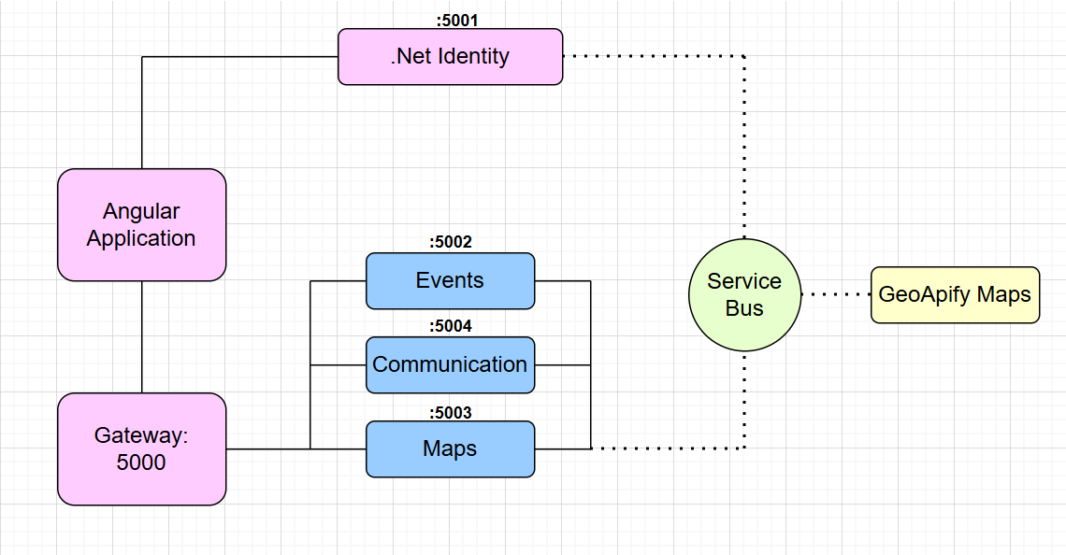

# Constraints

The development of FlatFam operates within several constraints to ensure efficient delivery and functionality. From a technology perspective, the platform is limited to Angular 18 for the frontend, ASP.NET Core for backend logic, and SQL Server for database management. These tools were selected to align with the project’s technical requirements and team expertise, but they also restrict the integration of alternative frameworks or tools.. Any changes or disruptions in these APIs could impact certain features of the platform. Finally, the project must be delivered within a specified timeframe, which necessitates efficient planning, strict adherence to milestones, and prioritization of essential features to meet deadlines without compromising quality.

# Database Schema Overview

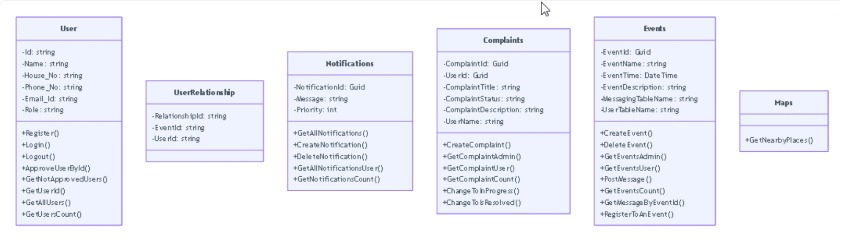

1. **WorkFlow**

The workflow of FlatFam is designed to ensure seamless interaction for both users and administrators. For users, the journey begins with registration or login through the Authentication API, providing secure access to the platform. Once logged in, users receive real-time notifications about events, announcements, or emergencies. They can explore and join events, as well as submit complaints using an intuitive interface.

For administrators, the workflow emphasizes efficient management. Admins log in to handle events, notifications, and complaints through dedicated modules.

