- Team Name
AutoSpeed

2. Project Title
A Novel Method to interface Launchpad and Android for Automated Vehicle Speed Management.

3. Proposal
Nobody in the modern world wants to waste their time by obeying speed limits. They fail to understand that the consequences of an accident due to over speeding might be greater than the time they thought they might save.
Thus by applying few of the modern technologies together, a solution to the ever haunting problem of road accidents and deaths was found. The precious life of the driver and passenger can be saved for years to come with minimal investment.
Hence we present our innovation called AutoSpeed - A device that is capable of saving your life while you enjoy your drive.

4. Description
AutoSpeed interfaces an Android based mobile phone with MSP430 Launchpad along with other required sensors to automatically control the speed of the vehicle in accordance with the speed limit of that particular locality.
This is a closed loop control system where the control variable is velocity of the vehicle. The front wheel of the vehicle is fitted with a magnets. A Hall Effect sensor mounted on the front shock absorber outputs pulses proportional to the vehicle speed. This is the feedback signal for the control system for accurate processing.
The current location of the vehicle is refreshed every second and fed to Launchpad via Bluetooth from a GPS/GLONASS inbuilt Android phone running a custom written application.
The Launchpad is programmed with a database of the speed limits of various geographical locations. Thus according to the current location and speed of the vehicle the Launchpad decides whether to control the speed or not.
A potentiometer inbuilt accelerator (E-bike accelerator) feeds the throttle demand of the driver to the Launchpad. If the vehicle is in a speed limited zone and the vehicle speed is greater than the speed limit then the speed is controlled by PWM signals sent to the high torque servo motor connected to the accelerator cable which in turn is attached to the carburetor.
On the contrary if the vehicle speed is less than the speed limit or if it is in an unrestricted zone, the driver’s demand is directly transferred to the servo motor.

5. Block Diagram
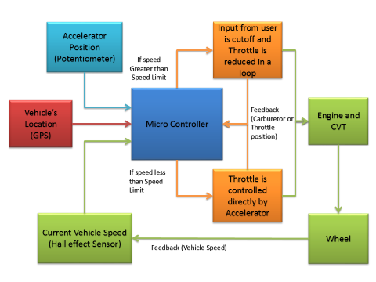
6. High Level Schematic

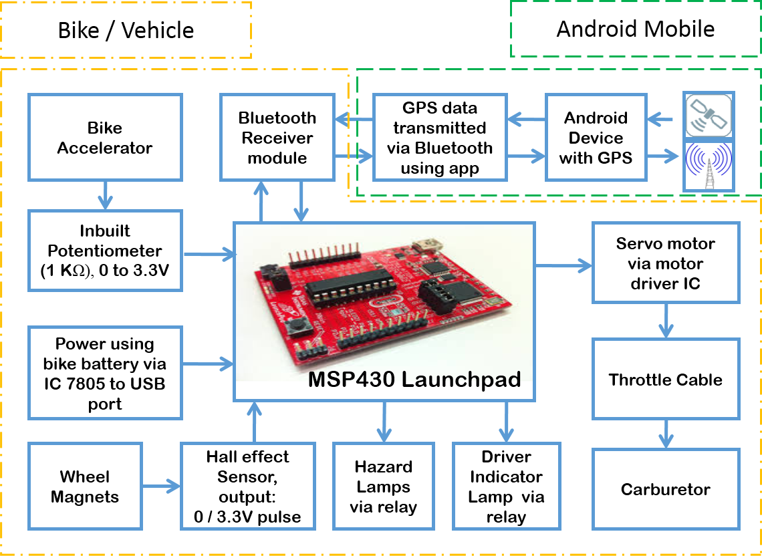
7. Why do you think your solution is unique?
AutoSpeed is the beginning in automatic speed regulation for 2 wheelers in India. It provides a cost effective solution and is developed with a frugal engineering approach of minimizing the number of hardware used while maximizing the possibilities and usage.
AutoSpeed is also a future proof device as it is not designed to be a standalone device. Since it is connected through the Android app to a smartphone and, the accuracy, speed and features of which is constantly updated as the years move, the firmware of AutoSpeed can also be updated to maximize the utilization of the smartphone and also introduce new and better features in future.
AutoSpeed is not only a concept but is also a prototype that is currently being tested for its robustness and responsiveness using a Honda Activa.
Initial testing results are positive and the device is responsive enough to be used for general driving.
AutoSpeed is also equipped with other safety features for the user like automatic real time location reporting in case of an emergency to alert Emergency services like hospitals and ambulances. And also vehicle immobilizer and vehicle tracking in case of theft.

