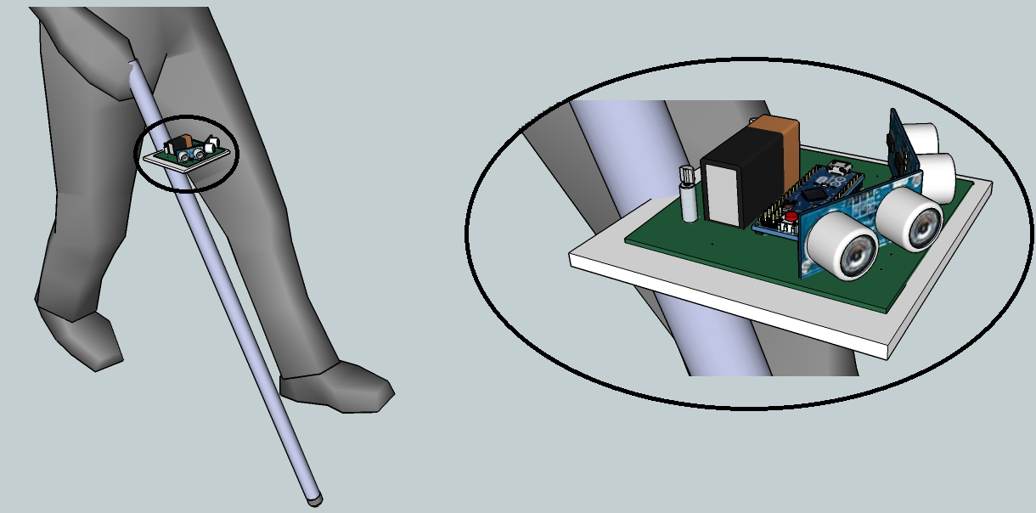

Intelligent walking stick for the blind CHILDREN

By: Saipreethi and Saran (X Standard)

For the CBSE Science exhibition – Material for Children with visual impairment.

September 2, 2013

Table of Contents

Objective 1

Scientific Principle Involved 1

Materials used 2

Arduino 2

Ultrasonic sensors 3

Printed circuit board 3

Vibration motors 4

Other miscellaneous uses 5

Battery 5

Walking stick 5

Ball castor 6

# Objective

The aim of this project is to help the visually impaired children to cope up with the physical environment and traverse easily without any guidance, both indoors and outdoors.

# Scientific Principle Involved

Ultrasonic waves are very high frequency waves of the order of greater than 20000 Hz. These are sound waves that get reflected very similar to the ordinary audible sound waves and produces echoes. Due to its very high frequency ultrasound has much greater penetrating power than ordinary sound which makes it a good option to detect any object/obstacle. And if audible sound waves are used it would annoy the people or animals near-by. But humans cannot hear the sound waves in the ultrasonic frequencies which makes it a suitable candidate for numerous applications.

SONAR stands for Sound Navigation and Ranging, this is the technique used in ships and submarines to locate any object underneath the ocean and to map the ocean floor. In this process ultrasonic waves are transmitted and the time taken for the wave to reach back is computed, with which the distance between the obstacle and the ship/submarine is calculated. This data helps the captain to traverse around the obstacle without a problem.

Bat, a bird species also utilizes this sonar phenomenon to travel around in the night and catch its prey. It has a lack of vision and flies only at night, because of which it depends entirely on the ultrasonic waves that it emits to check for obstacles.

SONAR apparatus essentially has an ultrasonic transmitter and a receiver. The transmitter essentially transmits ultrasonic waves and if there is an obstacle in the path the waves get reflected back and the receiver senses this. The time taken or the duration between the transmission and reception is computed and used as below to get the distance.

Let the time taken = T seconds

Velocity of sound = 340 meter/second

Velocity = Distance / Time

Distance = Velocity X Time

Thus the distance between the apparatus and the obstacle would be = (340 X T) meters

# Materials used

### Arduino

This is an open source embedded platform for building projects that require a microcontroller. It is used by both students and experts alike in numerous projects around the globe. It is accompanied with an easy to code software named arduino.

There are many different arduino boards available, out which arduino micro was chosen to be the best for its compactness and efficiency. It uses a microcontroller named atmega and a microcontroller can be assumed to be a miniature sized computer with all the memory and input output ports fabricated into a single monolithic integrated circuit (IC).

Arduino micro can be programmed easily using the arduino software and a connecting USB cable.

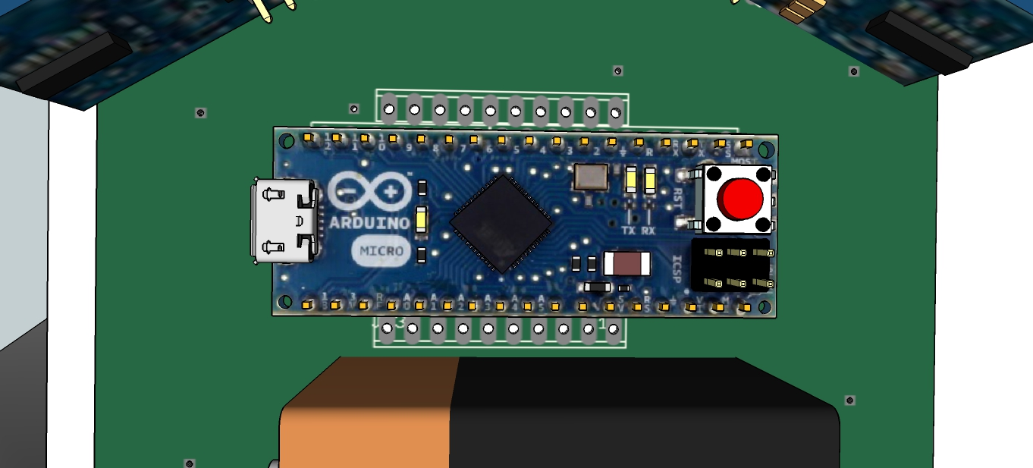

### Ultrasonic sensors

This is a transreciever that is used to transmit and receive the ultrasonic waves. These are used to implement the principle of sonar.

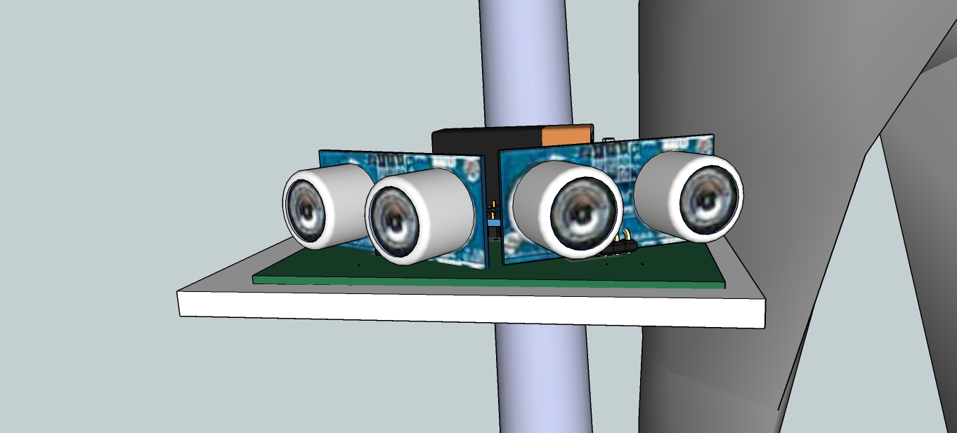

We have employed two ultrasonic sensors in our project to detect obstacles in both the directions.

The ultrasonic sensor also termed as a ping sensor measures distance using sonar concept, by which an ultrasonic pulse is transmitted from the unit and the distance to target is determined by measuring the time required for the echo to return. Output from the ping sensors is a variable width pulse that corresponds to the distance from the target. It easily interfaces with the arduino micro.

Thus the arduino micro sends in an output pulse that corresponds to the triggering of the ping transmitter and when an input is received from the environment the receiver sends a signal to the arduino micro which in-turn helps to calculate the time interval that aids in calculating the distance as explained before.

### Printed circuit board

The printed circuit board is the base of the apparatus that helps hold together all the various components from the sensors to the microcontroller board. It has all the wire connections build in to it as copper tracks.

The printed circuit board usually abbreviated as PCB was designed using easily applicable graphic layout editor software. The usual process involves etching these designed tracks onto the copper clad epoxy sheet.

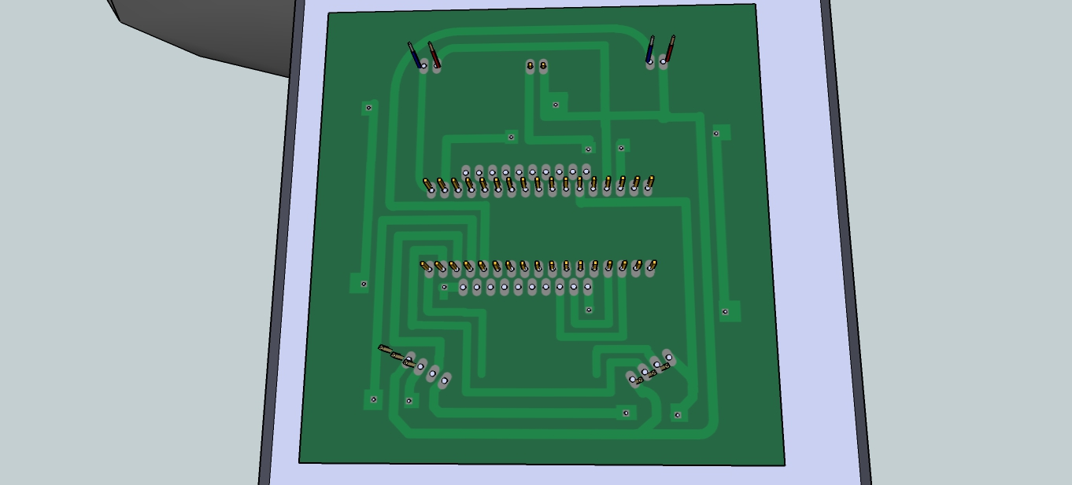

### Vibration motors

These are miniature sized motors that produce vibration when triggered with a supply. These motors are special as the have an unbalanced load on their shaft. We have employed two of these motors to signal the user about the objects/obstacles on either sides. That is when an obstacle is detected by the ultrasonic sensor on to the right the microcontroller sends in a signal to the right side vibration motor and vice versa.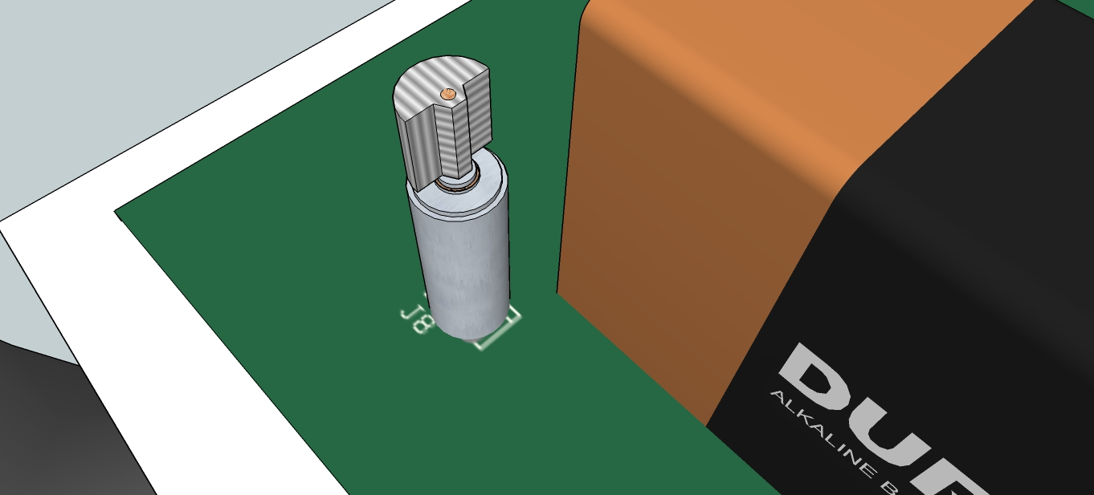

### Other miscellaneous uses

### Battery

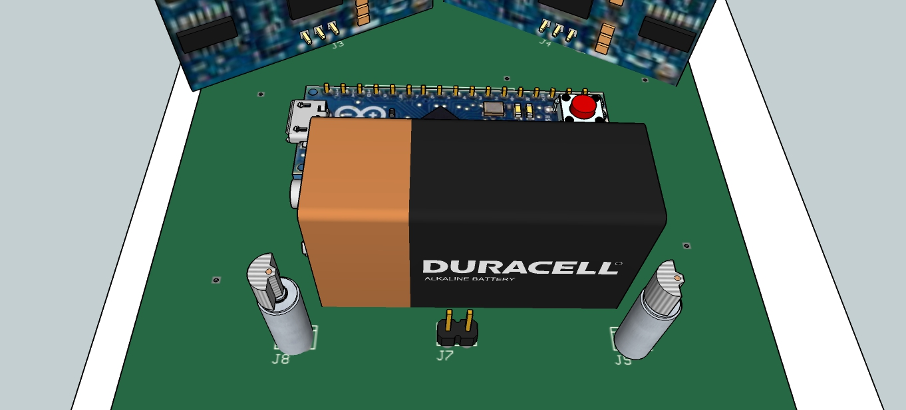

### Walking stick



### Ball castor

