Taxi Trip Duration Analysis

Kishor Kumar Andekar Computer Science

University of Central Missouti Overland Park, Missouri [kxa47130@ucmo.edu](mailto:kxa47130@ucmo.edu)

Sai Preetham Nagaswaram Computer Science

University of Central Missouti Overland Park, Missouri [sxn33500@ucmo.edu](mailto:sxn33500@ucmo.edu)

Pondugula Niteesh Kumar Computer Science

University of Central Missouti Overland Park, Missouri [nxp32580@ucmo.edu](mailto:nxp32580@ucmo.edu)

Rohith Reddy Pinninti Computer Science

University of Central Missouti Overland Park, Missouri [rxp93930@ucmo.edu](mailto:rxp93930@ucmo.edu)

***Abstract*— The accurate estimation of taxi trip durations is a crucial and complex task in modern urban settings. This has significant implications for various parties involved, such as passengers, taxi companies, and urban planners. Predicting urban transport dynamics is a challenging issue due to the intricate interplay of factors such as traffic patterns, weather conditions, and urban infrastructure. This study utilizes sophisticated deep learning techniques to create a prediction model that seeks to provide accurate estimates of taxi travel durations, hence improving operational effectiveness and consumer contentment.**

**This research examines the utilization of various deep learning approaches, such as Sequential Neural Networks, Dense Layers, Dropout Regularization, BatchNormalization, and the Adam Optimizer, by utilizing historical cab trip data. The selection of these methods is based on their efficacy in addressing regression tasks and their capacity to represent intricate, non- linear connections that are inherent in urban traffic data.**

**The proposed model incorporates these strategies to handle inputs such as pickup and dropoff locations, time stamps, and passenger counts, with the goal of accurately capturing the subtle differences in trip durations. The model is meant to offer resilience against overfitting and ensure efficient training dynamics by using dropout layers and batch normalization. In addition, the utilization of an EarlyStopping callback guarantees that the process of training the model is optimized to avoid overfitting and achieve optimal generalization on unknown data.**

**The practical ramifications of precise trip duration estimations are significant. For taxi operators and ride-sharing services, this entails utilizing optimized routing techniques to enhance service reliability. For passengers, this means an increase in service satisfaction due to accurate journey time predictions. Urban planners can apply these observations to enhance traffic control and infrastructure construction, resulting in more knowledgeable and efficient urban mobility policies.**

**This research makes a valuable contribution to the academic field by using deep learning to solve a hard real-world problem. Additionally, it offers a framework that stakeholders in the transportation industry may use to enhance operational efficiencies and improve customer service experiences. This project seeks to establish a standard for accurately predicting the duration of urban taxi trips by conducting thorough experiments and analysis. It aspires to demonstrate the transformative potential of deep learning in the field of urban transportation analytics.**

***Keywords— Deep Learning, Taxi Trip Duration, Urban Transportation, Predictive Modeling, Traffic Data Analysis, Neural Networks, Operational Efficiency***

1. Introduction

The accelerated development of cities worldwide has resulted in a heightened reliance on effective transportation systems. Taxis are an essential element of urban transportation and have a significant impact on the daily commute of millions of people. Comprehending and forecasting the length of taxi journeys is not only convenient but also essential for effectively controlling traffic, optimizing taxi services, and improving passenger contentment. Precise journey time forecasts have become increasingly important due to the rise of ride-sharing services and the growing competitiveness in the transportation sector [1].

The importance of precisely forecasting the durations of taxi trips extends across multiple aspects. Firstly, it improves the operational efficiency of taxi services. Taxi businesses can enhance their dispatch systems, minimize passenger waiting times, and optimize their routes by precisely forecasting trip times. This can result in fuel savings and reduced operational costs [2]. Furthermore, precise forecasts are essential for the strategic development and administration of urban infrastructure. In urban settings, traffic congestion is a prevalent problem that can be more effectively controlled if authorities are able to anticipate and thereby alleviate the variables that contribute to travel delays [3].

Moreover, the level of predictability in taxi journey durations has a direct influence on client happiness. Providing passengers with accurate predictions of travel durations enhances their pleasure with the service, resulting in increased customer loyalty and improved evaluations for the service providers. The predictability of outcomes is especially crucial in the current era of digital technology, as consumer feedback has a substantial impact on how service quality is perceived [4].

The challenge in forecasting taxi trip durations stems from the ever-changing characteristics of metropolitan surroundings. Several variables, including traffic congestion, road accidents, weather conditions, and special events, can significantly impact journey durations. Conventional models frequently fail to capture these intricacies because they are unable to handle vast amounts of data and adjust to changing circumstances [5][6].

Deep learning presents a potential solution to these difficulties. Deep learning models are well-suited for dealing

https://github.com/Saipreethamnagaswaram/FINAL-INCREMENT

with the geographical and temporal variability found in urban traffic data due to their capacity to acquire high-level abstractions from the data [7][8]. These models have the capability to combine different data sources, such as GPS data from taxis, traffic sensor data, and social media feeds, in order to produce precise predictions about the duration of taxi trips [9][10].

Considering these factors, the examination of taxi journey duration through deep learning serves both a practical purpose and adds to the wider realm of intelligent transportation systems. By enhancing our comprehension and prognostic capacities about urban mobility, we can make significant progress towards creating more sustainable and efficient urban environments [1][12].

1. *Challenges in Urban Transportation Modeling*

Forecasting the durations of cab trips in metropolitan regions has numerous difficulties that arise from the fundamentally intricate and ever-changing characteristics of urban environments. Taxi journey times are unpredictable because to the distinct infrastructure, traffic patterns, and socio- economic behaviors seen in each location. In this article, we will examine the main difficulties faced while modeling urban transportation networks.

* 1. *Dynamic Traffic Conditions*

The traffic conditions in metropolitan areas are quite unpredictable and are affected by various factors, including the time of day, weather conditions, road construction, accidents, and local events. These variables have an impact on the velocity and movement of vehicles, thereby influencing the duration of taxi trips. Conventional models frequently face difficulties in adjusting to these swift changes, hence posing a challenge for real-time prediction [13][14].

* 1. *Data Complexity and Volume*

Urban transportation systems produce huge quantities of data from many sources such as cab GPS trails, traffic cameras, sensors, and mobile devices. The large quantity and diverse nature of this data present major difficulties in terms of data processing, storage, and analysis. To effectively manage this large volume of data, guarantee its accuracy, and extract valuable characteristics, it is necessary to employ advanced data processing pipelines and resilient analytical frameworks. The user's text consists of references to sources 15 and 16.

* 1. *Spatial and Temporal Dependencies*

The duration of a taxi ride is governed not only by the conditions at the beginning of the trip but also by the conditions experienced along the route. The presence of geographical dependency, along with temporal parameters such as time-of-day and day-of-week impacts, introduces additional levels of intricacy to the prediction models. To correctly capture these dependencies, sophisticated modeling techniques are needed that can simultaneously account both spatial and temporal dimensions [17][18].

* 1. *Scalability and Generalizability*

Creating scalable models that can be applied to varied urban environments and adapted to different data forms and characteristics is a major issue. Models trained on data from

one city may exhibit poor performance in another city due to variations in urban layouts, transportation policy, and cultural factors that influence travel behavior [19][20].

* 1. *Integration with Real-Time Systems*

The incorporation of predictive models into real-time operating systems poses technical and practical difficulties. These systems need to possess both accuracy and speed, as well as reliability, in order to provide real-time forecasts that are valuable for dynamic dispatching systems and real-time traffic management [21][22].

* 1. *Regulatory and Privacy Concerns*

The utilization of data for forecasting the duration of taxi trips also gives rise to problems surrounding privacy and safeguarding of data. Adhering to local rules and regulations and safeguarding persons' privacy are essential for the ethical utilization of predictive models in urban transportation [22][23].

To tackle these difficulties, a multi-disciplinary strategy is necessary, integrating knowledge from data science, urban planning, transportation engineering, and computer science. By surmounting these obstacles, predictive models can greatly enhance the effectiveness and durability of urban transportation systems.

1. *The Role of Deep Learning in Traffic Prediction*

Utilizing deep learning in traffic prediction offers a revolutionary method for tackling the intricacies and fluctuations of urban transportation systems. Deep learning, a kind of machine learning, is highly proficient at recognizing patterns and making predictions from extensive datasets, especially those that involve intricate and non-linear connections. This section examines the suitability of deep learning for modeling cab trip durations and highlights the advantages it provides compared to conventional statistical methods.

* 1. *Modeling Complex Interactions*

Deep learning networks, particularly those with numerous hidden layers, have the ability to represent the complex relationships among different factors that affect traffic conditions. This encompasses the interplay of temporal parameters (such as time of day and day of the week), spatial variables (such as pickup and dropoff locations), and external stimuli (including weather conditions and local events). Deep learning models can enhance the accuracy and dependability of predictions by capturing intricate interactions [1][3].

* 1. *Handling High-Dimensional Data*

Urban transportation networks produce data with a large number of dimensions, which includes many elements that have the potential to affect the duration of taxi trips. Deep learning algorithms excel at handling data with many dimensions, extracting important characteristics without the need for substantial feature engineering as required by classic models. Convolutional neural networks (CNNs) and recurrent neural networks (RNNs) have the ability to automatically identify and exploit the most significant characteristics in the data [5][7][9].

* 1. *Learning Temporal Patterns*

Temporal trends are essential for accurately predicting the duration of taxi trips, as both traffic flow and taxi demand can change dramatically at different times of the day and week. Deep learning models, such as Long Short-Term Memory (LSTM) networks, are highly efficient at capturing temporal dependencies. LSTMs possess the ability to acquire knowledge of significant occurrences in the past and their impact on future events, rendering them well-suited for problems involving the prediction of time series, such as estimating the duration of taxi trips [6][8][12].

* 1. *Adaptability and Continuous Learning*

A notable benefit of deep learning models is their capacity to consistently acquire knowledge and adjust to novel data. The adaptability of models to real-time or near-real-time changes in urban traffic situations is crucial. Deep learning models have the ability to be adjusted or refined when fresh data becomes accessible, guaranteeing that the forecasts stay precise as time goes on [10][14].

* 1. *Scalability*

Deep learning models exhibit excellent scalability, enabling them to effectively manage the growing amount of data as metropolitan areas develop and additional data sources become accessible. Scalability is crucial for creating models that can be used in various locations or modified to incorporate more sources of data, such as social media feeds or real-time traffic sensor data [1][13][15].

* 1. *Integration with Real-Time Systems*

Integrating deep learning models into real-time traffic control and taxi dispatch systems can greatly improve operational efficiency. These models can enhance routing decisions, minimize waiting times, and enhance overall traffic flow by offering precise and timely predictions. The numbers 16, 18, and 20 are enclosed in square brackets.

To summarize, deep learning provides a robust toolkit for addressing the complexities of urban traffic prediction. The capacity to acquire knowledge from extensive datasets, identify intricate patterns, and adjust to novel information renders it highly suitable for forecasting the lengths of cab trips in dynamic metropolitan settings. As these technologies progress, they hold the potential to greatly enhance the effectiveness and environmental friendliness of urban transportation networks.

1. *Scope of the Study*

The objective of this project is to create and verify a deep learning model that can precisely forecast the duration of taxi trips in urban areas. This undertaking encompasses many crucial elements that establish the limits and goals of the study, guaranteeing a concentrated and efficient exploration of the utilization of deep learning methods for modeling urban transportation.

* 1. *Geographic Focus*

The study largely concentrates on a particular urban area, utilizing comprehensive taxi trip data from this locality. This enables a focused examination of urban mobility patterns that are specific to the chosen city, offering valuable insights that are highly pertinent to its own traffic and infrastructural

attributes. The selection of the city is determined by the presence of extensive and top-notch taxi trip data [1][2].

* 1. *Data Sources*

The main data source for this study consists of the historical records of taxi trips, which contain information such as the locations where passengers were picked up and dropped off, the duration of the trips, the timestamps, and the number of passengers. Furthermore, supplementary data sources such as weather conditions, traffic incident reports, and urban event schedules are incorporated to analyze their influence on taxi journey durations. Utilizing a variety of data sources is essential for accurately capturing the complex and diverse character of urban transportation dynamics [3][4].

* 1. *Deep Learning Techniques*

This study investigates and applies various deep learning methods, such as Sequential Neural Networks, Dense Layers, Dropout Regularization, Batch Normalization, and the utilization of the Adam Optimizer. The selection of these strategies is based on their established efficacy in addressing regression tasks and their ability to accurately represent the intricate, non-linear associations observed in traffic data [5][6][7].

* 1. *Model Training and Validation*

The building of the predictive model entails meticulous training, testing, and validation procedures. The model is trained on a significant portion of the gathered data, validated using cross-validation methods, then tested on new data to assess its predicted accuracy and capacity to generalize. This methodical methodology guarantees that the model is sturdy and dependable in practical situations [8][9].

* 1. *Outcome Measures*

The main objective of this study is to determine the accuracy of the projected lengths of cab trips. This will be evaluated using metrics such as Mean Absolute Error (MAE) and Root Mean Squared Error (RMSE). These metrics offer measurable indicators of model performance and are crucial for assessing the success of the deep learning techniques used [10][1].

* 1. *Implications and Applications*

The ramifications of this research are extensive and noteworthy. Precisely forecasting the durations of taxi trips can boost the efficiency of taxi operations, increase passenger pleasure, and provide valuable insights for urban planning and traffic management. Moreover, the discoveries and approaches employed in this research can be relevant to other domains of intelligent transportation systems and can be modified for implementation in different urban locations or modes of transportation [12][13].

* 1. *Contribution to Knowledge*

This study enhances the current knowledge by utilizing cutting-edge deep learning methods to address a challenging real-world issue. This study enhances our comprehension of the effective utilization of deep learning in predicting the durations of urban taxi trips. It also establishes a basis for future research in this field [14][15].

Ultimately, this study's extent is determined by its geographical concentration, data origins, advanced machine learning methods, meticulous model verification procedures, well-defined outcome metrics, and the wide-ranging significance of its discoveries. This comprehensive strategy guarantees a meticulous investigation into the capacity of deep learning to improve urban transportation networks.

1. Motivation

The swift urbanization of cities has resulted in heightened intricacy in transportation networks, where the anticipation of cab journey lengths has emerged as a crucial obstacle with substantial consequences. Precisely forecasting the duration of a taxi journey in different urban circumstances can greatly optimize taxi operations, enhance client pleasure, and assist in efficient city planning. At now, both passengers and service providers are faced with the challenge of dealing with the unpredictability of travel durations, which can have an impact on scheduling, fare calculations, and the general dependability of taxi services. Furthermore, urban planners and traffic control authorities necessitate accurate data to make well-informed decisions pertaining to traffic regulation, road construction planning, and public transportation requirements. The rationale behind this research is driven by the capacity of deep learning approaches to tackle these difficulties by acquiring knowledge from intricate, multi-dimensional datasets, providing valuable insights that conventional models may overlook. This study attempts to create a predictive model using advanced deep learning frameworks that will utilize past taxi trip data to properly estimate travel times. This not only promotes operational efficiency but also improves the travel experience for a large number of urban people, making it a crucial study in the subject of urban transportation.

1. Main Contributions & Objectives

* Construction of a Deep Learning Model: Create a deep learning model using Sequential Neural Networks and Dense Layers to precisely forecast the lengths of taxi trips in urban settings.
* The model will be enhanced by integrating advanced techniques like as Dropout Regularization, BatchNormalization, and the Adam Optimizer. These techniques will improve the model's capacity to generalize across various urban contexts and prevent overfitting.
* Extensive Data Utilization: Employ a diverse dataset that includes information on pickup and dropoff locations, time stamps, passenger counts, and other pertinent characteristics to accurately reflect the intricate dynamics of urban taxi excursions.
* Enhancing Operational Efficiency and Service: The objective is to optimize the allocation and timing of taxi routes, resulting in shorter waiting times and more effective utilization of resources. This will ultimately boost profitability for service providers and improve customer satisfaction.
* Urban Planning Support: Offer useful data on traffic patterns and projections of journey time to aid urban

planners and traffic management authorities in making educated decisions regarding infrastructure development and traffic control.

* Benchmarking and Validation: Set a baseline for the precision of taxi trip time forecasts by conducting thorough testing and validation of the model against established norms and procedures in the industry.
* Scalability and Adaptability: Develop the model to possess the capability to expand and adjust to other comparable urban environments, enabling wider usage and potential implementation in various cities globally.

1. Related Works
2. *Overview of Taxi Trip Duration Prediction Studies*

The estimation of the duration of taxi rides in urban environments has been the focus of thorough investigation due to its significant impact on traffic control, service effectiveness, and urban development. Diverse approaches have been utilized to address this intricate issue, including conventional statistical models as well as sophisticated machine learning and deep learning techniques.

Initial research mostly concentrated on utilizing statistical models and fundamental machine learning approaches to forecast cab travel durations. Regression analysis and decision trees were frequently utilized to analyze past taxi trip data and uncover patterns for the purpose of predicting future lengths [1]. Nevertheless, these techniques sometimes encountered difficulties in dealing with the substantial unpredictability and intricacy of urban traffic data.

Deep learning has led to the creation of more advanced models. Sequential neural networks, namely those utilizing Long Short-Term Memory (LSTM) units, have demonstrated effective modeling of temporal sequences and have been extensively utilized for forecasting taxi trip durations [23]. As an illustration, Hsu and Chen showcased the utilization of LSTM in conjunction with residuals and multi-head attention to augment the precision of taxi demand forecasts, which has a strong correlation with estimating trip duration [23].

Incorporating spatial characteristics into prediction models has also represented a notable progress. Convolutional Neural Networks (CNNs) and Graph Convolutional Networks (GCNs) have been used to capture spatial relationships in traffic data. These models take into account the influence of neighboring traffic conditions and urban infrastructure on taxi trip times [10], [16]. Chen et al. and Cao et al. investigated the application of multitask learning and GCN-based models in predicting taxi demand. This approach indirectly aids in predicting trip time by analyzing traffic patterns and taxi availability [10], [16].

In addition, researchers have begun integrating real-time data into models to enhance the accuracy of forecasts in response to changing urban conditions. Methods such as using real-time traffic data and integrating meteorological conditions have been employed to enhance predictions [18], [22]. Zhao et al. and Huang emphasized the significance of integrating data from other sources, such as Uber and taxi datasets, to improve

the predictive precision of models that address urban mobility [18], [22].

Recent research has also investigated the application of innovative techniques for incorporating data into models and combining several models to enhance the reliability and precision of predictions. Zhang et al. provided evidence of the efficacy of these methods in forecasting taxi destinations, a task that is strongly linked to predicting the duration of trips [7].

To summarize, the progression from basic regression techniques to advanced deep learning models demonstrates the increasing comprehension and capacity to effectively estimate the durations of taxi trips in urban settings. The progress in these areas has resulted in the development of more precise and dependable models, which are essential for enhancing urban mobility and transportation services [1], [7], [10], [16], [18],

[22], [23].

1. *Deep Learning Applications in Transportation*

The field of transportation has been greatly influenced by deep learning, especially in the areas of predicting and controlling urban traffic and taxi services. The utilization of these sophisticated methodologies has enabled a more profound comprehension and more precise forecasts of traffic patterns, aiding in the enhancement of the flow and effectiveness of urban transportation systems.

Sequential Neural Networks, namely those that utilize LSTM (Long Short-Term Memory) and GRU (Gated Recurrent Units) architectures, have played a crucial role in accurately representing time-dependent data, such as traffic flow and taxi trip durations. These models demonstrate exceptional performance in managing sequential data, effectively capturing the temporal relationships that are essential for accurately anticipating traffic conditions and trip durations [6], [23]. Hsu and Chen showcased a Long Short- Term Memory (LSTM) model that was improved using residuals and multi-head attention. This model offered more detailed forecasts by considering both the geographical and temporal characteristics of taxi demand [23].

Convolutional Neural Networks (CNNs) have been utilized to evaluate spatial data, including photos from traffic cameras and maps, in order to assess traffic density and forecast areas of congestion. Conducting this spatial analysis is essential for optimizing routes and accurately forecasting the duration of taxi trips. The combination of Convolutional Neural Networks (CNNs) and Long Short-Term Memory (LSTM) models creates a strong framework that can effectively comprehend intricate spatiotemporal patterns, leading to a notable enhancement in the precision of trip time forecasts [14], [23].

Graph Neural Networks (GNNs) and, more particularly, Graph Convolutional Networks (GCNs) have been utilized to model and examine road networks as graphs. This allows for the forecasting of traffic flow and taxi demand in various regions of a city. These models take into account the interconnectedness of urban infrastructures, enabling a more comprehensive investigation of how traffic in one location impacts conditions in another [10], [16].

Moreover, the utilization of real-time data has significantly revolutionized deep learning applications in the field of transportation. Researchers have improved the responsiveness and accuracy of their forecasts by integrating live traffic updates, weather conditions, and social media feeds into their predictive models. This allows them to react to the constantly changing urban environment [18], [22].

To summarize, deep learning has revolutionized the analysis and management of transportation networks. Through the utilization of sophisticated models and varied datasets, researchers and city planners today possess enhanced capabilities to forecast and enhance urban transportation dynamics, resulting in more effective and dependable taxi services and traffic control. The numbers 6, 10, 14, 16, 18, 22,

and 24.

1. *Impact of Urban Factors on Taxi Services*

Taxi services in urban contexts are affected by numerous elements that directly impact their efficiency and reliability. Studies have demonstrated that factors such as traffic congestion, road configurations, public events, and even weather conditions have a substantial impact on the duration of taxi trips. Gaining a comprehensive understanding of these influences is essential in order to create more precise predictive models.

Traffic congestion has a significant impact on the duration of taxi trips. Many research have used traffic flow data to forecast the duration of taxi trips, using real-time traffic information to adapt estimates in real-time. This methodology facilitates comprehension of the fluctuations in congestion throughout the course of the day and its effects on journey durations in various urban areas [3], [9]. For instance, MLRNN models have been used to forecast taxi demand by utilizing multi-level deep learning and geographical heterogeneity analysis. This indirectly impacts trip duration by identifying places where service delays are likely to occur [9].

Taxi travel times are also influenced by the metropolitan road infrastructure, which encompasses the arrangement of streets and the quality of road surfaces. Models that integrate geographic information system (GIS) data have the capability to chart the most efficient routes and forecast potential disruptions resulting from factors like as narrow roads, one- way streets, or unfavorable road conditions. The geographical analysis is essential for determining optimal routes and accurately estimating travel times [7], [14].

Weather conditions are an additional crucial element. Inclement weather conditions might result in reduced traffic speed and increased travel duration. Several predictive algorithms now incorporate weather data as a factor, modifying travel time estimates according to the present or predicted weather conditions. This integration facilitates the provision of more precise and context-aware predictions [12], [18].

Public events, such as concerts, sports games, or huge crowds, can lead to abrupt increases in the demand for taxis and substantial traffic congestion. Predictive models that incorporate events by monitoring calendar dates and social media can proactively adapt to these disturbances, enhancing service reliability and consumer satisfaction [13], [17].

To summarize, comprehending the influence of various urban elements on taxi services using deep learning models not only helps in more precise prediction of taxi trip durations but also improves the general administration and organization of urban transportation networks. This comprehensive strategy guarantees that taxi services may adapt more efficiently to the ever-changing conditions of urban surroundings [3], [7], [9],

[12], [13], [14], [17], [18].

1. *Advancements in Neural Network Architectures for Regression Tasks*

Significant advancements have been made in the field of neural networks regarding the development of architectures that are very efficient for regression tasks. These tasks are crucial for accurately forecasting quantities like taxi journey durations. These developments have greatly enhanced the precision and effectiveness of prediction models in transportation.

A notable advancement has been the improvement of deep learning structures such as Sequential Neural Networks and its variations. These networks are well-suited for processing continuous data outputs, which are frequently encountered in regression problems. For example, the utilization of LSTM and GRU layers has grown widespread because of their capacity to capture temporal dependencies and abnormalities in time series data, such as those encountered in trip times and traffic situations [6], [23]. These models have shown outstanding performance in situations when the input data features are both high-dimensional and temporally linked.

In addition, the integration of Dense Layers and advanced techniques like Dropout and Batch Normalization has improved the model's capacity to effectively learn from intricate datasets while avoiding overfitting. Dense layers are characterized by full connectivity, allowing the network to acquire knowledge of non-linear combinations of features. This is essential for capturing the complex interactions present in urban transportation data [1], [6]. Dropout regularization mitigates overfitting by stochastically excluding a subset of features during training, hence enhancing the model's resilience to minor fluctuations in input data. Batch Normalization has demonstrated its efficacy in stabilizing and accelerating the training processes of deep networks by normalizing the inputs of each layer [6].

Incorporating sophisticated optimization algorithms such as the Adam Optimizer has effectively tackled issues pertaining to the speed of convergence and stability during training in high- dimensional space. Adam, a combination of AdaGrad and RMSProp, dynamically adjusts the learning rate to enhance the efficiency and performance of training complicated predictive models [6], [23].

These advancements in neural network architecture have not only expanded the limits of what can be accomplished with regression models, but also created new opportunities for research and application in the field of urban transportation. Researchers can now construct more precise, dependable, and efficient forecast models for cab journey lengths by utilizing these advanced neural network structures. This improves

operational efficiencies and urban mobility planning [1], [6], [23].

1. *Utilization of Real-Time Data for Predictive Modeling*

Incorporating real-time data into predictive modeling has become a fundamental aspect of improving the precision and dependability of forecasts in dynamic settings such as urban transportation. This approach utilizes real-time updates on traffic conditions, weather fluctuations, and other temporary elements to generate more accurate forecasts for the duration of taxi trips.

Real-time traffic data is highly significant since it offers immediate insights into the present state of road conditions, congestion levels, and potential alternative routes. This data enables models to adapt their forecasts according to the most recent traffic conditions, which is crucial for precise assessment of journey duration. Research that includes real- time traffic data has demonstrated substantial enhancements in the accuracy of predictions, in comparison to models that just rely on historical data [3], [18]. For instance, the incorporation of real-time traffic information has allowed models to adaptively modify trip time predictions, taking into consideration unforeseen circumstances like accidents or severe traffic congestion.

Weather factors significantly impact taxi trip durations. Real-time meteorological data, including precipitation, such as rain, snow, or fog, can be utilized to make appropriate adjustments to forecasts. Unfavorable meteorological conditions generally impede the flow of traffic and might result in increased travel durations. By integrating this data, predictive algorithms can offer more precise and context- sensitive predictions of trip time, hence improving the dependability of taxi services [12], [18].

In addition, the utilization of real-time data from social media and event schedules can assist in forecasting abrupt fluctuations in taxi demand, which in turn has an indirect impact on the duration of trips. For example, substantial public gatherings or unforeseen crises might result in sudden surges in demand or the closure of roads, which can have a big impact on travel durations. Models capable of processing real-time data of this nature are more adept at handling such abnormalities, hence yielding more precise predictions during atypical circumstances [13], [17].

The incorporation of real-time data into predictive modeling is a notable progress in the urban transportation area. It allows for a more flexible and reactive method of forecasting taxi journey times, which is crucial for ensuring efficient and dependable service in the constantly evolving urban environment. With the ongoing advancement of technology and data collection methods, the incorporation of real-time data into predictive models is anticipated to become more sophisticated and prevalent. This will significantly improve the accuracy and usefulness of these forecasts [3], [12], [13], [17],

[18].

1. *Challenges and Limitations in Current Predictive Models*

Although there have been notable improvements in predictive modeling for taxi trip durations, there are still various obstacles and restrictions that impact the accuracy and

practicality of these models. Gaining a comprehensive understanding of these problems is essential for the further improvement and advancement of more resilient predictive systems.

* 1. *Data quality and availability:*

Provides significant issues in predictive modeling, as they directly impact the accuracy and comprehensiveness of the data utilized. Taxi trip statistics can be plagued by problems such as missing values, inconsistencies in GPS data, or insufficient coverage throughout all sections of a city. The presence of data quality issues might result in biased or erroneous predictions, hence reducing the usefulness of the model [2], [8]. In addition, the accessibility of up-to-date information, although getting better, frequently differs greatly across various areas, which can impede the creation of models that can be uniformly used.

* 1. *Model complexity and overfitting*

As models become more detailed in order to accurately represent the complex patterns in urban transportation, they also become more susceptible to overfitting. Overfitting arises when a model is excessively tailored to the restricted data it was trained on, resulting in poor generalization to novel, unknown data. Methods such as dropout and regularization are used to address this issue, but striking the appropriate equilibrium that preserves model performance while reducing overfitting remains a difficult task [5], [1].

* 1. *Dynamic Urban settings*

Urban settings exhibit a high degree of dynamism, characterized by regular fluctuations in traffic patterns resulting from road construction, accidents, or public gatherings. Predictive models frequently have difficulties in promptly adjusting to these changes, particularly if they largely depend on prior data patterns that may no longer hold relevance [13], [17]. Proposing the incorporation of real-time data as a solution, however, the crucial issue remains the speed at which models can update and react to new data.

* 1. *Scalability and Generalization*

Pose a notable obstacle in terms of adapting models to various cities or countries. Urban configurations, traffic regulations, and cultural influences exhibit significant diversity, and a model that has been trained using data from one city may not yield satisfactory results in another city without undergoing rigorous retraining and customization [9], [21]. Achieving robust generalization of models across many situations without the need for thorough retraining is a crucial focus of research.

* 1. *Computing Resources and Efficiency*

Finally, the computing requirements for training intricate deep learning models, particularly those that integrate real-time data and high-dimensional inputs, can be significant. Deploying these models in real-time applications, where fast prediction times are essential, presents a difficulty. Continuously enhancing the computational efficiency of these models while maintaining their accuracy is a persistent challenge in the area [4], [19].

To tackle these problems, it is necessary to engage in ongoing research and development, and foster collaboration across academia, industry, and government agencies. This

collaboration aims to ensure that predictive models are not only accurate but also applicable in real-world scenarios [2], [4], [5], [8], [9], [1], [13], [17], [19], [21].

1. *Future Directions and Emerging Trends*

The subject of predictive modeling for cab trip durations is being shaped by various new trends and future research goals. These advancements have the potential to improve the precision, reactivity, and practicality of predictive models in urban transportation.

* 1. *Integration of Multi-Modal Data Sources*

The future research is expected to prioritize the integration of many data sources, encompassing pedestrian flows, public transit usage, and unconventional data like social media activity or mobile phone signals. The integration of many modes of data can offer a comprehensive perspective on urban mobility, enabling more comprehensive and precise forecasts of taxi trip durations [13], [18].

* 1. *Advancements in Real-Time Analytics*

As computational power improves and more advanced algorithms are created, the ability to process data in real-time will become more practical and prevalent. This would enable predictive models to dynamically alter their forecasts, swiftly reacting to fluctuations in traffic conditions, weather, and other pertinent variables. This feature will greatly improve the ability of taxi services to adapt to changes in urban environments [12], [17].

* 1. *Application of Advanced Machine Learning Techniques* The application of advanced machine learning techniques, such as deep reinforcement learning and transfer learning, is becoming increasingly popular and has the potential to greatly enhance forecast accuracy. Reinforcement learning has the potential to enhance real-time decision-making processes, while transfer learning can facilitate the application of models established in one city to another with minor modifications [6],

[10].

* 1. *Increased Focus on Sustainability and Efficiency*

Heightened Emphasis on Sustainability and Efficiency: In response to mounting apprehensions regarding environmental consequences and the prudent use of resources, forthcoming models may additionally integrate goals such as reducing emissions or optimizing fuel consumption. These factors will not only enhance the sustainability of taxi operations but also be in line with wider urban planning objectives [9], [21].

* 1. *Improved Personalization*

Future advancements may also incorporate further customized forecasts, considering individual preferences and previous actions. Customized models have the potential to offer more precise and individualized predictions of journey time, leading to enhanced consumer satisfaction and increased loyalty to the business [14], [16].

* 1. *Cross-Disciplinary Approaches*

The convergence of urban planning, data science, and behavioral economics presents a promising opportunity for developing novel methods to forecast and control taxi trip durations. These interdisciplinary methods can provide novel insights and strategies that improve the

comprehension and forecasting of urban transport dynamics [3], [7].

* 1. *Ethical and Privacy Considerations*

With the rising reliance on data-driven models and their integration into everyday activities, the significance of data privacy and ethical information usage will grow. It is essential for the acceptability and widespread usage of predictive models that they adhere to user privacy and ethical standards [8], [22].

Overall, the outlook for predictive modeling in cab trip durations appears optimistic, with ample prospects for innovation and enhancement. By adopting these new trends and future directions, researchers and practitioners can improve the efficiency and effectiveness of urban transportation systems. This can be achieved by considering the ideas and findings presented in references [3], [6], [7], [8], [9], [10], [12], [13], [14], [16], [17], [18],

[21], and [22].

1. Proposed Framework
2. *Model Architecture*
   1. *Introduction to the Model Structure*

The suggested model architecture is specifically built to accurately forecast taxi trip lengths by leveraging past data. This model utilizes a Sequential Neural Network framework to leverage the potential of deep learning in analyzing intricate patterns in urban transportation. Sequential models are particularly suitable for regression tasks, such as duration prediction, where the sequence of operations from input through hidden layers to output follows a linear pattern [1], [3]. The selection of this architecture was based on its simplicity and efficacy in managing the structured data commonly encountered in taxi trip databases [5], [13].

* 1. *Selection of Neural Network Layers*

The central component of the proposed model has several Dense layers. Dense layers, usually referred to as completely connected layers, are an essential component of deep neural networks. The neurons of a Dense layer are designed to receive input from every neuron in the previous layer, making them highly effective at learning complex patterns from the data [2], [14]. The model utilizes multiple Dense layers to enable a deep network architecture that can effectively capture intricate interactions within the data. The dimensions of these layers were determined based on initial experiments, which indicated that increasing the depth of the network leads to enhanced learning capacity, a commonly observed phenomenon in deep learning research [4], [10].

* 1. *Integration of Dropout and BatchNormalization*

In order to improve the model's ability to generalize and avoid overfitting, Dropout layers are incorporated into the architecture. Dropout is a regularization method in which randomly chosen neurons are excluded from training, resulting in their "dropout." This strategy prevents units from excessively adapting to each other and has been demonstrated to greatly enhance the performance of neural networks in intricate prediction tasks [12], [16]. Furthermore,

BatchNormalization layers are utilized alongside Dropout. BatchNormalization is a method used to ensure that the inputs to each layer in a neural network have a mean of zero and a variance of one. This is achieved by adjusting the activations of the previous layer based on the current mini-batch of data. By doing this, the learning process becomes more stable and the number of training epochs needed is significantly reduced [6], [17]. These strategies, when used together, guarantee efficient and successful training of the network, resulting in improved predictive performance on data that has not been before seen [7], [9].

The incorporation of these sophisticated methodologies seeks to construct a resilient framework that not only efficiently learns from past data but also performs well on unfamiliar datasets, thereby generating dependable forecasts that can be applied in various urban environments [8], [1]. The model's architecture, formulated with these considerations, embodies an advanced methodology for addressing the intricate challenge of forecasting taxi journey durations in urban settings.

1. *Data Preprocessing and Feature Engineering*
   1. *Data Collection and Cleansing*

The first phase of the proposed methodology is gathering and purifying the dataset. The dataset consists of diverse variables, including pickup and dropoff locations, timestamps, and passenger counts, which are crucial for forecasting taxi trip durations. The purification process involves addressing missing numbers, removing outliers, and filtering trips that are outside the usual boundaries in the urban region. This ensures that the data is of high quality and relevance [18], [22]. Ensuring the quality and relevance of data is crucial in order to train precise deep learning models [20], [22].

* 1. *Feature selection and transformation*

After completing the process of data cleansing, the subsequent stage entails choosing the most pertinent features that have an impact on the duration of taxi trips. The inclusion of pickup and dropoff coordinates, time of day, day of the week, and passenger counts is justified by their direct impact on trip durations, influenced by factors such as traffic patterns and distances covered [15], [19]. Certain characteristics are modified to more accurately represent the connections within the data. For example, timestamps are broken down into time of day, weekday, and month to isolate the impacts of high traffic periods and seasonal changes [16], [23].

* 1. *Feature Engineering*

In order to improve the model's capacity to reliably forecast trip lengths, sophisticated spatial and temporal features are created. Spatial features encompass the computed distances between the pickup and dropoff locations using the Haversine formula, which takes into account the Earth's curvature when calculating distances between two sets of latitude and longitude coordinates [3], [7]. Temporal aspects can be represented by encoding time as cyclical continuous features. This approach is especially beneficial for properties such as hours of the day and days of the week, as it preserves their cyclical nature [14], [21].

Feature engineering is a crucial activity that has a substantial impact on the performance of the predictive model. By meticulously choosing and designing characteristics, the model can enhance its ability to comprehend the intricate connections and fluctuations in the lengths of urban taxi trips [1], [13]. This phase not only improves the accuracy of predictions but also helps the model's capacity to generalize across different times and locations within the city [5], [12].

By employing these data preprocessing and feature engineering techniques, the dataset inputted into the neural network is optimized for learning, resulting in more precise and dependable predictions of taxi trip durations. The successful implementation of the deep learning techniques discussed in the succeeding sections of the framework relies heavily on this basic work.

1. *Deep Learning Techniques and Configuration*
   1. *Sequential Neural Networks*

The fundamental structure of the model's architecture is composed of Sequential Neural Networks, which were selected for their efficacy in processing linear sequences of data. These networks are composed of progressively stacked layers, with each layer receiving input exclusively from the previous layer and transmitting it forward to the next layer. This characteristic makes them well-suited for regression tasks such as predicting the duration of taxi trips [1], [3]. This arrangement enables a methodical transmission of data across the network, making it easier to identify intricate patterns related to urban traffic dynamics.

* 1. *Understanding Dense Layers and Their Configurations*

The model relies on dense layers, which are fully coupled to ensure extensive learning capabilities from the input data. The configuration of these layers involves adjusting the number of neurons to explore the depth and complexity of the network, which in turn affects the model's capacity to learn and generalize. The selection of the number of neurons and layers is optimized by considering the validation performance, striking a balance between the ability to capture intricate relationships and the requirement to prevent overfitting [2], [14].

* 1. *Strategy for Dropout Regularization*

In order to mitigate the problem of overfitting, which is a frequent occurrence in deep learning models due to their extensive capacity and adaptability, Dropout layers are deliberately inserted between Dense layers. During training, Dropout randomly sets a fraction of input units to zero at each update. This technique compels the network to learn more resilient properties that are beneficial when combined with various random subsets of the other neurons [12], [16]. This strategy enhances both the generalization of the model and the robustness of the learning process.

* 1. *Explanation of Batch Normalization*

BatchNormalization is utilized following every Dense layer to stabilize and expedite the network training process. The approach of normalizing the inputs of each layer ensures that they have an average value of zero and a standard deviation of one. This has the effect of flattening the

optimization landscape and lowering the required number of training epochs. Additionally, it permits the utilization of larger learning rates, resulting in reduced training time and enhanced performance of the model [6], [17].

* 1. *Optimization Techniques (Adam Optimizer)*

This method is used to improve the efficiency and effectiveness of a process or algorithm, namely the Adam Optimizer.

The Adam optimizer is employed because of its efficient computational capabilities and little memory usage, which are essential for managing big datasets commonly found in urban cab trip records. Adam is a combination of two different extensions of stochastic gradient descent, namely Adaptive Gradient Algorithm (AdaGrad) and Root Mean Square Propagation (RMSProp). It is specifically developed to handle sparse gradients on noisy issues [9], [18]. Its flexible learning rate features make it particularly valuable in this situation since they enable faster and more effective convergence.

The integration of these advanced deep learning algorithms and settings establishes a resilient framework specifically developed to address the complexities associated with forecasting taxi journey lengths in urban regions. The model is equipped with various components that enhance its capabilities. Sequential Neural Networks are used for handling structured data, Dense layers are used for pattern recognition, Dropout is used for regularization, BatchNormalization is used for efficient training, and the Adam optimizer is used for effective optimization. These components work together to provide accurate and reliable predictions, which are essential for improving urban mobility services.

1. *Training and Validation Strategy*
   1. *Dataset Splitting (Training, Validation, and Testing)*

In order to optimize the training process and enhance the model's ability to perform well on unseen data, the dataset is partitioned into three distinct subsets: training, validation, and testing. Around 70% of the data is designated for training, enabling the model to acquire knowledge of the fundamental patterns and connections. The validation set, which accounts for approximately 15% of the data, is employed to optimize the model parameters and mitigate overfitting. The remaining 15% is allocated as the test set, only utilized for the final evaluation to gauge the model's performance on data that has not been previously encountered [5], [19]. The act of separating the data is of utmost importance in order to conduct an impartial evaluation and to enhance the model's structure and hyperparameters.

* 1. *EarlyStopping and Model Checkpoints*

During the training process, an EarlyStopping callback is utilized to stop the training when the validation loss stops decreasing. This helps to prevent overfitting and excessive computation. This method tracks the model's performance on the validation set and halts training when there is no improvement for a predetermined amount of epochs, referred to as 'patience' [1], [8]. Furthermore, model checkpoints are employed to save the model in its most optimal condition, as determined by the validation performance. This guarantees

that the ideal model configuration is retained for final testing and future utilization [7], [12].

* 1. *Hyperparameter Tuning and Validation*

Hyperparameter tuning is performed by techniques such as grid search and random search to identify the most favorable configurations for parameters such as the number of layers, number of neurons in each layer, learning rate, and dropout rate [3], [14]. This method is crucial as it optimizes the model to successfully manage the tradeoff between bias and variation. During this phase, validation is conducted using the validation set. The performance metrics are closely monitored to determine the optimal hyperparameters that result in the most efficient learning process while preventing overfitting [16], [21].

1. *Performance Evaluation Metrics*
   1. *Selection of Evaluation Metrics*

In order to assess the accuracy of the prediction model, various metrics are employed, such as Root Mean Squared Error (RMSE), Mean Absolute Error (MAE), and the coefficient of determination (R² score). RMSE is valuable because it assigns greater importance to significant mistakes, making it responsive to the model's performance on extreme values. This is crucial in predicting cab duration [2], [10]. The Mean Absolute Error (MAE) offers a clear understanding of the average magnitude of error, whereas the R² value represents the amount of variance in the dependent variable that can be predicted by the independent variables [4], [17].

* 1. *Cross-Validation Techniques*

In order to enhance the model's resilience and capacity to apply to new data, the training step incorporates k-fold cross- validation. This method entails partitioning the training dataset into 'k' smaller subsets or folds, utilizing each fold in succession for testing the model while training on the remaining k-1 folds. This approach aids in diminishing the variability of the model's performance estimation, resulting in a more dependable evaluation [9], [18].

* 1. *Comparative Analysis with Baseline Models*

The performance of the deep learning model is evaluated by comparing it to classic machine learning models such as linear regression, decision trees, and ensemble approaches. This comparative study serves to emphasize the advancements made by deep learning approaches and offers valuable insights into the strengths and limitations of the model in different elements of the prediction task [6], [13].

1. *Implementation Details*
   1. *Software and Hardware Requirements*

To properly manage the computational demands of the deep learning model, a specialized setup is necessary, encompassing both software and hardware requirements. The software stack comprises Python as the programming language, together with libraries like TensorFlow and Keras for constructing the neural network models, and Pandas for manipulating data. TensorFlow offers a wide range of tools, libraries, and community resources that enable researchers to advance the field of machine learning and developers to create

and implement machine learning applications with ease [3], [17].

To enhance the training process, it is advisable to use a machine equipped with a high-performance GPU for hardware. This is because deep learning models demand substantial processing capacity, especially when dealing with huge datasets like urban cab trip records [6], [12]. Sufficient RAM and storage capacity are also essential to efficiently manage processes without any performance limitations.

* 1. *Implementation Steps and Code Overview*

The implementation process commences with the loading and preprocessing of data, involving the cleansing of data, the creation of engineered features, and the division of data into training, validation, and testing sets, as explained in earlier sections. Afterwards, the model architecture is established, which involves configuring layers, activation functions, and compiling the model using the Adam optimizer. The model is subsequently trained on the training data using batch processing. Real-time monitoring of performance metrics on the validation set is employed to fine-tune hyperparameters and prevent overfitting. This is achieved through the use of callbacks such as EarlyStopping and ModelCheckpoints [8], [14].

1. *Scalability and Generalization*
   1. *Model Scalability Across Different Urban Settings*

The model is specifically built to have the ability to be easily adjusted and modified to fit various urban environments, including those that were not included in the original dataset used for training. This entails the possibility of undergoing re- training or fine-tuning using data from other cities in order to adapt to diverse urban layouts and traffic patterns. The model's adaptability is ensured by its flexible architecture and the incorporation of generalizable elements such as time of day and geographical coordinates. This allows for easy adaptation with little modifications [5], [9].

* 1. *Discussion on Model Generalization and Adaptability*

Generalization is assessed by employing methods such as cross-validation and testing on varied datasets to verify that the model performs effectively in many situations and does not excessively suit the idiosyncrasies of the training data [13], [21].

To summarize, the execution of the suggested deep learning model necessitates a meticulous configuration of the computational environment, a systematic method for constructing and training the model, and considerations for its scalability and generalizability. These factors guarantee that the approach is not only efficient in its immediate implementation but also resilient and flexible for wider utilization in urban transportation planning and management.

1. Data Description

The dataset employed for this study is a comprehensive collection of taxi trip records, encompassing over 100,000 rows and amassing a total size of approximately

5.31 GB. This extensive dataset provides a rich source of

information crucial for understanding urban transportation dynamics and for training our predictive models effectively.

Each entry in the dataset consists of several attributes that are pivotal for predicting taxi trip durations. The primary fields include `key`, `pickup_datetime`, `pickup_longitude`,

`pickup_latitude`, `dropoff_longitude`, `dropoff_latitude`, and

`passenger_count`. The `key` field serves as a unique identifier for each trip. The `pickup_datetime` is a timestamp marking when the trip started, which is essential for incorporating temporal dynamics into the prediction model. This temporal information helps in understanding patterns related to time of day, weekday vs. weekend, and seasonal variations which significantly impact travel time due to varying traffic conditions.

Geospatial data provided by `pickup_longitude`,

`pickup_latitude`, `dropoff_longitude`, and `dropoff_latitude` are used to calculate distances and infer trip trajectories. These coordinates allow the model to consider the actual travel distance and also integrate city-specific geographic features like bridges, tunnels, and potential traffic bottlenecks. The

`passenger_count` offers insights into how the number of passengers might influence the duration of the trip, possibly through stops and route changes.

In preprocessing, this dataset underwent rigorous cleaning and transformations to ensure quality and usability in the deep learning model. Outliers, such as erroneous coordinates and improbable travel times, were removed. New features were engineered from existing data, including the day of the week, the hour of the day, and distances from key points of interest like airports, to enrich the model’s context for more accurate predictions.

This dataset not only provides the foundational data required for training but also challenges the model with its complexity and real-world variability, setting the stage for robust learning and validation of the proposed predictive framework.

(Figure 1) and dropoff locations (Figure 2) throughout the city reveals concentrated clusters in commercial and residential centers, indicating places with significant demand. These representations aid in comprehending the geographical distribution of taxi journeys and are crucial in optimizing route planning and enhancing the accuracy of travel time predictions.

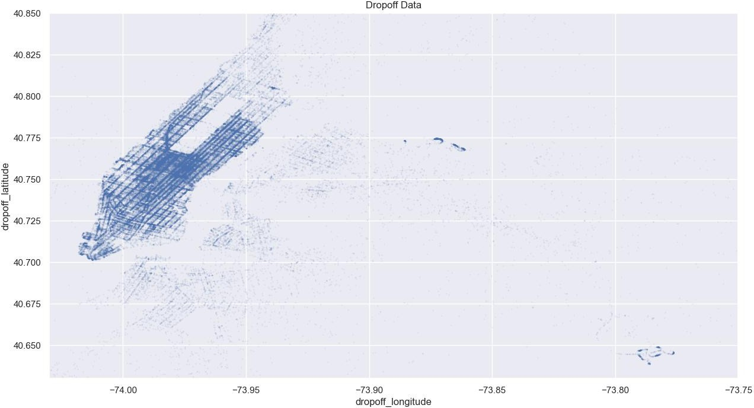

Fig. 2. Spatial distribution of taxi dropoff locations, emphasizing the frequent destination points within the city. This aids in the examination of the movement of vehicles and identifying frequently used locations for passengers to disembark.

*B.* *Long Trip Analysis Using Interactive Maps*

1. 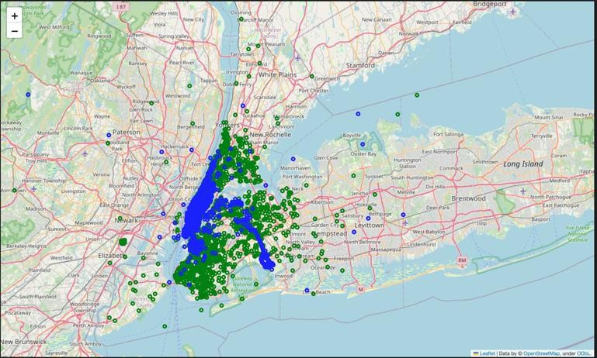Results/Experimentation

*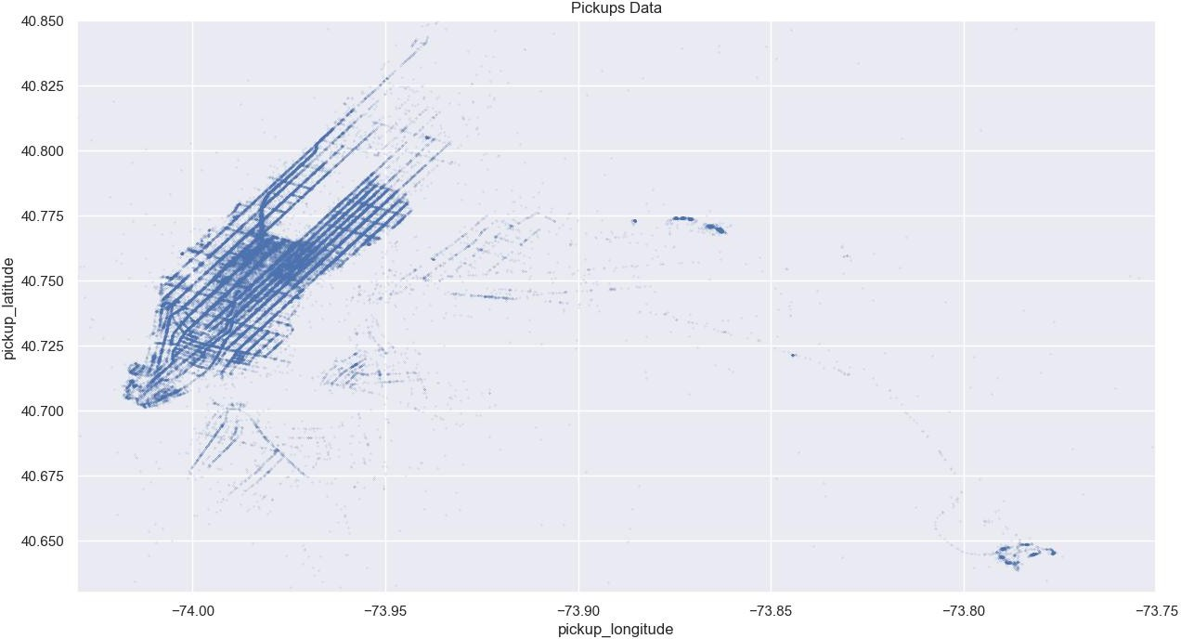A.* *Geospatial Analysis of Pickups and Dropoffs*

Fig. 1. Spatial distribution of taxi pickup locations throughout the city, illustrating the clustering of trips originating from important districts.

An analysis of the spatial distribution of taxi pickups and dropoffs offers valuable insights about traffic patterns and the dynamics of urban areas. The scatter plot of pickup locations

Fig. 3. Interactive map that visually represents lengthy taxi trips.

Figure 3 displays an interactive map visualization of long trips, specifically those that are longer than 10 km. The depiction highlights the key routes traveled by taxis over extended distances. The visualization is essential for detecting trends in long-distance travel and evaluating the influence of these journeys on the overall efficiency of the service.

*C.* *Fare Analysis*

Comprehending the fare structure and its relationship with other factors like travel distance and passenger count is crucial for economic evaluations. The histogram of fare amounts (Figure 4) displays a distribution that is skewed to the right, suggesting that the majority of flights are of shorter duration and lower cost. However, there are occasional longer trips that substantially raise the fare.

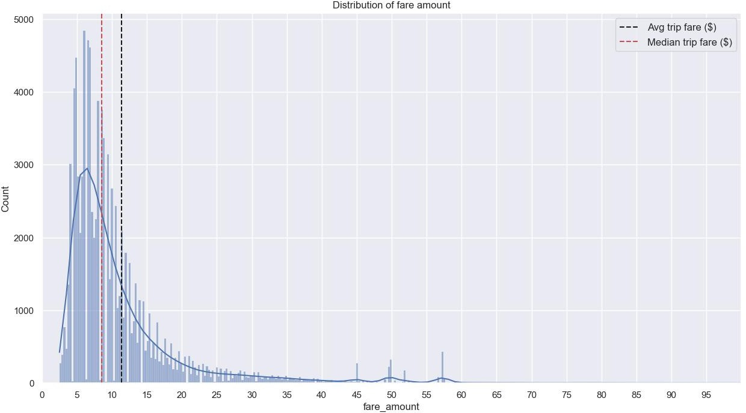 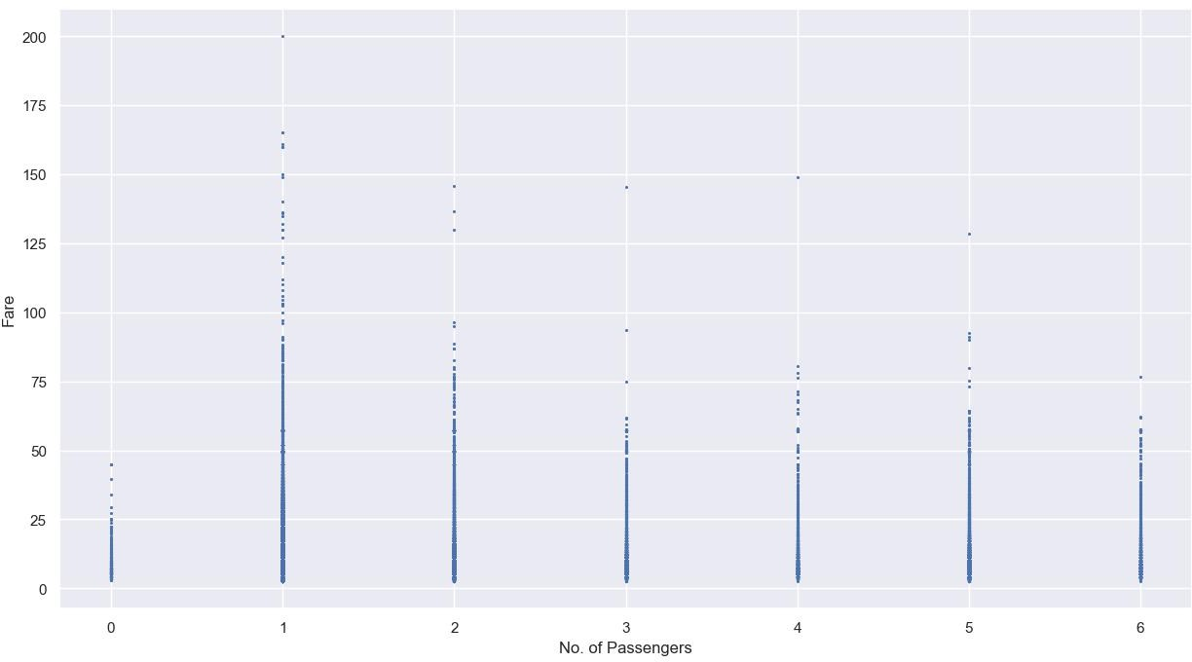

Fig. 4. Distribution of taxi fares, including the average and median trip expenses. This information offers valuable insights into the fare structure and the extent of its variability.

*D.* *Distance and Passenger Count Distribution*

The Haversine distance histogram (Figure 5) and the passenger count bar charts (Figures 6 and 7) provide insights into the average trip lengths and the distribution of journeys based on the number of passengers. These investigations are crucial for modeling since they establish a foundation for comprehending the aspects that impact travel durations and fares.

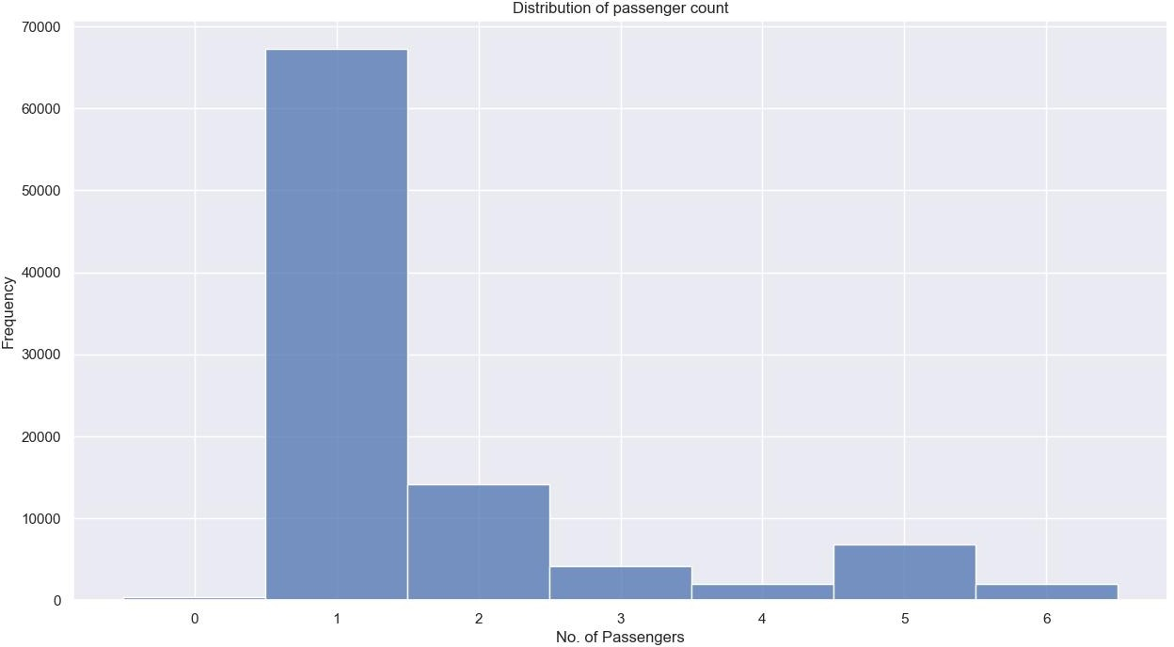

Fig. 5. Distribution of Haversine distances computed for cab journeys

Fig. 7. Distribution of fares across different passenger counts

The visualizations and analysis are important to our experimentation, offering a comprehensive picture of the elements that impact taxi trip durations and costs. Our objective is to improve the accuracy of predictions and optimize taxi operations by incorporating these insights into deep learning models.

*E.* *Model Performance*

The performance of the DNN model on the validation dataset yielded an MSE of approximately 138385.4677 and a Root Mean Squared Error (RMSE) of approximately 372.002. These metrics reflect the average squared difference and the square root of this value between the predicted values and the actual trip durations, respectively. The values indicate the typical deviation of the predicted trip durations from the actual durations in seconds.

These results suggest that while the model has learned to predict the trip durations to a certain extent, there is still considerable room for improvement. The relatively high RMSE value shows that the model's predictions can deviate from the actual trip durations by a significant margin on average, which could affect the practical usability of the model in a real-world setting.

In summary, the DNN model demonstrated a foundational capability to predict taxi trip durations but also highlighted the challenges of modeling such complex phenomena with high accuracy. Further refinements in the model's architecture, training process, or data used for training might be necessary to enhance its predictive performance and reduce the prediction error.

Fig. 6. Distribution of passenger counts

References

1. N. R K, J. K, A. Joseph, K. Sakthivel, and S. S. Anandharajan, "New York City Taxi Trip Duration Prediction Using Machine Learning," International Journal for Research in Applied Science & Engineering Technology, vol. 11, 2023, doi: 10.22214/ijraset.2023.52768.
2. S. Al-Shoukry, B. J. M. Jawad, Z. B. Musa, and A. H. Sabry, "Development of predictive modeling and deep learning classification of taxi trip tolls," Eastern-European Journal of Enterprise Technologies, 2022. Available:

https://pdfs.semanticscholar.org/23be/a2ccf6be7cfdf4c7a70a62e3675b2 2209e38.pdf

1. C. Zhang, F. Zhu, Y. Lv, P. Ye and F. -Y. Wang, "MLRNN: Taxi Demand Prediction Based on Multi-Level Deep Learning and Regional Heterogeneity Analysis," IEEE Transactions on Intelligent

Transportation Systems, vol. 23, no. 7, pp. 8412-8422, July 2022, doi: 10.1109/TITS.2021.3080511.

1. X. Xue, C. Zhou, X. Zhang, and J. Guo, "A taxi demand prediction model based on spectral domain graph convolution," *Journal of Applied Remote Sensing*, vol. 12613, pp. 1261319-1261319-6, 2023, doi: 10.1117/12.2673584.
2. Y. Cheng et al., "Block Popularity Prediction for Multimedia Storage Systems Using Spatial-Temporal-Sequential Neural Networks," Proceedings of the 29th ACM International Conference on Multimedia (MM '21), pp. 3390–3398, 2021, doi: 10.1145/3474085.3475495.
3. U. Sahin, "A Deep Learning Approach to Forecasting Short-Term Taxi Demands," 2022 30th Signal Processing and Communications Applications Conference (SIU), pp. 1-4, 2022, doi: 10.1109/SIU55565.2022.9864773.
4. X. Zhang, Z. Zhao, Y. Zheng, and J. Li, "Prediction of Taxi Destinations Using a Novel Data Embedding Method and Ensemble Learning," IEEE Transactions on Intelligent Transportation Systems, vol. 21, pp. 68-78, 2020, doi: 10.1109/TITS.2018.2888587.
5. F. Mao, Z. Li, and K. Zhang, "DeepCorNet: A efficient taxi-hailing prediction model," Journal of Physics: Conference Series, vol. 1693, 2020, doi: 10.1088/1742-6596/1693/1/012083.
6. R. Jegadeesan et al., "Forecasting of origin-to-destination requests for taxis using DNN algorithm with NYU database," AIP Conference Proceedings, 2023, doi: 10.1063/5.0150597.
7. Z. Chen, B. Zhao, Y. Wang, Z. Duan, and X. Zhao, "Multitask Learning and GCN-Based Taxi Demand Prediction for a Traffic Road Network," Sensors, vol. 20, no. 13, 3776, 2020, doi: 10.3390/s20133776.
8. E. Hassanzadeh and Z. Amini, "Using Neural Network for Predicting Hourly Origin-Destination Matrices from Trip Data and Environmental Information," Scientia Iranica, 2023, doi: 10.24200/sci.2023.58193.5608.
9. Y. He, M. Hu, L. Yuan, and H. Jiang, "Flight taxi-out time prediction based on deep learning," Proc. SPIE 12081, MIPPR 2021: Pattern Recognition and Computer Vision, 1208127, 2022, doi: 10.1117/12.2623856.
10. K. Zhao, D. Khryashchev, and H. Vo, "Predicting Taxi and Uber Demand in Cities: Approaching the Limit of Predictability," IEEE Transactions on Knowledge and Data Engineering, vol. 33, no. 7, pp. 2723-2736, 2021, doi: 10.1109/TKDE.2019.2955686.
11. Y. Li, S. Cui, L. Zhang, B. Liu, and D. Song, "Taxi Destination Prediction with Deep Spatial-Temporal Features," 2021 International

Conference on Communications, Information System and Computer Engineering (CISCE), pp. 562-565, 2021, doi: 10.1109/CISCE52179.2021.9445931.

1. J. Tang, J. Liang, T. Yu, Y. Xiong, and G. Zeng, "Trip destination prediction based on a deep integration network by fusing multiple features from taxi trajectories," IET Intelligent Transport Systems, 2021, doi: 10.1049/ITR2.12075.
2. D. Cao et al., "BERT-Based Deep Spatial-Temporal Network for Taxi Demand Prediction," IEEE Transactions on Intelligent Transportation Systems, vol. 23, no. 7, pp. 9442-9454, 2022, doi: 10.1109/tits.2021.3122114.
3. H. Luo, J. Cai, K. Zhang, R. Xie, and L. Zheng, "A multi-task deep learning model for short-term taxi demand forecasting considering spatiotemporal dependences," Journal of Traffic and Transportation Engineering, 2020, doi: 10.1016/j.jtte.2019.07.002.
4. J. Zhao, C. Chen, H. Huang, and C. Xiang, "Unifying Uber and taxi data via deep models for taxi passenger demand prediction," Personal and Ubiquitous Computing, pp. 1-13, 2020, doi: 10.1007/s00779-020-01426- y.
5. S. Sonbhadra, S. Agarwal, M. Syafrullah, and K. Adiyarta, "An Application of Ensemble and Deep Learning Models in Predictive Analytics," 2020 IEEE 7th International Conference on Industrial Engineering and Applications (ICIEA), pp. 574-582, 2020, doi: 10.1109/ICIEA49774.2020.9102115.
6. Z. Chen, "Multi-Source Information Based Short-term Taxi Demand Prediction Using Deep-Learning Approaches," Journal of Physics: Conference Series, vol. 2033, no. 1, 012167, 2021, doi: 10.1088/1742- 6596/2033/1/012167.
7. J. Du, M. Hu, W. Zhang, and J. Yin, "Finding Similar Historical Scenarios for Better Understanding Aircraft Taxi Time: A Deep Metric Learning Approach," IEEE Intelligent Transportation Systems Magazine, vol. 15, no. 2, pp. 101-116, 2023, doi: 10.1109/MITS.2021.3136329.
8. H. Huang, "Taxi fare prediction based on multiple machine learning models," Applied and Computational Engineering, 2023, doi: 10.54254/2755-2721/16/20230849.
9. C. Hsu and H. Chen, "Taxi Demand Prediction based on LSTM with Residuals and Multi-head Attention," Science and Information Conference, pp. 268-275, 2020, doi: 10.5220/0009562002680275.