## **Project Title: Women Accessories**

## **Website Name: S&H Women Accessories**

## **Team members: Aneesha Devulapally (axd )**

## **Saipriya Nimmagadda (sxn200007)**

**Description:**

S&H website is targeted for women who love to shop different types of Shoes and Handbags online.

Customers can use the website for browsing through various varieties of cataloged items, selecting an item, adding it to the cart and then placing an order of the items in the cart.

They can also further search for any specific item that they are looking for or use the filter function to narrow down their search using some specifications. Also, the customers can see their history of saved purchases.

Admins can use this website to add, update and delete the various cataloged items.

Both customers and admins need to first create an account and login in order to navigate to the main page of the website to shop or make changes.

**Database Model:**

The following are the tables that are created with a respective primary and foreign key:

|  |  |  |
| --- | --- | --- |
| Table Name | Primary Key | Foreign Key |
| User | username |  |
| Cart_items | user_id |  |
| Product | pid |  |
| User_history | user_id |  |

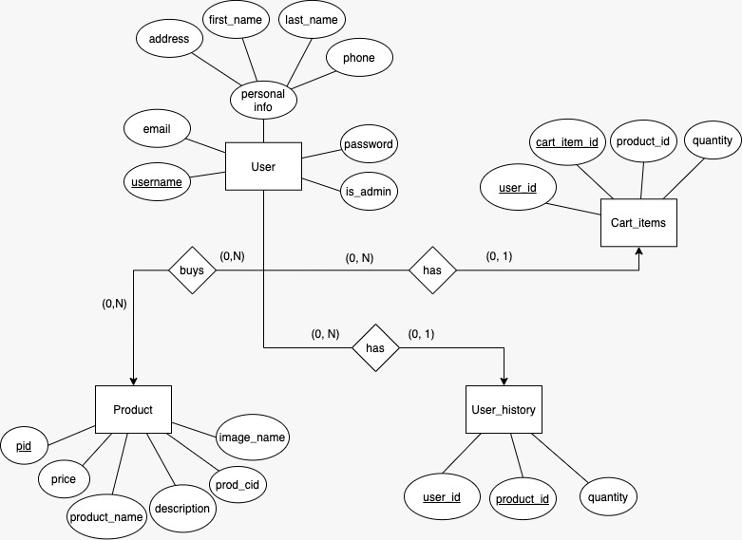

Fig: ER diagram

**Queries:**

**1)**

**2)**

**3)**

**Screenshots:**

**Work Division:**