DATA ANALYTICS WITH TABLEAU

NAME :PATHA LAKSHMI SAI PRIYA

ROLL NO:20NN1A05G3

COLLEGE NAME:VNITSW

ASSIGNMENT 4 TASK :

* Task 1:- Create one fixed and one exclude LOD expression.
* Task 2: Create any 2 map visualizations using geographical data.
* Task 3: Create Top N and/or Dynamic dimension parameters and utilize those in your workbook.

Explain LOD Expression, Map Visualizations using geographical data and Top N, Dynamic dimension Parameters .

LOD Expression :- Level of Detail (LOD) expressions are used to run complex queries involving many dimensions at the data source level instead of bringing all the data to Tableau interface.

Different types of LOD functions :- There are three types LOD functions:-

1) Fixed

2) Include

3) Exclude

Map Visualization using geographical data :- Tableau is a tool for analyzing geographical data. It can automatically turn location data into interactive maps.

ZOOM Levels :- 16 In Map Visualization, Geographical fields are double click on the field the data pane and tableau will create a map using generated latitude and longitude fields.

Top N Parameter:-

Top N parameter uses a value selected by the user, where N is a value. The value can be static or controlled by a parameter.

Top N parameter is also known as Bottom N. Tableau allows users to filter and display a certain percentage of their data.

Dynamic Dimension Parameters:- Create a Parameter. Create a new Parameter that lists your dimensions. Create a Calculated field that will be used as a dimension in your worksheet. Dimension to display when a particular parameter value is selected.

Add the calculated fields to the canvas.

1) Colours

2) Filters

3) Select any ratings or price ranges.

DATASET : [Sample - Superstore.xls](https://docs.google.com/spreadsheets/d/1Vmsk3xJ_qp69U0AZzCpNybqX0AP4KSon/edit#gid%3D972120833)



Upload the Dataset in Tableau :

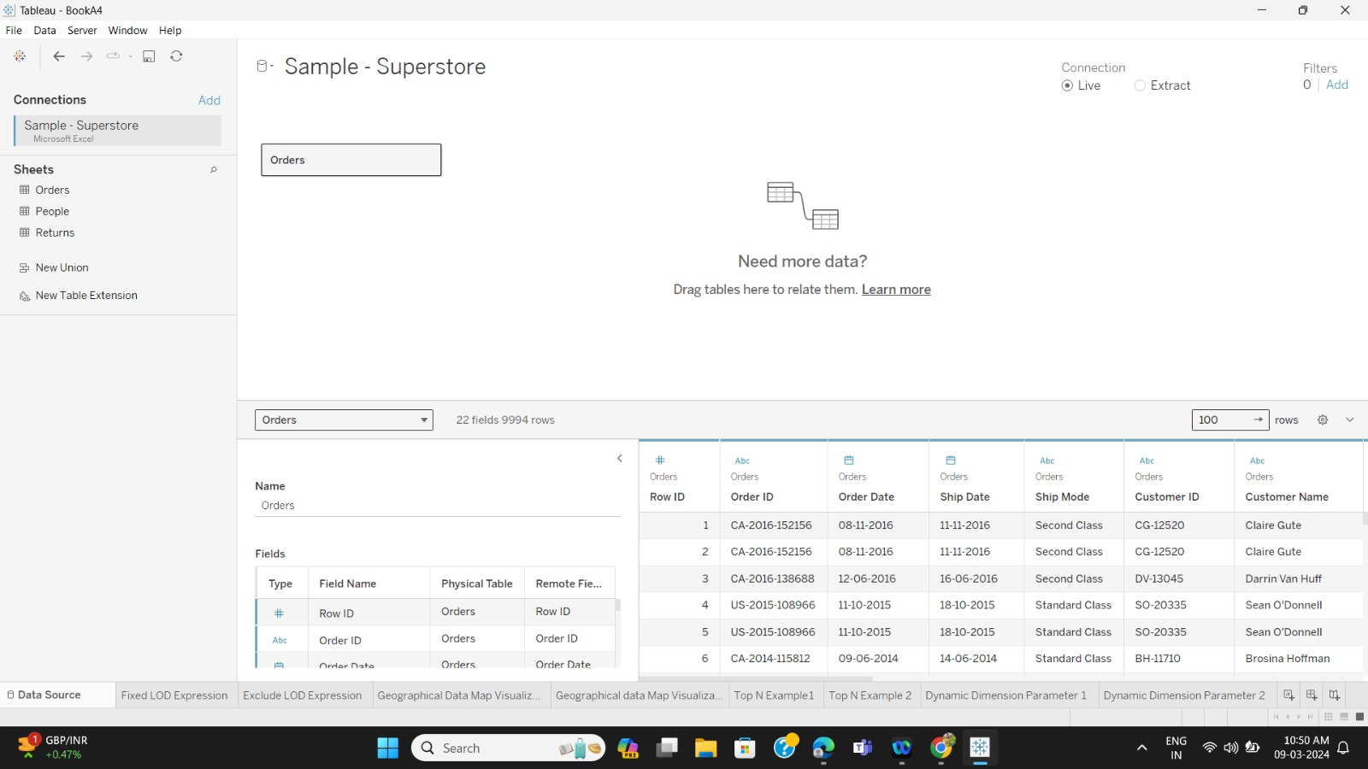

Create One Fixed LOD Expression and one exclude LOD expression:-

One Fixed LOD:-

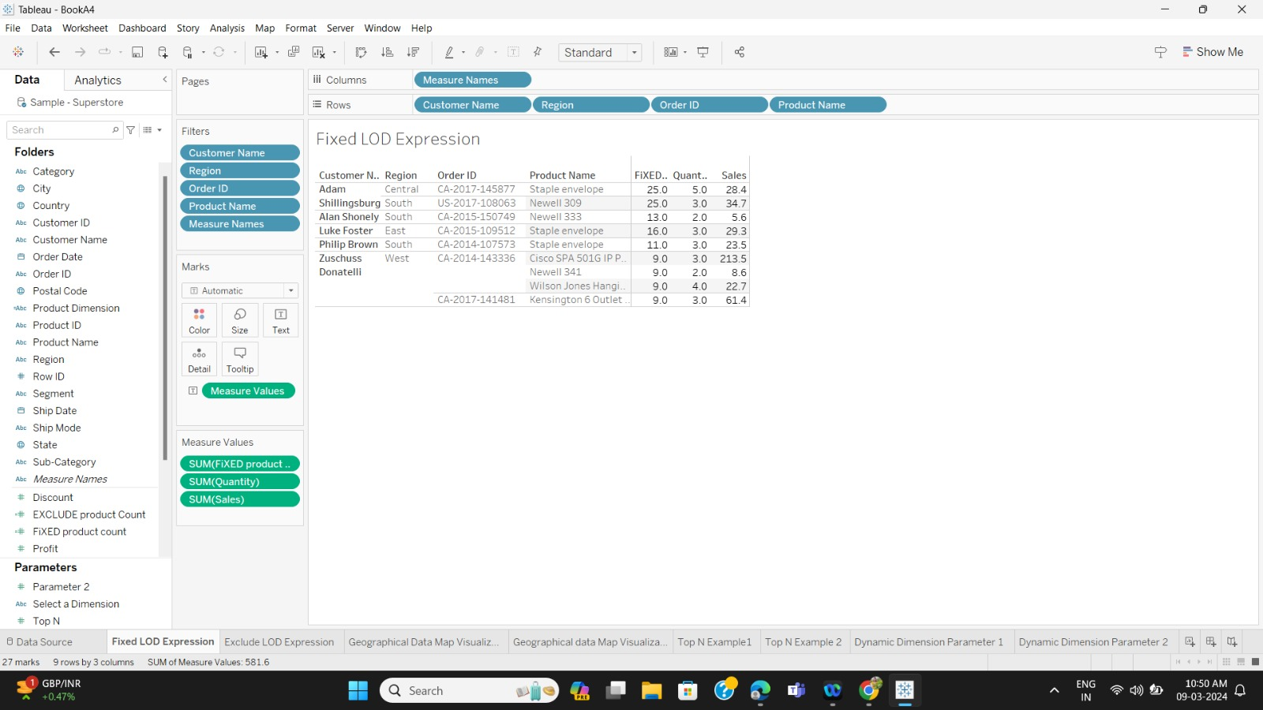

One Exclude LOD Expression:-

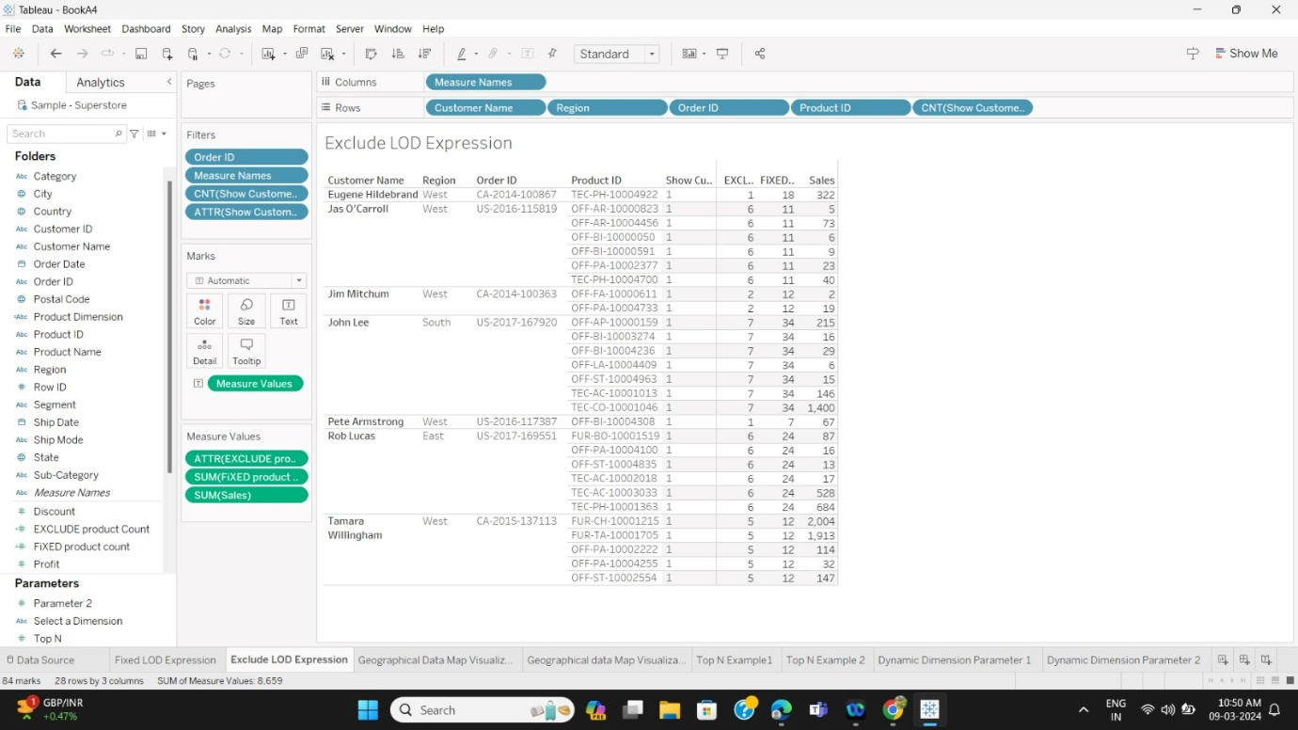

Create any 2 map visualizations using geographical data:- Map visualization 1:-

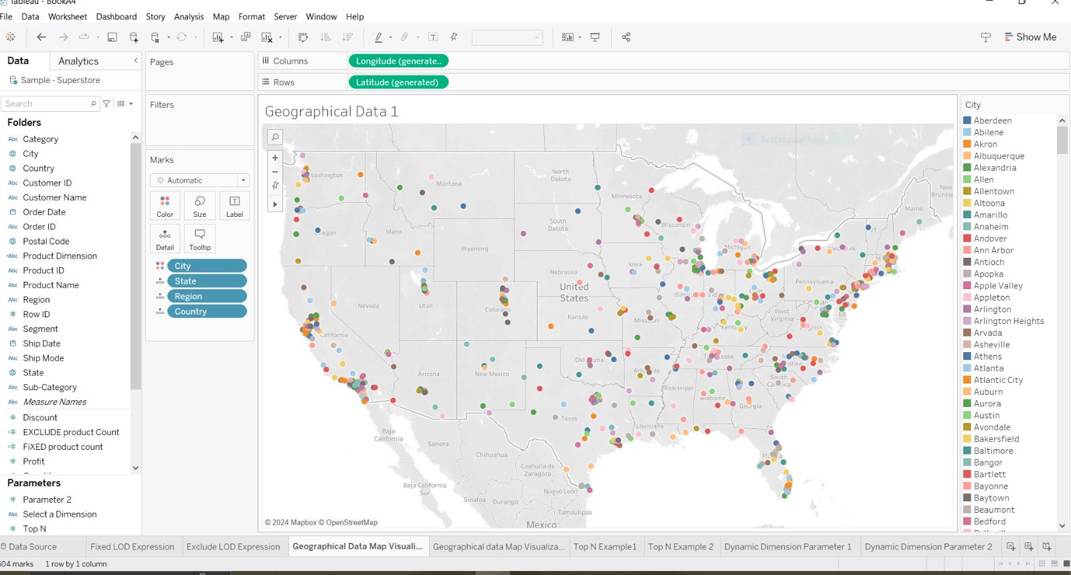

Map visualization 2:-

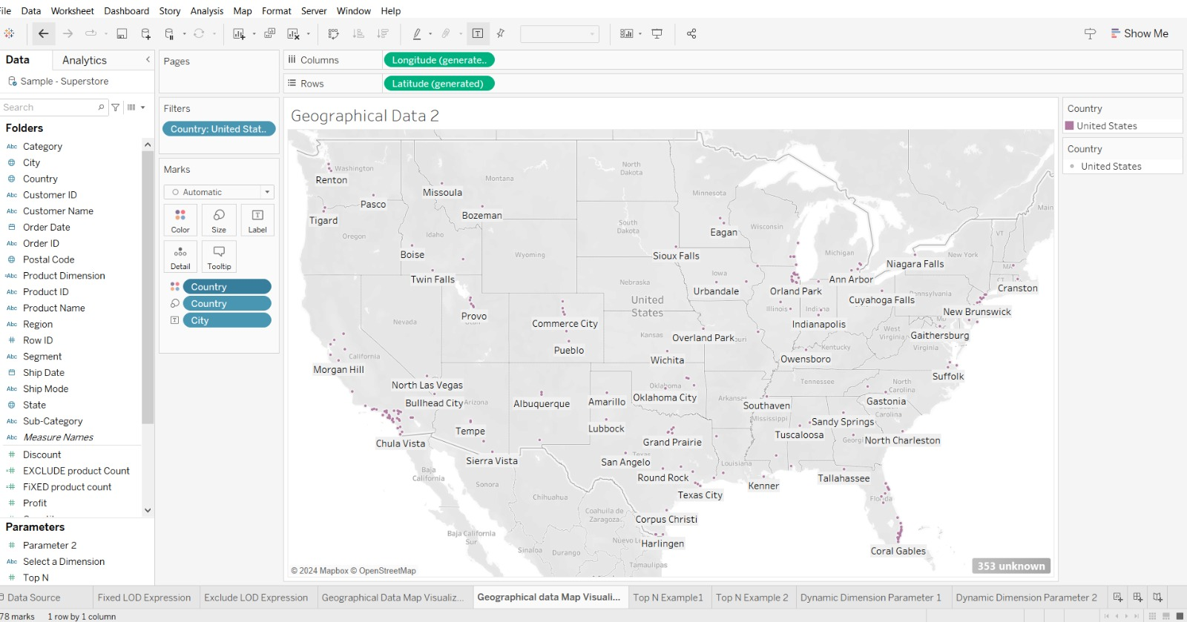

Create Top N and/or Dynamic dimension parameters and utilize those in your workbook:-

Top N Parameters:-

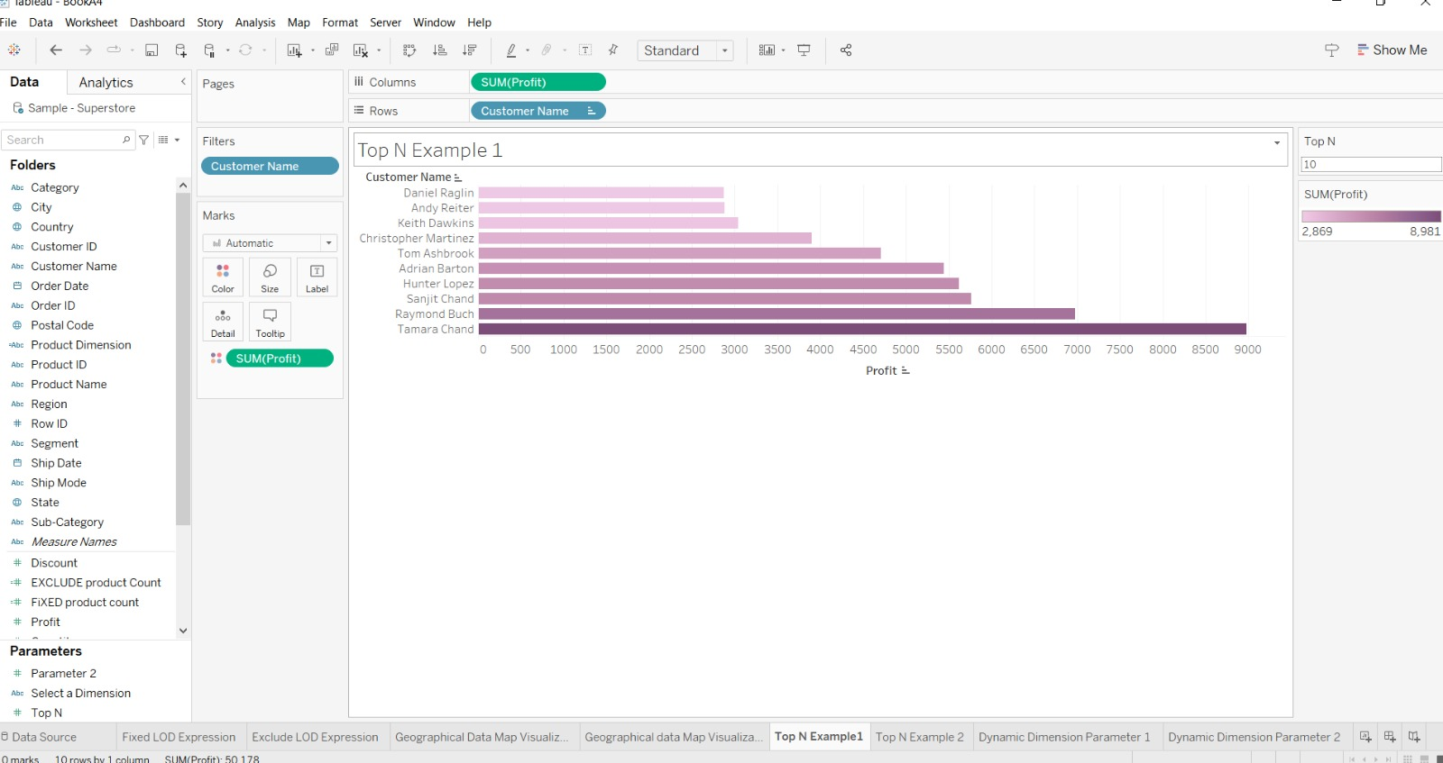

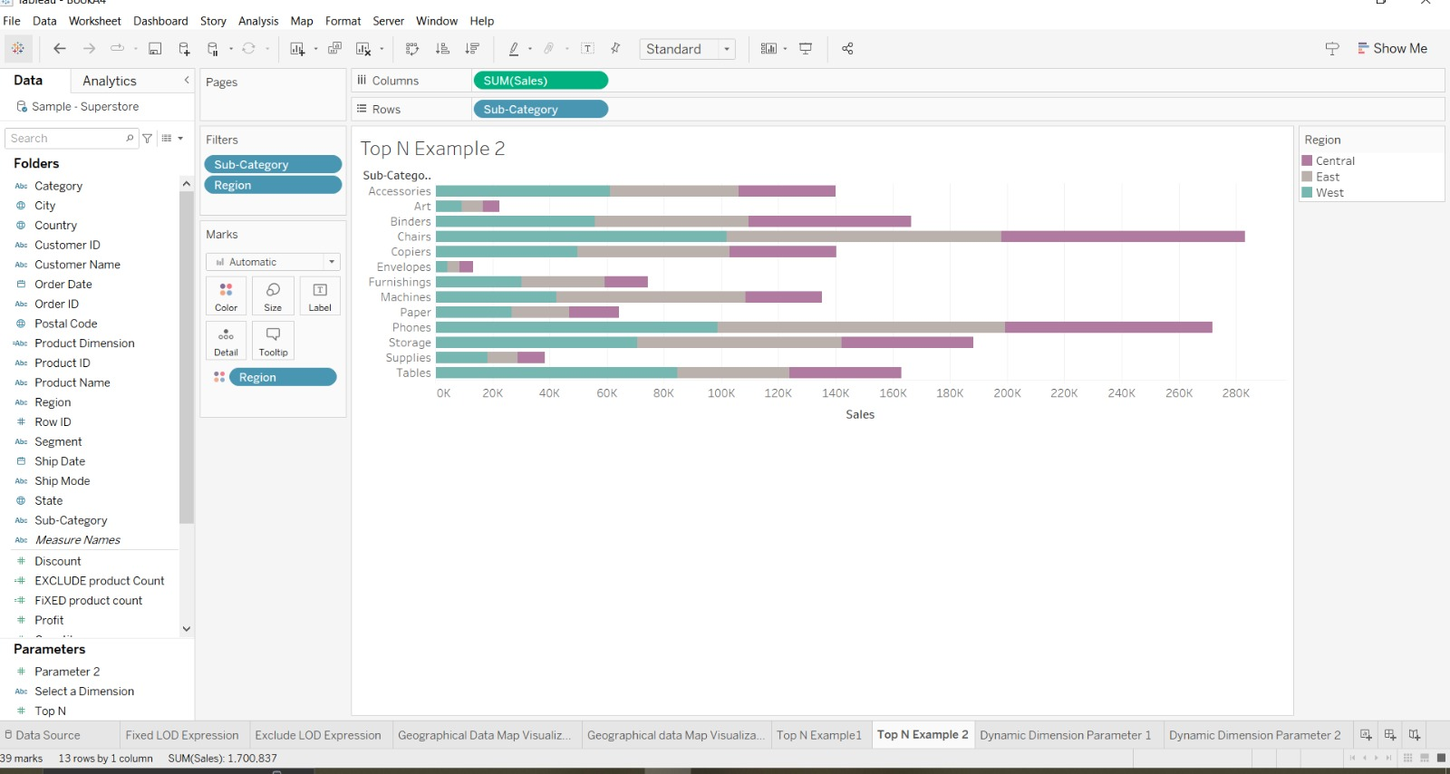

Dynamic Dimension Parameters:-

