What are the needed ?
Infrastructure:
1.EKS Cluster
2.nodegroup
3. ECR
4. master server
Aws install
Kubectl install
Helm install
Eksctl install
5. aws load balancer controller install
Devops:
1.developer code
2.dockerfile
3.k8s manifest files
4. CI/CD actions workflow
Steps we did
1. We have to create a EKS Cluster it takes 10min to create.
2. After creating it in compute we need to add the nodegroups.
3. we have the create the master server:
In master server:
a. downloading awscli, docker
b. configure the aws secret key and access key
c. kubectl install

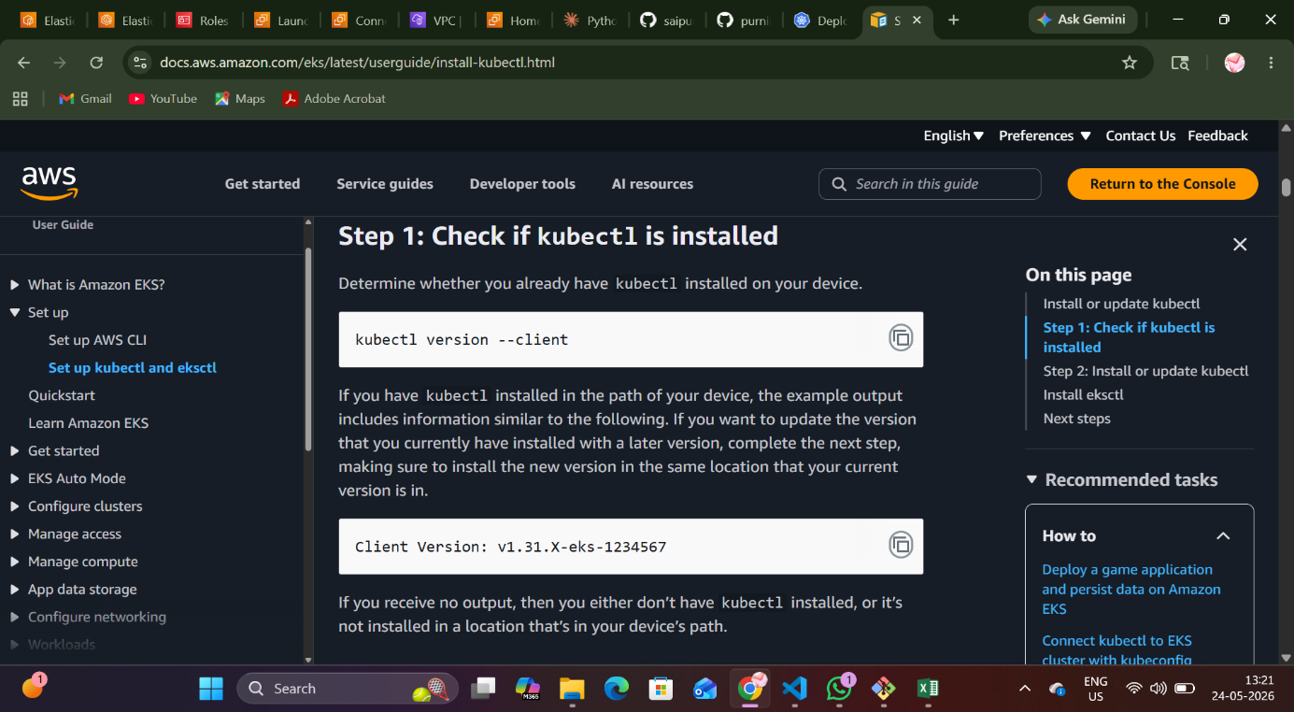

First checking whether the kubectl is there or not and we are installing the kubernetes version 1.34. And verifying it with SHA-256. Checking whether it is downloaded or not. And chmod kubectl.

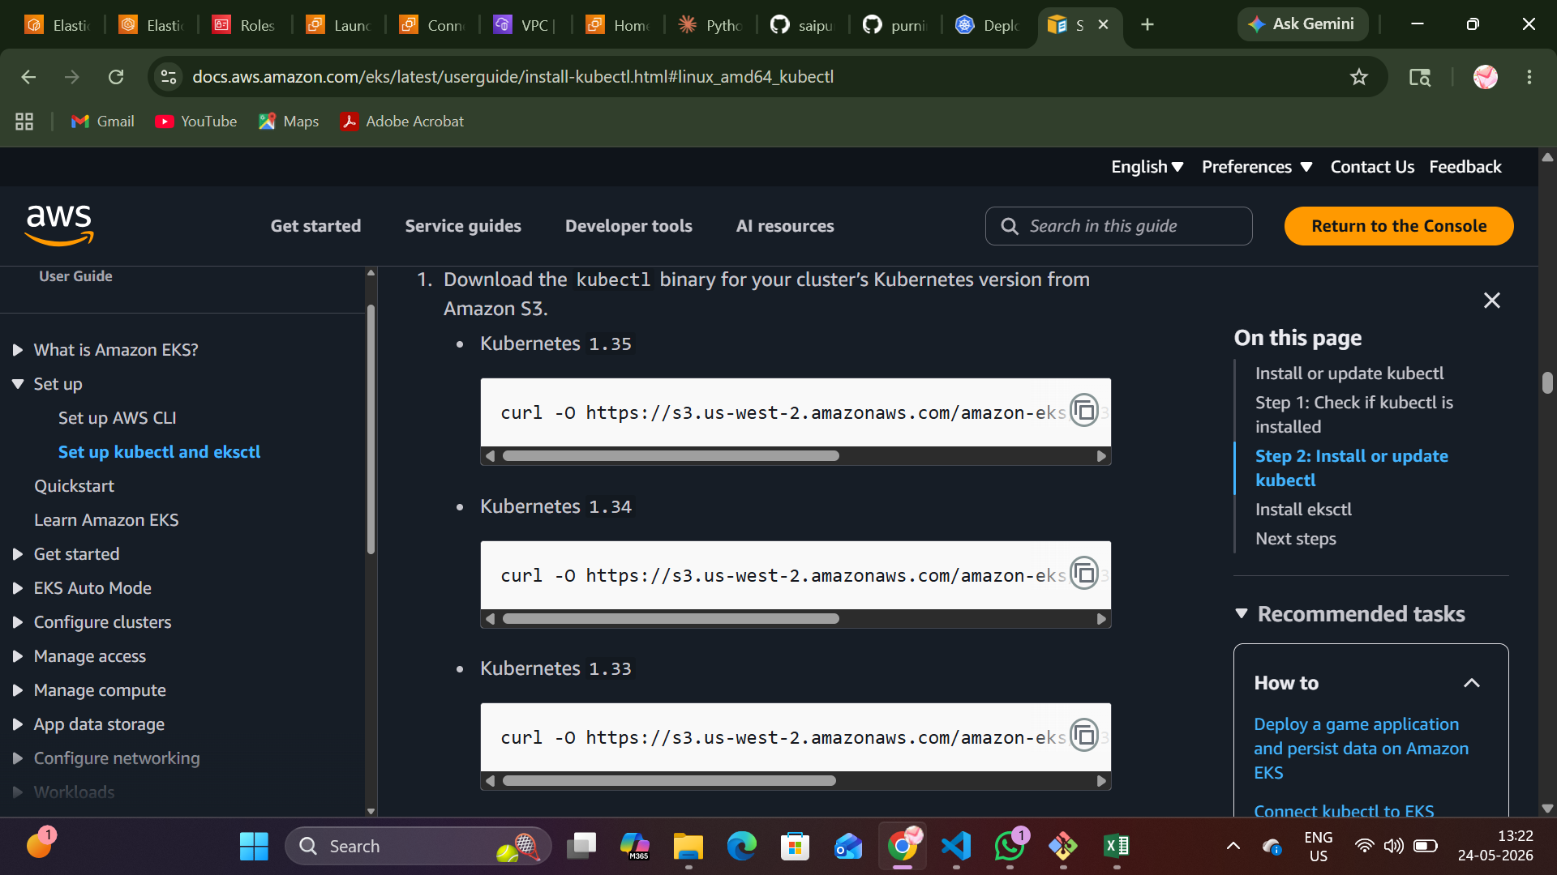

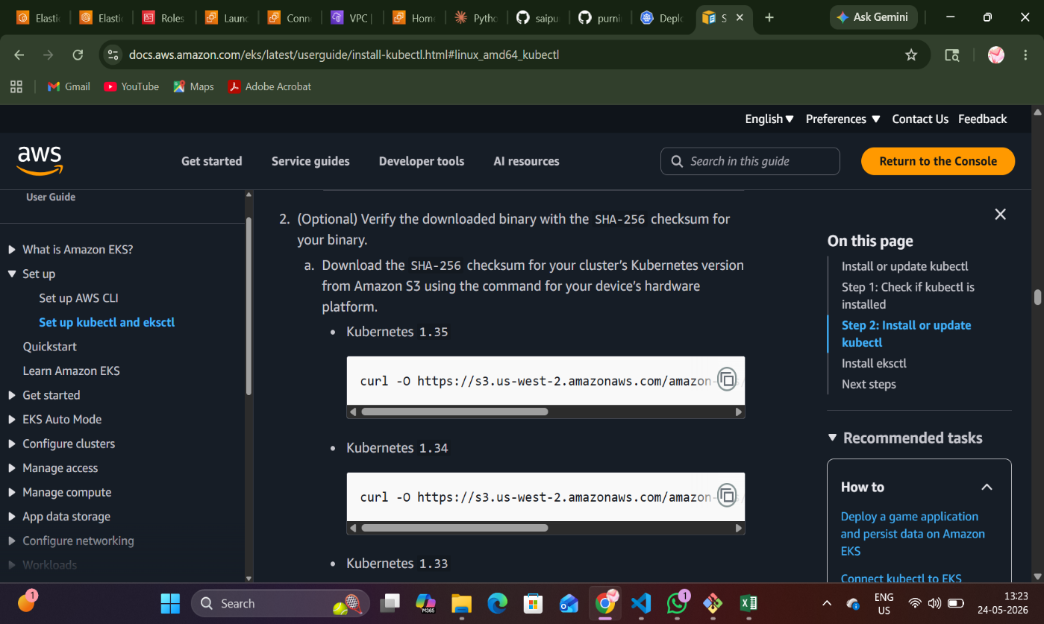

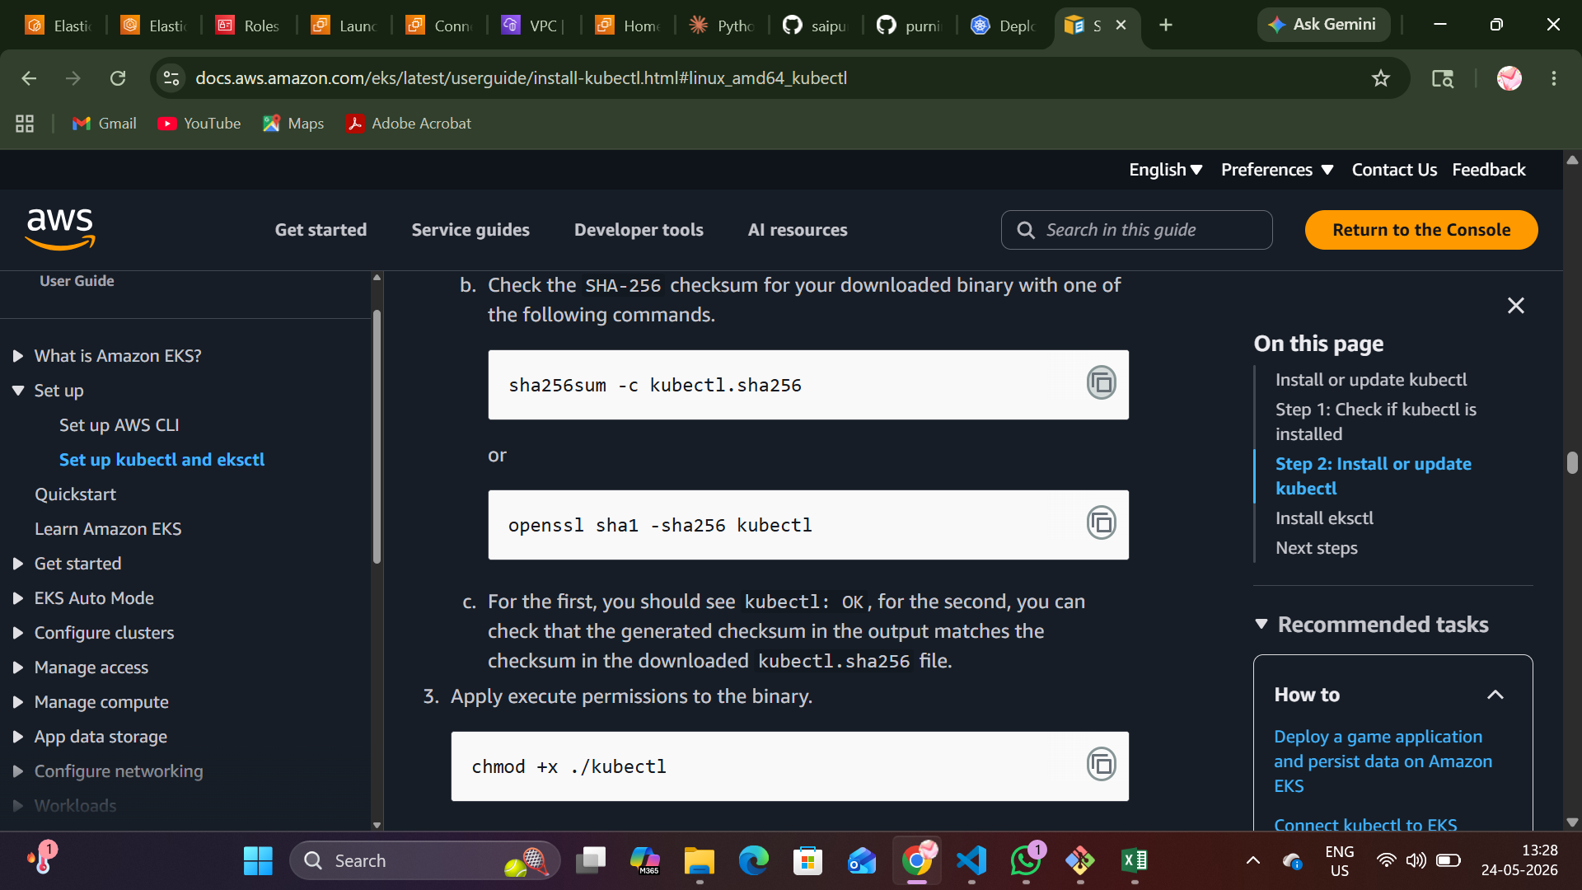
Creating the directory
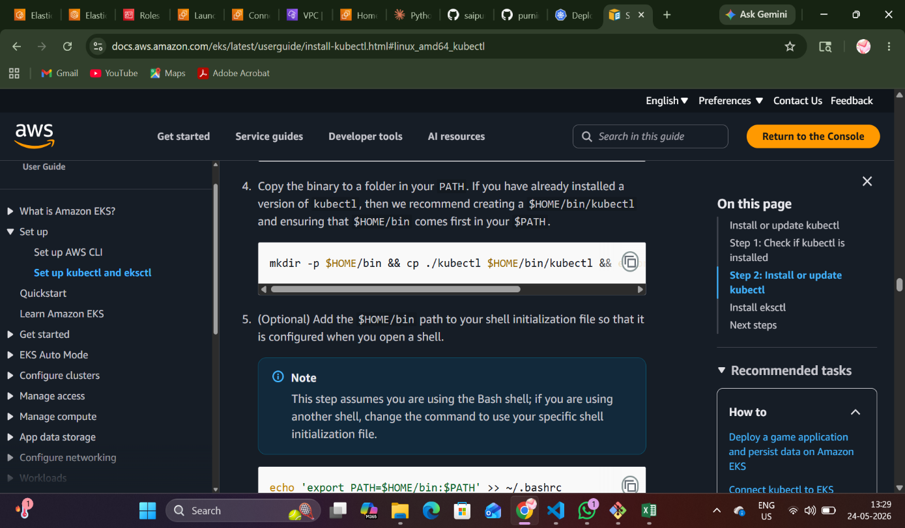

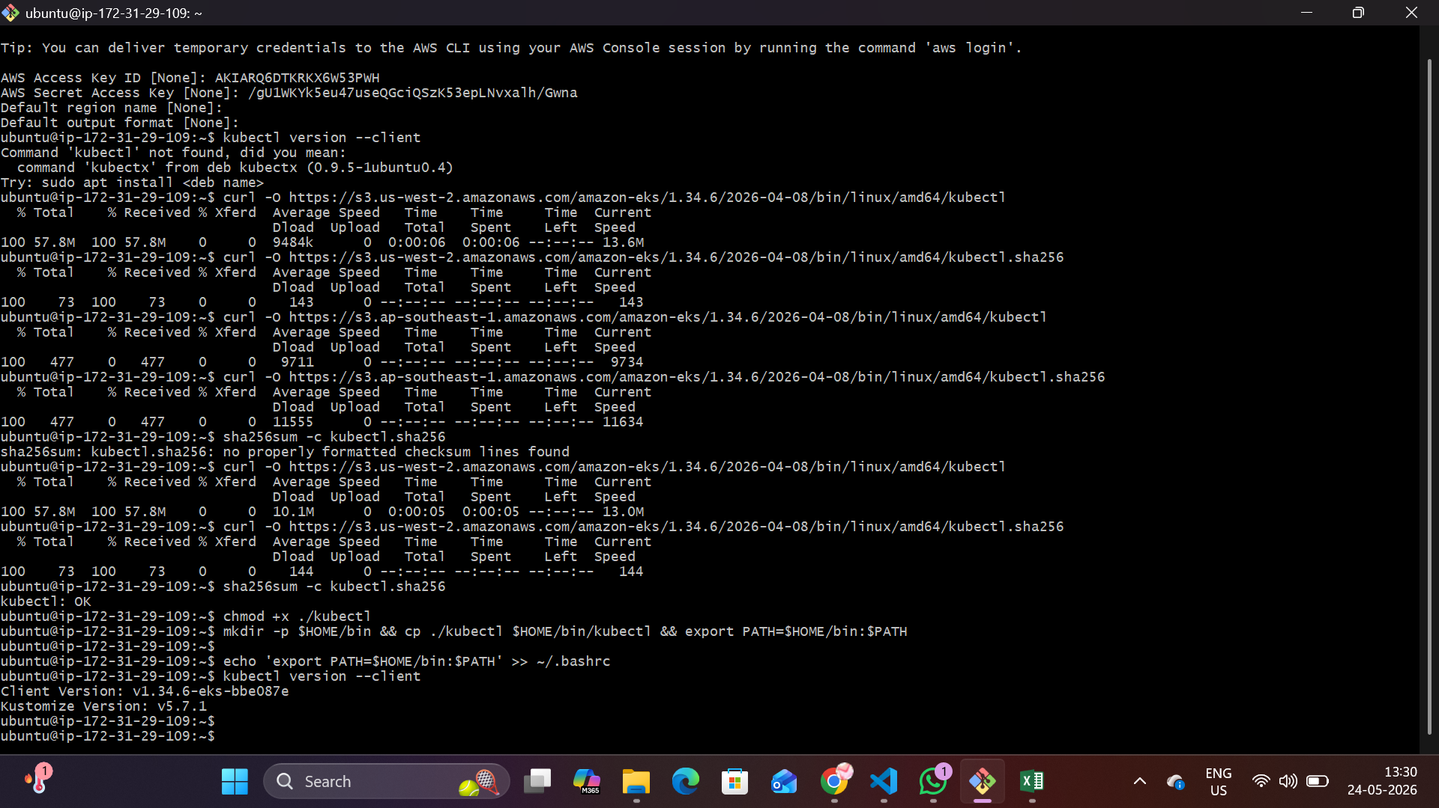
The above picture shows how we doing the installation process in the CLI. And the kubectl is installed it is showing the version.
For now my EC2, ECR, CLUSTER, NODEGROUP were Ready.
And then I have taken the code in the claude.ai and my code is ready. I have created a repository and uploaded the files I get from the Ai in the git hub.
And adding the deployment.yaml file from the kubernetes official website and change the changes.
Same like that add the service.yaml file.
And then take the ingress.yaml file and change the changes and add the annotations.
And we have to install the AWS load Balancer with helm.
First we need to install the helm for plugins.
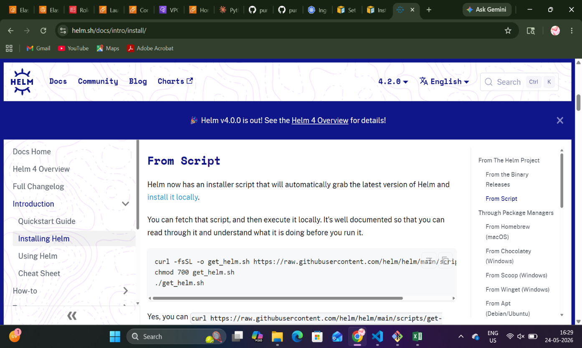
And we need to install the eksctl. Copy the script.
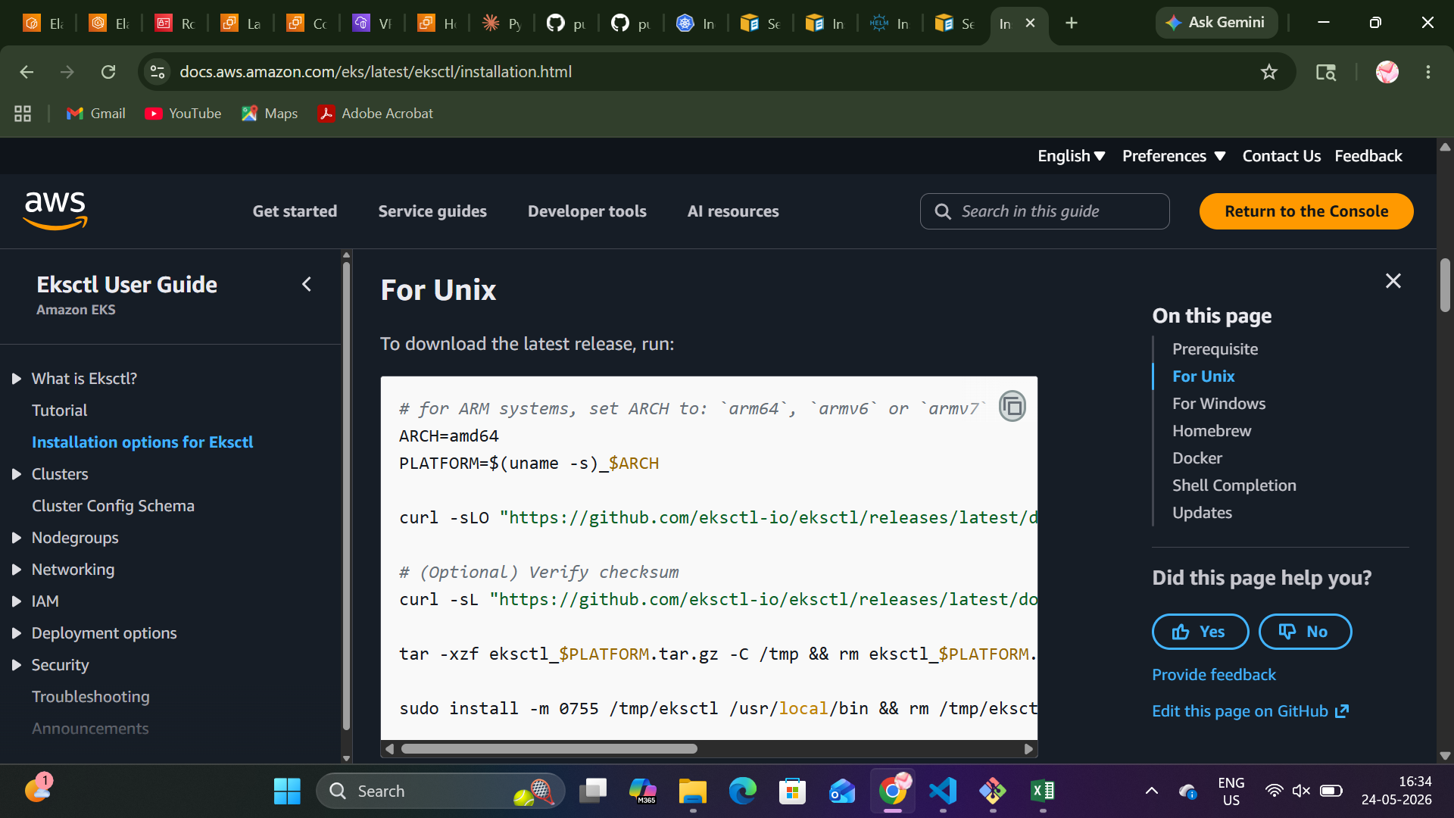
After the installations steps loadbalancer starts.
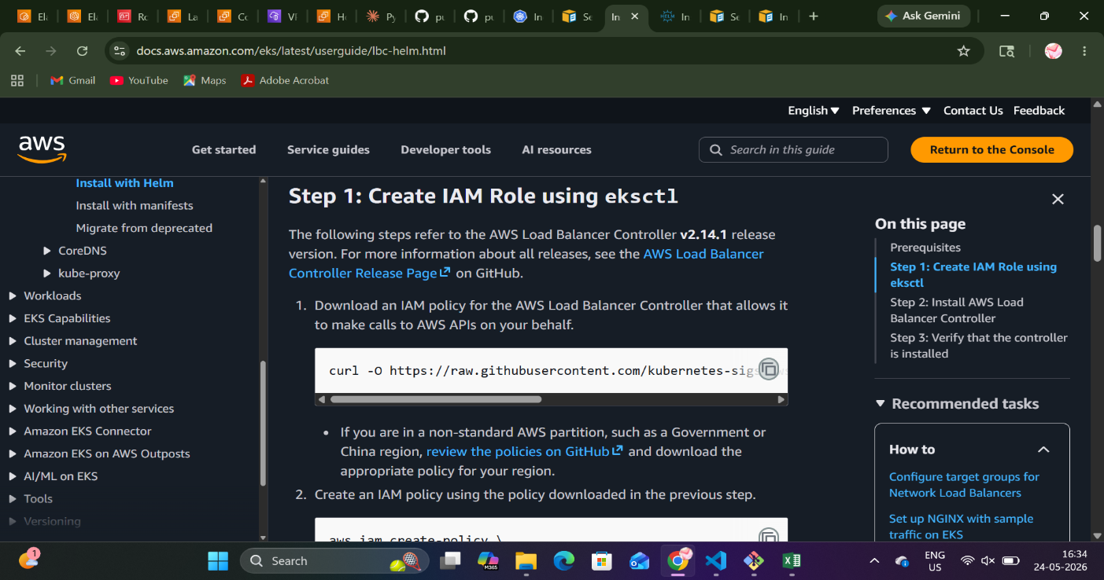

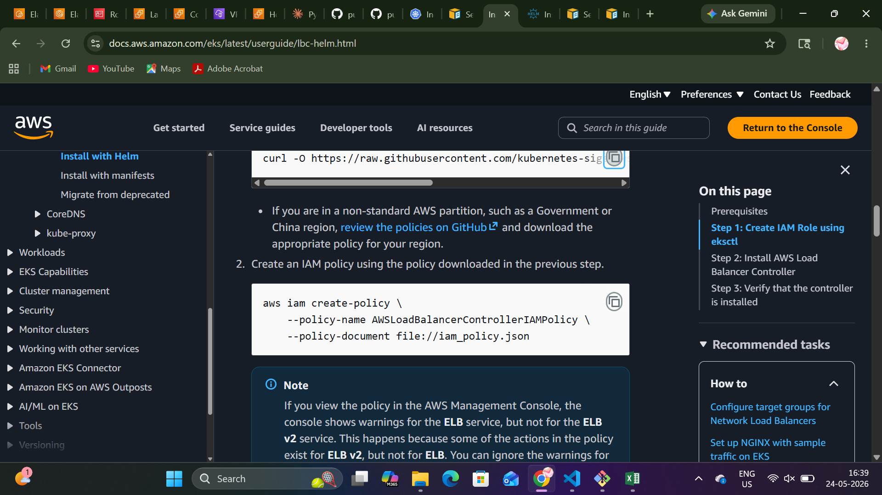

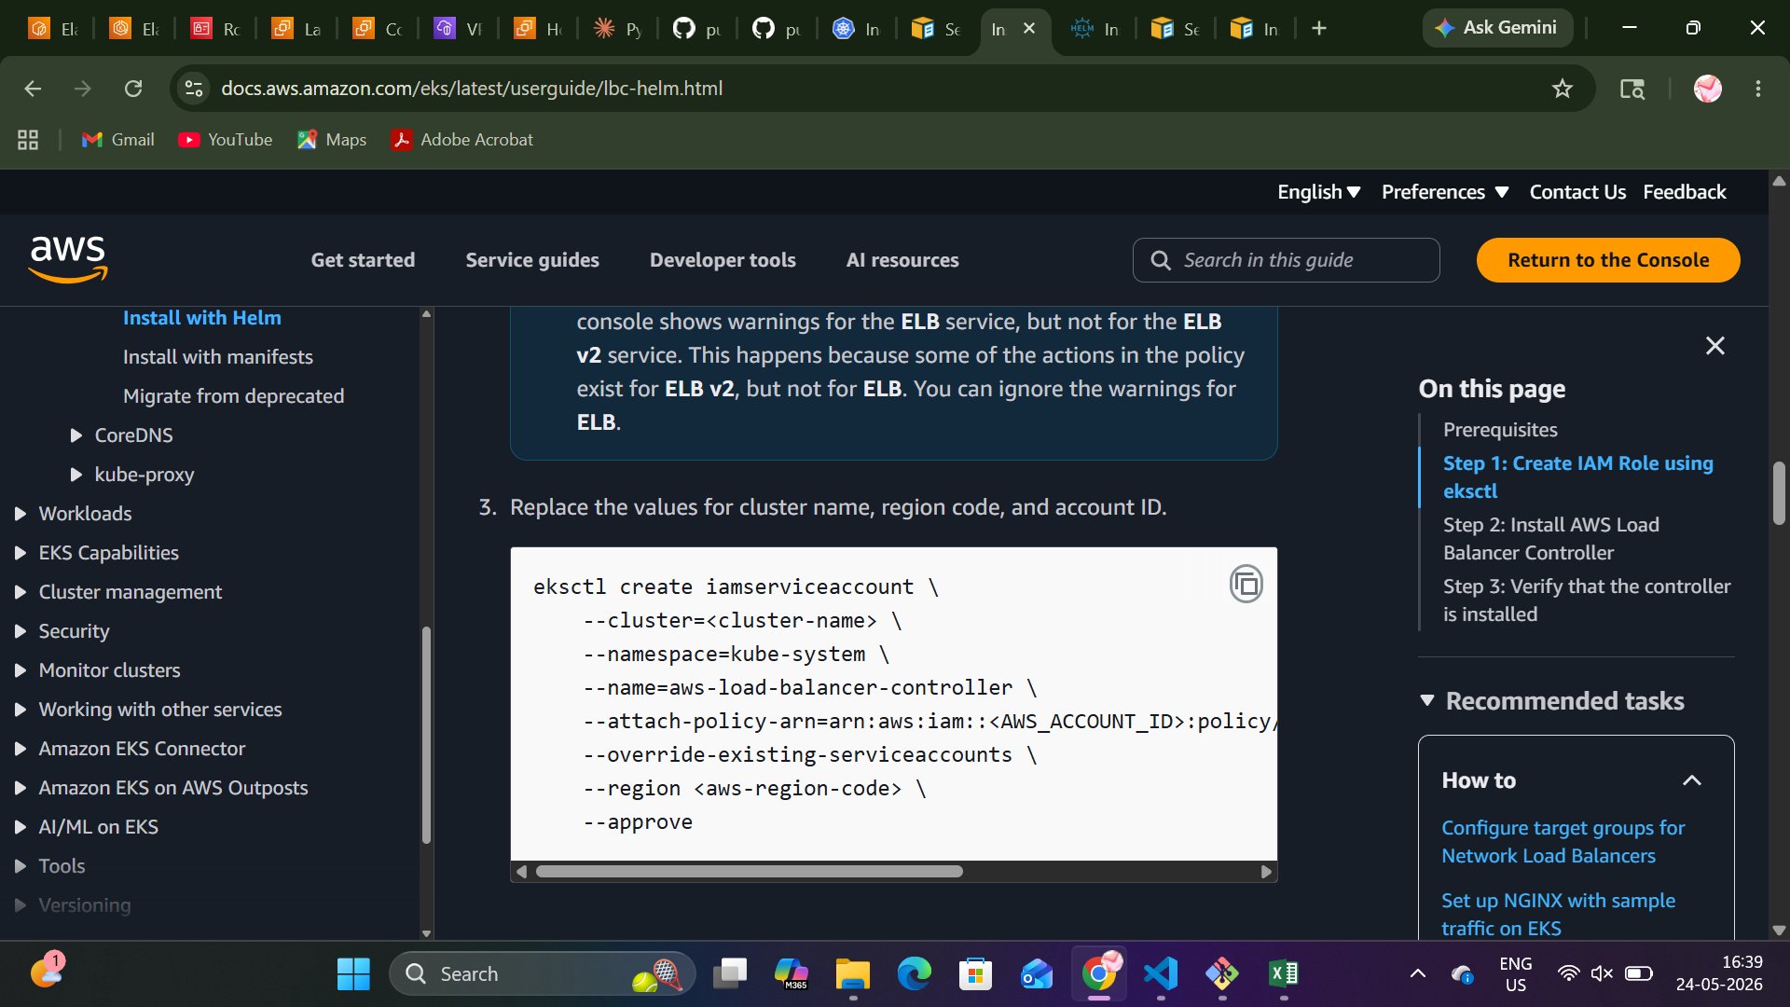

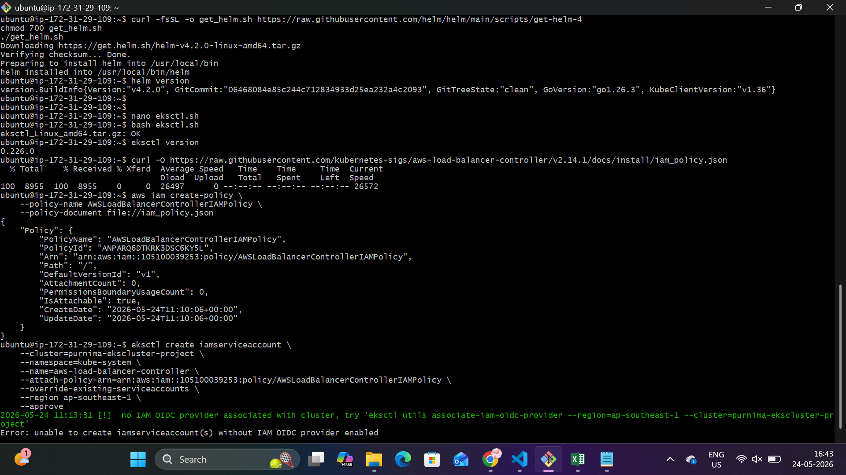
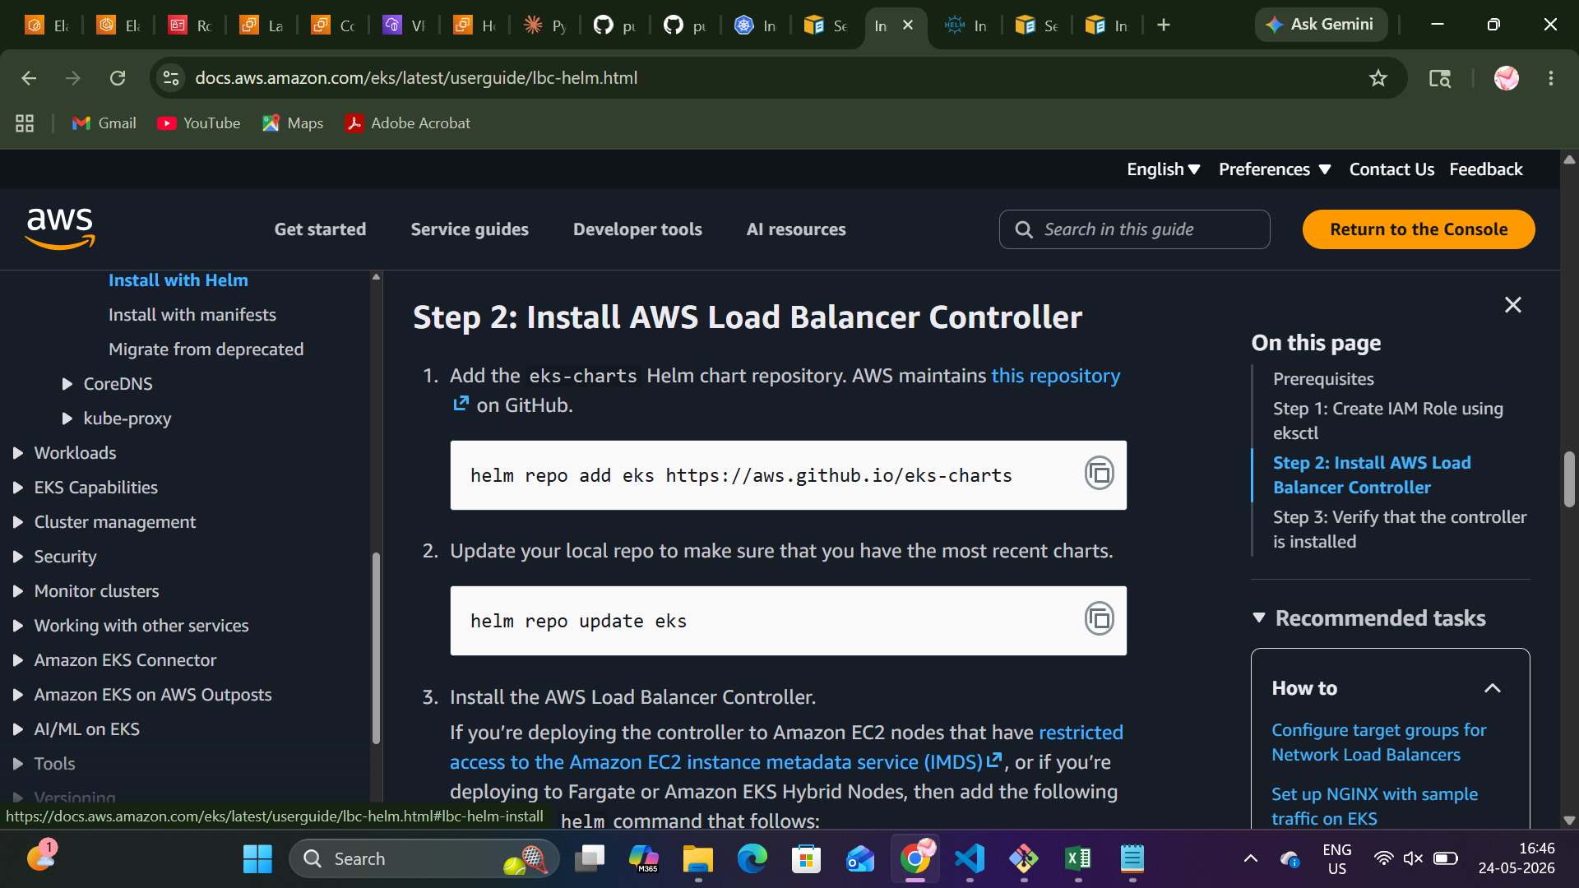

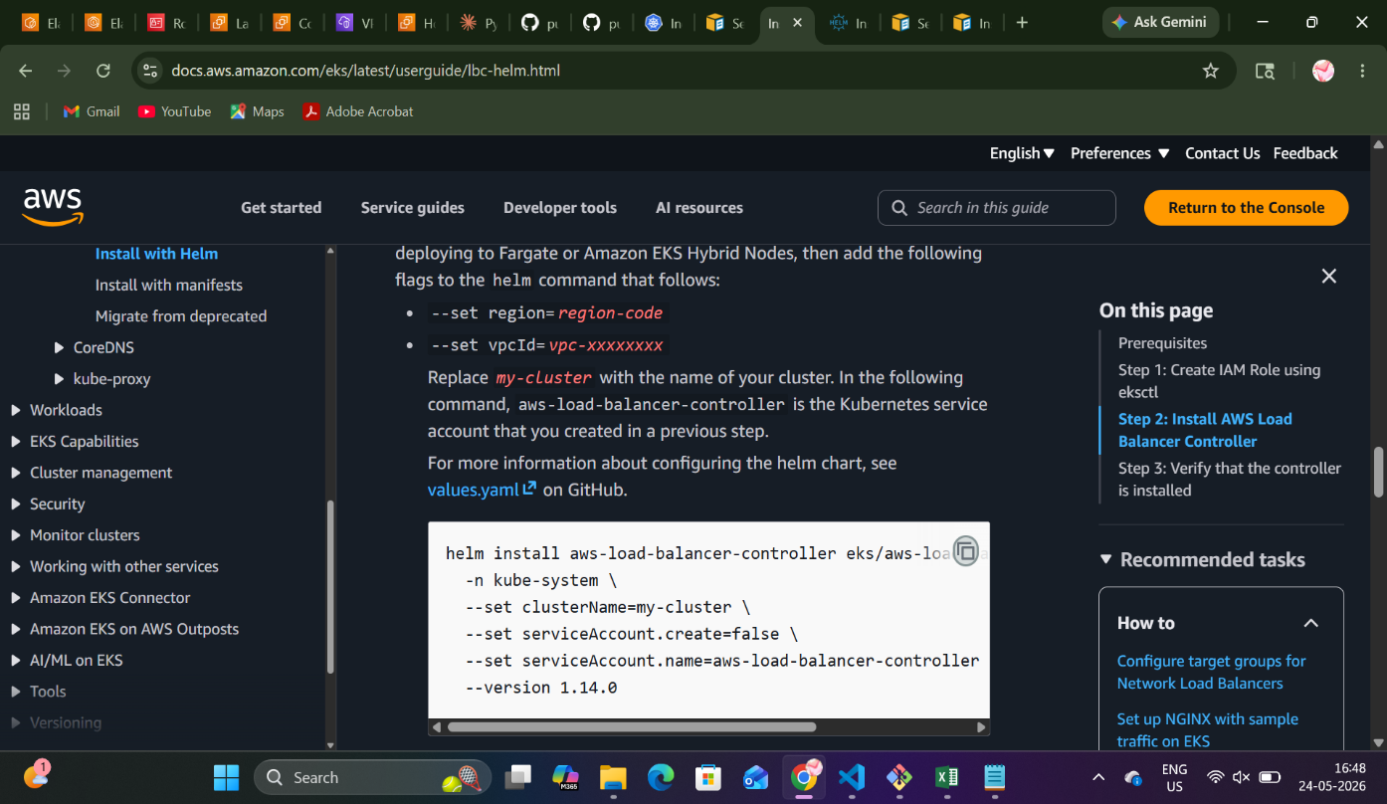

Here we will set the region and the vpcId

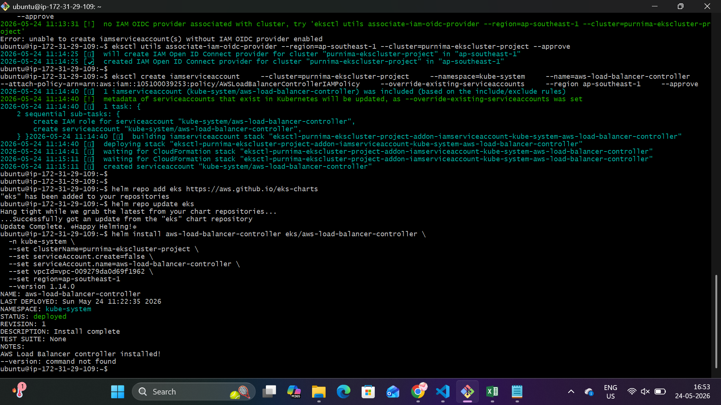
The Load Balancer controller is installed
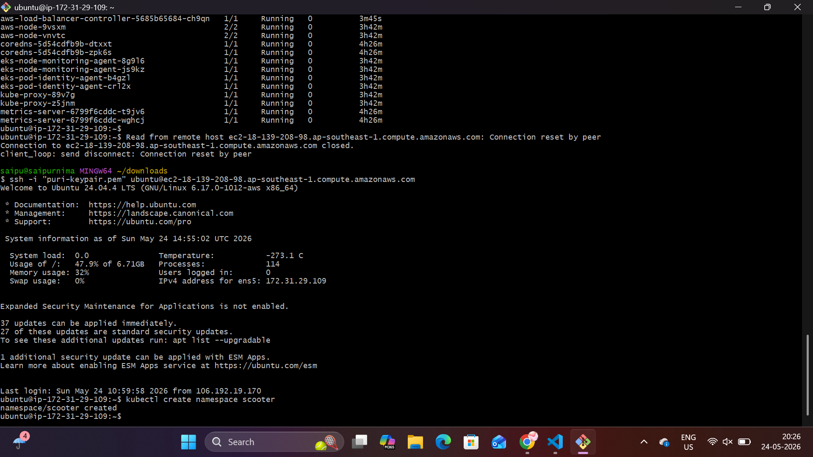

Every thing is ready and we need to write pipeline.
After that we need to add the access_key and the secret_key to the secrets of my repo.
After the deployment is successful we need to add the pipeline and the code will deploy in github actions.
And add the DNS record.
