Disorder detection OF TOMATO plant using IOT and ensemble techniques

Saiqa Khan
Assistant Professor:
Dept of Comp Engg
M H Saboo Siddik College of Engineering
Mumbai, India
saiqa.comp@gmail.com

Muteeullah Shaikh
Dept of Comp Engg
M H Saboo Siddik College of Engineering
Mumbai, India
Muteeullahmd@gmail.com
Dr. Meera Narvekar
Professor and Assoc. Head: Dept of Comp Engg
D.J.Sanghvi Engineering College,
Mumbai, India
meera.narvekar@djsce.ac.in

Bhumit Adivarekar
Dept of Comp Engg
M H Saboo Siddik College of Engineering
Mumbai, India bhumit97ad@gmail.com
Praneet Bomma
Dept of Comp Engg
M H Saboo Siddik College of Engineering
Mumbai, India
praneetbomma@gmail.com

Misbah Sayyed
Dept of Comp Engg
M H Saboo Siddik College of Engineering
Mumbai, India
misbahsayyed27@gmail.com

Abstract

India is one of the countries that makes use of fertilizers and pesticides in the field of agriculture. While fertilizers help in plant growth, pesticides work to safeguard the plant against pest. The method primarily adopted for detecting the disorders is naked eye visual observation but proves to be expensive. Many authors have proposed various solutions to this problem such as using IOT for grapes, or a system designed for accurate detection of disorder using machine learning with limited scope, or use of spectral data, etc. This paper proposes a prototype that uses multi-model analysis through sensor data and computer vision techniques. The main objective is to detect plant disorder in a tomato plant using machine learning, IOT, cloud computing and image processing.

Index Terms— Image processing, plant disorder, feature extraction.

1. Introduction

Over the past 50 years Global warming is likely to have been rising due to man-made activities. Due to which uncertain climatic conditions are also on the rise. However, these uncertain climatic conditions influence all components in plant growth which includes soil (that becomes infertile), cropping area (where plants are harvested), cropping intensity. Infertile soil is not suitable for farming because of which we make use of fertilizers as these substances contain plant nutrients such as nitrogen, phosphorus, and potassium. This paper focuses on detecting the disorders found in Solanum Lycopersicum plant, commonly known as tomato [3] belongs to the nightshade family, Solanaceae [1]. Analysing large number of data set of values tend to consume more memory space and high computation power or it may lead to over fitting in training sample and wrong generalizations to some new samples. Every part of the plant is affected differently with different types of diseases. According to research, leaves are the most affected parts of the plants in case of any disease. Their properties provide important insight into identification of the disorder and its current status. Thus, feature extraction is an important field in Machine Learning with respect to images [4]. The thresholds of the properties of the plant during one disorder closely resemble those of the other. These patterns in the properties of the plant and its features, help in identifying the disorder of the plant. Proposed study targets to predict the disorder that is most possible.

2. RELATED WORK

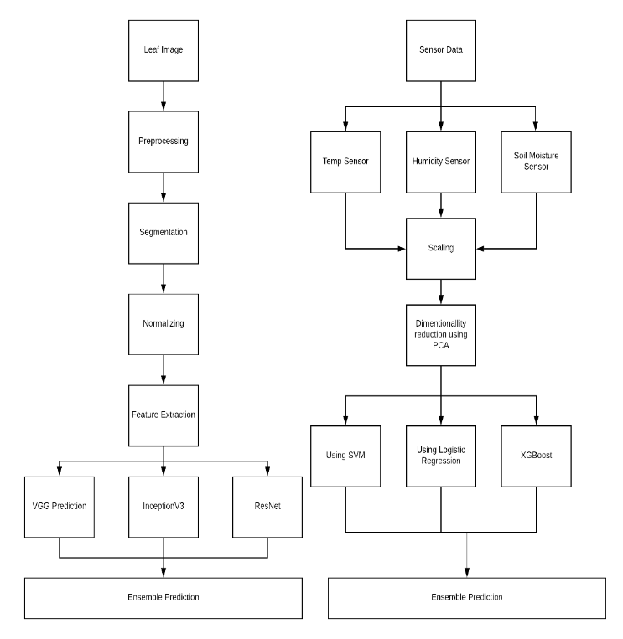
Many Authors have worked on various feature identification techniques. Stephan Gang Wu et al. has made use of probabilistic neural network along with image and data processing to implement general purpose automated leaf recognition for plant classification [5]. Harish Velingkar et al. have used pre-processing of images and K-means clustering technique for classification and SVM for feature extraction [6]. Whereas authors in [7] and [11] have used CNN for learning raw features from the leaf images. Alvaro Fuentes et al used Faster Region-based Convolutional Neural Network (Faster R-CNN), Region-based Fully Convolutional Network (R-FCN), and Single Shot Multibox Detector (SSD) [12]. In [8] Mohammed A. Hussein Amel H. Abbas has considered various feature extraction methods like Texture Based Features, Colour Moments, Shape-Based Features etc. Sanjay Mirchandani et al in [9] used ANN life feed-forward neural networks with image processing. Jihen Amara et al used LeNet Architecture for leaf classification [10] which is a CNN.

3. METHODS FOR FEATURE EXTRACTION

Most of the available feature extraction methods only consider visual properties of leaf and try to deduce the necessary information. The proposed system considers both features i.e. sensor’s data and leaf image. It aims at mapping the semantic relationship between the image and the sensor’s data (Humidity, Temperature, Moisture). Features are divided into two categories; 1. Sensor’s Based Feature Extraction, 2. Deep Learning Based Feature Extraction.

3.1. Sensor Based Feature Extraction.
The environmental condition plays an important role in determining the health of the plant. For this, the system will be using three sensors moisture, temperature, and humidity sensor. Such data will be gathered through IoT and be pushed to a cloud. When enough amount of sensor data is available, it will be used in machine learning algorithms to get the pattern and predict the outcome [2]. It will consist of two classes, healthy and not healthy. SVM and XGBoost Algorithm will be used as the performance outcome of these algorithms on statistical data is preferable than any other algorithm [14].

3.2. Deep Learning Based Feature Extraction.
The input parameters to the model will be leaf image and the properties of the plant, like Temperature, Moisture, Humidity, etc. Training the model on limited data fails to give good enough accuracy. Using Transfer Learning, the model can be trained on pre-defined weights. VGG19, ResNet, Inceptionv3 are some of the examples. CNNs are considered to be the best architectures for image-based models. CNNs extract features from the image that help in predicting plant to be healthy or unhealthy.
These features along with the sensor data like, Temperature, Humidity and Moisture will be the input features to the model. These detailed features of a plant can help in defining a pattern of a plant with certain disorder. Using Deep Learning Based Feature Extraction, every input feature
will be assigned weights based on their importance to the final prediction.

5. PROPOSED SYSTEM

5.1. Materials and Methods
The proposed system is using 8 – 10 tomato plants as samples which are being taken care of in an enclosed environment called Greenhouse. The Greenhouse is located in M. H. Saboo Siddik College, Mumbai with latitude 18.9685103° N, longitude 72.8288362° E, temperature 29°C and Humidity: 69%. The dataset consists of Plant Village Dataset Images, some real-world images and some images downloaded from the internet.
Following Fig 1. Shows green house set up along with IOT components used for implementation.

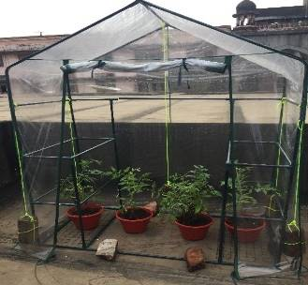
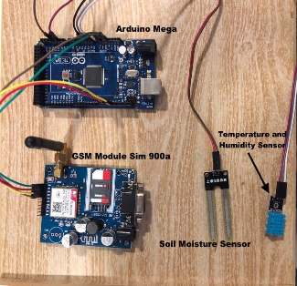

Fig. 1. Greenhouse and IOT Components

5.2 Implementation Methodology
Following are the steps to be followed:
    - Pre-processing
In this step, the images are prepared through Image Enhancement, Noise Removing, and Resizing. It helps in reducing computation cost and computation time too.
5.2.2 Feature Extraction
The proposed system will be extracting features from the sensor’s data and from the leaf image. As only visual properties are not enough to describe its properties, system will be using sensor’s data with IoT. It will help to decide multiple parameters for classifying the image.

    - Ensemble Classification
The proposed system will be using multiple deep neural nets and sensor data. This will help create a voting system or called an ensemble technique to predict considering multiple outputs from multiple models. Ensemble techniques take multiple classifiers as input and predict based on multiple models.
Following Fig 2 shows block diagram of a proposed system where ensemble prediction depends on using sensor data and leaf images . Basically, features are extracted to aid in disorder detection process.

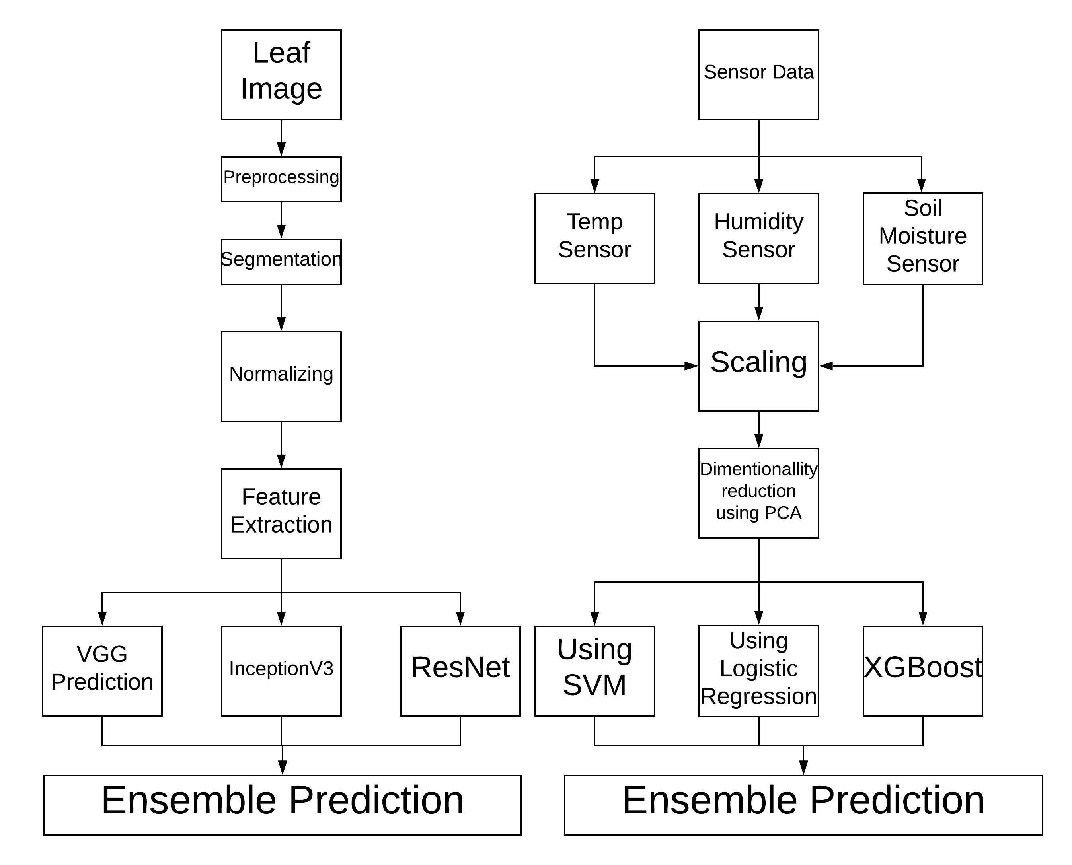Fig. 2. Proposed System.

conclusion
All the past work in disorder detection process directed towards the use of leaf images or sensor-based data. This paper has given significance to a process where leaf images are combined with sensory input to aid in reliable and efficient detection process.

References

- M.M Peet, G Welles (2005). Green House Tomato Production. CAB International 2005. Tomatoes (ed. E. Heuvelink).
- M. S. Kumar, T. R. Chandra, D. P. Kumar and M. S. Manikandan, "Monitoring moisture of soil using low cost homemade Soil moisture sensor and Arduino UNO," 2016 3rd International Conference on Advanced Computing and Communication Systems (ICACCS), Coimbatore, 2016, pp. 1-4. doi: 10.1109/ICACCS.2016.7586312 URL: http://ieeexplore.ieee.org/stamp/stamp.jsp?tp=&arnumber=7586312&isnumber=7586284
- Tomatoes, Advisory Committee on Vegetable Crops. Vegetable Crops Production Guide. Services Coordinating Committee. [online] Available at https://www.faa.gov.nl.ca/agrifoods/plants/pdf/tomatoes.pdf.s
- Gaurav Kumar, Pradeep Kumar Bhatia (2014). A Detailed Review of Feature Extraction in Image Processing Systems. IEEE Explore. 2014 fourth international conference on advance computing and communication technology
- Gang Wu, S., Sheng Bao, F., & You Xu, E. (n.d.). A Leaf Recognition Algorithm for Plant Classification Using Probabilistic Neural Network - IEEE Conference Publication. Retrieved from https://ieeexplore.ieee.org/abstract/document/4458016/
- Shambhuraj Porob, et al. “Figure 2f from: Irimia R, Gottschling M (2016) Taxonomic Revision of Rochefortia Sw. (Ehretiaceae, Boraginales). Biodiversity Data Journal 4: e7720. Https://Doi.org/10.3897/BDJ.4.e7720.”
- “How Deep Learning Extracts and Learns Leaf Features for Plant Classification.” NeuroImage, Academic Press, 18 May 2017, www.sciencedirect.com/science/article/pii/S003132031730198X.
- Hussein, Mohammed A., and Amel H. Abbas. “Comparison of Features Extraction Algorithms Used in the Diagnosis of Plant Diseases.” Ibn AL- Haitham Journal For Pure and Applied Science, www.jihcoed.com/ihj/index.php/j/article/view/1785.
- Mirchandani, Sanjay, et al. “Figure 2f from: Irimia R, Gottschling M (2016) Taxonomic Revision of Rochefortia Sw. (Ehretiaceae, Boraginales). Biodiversity Data Journal 4: e7720. Https://Doi.org/10.3897/BDJ.4.e7720.”
- Amara, Jihen, et al. “Figure 2f from: Irimia R, Gottschling M (2016) Taxonomic Revision of Rochefortia Sw. (Ehretiaceae, Boraginales). Biodiversity Data Journal 4: e7720. Https://Doi.org/10.3897/BDJ.4.e7720.” A Deep Learning-Based Approach for Banana Leaf Diseases Classification, 2017, doi:10.3897/bdj.4.e7720.figure2f.
- Kamilaris, Andreas, and Francesc X. Prenafeta-Boldú. “Deep Learning in Agriculture: A Survey.” Computers and Electronics in Agriculture, vol. 147, 2018, pp. 70–90., doi:10.1016/j.compag.2018.02.016.
- Fuentes, Alvaro, et al. “A Robust Deep-Learning-Based Detector for Real-Time Tomato Plant Diseases and Pests Recognition.” Sensors, vol. 17,no.9,Apr.2017,p.2022.,doi:10.3390/s17092022.
- LeBoeuf / OMAFRA, Janice, et al. “Bacterial Diseases Of Tomato: Bacterial Spot, Bacterial Speck, Bacterial Canker.” Soil Erosion Causes andEffects,www.omafra.gov.on.ca/english/crops/facts/05-069.htm.
- Ferdoush, S. and Li, X. (2014). Wireless Sensor Network System Design Using Raspberry Pi and Arduino for Environmental Monitoring Applications. Procedia Computer Science, 34, pp.103-110.

