**Experiment: 8 SAIRA BANU M**

**230701278**

**Create storyboards to represent the user flow for a mobile app (e.g., food delivery app) using Balsamiq.**

# 1. Introduction

This document outlines the wireframes for the Swiggy food delivery application. The wireframes represent essential user interface screens that guide a user through browsing, adding items to cart, and confirming their order. These mockups are designed to focus on user experience and efficient interaction flow.

# 2. User Flow

The typical user flow in the Swiggy app is:  
1. Home Screen – Browse and search for food or restaurants.  
2. Add to Cart – Select food items and add them to the shopping cart.  
3. Confirm Payment – Finalize the order and make the payment.

# 3. Screen Documentation

## Screen 1: Home Screen

Purpose: To allow users to explore restaurants and food items from their location and login into their account.

Components:

* - A top search bar for entering restaurant or dish names.
* - Category icons or tabs for different cuisines or types.
* - Promotional banners or offer carousels.
* - A scrollable list of popular restaurants.

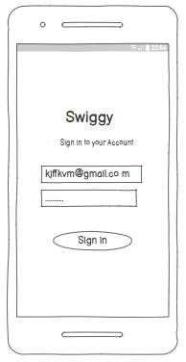

## Screen 2: Add to Cart

Purpose: This screen displays all items the user has selected before proceeding to payment.

Components:

* - A list of added food items with names, prices, and quantities.
* - Option to increase or decrease item quantity.
* - Subtotal and taxes breakdown.
* - A button to proceed to checkout.

## 

## Screen 3: Confirm Payment

Purpose: Final step where the user confirms the order and completes the transaction.

Components:

* - Address confirmation and delivery time details.
* - Payment method selection (Card, UPI, Wallet, COD).
* - Final order summary with total payable amount.
* - A 'Place Order' button to complete the order.

# 

# 4. Conclusion

These wireframes provide a visual blueprint for the key user interfaces in the Swiggy app. They aim to simplify the ordering process while ensuring a smooth and efficient user experience. Each screen is designed with usability and clarity in mind, helping users navigate easily through the app.