**UID EXPERIMENT 9**

**Design input forms that validate data (e.g., email, phone number) and display error messages using HTML/CSS, JavaScript (with Validator.js)**

**SAIRA BANU M**

**230701278**

**AIM**

The aim of this exercise is to design input forms that validate data (e.g., email, phone number) and display error messages using HTML/CSS and JavaScript with Validator.js.

**PROCEDURE**

Step 1: Setting Up the HTML Form

Create an HTML form with input fields for email and phone number.

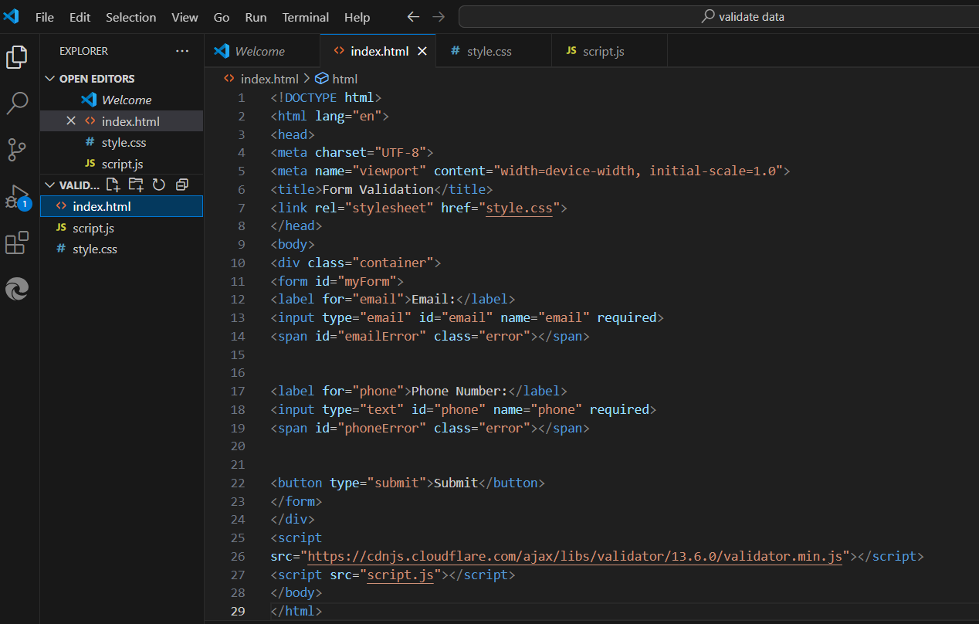

Step 2: Styling the Form with CSS

Add CSS to style the form for a better user experience.

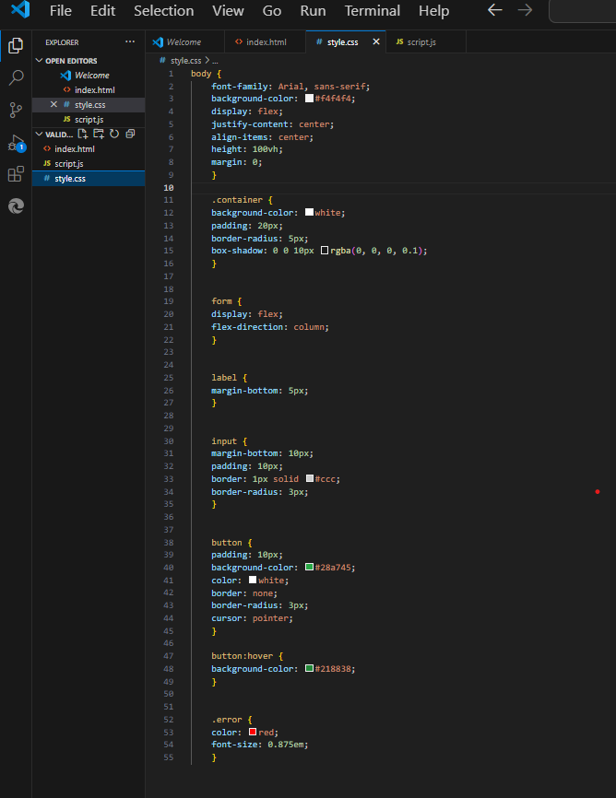

Step 3: Adding JavaScript for Validation

Use JavaScript and Validator.js to validate the form inputs and display error messages.

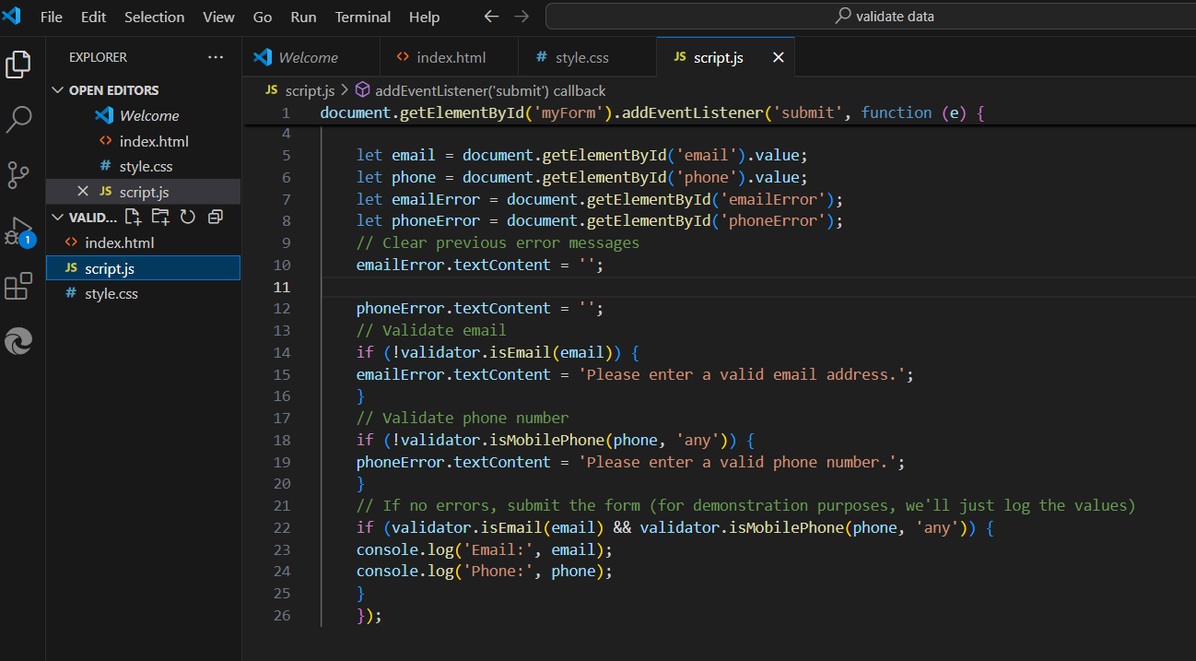

**Output:**

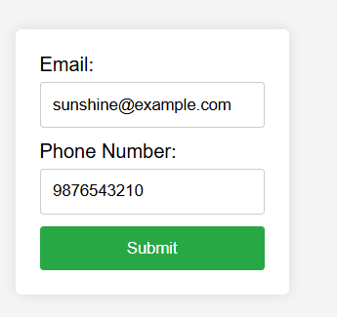

* Doesn’t show error when the email is given with @ and domain.

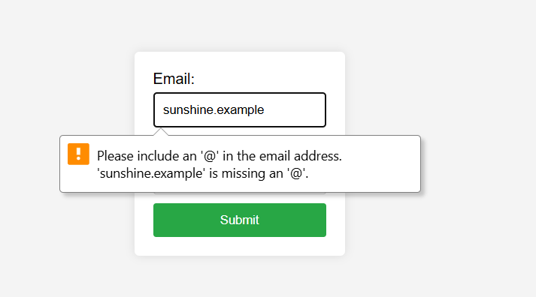

* Shows a warning message when ‘@’ symbol is missed out.

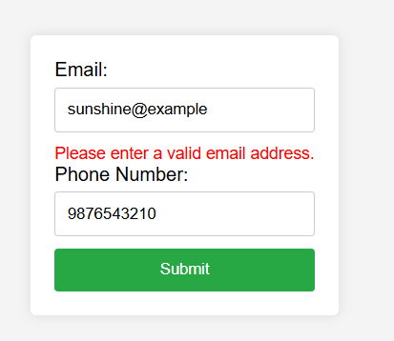

* Shows an error message whenever proper domain is missed out or not given properly.

**Conclusion**

This exercise demonstates how to create a form with validation for email and phone number inputs using HTML, CSS, and JavaScript with the Validator.js library. The form provides real-time error feedback to users, ensuring data is entered correctly before submission.