**Exercise 5a 230701278**

# Simulate the lifecycle stages for UI design using the RAD model and develop a small interactive interface using Axure RP

A crucial component of application development is user interface (UI) design, which aims to improve user experience by creating layouts that are easy to use and accessible. The Rapid Application Development (RAD) model, which prioritizes quick prototyping, user participation, and iterative enhancements, is used in this project to illustrate the UI design lifecycle. The objective is to use Axure RP to build a fashion shopping app prototype while simulating each of the RAD phases: requirements planning, user design, construction, and cutover.

Important features like category-based product browsing, dynamic product listings, and user authentication are all included in the prototype. Wireframes and interactions were produced quickly and effectively with Axure RP, allowing for rapid feedback and improvement. This method demonstrates how RAD speeds up UI development while maintaining user-centered design, which results in a useful and entertaining shopping experience.

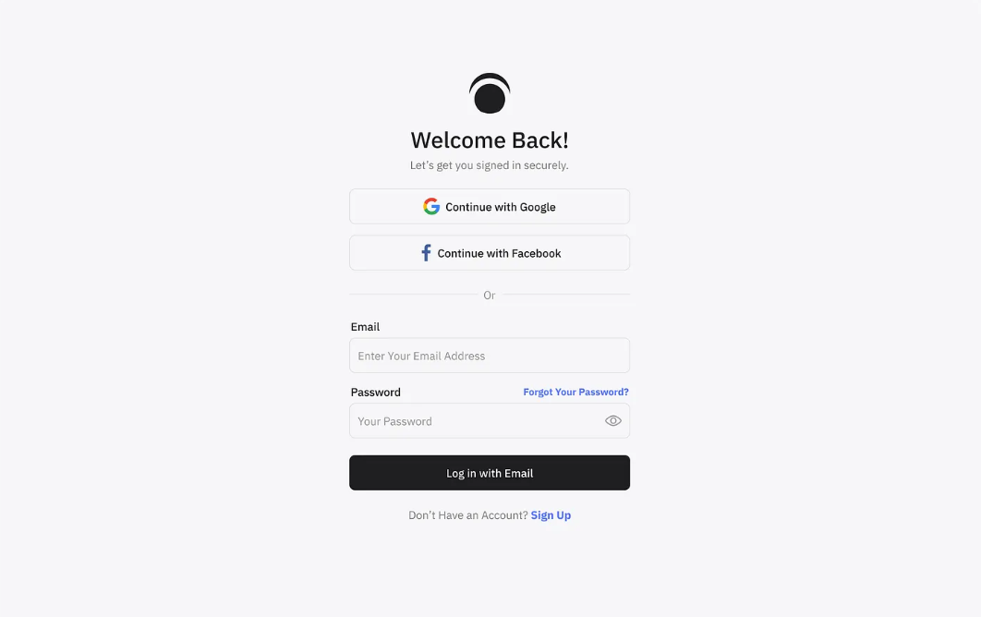

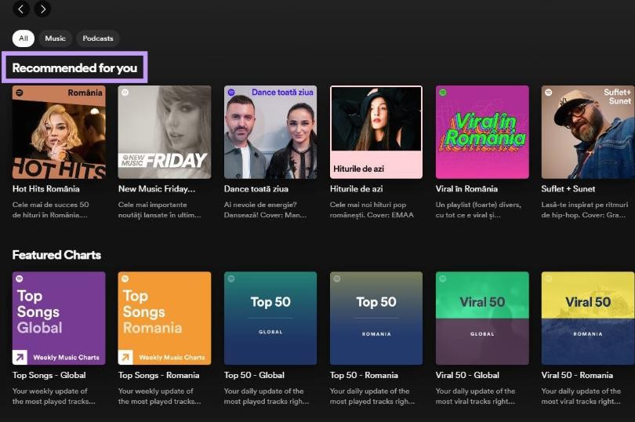

# Applying the RAD Model to UI Design

## Phase 1: Requirements Planning Key Features Identified:

*User Authentication*: Login with email/password and Google.

*Product Browsing*: View categories and product listings. *Product Filters*: Tabs like Mega Price Drop and Top Rated. **User Stories:**

As a user, I want to log in easily so I can access my shopping dashboard. As a user, I want to browse clothes by category and popularity.

As a user, I want to view detailed product prices before purchasing.

## Phase 2: User Design

*Tool Used*: Axure RP (https://[www.axure.com)](http://www.axure.com/) *Project Name*: Fashion Shopping App Interface **Wireframes Designed**:

## Login Screen

Email and password fields

"Remember me" and "Forgot password" options Sign-up and Google login buttons

## Product Listing Screen

Horizontal scroll of categories (Kurta sets, Co-ords, etc.) Tabs for filtering (Mega Price Drop, Top Rated)

Grid view of products with images and prices

## Interactions Added:

Click on "Sign up" to navigate to registration.

"Sign in with Google" triggers external auth flow (prototype level). Product category or filter selection updates the listing dynamically. **Masters Created:**

Header with tabs and category bar for reusability.

## Annotations:

Each widget annotated to indicate functionality (e.g., “Tapping this button logs in the user”).

## Phase 3: Construction Interactive Prototype Developed:

Screens linked using OnClick interactions in Axure.

Product list uses repeater or dynamic panels to simulate real-time listing changes.

## Testing and Feedback:

Internal testing for screen navigation, button actions.

Peer review to ensure intuitive flow and clean visual hierarchy.

Feedback incorporated: improved CTA button contrast, adjusted image scaling.

## Phase 4: Cutover Deployment:

Prototype published using Axure Cloud for demonstration. Shared with classmates/instructor via public link.

## Training & Support:

Documentation created explaining screen purposes and navigation. Users guided on how to interact with prototype features.