【별첨1】
산학협력 프로젝트 결과보고서

과 제 명 | Sub-typing Cancer Cells using Machine Learning
협력기관명 | 백제현Director (R&D Center for Clinical Mass Spectrometry, Seegene Medical Foundation) | 과제책임자 | 백은옥 교수님
참여인원 | (총 8명) 기업체 1명, 참여교수 1명, 학부과정 5명, 대학원과정 1명
수행기간 | 2020.04.20 ~2020.10.07 | 소요비용 | 비워두세요.
추진배경
Working on a graduation project can be proven to be difficult for undergrad students. Especially working on such a big project with limited knowledge can be confusing and proper guidance is necessary. That is why our department has provided students with mentoring sessions. The mentors were matched with the students according to the similarity of the graduation project and fieldwork. The main objective of mentoring sessions was to provide us the students, proper guidelines, advice, and a helping hand for the graduation project.
From April to October, the online mentoring session was held 3 times through google meet, and each time the duration was 60 mins. The students would ask questions regarding their projects and the mentor would provide thoughtful insights. Each new session, discussion on the previous approaches, and up to date analysis of the project would be held as well.
목표 및 내용
The mentoring style was mainly question and answer. As a computer science major, our understanding of bioinformatics especially about working with peptides, mass analysis, the chemistry of amino acids was very limited. However, we had to work with labeled and non-labeled data of peptides, fragments(informatics), etc. Therefore, to understand the data properly and how to analyze it properly, we had to stumble upon many questions and obstacles. After asking our mentor proper questions regarding our project, he kindly guided us to many resources and advice. some of the topics that we had learned and discussed during our mentoring period are mentioned as follows:
- Explanation of what is being done at the Mass Analysis Research Institute of the current company.
- Basic principles of mass analysis
- Explanation of the physical chemistry and charge of amino acids
- Characteristics of peptide made by truncation of tripsin
- Ionization of peptide
- PI values and ionization of amino acids
- Basicity and ionization efficiency of lysine, arginine, and histidine
- Explanation of the cutting and sculptural ion formation in the gas phase of peptide (n-terminal side = b-ion, c-terminal side = y-ion formation)
- Introduce the security of Precursors and weaknesses of the TMT analysis (example of the effects of quantitative values according to purify)
- Explain the accuracy of the TMT quantitative results affected by the purity of the Precursor peak and the relationship between the accuracy of the classifications of the calculator-subtype
- Explain the basic contents and pros and cons of the quantitative methods of Parallel reaction monitoring (PRM) and general Label Free Quantification (LFQ).

- what are some of the usual methods of doing normalization?

- working with labeled data. Effect of temperature, initial pH, rotation speed

- working with a unique peptide

- biological factors, negligible data (how to calculate it)

- PIP Precursor Isolation Purity and Filtering
The Mentoring session did not just include academic mentoring but also career-based mentoring as well. Some of the advice we received from our mentor is as follow:
- How to find a well-paid job
- What path do I have to follow to become a professor?
- How to get a master's degree in a situation of hard work
- What to do when someone doesn't know if they want to work or master after graduation.
- How to get a job in Korea as a foreigner
- How to prepare for the job test and interview

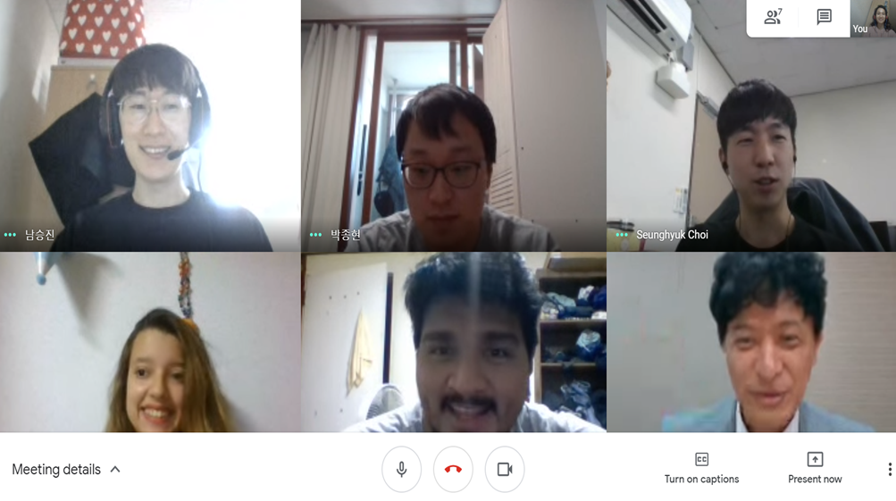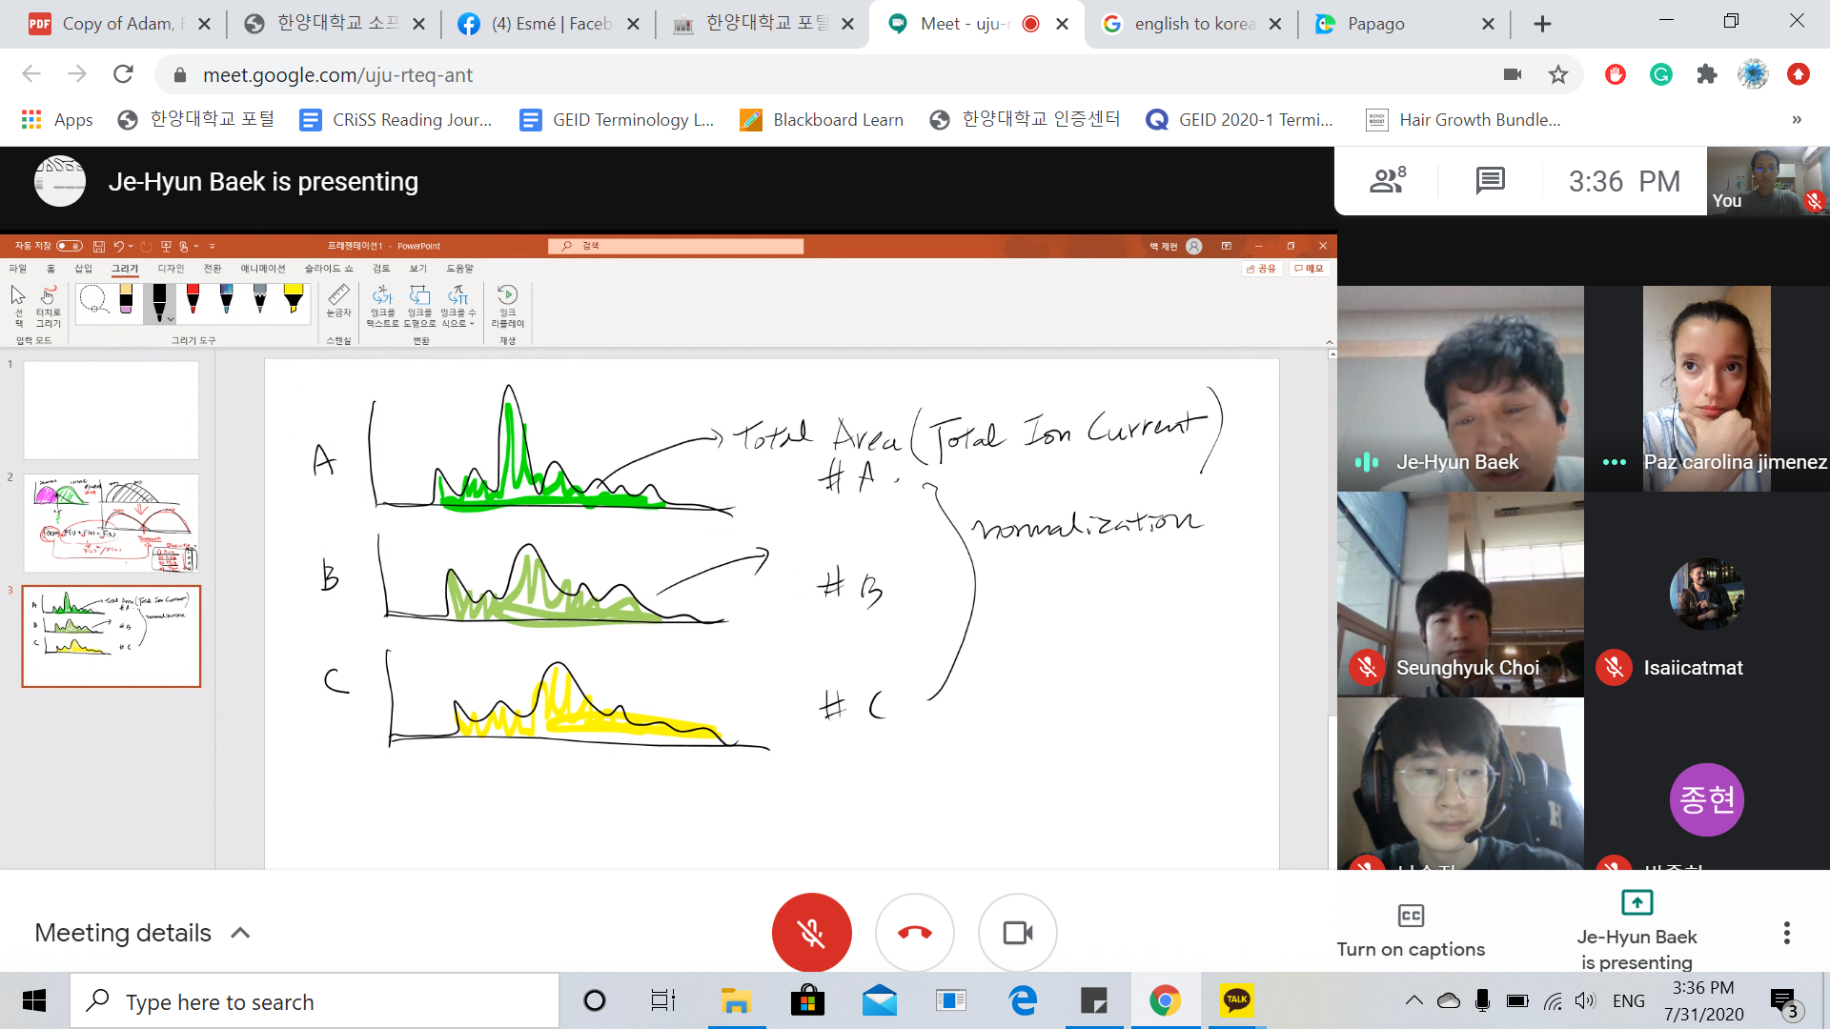

Fig 1 & 2: Mentoring in session

수행결과
◦
- For every mentoring session, we filled the mentor with details of our project's current status, our ideas and approaches. He would provide insights and analysis of them. We proceeded according to them.
For example, we had to work with labeled data. one of our confusion was about the method of normalizing and working with labeled peptides. After the counseling, he gave in-depth answers to all our questions which helped solve all our questions and confusions. We proceeded with data processing according to it.

One of the challenges for our project was training our CNN model with a small amount of data. Even though the mentor himself wasn't able to provide us with a specific technology that can be used. He however did show us some examples and possible technology. However, our TA had possible ideas and one of them was one-shot-learning. We showed the regarding the paper to the mentor and he approved of it, promising us assurance.

