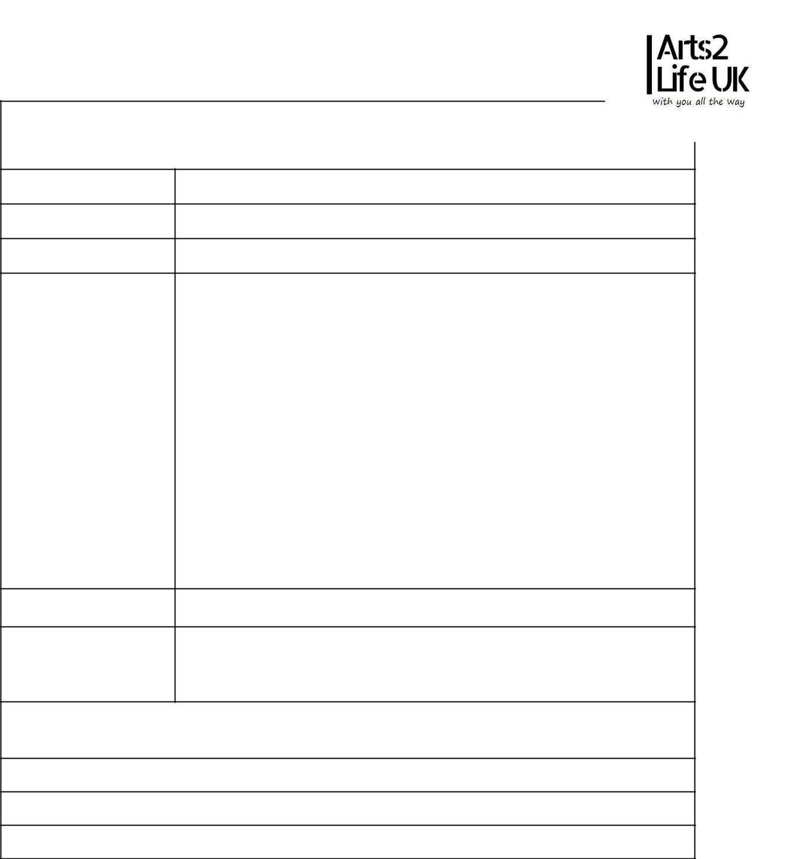
Arts2Life Artist Registration Form

Please complete EVERY section of this form

Artist Info

Name of Act:

Number of Members:

Genre:

Bio/Brief Description

of Act

Links To Music:

Links to Social

Media:

Personal Info

Main Contact Name:

Main Contact Mobile Number:

Email Address:
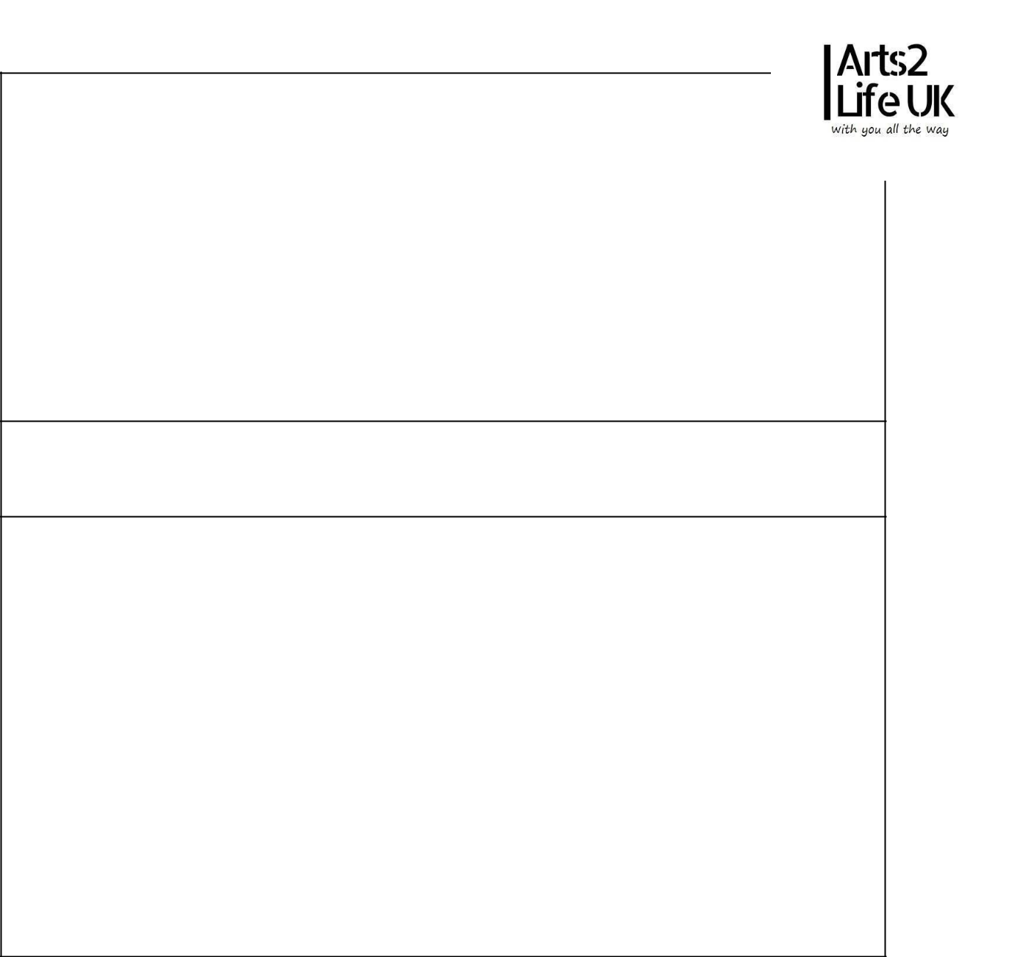
Technical Specifications/Requirements

Notes:

We ask that you give us full support with promoting any event that you may be involved with – Sharing our social media posts, making your own posts from our guidelines, word of mouth etc. This is essential to making the event a success for everyone involved, and we really appreciate it!

Photoshoot: ​You will be offered a FREE photoshoot as part of your experience with us. The images taken at this shoot will be yours to keep following the event. This is also FREE. Please make every effort to participate in these shoots as the images will be used to promote you/your music. If you do not participate in them, our promotions team will be unable to promote you as well as they could. If you are not within distance for a Photoshoot to occur, you will be advised to supply images.

Arts2Life is a group of volunteers dedicated to promoting Bristol’s unsigned artists. Our volunteers' time is very valuable, and we really appreciate your full and prompt cooperation with any requests that they have from you.

Once you have completed this form, please return to ​arts2lifeukevents@gmail.com​with the subject title as: ​Artist Application.

