ASSIGNMENT-4

G.Sai Sriragh
201501113

8 GB RAM,I5 processor

Sort Merge Join:

Blocks given | Time taken in seconds
50 | 3.666
60 | 3.624
70 | 3.521
80 | 3.498
90 | 3.366
100 | 3.177
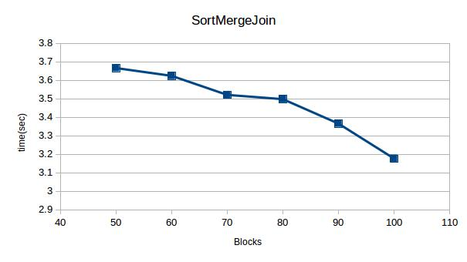

As number of blocks increases time decreases.

Hash Join:
Blocks | Time(sec)
50 | 4.276
60 | 4.037
70 | 3.739
80 | 3.701
90 | 3.689
100 | 3.537
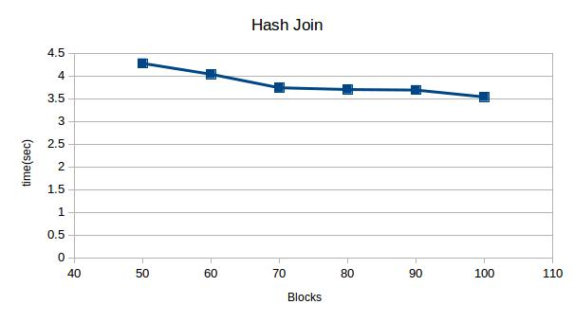
As number of blocks increases time decreases.

