I
DESIGN AND 32-nm PHYSICAL IMPLEMENTATION OF A
HIGH-PERFORMANCE PIPELINED INT8 SYSTOLIC-ARRAY
AI ACCELERATOR
A Dissertation work submitted in partial fulfillment of the requirement
for the award of the degree of
MASTER OF TECHNOLOGY
In
VLSI DESIGN
By
[STUDENT NAME]
Regd.No: [REGISTRATION NUMBER]
Under the esteemed guidance of
[GUIDE NAME], M.Tech (Ph.D)
Assistant Professor
Department of Electronics and Communication Engineering
B V RAJU INSTITUTE OF TECHNOLOGY
(Approved by AICTE, New Delhi and Affiliated to JNTUH, Hyderabad)
Vishnupur, Narsapur, Medak. (Dist)-502313
2025-2026

II
B.V. RAJU INSTITUTE OF TECHNOLOGY
Vishnupur, Narsapur, Medak. (Dist.) Pin: 502313
(Affiliated to JNTU, Hyderabad)
Department of Electronics and Communication Engineering
CERTIFICATE
This is to certify that the Dissertation work entitled “Design and 32-nm Physical Implementation of a High-Performance Pipelined INT8 Systolic-Array AI Accelerator” is being submitted by [STUDENT NAME] in partial fulfillment of the requirement for the award of the degree of M.Tech in VLSI Design, B V RAJU INSTITUTE OF TECHNOLOGY, Narsapur, Medak, affiliated to Jawaharlal Nehru Technological University, Hyderabad, under my guidance and supervision.
The results presented in this major project have been verified and are found to be satisfactory.

Head of the Department | Internal Guide
[HOD NAME]  Professor and HOD  Department of ECE | [GUIDE NAME]  Assistant Professor  Department of ECE

External Examiner

III
ACKNOWLEDGEMENT
It has been a great privilege to be a postgraduate student of the Department of Electronics and Communication Engineering at B V RAJU INSTITUTE OF TECHNOLOGY, Narsapur. The academic environment, laboratory facilities, and constant support from the faculty have provided the necessary motivation to complete this dissertation work successfully.
I express my sincere gratitude to our college management and the Principal for providing the required infrastructure and facilities for carrying out the project work. I am also thankful to the Head of the Department for continuous encouragement, monitoring, and support during the execution of the project.
I would like to express my deep sense of gratitude to my internal guide, [GUIDE NAME], Assistant Professor, Department of ECE, for valuable guidance, suggestions, and technical support throughout the project. His/her guidance helped me understand the RTL design, synthesis flow, and physical implementation stages in a systematic manner.
I also thank all faculty members and non-teaching staff of the ECE Department for their direct and indirect support. Finally, I extend my heartfelt thanks to my family and friends for their constant encouragement and support throughout the completion of this project.

[STUDENT NAME]
([REGISTRATION NUMBER])

IV
DECLARATION
I hereby declare that the work presented in this project entitled “Design and 32-nm Physical Implementation of a High-Performance Pipelined INT8 Systolic-Array AI Accelerator” submitted towards completion of the major project in the second year of M.Tech in VLSI Design at B V RAJU INSTITUTE OF TECHNOLOGY, Narsapur, is an authentic record of original work carried out under the guidance of [GUIDE NAME], Assistant Professor, Department of ECE.
The matter embodied in this dissertation has not been submitted previously for the award of any degree or diploma in any other institution.

Place: Narsapur
Date: [DATE]

[STUDENT NAME]
[REGISTRATION NUMBER]

V
CONTENTS
Certificate | II
Acknowledgement | III
Declaration | IV
Abstract | XI
CHAPTER 1 : INTRODUCTION | 1-9
1.1 Introduction | 1
1.2 Artificial Intelligence Accelerators | 2
1.3 Matrix Multiplication in Machine Learning | 3
1.4 Need for Systolic Array Architecture | 4
1.5 Problem Statement | 5
1.6 Motivation and Objectives | 6-7
1.7 Expected Contributions | 8
1.8 Scope of the Project | 9
CHAPTER 2 : LITERATURE SURVEY | 10-19
2.1 Introduction to Literature Survey | 10
2.2 Review of Base Paper | 11-12
2.3 Existing Systolic Array Accelerators | 13-15
2.4 Processing Element Optimizations | 16
2.5 Pipelining in VLSI Datapaths | 17
2.6 Research Gap | 18-19
CHAPTER 3 : BASELINE ARCHITECTURE | 20-30
3.1 Baseline Accelerator Overview | 20
3.2 Processing Element Design | 21-22
3.3 8x8 Systolic Array Structure | 23-25
3.4 Register Interface and Control | 26
3.5 Limitations of Existing System | 27-30
CHAPTER 4 : PROPOSED METHODOLOGY | 31-50
4.1 Proposed Pipelined Design Approach | 31
4.2 Critical Path Analysis | 32-34
4.3 Pipelined Processing Element | 35-38
4.4 Array-Level Timing Modification | 39-40
4.5 RTL Verification Methodology | 41-43
4.6 SDC Constraint Methodology | 44-45
4.7 Design Compiler Methodology | 46-47
4.8 ICC2 Physical Design Methodology | 48-50
CHAPTER 5 : IMPLEMENTATION | 51-72
5.1 Inputs Required for Physical Design | 51-52
5.2 Design Import and Library Setup | 53-54
5.3 Floorplanning | 55-56
5.5 Placement and Pre-CTS Optimization | 59-61
5.4 Power Planning | 57-58
5.6 Clock Tree Synthesis | 62-64
5.7 Routing | 65-66
5.8 Physical Verification | 67-69
5.9 Report Generation and Output Files | 70-71
5.10 Final Implementation Checklist | 72
CHAPTER 6 : RESULTS AND DISCUSSION | 73-79
6.1 Result Parameters | 73
6.2 Synthesis Results | 74-75
6.3 Physical Design Results | 76-77
6.4 Baseline vs Proposed Comparison | 78-79
CHAPTER 7 : CONCLUSION | 80-82
7.1 Summary | 80
7.2 Future Scope | 81-82
REFERENCES | 83-84
APPENDIX | 85-90

IX
LIST OF FIGURES
Fig 1.1 RTL-to-GDSII project flow | 3
Fig 3.1 8x8 systolic array architecture | 23
Fig 3.2 Baseline processing element datapath | 22
Fig 4.1 Proposed pipelined processing element | 36
Fig 4.2 Accelerator data movement | 40
Fig 4.3 Accelerator control flow | 42
Fig 4.4 Design Compiler flow | 46
Fig 4.5 ICC2 physical design flow | 49
Fig 5.1 Inputs required for physical design | 52
Fig 5.2 Design import and library setup in ICC2 | 54
Fig 5.3 Floorplan of the pipelined systolic-array accelerator | 56
Fig 5.4 Power planning structure | 58
Fig 5.5 Standard-cell placement of the accelerator | 61
Fig 5.6 Clock tree synthesis for the proposed accelerator | 64
Fig 5.7 Routed layout of the accelerator | 66
Fig 5.8 Physical verification checks after routing | 69
Fig 5.9 Final GDS layout view | 71
Fig 6.1 Critical path reduction by pipelining | 75
Fig 6.2 Expected ICC2 layout view | 77
Fig 6.3 Power, performance and area metrics | 78
Fig 7.1 Project execution plan | 82

XI
ABSTRACT
Artificial intelligence and machine-learning applications require a large number of arithmetic operations, especially multiplication and accumulation operations. Matrix multiplication is one of the most important computations used in neural-network inference, convolutional neural networks, and deep-learning accelerators. General-purpose processors are not always efficient for executing such repeated and parallel arithmetic operations. Therefore, dedicated hardware accelerators are widely used to improve computational performance.
This project presents the design and 32-nm physical implementation of a high-performance INT8 systolic-array AI accelerator. The baseline architecture consists of an 8x8 systolic array with 64 processing elements. Each processing element performs signed 8-bit multiplication and 32-bit accumulation. The accelerator is mainly designed for matrix-multiplication-based machine-learning workloads.
The main objective of this project is to improve the timing performance of the baseline systolic-array accelerator. In the baseline design, the multiplier and accumulator adder are present in the same combinational path inside the processing element. This increases the critical path delay and limits the maximum operating frequency. To overcome this limitation, a pipelined processing-element architecture is proposed. In the proposed design, a pipeline register is inserted between the multiplication stage and the accumulation stage. This divides the MAC operation into separate pipeline stages and reduces the critical path delay.
The RTL design is developed using Verilog HDL and verified using simulation testbenches. The baseline and proposed designs are synthesized using Synopsys Design Compiler with a 32-nm standard-cell library. Physical implementation is carried out using Synopsys ICC2, including floorplanning, placement, clock-tree synthesis, routing, and post-route timing analysis. The two designs are compared in terms of area, power, timing, maximum operating frequency, and physical layout quality.

CHAPTER 1
INTRODUCTION
1.1 Introduction
The rapid growth of artificial intelligence has increased the demand for high-speed hardware architectures that can execute repeated arithmetic operations efficiently. A large portion of modern machine-learning computation is dominated by multiply-accumulate operations. These operations appear in convolution, matrix multiplication, fully connected layers, and many signal-processing workloads. When these operations are executed using a general-purpose processor, the available parallelism is not fully utilized. This motivates the design of dedicated hardware accelerators.
An AI accelerator is a hardware block designed to perform a particular set of arithmetic operations faster and more efficiently than a general-purpose processor. In neural-network inference, 8-bit integer arithmetic is widely used because it provides a good balance between accuracy, area, and speed. INT8 arithmetic reduces storage requirements and simplifies multiplier hardware compared with floating-point arithmetic. Therefore, INT8 systolic-array accelerators are suitable for embedded and edge AI applications.
This project focuses on the design and implementation of an 8x8 INT8 systolic-array AI accelerator. The project starts from a baseline RTL design and improves its timing performance by introducing a pipelined processing element. The final design is targeted for a 32-nm ASIC design flow using Synopsys Design Compiler and Synopsys ICC2.
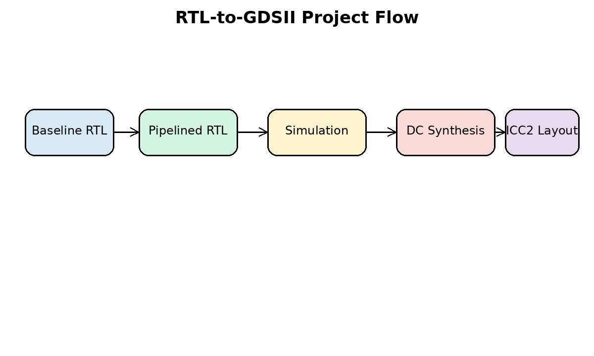
Fig 1.1 RTL-to-GDSII project flow
1.2 Artificial Intelligence Accelerators
AI accelerators are specialized hardware engines used to speed up machine-learning workloads. These accelerators may be implemented as GPUs, TPUs, DSP accelerators, FPGAs, or ASIC blocks. ASIC-based AI accelerators provide the best opportunity for optimized power, performance, and area because the architecture can be tailored to the computation pattern.
The most common operation in neural-network inference is the MAC operation. A MAC unit multiplies two operands and accumulates the result with previous partial sums. When thousands or millions of MAC operations are required, a parallel hardware architecture is necessary. Systolic arrays are among the most important structures used for this purpose.
Unlike a CPU, which executes operations sequentially or with limited SIMD parallelism, a systolic-array accelerator contains many small processing elements operating simultaneously. This improves throughput and reduces unnecessary data movement by passing values directly between neighboring processing elements.
1.3 Matrix Multiplication in Machine Learning
Matrix multiplication is the backbone of many machine-learning algorithms. In convolutional neural networks, convolution can be transformed into matrix multiplication using data rearrangement techniques. In fully connected layers, the output is obtained by multiplying the input activation matrix with the weight matrix. Transformer models also rely heavily on matrix multiplication for attention and feed-forward operations.
For two matrices A and B, the output matrix C is computed by multiplying rows of A with columns of B. Each output element is obtained by repeatedly multiplying corresponding elements and accumulating the partial products. This computation maps naturally to an array of MAC units.
In this project, the accelerator is designed for INT8 matrix multiplication. The operands are signed 8-bit values and the partial sums are accumulated using 32-bit registers. The use of 32-bit accumulation avoids overflow for typical INT8 matrix operations and provides sufficient precision for inference workloads.
1.4 Need for Systolic Array Architecture
A systolic array is a regular arrangement of processing elements connected in a grid. Data flows through the array in a rhythmic manner, similar to the pumping action of a heart. Each processing element performs local computation and forwards data to its neighboring elements. This regular communication pattern makes systolic arrays highly suitable for VLSI implementation.
The main advantages of systolic arrays are high parallelism, local interconnection, high data reuse, and scalable design. Since data is reused within the array, memory bandwidth requirements are reduced. Local interconnection also simplifies physical design compared with fully connected architectures.
The selected architecture uses an 8x8 systolic array containing 64 processing elements. After the pipeline is filled, multiple MAC operations can be executed in parallel every clock cycle. This makes the design suitable for high-throughput matrix multiplication.
1.5 Problem Statement
The baseline 8x8 INT8 systolic-array accelerator has a processing element in which multiplication and accumulation occur within the same combinational path. The critical path includes the signed multiplier, sign extension logic, 32-bit adder, and accumulator register setup time. This long path limits the maximum operating frequency of the accelerator.
For high-performance ASIC implementation, the critical path must be reduced. A shorter critical path allows the design to meet tighter clock constraints and improves the maximum frequency. Therefore, the problem addressed in this project is the timing limitation caused by the long MAC datapath inside the processing element.
The proposed solution is to pipeline the processing element by inserting a register after the multiplier. This separates multiplication and accumulation into two stages and reduces the delay of each clock cycle.
1.6 Motivation and Objectives
The motivation for this project is to improve the timing performance of an AI accelerator using a practical VLSI design technique. Pipelining is one of the most widely used methods to improve throughput and maximum operating frequency in digital systems. By applying pipelining at the processing-element level, the timing performance of the complete systolic array can be improved.
The objectives of the project are to study systolic-array accelerators, understand the baseline RTL, identify the critical path, design a pipelined PE, verify the functionality, synthesize the design using Design Compiler, implement the physical layout using ICC2, and compare the baseline and proposed architectures using PPA metrics.
- Study the architecture of systolic-array-based AI accelerators.
- Analyze the baseline 8x8 INT8 systolic-array RTL design.
- Identify the timing-critical path inside the processing element.
- Introduce a pipeline register between multiplication and accumulation.
- Verify the RTL using simulation testbenches.
- Synthesize the design using Synopsys Design Compiler and a 32-nm standard-cell library.
- Perform physical implementation using Synopsys ICC2.
- Compare timing, area, power, and layout quality between the baseline and proposed designs.
1.7 Expected Contributions
The main contribution of this project is the design of a high-performance pipelined processing element for an INT8 systolic-array AI accelerator. The proposed architecture reduces the PE critical path by registering the multiplier output before accumulation. This design change enables improved frequency and better timing closure during synthesis and physical implementation.
Another contribution is the complete RTL-to-GDSII implementation flow. The design is not limited to RTL simulation; it is carried through synthesis and physical design using industrial Synopsys tools. This makes the project suitable for an M.Tech VLSI major project because it covers architecture, RTL design, verification, synthesis, timing analysis, physical design, and results comparison.
1.8 Scope of the Project
The scope of this project is limited to INT8 matrix-multiplication acceleration using an 8x8 systolic array. The project does not claim to implement a complete processor or a full neural-network system. Instead, it implements a hardware accelerator block that can be integrated into a larger SoC.
The project focuses on performance improvement through pipelining. It does not focus on low-power clock gating, fault tolerance, redundancy, or algorithmic accuracy improvement. The evaluation is based on area, timing, power, utilization, and physical design reports obtained from Synopsys DC and ICC2.

CHAPTER 2
LITERATURE SURVEY
2.1 Introduction to Literature Survey
The literature survey provides the technical background required for this project. It covers systolic arrays, machine-learning accelerators, processing-element optimization, pipelining, and ASIC implementation methodology. The survey also identifies the research gap addressed by the proposed work.
Systolic arrays have been studied for several decades and continue to be important in modern AI accelerators. Their regular structure, local data movement, and high computational density make them suitable for VLSI implementation. Modern AI accelerators use systolic arrays or similar MAC arrays to improve throughput for neural-network inference.
2.2 Review of Base Paper
The selected base paper for this project is “Hybrid Accumulator Factored Systolic Array for Machine Learning Acceleration” by Kashif Inayat and Jaeyong Chung, published in IEEE Transactions on Very Large Scale Integration Systems in 2022. The paper focuses on systolic-array optimization for machine-learning acceleration. It discusses the importance of processing-element and accumulator-level design decisions in systolic-array hardware.
The base paper is relevant because it demonstrates that optimization at the processing-element level can affect the complete systolic array. Since a systolic array contains many repeated PEs, even a small change inside one PE is multiplied across the array. This observation directly motivates the present project, where the PE datapath is modified using pipelining to improve timing performance.
The difference between the base paper and the present work is the optimization target. The base paper studies accumulator factoring, whereas this project focuses on timing improvement through pipelining. Both works belong to the same domain of systolic-array accelerator optimization for machine-learning workloads.
2.3 Existing Systolic Array Accelerators
Existing AI accelerators use different forms of matrix-multiplication engines. The Tensor Processing Unit popularized the use of a large systolic array for neural-network inference. Many academic and industrial designs use arrays of MAC units to exploit data reuse and parallelism. The regular layout of systolic arrays is advantageous for ASIC physical design because the design can be replicated systematically.
A typical systolic array receives activations from one direction and weights from another direction. Each PE performs a MAC operation and forwards data to neighboring PEs. Depending on how partial sums, activations, and weights are stored or moved, the dataflow may be weight-stationary, output-stationary, or row-stationary. The present design uses INT8 input operands and 32-bit accumulation for matrix multiplication.
Several accelerator designs use reduced precision arithmetic such as INT8 or INT4 to reduce area and improve throughput. INT8 is commonly used because it provides a practical balance between hardware efficiency and inference accuracy. This project adopts INT8 multiplication and 32-bit accumulation, which is a common design choice for inference accelerators.
2.4 Processing Element Optimizations
The processing element is the most important unit in a systolic array. Since it is repeated many times, its design affects area, power, timing, and routing. PE optimization may focus on multiplier architecture, accumulator design, data storage, operand reuse, pipeline depth, and local control.
A long critical path inside the PE reduces the maximum clock frequency of the complete accelerator. Therefore, many designs use pipelined MAC units to improve timing. Pipeline registers split a long computation into shorter stages. This improves frequency but may increase latency and sequential area. The present project follows this principle by inserting a product pipeline register between multiplier and accumulator.
2.5 Pipelining in VLSI Datapaths
Pipelining is a fundamental technique in high-performance digital design. In a non-pipelined datapath, a complete operation must finish within one clock cycle. If the operation contains multiple logic stages, the clock period must be long enough to include the total delay. In a pipelined datapath, registers are inserted between logic stages, and the work is divided across multiple cycles.
The key benefit of pipelining is improved maximum frequency. Each pipeline stage has a smaller delay, allowing a shorter clock period. The trade-offs are increased register count, additional latency, and possible increase in power. In an accelerator, these trade-offs are acceptable if the throughput or operating frequency improves significantly.
2.6 Research Gap
The literature shows that systolic arrays are effective for machine-learning acceleration and that PE-level optimization is important. However, a baseline systolic-array RTL may not meet aggressive timing constraints if the MAC datapath is not pipelined. Many student-level designs stop at functional RTL verification and do not carry the design through complete 32-nm physical implementation.
The research gap addressed in this project is the need for a practical high-performance pipelined systolic-array implementation verified through synthesis and physical design reports. The project bridges architecture modification and ASIC implementation by comparing baseline and proposed designs using PPA metrics.
2.7 Summary of Literature Survey
Reference / Area | Main Contribution | Relevance to Present Project
Hybrid accumulator factored systolic array | Optimizes accumulator structure in systolic arrays for ML acceleration | Motivates PE-level optimization for systolic arrays
Systolic array architectures | Uses regular MAC arrays for matrix multiplication | Provides baseline architecture concept
INT8 accelerator designs | Uses quantized arithmetic for inference workloads | Supports use of signed INT8 multiplier and 32-bit accumulator
Pipelined datapath design | Splits long combinational paths using registers | Supports proposed PE pipelining
ASIC RTL-to-GDSII methodology | Synthesizes and physically implements digital designs | Supports DC and ICC2 flow used in this work

CHAPTER 3
BASELINE ARCHITECTURE
3.1 Baseline Accelerator Overview
The baseline architecture is an 8x8 INT8 systolic-array accelerator. It contains 64 processing elements arranged in 8 rows and 8 columns. The accelerator is designed to perform matrix multiplication using signed 8-bit input operands and 32-bit accumulated outputs.
The main modules in the baseline design are systolic_pe.v, systolic_array_8x8.v, accel_regs.v, accel_top.v, cpu_bfm.v, and soc_top.v. The processing element performs multiplication and accumulation. The array module connects all PEs. The register module provides control and status registers. The top-level module integrates the register interface with the systolic array.
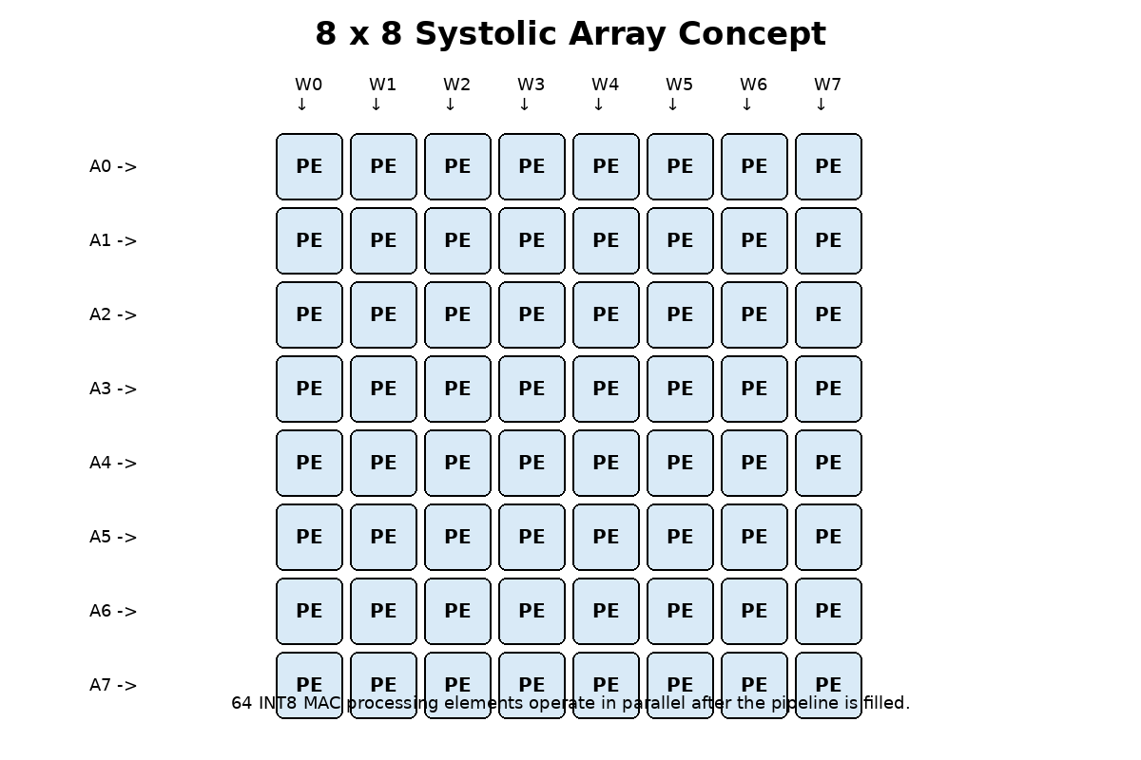
Fig 3.1 8x8 systolic array architecture
3.2 Processing Element Design
The PE is the basic computational unit of the systolic array. It receives an activation input and a weight input, performs signed multiplication, and accumulates the product into a 32-bit accumulator. The PE also forwards activation and weight values to neighboring PEs so that data can propagate through the array.
In the baseline PE, the product of the activation and weight is directly added to the accumulator in the same clock cycle. This creates a long combinational path. The longest path approximately consists of input data, signed multiplier, sign extension, 32-bit adder, and accumulator register setup time. This path determines the minimum possible clock period.
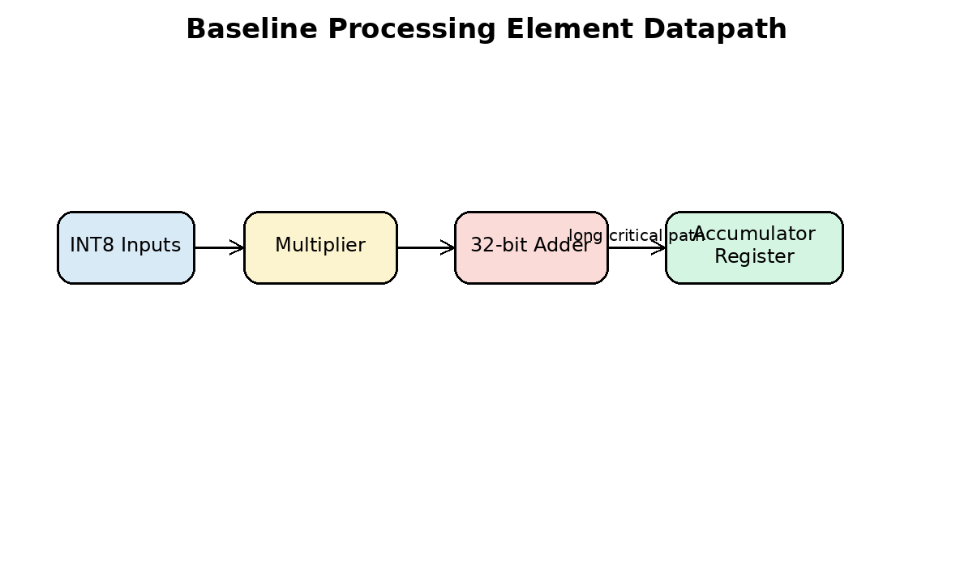
Fig 3.2 Baseline processing element datapath
3.3 8x8 Systolic Array Structure
The systolic_array_8x8 module instantiates 64 processing elements. Activations are applied to the left side of the array and weights are applied to the top side. Data moves from one PE to the next on every clock cycle. Each PE calculates a partial sum based on the data it receives.
The array has a regular structure, which simplifies design and physical implementation. Since the same PE is repeated, the array is modular and scalable. In a larger design, the same idea could be extended to 16x16 or 32x32 arrays, although area and routing complexity would increase.
The baseline array requires a fixed number of compute cycles to complete the matrix operation and drain the results. In the proposed design, one additional cycle is required because of the new pipeline register introduced inside the PE.
3.4 Register Interface and Control
The accelerator includes a simple control and register interface. The register block allows a host or testbench to configure the accelerator, load data, start computation, and read status. Important signals include start, done, clear, compute enable, and configuration cycle count.
The top module maintains compatibility with the existing interface wherever possible. This is useful because the same testbench and synthesis flow can be reused with minor updates. The design is suitable for integration into a larger SoC using a memory-mapped interface.
3.5 Limitations of Existing System
The major limitation of the baseline system is timing performance. Since multiplication and accumulation are performed in the same clock cycle, the PE critical path is long. When the clock period is reduced, the design may fail timing during synthesis or physical implementation.
Another limitation is that the long combinational path affects all PEs. Since there are 64 PEs in the 8x8 array, the timing behavior of the PE is critical for the complete accelerator. Improving the PE critical path is therefore an effective strategy for improving the overall design.
The baseline design is functionally correct for matrix multiplication, but it is not optimized for high-frequency operation. Therefore, the proposed work focuses on performance optimization rather than changing the external functionality of the accelerator.
Parameter | Baseline Design Description
Array size | 8 rows x 8 columns
Number of PEs | 64
Operand precision | Signed INT8 activations and weights
Accumulator precision | 32-bit
Main operation | Multiply-accumulate
Critical path | Multiplier plus accumulator adder
Primary limitation | Lower maximum operating frequency due to long MAC path

CHAPTER 4
METHODOLOGY
4.1 Proposed Pipelined Design Approach
The proposed methodology improves the baseline accelerator by modifying the processing element. A pipeline register is inserted at the output of the multiplier. The registered product is accumulated in the next stage. As a result, the multiplier delay and the accumulator adder delay are separated across two clock cycles.
The proposed PE has two main computation stages. In the first stage, signed INT8 operands are multiplied and the product is stored in a product pipeline register. In the second stage, the registered product is sign-extended and added to the accumulator. This approach reduces the critical path and improves timing performance.
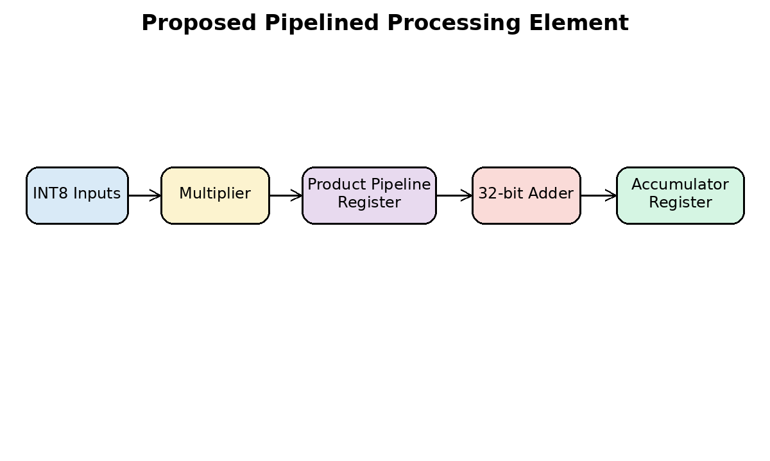
Fig 4.1 Proposed pipelined processing element
4.2 Critical Path Analysis
Critical path analysis is the first step in performance optimization. The critical path is the longest timing path between two sequential elements. In the baseline PE, the critical path includes multiplication and accumulation in one clock cycle. This path limits the minimum clock period.
After pipelining, the critical path is split into two smaller paths. The first path includes input register to multiplier and product register. The second path includes product register to accumulator adder and accumulator register. Since each path is shorter than the original combined path, the clock period can be reduced.
The expected timing improvement should be verified using Synopsys report_timing after synthesis and after physical implementation. The final result must be based on actual reported slack and critical path delay.
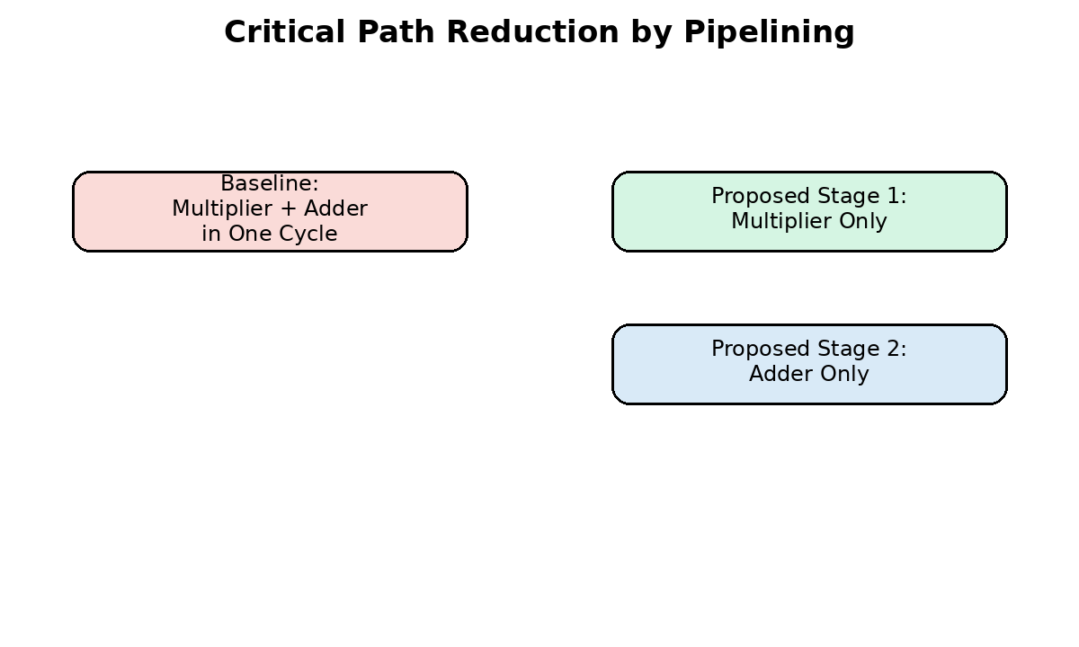
Fig 4.2 Critical path reduction by pipelining
4.3 Pipelined Processing Element
The proposed processing element keeps the same basic function as the baseline PE. It still performs signed INT8 multiplication and 32-bit accumulation. The main difference is the addition of a pipeline register called product_pipe. This register stores the multiplication result before it is added to the accumulator.
The RTL behavior can be described as follows. When compute_en is active, the product of a_in and w_in is calculated and stored in product_pipe. During the next cycle, product_pipe is added to the accumulator. The output partial sum is then available from the accumulator register.
Because the product is delayed by one clock cycle, the systolic array control must allow one additional computation cycle to flush the pipeline. Therefore, the compute cycle count is updated from the baseline value to include the extra pipeline latency.
// Conceptual proposed PE datapath
always @(posedge clk or negedge rst_n) begin
if (!rst_n) begin
product_pipe <= 16'sd0;
acc <= 32'sd0;
end else if (clear) begin
product_pipe <= 16'sd0;
acc <= 32'sd0;
end else if (compute_en) begin
product_pipe <= a_in * w_in; // Stage 1
acc <= acc + product_pipe; // Stage 2
end
end
4.4 Array-Level Timing Modification
The systolic array must be modified to account for the additional latency introduced by the PE pipeline. If the original array required 22 compute cycles, the pipelined version requires 23 compute cycles. The extra cycle allows the last valid product stored in the pipeline register to be accumulated correctly.
This change is important for functional correctness. Without updating the compute cycle count, the accelerator may stop one cycle early and produce incomplete results. Therefore, the register configuration and control logic are updated to use the proposed compute cycle count.
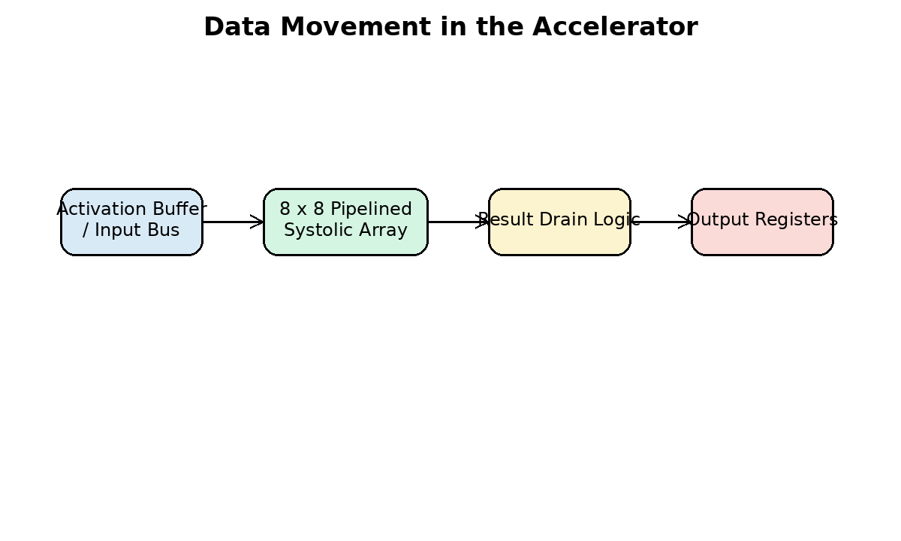
Fig 4.3 Accelerator data movement
4.5 RTL Verification Methodology
Functional verification is performed using Verilog testbenches. The PE testbench checks multiplication, accumulation, clear operation, and pipeline behavior. The systolic-array testbench checks matrix multiplication operation across the 8x8 array. The top-level testbench checks register control, start signal, done signal, and result output.
The expected output timing must account for the extra pipeline stage. The numerical result should remain the same as the baseline design, but the valid output appears one cycle later. Therefore, the testbench includes timing adjustments for the proposed design.
Verification should be performed before synthesis. A design that does not pass functional simulation should not be synthesized. After synthesis, gate-level simulation can also be performed if the library and SDF data are available.
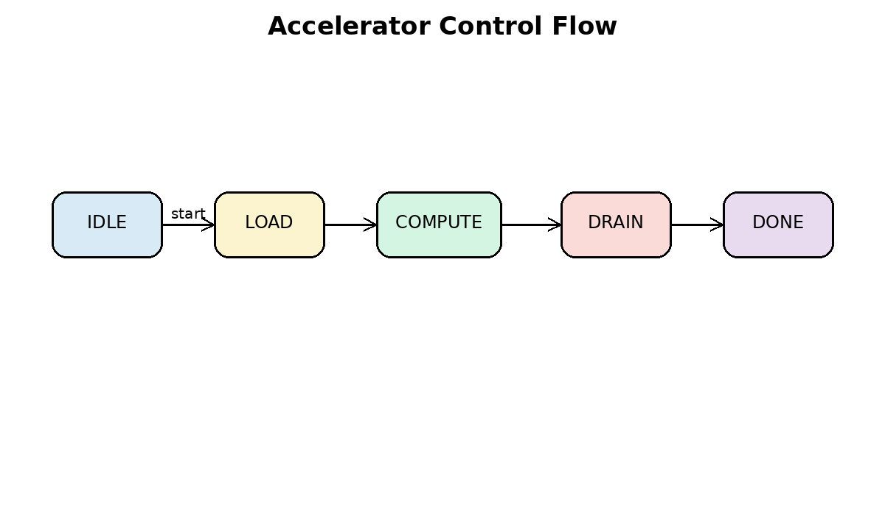
Fig 4.4 Accelerator control flow
4.5.1 Functional Simulation Using Synopsys VCS
Functional simulation is an important verification stage before synthesis and physical implementation. In this project, Synopsys VCS can be used to compile, elaborate, and simulate the Verilog RTL design. The objective of VCS simulation is to confirm that the proposed pipelined INT8 systolic-array accelerator produces functionally correct results before it is given to Design Compiler for synthesis.
Since the proposed architecture includes an additional pipeline register inside the processing element, simulation is required to verify both numerical correctness and timing correctness. The output values must match the expected matrix-multiplication results, but the result availability occurs with the updated pipeline latency. Therefore, the testbench must check both data values and valid output timing.
[IMAGE PLACEHOLDER: Insert VCS simulation flow diagram here]
Fig 4.5 VCS simulation flow for RTL verification
Image Generation Prompt: Create a clean VLSI verification flow diagram for Synopsys VCS simulation. Show Verilog RTL files, testbench files, filelist.f, VCS compile, simulation run, waveform dump, log file, and PASS/FAIL result as connected blocks. Use a white background, black labels, and academic report style.
4.5.2 Inputs Required for VCS Simulation
The main inputs required for VCS simulation are the RTL source files, testbench files, simulation filelist, timescale definition, and optional waveform dump commands. The RTL files describe the design functionality, while the testbench files apply input stimulus and check the output results. A filelist is used to provide all required Verilog source files to the VCS compiler in the correct order.
For this project, the RTL simulation is performed before synthesis. Therefore, standard-cell timing libraries are not required for the initial RTL simulation. However, after synthesis, gate-level simulation may be performed using the mapped gate-level netlist, 32-nm standard-cell Verilog models, and optional SDF timing annotation.
Input File / Data | Purpose in Simulation
systolic_pe.v | RTL model of the pipelined processing element
systolic_array_8x8.v | RTL model of the 8x8 systolic array
accel_regs.v | Control and status register interface
accel_top.v | Top-level accelerator module
tb_systolic_pe.v | Testbench for PE-level functional verification
tb_systolic_array_8x8.v | Testbench for array-level matrix multiplication verification
tb_accel_top.v | Testbench for top-level control and result verification
filelist_vcs.f | List of RTL and testbench files passed to VCS
vcs_compile.log / vcs_run.log | Compilation and simulation log outputs
waveform.vcd / waveform.fsdb | Waveform database for debugging and documentation
Table 4.1 Inputs required for Synopsys VCS simulation
4.5.3 Testbench Hierarchy
The verification environment is organized in three levels. The first level verifies the individual processing element. The second level verifies the complete 8x8 systolic-array datapath. The third level verifies the top-level accelerator, including control signals, start operation, done indication, and output result behavior.
The processing-element testbench applies signed INT8 activation and weight values and verifies the product and accumulated partial sum. The systolic-array testbench applies input matrices and compares the output matrix with a golden reference model. The top-level testbench verifies whether the accelerator responds correctly to control signals and generates the done signal after the required number of compute cycles.
Testbench | Design Under Test | Verification Target
tb_systolic_pe.v | systolic_pe | Multiplier pipeline, accumulation, clear signal, and output propagation
tb_systolic_array_8x8.v | systolic_array_8x8 | 8x8 matrix multiplication, pipeline timing, and result drain behavior
tb_accel_top.v | accel_top | Register interface, start/done control, and top-level result output
Table 4.2 VCS simulation testbench hierarchy
4.5.4 VCS Filelist Preparation
A filelist is prepared to provide the required RTL and testbench files to VCS. Separate filelists may be created for PE simulation, systolic-array simulation, and top-level simulation. This avoids unnecessary recompilation and makes debugging easier.
# Example filelist for PE-level simulation: filelist_pe.f
../rtl/systolic_pe.v
../tb/tb_systolic_pe.v
# Example filelist for array-level simulation: filelist_array.f
../rtl/systolic_pe.v
../rtl/systolic_array_8x8.v
../tb/tb_systolic_array_8x8.v
# Example filelist for top-level simulation: filelist_top.f
../rtl/systolic_pe.v
../rtl/systolic_array_8x8.v
../rtl/accel_regs.v
../rtl/accel_top.v
../tb/tb_accel_top.v
4.5.5 VCS Compilation and Simulation Commands
The VCS simulation flow consists of compilation, elaboration, simulation execution, and waveform analysis. The -full64 option is used for 64-bit compilation. The -sverilog option enables SystemVerilog compatibility if required by the testbench. The -debug_access+all option enables waveform debugging and signal visibility. The -l option stores the tool output in a log file.
# PE-level compilation and simulation
vcs -full64 -sverilog -timescale=1ns/1ps -debug_access+all \
-f filelist_pe.f -top tb_systolic_pe -l logs/vcs_compile_pe.log
./simv -l logs/vcs_run_pe.log
# Array-level compilation and simulation
vcs -full64 -sverilog -timescale=1ns/1ps -debug_access+all \
-f filelist_array.f -top tb_systolic_array_8x8 -l logs/vcs_compile_array.log
./simv -l logs/vcs_run_array.log
# Top-level accelerator compilation and simulation
vcs -full64 -sverilog -timescale=1ns/1ps -debug_access+all \
-f filelist_top.f -top tb_accel_top -l logs/vcs_compile_top.log
./simv -l logs/vcs_run_top.log
[SCREENSHOT PLACEHOLDER: Insert VCS compilation terminal showing zero errors]
Fig 4.6 VCS compilation output
Image Generation Prompt: Create a simple terminal-style illustration showing Synopsys VCS compilation flow. Include command line, filelist input, successful compilation, simv executable generation, and zero errors message. Keep the image clean and suitable for a dissertation.
4.5.6 PE-Level Simulation
PE-level simulation verifies the smallest computational block of the accelerator. The testbench applies different signed activation and weight values to the processing element and checks whether the product is correctly generated and accumulated. Since the proposed PE contains a product pipeline register, the testbench must wait one additional cycle before checking the accumulated value.
The important signals to observe in the PE simulation waveform are clk, rst_n, clear, compute_en, a_in, w_in, product_pipe, acc, a_out, w_out, and psum_out. The reset operation should clear the accumulator and pipeline register. During compute cycles, the product should be registered first and then accumulated in the next clock cycle.
// Example PE test sequence placeholder
reset_design();
clear_accumulator();
apply_input(8'sd3, 8'sd4);
wait_for_pipeline();
check_accumulator(32'sd12);
apply_input(-8'sd2, 8'sd5);
wait_for_pipeline();
check_accumulator(32'sd2);
[WAVEFORM PLACEHOLDER: Insert PE-level waveform showing product_pipe and accumulator update]
Fig 4.7 PE-level VCS simulation waveform
Image Generation Prompt: Create a digital waveform diagram for a pipelined MAC processing element. Show clk, rst_n, compute_en, a_in, w_in, product_pipe, acc, and psum_out. Highlight that product_pipe updates one cycle before accumulator update.
4.5.7 Systolic-Array-Level Simulation
Array-level simulation verifies the complete 8x8 systolic-array datapath. The testbench applies activation and weight matrix values to the array and checks the generated output matrix. A simple golden reference model can be used inside the testbench to compute the expected matrix multiplication result.
In this stage, it is important to verify that the extra PE pipeline stage does not change the numerical result. Only the result timing is shifted by one clock cycle. The compute cycle count must therefore match the updated pipelined architecture. If the baseline design used 22 compute cycles, the proposed pipelined design can require 23 cycles to flush the additional pipeline stage.
// Golden matrix multiplication model placeholder
for (i = 0; i < 8; i = i + 1) begin
for (j = 0; j < 8; j = j + 1) begin
golden[i][j] = 0;
for (k = 0; k < 8; k = k + 1) begin
golden[i][j] = golden[i][j] + A[i][k] * B[k][j];
end
end
end
[WAVEFORM PLACEHOLDER: Insert array-level waveform showing compute cycles, done signal, and output drain]
Fig 4.8 Systolic-array VCS simulation waveform
Image Generation Prompt: Create a waveform-style verification figure for an 8x8 systolic-array accelerator. Show clock, reset, compute_enable, cycle_count, done, and result_valid signals. Indicate pipeline fill, compute phase, and result drain phase using labels.
4.5.8 Top-Level Accelerator Simulation
Top-level simulation verifies the accelerator from the control-interface point of view. The testbench writes configuration values, asserts the start signal, waits for the done signal, and reads the result output. This verifies that the RTL blocks operate correctly when connected together in the top-level module.
The top-level testbench should check reset behavior, start pulse generation, busy status, done status, compute cycle count, and final output result. A successful top-level simulation provides confidence that the design is ready for synthesis using Synopsys Design Compiler.
// Top-level simulation sequence placeholder
apply_reset();
write_control_register(START_BIT);
wait_until_done();
read_result_registers();
compare_with_expected_matrix();
if (all_results_match) $display("TEST PASSED");
else $display("TEST FAILED");
[SCREENSHOT PLACEHOLDER: Insert top-level VCS simulation PASS message]
Fig 4.9 Top-level accelerator simulation result
Image Generation Prompt: Create a clean verification result diagram for top-level accelerator simulation. Show reset, register write, start, compute, done, read results, and PASS status in a linear flowchart format.
4.5.9 Waveform Debug and Result Documentation
Waveform analysis is used to debug signal activity and confirm that the pipeline behaves as expected. VCS can generate waveform databases that may be opened using DVE or Verdi, depending on the available tool setup. The waveform screenshots should be included in the report to support the functional verification claim.
The most useful waveforms for documentation are reset and clock behavior, PE product pipeline behavior, accumulator update, systolic-array compute cycle counter, done signal generation, and output result drain timing. Each waveform screenshot should clearly show the signal names and the time at which valid data is produced.
// VCD waveform dump placeholder inside testbench
initial begin
$dumpfile("waveform.vcd");
$dumpvars(0, tb_accel_top);
end
// Optional FSDB dump placeholder if Verdi/FSDB support is available
initial begin
$fsdbDumpfile("waveform.fsdb");
$fsdbDumpvars(0, tb_accel_top);
end
[SCREENSHOT PLACEHOLDER: Insert DVE/Verdi waveform window showing important simulation signals]
Fig 4.10 Waveform analysis using VCS simulation output
Image Generation Prompt: Create a realistic but clean digital waveform screenshot illustration for a Verilog simulation. Include signals clk, rst_n, start, compute_en, product_pipe, acc, done, and result_valid. Use black waveform background with readable labels, or a white academic-style waveform if preferred.
4.5.10 Optional Gate-Level Simulation
After Design Compiler synthesis, optional gate-level simulation may be performed to verify that the synthesized netlist is functionally equivalent to the RTL. Gate-level simulation requires the mapped Verilog netlist and standard-cell Verilog models. If timing verification is required, the SDF file generated after synthesis or physical implementation can be annotated during simulation.
Gate-level simulation is not a replacement for static timing analysis, but it is useful for checking reset behavior, X-propagation, library linking, and basic post-synthesis functionality. If SDF annotation is used, the testbench timing must be adjusted to account for cell and interconnect delays.
# Gate-level simulation placeholder
vcs -full64 -sverilog -timescale=1ns/1ps -debug_access+all \
../syn/outputs/accel_top_mapped.v \
/path/to/32nm/standard_cell_models.v \
../tb/tb_accel_top.v \
-top tb_accel_top -l logs/vcs_compile_gls.log
./simv +sdfverbose -l logs/vcs_run_gls.log
4.5.11 Simulation Result Placeholders
The following table can be filled after running VCS simulation in the laboratory environment. The final report should include screenshots of the compile log, simulation log, waveform window, and PASS message from the testbench.
Simulation Level | Command / Testbench | Expected Status | Actual Status
PE simulation | tb_systolic_pe | PASS with correct pipelined MAC result | To be filled
Array simulation | tb_systolic_array_8x8 | PASS with correct 8x8 matrix result | To be filled
Top-level simulation | tb_accel_top | PASS with correct start/done/result behavior | To be filled
Optional gate-level simulation | tb_accel_top with mapped netlist | PASS after synthesis | To be filled
Table 4.3 VCS simulation result summary
4.5.12 VCS Simulation Checklist
The design is considered ready for synthesis only after the VCS simulation reports zero compilation errors, zero fatal simulation errors, correct reset behavior, correct product pipeline behavior, correct accumulation, correct done signal generation, and correct final matrix output. Any mismatch between the expected result and the simulated result must be corrected at RTL level before starting synthesis.
The final documentation should include the following simulation evidence: VCS compile log screenshot, VCS run log screenshot, PE waveform screenshot, systolic-array waveform screenshot, top-level PASS message, and a table summarizing the simulation status.

4.6 SDC Constraint Methodology
The Synopsys Design Constraints file defines the timing environment for synthesis and physical design. The most important constraint is the clock period. For this project, a 2 ns clock period may be used as an initial target, corresponding to 500 MHz. The final achievable frequency must be determined from timing reports.
Other important constraints include input delay, output delay, clock uncertainty, reset false path, maximum transition, maximum fanout, and output load. These constraints help the synthesis and physical design tools optimize the design under realistic assumptions.
create_clock -name clk -period 2.000 [get_ports clk]
set_clock_uncertainty 0.100 [get_clocks clk]
set_input_delay 0.300 -clock clk [remove_from_collection [all_inputs] [get_ports clk]]
set_output_delay 0.300 -clock clk [all_outputs]
set_false_path -from [get_ports rst_n]
set_max_transition 0.100 [current_design]
set_max_fanout 16 [current_design]
4.7 Design Compiler Methodology
Synopsys Design Compiler is used for logic synthesis. It reads Verilog RTL and maps the design to a 32-nm standard-cell library. The output of synthesis is a gate-level netlist along with area, timing, power, and QoR reports.
The DC flow consists of setting libraries, reading RTL, elaborating the top module, linking the design, reading constraints, checking the design, compiling with optimization, and writing output files. Both baseline and proposed designs should be synthesized with the same constraints so that the comparison is fair.
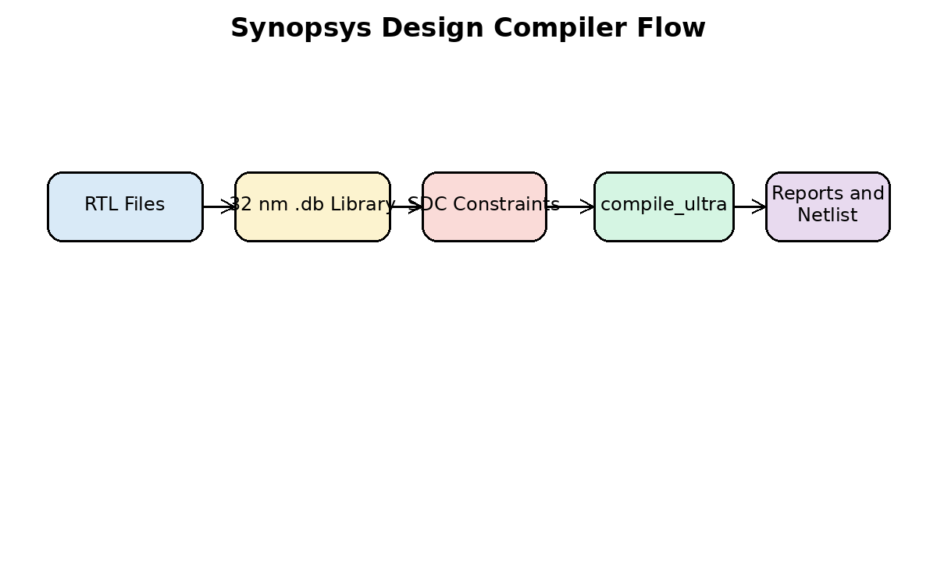
Fig 4.5 Design Compiler flow
4.8 ICC2 Physical Design Methodology
Synopsys ICC2 is used for physical implementation. It converts the synthesized netlist into a physical layout. The physical design flow includes floorplanning, power planning, placement, clock tree synthesis, routing, post-route optimization, and GDSII generation.
Physical implementation is important because synthesis results alone do not include complete routing effects. After placement and routing, timing can change due to wire delays, clock tree insertion delay, congestion, and parasitic effects. Therefore, post-layout timing and power reports are necessary for final evaluation.
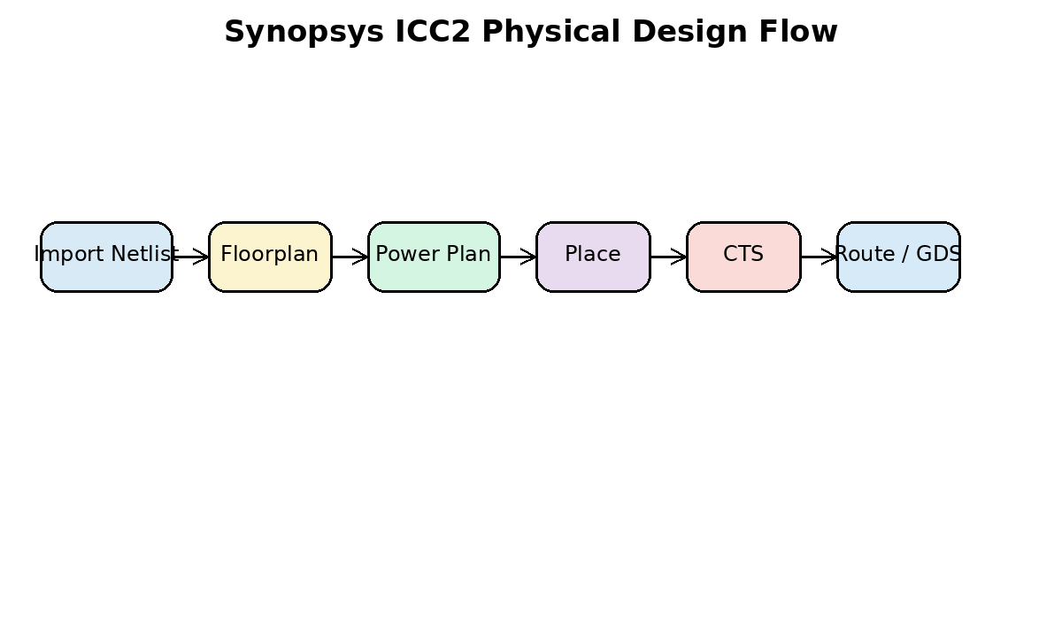
Fig 4.6 ICC2 physical design flow
4.9 Power, Performance and Area Methodology
The proposed project is evaluated using PPA metrics. Performance is measured using critical path delay, worst negative slack, and maximum frequency. Area is measured using combinational area, sequential area, and total cell area. Power is measured using dynamic power, leakage power, and total power.
The proposed design is expected to improve performance, but it may increase sequential area due to additional registers. This is a normal area-performance trade-off in pipelined digital systems.
4.10 Fair Comparison Method
A fair comparison requires that the baseline and proposed designs use the same technology library, same top module constraints, same clock period, same input/output delay assumptions, and same synthesis effort. Only then can the improvement be attributed to the proposed pipelined PE architecture.
Reports should be generated for both versions. The values must be copied directly from Synopsys reports without modification. Estimated or assumed values should not be used in the final result section.
4.11 Verification Checklist
The verification checklist includes reset behavior, clear behavior, compute enable behavior, correct product generation, correct accumulation, correct done signal generation, and correct result drain timing. All tests must pass before the design is considered ready for synthesis.
Waveform screenshots may be included in the final documentation. The most useful screenshots are clock and reset, compute enable, product pipeline register, accumulator output, done signal, and final result bus.
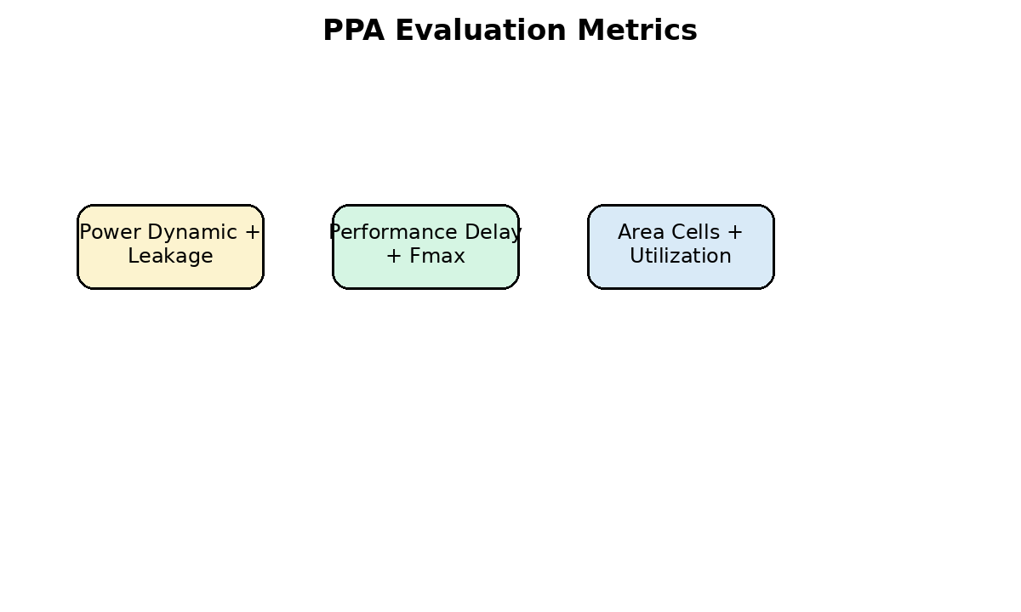
Fig 4.7 Power, performance and area metrics

CHAPTER 5
IMPLEMENTATION
File Name | Purpose | Modification
systolic_pe.v | Processing element with INT8 MAC | Product pipeline register added
systolic_array_8x8.v | 8x8 PE array | Compute cycle count updated
accel_regs.v | Configuration and status registers | Default config cycle updated
accel_top.v | Top-level accelerator | Interface retained
soc_top.v | System-level wrapper | Used for integration study
cpu_bfm.v | Bus functional model | Used in top-level testbench
Testbench | Verification Target | Expected Check
tb_systolic_pe.v | Single processing element | Product and accumulator correctness
tb_systolic_array_8x8.v | Complete array | Matrix multiplication result
tb_accel_top.v | Top-level accelerator | Register control and done status
5.1 Inputs Required for Physical Design
Physical design is the stage where the synthesized gate-level netlist is converted into a manufacturable chip layout. For this project, the proposed pipelined INT8 systolic-array accelerator is first synthesized using Synopsys Design Compiler, and the generated netlist and constraints are then used as inputs to Synopsys ICC2. Correct physical design setup is important because library, timing, routing, and parasitic files directly affect placement quality, timing closure, power estimation, and final GDS generation.
The major inputs required for physical design are the mapped Verilog netlist, SDC timing constraints, technology file, standard-cell physical libraries, timing libraries, parasitic extraction files, and GDS layer mapping information. These files must be selected from the same 32-nm technology library environment to avoid library mismatch and linking errors.
Input File / Data | Purpose in Physical Design | Placeholder to Fill
Gate-level Verilog netlist | Contains mapped standard-cell instances generated from Design Compiler. | [Insert path: accel_top_mapped.v]
SDC constraint file | Defines clock period, input/output delay, uncertainty, false paths, and design constraints. | [Insert path: accel_top_mapped.sdc]
Technology file | Defines physical layers, routing rules, vias, and design-rule information. | [Insert .tf file name]
Reference libraries / NDM libraries | Provide physical views of standard cells used for placement and routing. | [Insert 32-nm reference libraries]
Timing libraries | Provide delay, transition, power, and timing arc information for cells. | [Insert .lib/.db libraries]
TLU+ / RC files | Provide parasitic extraction data for interconnect delay calculation. | [Insert max/min TLU+ files]
GDS map file | Maps design layers to GDSII stream layers during final layout export. | [Insert GDS map file]
[IMAGE PLACEHOLDER: Insert physical design input file flow diagram here]
Fig 5.1 Inputs required for physical design
Image Generation Prompt: Create a clean VLSI physical design input-flow diagram showing RTL synthesis output files entering ICC2. Include gate-level netlist, SDC, technology file, standard-cell library, TLU+ parasitic files, and GDS map file as input blocks, with arrows pointing to an ICC2 physical design block. Use a simple academic report style with white background and black labels.
5.2 Design Import and Library Setup
The first step in ICC2 implementation is to create a design library and load the required physical and timing libraries. The design library stores the physical database generated during floorplanning, placement, CTS, routing, and optimization. The technology file and reference libraries must be correctly specified before importing the synthesized netlist.
After creating the library, the mapped Verilog netlist generated from Design Compiler is read into ICC2. The top-level design is set to accel_top, and the design is linked with the 32-nm standard-cell libraries. The SDC file is then read so that ICC2 can understand the timing requirements used during synthesis. Basic design checks are performed to identify missing cells, unresolved references, missing clocks, or unconstrained paths.
# ICC2 design import and library setup placeholder
set TOP accel_top
set TECH_FILE /path/to/32nm/tech_file.tf
set REF_LIBS [list /path/to/32nm/stdcell.ndm]
set NETLIST ../syn/outputs/accel_top_mapped.v
set SDC_FILE ../syn/outputs/accel_top_mapped.sdc
create_lib -technology $TECH_FILE -ref_libs $REF_LIBS work/${TOP}.dlib
read_verilog $NETLIST
current_design $TOP
link_block
read_sdc $SDC_FILE
check_design -summary
check_timing
[SCREENSHOT PLACEHOLDER: Insert ICC2 terminal or GUI screenshot after successful design import]
Fig 5.2 Design import and library setup in ICC2
Image Generation Prompt: Create an ICC2 design import workflow diagram. Show create_lib, read_verilog, current_design, link_block, read_sdc, check_design, and check_timing as sequential blocks. The diagram should be suitable for a VLSI M.Tech project report and must not contain any company logo.
The expected output of this stage is a linked design block with no unresolved references. If unresolved references are reported, the standard-cell reference library or target library path must be corrected before proceeding to floorplanning.
5.3 Floorplanning
Floorplanning defines the physical size, shape, utilization, and placement boundary of the chip or design block. It is one of the most important stages in physical design because it strongly affects placement density, routing congestion, power distribution, timing closure, and final layout quality. For the proposed accelerator, the design mainly consists of standard cells because the systolic array is implemented using RTL and synthesized into standard-cell logic.
The floorplan should provide enough area for standard cells, clock buffers, routing tracks, and power straps. A very high utilization may cause routing congestion and timing violations, while a very low utilization wastes silicon area. For this project, an initial core utilization of around 60% to 70% can be used. The final value may be adjusted based on congestion and timing results.
Important floorplanning decisions include aspect ratio, core utilization, core margin, IO pin placement, placement blockage creation, and macro location. If SRAM macros or memory blocks are added in future work, they should be placed during this stage. In the present design, the focus is on standard-cell physical implementation of the pipelined systolic-array accelerator.
# Floorplan command placeholder
initialize_floorplan \
-core_utilization 0.65 \
-core_offset {5 5 5 5} \
-side_ratio {1 1}
# Optional checks
report_utilization > reports/floorplan_utilization.rpt
check_legality -verbose > reports/floorplan_legality.rpt
Floorplan Parameter | Recommended Starting Value | Final Value from ICC2
Core utilization | 0.60 to 0.70 | [To be filled]
Aspect ratio | 1:1 for near-square block | [To be filled]
Core offset | 5 um to 10 um | [To be filled]
Macro placement | Not applicable / no macros | [To be filled]
Placement blockage | As required for congestion control | [To be filled]
[SCREENSHOT PLACEHOLDER: Insert initial floorplan view from ICC2 GUI]
Fig 5.3 Floorplan of the pipelined systolic-array accelerator
Image Generation Prompt: Create a simple top-view floorplan diagram for a standard-cell AI accelerator block. Show die boundary, core area, IO pins around the boundary, standard-cell placement region, and power ring space. Use labels such as Die, Core, IO Pins, Standard-Cell Region, and Power Ring.
5.4 Power Planning
Power planning creates the VDD and VSS distribution network required to supply power to all standard cells. A good power plan reduces IR drop, improves reliability, and ensures that every cell receives stable supply voltage. In a standard-cell-based accelerator, power planning usually includes creating power rings, power straps, standard-cell rails, and power-ground connections.
The power plan must be designed before placement and routing so that standard cells can be placed with access to power rails. In ICC2, power nets are created and connected to the corresponding power and ground pins of the standard cells. After the power network is generated, connectivity checks are performed to verify that VDD and VSS are properly connected.
For the proposed 8x8 systolic-array accelerator, switching activity is concentrated in the PE array, multiplier logic, accumulator registers, and clock network. Therefore, the power grid must be strong enough to support simultaneous switching of multiple MAC units. After routing, IR-drop and power integrity analysis can be performed if the required signoff tools are available.
# Power planning command placeholders
create_net -power VDD
create_net -ground VSS
connect_pg_net -net VDD [get_pins -hierarchical */VDD]
connect_pg_net -net VSS [get_pins -hierarchical */VSS]
# Example placeholders for power ring and mesh creation
# create_pg_ring_pattern ...
# set_pg_strategy ...
# compile_pg
check_pg_connectivity > reports/pg_connectivity.rpt
Power Planning Item | Purpose | Report / Screenshot Placeholder
Power nets | Define VDD and VSS supply nets. | [Insert command output]
Power ring | Provides strong power boundary around the core. | [Insert ring screenshot]
Power straps | Distribute supply across the core region. | [Insert strap screenshot]
Standard-cell rails | Connect standard cells to VDD and VSS. | [Insert rail view]
PG connectivity check | Verifies that all cells are connected to power and ground. | [Insert report summary]
[SCREENSHOT PLACEHOLDER: Insert power ring, power straps, and standard-cell rail view]
Fig 5.4 Power planning structure
Image Generation Prompt: Create a VLSI power planning diagram showing core boundary, VDD/VSS power ring, vertical and horizontal power straps, and standard-cell rails. Use blue for VDD and black for VSS only if color is allowed; otherwise use clear line labels. Keep the diagram neat for an academic dissertation.
5.5 Placement and Pre-CTS Optimization
Placement determines the exact location of each standard cell inside the core area. The objective of placement is to minimize wirelength, reduce congestion, improve timing, and prepare the design for clock-tree synthesis. Since the proposed accelerator contains repeated PE logic, the placement tool attempts to place logically connected cells near each other to reduce interconnect delay.
In the placement stage, ICC2 performs global placement, legalization, and optimization. Timing-driven placement is important for the proposed pipelined accelerator because the goal of the project is high performance. The placement result should be checked for utilization, congestion, cell legality, and timing quality. If congestion is high, utilization or floorplan dimensions may need adjustment.
Pre-CTS optimization is performed after placement and before clock-tree synthesis. At this point, the clock is still considered ideal or propagated only through estimated clock networks. The tool optimizes data paths, buffer insertion, cell sizing, and logic restructuring to improve setup timing before CTS.
# Placement and pre-CTS optimization placeholders
place_opt
check_legality -verbose > reports/place_legality.rpt
report_utilization > reports/place_utilization.rpt
report_congestion > reports/place_congestion.rpt
report_timing -max_paths 10 > reports/pre_cts_timing.rpt
[SCREENSHOT PLACEHOLDER: Insert standard-cell placement view from ICC2 GUI]
Fig 5.5 Standard-cell placement of the accelerator
Image Generation Prompt: Create a simplified standard-cell placement diagram for an 8x8 systolic-array accelerator. Show dense standard-cell rows inside a core boundary, with highlighted regions for control logic, register interface, and systolic-array datapath. Use a professional VLSI layout illustration style.
At the end of placement, there should be no illegal cell placement. The congestion map should be acceptable, and setup timing should be close enough for CTS and routing optimization to complete successfully.
5.6 Clock Tree Synthesis
Clock Tree Synthesis is the stage where the ideal clock is converted into a real physical clock network. Before CTS, the clock is assumed to arrive at all sequential elements ideally. In actual silicon, the clock signal must travel through buffers, inverters, and interconnects before reaching flip-flops. CTS builds this clock network and tries to control clock skew, clock latency, transition time, and clock power.
The proposed pipelined accelerator contains additional registers compared with the baseline design. Therefore, the clock network becomes important because more sequential elements must be driven. The CTS engine inserts clock buffers and balances clock paths so that all flip-flops receive the clock within acceptable skew limits.
For this project, CTS quality is evaluated using clock latency, clock skew, number of clock buffers, setup timing, and hold timing. Since the design goal is high performance, the clock tree must support the selected target frequency without creating excessive setup or hold violations.
# CTS and clock optimization placeholders
clock_opt
report_clock_qor > reports/clock_qor.rpt
report_clock_timing -type skew > reports/clock_skew.rpt
report_clock_timing -type latency > reports/clock_latency.rpt
report_timing -delay_type max -max_paths 10 > reports/post_cts_setup.rpt
report_timing -delay_type min -max_paths 10 > reports/post_cts_hold.rpt
CTS Metric | Meaning | Value from ICC2
Clock latency | Delay from clock source to register clock pins. | [To be filled]
Clock skew | Difference in clock arrival time between registers. | [To be filled]
Clock buffers/inverters | Cells inserted to build the clock tree. | [To be filled]
Setup WNS after CTS | Worst setup slack after clock network creation. | [To be filled]
Hold WNS after CTS | Worst hold slack after clock network creation. | [To be filled]
[SCREENSHOT PLACEHOLDER: Insert clock tree or clock latency view from ICC2 GUI]
Fig 5.6 Clock tree synthesis for the proposed accelerator
Image Generation Prompt: Create a clock tree synthesis diagram for a digital accelerator. Show one clock source feeding a balanced tree of buffers and then multiple registers. Label clock source, clock buffers, register clock pins, skew, and latency. Keep the style similar to a VLSI physical design textbook figure.
5.7 Routing
Routing creates the actual metal interconnections between placed standard cells. It connects signal nets, clock nets, and power-ground structures according to the design rules of the 32-nm technology. Routing is performed after placement and CTS because the router needs the final cell locations and clock tree structure.
The routing stage normally includes global routing, track assignment, detailed routing, and post-route optimization. Global routing estimates the routing paths and detects congestion. Detailed routing creates exact metal wires and vias. Post-route optimization fixes timing violations, transition violations, capacitance violations, and design-rule violations.
For the proposed systolic-array accelerator, routing quality is important because the PE array contains many local interconnections for activation, weight, and partial-sum movement. If routing congestion is high, the design may require lower utilization, better floorplanning, or additional optimization.
# Routing command placeholders
route_auto
route_opt
check_routes > reports/route_check.rpt
report_congestion > reports/post_route_congestion.rpt
report_timing -delay_type max -max_paths 10 > reports/post_route_setup.rpt
report_timing -delay_type min -max_paths 10 > reports/post_route_hold.rpt
[SCREENSHOT PLACEHOLDER: Insert routed layout view from ICC2 GUI]
Fig 5.7 Routed layout of the accelerator
Image Generation Prompt: Create a simplified routed VLSI layout diagram showing standard cells, horizontal and vertical routing layers, clock routes, and signal routes. Use clear labels for Placement, Clock Routing, Signal Routing, and Power Straps. The image should look like a clean educational figure, not a real confidential layout.
5.8 Physical Verification
Physical verification ensures that the final layout satisfies manufacturing and electrical correctness requirements. After routing, the layout must be checked for design-rule violations, connectivity errors, missing power-ground connections, antenna violations, and timing violations. These checks are necessary before generating the final GDSII file.
Design Rule Check verifies whether the layout follows the spacing, width, via, enclosure, and density rules of the 32-nm technology. Layout Versus Schematic compares the final layout connectivity with the original netlist to ensure that the routed layout matches the intended circuit. Antenna checks detect possible charge accumulation issues during fabrication.
In an academic Synopsys flow, ICC2 checks such as check_routes, check_lvs, check_pg_connectivity, and timing reports can be included. If signoff tools such as Synopsys ICV or Mentor Calibre are available, final DRC and LVS reports should also be added to the documentation.
# Physical verification placeholders
check_routes > reports/check_routes.rpt
check_lvs > reports/check_lvs.rpt
check_pg_connectivity > reports/check_pg_connectivity.rpt
report_constraints -all_violators > reports/constraint_violations.rpt
report_timing -delay_type max > reports/final_setup_timing.rpt
report_timing -delay_type min > reports/final_hold_timing.rpt
Physical Check | Purpose | Final Status
DRC | Checks layout design-rule correctness. | [Pass/Fail]
LVS | Checks layout connectivity against netlist. | [Pass/Fail]
Antenna check | Checks antenna-related manufacturing issues. | [Pass/Fail]
PG connectivity | Checks VDD/VSS connectivity. | [Pass/Fail]
Setup timing | Checks maximum delay timing. | [Pass/Fail]
Hold timing | Checks minimum delay timing. | [Pass/Fail]
[SCREENSHOT PLACEHOLDER: Insert DRC/LVS/route check summary screenshot]
Fig 5.8 Physical verification checks after routing
Image Generation Prompt: Create a physical verification flow diagram for ASIC design. Include routed layout, DRC check, LVS check, antenna check, timing signoff, power signoff, and final GDSII output. Use simple arrows and report-style formatting.
5.9 Report Generation and Output Files
After physical implementation, ICC2 generates reports and output files required for analysis and documentation. These files are used to compare baseline and proposed designs in terms of area, timing, power, congestion, utilization, clock quality, and layout correctness. All final results in the report must be copied from the generated tool reports.
Output File / Report | Purpose | Placeholder
post_route_timing.rpt | Final setup and hold timing analysis. | [Insert WNS/TNS values]
post_route_power.rpt | Final dynamic, leakage, and total power. | [Insert power values]
post_route_area.rpt | Final cell area and design size. | [Insert area values]
clock_qor.rpt | Clock tree quality, skew, and latency. | [Insert CTS values]
congestion.rpt | Routing congestion information. | [Insert congestion summary]
accel_top.gds | Final GDSII layout file. | [Generated / Not generated]
accel_top.def | Physical design exchange format. | [Generated / Not generated]
accel_top_final.v | Final post-route Verilog netlist. | [Generated / Not generated]
# Final output generation placeholders
write_verilog -output outputs/accel_top_final.v
write_sdc -output outputs/accel_top_final.sdc
write_def -output outputs/accel_top_final.def
write_parasitics -format spef -output outputs/accel_top_final.spef
write_gds -output outputs/accel_top.gds
[SCREENSHOT PLACEHOLDER: Insert final layout / GDS view]
Fig 5.9 Final GDS layout view
Image Generation Prompt: Create an academic-style final chip layout illustration for a small standard-cell AI accelerator. Show a rectangular core with visible placement density, routing tracks, power grid, and labels for Systolic Array Datapath, Register Interface, Control Logic, and Clock Network.
5.10 Final Implementation Checklist
The following checklist should be completed before using the physical implementation results in the final project report. This checklist ensures that the design has passed the essential implementation stages and that the result values are taken from valid reports.
- The synthesized netlist from Design Compiler is imported into ICC2 without unresolved references.
- The SDC file is read correctly and the clock is recognized by ICC2.
- The floorplan is created with acceptable utilization and enough routing area.
- Power and ground nets are created and connected to all standard cells.
- Placement completes successfully with legal standard-cell placement.
- Pre-CTS timing and congestion reports are generated.
- Clock Tree Synthesis completes and clock skew/latency reports are saved.
- Routing completes without serious design-rule or connectivity errors.
- Post-route setup and hold timing reports are generated.
- Area, power, timing, utilization, and congestion results are copied into Chapter 6.
- Final GDSII output is generated and stored in the output directory.
- Screenshots of floorplan, placement, CTS, routing, and final layout are inserted in the report.
This completes the implementation chapter. The next chapter presents the result tables and discussion based on the reports generated from Design Compiler and ICC2.

CHAPTER 6
RESULTS AND DISCUSSION
6.1 Result Parameters
The final results of the project should be obtained from Synopsys reports. The baseline and proposed designs must be compared using the same constraints and library. The most important parameters are area, timing, power, and physical design metrics.
Since actual Synopsys reports depend on the 32-nm library and tool setup used in the laboratory, placeholder tables are provided in this document. These placeholders must be replaced with actual values after running Design Compiler and ICC2.
6.2 Synthesis Results
Parameter | Baseline Design | Proposed Pipelined Design | Observation
Total cell area | To be filled | To be filled | Compare overall area
Combinational area | To be filled | To be filled | Logic area comparison
Sequential area | To be filled | To be filled | Proposed may increase
Dynamic power | To be filled | To be filled | Compare switching power
Leakage power | To be filled | To be filled | Compare leakage
Total power | To be filled | To be filled | Power trade-off
Critical path delay | To be filled | To be filled | Proposed should reduce
Maximum frequency | To be filled | To be filled | Proposed should improve
WNS | To be filled | To be filled | Timing slack comparison
TNS | To be filled | To be filled | Overall timing violation comparison

6.3 Physical Design Results
Parameter | Baseline Design | Proposed Pipelined Design | Observation
Core area | To be filled | To be filled | Layout area comparison
Core utilization | To be filled | To be filled | Placement density
Standard-cell count | To be filled | To be filled | Cell count comparison
Setup WNS | To be filled | To be filled | Post-route setup timing
Hold WNS | To be filled | To be filled | Post-route hold timing
Clock latency | To be filled | To be filled | CTS quality
Clock skew | To be filled | To be filled | CTS balance
Total power | To be filled | To be filled | Post-layout power
Routed wire length | To be filled | To be filled | Routing comparison
GDS generated | Yes/No | Yes/No | Final output

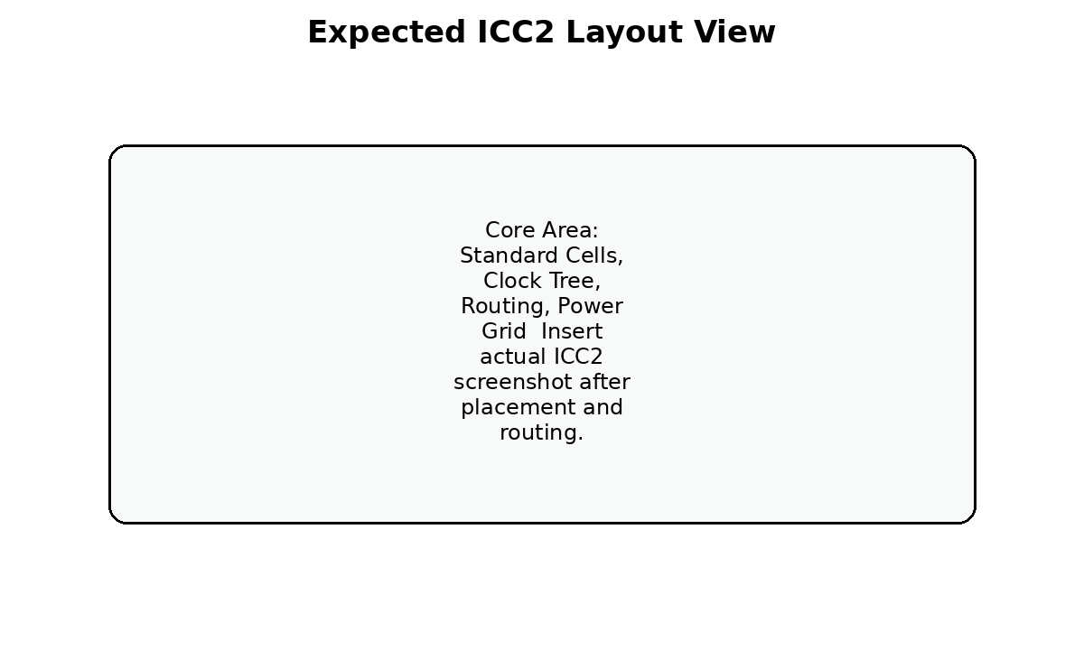
Fig 6.1 Expected ICC2 layout view
6.4 Baseline vs Proposed Comparison
The proposed pipelined design is expected to reduce the critical path delay compared with the baseline design. The improvement occurs because multiplication and accumulation no longer share the same combinational timing path. The maximum operating frequency should therefore increase.
The expected trade-off is an increase in sequential area due to the new pipeline registers. Dynamic power may also change due to additional register switching. However, the main objective of this project is high performance, so this trade-off is acceptable if the timing improvement is significant.
The final discussion should be based on the actual numbers generated by Design Compiler and ICC2. If the proposed design improves WNS and maximum frequency with a reasonable area overhead, the project objective is achieved.
6.5 Reports to be Inserted
- Design Compiler report_area screenshot or text summary.
- Design Compiler report_timing screenshot showing critical path.
- Design Compiler report_power screenshot.
- ICC2 floorplan screenshot.
- ICC2 placement screenshot.
- ICC2 CTS clock tree or clock report screenshot.
- ICC2 routing screenshot.
- Post-route timing report.
- Final GDSII layout screenshot.

CHAPTER 7
CONCLUSION
7.1 Summary
This project presents the design and 32-nm physical implementation of a high-performance pipelined INT8 systolic-array AI accelerator. The accelerator is based on an 8x8 systolic array containing 64 processing elements. Each processing element performs signed INT8 multiplication and 32-bit accumulation for matrix-multiplication-based machine-learning workloads.
The baseline design has a long critical path because the multiplier and accumulator adder are present in the same combinational path. To improve timing performance, the proposed design inserts a pipeline register between the multiplication stage and the accumulation stage. This modification splits the MAC datapath into two stages and reduces the critical path delay.
The design is implemented in Verilog HDL and verified using testbenches. It is synthesized using Synopsys Design Compiler with a 32-nm standard-cell library and physically implemented using Synopsys ICC2. The final results are evaluated using area, power, timing, utilization, and post-route layout metrics.
7.2 Future Scope
The project can be extended in several directions. The current 8x8 systolic array can be scaled to 16x16 or larger arrays to increase throughput. Multi-precision operation can be added to support INT4 and INT8 modes. On-chip SRAM buffers can be included to reduce input-output bandwidth requirements. A standard bus interface such as AXI or APB can be added for SoC integration.
Further work can also include clock gating for low-power operation, formal verification, post-layout simulation using SDF, and integration with a RISC-V processor. CNN-specific frontend logic such as im2col data generation can also be added to support convolution acceleration directly.
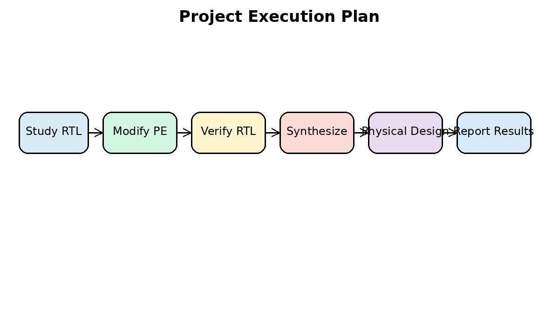
Fig 7.1 Project execution plan

REFERENCES
[1] Kashif Inayat and Jaeyong Chung, “Hybrid Accumulator Factored Systolic Array for Machine Learning Acceleration,” IEEE Transactions on Very Large Scale Integration (VLSI) Systems, vol. 30, no. 7, pp. 881-892, July 2022.
[2] H. T. Kung, “Why Systolic Architectures?” Computer, vol. 15, no. 1, pp. 37-46, 1982.
[3] N. P. Jouppi et al., “In-Datacenter Performance Analysis of a Tensor Processing Unit,” Proceedings of the 44th Annual International Symposium on Computer Architecture, 2017.
[4] Synopsys, Design Compiler User Guide.
[5] Synopsys, IC Compiler II Implementation User Guide.
[6] J. Bhasker and R. Chadha, Static Timing Analysis for Nanometer Designs: A Practical Approach.
[7] IEEE Standard for Verilog Hardware Description Language.
[8] M. S. Lam, “Software pipelining: An effective scheduling technique for VLIW machines,” ACM SIGPLAN, 1988.
[9] S. Mittal, “A survey of FPGA-based accelerators for convolutional neural networks,” Neural Computing and Applications, 2020.
[10] D. Patterson and J. Hennessy, Computer Organization and Design: The Hardware/Software Interface.

APPENDIX
Appendix A: Files Used in the Project
Category | Files
RTL | systolic_pe.v, systolic_array_8x8.v, accel_regs.v, accel_top.v, soc_top.v, cpu_bfm.v
Testbench | tb_systolic_pe.v, tb_systolic_array_8x8.v, tb_accel_top.v
Constraints | accel_top_32nm.sdc
Scripts | run_dc.tcl, run_icc2.tcl, run_iverilog_smoke.sh
Reports | area.rpt, timing.rpt, power.rpt, qor.rpt, post_route_timing.rpt, post_route_power.rpt

Appendix B: Important Design Commands
# Simulation smoke test
iverilog -g2012 -o simv rtl/*.v tb/tb_systolic_array_8x8.v
vvp simv
# Design Compiler
mkdir -p syn/reports syn/outputs
cd syn
dc_shell -f ../scripts/run_dc.tcl | tee dc.log
# ICC2
mkdir -p pnr/reports pnr/outputs
cd pnr
icc2_shell -f ../scripts/run_icc2.tcl | tee icc2.log
Appendix C: One-Minute Explanation for Viva
This project designs a high-performance INT8 AI accelerator based on an 8x8 systolic array. The accelerator performs matrix multiplication using 64 processing elements. Each processing element performs signed 8-bit multiplication and 32-bit accumulation. In the baseline design, the multiplier and accumulator are present in the same clock path, which limits the maximum frequency.
The proposed design improves timing by adding a pipeline register between the multiplier and the accumulator. This reduces the critical path delay and increases the achievable operating frequency. The RTL is verified using testbenches, synthesized using Synopsys Design Compiler, and physically implemented using Synopsys ICC2 in 32-nm technology. The baseline and proposed designs are compared using area, power, timing, and layout reports.
Appendix D: Final Submission Checklist
- Replace [STUDENT NAME], [REGISTRATION NUMBER], [GUIDE NAME], and [DATE].
- Insert actual simulation waveform screenshots.
- Insert actual Design Compiler area, timing, power, and QoR reports.
- Insert actual ICC2 floorplan, placement, CTS, routing, and GDS screenshots.
- Fill all result tables using actual values from reports.
- Check references and base paper details.
- Verify final formatting, page numbers, and figure captions before printing.
Appendix E: Notes on Result Interpretation
If the proposed design shows higher maximum frequency but slightly higher area, the result is valid because the project objective is high performance. A pipelined design normally uses extra registers, which increases sequential area. The improvement must be explained as an area-performance trade-off.
If the proposed design has higher dynamic power, the reason may be additional flip-flop switching. This does not invalidate the project because the goal is not low-power optimization. However, the power increase should be reported honestly and discussed clearly.
If the post-route timing is worse than synthesis timing, the reason is routing parasitic delay and clock tree insertion delay. This is normal in physical design. The final conclusion should preferably use post-route reports because they are closer to the actual implemented layout.

