**Thanks for your purchase.**

First of all, you have to get [DOTWEEN](http://u3d.as/aZ1) from the Asset Store :

<http://u3d.as/aZ1>

(it’s free)

1/ Import Dotween from the asset store : <http://u3d.as/aZ1>

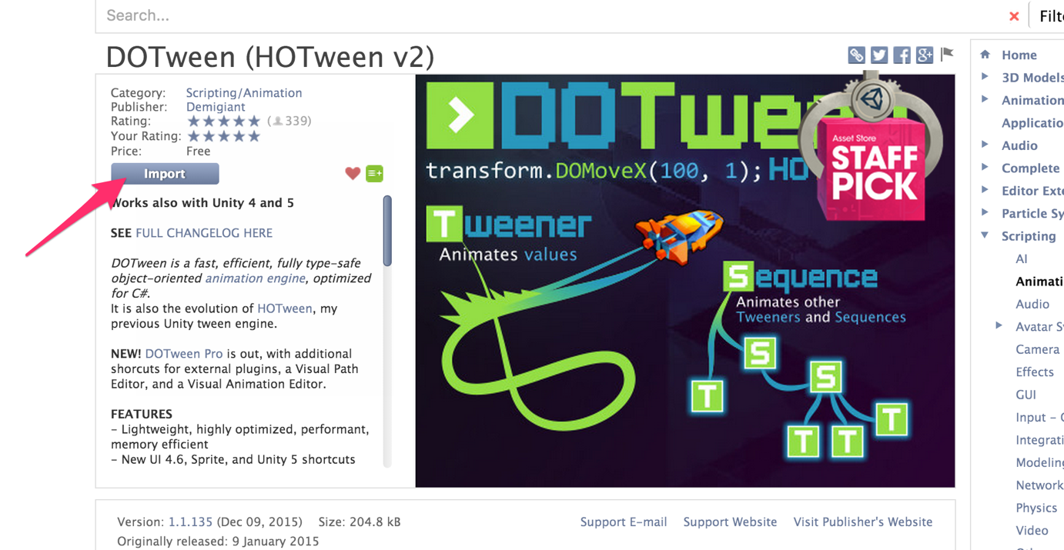

2/ Import the package into Unity

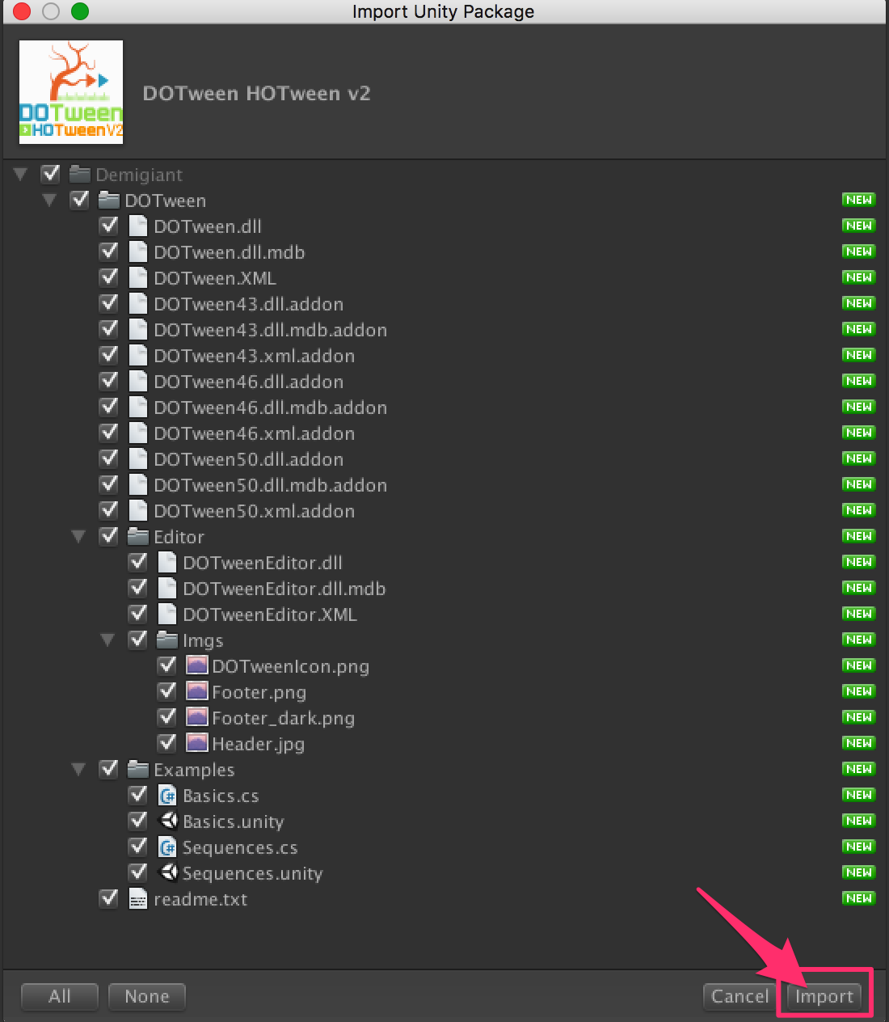

3/If you don’t see the « Tools » in the top of the Unity Screen, please do this :

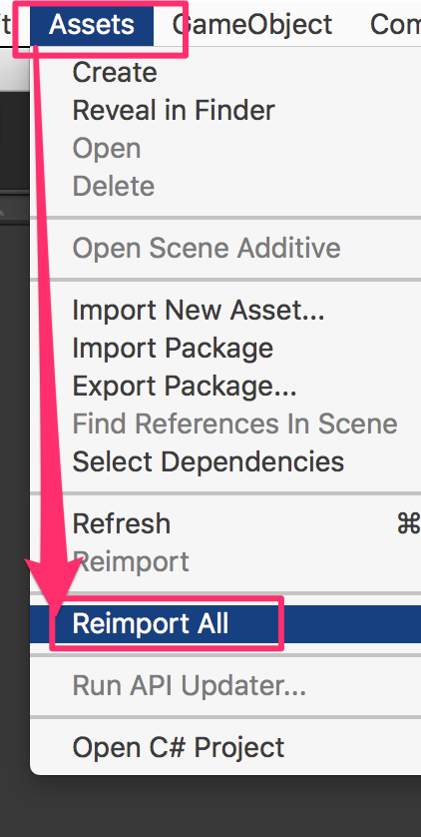

4/Now you have the « Tools ». Open it and click on « DOTween Utility Panel ».

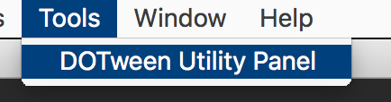

5/Click on « Setup DOTween ».

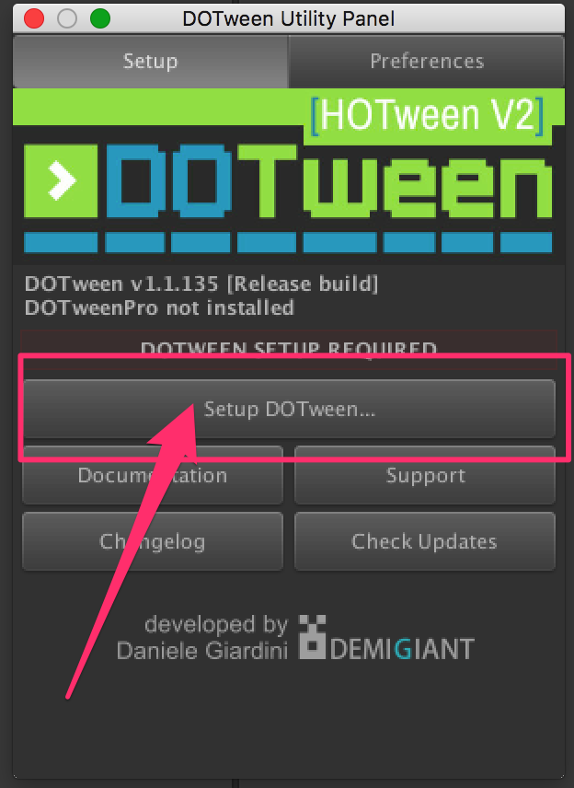

6/And to finish, click on the « OK » button.

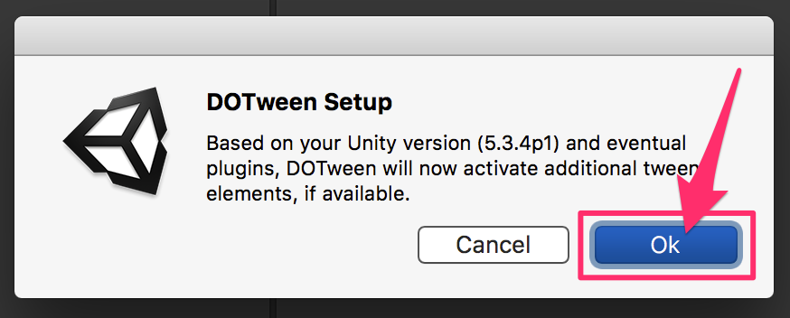

**Video tutorial : https://www.youtube.com/watch?v=wxfowqMV9z0**

**// FIRST OF ALL ///////////////////////////**

**SOURCE CODE DOCUMENTATION AVAILABLE HERE :**

<https://db.tt/FF8M7cYi>

**To begin, open the scene « aa ».**

**1 - Music:**

To add a background music: Find the GameObject « Main Camera »,

and add your music to his child « Music ».

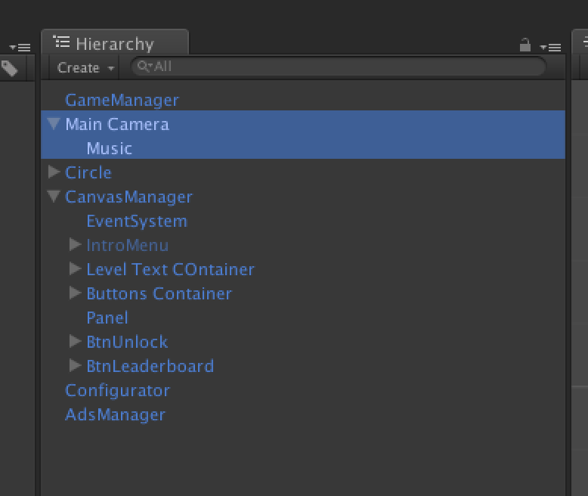

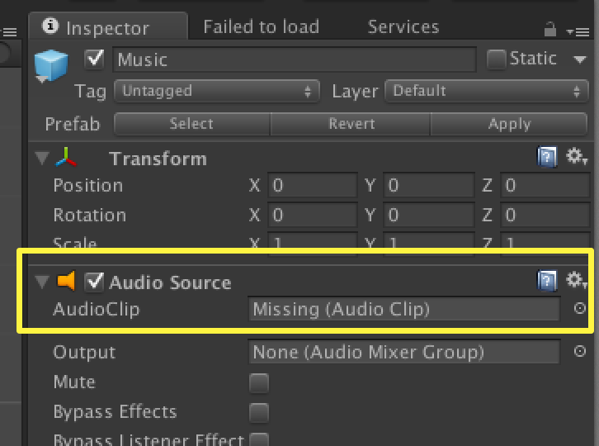

**2 - Dots:**

All the circle in the game (big, small, and for the buttons) use the same image :

« Circle » (in the folder aa/image »).

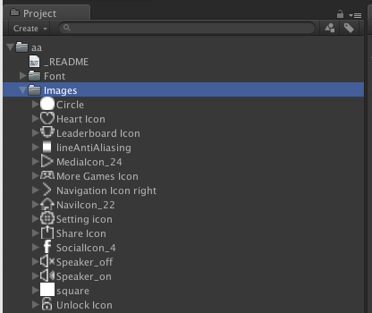

If you want to change it, please respect the size: it will be easier for you if it’s exactly the same.

**3 - Menu:**

The menu is in the GameObject « CanvasManager ». Check the childs, they are named logically.

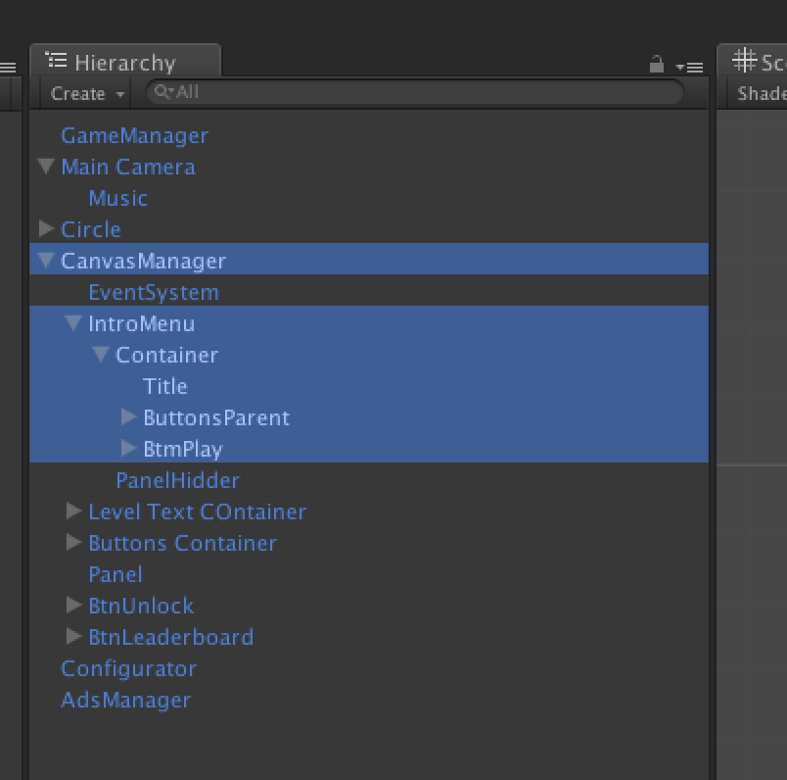

**4 - Scripts:**

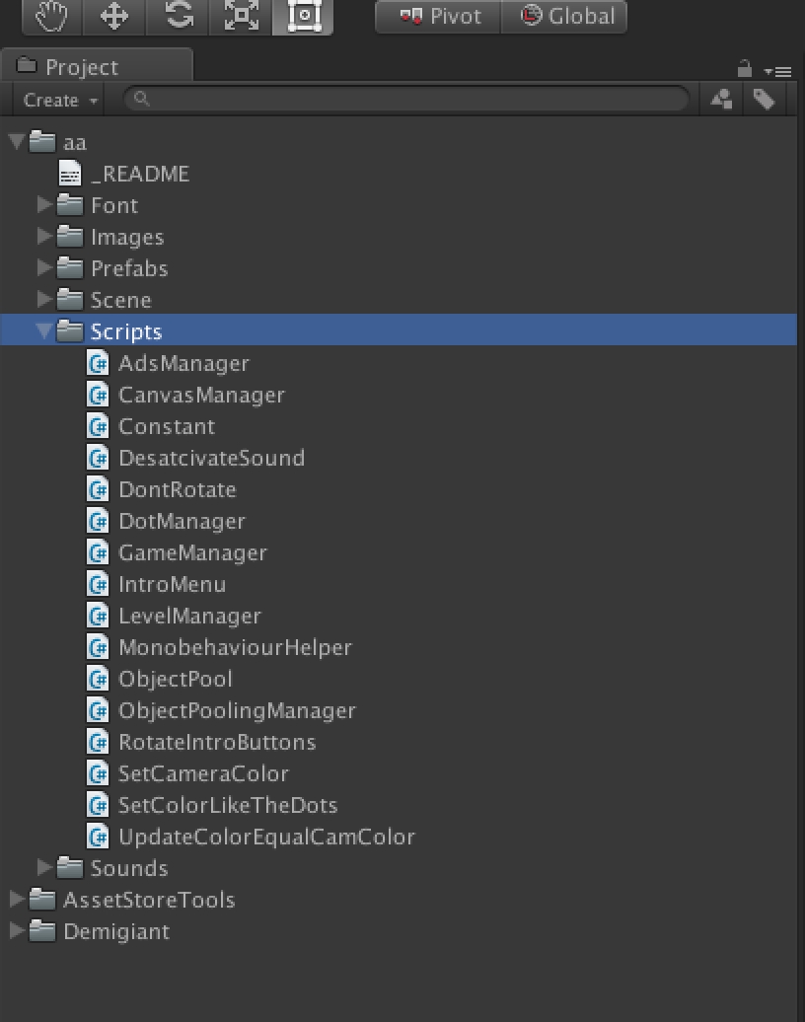

**CanvasManager.cs:**

This script is attached to the GameObject « CanvasManager ».

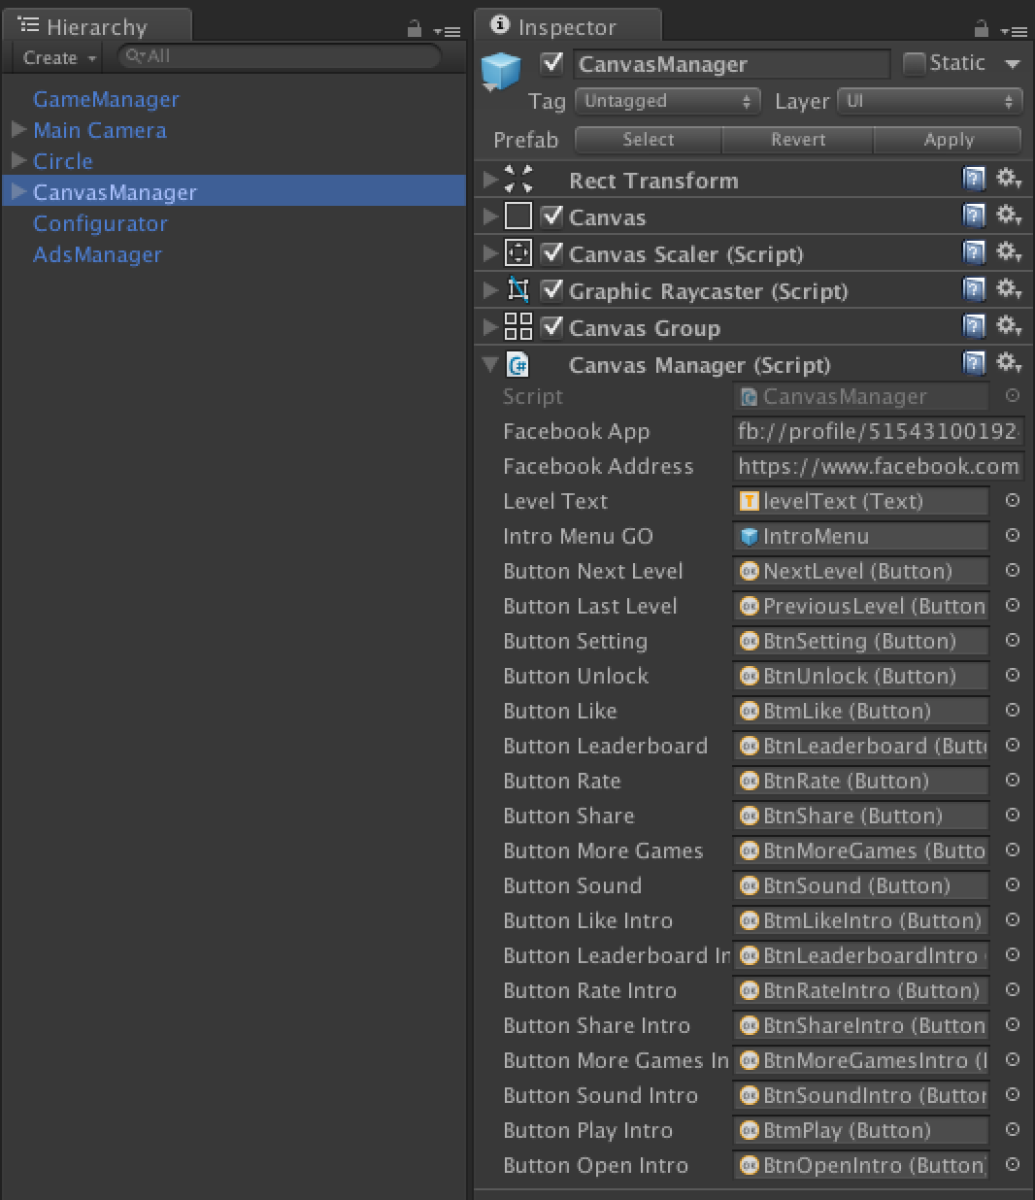

Please change the links : Facebook App (to open directly the Facebook app in your fan page on mobile), and the Facebook Address (if the app doesn’t exist, or on desktop, it will open safari or web browsers).

**Constant.cs:**

Some constants use in the app.

This script is attached to the GameObject « Configurator ».

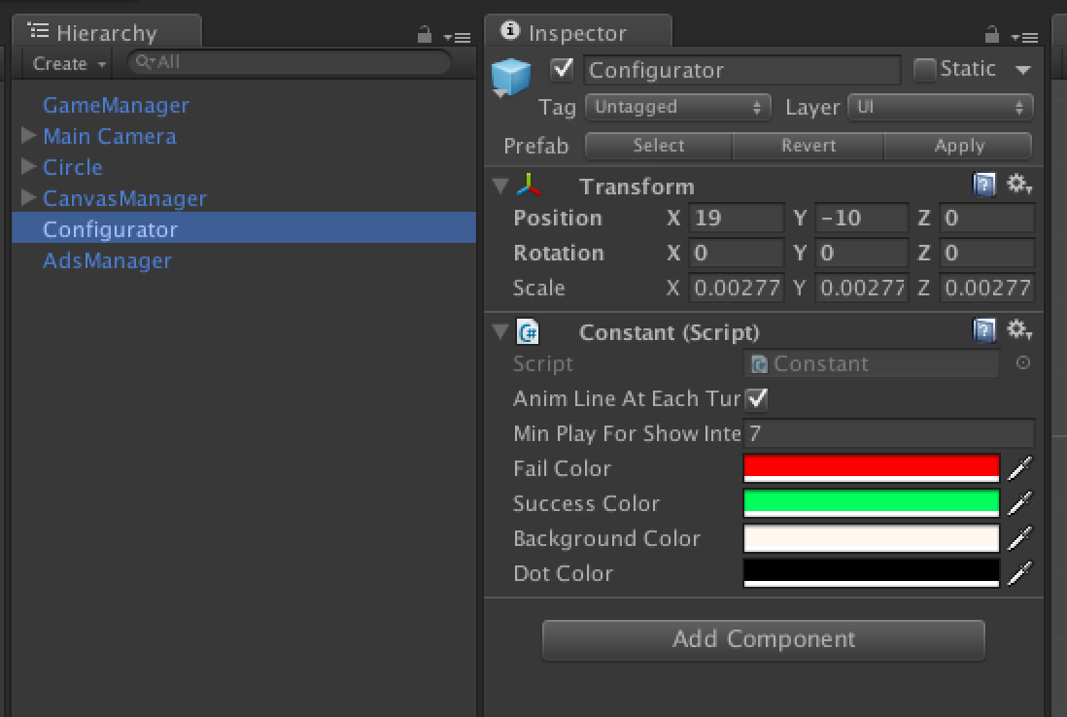

You can change all the color in this game object :

* Fail color

* Success Color

* Background Color

* Dot Color

**DesactivateSound.cs:**

Use to disable all the sound effects, and the background music, or to enable them. This script is attached to the GameObject « TurnSoundOff » and « TurnSoundOn ». You can find them in the « CanvasManager » GameObject in the scene : CanvasManager/Buttons Container/BtnSound.

**DotManager.cs:**

All the dot prefabs have a « DotManager.cs » attached.

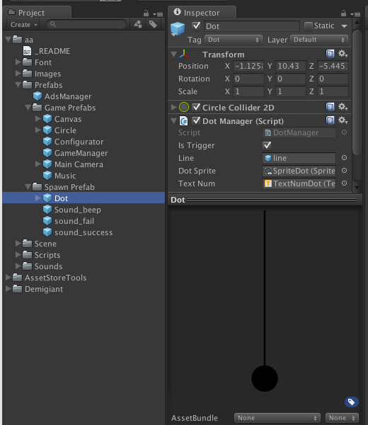

This script is responsible to detect collision, enable the shoot or to add the dot in the big circle on center.

**GameManager.cs:**

This script is attached to the GameObject « GameManager ».

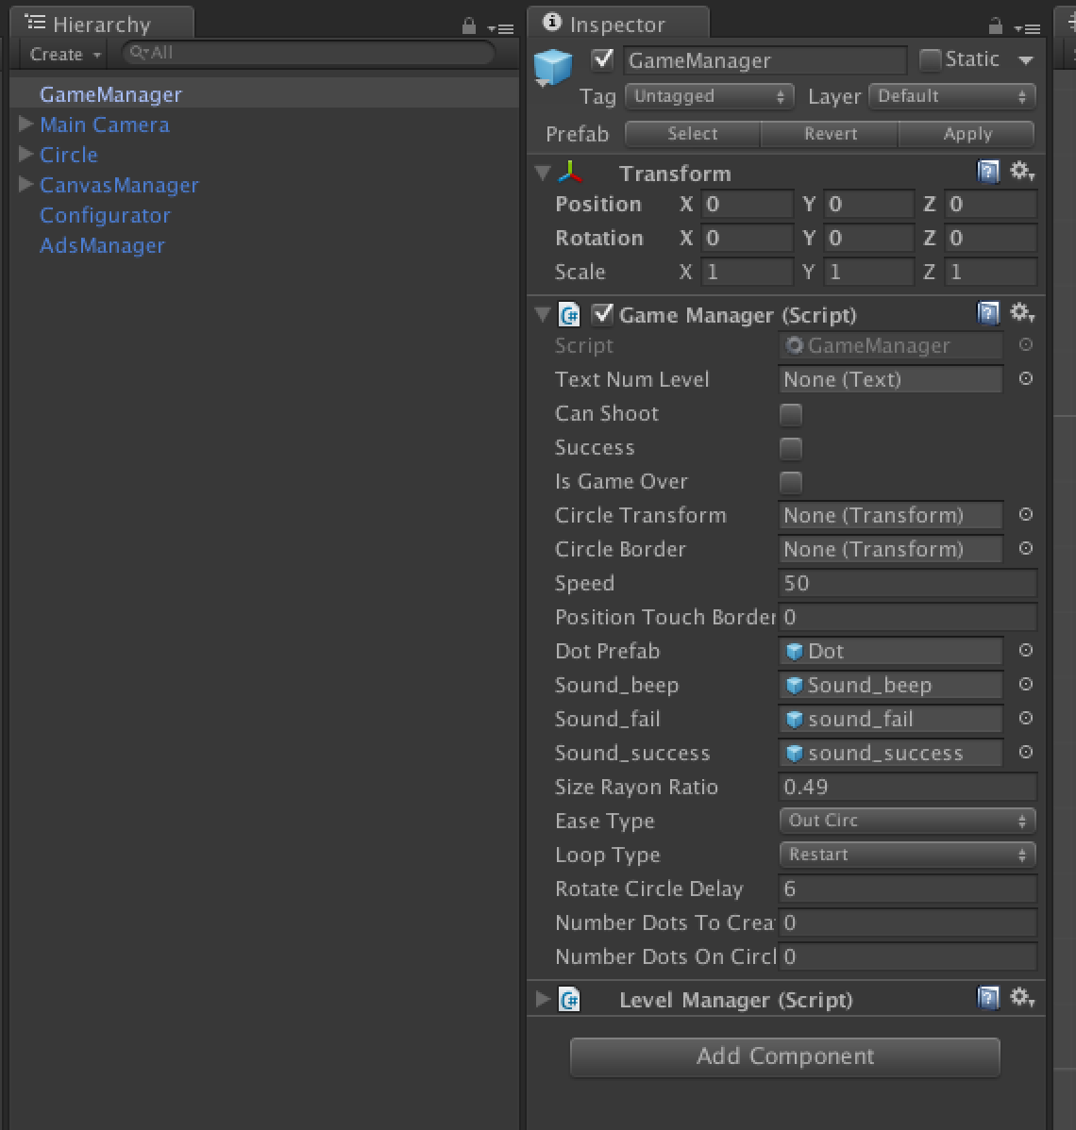

This script is responsible to create game, and detect all the event in the game : Success / Game Over.

**ObjectPool.cs/ObjectsPoolingManager:**

Instantiate and destroy prefabs are not good. So we use this to do that to simple enable and disable prefabs. Search on google « Object pooling » or write me if you want to understand the principle.

**MonobehaviorHelper.cs:**

Some class (like CanvasManager, GameManager..) derives from this class to have clearer code.

**IntroMenu.cs:**

This script is attached to the GameObject "IntroMenu" (child of "CanvasManager"). It's the view you see at start. 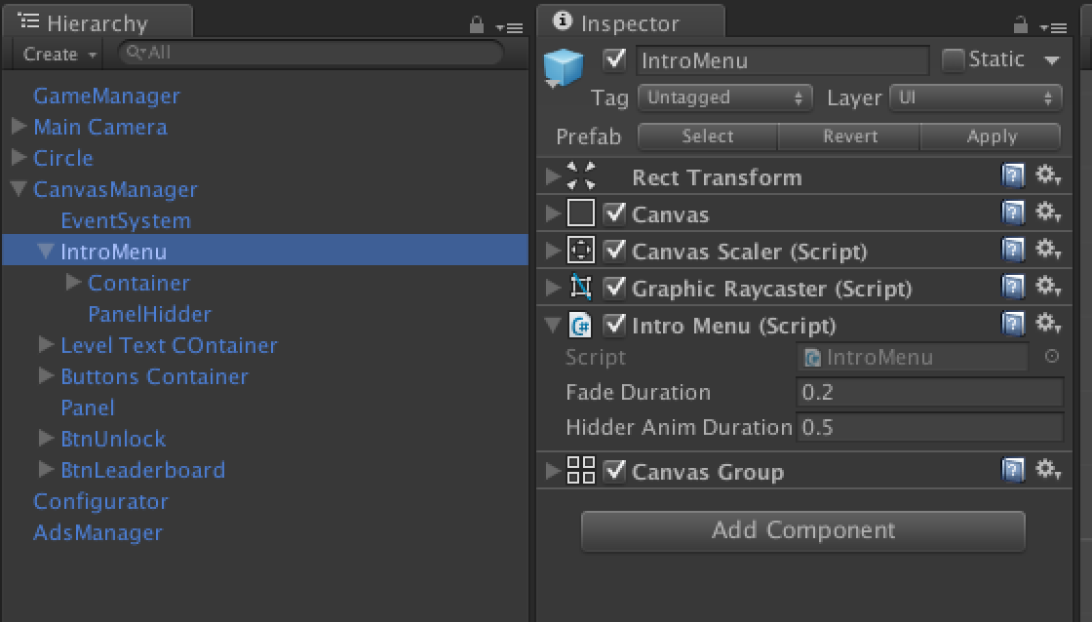

**InputTouch.cs :**

In charge to handle input in the game.

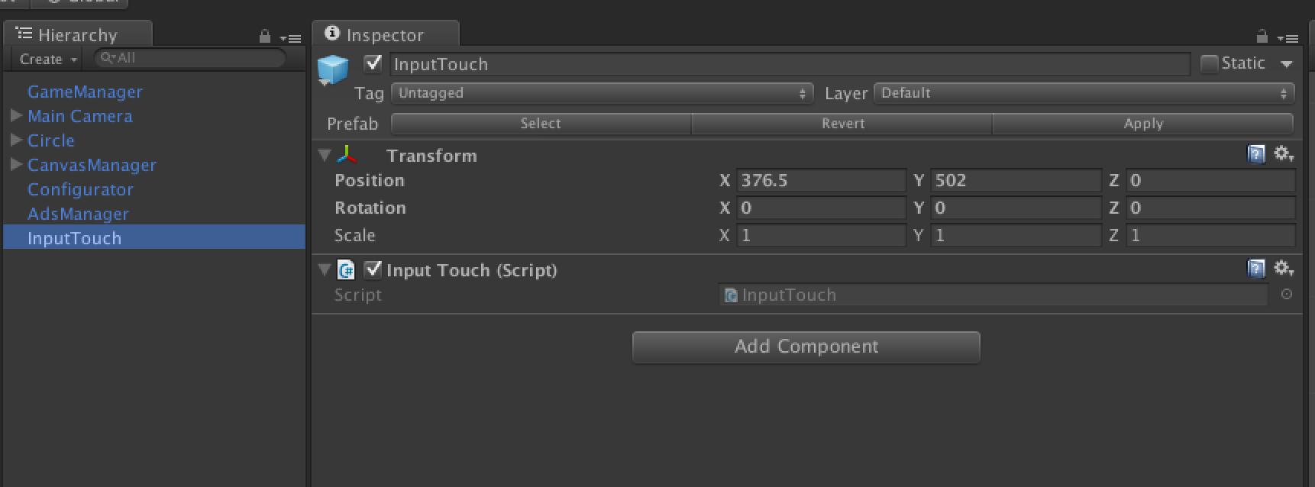

**RateUsManager.cs :**

In charge to handle input in the game.

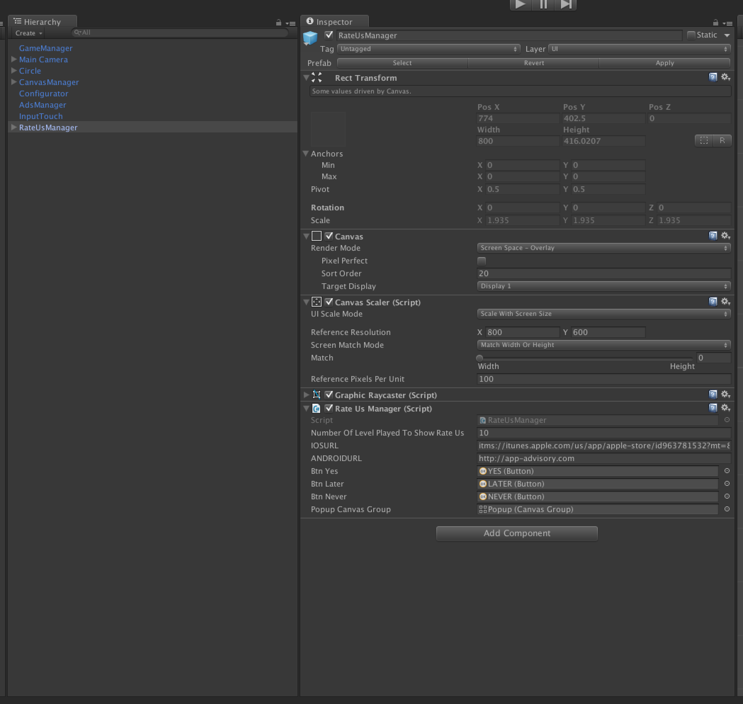

Change the url to redirect to your app.

Change the « Number Of Level Played To Show Rate Us » to change the moment we prompt the pop up to ask to rate.

**ADS :**

Everything is done for you : « Very Simple Ads » is already implemented.

Get it here : http://u3d.as/oWD

Thanks !

Our other assets : <http://u3d.as/9cs>

Contact : [contact@app-advisory.com](mailto:contact@app-advisory.com)