Q-1. Write an SQL query to fetch “FIRST_NAME” from Worker table using the alias

name as <WORKER_NAME>

ANS. select first_name as WorkerName from [dbo].[Worker]

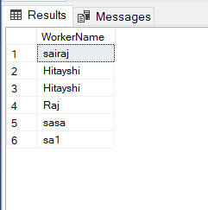

Q-2. Write an SQL query to fetch unique values of DEPARTMENT from Worker table.

ANS .select distinct department from [dbo].[Worker]

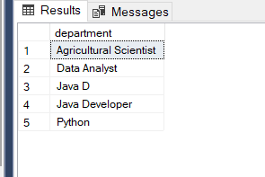

Q-3. Write an SQL query to show the last 5 record from a table.

Ans .SELECT Top 5 * from Worker ORDER by customer_id DESC

